Questions
Q1.
The first ionization energies, in kJ mol⁻¹, of four elements with consecutive atomic
numbers are shown below.
A 1680
B 2080
C 496
D 738
(a) Which element could be an inert gas?
(1)
A
B
C
D
(b) Which element could be X in a covalent compound with formula HX?
(1)
A
B
C
D
(c) Which element could be Y in an ionic compound with formula YH₂?
(1)
A
B
C
D
(Total for question = 3 marks)

Q2.
Which of the following covalent bonds is the shortest?
A H—F
B H—Cl
C H—Br
D H—I
(Total for question = 1 mark)

Q3.
The bonding in magnesium oxide, MgO, is
A ionic.
B metallic and ionic.
C ionic and covalent.
D metallic and covalent.
(Total for question = 1 mark)

Q4.
Covalent bonding results from the strong electrostatic attractions between
A instantaneous dipoles.
B electron clouds.
C electrons in the bonding pair.
D bonding pairs of electrons and nuclei.
(Total for Question = 1 mark)

Q5.
The bonding in lithium iodide has some covalent character because
A the lithium ion polarizes the iodide ion.
B the iodide ion polarizes the lithium ion.
C there is a very large difference in electronegativity between lithium and iodine.
D there is a very small difference in electronegativity between lithium and iodine.

(Total for question = 1 mark)

Q6.
Which of the following data is not needed to calculate the lattice energy of sodium chloride when using a Born-Haber cycle?
A Enthalpy change of formation of sodium chloride.
B Enthalpy change of atomization of sodium.
C First ionization energy of chlorine.
D Electron affinity of chlorine.

(Total for question = 1 mark)

Q7.
Which of the following contains a dative covalent bond?
A N₂
B NH₃
C NH₂⁻
D NH₄⁺

(Total for question = 1 mark)

Q8.
Which of these equations represents the electron affinity of chlorine?
A Cl₂(g) + 2e⁻ → 2Cl⁻(g)
B Cl₂(g) - 2e⁻ → 2Cl⁻(g)
C ½Cl₂(g) + e⁻ → Cl⁻(g)
D Cl(g) + e⁻ → Cl⁻(g)
(Total for question = 1 mark)

Q9.
Which of the equations below represents the first electron affinity for oxygen?

A O₂(g) + 2e⁻ → 2O⁻(g)
B O₂(g) − 2e⁻ → 2O⁻(g)
C ½O₂(g) + e⁻ → O⁻(g)
D O(g) + e⁻ → O⁻(g)
(Total for Question = 1 mark)

Q10.
Which of the following has the largest ionic radius?

A S²⁻
B Cl⁻
C K⁺
D Ca²⁺
(Total for Question = 1 mark)

Q11.
In which of the following electronic configurations are only two of the electrons unpaired?
A 1s² 2s²
B 1s² 2s² 2p³
C 1s² 2s² 2p⁴
D 1s² 2s² 2p⁵

(Total for question = 1 mark)

Q12.
Which of these electron density maps best represents the bonding in the compound
lithium iodide, LiI?
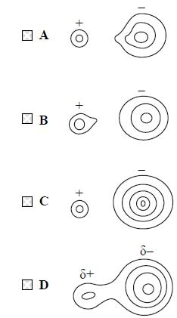
(Total for question = 1 mark)

Q13.
Which of the following does not have exactly 10 electrons?
A An ion of fluorine, F⁻
B A molecule of methane, CH₄
C A molecule of nitrogen, N₂
D An ion of sodium, Na⁺
(Total for question = 1 mark)

Q14.
A drop of concentrated nickel(II) sulfate solution, which is green, is placed on moist
filter paper on a microscope slide and the ends of the slide are connected to a 24 V DC
power supply. After ten minutes,
A a blue colour has moved towards the negative terminal and a yellow colour
towards the positive terminal.
B a blue colour has moved towards the positive terminal and a yellow colour
towards the negative terminal.
C a green colour has moved towards the negative terminal but there is no other
visible change.
D a green colour has moved towards the positive terminal but there is no other
visible change.
(Total for question = 1 mark)

Q15.
Which of the following represents the process occurring when the enthalpy change of atomization of bromine is measured?
A ½Br₂(l) → Br(g)
B ½Br₂(g) → Br(g)
C Br₂(l) → Br⁺(g) + Br⁻(g)
D Br₂(g) → Br⁺(g) + Br⁻(g)
(Total for question = 1 mark)

Q16.
Which of the following statements is evidence for the existence of ions in ionic compounds?
A Ionic compounds, in the solid state, conduct electricity.
B When any ionic compound in solution is electrolysed, the migration of ions
can be seen.
C In electron density maps for ionic compounds, there is no single line
representing electron density that surrounds both cations and anions.
D In electron density maps for ionic compounds, there are some single lines
representing electron density that surround both cations and anions.
(Total for question = 1 mark)

Q17.
A spot of blue solution was placed in the centre of a piece of moist filter paper supported on a microscope slide and the following experiment was carried out.
After some time, a blue colour moved towards the negative terminal, but no change was visible in the region of the positive terminal. This is because
A the negative ions in the solution were colourless and the positive ions were blue.
B the positive ions in the solution were colourless and the negative ions were blue.
C the negative ions in the solution had not moved but the positive ions had moved.
D the positive ions in the solution had not moved but the negative ions had moved.

(Total for question = 1 mark)

Q18.
Which of the following quantities, used in the calculation of the lattice energy of lithium oxide, Li₂O, has a negative value?

A The enthalpy change of atomization of lithium.
B The first ionization energy of lithium.
C The first electron affinity of oxygen.
D The second electron affinity of oxygen.
(Total for Question = 1 mark)

Q19.
The ionic radii in nm of some ions are given below.
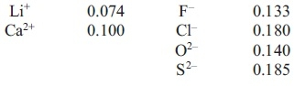
(a) Which of the following compounds has the most exothermic lattice energy? They all
have the same crystal structure.
(1)
A LiF
B LiCl
C CaO
D CaS
(b) Which of the following compounds will show the greatest difference between the
experimental (Born-Haber) lattice energy and that calculated from a purely ionic
model?
(1)
A LiF
B Li₂O
C CaO
D CaS
(Total for question = 2 marks)

Q20.
A drop of sodium manganate(VII) solution is placed at the centre of a piece of moist filter paper on a microscope slide. The ends of the paper are clipped to a 30 V DC power supply. After a few minutes,

A a purple colour has moved towards the positive terminal.
B a purple colour has moved towards the negative terminal.
C an orange colour has moved towards the positive terminal.
D an orange colour has moved towards the negative terminal.
(Total for Question = 1 mark)

Q21.
Which of the following ions would be deflected most in a mass spectrometer?
A ³⁵Cl⁺
B ³⁷Cl⁺
C ³⁷Cl²⁺
D (³⁵Cl — ³⁷Cl)⁺

(Total for question = 1 mark)

Q22.
Which of the following oxides would be expected to have the most exothermic lattice energy?

A Na₂O
B MgO
C CaO
D K₂O
(Total for Question = 1 mark)

Q23.
Going down Group 1 from lithium to rubidium
A the radius of the atom decreases.
B the radius of the ion decreases.
C the first ionization energy decreases.
D the polarizing power of the ion increases.
(Total for question = 1 mark)

Q24.
Which of the following ions has the largest ionic radius?
A F⁻
B Mg²⁺
C Na⁺
D O²⁻

(Total for question = 1 mark)

Q25.
Magnesium chloride, M_{g}Cl₂, has two lattice energy values quoted in the data booklet. The first is the experimental value, obtained from the Born-Haber cycle, −2526 kJ mol⁻¹; the second is the theoretical value, −2326 kJ mol⁻¹. Why are the two values different?
A The cation polarizes the anion leading to some covalent bonding.
B The anion polarizes the cation leading to some covalent bonding.
C Magnesium chloride is a covalent substance.
D The results from the Born-Haber cycle are too inaccurate to be reliable.
(Total for question = 1 mark)

Q26.
Which equation represents the reaction for which the enthalpy change is the lattice
energy of sodium fluoride, NaF?
A Na(s) + ½F₂(g) → NaF(s)
B Na(g) + F(g) → NaF(s)
C Na⁺(g) + F⁻(g) → NaF(s)
D Na(g) + ½F₂(g) → NaF(s)
(Total for question = 1 mark)

Q27.
The lattice energy of magnesium oxide is more negative than the lattice energy of magnesium fluoride because
A oxide ions are larger than fluoride ions.
B oxide ions are larger than magnesium ions.
C oxide ions are more highly charged than fluoride ions.
D there is only one oxide ion but two fluoride ions per magnesium ion.

(Total for question = 1 mark)

Q28.
Metals are good conductors of electricity because
A metal atoms are arranged in a regular lattice.
B metal ions are very close to each other.
C metal ions are free to move through the lattice.
D electrons are free to move through the lattice.
(Total for question = 1 mark)

Q29.
Which of these statements is incorrect?
A The atomic radius of metals increases down a Group.
B The trend in the melting temperature of successive elements across Period 2 is
similar to that in Period 3.
C A metallic structure is held together by attractions between metal atoms and
delocalized electrons.
D Na⁺ and O²⁻ ions are isoelectronic.
(Total for question = 1 mark)

Q30.
Element R is in Group 1 of the Periodic Table and element T is in Group 6. R and T are not the symbols for the elements.
(a) The compound of R and T will have the formula
(1)
A RT
B RT₆
C RT₂
D R₂T
(b) The compound of R and T will have bonding which is predominantly
(1)
A ionic.
B covalent.
C dative covalent.
D metallic.
(c) In terms of its electrical conductivity, the compound of R and T will
(1)
A conduct when solid and liquid.
B conduct when solid but not when liquid.
C conduct when liquid but not when solid.
D not conduct when solid or liquid.
(Total for question = 3 marks)

Q31.
Which of the following graphs shows the variation in the ionic radius of the Group 2
elements?
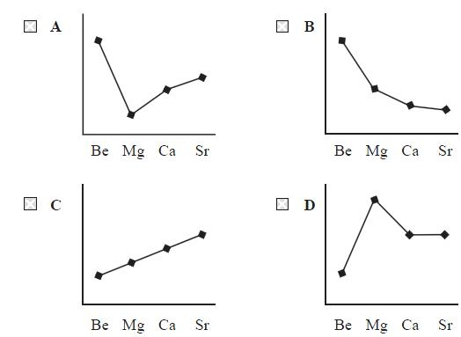
(Total for question = 1 mark)

Q32.
Going across the Periodic Table from sodium to aluminium,
A the melting temperature increases.
B the radius of the atom increases.
C the radius of the metal ion increases.
D the bonding in the element changes from metallic to covalent.
(Total for question = 1 mark)

Q33.
In which of the following compounds is the anion most polarized?

A LiF
B LiI
C LiI
D KI
(Total for Question = 1 mark)

Q34.
Which of these ions has the greatest ability to polarize an anion?
A Ba²⁺
B Ca²⁺
C Cs⁺
D K⁺
(Total for question = 1 mark)

Q35.
Metals usually have high melting temperatures and boiling temperatures because there are
A strong attractions between the ions.
B strong attractions between the delocalised electrons.
C strong attractions between the ions and the delocalised electrons.
D strong intermolecular forces.
(Total for question = 1 mark)

Q36.
Which of the following has the smallest ionic radius?
A F⁻
B Na⁺
C Mg²⁺
D O²⁻
(Total for question = 1 mark)

Q37.
An organic compound is represented by the skeletal formula shown below.
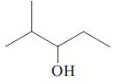
The compound is
A CH₃CH₂CH₂CH(OH)CH₂CH₃
B (CH₃)₂CHC(OH)(CH₃)₂
C (CH₃)₂CHCH₂CH(OH)CH₃
D (CH₃)₂CHCH(OH)CH₂CH₃
(Total for question = 1 mark)

Q38.
In the Born-Haber cycle for potassium iodide, which of the following steps is exothermic?

A K(s) → K(g)
B K(g) → K⁺(g) + e⁻
C ½I₂(s) → I(g)
D I(g) + e⁻ → I⁻(g)
(Total for Question = 1 mark)

Q39.
Which of the graphs shows (from left to right) the trend in the ionic radius of the
isoelectronic ions N³⁻, O²⁻, F⁻, Na⁺, Mg²⁺, Al³⁺?
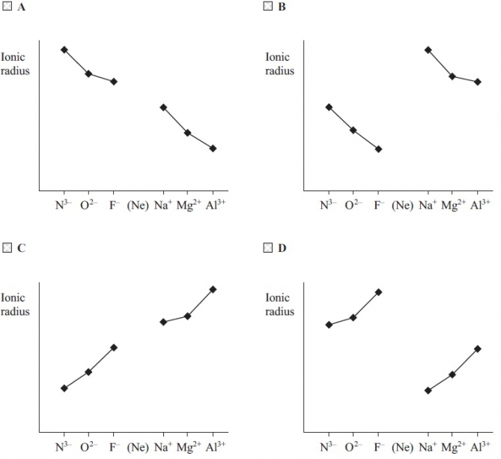
(Total for question = 1 mark)

Q40.
Theoretical lattice energies can be calculated from electrostatic theory. Which of the
following affects the magnitude of the theoretical lattice energy of an alkali metal halide,
M⁺X⁻ ?
A The first electron affinity of X.
B The first ionization energy of M.
C The enthalpy of atomization of M.
D The radius of the X⁻ ion.
(Total for question = 1 mark)

Q41.
The graph below represents the successive ionization energies of an element X plotted against the number of the electron removed. X is not the symbol for the element.
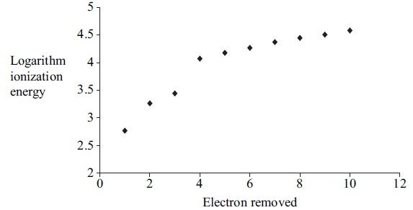
(a) From this graph it is possible to deduce the group in the Periodic Table to which X belongs. X is in
(1)
A Group 1
B Group 3
C Group 5
D Group 7
(b) From the graph it is possible to deduce that the most stable ion of X will be
(1)
A X³⁺
B X⁺
C X⁻
D X³⁻
(Total for question = 2 marks)

Mark Scheme
Q1.

Q2.

Q3.

Q4.

Q5.

Q6.

Q7.

Q8.

Q9.

Q10.

Q11.

Q12.

Q13.

Q14.

Q15.

Q16.

Q17.

Q18.

Q19.

Q20.

Q21.

Q22.

Q23.

Q24.

Q25.

Q26.

Q27.

Q28.

Q29.

Q30.

Q31.

Q32.

Q33.

Q34.

Q35.

Q36.

Q37.

Q38.

Q39.

Q40.

Q41.

