Questions
Q1.
All alkenes have
A the same empirical formula and the same general formula.
B the same molecular formula and the same general formula.
C the same molecular formula and the same empirical formula.
D the same empirical formula and the same structural formula.
(Total for Question = 1 mark)

Q2.
The first ionization energies, in kJ mol⁻¹, of four elements with consecutive atomic
numbers are shown below.
A 1680
B 2080
C 496
D 738
(a) Which element could be an inert gas?
(1)
A
B
C
D
(b) Which element could be X in a covalent compound with formula HX?
(1)
A
B
C
D
(c) Which element could be Y in an ionic compound with formula YH₂?
(1)
A
B
C
D
(Total for question = 3 marks)

Q3.
The graph below shows the second ionization energy of a series of elements with
consecutive atomic numbers.
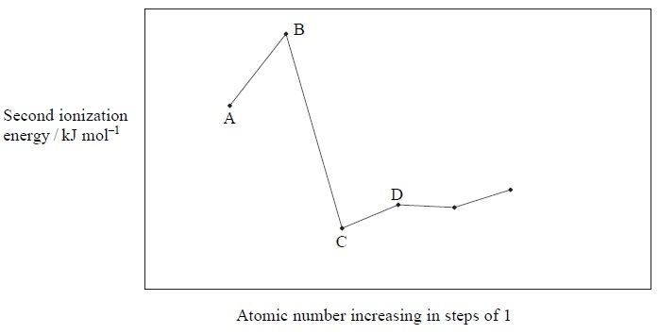
Which element could be lithium?
A
B
C
D
(Total for question = 1 mark)

Q4.
Which of the following diagrams represents the electrons in the ground state of a boron atom?
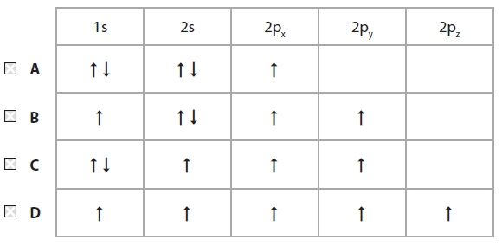

(Total for question = 1 mark)

Q5.
The first five ionization energies, in kJ mol⁻¹, of aluminium are
578 1817 2745 11 578 14 831
The orbitals from which the first five electrons are removed during ionization, starting
with the first electron, are
A 1s 2s 2p 3s 3p
B 1s 1s 2s 2s 2p
C 3p 3s 2p 2s 1s
D 3p 3s 3s 2p 2p
(Total for question = 1 mark)

Q6.
Which pair of ions is isoelectronic?

A Ca²⁺ and O²⁻
B Na⁺ and O²⁻
C Li⁺ and Cl⁻
D Mg²⁺ and Cl⁻
(Total for Question = 1 mark)

Q7.
A particle with a single positive charge and with the electronic configuration 1s² 2s² 2p⁶ is
A a sodium ion.
B a fluoride ion.
C an oxide ion.
D a potassium ion.

(Total for question = 1 mark)

Q8.
When an Al⁴⁺ ion is formed from an Al atom, the fourth electron is lost from the
A 1s sub-shell.
B 2s sub-shell.
C 2p sub-shell.
D 3s sub-shell.
(Total for question = 1 mark)

Q9.
The electronic structures of four elements are given below. Which of these elements has the highest first ionization energy?
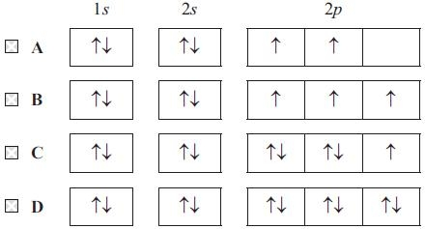
(Total for question = 1 mark)

Q10.
If X represents the element of atomic number 9 and Y the element of atomic number 20, the compound formed between these two elements is
A covalent, YX₂.
B ionic, YX₂.
C covalent, YX.
D ionic, YX.
(Total for question = 1 mark)

Q11.
Which of the following formulae for compounds of germanium, Ge, is unlikely to be
correct, given the position of germanium in the Periodic Table?
A GeF₃
B GeS₂
C GeO₂
D GeH₄
(Total for question = 1 mark)

Q12.
The electronic structure of an atom of an element in Group 6 of the Periodic Table could
be
A 1s² 2s² 2p²
B 1s² 2s² 2p⁴
C 1s² 2s² 2p⁶ 3s² 3p⁶ 3d⁶ 4s²
D 1s² 2s² 2p⁶ 3s² 3p⁶ 3d¹⁰ 4s² 4p⁶
(Total for question = 1 mark)

Q13.
The mass spectrum for a sample of a metal is shown below.
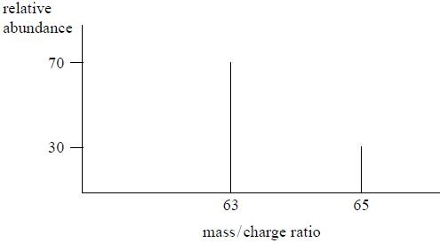
The relative atomic mass of the metal is
A 63.2
B 63.4
C 63.6
D 64.0
(Total for question = 1 mark)

Q14.
The equation representing the reaction between copper(II) oxide and dilute sulfuric acid is
CuO(s) + H₂SO₄(aq) → CuSO₄(aq) + H₂O(l)
The ionic equation for the reaction is
A Cu²⁺(s) + SO₄²⁻(aq) → CuSO₄(aq)
B O²⁻(s) + H₂SO₄(aq) → H₂O(l) + SO₄²⁻(aq)
C CuO(s) + 2H⁺(aq) → Cu²⁺(aq) + H₂O(l)
D CuO(s) + H₂SO₄(aq) → Cu²⁺SO₄²⁻(aq) + H₂O(l)
(Total for question = 1 mark)

Q15.
Which of the following equations represents the second ionization energy of chlorine?

A Cl⁺(g) → Cl²⁺(g) + e⁻
B Cl(g) → Cl²⁺(g) + 2e⁻
C Cl(g) → Cl²⁻(g) − 2e⁻
D Cl⁻(g) → Cl²⁻(g) − e⁻
(Total for Question = 1 mark)

Q16.
The first five ionization energies of an element, X, are
578, 1817, 2745, 11578 and 14831 kJ mol⁻¹, respectively.
In which group of the Periodic Table is X found?

A 1
B 2
C 3
D 4
(Total for Question = 1 mark)

Q17.

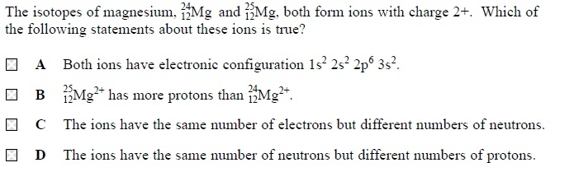
(Total for question = 1 mark)

Q18.
An isotope of an element, atomic number z, has mass number 2z + 4. How many neutrons are in the nucleus of the element?
A z + 4
B z + 2
C z
D 4
(Total for question = 1 mark)

Q19.
The electronic configurations of the atoms of four different elements are given below.
For which element would you expect the value of the first ionization energy to be the
largest?
A 1s¹
B 1s²
C 1s² 2s¹
D 1s² 2s²
(Total for question = 1 mark)

Q20.
Bromine has two isotopes with relative isotopic masses 79 and 81. Which of the following values for mass/charge ratio could correspond to a peak in the mass spectrum of bromine, Br₂? You should assume the ions detected have a single positive charge.

A 79.9
B 80
C 159
D 160
(Total for Question = 1 mark)

Q21.
Chlorine has two isotopes with relative isotopic mass 35 and 37. Four m/z values are
given below. Which will occur in a mass spectrum of chlorine gas, Cl₂, from an ion
with a single positive charge?
A 35.5
B 36
C 71
D 72
(Total for question = 1 mark)

Q22.
Which of the following ions would undergo the greatest deflection in a
mass spectrometer?
A ³⁵Cl²⁺
B ³⁵Cl⁺
C ³⁷Cl⁺
D ³⁵Cl³⁷Cl⁺
(Total for question = 1 mark)

Q23.
The correct sequence for the processes that occur in a mass spectrometer is
A vaporization, ionization, acceleration, deflection and detection.
B vaporization, acceleration, ionization, deflection and detection.
C ionization, vaporization, acceleration, deflection and detection.
D ionization, vaporization, deflection, acceleration and detection.

(Total for question = 1 mark)

Q24.
In which of the following series of elements is there an increase in the melting temperatures from left to right?
A Na Mg Al
B Li Na K
C B C N
D Si P S

(Total for question = 1 mark)

Q25.
Which of the following species contains the same number of electrons as neutrons?
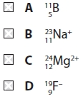

(Total for question = 1 mark)

Q26.
For Period 3 of the Periodic Table, from sodium to argon, what is the trend in the melting temperatures of the elements?

A A steady decrease
B A steady increase
C A decrease to silicon then an increase
D An increase to silicon then a decrease
(Total for Question = 1 mark)

Q27.
The first five successive ionization energies of an element, X, are shown in the table
below.
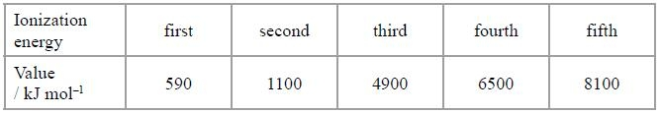
Which ion is X most likely to form when it reacts with chlorine?
A X⁺
B X²⁺
C X³⁺
D X⁴⁺
(Total for question = 1 mark)

Q28.
The first five ionization energies of an element, Z, are:
790, 1600, 3200, 4400, 16100 kJ mol⁻¹
In which group of the Periodic Table is Z found?
A 2
B 3
C 4
D 5
(Total for question = 1 mark)

Q29.
The graph below represents the successive ionization energies of an element X plotted against the number of the electron removed. X is not the symbol for the element.
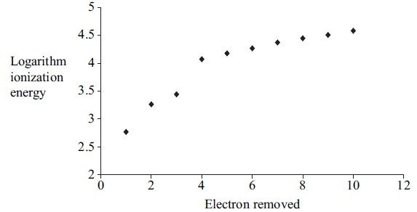
(a) From this graph it is possible to deduce the group in the Periodic Table to which X belongs. X is in
(1)
A Group 1
B Group 3
C Group 5
D Group 7
(b) From the graph it is possible to deduce that the most stable ion of X will be
(1)
A X³⁺
B X⁺
C X⁻
D X³⁻
(Total for question = 2 marks)

Q30.
The first eight ionization energies of an element are (in kJ mol⁻¹):
789, 1577, 3232, 4356, 16091, 19785, 23787, 29253.
A Group 1
B Group 2
C Group 3
D Group 4
(Total for question = 1 mark)

Q31.
Which of the following represents a pair of isotopes?

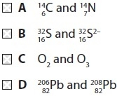
(Total for Question = 1 mark)

Q32.
Which of these statements is incorrect?
A The atomic radius of metals increases down a Group.
B The trend in the melting temperature of successive elements across Period 2 is
similar to that in Period 3.
C A metallic structure is held together by attractions between metal atoms and
delocalized electrons.
D Na⁺ and O²⁻ ions are isoelectronic.
(Total for question = 1 mark)

Q33.
Which pair of atomic numbers represents elements which are both in the p-block of the
Periodic Table?
A 4, 8
B 6, 12
C 8, 16
D 10, 20
(Total for question = 1 mark)

Q34.
The sketch graph below shows the trend in first ionization energies for some elements in
Periods two and three.
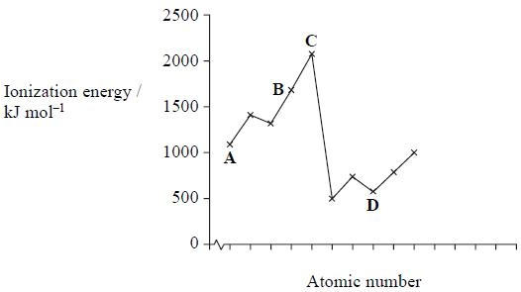
Select, from the elements A to D, the one that
(a) has atoms with five p electrons.
(1)
A
B
C
D
(b) is a member of Group 3.
(1)
A
B
C
D
(c) is likely to be very unreactive.
(1)
A
B
C
D
(d) normally forms four covalent bonds per atom.
(1)
A
B
C
D
(Total for question = 4 marks)

Q35.
The first five ionization energies of an element, X, are shown in the table.
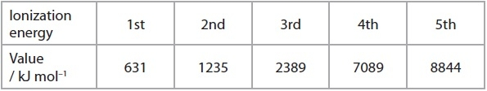
What is the mostly likely formula of the oxide that forms when X burns in oxygen?

A X₂O
B XO
C X₂O₃
D XO₂
(Total for Question = 1 mark)

Q36.
Going across the Periodic Table from sodium to aluminium,
A the melting temperature increases.
B the radius of the atom increases.
C the radius of the metal ion increases.
D the bonding in the element changes from metallic to covalent.
(Total for question = 1 mark)

Q37.
White phosphorus consists of
A a giant structure of atoms.
B a giant structure of ions.
C small molecules.
D single atoms.
(Total for question = 1 mark)

Q38.
In which of the following cases would a cation be most polarizing?
Radius Charge
A small small
B small large
C large small
D large large
(Total for question = 1 mark)

Q39.
Which of these equations represents the electron affinity of chlorine?
A Mg⁺(g) → Mg²⁺(g) + e⁻
B Mg(g) → Mg²⁺(g) + 2e⁻
C Mg⁺(g) + e⁻ → Mg²⁺(g)
D Mg(g) + 2e⁻ → Mg²⁺(g)
(Total for question = 1 mark)

Q40.
The equation for the complete combustion of pentane is
The standard enthalpy change of formation of CO₂(g) is −394 kJ mol⁻¹ and that of H₂O(l) is −286 kJ mol⁻¹.
The standard enthalpy change of formation of pentane (in kJ mol⁻¹) is
A 5(−394) + 6(−286) + (−3509)
B 5(−394) + 6(−286) − (−3509)
C −5(−394) − 6(−286) + (−3509)
D −5(−394) − 6(−286) − (−3509)
(Total for Question = 1 mark)

Q41.
The nucleus of a atom contains
A 11 protons and 12 neutrons.
B 11 protons and 12 electrons.
C 23 protons and 11 neutrons.
D 23 protons and 11 electrons.
(Total for question = 1 mark)

Mark Scheme
Q1.

Q2.

Q3.

Q4.

Q5.

Q6.

Q7.

Q8.

Q9.

Q10.

Q11.

Q12.

Q13.

Q14.

Q15.

Q16.

Q17.

Q18.

Q19.

Q20.

Q21.

Q22.

Q23.

Q24.

Q25.

Q26.

Q27.

Q28.

Q29.

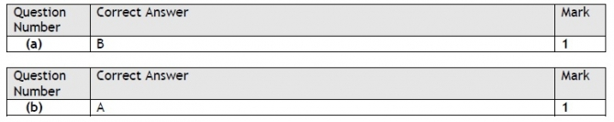

Q30.

Q31.

Q32.

Q33.

Q34.

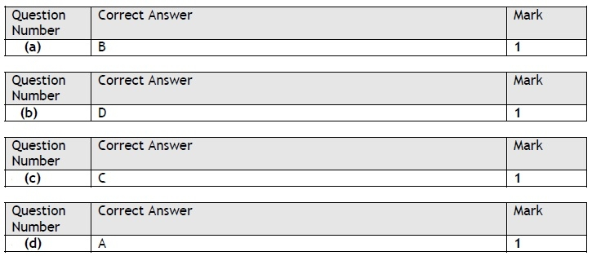

Q35.

Q36.

Q37.

Q38.

Q39.

Q40.

Q41.

