Questions
Q1.
Select the correct pH for each of the following solutions.
(a) Nitric acid, HNO₃, of concentration 2 mol dm⁻³, assuming it is fully dissociated.
(1)

A −0.3
B 0.0
C 0.3
D 2.0
(b) Sodium hydroxide, NaOH, of concentration 2 mol dm⁻³, using K_{w} = 1.0 × 10⁻¹⁴ mol² dm⁻⁶
(1)

A −13.7
B 13.7
C 14.0
D 14.3
(c) Ethanoic acid, CH₃COOH, of concentration 2 mol dm⁻³, making the usual assumptions.
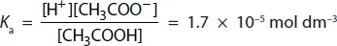
(1)

A 2.2
B 2.4
C 4.5
D 4.8
(d) The mixture formed when 25 cm³ of 2 mol dm⁻³ sodium hydroxide solution is added to 50 cm³ of 2 mol dm⁻³ ethanoic acid, for which K_{a} = 1.7 × 10⁻⁵ mol dm⁻³.
(1)

A 2.2
B 2.5
C 4.5
D 4.8
(Total for Question = 4 marks)

Q2.
The organic product of the reaction between ethanoyl chloride and methylamine has the formula
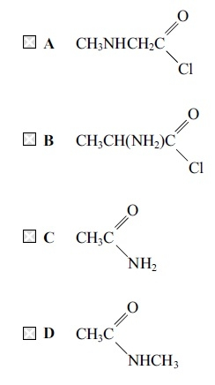
(Total for question = 1 mark)

Q3.
A solution of 2,4-dinitrophenylhydrazine (Brady's reagent) is used as a test for organic functional groups.
(a) The positive result of the test is the formation of
(1)

A a yellow solution.
B an orange precipitate.
C a red solution.
D a green precipitate.
(b) Which of the following gives a positive result with a solution of 2,4-dinitrophenylhydrazine?
(1)

A Only aldehydes
B Only ketones
C Only aldehydes and ketones
D Any compound containing the CO group
(c) The initial attack by 2,4-dinitrophenylhydrazine, when it reacts, is by
(1)

A a free radical.
B an electrophile.
C a nucleophile.
D a negative ion.
(d) The product of a positive test, a 2,4-dinitrophenylhydrazone, contains which of the following bonds?
(1)

A NN
B CN
C CC
D CO
(Total for Question = 4 marks)

Q4.
An organic compound reacts with both acidified potassium dichromate(VI) and lithium tetrahydridoaluminate (lithium aluminium hydride). The organic compound could be

A a primary alcohol.
B an aldehyde.
C a ketone.
D a carboxylic acid.
(Total for Question = 1 mark)

Q5.
Ketones react with

A both 2,4-dinitrophenylhydrazine solution and Tollens' reagent.
B 2,4-dinitrophenylhydrazine solution but not with Tollens' reagent.
C Tollens' reagent but not with 2,4-dinitrophenylhydrazine solution.
D neither Tollens' reagent nor 2,4-dinitrophenylhydrazine solution.
(Total for Question = 1 mark)

Q6.
Ethanoic acid, CH₃COOH, can be converted into ethanoyl chloride, CH₃COCl, by the action of
A phosphorus(V) chloride.
B chlorine.
C dilute hydrochloric acid.
D concentrated hydrochloric acid.
(Total for question = 1 mark)

Q7.
When the following reaction mixtures are warmed, which will contain ethanoic acid as one of the products?
A Ethyl methanoate and sodium hydroxide solution.
B Ethyl methanoate and dilute sulfuric acid.
C Methyl ethanoate and sodium hydroxide solution.
D Methyl ethanoate and dilute sulfuric acid.
(Total for question = 1 mark)

Q8.
Ethanoic acid is not a product in the reaction of
A ethanal with lithium tetrahydridoaluminate.
B ethanoyl chloride with water.
C ethyl ethanoate with dilute sulfuric acid.
D ethanol refluxed with potassium dichromate(VI) and sulfuric acid.
(Total for question = 1 marks)

Q9.
This question is about the following isomeric compounds with the molecular formula C₄H₈O and molar mass 72 g mol⁻¹.

A CH₃CH₂CH₂CHO
B (CH₃)₂CHCHO
C CH₃CH₂COCH₃
D CH₃CHCHCH₂OH
(a) Which compound would you expect to give a peak at m/e = 41 in its mass spectrum?
(1)

A
B
C
D
(b) Which compound would NOT react with an acidified solution of potassium dichromate(VI)?
(1)

A
B
C
D
(c) Which compound would give a pale yellow precipitate when reacted with iodine in alkaline solution?
(1)

A
B
C
D
(d) Which compound can be reduced to give a chiral product?
(1)

A
B
C
D
(e) Which compound would NOT react with hydrogen cyanide under suitable conditions to form a hydroxynitrile?
(1)

A
B
C
D
(Total for Question = 5 marks)

Q10.
Transesterification involves the conversion of

A esters into different esters.
B esters into carboxylic acids.
C cis carbon-carbon double bonds to the trans arrangement.
D trans carbon-carbon double bonds to the cis arrangement.
(Total for Question = 1 mark)

Q11.
Biodiesel is formed by transesterification. It is used as a fuel in preference to untreated vegetable oils because

A on combustion, biodiesel produces less carbon dioxide than vegetable oils.
B on combustion, biodiesel produces more energy than vegetable oils.
C biodiesel vaporises more easily than vegetable oils.
D biodiesel is less volatile than vegetable oils.
(Total for Question = 1 mark)

Q12.
Propanoic acid reacts with methanol to form an ester. The structure of the ester is

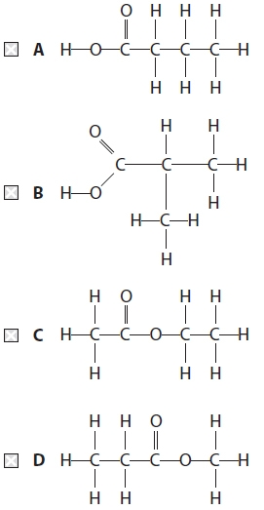
(Total for Question = 1 mark)

Q13.
The boiling temperature of ethanoic acid is very much higher than that of butane although these molecules have similar numbers of electrons. This is because ethanoic acid has

A stronger covalent bonds.
B stronger ionic bonds.
C greater London forces.
D hydrogen bonding.
(Total for Question = 1 mark)

Q14.
Ethanoic acid, CH₃COOH, may be prepared from ethanenitrile, CH₃CN. This reaction is best described as

A reduction.
B oxidation.
C hydrolysis.
D condensation.
(Total for Question = 1 mark)

Q15.
Select the word that best describes the effect of a chiral molecule on the plane of plane-polarized light. The plane of polarization of light is

A reflected.
B refracted.
C resolved.
D rotated.
(Total for Question = 1 mark)

Q16.
Which of the following methods may be used in a single step to make carboxylic acids?
A Hydrolysis of an ester with an alkali.
B Reaction of acidified potassium manganate(VII) with an alkene.
C Hydrolysis of a nitrile with hydrochloric acid.
D Reaction of an acyl chloride with ammonia.
(Total for question = 1 mark)

Q17.
Which of the following compounds would react with lithium tetrahydridoaluminate
(lithium aluminium hydride) and also with phosphorus(V) chloride (phosphorus
pentachloride)?
A CH₃CH₂CH₂COOH
B CH₃CH₂COCH₃
C CH₃CHCHCH₃
D CH₂CHCH₂CH₂OH
(Total for question = 1 mark)

Q18.
This question is about four compounds with molecular formula C₄H₈O.
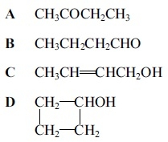
(a) The compounds which react when heated with a mixture of potassium dichromate(VI) and sulfuric acid are (1)
A
B
C
D
(b) The compound which produces a yellow precipitate when heated with a mixture of iodine and sodium hydroxide is (1)
A
B
C
D
(c) There would not be a significant peak at mass/charge ratio of 15 in the mass spectrum of (1)
A Titrations A and B only.
B Titrations A, B and D only.
C Titration C only.
D Titrations A, B, C and D.
(Total for question = 3 marks)

Q19.
What is the correct name for the molecule shown below?
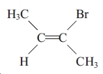
A Z-2-bromobut-2-ene
B E-2-bromobut-2-ene
C E-3-bromobut-2-ene
D Z-3-bromobut-2-ene
(Total for question = 1 mark)

Q20.
Which of the following compounds has both optical and E-Z isomers?
A CH₃CHCHCH₂CH₃
B CH₃CHClCHC(CH₃)₂
C CH₃CClCClCH₃
D CH₃CHBrCHCHCl
(Total for question = 1 mark)

Q21.
Which of the following has both optical and E-Z isomers?
A ClCH₂CHClCH==CH₂
B CH₂==CClCH₂CH₂Cl
C ClCH₂CH==CHCH₂Cl
D CHCl==CHCHClCH₃
(Total for question = 1 mark)

Q22.
One optically active isomer of 2−chlorobutane reacts with hydroxide ions to form
butan−2−ol.
C₂H₅CHClCH₃ + OH⁻ → C₂H₅CH(OH)CH₃ + Cl⁻
The organic product is a mixture of enantiomers because
A butan−2−ol contains a chiral carbon atom.
B the reaction is a nucleophilic substitution.
C 2−chlorobutane forms a carbocation intermediate.
D 2−chlorobutane forms a five-bonded transition state.
(Total for question = 1 mark)

Q23.
This question is about calcium chloride, CaCl₂.
It can be formed by burning calcium in chlorine.
You must include a sign and units in your answers to the calculations in this question.
(a) (i) The standard molar entropy at 298 K for 1 mole of chlorine molecules, Cl₂, is +165 J mol⁻¹ K⁻¹. Use this, and appropriate values from your Data Booklet, to calculate the standard entropy change, , for this reaction.
(2)
*(ii) Explain fully why the sign for the standard entropy change of the system, is as you would expect.
(2)
.............................................................................................................................................
.............................................................................................................................................
.............................................................................................................................................
.............................................................................................................................................
(b) Calculate the total entropy change, , in J mol⁻¹ K⁻¹, for this reaction, giving your answer to three significant figures.
(2)
(c) Use the standard entropy change of the surroundings, , to calculate the standard enthalpy change, , in kJ mol⁻¹, for the reaction at 298 K.
(2)
(d) 0.0500 mol of calcium chloride, prepared by burning calcium in chlorine, is added to 51.8 cm³ of water.
50.0 cm³ of a 1.00 mol dm⁻³ solution is formed, and the temperature rise, ΔT, is 15.0°C.
(i) Calculate the energy transferred, in joules, for this process using:
Energy transferred in joules = volume of solution formed × 4.2 × ΔT
(1)
(ii) Calculate the enthalpy change of solution, , of calcium chloride in kJ mol⁻¹.
(2)
*(iii) The enthalpy change of hydration of Ca²⁺(g) is −1560 kJ mol⁻¹.
Use this, your value from (d)(ii) and the experimental lattice energy from your Data Booklet, to calculate the standard enthalpy change of hydration of Cl⁻(g).
(3)
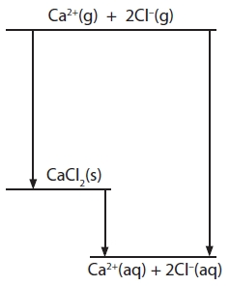
Answer ........................................................... kJ mol⁻¹
(iv) Draw diagrams to represent hydrated calcium ions and hydrated chloride ions.
(2)
(v) Suggest why the addition of anhydrous calcium chloride to water results in an increase in temperature and a decrease in volume.
(2)
Temperature increases
.............................................................................................................................................
.............................................................................................................................................
.............................................................................................................................................
Volume decreases
.............................................................................................................................................
.............................................................................................................................................
.............................................................................................................................................

(Total for question = 18 marks)

Q24.
In the synthesis of an ester, the use of an acyl chloride and an alcohol gives a better yield than the use of a carboxylic acid and an alcohol.
This is because the reaction between
A an acyl chloride and an alcohol is an equilibrium.
B an acid and an alcohol goes to completion.
C an acid and an alcohol requires a catalyst.
D an acyl chloride and an alcohol goes to completion.
(Total for question = 1 mark)

Q25.
Ethanal, CH₃CHO, can be converted by a two-step synthesis into 2-hydroxypropanoic acid.
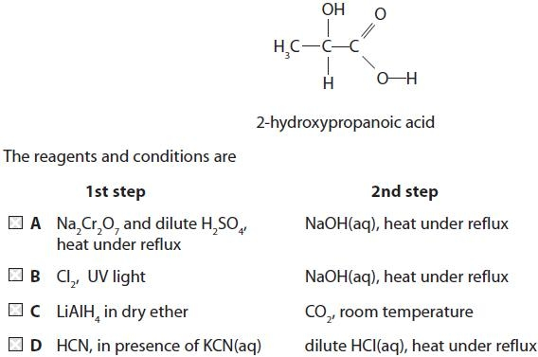
(Total for question = 1 mark)

Q26.
Which of the following statements about ethanoyl chloride is not correct?
A It reacts with ammonia to make an amine.
B It reacts with an amine to make an amide.
C It reacts with an alcohol to make an ester.
D It reacts with water to make an organic acid.
(Total for question = 1 marks)

Q27.
Which of the following does not have hydrogen bonding in a pure sample, but forms
hydrogen bonds with water when it dissolves?
A Propane
B Propanal
C Propanol
D Propanoic acid
(Total for question = 1 mark)

Q28.
Which of the following molecules is a methyl ester?
A CH₃COOCH₂CH₃
B HCOOCH₃
C CH₃COCH₂CH₃
D CH₃COCl
(Total for question = 1 mark)

Q29.
A compound, Q, gives an orange precipitate with 2, 4-dinitrophenylhydrazine.
Compound Q is resistant to oxidation.
On reduction, Q gives a product made up of a pair of optical isomers.
Which of the following compounds could be compound Q?
A CH₃CH₂CH₂COCH₃
B CH₃CHCHCH(OH)CH₃
C CH₃CH₂CH₂CH₂CHO
D CH₃CH₂COCH₂CH₃
(Total for question = 1 mark)

Q30.
When propanone reacts with iodine in the presence of sodium hydroxide, the crystalline solid product has the formula
A CH₃I
B CHI₃
C CH₃COCH₂I
D CH₃COCI₃
(Total for question = 1 mark)

Q31.
The formula for oleic acid, which is present in fingerprints, is shown below.
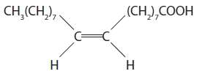
(a) The systematic name for oleic acid is
(1)
A E-octadec-9-enoic acid.
B Z-octadec-9-enoic acid.
C E-octadec-8-enoic acid.
D Z-octadec-8-enoic acid.
(b) Which intermolecular forces are present between oleic acid molecules?
(1)
A Hydrogen bonds only.
B Hydrogen bonds and permanent dipole-dipole forces only.
C Hydrogen bonds, permanent dipole-dipole forces and London forces.
D Hydrogen bonds and London forces only.
(c) Which of the following species is most likely to cause a peak at m/e = 45 in the mass spectrum of oleic acid?
(1)
A CH₂CH₂OH
B CH₂CH₂OH⁺
C COOH
D COOH⁺
(d) What would you expect to see if oleic acid is tested separately with bromine water and with phosphorus(V) chloride, PCl₅?
(1)
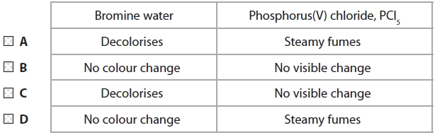

(Total for question = 4 marks)

Q32.
The formula for oleyl alcohol, which is present in sperm whale oil and was used as a lubricant, is shown below.
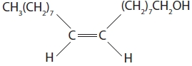
(a) The systematic name for oleyl alcohol is
(1)
A E-octadec-9-en-1-ol.
B Z-octadec-9-en-1-ol.
C E-octadec-8-en-1-ol.
D Z-octadec-8-en-1-ol.
(b) Which intermolecular forces are present between oleyl alcohol molecules?
(1)
A London forces only
B Hydrogen bonds and London forces only
C Hydrogen bonds and permanent dipole–dipole forces only
D Hydrogen bonds, permanent dipole–dipole and London forces
(c) Which of the following is the most likely structure of the species to cause a peak at m/e 31 in the mass spectrum of oleyl alcohol?
(1)
A CH₃O
B CH₂OH
C CH₃O⁺
D CH₂OH⁺
(d) What would you expect to see if oleyl alcohol is tested separately with bromine water and heated with acidified sodium dichromate(VI) solution?
(1)
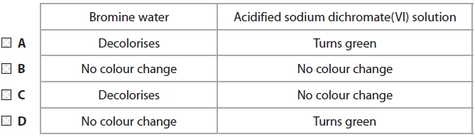

(Total for question = 4 marks)

Q33.
The following tests can be carried out on organic compounds.
A Warm with 2,4-dinitrophenylhydrazine.
B Warm with Fehling's or Benedict's solution.
C Add solid sodium carbonate.
D Add phosphorus(V) chloride, PCl₅.
(a) Which test would give a positive result with propanoic acid but not with propan-1-ol? (1)
A
B
C
D
(b) Which test would give a positive result with propanoic acid and with propan-1-ol? (1)
A
B
C
D
(c) Which test would give a positive result with propanal but not with propanone? (1)
A
B
C
D
(Total for question = 3 marks)

Q34.
An example of a polyester is
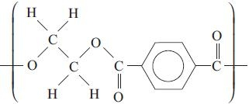
(a) The two monomers needed to form this polymer are
(1)
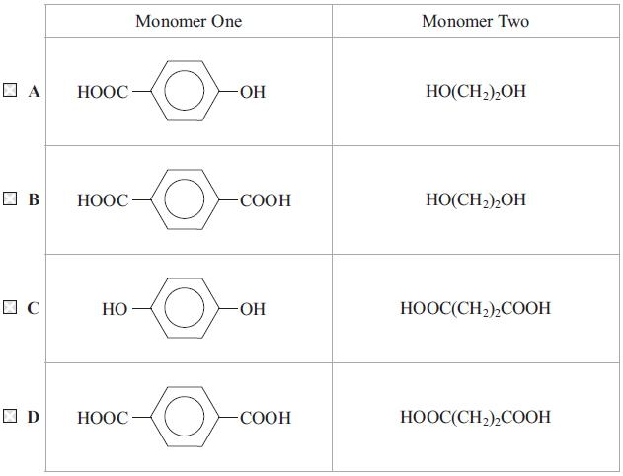
(b) The type of reaction to form this polymer is
(1)
A addition.
B substitution.
C condensation.
D hydrolysis.
(Total for question = 2 marks)

Q35.
Butane-1,4-diol, HO(CH₂)₄OH, and benzene-1,4-dicarboxylic acid,
HOOC | 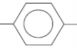 | COOH, react to form a polyester.
(a) The repeat unit of the polyester is
(1)
A | 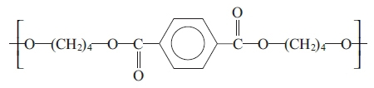
B | 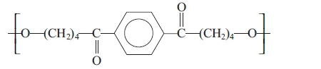
C | 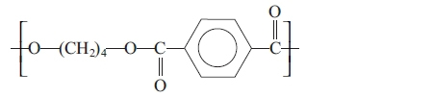
D | 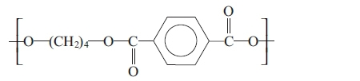

(b) The type of reaction is
(1)
A hydrolysis.
B addition.
C substitution.
D condensation.
(Total for question = 2 marks)

Q36.
The repeat unit of the polyester formed from ethane-1,2-diol, HOCH₂CH₂OH, and
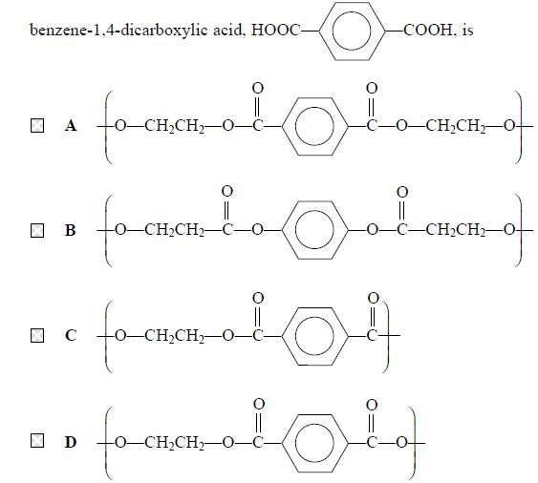
(Total for question = 1 mark)

Q37.
A section of a polymer is shown below. Which of the following monomers would form
this polymer?
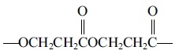
A HOCH₂CH₂OH and ClCOCH₂CH₂COCl
B HOCH₂CH₂OH and HOOCCH₂CH₂COOH
C ClCH₂CH₂COCl alone
D HOCH₂CH₂COOH alone
(Total for question = 1 mark)

Q38.
Which of the following reagents could be used to produce propanamide,
CH₃CH₂CON₂?
A Ammonia and 1-chloropropane
B Ammonia and propanoyl chloride
C Methylamine and 1-chloropropane
D Methylamine and propanoyl chloride
(Total for question = 1 mark)

Q39.
In order to make CH₃CH₂CONHCH₃, you could use
A CH₃CH₂COOCH₃ + NH₃
B CH₃CH₂COCl + CH₃NH₂
C CH₃CH₂COO⁻Na⁺ + CH₃NH₂
D CH₃CH₂CONH₂ + CH₃NH₂
(Total for question = 1 mark)

Q40.
This question is about four organic compounds, each containing two carbon atoms.
A CH₃CH₂OH
B CH₃CHO
C CH₃COOH
D CH₃COCl
(a) Which is oxidized by ammoniacal silver nitrate?
(1)
A
B
C
D
(b) Which has the highest boiling temperature?
(1)
A
B
C
D
(c) 0.01 mol of each compound is heated separately with excess acidified sodium dichromate(VI).
Which compound reduces the largest amount of sodium dichromate(VI)?
(1)
A
B
C
D
(d) 0.01 mol of each compound is added separately to identical volumes of water. Which solution would have the lowest pH?
(1)
A
B
C
D

(Total for question = 4 marks)

Q41.
Four organic compounds are:
A CH₃OH
B HCHO
C HCOOH
D HCOOCH₃
(a) Which of these compounds has a fruity smell?
(1)
A
B
C
D
(b) 0.01 mol of each compound is added separately to identical volumes of water.
Which solution would have the lowest pH?
(1)
A
B
C
D
(c) 0.01 mol of each compound is heated separately with excess acidified sodium dichromate(VI) solution. Which compound reduces the largest amount of sodium dichromate(VI)?
(1)
A
B
C
D
(d) Which compound has the highest boiling temperature?
(1)
A
B
C
D
(e) Which of these compounds can be oxidized by ammoniacal silver nitrate?
(1)
A
B
C
D

(Total for question = 5 marks)

Q42.
When one optically active isomer of 3-chloro-3-methylhexane reacts with hydroxide ions to form 3-methylhexan-3-ol, a racemic mixture forms because
A 3-chloro-3-methylhexane forms a carbocation intermediate.
B the reaction is a nucleophilic substitution.
C 3-chloro-3-methylhexane forms a five-bonded transition state.
D 3-methylhexan-3-ol contains a chiral carbon.

(Total for question = 1 mark)

Q43.
Which of the following reacts with hydrogen cyanide, HCN, to make a racemic mixture?
A Methanal, HCHO
B Ethanal, CH₃CHO
C Propanone, CH₃COCH₃
D Pentan-3-one, C₂H₅COC₂H₅
(Total for question = 1 mark)

Q44.
The equation for the reaction between ethanoic acid and phosphorus(V) chloride is
A CH₃COOH + PCl₅ → CH₃COCl + POCl₃ + HCl
B CH₃COOH + PCl₅ → CH₃COOCl + PCl₃ + HCl
C CH₃COOH + PCl₅ → CH₃COCl + PCl₃ + HOCl
D 2CH₃COOH + PCl₅ → (CH₃CO)₂O + PCl₃ + H₂O + Cl₂
(Total for question = 1 mark)

Q45.
Hydrogen cyanide, HCN, reacts with propanal, CH₃CH₂CHO, in the presence of
potassium cyanide, KCN.
(a) The mechanism for this reaction is
(1)
A nucleophilic addition.
B nucleophilic substitution.
C electrophilic addition.
D electrophilic substitution.
(b) The first stage of the mechanism of this reaction is
(1)
A the lone pair of electrons on carbon in CN¯ attacking C^{δ+} of propanal.
B the lone pair of electrons on nitrogen in CN¯ attacking C^{δ+} of propanal.
C the lone pair of electrons on oxygen in propanal attacking C^{δ+} of HCN.
D the lone pair of electrons on oxygen in propanal attacking H^{δ+} in HCN.
(c) The product of the reaction is
(1)
A 1−hydroxypropanenitrile.
B 2−hydroxypropanenitrile.
C 1−hydroxybutanenitrile.
D 2−hydroxybutanenitrile.
(Total for question = 3 marks)

Q46.
Ketones react with hydrogen cyanide, HCN, in the presence of cyanide ions, CN^{&#150;}.
(a) Which of these ketones does not form a racemic mixture in this reaction?
(1)
A CH₃CH₂CH₂COCH₃
B CH₃CH₂COCH₂CH₃
C CH₃CH₂CH₂CH₂COCH₃
D CH₃CH₂CH₂COCH₂CH₃
(b) This type of reaction is classified as
(1)
A nucleophilic substitution.
B nucleophilic addition.
C electrophilic addition.
D electrophilic substitution.
(Total for question = 2 marks)

Q47.
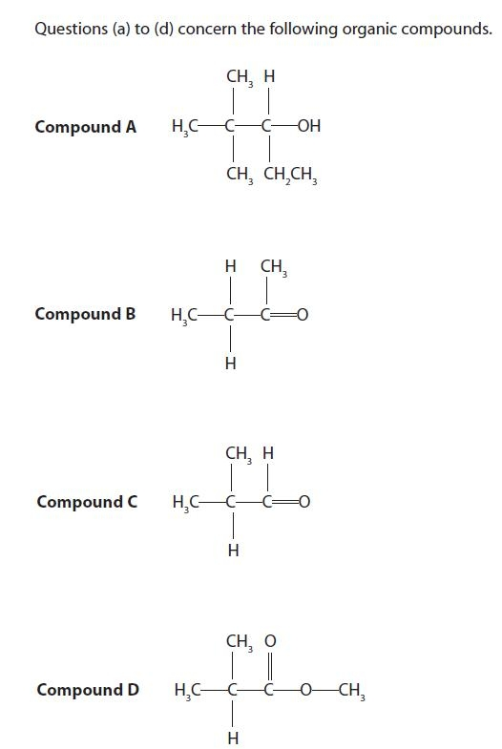
Select from A to D the compound that
(a) forms iodoform with iodine in the presence of alkali.
(1)
A
B
C
D
(b) is chiral.
(1)
A
B
C
D
(c) reacts with Tollens' reagent.
(1)
A
B
C
D
(d) can be oxidized to form a ketone.
(1)
A
B
C
D
(Total for question = 4 marks)

Q48.
Which of these is not observed when ethanoyl chloride reacts with water?
A Misty fumes given off.
B The gas given off turns damp blue litmus paper red.
C The mixture gets hot.
D A white precipitate forms.
(Total for question = 1 mark)

Q49.
This question is about the four organic substances shown below.
A CH₃CH₂CH₂CH₂CHO
B CH₃CH₂CH₂CH₂COOH
C CH₃COCH₂CH₂CH₃
D CH₃CH₂CH₂CH₂COCl
Which substance will
(a) give a positive result with both Brady's and Tollens' reagents?
(1)
A
B
C
D
(b) be formed by the oxidation of a secondary alcohol?
(1)
A
B
C
D
(c) form the most acidic solution when equal amounts are each mixed with 100 cm³ of water?
(1)
A
B
C
D
(d) form steamy fumes in the reaction with PCl₅?
(1)
A
B
C
D
(Total for question = 4 marks)

Q50.
Which of the following is a redox reaction?
A Ethanal reacting with Tollens' reagent.
B Ethanoyl chloride reacting with ammonia.
C Ethanoic acid reacting with ethanol.
D Ethanoic acid reacting with sodium hydroxide.
(Total for question = 1 mark)

Q51.
The following methods can be used to distinguish between pairs of organic compounds without further tests.
A Warm each compound with Fehling's or Benedict's solution.
B Add solid sodium carbonate to each compound.
C Add 2,4-dinitrophenylhydrazine (Brady's reagent) to each compound.
D Add water, drop by drop, to each compound.
(a) Which test would distinguish propanone from propan-1-ol?
(1)
A
B
C
D
(b) Which test would distinguish between aqueous solutions of ethanoic acid and ethanol?
(1)
A
B
C
D
(c) Which test would distinguish ethanoyl chloride from ethanol?
(1)
A
B
C
D
(Total for question = 3 marks)

Q52.
Which of the following compounds is a Z isomer and contains a chiral carbon atom?
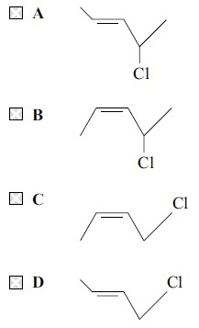
(Total for question = 1 marks)

Mark Scheme
Q1.
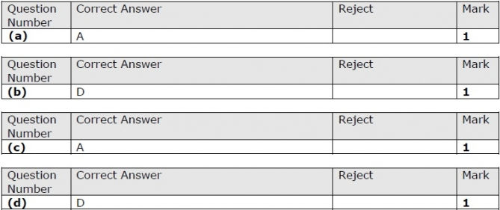

Q2.

Q3.
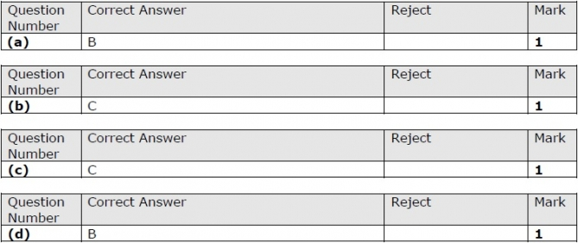

Q4.

Q5.

Q6.

Q7.

Q8.

Q9.

Q10.

Q11.

Q12.

Q13.

Q14.

Q15.

Q16.

Q17.

Q18.

Q19.

Q20.

Q21.

Q22.

Q23.
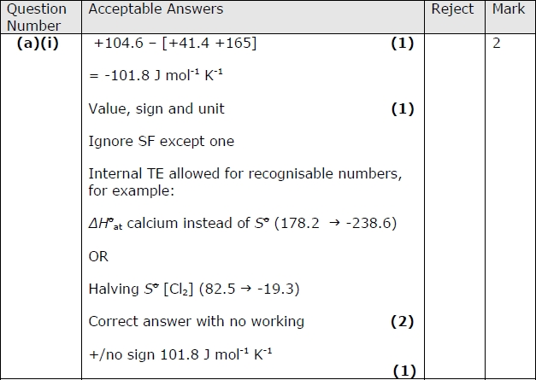
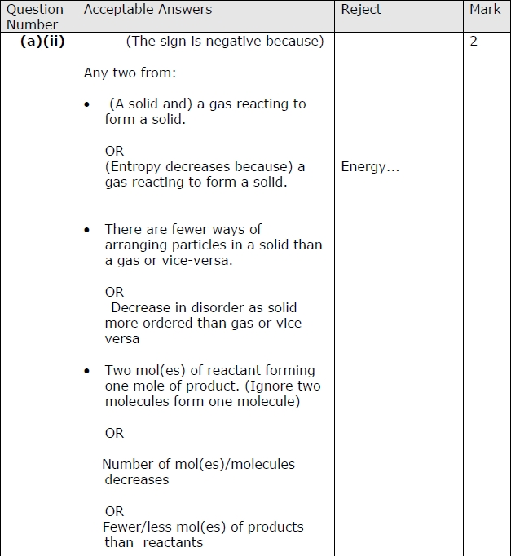
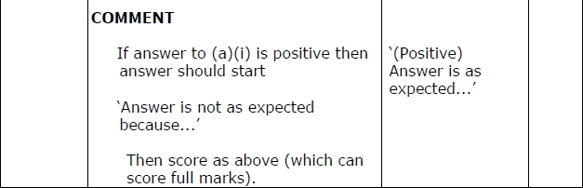
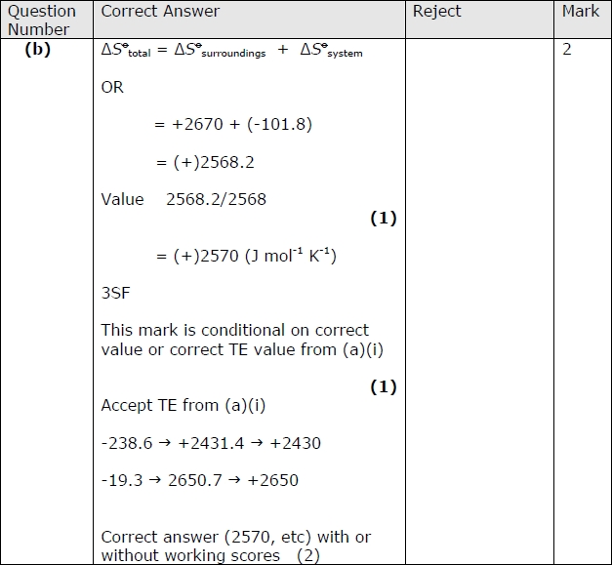
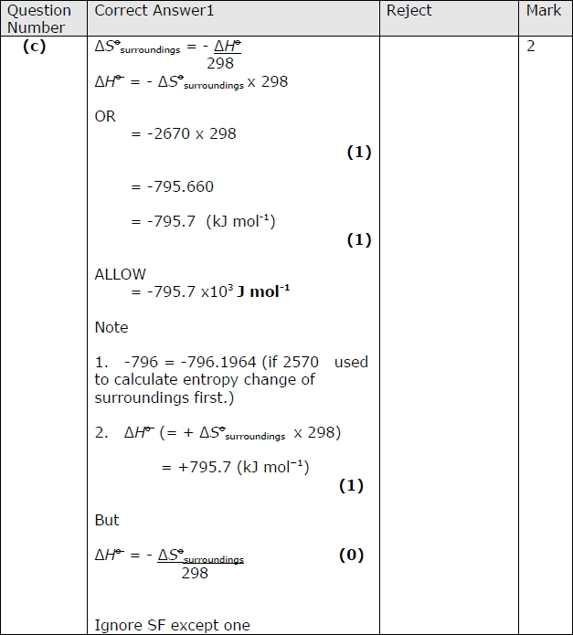
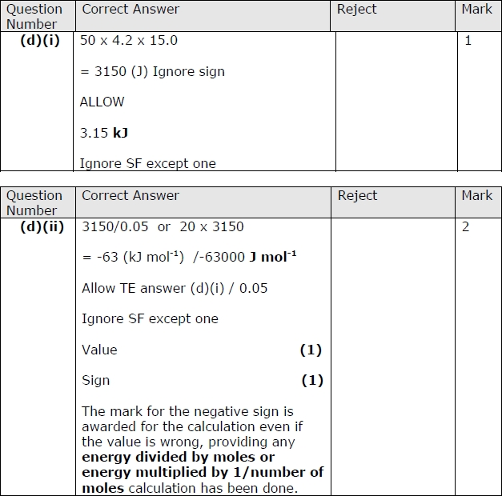
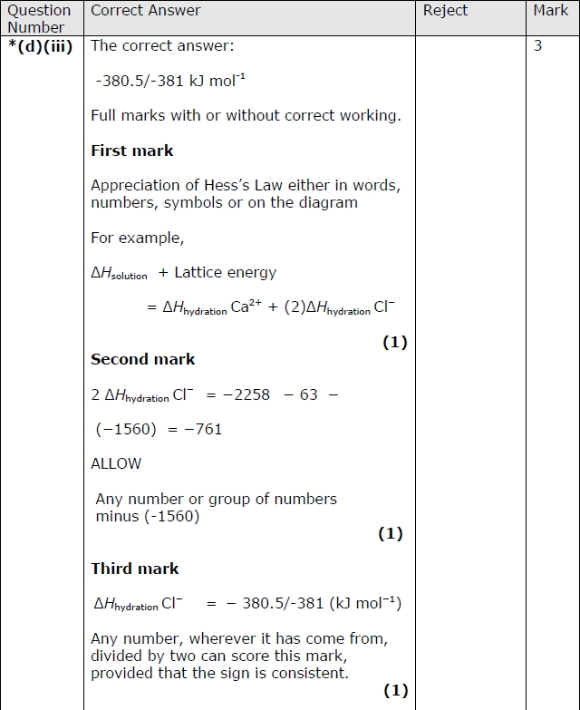
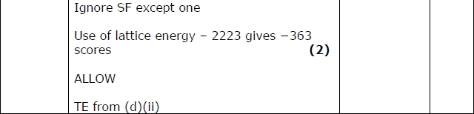
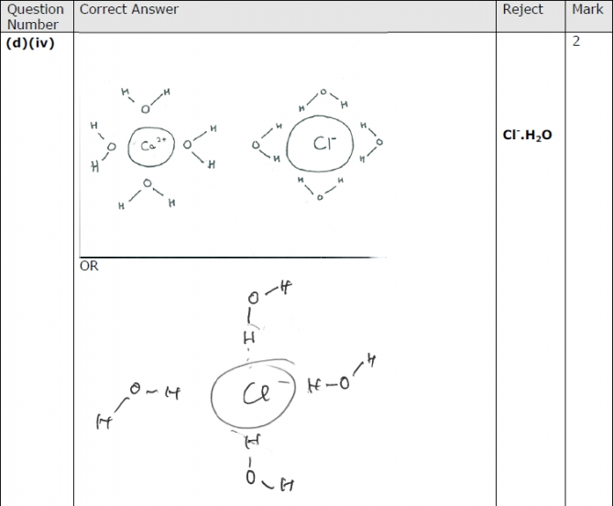
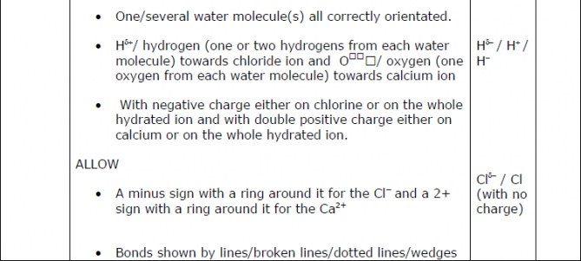
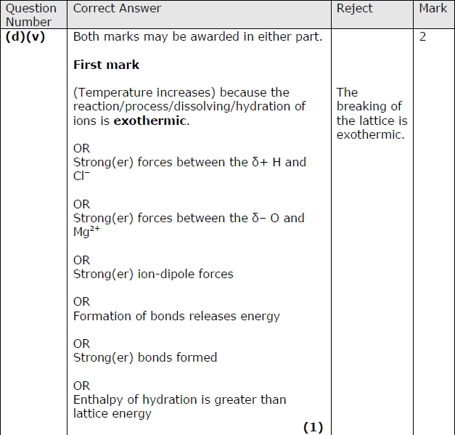
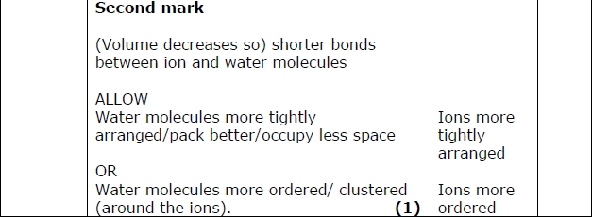

Q24.

Q25.

Q26.

Q27.

Q28.

Q29.

Q30.

Q31.
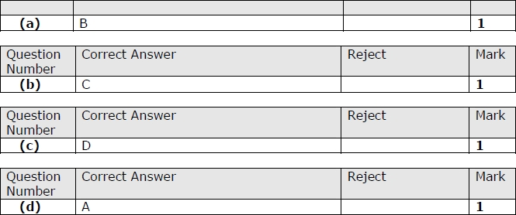

Q32.
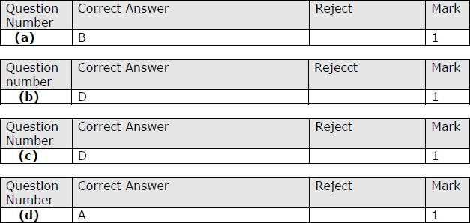

Q33.

Q34.
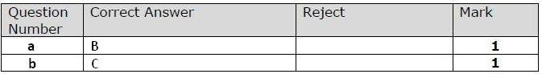

Q35.

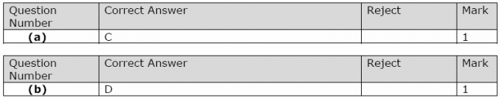

Q36.

Q37.

Q38.

Q39.
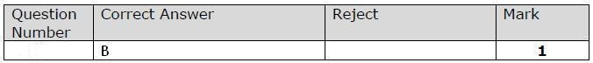

Q40.
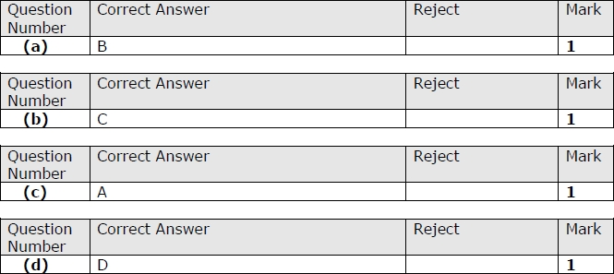

Q41.
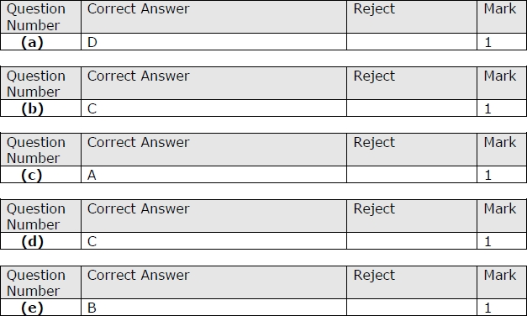

Q42.

Q43.

Q44.
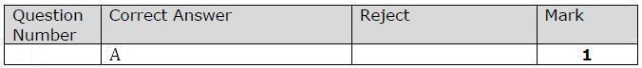

Q45.

Q46.

Q47.
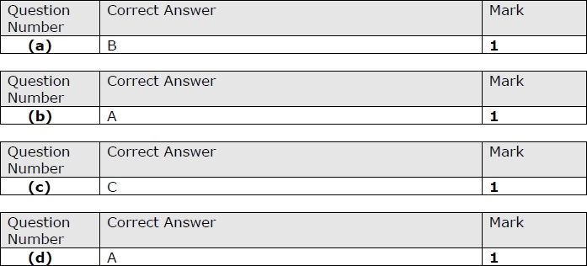

Q48.

Q49.
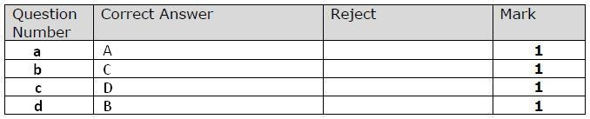

Q50.

Q51.

Q52.

