Questions
Q1.
1-butylamine, CH₃CH₂CH₂CH₂NH₂, reacts with ethanoyl chloride to form
A CH₃CH₂CH₂CH₂NH₃⁺Cl⁻
B CH₃CH₂CH₂CH₂NHCOCH₃
C CH₃CH₂CH₂CH₂NHCH₂CH₃
D CH₃CH₂CH₂CH(COCH₃)NH₂
(Total for question = 1 mark)

Q2.
Bromine reacts much faster with phenylamine than with benzene. This is because
A N—H bonds are weaker than C—H bonds.
B nitrogen is very electronegative.
C the benzene ring has greater electron density in phenylamine than in benzene.
D phenylamine reacts by addition whereas benzene reacts by substitution.
(Total for question = 1 mark)

Q3.
Phenylamine, C₆H₅NH₂, and benzene react with bromine in a similar way, but phenylamine reacts much faster. This increased rate of reaction is most likely due to the effect that the

A electronegativity of the nitrogen has on the benzene ring.
B electronegativity of the nitrogen has on the bromine molecule.
C lone pair of electrons of the nitrogen has on the benzene ring.
D lone pair of electrons of the nitrogen has on the bromine molecule.
(Total for Question = 1 mark)

Q4.
The distance on a chromatogram moved by an individual amino acid, in a mixture of
different amino acids, mainly depends on
A the molar mass of the amino acid.
B the molar mass of the solvent used.
C the intermolecular forces between the solvent and the stationary phase.
D the intermolecular forces between the amino acid and both the solvent and the
stationary phase.
(Total for question = 1 mark)

Q5.
In an aqueous solution with a pH of 7, the amino acid alanine exists mainly as
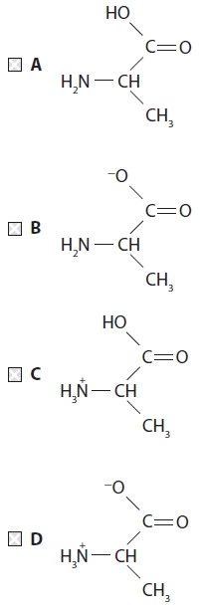

(Total for question = 1 mark)

Q6.
In an aqueous solution with a pH of 12, the amino acid alanine exists mainly as
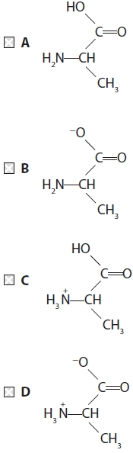

(Total for question = 1 mark)

Q7.
A white organic compound, X, is optically active and reacts with ninhydrin to give a
coloured product. The structural formula of X could be
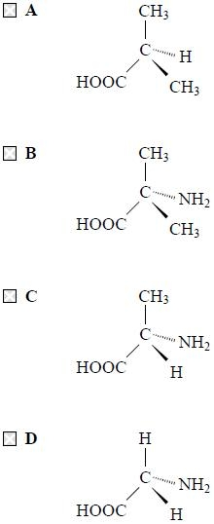
(Total for question = 1 mark)

Q8.
Which of the following structures best represents the amino acid, alanine, in an aqueous solution with a pH of 12?

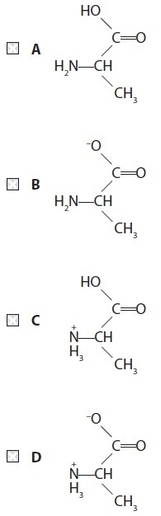
(Total for Question = 1 mark)

Q9.
Amino acids are crystalline solids with a high melting temperature because
A each molecule has a large number of electrons.
B each molecule forms hydrogen bonds at both ends.
C a proton is transferred from one end of the molecule to the other.
D their shape allows the molecules to pack close together.
(Total for question = 1 mark)

Q10.
The total number of isomers of dibromobenzene, C₆H₄Br₂, containing a benzene ring is

A 2
B 3
C 4
D 5
(Total for Question = 1 mark)

Q11.
Which sequence shows the bases in order of decreasing strength?
A C₆H₅NH₂ > CH₃NH₂ > NH₃
B NH₃ > CH₃NH₂ > C₆H₅NH₂
C CH₃NH₂ > NH₃ > C₆H₅NH₂.
D NH₃ > C₆H₅NH₂ > CH₃NH₂
(Total for question = 1 mark)

Q12.
X-ray diffraction provides evidence that benzene molecules have
A delocalized π electrons.
B carbon–carbon bonds that are all the same length.
C lower thermodynamic stability than molecules of 1,3,5-cyclohexatriene.
D greater thermodynamic stability than molecules of 1,3,5-cyclohexatriene.
(Total for question = 1 mark)

Q13.
Benzene (T_{b} = 80.1°C) has a higher boiling temperature than ethanol (T_{b} = 78.5°C).
This is because the
A benzene ring is stabilised.
B London forces between benzene molecules are stronger than the hydrogen bonds between ethanol molecules.
C hydrogen bonds between benzene molecules are stronger than the hydrogen bonds between ethanol molecules.
D C–H bonds in benzene are stronger than the C–H bonds in ethanol.

(Total for question = 1 mark)

Q14.
The benzenediazonium ion, C₆H₅N₂⁺, is an intermediate in the preparation of azo dyes.
(a) In the formation of an azo dye, the benzenediazonium ion is
(1)
A an electrophile.
B a nucleophile.
C a carbocation.
D a substituent.
(b) The temperature of the aqueous reaction mixture must be kept below 10°C to prevent the benzenediazonium ion being converted into
(1)
A benzene.
B nitrobenzene.
C phenylamine.
D phenol.

(Total for question = 2 marks)

Q15.
Benzocaine is used as a local anaesthetic.
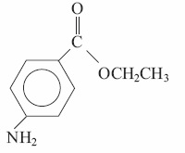
Separate samples of a solution of benzocaine are added to 2,4-dinitrophenylhydrazine,hot aqueous sodium hydroxide, and dilute hydrochloric acid.
Which chemicals react with benzocaine?
A All three
B Only sodium hydroxide and hydrochloric acid
C Only hydrochloric acid
D Only sodium hydroxide
(Total for question = 1 mark)

Q16.
The structural formula of caffeine, C₈H₁₀O₂N₄, is shown below.
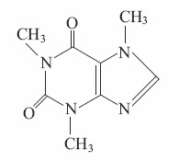
(a) How many main peaks would you expect in the proton nuclear magnetic resonance spectrum of caffeine?
(1)
A 1
B 2
C 3
D 4
(b) At which of the following wavenumbers is an absorption peak not present in the infrared spectrum of caffeine?
(1)
A 3600 cm⁻¹
B 2925 cm⁻¹
C 1690 cm⁻¹
D 1660 cm⁻¹
(c) The parent ion peak of caffeine in the mass spectrum of caffeine would be at m/e ratio
(1)
A 101
B 102
C 193
D 194
(d) Intermolecular forces between caffeine molecules would include
(1)
A London forces only.
B London forces and hydrogen bonds.
C London forces and permanent dipole forces.
D London forces, permanent dipole forces, and hydrogen bonds.
(Total for question = 4 marks)

Q17.
(a) The principal advantage of combinatorial chemistry over traditional methods for developing pharmaceuticals is that
(1)
A very small amounts of compounds are used.
B many more compounds can be made in a given time.
C compounds formed are more powerful drugs.
D compounds formed have fewer side effects.
(b) A refinement of combinatorial chemistry involves initially attaching compounds firmly to polymer beads. The type of attachment is most likely to be by
(1)
A metallic bonds.
B covalent bonds.
C London forces.
D permanent dipole forces.
(Total for question = 2 marks)

Q18.
The distinguishing characteristic of combinatorial chemistry is that it involves the
A simultaneous synthesis of many products.
B interaction of starting materials to form a unique product.
C use of catalysts.
D use of polymer supports.
(Total for question = 1 mark)

Q19.
A 50 cm³ sample of a gaseous hydrocarbon required exactly 250 cm³ of oxygen for complete combustion. A volume of 150 cm³ of carbon dioxide was produced.
[All volume measurements were made at the same temperature and pressure.]
Which of the following is the correct formula of the hydrocarbon?

A C₃H₄
B C₃H₈
C C₅H₁₀
D C₅H₁₂
(Total for Question = 1 mark)

Q20.
Which of the following reagents and conditions would enable phenylamine to be
converted to the yellow dye 4-hydroxyazobenzene in a good yield?
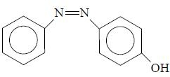
A Sodium nitrite, NaNO₂, in concentrated HCl, between 0°C and 10°C; followed
by an alkaline solution of phenol.
B Sodium nitrite, NaNO₂, in concentrated HCl, between 0°C and 10°C; followed
by an acidic solution of phenol.
C Sodium nitrate, NaNO₃, in concentrated HCl, between 0°C and 10°C; followed
by an alkaline solution of phenol.
D Sodium nitrite, NaNO₂, in concentrated HCl, room temperature; followed by an
alkaline solution of phenol.
(Total for question = 1 mark)

Q21.
The structure below shows the repeating pattern of a polymer.

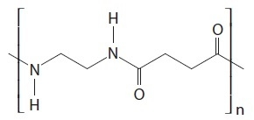
Which of the following pairs of compounds could react rapidly to form this polymer?
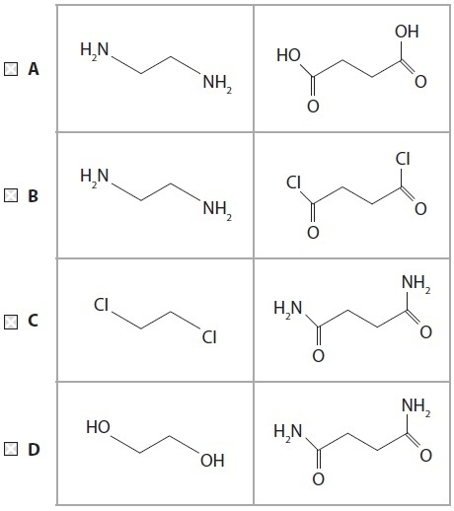
(Total for Question = 1 mark)

Q22.
15 cm³ of a gaseous hydrocarbon requires 90 cm³ of oxygen for complete combustion, both volumes being measured at 15°C and 1 atm. The formula of the hydrocarbon is
A C₄H₆
B C₄H₈
C C₄H₁₀
D impossible to calculate without knowing the molar volume of gases under these conditions.

(Total for question = 1 mark)

Q23.
Which of the following shows the generation of the electrophile in the reaction of
benzene with ethanoyl chloride in the presence of anhydrous aluminium chloride?
A CH₃COCl + AlCl₃ → [CH₃CO] ⁺ + AlCl₄⁻
B CH₃COCl + AlCl₃ → [CH₃CO]⁻ + AlCl₄⁺
C CH₃CH₂Cl + AlCl₃ → [CH₃CH₂]⁺ + AlCl₄⁻
D CH₃COOCl + AlCl₃ → [CH₃COO] ⁻ + AlCl4⁺
(Total for question = 1 mark)

Q24.
The compound shown below is found in cocoa beans and in chocolate. Which of the groups listed is not present in its structure?
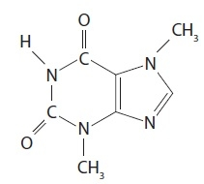
A Alkyl
B Amide
C Amine
D Ketone
(Total for question = 1 mark)

Q25.
Glycine, H₂NCH₂COOH, is a solid that has a melting temperature of about 250°C, and
it is very soluble in water. This is because of the
A formation of intermolecular hydrogen bonds in the solid and hydrogen bonds
with water.
B formation of H₃N⁺CH₂COO⁻ ions which interact strongly with each other in the
solid and with water.
C dissociation of the molecule to form H₂NCH₂COO⁻ and H⁺ ions in the solid and
the solution.
D protonation of the molecule to form H₃N⁺CH₂COOH ions in both the solid and
the solution.
(Total for question = 1 mark)

Q26.
In a high resolution proton nmr spectrum of ethanoic acid, CH₃COOH, the peak due to
the hydrogen atoms in the methyl group would be a
A singlet.
B doublet.
C triplet.
D quartet.
(Total for question = 1 mark)

Q27.
In a high resolution proton nmr spectrum of ethyl ethanoate, CH₃COOCH₂CH₃, the peak due to the hydrogen atoms shown in bold would be a
A singlet.
B doublet.
C triplet.
D quartet.
(Total for question = 1 mark)

Q28.
Butylamine (T_{b} = 77.8°C) has a higher boiling temperature than propylamine (T_{b} = 47.7°C).
This is because the
A hydrogen bonds of butylamine are stronger than the hydrogen bonds of propylamine.
B London forces of butylamine are stronger than the hydrogen bonds of propylamine.
C London forces of butylamine are stronger than the London forces of propylamine.
D C—H bonds of butylamine are stronger than the C—H bonds of propylamine.

(Total for question = 1 mark)

Q29.
A section of the polypeptide made from a single amino acid is shown below.
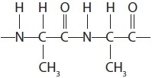
The polypeptide was heated with excess dilute sodium hydroxide solution until no further change took place.
Which of the following products is formed?

A 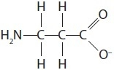
B 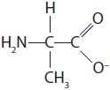
C 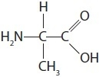
D 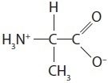
(Total for Question = 1 mark)

Q30.
A compound is known to have either the structure H₂NCH₂CH₂NH₂ or H₂NCH₂COOH.
Which of the following tests would best distinguish between the two compounds?
A Reaction with concentrated aqueous sodium hydroxide.
B Reaction with nitrous acid.
C Reaction with aqueous sodium hydrogencarbonate.
D Reaction with ethanoyl chloride.
(Total for question = 1 mark)

Q31.
An organic compound X is much more soluble in dilute hydrochloric acid than in water.
Compound X forms a coloured complex with aqueous copper(II) ions.
Compound X could be
A C₆H₅COOH
B C₆H₅NO₂
C C₆H₅NH₂
D C₆H₅OH
(Total for question = 1 mark)

Q32.
An organic compound, X, shows the following properties:
&#149; Oxidation of compound X produces a substance that reacts with 2,4-dinitrophenylhydrazine to give a yellow precipitate but does not react with Fehling's or Benedict's solution.
&#149; Compound X reacts with ice-cold nitrous acid to form a compound that gives a yellow precipitate with an alkaline solution of phenol.
What is the formula of compound X?
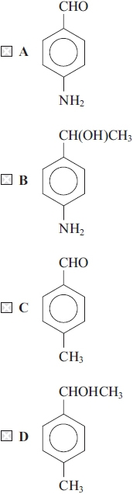
(Total for question = 1 mark)

Q33.
The monomer of the addition polymer poly(propenol) may be represented as
The repeat unit of the addition polymer is
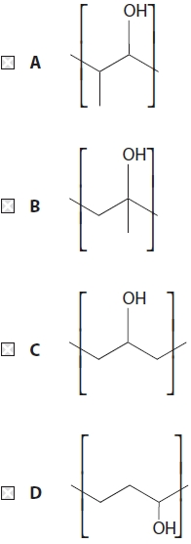

(Total for question = 1 mark)

Q34.
The monomer of the addition polymer poly(propenamide) is . The repeat unit of the polymer is
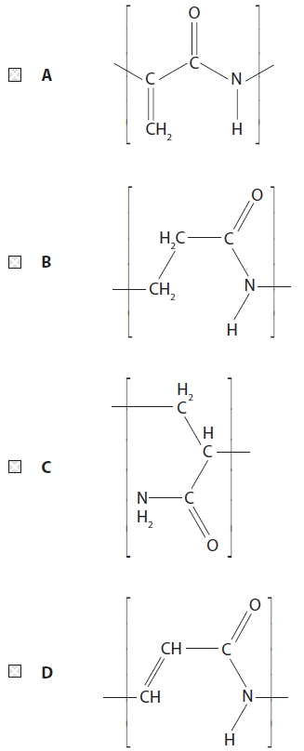

(Total for question = 1 mark)

Q35.
How many different peaks due to hydrogen atoms would you expect to see in a low
resolution proton nmr spectrum of propanoic acid, CH₃CH₂COOH?
A Two
B Three
C Five
D Six
(Total for question = 1 mark)

Q36.
How many peaks would you expect to see in a low resolution proton nmr spectrum of
the ester HCOOCH₂CH₂CH₃?
A 8
B 7
C 4
D 3
(Total for question = 1 mark)

Q37.
Which of the monomers A to D would form the polymer below?
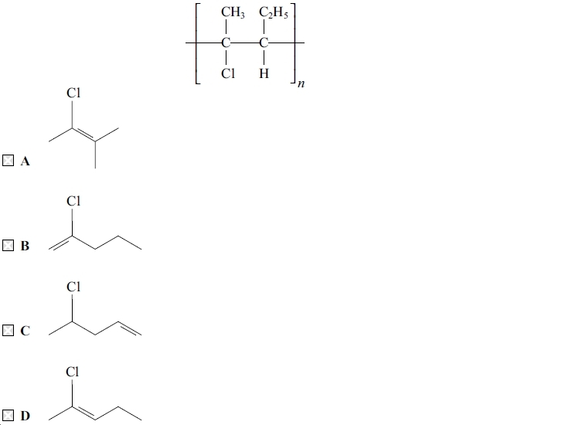
(Total for question = 1 mark)

Q38.
When benzene reacts with fuming sulfuric acid, which species is most likely to be the electrophile?
A H₃O⁺
B SO₃
C HSO₄⁻
D SO₄²⁻

(Total for question = 1 mark)

Q39.
Benzene is nitrated using a mixture of concentrated nitric and sulfuric acids. The sulfuric acid
A acts as a solvent for the benzene and the nitric acid.
B protonates the benzene to speed up the reaction.
C protonates the nitric acid which acts as a base.
D reacts with the benzene to form a benzenesulfonic acid intermediate.
(Total for question = 1 mark)

Q40.
For the nitration of phenol, which is the most suitable set of conditions and the reason for its use?
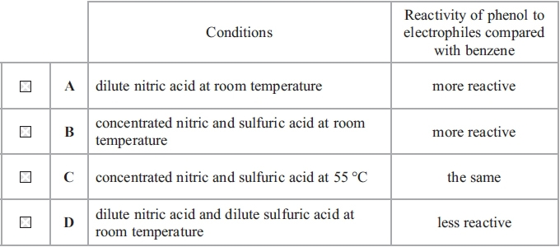
(Total for question = 1 mark)

Q41.
Which of these four amino acids could not rotate the plane of plane-polarised light?
A H₂NCH(CH₃)COOH
B H₂NCH(CH₂COOH)COOH
C H₂NCH₂COOH
D H₂NCH(CH₂SH)COOH
(Total for question = 1 mark)

Q42.
Which of the following amino acids is optically active and produces an approximately neutral solution when dissolved in water?

A H₂NCH₂COOH
B 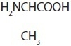
C 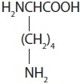
D 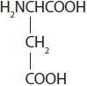
(Total for Question = 1 mark)

Q43.
Ammonia (NH₃), butylamine (CH₃CH₂CH₂CH₂NH₂) and phenylamine (C₆H₅NH₂) all
form alkaline solutions in water. The order of increasing pH of equimolar solutions is
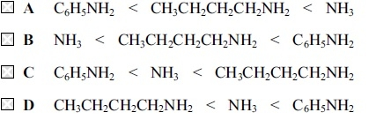
(Total for question = 1 mark)

Q44.
Separate 0.1 mol dm⁻³ aqueous solutions of ammonia, methylamine and phenylamine were prepared. Which of the following sequences shows the solutions in order of increasing pH?
A phenylamine, methylamine, ammonia
B phenylamine, ammonia, methylamine
C methylamine, ammonia, phenylamine
D methylamine, phenylamine, ammonia

(Total for question = 1 mark)

Q45.
Phenol reacts with excess bromine water to give as the organic product(s)
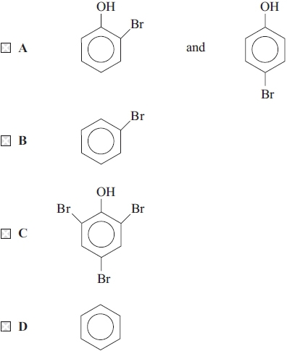
(Total for question = 1 mark)

Q46.
If phenol and benzene are tested separately with bromine water, you would expect to see
that
A benzene and phenol would both decolorize bromine water.
B benzene would decolorize bromine water, but phenol would not do so.
C neither benzene nor phenol would decolorize bromine water.
D benzene would not decolorize bromine water, but phenol would do so.
(Total for question = 1 mark)

Q47.
Phenylamine (aniline), C₆H₅NH₂, may be prepared from nitrobenzene, C₆H₅NO₂.
(a) The reagent normally used for this reaction is
(1)
A lithium tetrahydridoaluminate(III) (lithium aluminium hydride) in ether.
B concentrated ammonia in ethanol.
C potassium dichromate(VI) in sulfuric acid.
D tin in concentrated hydrochloric acid.
(b) The phenylamine is separated from the reaction mixture by
(1)
A paper chromatography.
B steam distillation.
C filtration.
D recrystallization.
(b) One test for phenylamine is to convert it into a diazonium ion which is then reacted with phenol to form an azo dye. The structure of this dye is
(1)
A 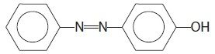
B 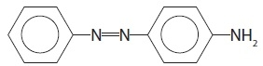
C 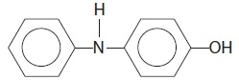
D 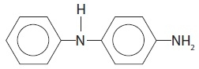
(Total for question = 3 marks)

Q48.
Poly(ethenol) is a water-soluble polymer. A section of the chain has the structure shown below.
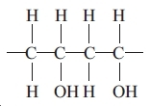
The polymer is used for making hospital laundry bags so that laundry can be loaded directly into washing machines without it having to be handled.
Poly(ethenol) is water soluble because the polymer
A is broken down by the water into monomers.
B is broken down by the washing detergent.
C breaks into monomers at the temperature of the wash.
D forms many strong hydrogen bonds with the water.
(Total for question = 1 mark)

Q49.
Which of the following pairs of compounds could form a polyamide?

A
B 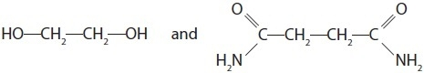
C 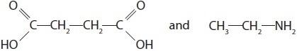
D 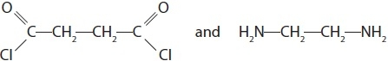
(Total for Question = 1 mark)

Q50.
Four polymers labelled A to D have the following formulae:
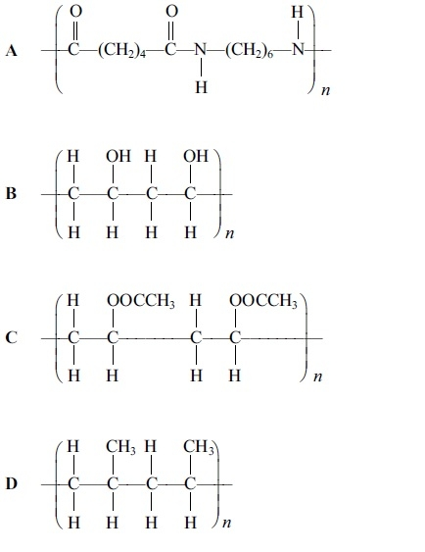
(a) Which polymer is most soluble in hot water?
(1)
A
B
C
D
(b) Which polymer is formed from the monomer shown below?
(1)
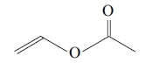
A
B
C
D
(c) Which polymer is a condensation polymer?
(1)
A
B
C
D
(Total for question = 3 marks)

Q51.
Which of these compounds will not form an amide in a reaction with ethanoyl chloride?
A NH₃
B CH₃CH₂NH₂
C CH₃CH₂NH(CH₃)
D CH₃CH₂N(CH₃)₂
(Total for question = 1 mark)

Q52.
This question concerns the following organic compounds.
A CH₃COCl
B CH₃COOH
C CH₃COOCH₂CH₃
D C₆H₅OH
Which compound is most likely to
(a) form the solution with the lowest pH when mixed with water?
(1)
A
B
C
D

(b) burn with a smoky flame?
(1)
A
B
C
D

(c) have a fruity smell?
(1)
A
B
C
D

(d) have an absorption in its IR spectrum at about 1795 cm^{&#150;1}?
(1)
A
B
C
D
(Total for question = 4 marks)

Q53.
Which of the following is true for all amino acids?
All amino acids

A exist as optical isomers.
B are neutral in solution.
C are essential to life.
D are crystalline solids at room temperature.
(Total for Question = 1 mark)

Q54.
When a solid is purified by recrystallization, the procedure involves the removal of impurities by filtration of the hot mixture followed by filtration of the cold mixture.
Which impurities are removed by these two filtrations?
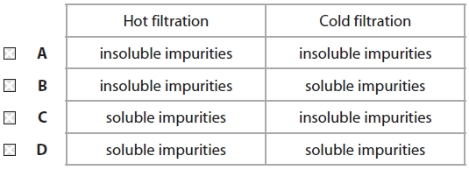

(Total for question = 1 mark)

Q55.
Bromoethane can be made by heating ethanol under reflux with 50% sulfuric acid and
sodium bromide. When the mixture is distilled, the products include sulfur dioxide,
bromine, hydrogen bromide and water as well as bromoethane.
The product mixture is shaken with sodium carbonate solution and later with anhydrous
sodium sulfate before being re-distilled. Which of the following shows the correct list
of impurities removed at each step?
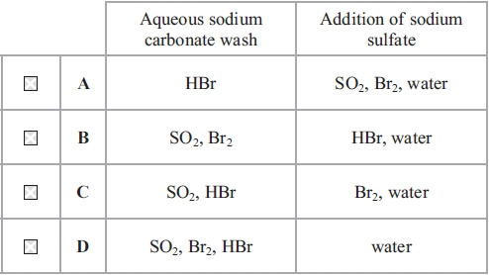
(Total for question = 1 mark)

Q56.
Which of these compounds, whose formulae are shown below, cannot exist as a racemic
mixture?
A CH₂ClCHClCOOH
B HOOCCHClCOOH
C CH₃CHClCOOH
D CH₃CH(OH)COOH
(Total for question = 1 mark)

Q57.
When dilute nitric(V) acid, HNO₃, reacts with phenylamine, the ion formed is

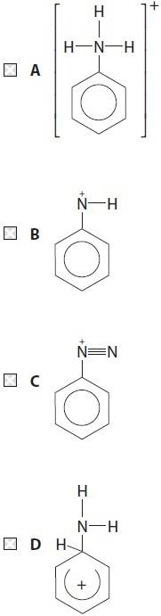
(Total for Question = 1 mark)

Q58.
Benzene reacts with a nitrating mixture of concentrated nitric and sulfuric acids.
Which species is least likely to be present in the nitrating mixture?
A NO₃⁻
B H₃O⁺
C HSO₄⁻
D NO₂⁺

(Total for question = 1 mark)

Q59.
Benzene reacts with propanoyl chloride in the presence of a suitable catalyst.
The skeletal formula of propanoyl chloride is
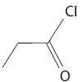
What is the organic product of this reaction?
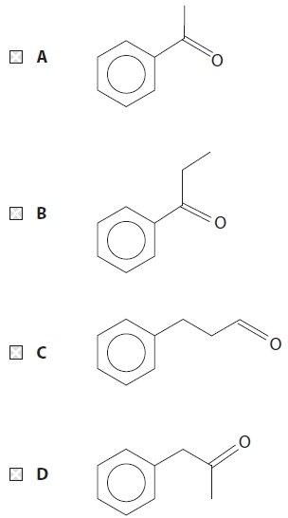

(Total for question = 1 mark)

Q60.
Bromine reacts with benzene on heating in the presence of a catalyst and with cyclohexa-1,3-diene in the cold. The types of reaction involved are

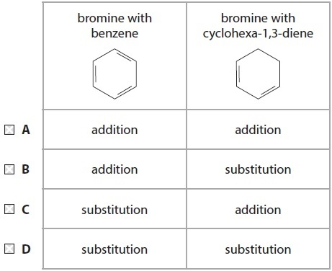
(Total for Question = 1 mark)

Q61.
Excess dilute sulfuric acid is added to phenylamine. What is the product of the reaction?
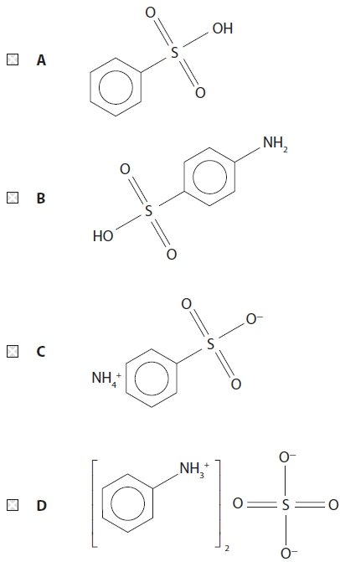

(Total for question = 1 mark)

Q62.
The compounds below were heated with aqueous sodium hydroxide solution. Which one of them did not give sodium ethanoate, CH₃COONa, as one of the products?
A CH₃COOCH₃
B CH₃COCH₃
C CH₃COOH
D CH₃COCl
(Total for question = 1 mark)

Q63.
Which of the following products is formed when phenylamine (aniline) is reacted with dilute sulfuric acid?
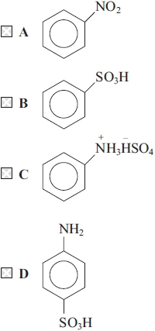
(Total for question = 1 mark)

Q64.
The formulae of some organic compounds labelled A to D are shown below.
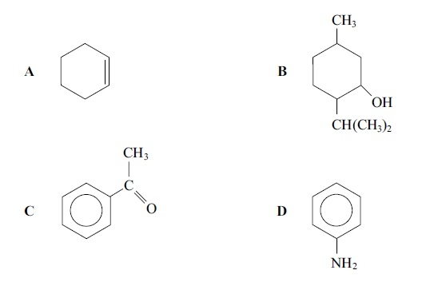
(a) Which compound reacts with sodium to form hydrogen?
(1)
A
B
C
D
(b) Which compound forms a green complex ion with CuSO₄(aq)?
(1)
A
B
C
D
(c) Which compound forms an orange precipitate with 2,4-dinitrophenylhydrazine?
(1)
A
B
C
D
(Total for question = 3 marks)

Q65.
Organic solids are often purified by recrystallization. This technique works on the basis
that
A the impurities must be insoluble in the solvent used.
B the impurities must react with the solvent used.
C the impurities crystallize first when the hot solution is cooled.
D the cooled solution is saturated with the desired material but not with the
impurities.
(Total for question = 1 mark)

Q66.
The best method for separating a mixture of amino acids in solution is
A distillation.
B solvent extraction.
C chromatography.
D recrystallization.
(Total for question = 1 mark)

Q67.
Which of the following is not planar?

A 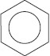
B CCl₄
C BF₃
D [Pt(NH₃)₂Cl₂]
(Total for Question = 1 mark)

Q68.
Methylamine, CH₃NH₂, is very soluble in water. This is because it

A forms hydrogen bonds with water.
B forms London forces with water.
C exists mainly as ions in aqueous solution.
D exists as a zwitterion.
(Total for Question = 1 mark)

Q69.
In the solid state, the amino acid serine exists in the form
A H₃N⁺CH(CH₂OH)COOH
B H₃N⁺CH(CH₂OH)CO₂^{&#150;}
C H₂NCH(CH₂OH)COOH
D H₂NCH(CH₂OH)CO₂^{&#150;}
(Total for question = 1 mark)

Q70.
Phenol reacts with bromine water whereas benzene reacts with bromine in the presence
of iron.
(a) The mechanism for both these reactions is
(1)
A electrophilic substitution.
B electrophilic addition.
C nucleophilic substitution.
D nucleophilic addition.
(b) In the reaction of benzene with bromine, iron
(1)
A acts as a heterogeneous catalyst.
B acts as a homogeneous catalyst.
C reacts with the bromine to make iron(III) bromide, FeBr₃.
D allows bromine to attack the hydrogen atoms on benzene more readily.
(c) Bromine reacts more readily with phenol than with benzene because the OH group
on phenol
(1)
A is a good leaving group.
B attracts the bromine particles more readily.
C is a good nucleophile.
D increases the electron density of the ring.
(Total for question = 3 marks)

Q71.
This question is about the reaction scheme below.
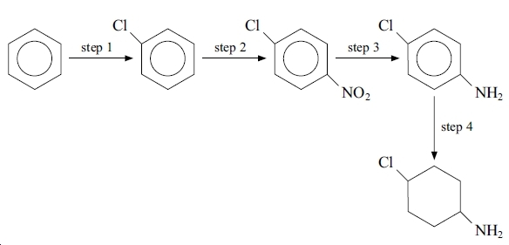
Which step is most likely to need
(a) tin and concentrated hydrochloric acid?
(1)
A Step 1
B Step 2
C Step 3
D Step 4

(b) a catalyst of iron(III) chloride?
(1)
A Step 1
B Step 2
C Step 3
D Step 4

(c) a nickel catalyst?
(1)
A Step 1
B Step 2
C Step 3
D Step 4
(Total for question = 3 marks)

Q72.
Chromatography may be used to separate mixtures of amino acids. This is best explained by the fact that different amino acids have different interactions with
A the mobile phase only.
B the stationary phase only.
C the mobile phase and the stationary phase.
D ninhydrin.

(Total for question = 1 mark)

Q73.
Ninhydrin is used in thin-layer chromatography to help with the identification of amino acids. This is because the ninhydrin
A reacts with amino acids to form a compound which has an intense colour.
B reacts with amino acids to form compounds each of which has a characteristic colour.
C increases the separation of the amino acids on the chromatogram.
D ensures that the mobile phase maintains a nearly constant pH for all the amino acids.

(Total for question = 1 mark)

Q74.
The addition polymer poly(ethenol) is water-soluble. The repeating unit of poly(ethenol)
is
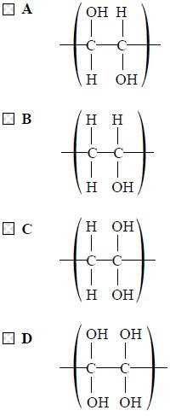
(Total for question = 1 mark)

Q75.
Consider the reaction scheme below and calculate the mass of aspirin you would expect
to form if you started with 47 g of phenol.
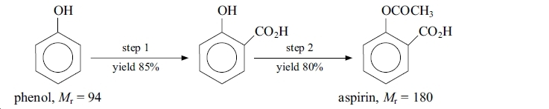
A 31.96 g
B 61.20 g
C 74.25 g
D 90.00 g
(Total for question = 1 mark)

Mark Scheme
Q1.

Q2.

Q3.

Q4.

Q5.

Q6.

Q7.

Q8.

Q9.

Q10.

Q11.

Q12.

Q13.

Q14.

Q15.
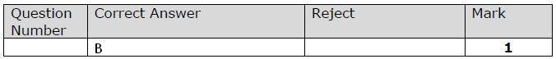

Q16.
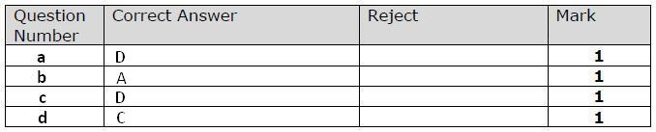

Q17.
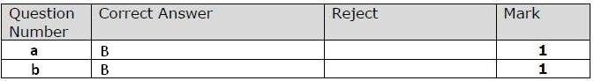

Q18.

Q19.

Q20.

Q21.

Q22.

Q23.

Q24.

Q25.

Q26.

Q27.

Q28.

Q29.

Q30.

Q31.

Q32.

Q33.

Q34.

Q35.

Q36.

Q37.

Q38.

Q39.

Q40.

Q41.

Q42.

Q43.

Q44.

Q45.

Q46.

Q47.

Q48.

Q49.

Q50.

Q51.

Q52.

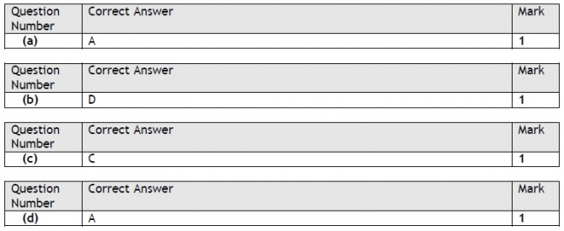

Q53.

Q54.

Q55.

Q56.

Q57.

Q58.

Q59.

Q60.

Q61.

Q62.

Q63.

Q64.

Q65.

Q66.

Q67.

Q68.

Q69.

Q70.

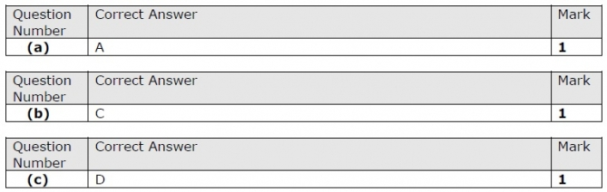

Q71.

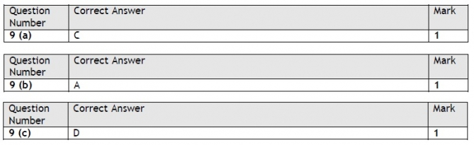

Q72.

Q73.

Q74.

Q75.

