ALEC REED ACADEMY
Mastery Booklet(Physics)
(Paper 1)
Name : ______________________
Teacher : ____________________
Date Given : __________________
These booklets are a consolidation of your learning. They should be used in the following way – You should attempt the questions WITHOUT looking at the answers. Then mark your questions with Green pen and add any missing marks you missed.
THIS WILL IMPROVE YOUR GRADES…!!

Year 11 GCSE Intervention Support 2019-20
These are your science exam dates for your
Paper 1
Biology 1…. …12th May 2020
Chemistry 1….. 14th May 2020
Physics 1…… 20th May 2020
These are your science exams for your
Paper 2
Biology2 1stJune 2020
Chemistry 2 10th June 2020
Physics 2 12th June 2020

IMPORTANT: This is not instead of revision at home. You should still do your own revision. This is just to help you with the toughest parts.
We know you have a lot to revise for and preparing for your exams can be stressful so here is a tool to help you.

STEP 1: You have finished your (B1, C1, and P1) year 9-11 learning so you can target all the areas you want support with.
HOW TO USE THIS BOOKLET
You know best. What your strengths and target areas are so please can you pick the topics you want most help with.
Tips:

Revision Tips
1. Plan to revise. Don’t sit down without knowing what to do, it feels awful.
Try this…. “Right I am going to do 30 minutes on radioactivity. I will list 10 key facts, one idea I find tough and try 1 past paper question.”
So plan your tasks and topics. It really helps. Ask for help with making a revision plan.
2. Avoid distractions. Revise with a friend so you don’t think about what they are doing. Avoid revising when really tired or hungry.
3. Reward yourself. “If I do an hour or two this morning then I can go out this afternoon”.
4. Make stuff. Put up posters, make flash cards or revision cards. Post-it your room with key ideas. Keep what you’ve made to help you realise you are working well.
5. Practice past paper questions. You have been provided with a free book of these and they are one of the best things you can do. Remember to B.U.G. (Box the keyword, Underline important info, Go through it twice).

Revision tools
1. Use Sam Learning. The centre code is TA6CT1 https://www.samlearning.com/ Use your revision guide to help with the tasks/tests.
2. Don’t just read your revision guide. Make lists of keywords then test yourself to see if you can describe the keywords. Practice drawing key diagrams from memory. Use the question pages in the revision guides.
3. Google “AQA Science A past papers” for year 10 topics. Google “AQA science past papers” for year 11 stuff. Lots to choose from.
4. GCSE Bitesize has recently been given a makeover and now has lots of helpful videos linked to the tests and tasks.
5. Check out www.getrevising.co.uk. Free revision planner tool and many free resources. For a small monthly fee you can download other people’s revision materials for AQA science.
6. Phone apps. App store search cgp revision guides, they are fairly cheap if you want an on the go revision guide.
7. YOUTUBE The “mygcse science” youtube channel has really lovely walkthrough commentaries with pictures for all your B/C/P topics. Have a look.

Q1.The diagram shows the circuit used to obtain the data needed to plot the current-potential difference graph for a filament lamp.
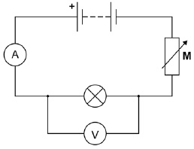
(a) Why is component M included in the circuit?
Tick one box.

To keep the current constant.
To keep the potential difference constant.
To vary the current.
(1)
(b) Why does the resistance of the lamp increase as the potential difference across the lamp increases?
___________________________________________________________________
___________________________________________________________________
(1)
(c) The potential difference across the lamp is 12.0 V. Calculate the energy transferred by the lamp when 8.5 C of charge flows through the lamp.Use the equation:
energy transferred = charge flow × potential difference
___________________________________________________________________
___________________________________________________________________
___________________________________________________________________
Energy transferred = ____________________ J
(2)
(d) The table gives data about two types of lamp that householders may use in their homes.

Type of lamp | Energy efficiency | Mean lifetime in hours
Halogen | 10% | 2000
LED | 90% | 36000
Both types of lamp produce the same amount of light.
Describe the environmental advantages of using the LED lamp compared with the halogen lamp.
___________________________________________________________________
___________________________________________________________________
___________________________________________________________________
___________________________________________________________________
(2)
(Total 6 marks)
Q2.The image shows a battery-powered drone.
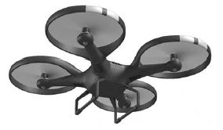
(a) Complete the sentences.
Choose the answers from the box.

 | chemical | elastic potential
gravitational potential |  | kinetic | nuclear
As the drone accelerates upwards
its _________________________________________ energy increases
and its _________________________________________ energy increases.
The _________________________________________ energy store
of the battery decreases.
(3)

(b) In the USA, drones are not allowed to be flown too high above the ground.
Suggest one possible risk of flying a drone too high above the ground.
___________________________________________________________________
___________________________________________________________________
___________________________________________________________________
(2)
(c) Write down the equation that links energy transferred, power and time.
___________________________________________________________________
(1)
(d) The drone can fly for 25 minutes before the battery needs recharging.
The power output of the battery is 65.0 W
Calculate the maximum energy stored by the battery.
___________________________________________________________________
___________________________________________________________________
___________________________________________________________________
___________________________________________________________________
Maximum energy = ____________________ joules
(3)
(Total 8 marks)
Q3.The diagram shows a climber part way up a cliff.
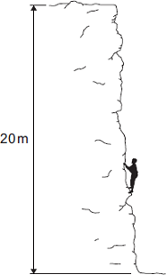
(a) Complete the sentence.
When the climber moves up the cliff, the climber
gains gravitational ______________________ energy.
(1)
(b) The climber weighs 660 N.
(i) Calculate the work the climber must do against gravity, to climb to the top of the cliff.
______________________________________________________________
______________________________________________________________
Work done = _________________________ J
(2)
(ii) It takes the climber 800 seconds to climb to the top of the cliff.
During this time the energy transferred to the climber equals the work done by the climber.
Calculate the power of the climber during the climb.
______________________________________________________________
______________________________________________________________
Power = _________________________ W
(2)
(Total 5 marks)
Q4.The specific heat capacity of aluminium can be determined by experiment.
(a) Draw a labelled diagram showing how the apparatus used to determine the specific heat capacity of aluminium should be arranged.
(3)
(b) Describe how you could use the apparatus you drew in part (a) to determine the specific heat capacity of aluminium.
(6)
(c) Methods used to determine the specific heat capacity of aluminium may give a value greater than the actual value. Explain why.
___________________________________________________________________
___________________________________________________________________
___________________________________________________________________
___________________________________________________________________
(2)
(Total 11 marks)
Q5. (a) In this question you will be assessed on using good English, organising information clearly and using specialist terms where appropriate.
The diagram shows the structure of a vacuum flask.
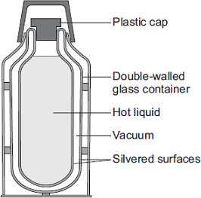
A vacuum flask is designed to reduce the rate of energy transfer by heating processes.
Describe how the design of a vacuum flask keeps the liquid inside hot.
___________________________________________________________________
___________________________________________________________________
___________________________________________________________________
___________________________________________________________________
___________________________________________________________________
___________________________________________________________________
___________________________________________________________________
___________________________________________________________________
___________________________________________________________________
(6)
(b) Arctic foxes live in a very cold environment.
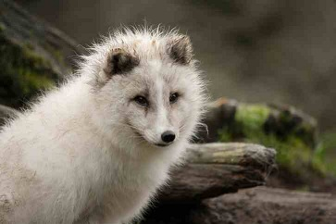

Arctic foxes have small ears. How does the size of the ears help to keep the fox warm in a cold environment?
___________________________________________________________________
___________________________________________________________________
___________________________________________________________________
___________________________________________________________________
___________________________________________________________________
(2)
(Total 8 marks)
Q6. Diagram 1 shows the energy transferred per second from a badly insulated house on a cold day in winter.
Diagram 1
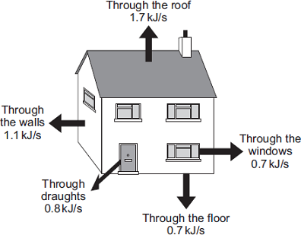
(a) (i) When the inside of the house is at a constant temperature, the energy transferred from the heating system to the inside of the house equals the energy transferred from the house to the outside.
Calculate, in kilowatts, the power of the heating system used to keep the inside of the house in Diagram 1 at a constant temperature.
1 kilowatt (kW) = 1 kilojoule per second (kJ/s)
______________________________________________________________
Power of the heating system = ___________________________ kW
(1)

(ii) In the winter, the heating system is switched on for a total of 7 hours each day. Calculate, in kilowatt-hours, the energy transferred each day from the heating system to the inside of the house.
______________________________________________________________
______________________________________________________________
Energy transferred each day = ___________________________ kWh
(2)
(iii) Energy costs 15 p per kilowatt-hour. Calculate the cost of heating the house for one day.
______________________________________________________________
Cost = _______________
(1)
(iv) The heating system is switched off at midnight. The graph shows how the temperature inside the house changes after the heating system has been switched off.
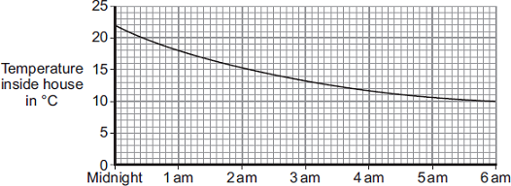
Time of day
Draw a ring around the correct answer in the box to complete the sentence.
Between midnight and 6 am the rate of energy transfer from

 | decreases.
the house | decreases then stays constant.
 | increases.
Give the reason for your answer.
______________________________________________________________
______________________________________________________________
(2)
(b) Diagram 2 shows how the walls of the house are constructed.
Diagram 3 shows how the insulation of the house could be improved by filling the air gap between the two brick walls with plastic foam.

Diagram 2 | Diagram 3
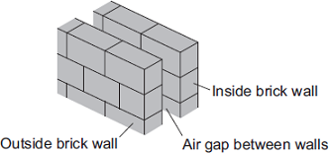 | 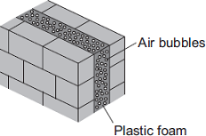
U-value of the wall = 0.7 | U-value of the wall = 0.3
The plastic foam reduces energy transfer by convection. Explain why.
___________________________________________________________________
___________________________________________________________________
___________________________________________________________________
___________________________________________________________________
(2)
(Total 8 marks)
Q7. (a) The pie chart shows the proportions of electricity generated in the UK from different energy sources in 2010.
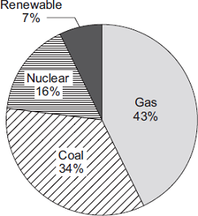
(i) Calculate the percentage of electricity generated using fossil fuels.
______________________________________________________________
Percentage = ______________________ %
(1)
(ii) The pie chart shows that 7% of electricity was generated using renewable energy sources. Which one of the following is not a renewable energy source?
Tick () one box.

Oil
Solar
Wind
(1)
(b) Complete the following sentence.
In some types of power station, fossil fuels are burned to heat ________________ to produce steam.
(1)
(c) Burning fossil fuels releases carbon dioxide into the atmosphere. Why do many scientists think adding carbon dioxide to the atmosphere is harmful to the environment?
Tick () one box.

Carbon dioxide is the main cause of acid rain.
Carbon dioxide causes global warming.
Carbon dioxide causes visual pollution.
(1)
(Total 4 marks)
Q8. A new design for a kettle is made from two layers of plastic separated by a vacuum.
After the water in the kettle has boiled, the water stays hot for at least 2 hours.The new kettle is shown below.
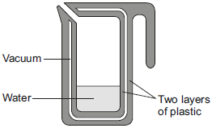
(a) The energy transferred from the water in the kettle to the surroundings in 2 hours is
46 200 J. The mass of water in the kettle is 0.50 kg.
The specific heat capacity of water is 4200 J/kg °C.
The initial temperature of the water is 100 °C.
Calculate the temperature of the water in the kettle after 2 hours.
___________________________________________________________________
___________________________________________________________________
___________________________________________________________________
___________________________________________________________________
Temperature after 2 hours = ___________ °C
(3)
(b) Calculate the average power output from the water in the kettle to the surroundings in 2 hours.
___________________________________________________________________
___________________________________________________________________
___________________________________________________________________
Average power output = ______________ W
(2)
(Total 5 marks)
Q9. A student investigated the properties of three types of insulation.
Figure 1 shows the apparatus the student used.
Figure 1
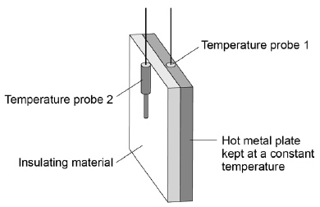
In the investigation different insulating materials were placed in contact with the hot metal plate. Temperature probes measured the temperature on each side of the material.
The temperature probes were connected to a data logger.
Figure 2 shows how the temperature measured by temperature probe 2 changed over 10 minutes for each of the materials.
Figure 2
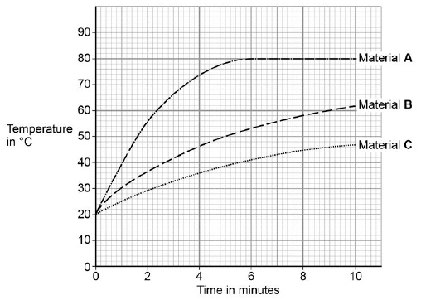
(a) What was the temperature of the hot metal plate?
____________________ °C
(1)
(b) Which material is the best insulator?
Tick one box.

A |  | B |  | C
Give the reason for your answer.
___________________________________________________________________
___________________________________________________________________
(2)
(c) Another student repeated the investigation but doubled the thickness for all three insulating materials.Suggest how using thicker insulation would affect the results of the second student's investigation compared with the first student's results.
___________________________________________________________________
___________________________________________________________________
___________________________________________________________________
___________________________________________________________________
___________________________________________________________________
(2)

(d) The students could have used a thermometer instead of temperature probes and a datalogger.
Figure 3 shows the datalogger screen and a thermometer.
Figure 3
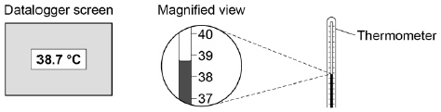
Give two advantages of using the datalogger and temperature probes compared to a thermometer.
1. _________________________________________________________________
___________________________________________________________________
2. _________________________________________________________________
___________________________________________________________________
(2)
(e) The table gives information about four types of insulation that could be used for insulating the cavity walls of houses.

Type of insulation | Thermal conductivity in W/m °C
Felt wool | 0.070
Mineral wool | 0.040
Polyurethane foam | 0.030
Rock wool | 0.045
Explain which one of the types of insulation in the table would be the best to use for cavity wall insulation.
___________________________________________________________________
___________________________________________________________________
___________________________________________________________________
___________________________________________________________________
___________________________________________________________________
(2)
(Total 9 marks)
Q10. Electricity can be generated using various energy sources.
(a) Give one advantage and one disadvantage of using nuclear power stations rather than gas-fired power stations to generate electricity.
Advantage __________________________________________________________
___________________________________________________________________
Disadvantage _______________________________________________________
___________________________________________________________________
(2)
(b) (i) A single wind turbine has a maximum power output of 2 000 000 W.
The wind turbine operated continuously at maximum power for 6 hours.
Calculate the energy output in kilowatt-hours of the wind turbine.
______________________________________________________________
______________________________________________________________
______________________________________________________________
Energy output = ____________________ kWh
(2)
(ii) Why, on average, do wind turbines operate at maximum power output for only 30% of the time?
______________________________________________________________
______________________________________________________________
(1)
(c) An on-shore wind farm is made up of many individual wind turbines.
They are connected to the National Grid using underground power cables.
Give one advantage of using underground power cables rather than overhead power cables.
___________________________________________________________________
___________________________________________________________________
(1)
(Total 6 marks)

Q11. Iceland is a country that generates most of its electricity using geothermal power stations and hydroelectric power stations.
(a) (i) Complete the following sentences to describe how some geothermal power stations work. In regions where volcanoes are active, the ground is hot.
Cold _______________________ is pumped down into the ground
and is _______________________ by hot rocks.
It returns to the surface as steam. The steam is used to turn a turbine.
The turbine drives a _______________________ to produce electricity.
(3)
(ii) Which one of the following statements about geothermal power stations is true?
Tick () one box.
Geothermal power stations use fossil fuels.
Geothermal power stations produce carbon dioxide.
Geothermal power stations provide a reliable source of electricity.
(1)
(b) What is needed for a hydroelectric power station to be able to generate electricity?
Tick () one box.
Falling water
A long coastline
Lots of sunny days
(1)
(Total 5 marks)
Q12. (a) In this question you will be assessed on using good English, organising information clearly and using specialist terms where appropriate.
A householder wants to reduce her energy bills. She collected information about a number of ways of reducing energy used. The information is shown in the table.

Ways of reducing  energy used | Cost to buy and  install in £ | Money saved  per year in £
Install an  energy-efficient boiler | 2 000 | 320
Insulate the loft | 400 | 200
Install double-glazed  windows | 12 000 | 120
Install cavity wall  insulation | 415 | 145
Use the information in the table to compare the different ways of reducing the energy used. Your answer should include some calculations.
___________________________________________________________________
___________________________________________________________________
___________________________________________________________________
___________________________________________________________________
___________________________________________________________________
___________________________________________________________________
___________________________________________________________________
___________________________________________________________________
___________________________________________________________________
___________________________________________________________________
(6)
(b) Increasing the amount of insulation in a house affects the total U-value of the house.
(i) What is meant by the term ‘U-value’?
______________________________________________________________
______________________________________________________________
(1)
(ii) How is the U-value affected by increasing the amount of insulation?
______________________________________________________________
(1)
(Total 8 marks)
Q13. Energy resources can be renewable or non-renewable.
(a) Coal is a non-renewable energy resource. Name two other non-renewable energy resources.
1. _________________________________________________________________
2. _________________________________________________________________
(2)
(b) Wind turbines are used to generate electricity. The graph below shows how the power output of a wind turbine changes over one day.
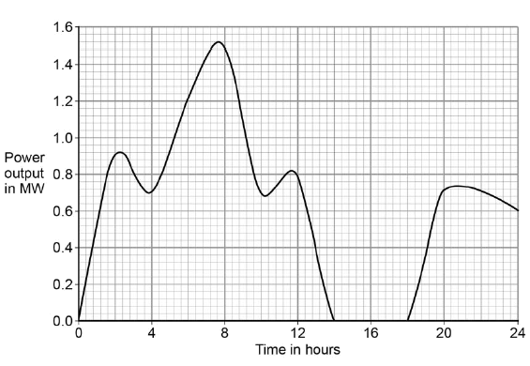
A wind turbine does not generate electricity constantly. For how many hours did the wind turbine generate no electricity?
___________________________________________________________________
Time = ________________________________ hours
(1)
(c) Electrical power is transferred from power stations to the National Grid.
What is the National Grid?

Tick one box.
a system of cables and pylons
a system of cables and transformers
a system of cables, transformers and power stations
(1)
(d) An island has a large number of wind turbines and a coal-fired power station. The island needs to use the electricity generated by the coal-fired power station at certain times.
Choose one reason why.

Tick one box.
Wind is a renewable energy resource.
Wind turbine power output is constant.
The power output of wind turbines is unpredictable.
The fuel cost for wind turbines is very high.
(1)
(e) A wind turbine has an average power output of 0.60 MW.
A coal-fired power station has a continuous power output of 1500 MW.
Calculate how many wind turbines would be needed to generate the same power output as one coal-fired power station.
___________________________________________________________________
___________________________________________________________________
Number of wind turbines = ______________________
(2)
(f) It is important that scientists develop new energy resources. Choose one reason why.

Tick one box.
All energy resources are running out.
All energy resources are used to generate electricity.
Most energy resources have negative environmental effects.
(1)
(Total 8 marks)

Q14.A student investigated the efficiency of a motor using the equipment in Figure 1.
Figure 1
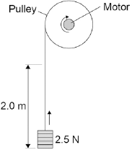
He used the motor to lift a weight of 2.5 N a height of 2.0 m.
He measured the speed at which the weight was lifted and calculated the efficiency of the energy transfer. He repeated the experiment to gain two sets of data.
(a) Give one variable that the student controlled in his investigation.
___________________________________________________________________
(1)
(b) Give two reasons for taking repeat readings in an investigation.
1. _________________________________________________________________
___________________________________________________________________
2. _________________________________________________________________
___________________________________________________________________
(2)
(c) Figure 2 shows a graph of the student’s results.
Figure 2
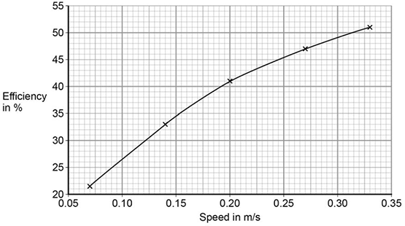
Give two conclusions that could be made from the data in Figure 2.
___________________________________________________________________
___________________________________________________________________
___________________________________________________________________
(2)
(d) Give the main way that the motor is likely to waste energy.
___________________________________________________________________
___________________________________________________________________
(1)
(e) When the total power input to the motor was 5 W the motor could not lift the 2.5 N weight. State the efficiency of the motor.
Efficiency = _______________________ %
(1)
(Total 7 marks)
Q1. A student rubs an acetate rod with a cloth. Figure 1 shows the charges on the acetate rod and cloth before and after rubbing.
Figure 1
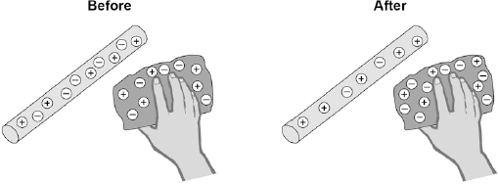
(a) Explain how rubbing an acetate rod with a cloth causes the rod and cloth to become charged.
___________________________________________________________________
___________________________________________________________________
___________________________________________________________________
___________________________________________________________________
___________________________________________________________________
___________________________________________________________________
___________________________________________________________________
(4)
(b) After charging them, the student moves the acetate rod and the cloth closer together.
Which statement is correct?

Tick one box.
There is no force between the acetate rod and the cloth.
There is a force of attraction between the acetate rod and the cloth.
There is a force of repulsion between the acetate rod and the cloth.
Give a reason for your answer.
___________________________________________________________________
___________________________________________________________________
___________________________________________________________________
(2)
(c) Figure 2 shows a Van de Graaff generator, which is used to generate static electricity.
Figure 2
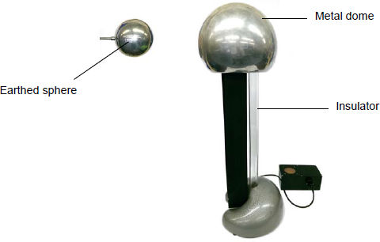
The longer the Van de Graaff generator is switched on, the more charge is stored on the metal dome. Use an answer from the box to complete the sentence.

decrease increase stay the same
The amount of charge on the metal dome is increased, which causes the potential
difference between the metal dome and the earthed sphere to ________________ .
(1)

(d) When the potential difference between the Van de Graaff generator and the earthed sphere is 60 kV, a spark jumps between the metal dome and the earthed sphere.
The spark transfers 0.000025 coulombs of charge to the earthed sphere.
The equation which links charge, energy and potential difference is:
energy transferred = charge × potential difference
Calculate the energy transferred by the spark.
___________________________________________________________________
___________________________________________________________________
___________________________________________________________________
Energy transferred = ______________________ J
(2)
(Total 9 marks)
Q2. The diagram shows the circuit used to obtain the data needed to plot the current-potential difference graph for a filament lamp.
(a) Why is component M included in the circuit? Tick one box.

To keep the current constant.
To keep the potential difference constant.
To vary the current.
(1)
(b) Why does the resistance of the lamp increase as the potential difference across the lamp increases?
___________________________________________________________________
___________________________________________________________________
___________________________________________________________________
(1)
(c) The potential difference across the lamp is 12.0 V. Calculate the energy transferred by the lamp when 8.5 C of charge flows through the lamp. Use the equation:
energy transferred = charge flow × potential difference
___________________________________________________________________
___________________________________________________________________
___________________________________________________________________
Energy transferred = ____________________ J
(2)
(d) The table gives data about two types of lamp that householders may use in their homes.

Type of lamp | Energy efficiency | Mean lifetime in hours
Halogen | 10% | 2000
LED | 90% | 36000
Both types of lamp produce the same amount of light. Describe the environmental advantages of using the LED lamp compared with the halogen lamp.
___________________________________________________________________
___________________________________________________________________
___________________________________________________________________
___________________________________________________________________
(2)
(Total 6 marks)
Q3. An electrician is replacing an old electric shower with a new one. The inside of the old shower is shown in the figure below.
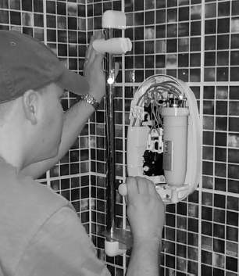
(a) The electrician should not change the shower unless he switches off the mains electricity supply. Explain why.
___________________________________________________________________
___________________________________________________________________
___________________________________________________________________
___________________________________________________________________
(2)
(b) The new shower has a power output of 10 690 W when it is connected to the 230 V mains electricity supply. The equation which links current, potential difference and power is:
current= 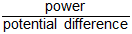
Calculate the current passing through the new shower. Give your answer to two significant figures.
___________________________________________________________________
___________________________________________________________________
___________________________________________________________________
Current = ______________________ A
(4)
(c) The new shower has a higher power rating than the old shower. How does the power of the new shower affect the cost of using the shower? Give a reason for your answer.
___________________________________________________________________
___________________________________________________________________
___________________________________________________________________
___________________________________________________________________
(2)
(Total 8 marks)
Q4. Solar cells produce electricity using light from the Sun.
The symbol for a solar cell is: 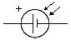
A householder has three solar cells.
Each solar cell has an output potential difference of 0.70 V

(a) Which arrangement of three solar cells will give a potential difference of 2.10 V? Tick one box.

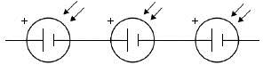
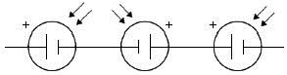
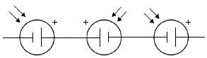
(1)
(b) A solar cell has a resistance of 2.5 Ω when the output potential difference is 0.70 V
Calculate the current through the solar cell. Use the equation:
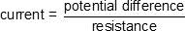
___________________________________________________________________
___________________________________________________________________
___________________________________________________________________
Current = ____________________ A
(2)
The graph below shows a graph of current against P.D.for a different type of solar cell.
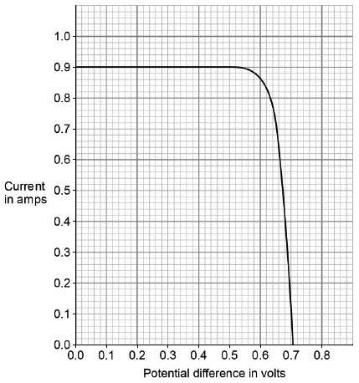

(c) The power output of the solar cell is calculated using the equation.
power = current × potential difference
Which value of potential difference on the graph above gives the maximum power output of the solar cell? Tick one box.

0.1 V |  | 0.3 V |  | 0.6 V |  | 0.7 V
Give the reason for your answer.
___________________________________________________________________
___________________________________________________________________
___________________________________________________________________
(2)
(d) Write down the equation that links efficiency, total power input and useful power output.
___________________________________________________________________
___________________________________________________________________
(1)
(e) The total power input to the solar cell is 2.4 W when the efficiency is 0.20
Calculate the useful power output of the solar cell.
___________________________________________________________________
___________________________________________________________________
___________________________________________________________________
___________________________________________________________________
Useful power output = ____________________ W
(3)
(Total 9 marks)
Q5. Many electrical appliances are connected to the mains supply using a three-core cable and a three-pin plug.
(a) Use the correct answer from the box to complete the sentence.

charge | energy | power
Electric current is the rate of flow of _______________________________ .
(1)
(b) The diagram shows a three-pin plug connected to a three-core cable.
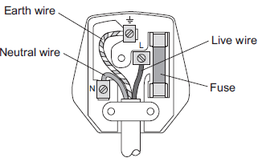
(i) The three wires of the three-core cable have different coloured coverings.
State the colour of the covering of the neutral wire.
______________________________________________________________
(1)
(ii) Which two parts of the plug shown above protect the wiring of a circuit?
Tick () two boxes.

Tick ()
Earth wire
Fuse
Live wire
Neutral wire
(2)
(c) Some electrical appliances are connected to the mains supply using a two-core cable and a three-pin plug. Appliances that are double insulated do not require all three wires.
(i) What does ‘double insulated’ mean?
______________________________________________________________
______________________________________________________________
(1)
(ii) State which of the three wires is not required.
______________________________________________________________
(1)
(d) (i) An electrical appliance is connected to a 20 V supply.
The current in the appliance is 3 A.
Calculate the power of the appliance.
______________________________________________________________
______________________________________________________________
Power = _________________________ W
(2)
(ii) Another electrical appliance is connected to a 20 V supply.The appliance transfers 300 J of energy. Calculate the charge. Give the unit.
______________________________________________________________
______________________________________________________________
Charge = _________________________
Unit _____________
(3)
(Total 11 marks)
Q6. A student finds some information about energy-saving light bulbs.
(a) A 30W light bulb uses 600J of electrical energy in a certain period of time. In that time, it produces 450 J of light energy. The rest of the energy is wasted.
(i) Calculate the energy wasted by the light bulb in this period of time.
______________________________________________________________
Wasted energy = _________________ J
(1)
(ii) What happens to the energy wasted by the light bulb?
______________________________________________________________
______________________________________________________________
(1)
(iii) Calculate the efficiency of this light bulb.
______________________________________________________________
______________________________________________________________
Efficiency = ______________________________
(2)

(iv) Calculate the period of time, in seconds, during which the 600 J is provided to the 30 W light bulb.
______________________________________________________________
______________________________________________________________
Time = _____________ s
(2)
(b) A company that makes light bulbs provides information about some of their products.
The table shows some of this information.

 | Power in watts | Lifetime in hours | Cost of bulb in £
Filament bulb | 60 | 1250 | 2.00
LED bulb | 12 | 50 000 | 16.00

(i) Suggest why it is important to confirm this information independently.
______________________________________________________________
(1)
(ii) A homeowner is thinking about replacing his filament bulbs with LED bulbs.
A 12 W LED bulb gives the same light output as a 60 W filament bulb.
Suggest reasons why the homeowner is likely to choose LED bulbs.
Use the information given in the table.
______________________________________________________________
______________________________________________________________
______________________________________________________________
______________________________________________________________
(2)
(iii) State one factor, other than efficiency, that is important when considering the choice of a bulb for lighting in the home.
______________________________________________________________
______________________________________________________________
(1)
(Total 10 marks)
Q7. Figure 1 shows a radio. The radio can be powered by connecting the two-core cable to the mains electricity supply.
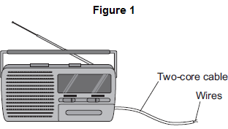
(a) (i) What must be fitted to the cable before it can be connected to the mains electricity supply?
______________________________________________________________
(1)
(ii) There are only two wires inside the cable. What are the names of the two wires inside the cable? Tick () one box.

Earth and live
Earth and neutral
Live and neutral
(1)
(iii) Use the correct answer from the box to complete the sentence.

double | extra | fully
It is safe to connect the radio to the mains electricity supply using a two-core
cable because the radio is ____________________________ insulated.
(1)
(b) The radio can also be powered by a battery. What type of current does a battery supply? Tick () one box.

Alternating current (a.c.) only
Direct current (d.c.) only
Both a.c. and d.c.
(1)
(c) Figure 2 shows a fuse and a circuit breaker. Fuses and circuit breakers are able to disconnect and switch off circuits.
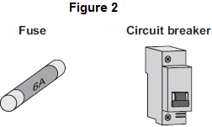
(i) Use the correct answer from the box to complete the sentence.

earth | live | neutral
A fuse or a circuit breaker is connected to the ____________________ wire in a circuit.
(1)
(ii) What happens to cause a fuse or circuit breaker to disconnect a circuit?
______________________________________________________________
______________________________________________________________
(1)
(iii) Suggest two advantages of using a circuit breaker to disconnect a circuit compared with using a fuse.
1. ____________________________________________________________
______________________________________________________________
2. ____________________________________________________________
______________________________________________________________
(2)
(Total 8 marks)
Q8.The diagram shows a temperature sensing circuit used to control a heating system in a house.
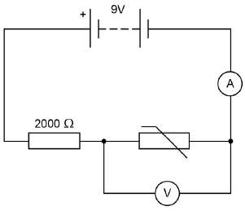
(a) What quantity does the ammeter measure?
___________________________________________________________________
(1)
(b) The current in the circuit is 3.5 mA when the potential difference across the thermistor is 4.2 V. Calculate the resistance of the thermistor.
___________________________________________________________________
___________________________________________________________________
___________________________________________________________________
Resistance = ____________________ Ω
(3)
(c) Calculate the charge that flows through the thermistor in 5 minutes when the current is 3.5 mA.
___________________________________________________________________
___________________________________________________________________
___________________________________________________________________
Charge = ____________________ C
(3)
(d) Explain why the potential difference across the thermistor changes as the temperature in the house decreases.
___________________________________________________________________
___________________________________________________________________
___________________________________________________________________
(2)
(e) The circuit shown in the diagram can be modified to turn lights on and off by replacing the thermistor with a Light Dependent Resistor (LDR). Draw the circuit symbol for an LDR in the space below.

(1)
(Total 10 marks)
Q9.Figure 1 shows the apparatus used to investigate how the current through a thermistor depends on the temperature of the thermistor.
Figure 1
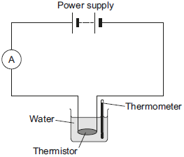
(a) Which one of the following is the correct circuit symbol for a thermistor? Tick (✔) one box.
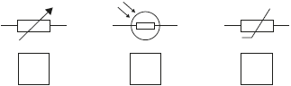
(1)
(b)To get a range of results, hot water at 60 °C was poured into the beaker.

The temperature of the water and current through the thermistor were then recorded as the water cooled. The results of the investigation are shown in Figure 2.
Figure 2
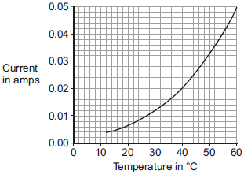
(i) Suggest one way the investigation could have been changed to give a wider range of temperatures.
______________________________________________________________
______________________________________________________________
(1)
(ii) Describe how the current through the thermistor depends on the temperature of the thermistor.
______________________________________________________________
______________________________________________________________
(1)
(iii) Use Figure 2 to determine the current through the thermistor at 40 °C.
Current at 40 °C = ___________ A
(1)
(iv) At 40 °C the thermistor has a resistance of 250 Ω.
Use your answer to part (iii) and the resistance of the thermistor to calculate the potential difference across the thermistor.
______________________________________________________________
______________________________________________________________
______________________________________________________________
______________________________________________________________
Potential difference = ___________ V
(2)
(v) The potential difference across the thermistor stays the same all through the investigation.
What conclusion can be made from the results in Figure 2 about the resistance of the thermistor as the temperature of the thermistor decreases?
Tick (✔) one box.

the resistance increases
the resistance does not change
the resistance decreases
(1)
(Total 7 marks)

Q10.The diagram shows an electrical circuit.
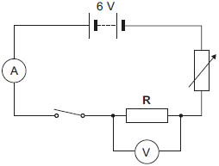
(a) The 6 V battery shown in the diagram is made up of a number of identical 1.5 V cells.
Calculate the minimum number of cells needed to make the battery.
___________________________________________________________________
Number of cells =_________________
(1)
(b) The switch in the diagram is shown in the open position. Closing the switch completes the circuit. Charge flows through the completed circuit and a reading is shown on both the ammeter and the voltmeter.
(i) In 10 seconds, 20 coulombs of charge flows through the circuit.
Calculate the current reading shown on the ammeter.
______________________________________________________________
______________________________________________________________
Current = ___________________ A
(2)
(ii) For 20 coulombs of charge to flow through the resistor R, 100 joules of work must be done.
Calculate the potential difference reading given by the voltmeter.
______________________________________________________________
______________________________________________________________
Potential difference = _______________ V
(2)
(Total 5 marks)

Q11. (a) Figure 1 shows the oscilloscope trace an alternating current (a.c.) electricity supply produces.
Figure 1
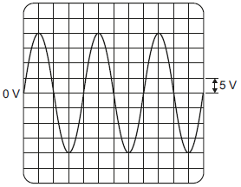
One vertical division on the oscilloscope screen represents 5 volts.
Calculate the peak potential difference of the electricity supply.
___________________________________________________________________
Peak potential difference = _________________________ V
(1)
(b) Use the correct answer from the box to complete the sentence.

40 | 50 | 60
In the UK, the frequency of the a.c. mains electricity supply is ______ hertz.
(1)
(c) Figure 2 shows how two lamps may be connected in series or in parallel to the 230 volt mains electricity supply.
Figure 2
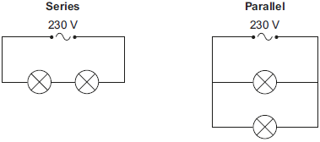
(i) Calculate the potential difference across each lamp when the lamps are connected in series. The lamps are identical.
______________________________________________________________
Potential difference when in series = ___________ V
(1)

(ii) What is the potential difference across each lamp when the lamps are connected in parallel?
Tick (✔) one box.

115 V |  | 230 V |  | 460 V
(1)
(iii) Give one advantage of connecting the lamps in parallel instead of in series.
______________________________________________________________
______________________________________________________________
(1)
(d) Figure 3 shows the light fitting used to connect a filament light bulb to the mains electricity supply.
Figure 3
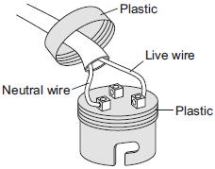
The light fitting does not have an earth wire connected.
Explain why the light fitting is safe to use.
___________________________________________________________________
___________________________________________________________________
___________________________________________________________________
___________________________________________________________________
(2)
(e) A fuse can be used to protect an electrical circuit.
Name a different device that can also be used to protect an electrical circuit.
___________________________________________________________________
(1)
(Total 8 marks)
Q12. A student set up the electrical circuit shown in the figure below.
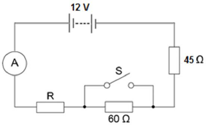
(a) The ammeter displays a reading of 0.10 A.
Calculate the potential difference across the 45 Ω resistor.
___________________________________________________________________
___________________________________________________________________
Potential difference = _______________________ V
(2)
(b) Calculate the resistance of the resistor labelled R.
___________________________________________________________________
___________________________________________________________________
___________________________________________________________________
Resistance = _______________________ Ω
(3)
(c) State what happens to the total resistance of the circuit and the current through the circuit when switch S is closed.
___________________________________________________________________
___________________________________________________________________
___________________________________________________________________
___________________________________________________________________
(2)
(Total 7 marks)

Q13. Figure 1 shows a graph of current against potential difference for a solar cell when light of intensity 450 W/m² is incident on it.
Figure 1
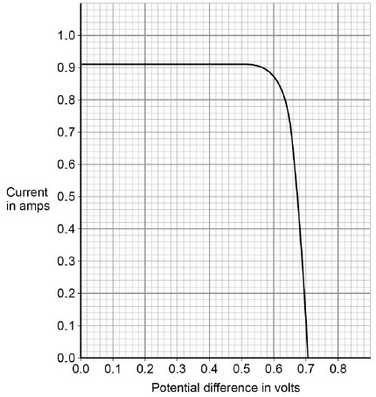
(a) Determine the power output of the solar cell when the potential difference is 0.5 V
Use data from Figure 1.
___________________________________________________________________
___________________________________________________________________
___________________________________________________________________
___________________________________________________________________
___________________________________________________________________
Power = ____________________ W
(3)
(b) Draw a sketch graph on Figure 2 to show how the power output of the solar cell varies with potential difference between 0.1 V and 0.5 V. No values need to be included on the vertical axis.

Figure 2
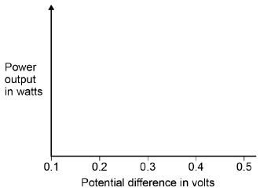
(2)
(c) The maximum power output of this solar cell is 0.52 W. When the light intensity is 450 W/m² the cell has an efficiency of 0.15 at the maximum power output. Calculate the area of the solar cell.
___________________________________________________________________
___________________________________________________________________
___________________________________________________________________
___________________________________________________________________
___________________________________________________________________
Area = ____________________ m²
(4)
(d) A householder has four solar cells. Each of the solar cells has a resistance of 0.78 Ω
Explain how the solar cells should be connected so that the total resistance is as low as possible.
___________________________________________________________________
___________________________________________________________________
___________________________________________________________________
(2)
(Total 11 marks)
Q14. A student wants to investigate how the current through a filament lamp affects its resistance.
(a) Use the circuit symbols in the boxes to draw a circuit diagram that she could use.

12 V battery | variable  resistor | filament  lamp | voltmeter | ammeter
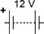

(2)
(b) Describe how the student could use her circuit to investigate how the current through a filament lamp affects its resistance.
___________________________________________________________________
___________________________________________________________________
___________________________________________________________________
___________________________________________________________________
___________________________________________________________________
___________________________________________________________________
___________________________________________________________________
___________________________________________________________________
(4)
(c) The student’s results are shown in Figure 1.
Figure 1
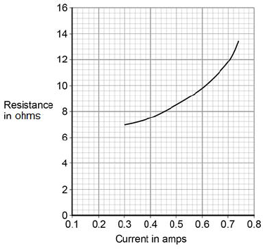
Describe how the resistance of the filament lamp changes as the current through it increases.
___________________________________________________________________
___________________________________________________________________
(1)
(d) Use Figure 1 to estimate the resistance of the filament lamp when a current of 0.10 A passes through the lamp.
Resistance = _____________________ Ω
(1)
(e) The current‑potential difference graphs of three components are shown in Figure 2.
Use answers from the box to identify each component.

diode | filament lamp | light dependent resistor
resistor at constant temperature |  | thermistor
Figure 2
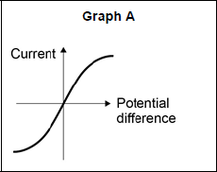 __________________________
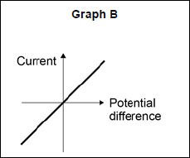 __________________________
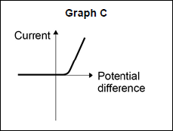 __________________________
(3)
(Total 11 marks)

Q1. A student wants to calculate the density of the two objects shown in the figure below.
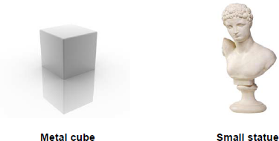
Describe the methods that the student should use to calculate the densities of the two objects.
_______________________________________________________________________
_______________________________________________________________________
_______________________________________________________________________
_______________________________________________________________________
_______________________________________________________________________
_______________________________________________________________________
_______________________________________________________________________
_______________________________________________________________________
_______________________________________________________________________
(Total 6 marks)
Q2.The figure below shows a balloon filled with helium gas.
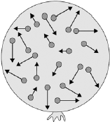
(a) Describe the movement of the particles of helium gas inside the balloon.
___________________________________________________________________
___________________________________________________________________
___________________________________________________________________
(2)

(b) What name is given to the total kinetic energy and potential energy of all the particles of helium gas in the balloon?

Tick one box.
External energy
Internal energy
Movement energy
(1)
(c) Write down the equation which links density, mass and volume.
___________________________________________________________________
(1)
(d) The helium in the balloon has a mass of 0.00254 kg. The balloon has a volume of 0.0141 m³. Calculate the density of helium. Choose the correct unit from the box.

m³ / kg kg / m³ kg m³
___________________________________________________________________
___________________________________________________________________
___________________________________________________________________
___________________________________________________________________
Density = __________________ Unit _________
(3)
(Total 7 marks)
Q3. (a) The diagrams show the arrangement of the particles in a solid and in a gas.
Each circle represents one particle.
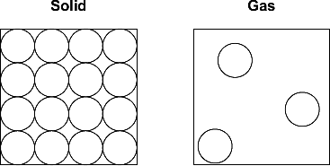
(i) Complete the diagram below to show the arrangement of the particles in a liquid.
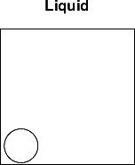
(2)
(ii) Explain, in terms of the particles, why gases are easy to compress.
______________________________________________________________
______________________________________________________________
______________________________________________________________
______________________________________________________________
(2)
(b) The diagram below shows the model that a science teacher used to show her students that there is a link between the temperature of a gas and the speed of the gas particles.
The ball-bearings represent the gas particles. Switching the motor on makes the ball-bearings move around in all directions.
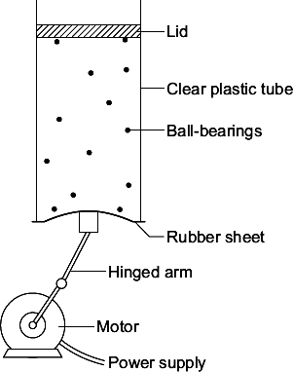
(i) How is the motion of the ball-bearings similar to the motion of the gas particles?
______________________________________________________________
______________________________________________________________
(1)
(ii) The faster the motor runs, the faster the ball-bearings move. Increasing the speed of the motor is like increasing the temperature of a gas.
Use the model to predict what happens to the speed of the gas particles when the temperature of a gas is increased.
______________________________________________________________
______________________________________________________________
(1)
(Total 6 marks)
Q4. (a) A company is developing a system which can heat up and melt ice on roads in the winter. This system is called ‘energy storage’.
During the summer, the black surface of the road will heat up in the sunshine.
This energy will be stored in a large amount of soil deep under the road surface.
Pipes will run through the soil. In winter, cold water entering the pipes will be warmed and brought to the surface to melt ice.
The system could work well because the road surface is black.
Suggest why.
___________________________________________________________________
___________________________________________________________________
(1)
(b) (i) What is meant by specific latent heat of fusion?
______________________________________________________________
______________________________________________________________
______________________________________________________________
______________________________________________________________
(2)
(ii) Calculate the amount of energy required to melt 15 kg of ice at 0 °C.
Specific latent heat of fusion of ice = 3.4 × 10⁵ J/kg.
______________________________________________________________
______________________________________________________________
Energy = ___________________ J
(2)

(c) Another way to keep roads clear of ice is to spread salt on them.
When salt is added to ice, the melting point of the ice changes.
A student investigated how the melting point of ice varies with the mass of salt added.
The figure below shows the equipment that she used.
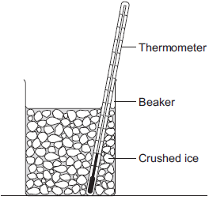
The student added salt to crushed ice and measured the temperature at which the ice melted.
(i) State one variable that the student should have controlled.
______________________________________________________________
______________________________________________________________
(1)
(ii) During the investigation the student stirred the crushed ice.
Suggest two reasons why.
Tick () two boxes.

Tick ()
To raise the melting point of the ice
To lower the melting point of the ice
To distribute the salt throughout the ice
To keep all the ice at the same temperature
To reduce energy transfer from the surroundings to the ice
(2)

(iii) The table below shows the data that the student obtained.

Mass of salt added in grams | 0 | 10 | 20
Melting point of ice in °C | 0 | -6 | -16
Describe the pattern shown in the table.
______________________________________________________________
______________________________________________________________
(1)
(d) Undersoil electrical heating systems are used in greenhouses. This system could also be used under a road.
A cable just below the ground carries an electric current. One greenhouse system has a power output of 0.50 kW.
Calculate the energy transferred in 2 minutes.
___________________________________________________________________
___________________________________________________________________
___________________________________________________________________
Energy transferred = ___________________ J
(3)
(e) In this question you will be assessed on using good English, organising information clearly and using specialist terms where appropriate.
A local council wants to keep a particular section of a road clear of ice in the winter.
Describe the advantages and disadvantages of keeping the road clear of ice using:
• energy storage
• salt
• undersoil electrical heating.
___________________________________________________________________
___________________________________________________________________
___________________________________________________________________
___________________________________________________________________
___________________________________________________________________
___________________________________________________________________
___________________________________________________________________
___________________________________________________________________
___________________________________________________________________
___________________________________________________________________
___________________________________________________________________
___________________________________________________________________
Extra space _________________________________________________________
___________________________________________________________________
___________________________________________________________________
___________________________________________________________________
___________________________________________________________________
___________________________________________________________________
___________________________________________________________________
(6)
(Total 18 marks)
Q5. A student investigated the cooling effect of evaporation.
She used the equipment in Figure 1 to measure how the temperature of three different liquids changed as the liquids evaporated.
Figure 1
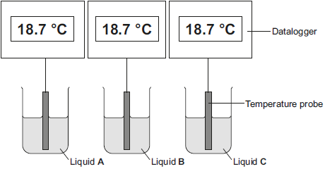
(a) The temperature and volume of each liquid was the same at the start of the investigation. State one further control variable in this investigation.
___________________________________________________________________
___________________________________________________________________
(1)
(b) Give two advantages of using dataloggers and temperature probes compared to using the thermometer shown in Figure 2.
Figure 2
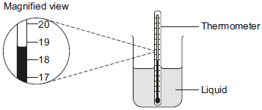
1. _________________________________________________________________
___________________________________________________________________
2. _________________________________________________________________
___________________________________________________________________
(2)
(c) The student’s results are shown in Figure 3.
Figure 3
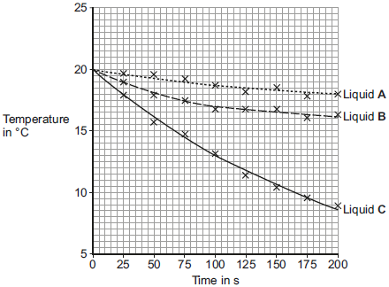
(i) Calculate the average rate of temperature decrease of liquid C between 0 and 100 seconds.
______________________________________________________________
______________________________________________________________
Average rate of temperature decrease = __________ °C / s
(2)
(ii) Give one conclusion that can be made about the rate of temperature decrease of all three liquids from the results in Figure 3.
______________________________________________________________
______________________________________________________________
(1)
(iii) Which liquid had the lowest rate of evaporation? Give a reason for your answer.
Liquid ________________________________________________________
Reason _______________________________________________________
______________________________________________________________
(1)
(iv) A second student did the same investigation but using a smaller volume of liquid than the first student. All other variables were kept the same.
What effect would this have on the results of the second student’s investigation?
______________________________________________________________
______________________________________________________________
(1)
(d) Explain how the evaporation of a liquid causes the temperature of the remaining liquid to decrease.
___________________________________________________________________
___________________________________________________________________
___________________________________________________________________
___________________________________________________________________
___________________________________________________________________
___________________________________________________________________
(3)
(Total 11 marks)
Q6. The diagram shows a metal pan being used to heat water.
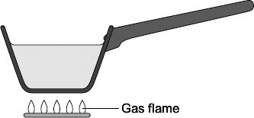
Energy from the gas flame is transferred through the metal pan by conduction. Explain the process of conduction through metals.
_______________________________________________________________________
_______________________________________________________________________
_______________________________________________________________________
_______________________________________________________________________
_______________________________________________________________________
_______________________________________________________________________
(Total 4 marks)
Q7. Two students investigated the change of state of stearic acid from liquid to solid.
They measured how the temperature of stearic acid changed over 5 minutes as it changed from liquid to solid.
Figure 1 shows the different apparatus the two students used.
Figure 1
Student A’s apparatus Student B’s apparatus
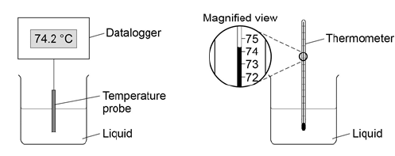

(a) Choose two advantages of using student A’s apparatus.

Tick two boxes.
Student A’s apparatus made sure the test was fair.
Student B’s apparatus only measured categoric variables.
Student A’s measurements had a higher resolution.
Student B was more likely to misread the temperature.
(2)
(b) Student B removed the thermometer from the liquid each time he took a temperature reading. What type of error would this cause?

Tick one box.
A systematic error
A random error
A zero error
(1)
(c) Student A’s results are shown in Figure 2.
Figure 2
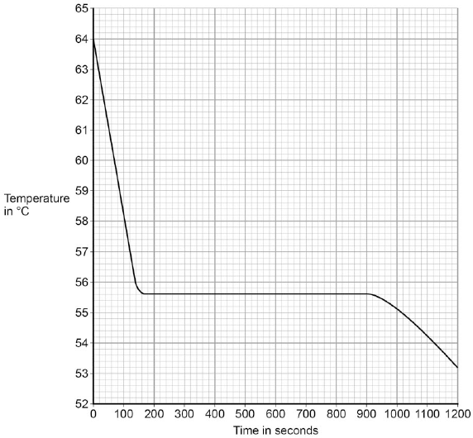
What was the decrease in temperature between 0 and 160 seconds?

Tick one box.
8.2 °C
8.4 °C
53.2 °C
55.6 °C
(1)

(d) Use Figure 2 to determine the time taken for the stearic acid to change from a liquid to a solid.
Time = ____________ seconds
(1)
(e) Calculate the energy transferred to the surroundings as 0.40 kg of stearic acid changed state from liquid to solid.
The specific latent heat of fusion of stearic acid is 199 000 J / kg.
Use the correct equation from the Physics Equations Sheet.
___________________________________________________________________
___________________________________________________________________
___________________________________________________________________
Energy = _____________________ J
(2)
(f) After 1200 seconds the temperature of the stearic acid continued to decrease. Explain why.
___________________________________________________________________
___________________________________________________________________
___________________________________________________________________
(2)
(Total 9 marks)
Q8. (a) The diagram shows a ski jacket that has been designed to keep a skier warm.
The jacket is made from layers of different materials.
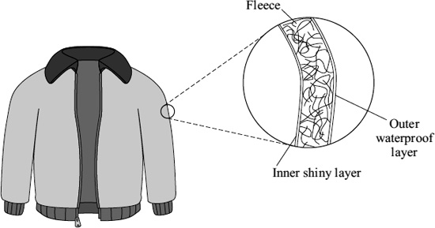
(i) The inner layer is shiny to reduce heat transfer. Which process of heat transfer will it reduce?
______________________________________________________________
(1)
(ii) Why is the layer of fleece good at reducing the transfer of heat from a skier’s body?
______________________________________________________________
______________________________________________________________
(1)
(b) A student tested four different types of fleece, J, K, L and M, to find which would make the warmest jacket. Each type of fleece was wrapped around a can which was then filled with hot water. The temperature of the water was taken every two minutes for 20 minutes.
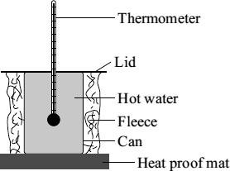
The graph shows the student’s results.
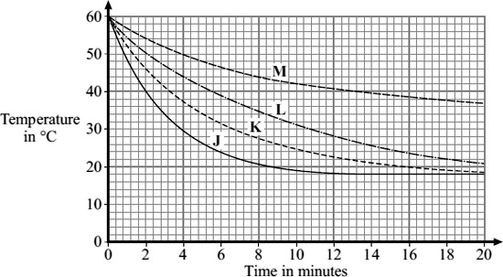
(i) In each test, the water cooled faster during the first five minutes than during the last five minutes. Why?
______________________________________________________________
______________________________________________________________
(1)
(ii) To be able to compare the results, it was important to use the same volume of water in each test. Give one other quantity that was the same in each test.
______________________________________________________________
______________________________________________________________
(1)
(iii) Look at the graph line for fleece K. Estimate what the temperature of the water in the can wrapped in fleece K would be after 40 minutes.
______________________________________________________________
(1)
(iv) Which type of fleece, J, K, L or M, should the student recommend to be used in the ski jacket?
______________________________________________________________
Give a reason for your answer.
______________________________________________________________
______________________________________________________________
______________________________________________________________
(2)
(Total 7 marks)
Q9. (a)The diagrams, X, Y and Z, show how the particles are arranged in the three states of matter.
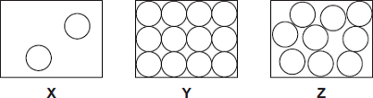
(i) Which one of the diagrams, X, Y or Z, shows the arrangement of particles in a liquid?
Write the correct answer in the box.
(1)
(ii) Which one of the diagrams, X, Y or Z, shows the arrangement of particles in a gas?
Write the correct answer in the box.
(1)
(b) Draw a ring around the correct answer in each box to complete each sentence.

 |  | vibrating in fixed positions.
(i) | In a gas, the particles are | moving randomly.
 |  | not moving.
(1)

 |  | stronger than
(ii) | In a solid, the forces between the particles are | equal to | the
 |  | weaker than
forces between the particles in a liquid.
(1)
(c) The picture shows a puddle of water in a road, after a rain shower.
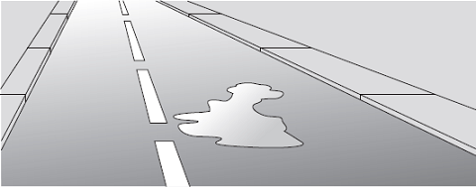
(i) During the day, the puddle of water dries up and disappears. This happens because the water particles move from the puddle into the air. What process causes water particles to move from the puddle into the air? Draw a ring around the correct answer.

condensation | evaporation | radiation
(1)
(ii) Describe one change in the weather which would cause the puddle of water to dry up faster.
______________________________________________________________
______________________________________________________________
(1)
(Total 6 marks)
Q10. A student investigated the cooling effect of evaporation. She used the equipment (datalogger and probe) shown in Figure 1 to measure how the temperature of a liquid changed as the liquid evaporated.
Figure 1
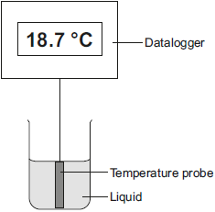
(a) Which type of variable was the temperature in this investigation?
Tick (✔) one box.

Tick (✔)
control
dependent
independent
(1)
(b) Before the investigation started, the student checked the accuracy of three different temperature probes. The student put the probes in a beaker of boiling water that had a temperature of 100.0 °C.
The readings from the three temperature probes are shown in Figure 2.
Figure 2
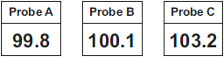
Which one of the temperature probes, A, B or C, was least accurate?
Write the correct answer in the box.
Give a reason for your answer.
___________________________________________________________________
___________________________________________________________________
(2)
(c) Figure 3 shows how the temperature recorded changed during the investigation.
Figure 3
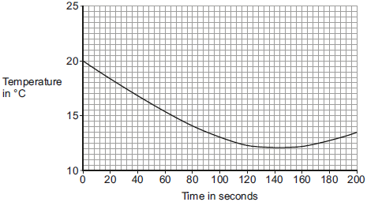
(i) Use Figure 3 to determine the lowest temperature recorded as the liquid evaporated.
Temperature = ______ °C
(1)
(ii) Use Figure 3 to determine how long it took for all the liquid to evaporate.
Give a reason for your answer.
Time = ________ seconds
Reason: __________________________________________________
______________________________________________________________
(2)
(iii) How would increasing the starting temperature of the liquid above 20 °C affect the rate of evaporation of the liquid?
______________________________________________________________
______________________________________________________________
(1)
(Total 7 marks)
Q11.A student investigated how the pressure of a gas varied with the volume of the gas.
The mass and temperature of the gas were constant.
Figure 1 shows the equipment the student used.
Figure 1
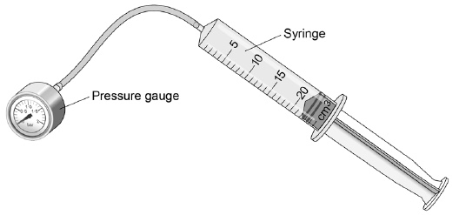
(a) What is the resolution of the syringe?
____________________ cm³
(1)
The student compressed the gas in the syringe and read the pressure from the pressure gauge.
Figure 2 shows the student's results.
Figure 2
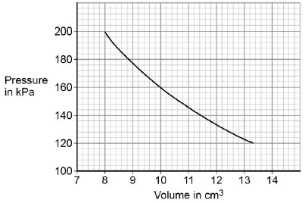
(b) What conclusion can the student make from the data in Figure 2? Use data from Figure 2 in your answer. Give the reason for your answer.
___________________________________________________________________
___________________________________________________________________
___________________________________________________________________
___________________________________________________________________
___________________________________________________________________
___________________________________________________________________
(3)
(c) Explain why the pressure in the gas increases as the gas is compressed.
___________________________________________________________________
___________________________________________________________________
___________________________________________________________________
___________________________________________________________________
___________________________________________________________________
___________________________________________________________________
___________________________________________________________________
___________________________________________________________________
___________________________________________________________________
(4)
(Total 8 marks)
Q12. Solid, liquid and gas are three different states of matter.
(a) Describe the difference between the solid and gas states, in terms of the arrangement and movement of their particles.
___________________________________________________________________
___________________________________________________________________
___________________________________________________________________
___________________________________________________________________
___________________________________________________________________
___________________________________________________________________
___________________________________________________________________
___________________________________________________________________
___________________________________________________________________
___________________________________________________________________
___________________________________________________________________
(4)
(b) What is meant by ‘specific latent heat of vaporisation’?
___________________________________________________________________
___________________________________________________________________
___________________________________________________________________
___________________________________________________________________
(2)
(c) While a kettle boils, 0.018 kg of water changes to steam.
Calculate the amount of energy required for this change.
Specific latent heat of vaporisation of water = 2.3 × 10⁶ J / kg.
___________________________________________________________________
___________________________________________________________________
___________________________________________________________________
Energy required = __________________ J
(2)

(d) The graph shows how temperature varies with time for a substance as it is heated. The graph is not drawn to scale.
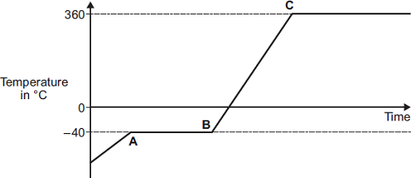
Explain what is happening to the substance in sections AB and BC of the graph.
Section AB _________________________________________________________
___________________________________________________________________
___________________________________________________________________
___________________________________________________________________
Section BC _________________________________________________________
___________________________________________________________________
___________________________________________________________________
___________________________________________________________________
(4)
(Total 12 marks)
Q1. Sources of background radiation are either natural or man-made.
(a) Which two of the sources listed in the table are natural sources of background radiation? Tick two boxes.

Cosmic rays
Medical X-rays
Nuclear power stations
Nuclear weapons testing
Radon gas
(2)
A teacher used a Geiger-Müller (GM) tube and counter to measure the background radiation in his laboratory. Figure 1 shows the GM tube and counter.
Figure 1
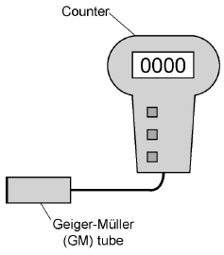
(b) The table gives three readings taken by the teacher at three different times on the same day.

Counts in 1 minute
16
21
18
What is the most likely reason for the readings being different? Tick one box.

Radioactive decay is a random process.
The air pressure in the laboratory increased.
The background radiation increased during the day.
The temperature in the laboratory decreased.
(1)
(c) The teacher takes a radioactive source from a storage box. Figure 2 shows the box.
Figure 2
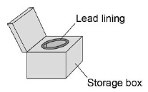
Why does storing the radioactive source in the box reduce the risk of radiation exposure to the teacher?
Tick one box.

The lead lining absorbs the emitted radiation.
The lead lining reflects the emitted radiation.
The lead lining transmits the emitted radiation.
(1)
(d) Figure 3 shows how the teacher used the GM tube and counter to measure the radiation emitted from the radioactive source. The counter was reset to zero.
The count after one minute was 159.
Figure 3
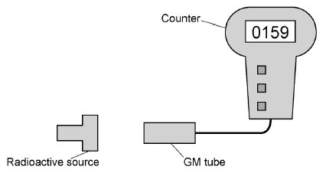
How should the teacher calculate the counts from the radioactive source? Tick one box.

Add the background count to 159
Divide the background count by 159
Multiply the background count by 159
Subtract the background count from 159
(1)
(e) The teacher passed the radiation through an electric field.
Figure 4 shows the path that the radiation took through the electric field.
Figure 4
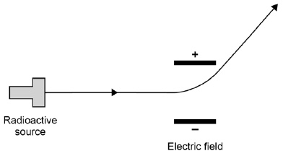
What type of radiation was being emitted by the radioactive source?
Tick one box.

Alpha |  | Beta |  | Gamma |  | Neutron
Explain the reason for your answer.
___________________________________________________________________
___________________________________________________________________
___________________________________________________________________
___________________________________________________________________
___________________________________________________________________
(3)
(Total 8 marks)
Q2. The diagram shows a lithium atom.
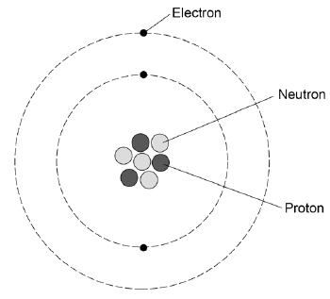
(a) What is the mass number of this lithium atom? Tick one box.

3 |  | 4 |  | 7 |  | 10
(1)
(b) What is the atomic number of a lithium atom? Tick one box.

3 |  | 4 |  | 7 |  | 10
Give a reason for your answer.
___________________________________________________________________
___________________________________________________________________
(2)
(c) Complete the sentence. Choose the answer from the box.

circles | levels | rings
The electrons in an atom orbit in different energy ____________________ .
(1)
(d) Some atomic nuclei are unstable and decay by emitting an alpha particle or a beta particle. Complete the symbols for an alpha particle and a beta particle.
Use answers from the box.

–1 | 0 | 1 | 2 | 4
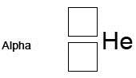
(3)
(e) Doctors may use nuclear radiation to diagnose certain types of illness. The table below gives data about three radiation sources used. Each source emits beta radiation.

Radiation source | Half-life in minutes
Carbon-11 | 20
Nitrogen-13 | 10
Oxygen-15 | 2
Explain why oxygen-15 is likely to pose the least risk to a patient.
___________________________________________________________________
___________________________________________________________________
___________________________________________________________________
___________________________________________________________________
(2)
(Total 9 marks)

Q3.Nuclear fission and nuclear fusion are two processes that release energy.
(a) The following nuclear equation represents the fission of uranium-235 (U-235).
Chemical symbols:
• Ba = barium
• Kr = krypton
• = neutron
Describe the process of nuclear fission.
Use the information in the equation.
___________________________________________________________________
___________________________________________________________________
___________________________________________________________________
___________________________________________________________________
___________________________________________________________________
___________________________________________________________________
___________________________________________________________________
___________________________________________________________________
(4)
(b) Explain what happens in the process of nuclear fusion.
___________________________________________________________________
___________________________________________________________________
___________________________________________________________________
___________________________________________________________________
___________________________________________________________________
___________________________________________________________________
(3)

(c) Fission reactors are used in nuclear power stations.
Engineers are developing fusion reactors for use in power stations.
Fusion uses isotopes of hydrogen called deuterium and tritium.
• Deuterium is naturally occurring and can be easily extracted from seawater.
• Tritium can be produced from lithium. Lithium is also found in seawater.
The table shows the energy released from 1 kg of fusion fuel and from 1 kg of fission fuel.

Type of fuel | Energy released from 1 kg of fuel in joules
Fusion | 3.4 × 10¹⁴
Fission | 8.8 × 10¹³
Suggest two advantages of the fuel used in a fusion reactor compared with the fuel used in a fission reactor.
1. _________________________________________________________________
___________________________________________________________________
___________________________________________________________________
2. _________________________________________________________________
___________________________________________________________________
___________________________________________________________________
(2)
(Total 9 marks)
Q4. In the early 20th century, scientists developed an alpha particle scattering experiment using gold foil.
The diagram shows the paths of some of the alpha particles in the alpha particle scattering experiment.
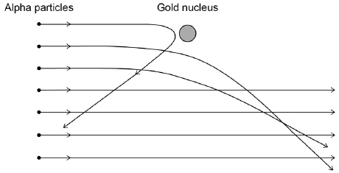
(a) Explain how the paths of the alpha particles were used to develop the nuclear model of the atom.
___________________________________________________________________
___________________________________________________________________
___________________________________________________________________
___________________________________________________________________
___________________________________________________________________
___________________________________________________________________
___________________________________________________________________
___________________________________________________________________
(4)
(b) Niels Bohr adapted the nuclear model by suggesting electrons orbited the nucleus at specific distances.
Explain how the distance at which an electron orbits the nucleus may be changed.
___________________________________________________________________
___________________________________________________________________
___________________________________________________________________
___________________________________________________________________
___________________________________________________________________
(3)
(Total 7 marks)
Q5. Many countries use nuclear power stations to generate electricity.
Nuclear power stations use the process of nuclear fission to release energy.
(a) (i) What is nuclear fission?
______________________________________________________________
______________________________________________________________
(1)
(ii) Plutonium-239 is one substance used as a fuel in a nuclear reactor. For nuclear fission to happen, the nucleus must absorb a particle.
What type of particle must be absorbed?
______________________________________________________________
(1)
(b) Nuclear fusion also releases energy. Nuclear fusion happens at very high temperatures. A high temperature is needed to overcome the repulsion force between the nuclei.
(i) Why is there a repulsion force between the nuclei of atoms?
______________________________________________________________
______________________________________________________________
(1)
(ii) Where does nuclear fusion happen naturally?
______________________________________________________________
(1)
(c) In 1991, scientists produced the first controlled release of energy from an experimental nuclear fusion reactor. This was achieved by fusing the hydrogen isotopes, deuterium and tritium. Deuterium is naturally occurring and can easily be extracted from seawater. Tritium can be produced from lithium. Lithium is also found in seawater.
The table gives the energy released from 1 kg of fusion fuel and from 1 kg of fission fuel.

Type of fuel | Energy released from  1 kg of fuel in joules
Fusion fuel | 3.4 × 10¹⁴
Fission fuel | 8.8 × 10¹³
(i) Suggest two advantages of the fuel used in a fusion reactor compared with plutonium and the other substances used as fuel in a fission reactor.
1. ____________________________________________________________
______________________________________________________________
2. ____________________________________________________________
______________________________________________________________
(2)
(ii) Some scientists think that by the year 2050 a nuclear fusion power station capable of generating electricity on a large scale will have been developed. Suggest one important consequence of developing nuclear fusion power stations to generate electricity.
______________________________________________________________
______________________________________________________________
______________________________________________________________
(1)
(d) Tritium is radioactive. After 36 years, only 10 g of tritium remains from an original sample of 80 g. Calculate the half-life of tritium.
Show clearly how you work out your answer.
___________________________________________________________________
___________________________________________________________________
Half-life = __________________ years
(2)
Q6. (a) Uranium-234 (²³⁴U) is a radioactive element. The graph shows the number of protons and neutrons in the nuclei of the elements formed when uranium-234 decays.
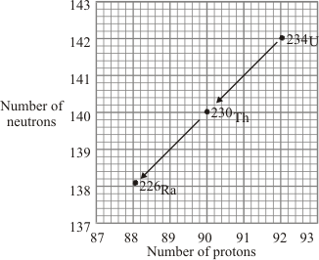
(i) How does the graph show that uranium-234 (²³⁴U) and thorium-230 (²³⁰Th) emit alpha particles?
______________________________________________________________
(1)
(ii) What makes uranium and thorium different elements?
______________________________________________________________
(1)
(iii) Radioactive decay may also produce gamma radiation.
Why does the emission of gamma radiation not cause a new element to be formed?
______________________________________________________________
______________________________________________________________
(1)

b) The graph shows how the thickness of different materials needed to absorb 90% of the gamma radiation emitted by a source depends on the energy of the radiation. The energy of the gamma radiation is given in units called electron-volts.
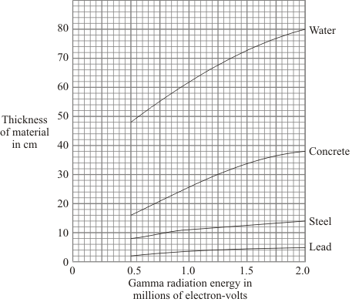
(i) Which of the materials shown is least effective at absorbing gamma radiation?
Use the information in the graph to give a reason for your answer.
______________________________________________________________
______________________________________________________________
(1)
(ii) For gamma radiation of energy 1.5 million electron-volts, how many times more effective is steel than water at absorbing the radiation? Show clearly how you obtain your answer.
______________________________________________________________
______________________________________________________________
______________________________________________________________
(2)

(c) Scientists in the early twentieth century thought that atoms were made up of electrons scattered inside a ball of positive charge. This was called the ‘plum-pudding’ model of the atom.
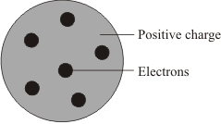
Plum pudding model
Rutherford and Marsden did an experiment, in which a beam of alpha particles was aimed at a thin sheet of gold.
Explain how the results of this experiment led to a new model of the atom.
You may include one or more diagrams in your answer.

___________________________________________________________________
___________________________________________________________________
___________________________________________________________________
___________________________________________________________________
___________________________________________________________________
___________________________________________________________________
(3)
(Total 9 marks)

Q7. In 2011 an earthquake caused severe damage to a nuclear power station in Japan.
The damage led to the release of large amounts of radioactive iodine-131 into the atmosphere.
(a) The table gives some information about an atom of iodine-131 .
Complete the table.

mass number | 131
number of protons | 53
number of neutrons
(1)
(b) Complete the sentence.
The number of protons in an atom is called the proton number or
the _______________ number.
(1)
(c) An atom of iodine-131 decays into an atom of xenon (Xe) by emitting a beta particle.
(i) The decay of iodine-131 can be represented by the equation below.
Complete the equation by writing the correct number in each of the two boxes.
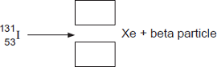
(2)
(ii) A sample of rainwater contaminated with iodine-131 gives a count rate of 1200 counts per second.
Calculate how many days it will take for the count rate from the sample of rainwater to fall to 75 counts per second.
Half-life of iodine-131 = 8 days
Show clearly how you work out your answer.
______________________________________________________________
_______________ days
(2)

(iii) If people drink water contaminated with iodine-131, the iodine-131 builds up in the thyroid gland. This continues until the thyroid is saturated with iodine-131 and cannot absorb any more. The radiation emitted from the iodine-131 could cause cancer of the thyroid. In Japan, people likely to be drinking water contaminated with iodine-131 were advised to take tablets containing a non-radioactive isotope of iodine.
Suggest why this advice was given.
______________________________________________________________
______________________________________________________________
______________________________________________________________
(2)
(Total 8 marks)
Q8. Different radioactive isotopes have different values of half-life.
(a) What is meant by the ‘half-life’ of a radioactive isotope?
___________________________________________________________________
___________________________________________________________________
___________________________________________________________________
(1)
(b) Figure 1 shows how the count rate from a sample of a radioactive isotope varies with time.
Figure 1
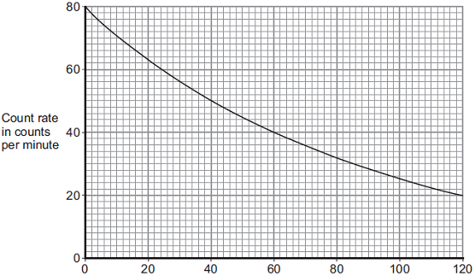
Time in days
Use information from Figure 1 to calculate the half-life of the radioactive isotope.
Show clearly on Figure 1 how you obtain your answer.
Half-life = ___________________ days
(2)
(c) The table below shows data for some radioactive isotopes that are used in schools.

Radioactive  isotope | Type of radiation  emitted | Half-life in  years
Americium-241 | Alpha and gamma | 460
Cobalt-60 | Gamma | 5
Radium-226 | Alpha, beta and gamma | 1600
Strontium-90 | Beta | 28
Thorium-232 | Alpha and beta | 1.4 x 10¹⁰
(i) State which radioactive isotope in the table above emits only radiation that is not deflected by a magnetic field. Give a reason for your choice.
______________________________________________________________
______________________________________________________________
______________________________________________________________
______________________________________________________________
(2)
(ii) Figure 2 shows a radioactive isotope being used to monitor the thickness of paper during production.
Figure 2
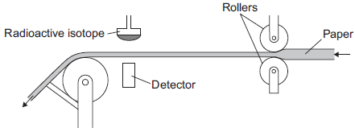
State which radioactive isotope in the table should be used to monitor the thickness of the paper. Explain your choice.
______________________________________________________________
______________________________________________________________
______________________________________________________________
______________________________________________________________
______________________________________________________________
(3)
All the radioactive isotopes in the table have practical uses. State which source in the table would need replacing most often.
Explain your choice.
______________________________________________________________
______________________________________________________________
______________________________________________________________
______________________________________________________________
______________________________________________________________
(3)
(iii) When the radioactive isotopes are not in use, they are stored in lead-lined wooden boxes. The boxes reduce the level of radiation that reaches the surroundings.
Figure 3 shows two of these boxes.
Figure 3
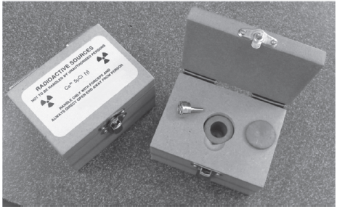
State one source from the table which emits radiation that could penetrate the box.
Explain your answer.
______________________________________________________________
______________________________________________________________
______________________________________________________________
______________________________________________________________
______________________________________________________________
______________________________________________________________
(3)
(Total 14 marks)
Q9. Electricity is generated in a nuclear power station.
Fission is the process by which energy is released in the nuclear reactor.
(a) Figure 1 shows the first part of the nuclear fission reaction.
Complete Figure 1 to show how the fission process starts a chain reaction.
Figure 1
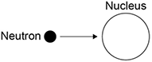
(3)
(b) Figure 2 shows the inside of a nuclear reactor in a nuclear power station.
Figure 2
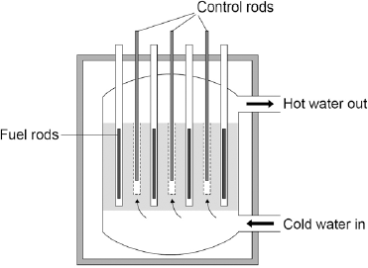
In a nuclear reactor a chain reaction occurs, which causes neutrons to be released.
The control rods absorb neutrons.
The control rods can be moved up and down.
Explain how the energy released by the chain reaction is affected by moving the control rods.
___________________________________________________________________
___________________________________________________________________
___________________________________________________________________
___________________________________________________________________
(2)

(c) Figure 3 shows how the power output of the nuclear reactor would change if the control rods were removed.
Figure 3
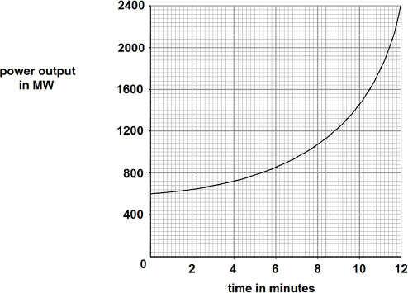
Calculate the rate of increase of power output at 10 minutes.
___________________________________________________________________
___________________________________________________________________
___________________________________________________________________
___________________________________________________________________
Rate of increase of power output = _________ MW / minute
(2)
(Total 7 marks)
Q10. The equation below shows the process by which two atomic nuclei join to form a different nucleus.
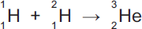

- Tick () one box.

Inside the Earth
Inside a nuclear power station
Inside the Sun
(1)
(b) Use the correct answer from the box to complete the sentence.

fission | force | fusion
The process of joining two atomic nuclei to form a different nucleus is called
nuclear _________________________ .
(1)
(c) What is released during this process?
Draw a ring around the correct answer.

charge | energy | force
(1)
(Total 3 marks)
Q11. Atoms are different sizes.
One of the heaviest naturally occurring stable elements is lead.
Two of its isotopes are lead-206 (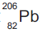) and lead-208 (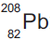).
(a) (i) What is meant by ‘isotopes’?
______________________________________________________________
______________________________________________________________
______________________________________________________________
______________________________________________________________
(2)
(ii) How many protons are in the nucleus of a atom?
__________________
(1)
(iii) How many neutrons are in the nucleus of a atom?
__________________
(1)

(b) A nucleus can be accelerated in a particle accelerator and directed at a large nucleus. This produces a heavy nucleus that will decay after a short time.
This is shown in Figure 1.
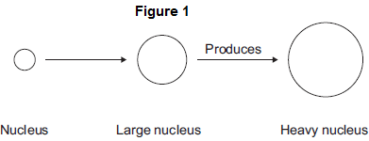
(i) In 1984, nuclei of iron (Fe) were directed at nuclei of lead (Pb). This produced nuclei of hassium (Hs). Complete the equation for this reaction by writing numbers in the empty boxes.
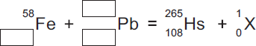
(3)
(ii) Use the correct answer from the box to complete the sentence.

an electron | a proton | a neutron
The particle X in part (b)(i) is _________________________________ .
(1)
(iii) After acceleration the iron nuclei travel at a steady speed of one-tenth of the speed of light. The speed of light is 3.00 × 10⁸ m/s. Calculate the time taken for the iron nuclei to travel a distance of 12 000 m.
______________________________________________________________
______________________________________________________________
Time taken = ____________________ s
(2)
(iv) Linear accelerators, in which particles are accelerated in a straight line, are not used for these experiments. Circular particle accelerators are used. Suggest why.
______________________________________________________________
______________________________________________________________
______________________________________________________________
______________________________________________________________
______________________________________________________________
______________________________________________________________
(3)
(c) Hassium-265 (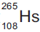) decays by alpha emission with a half-life of 0.002 seconds.
(i) What is meant by ‘half-life’?
Tick () two boxes.

Tick ()
The average time for the number of nuclei to halve
The time for count rate to be equal to background count
The time for background count to halve
The time for count rate to halve
(2)
(ii) Complete the equation for the decay of Hs-265 by writing numbers in the empty boxes.
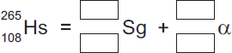
(2)
(d) The table below shows how the atomic radius of some atoms varies with atomic number.

Atomic  number | Atomic radius in  picometres (pm)
15 | 100
35 | 115
50 | 130
70 | 150
95 | 170
1 pm = 10^{–12} m
(i) On Figure 2, use the data from the table above to plot a graph of atomic radius against atomic number and draw a line of best fit. Two points have been plotted for you.
Figure 2
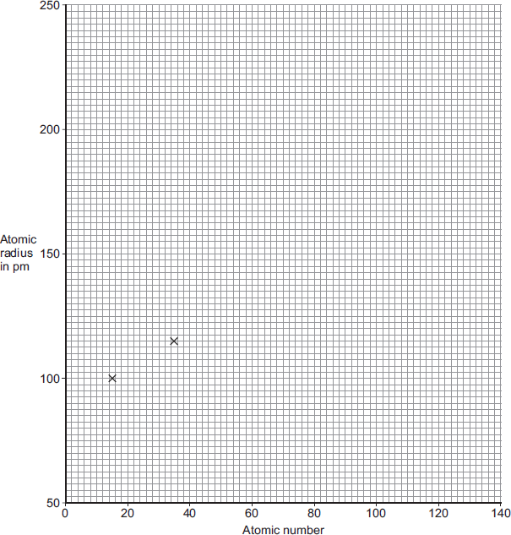
(2)
(ii) Scientists believe that the element with atomic number 126 can be produced and that it will be stable. Use your graph in Figure 2 to predict the atomic radius of an atom with atomic number 126.
Atomic radius = ____________________ pm
(1)
(Total 20 marks)
Q12.A student models the random nature of radioactive decay using 100 dice. He rolls the dice and removes any that land with the number 6 facing upwards. He rolls the remaining dice again.The student repeats this process a number of times.The table below shows his results.

Roll number | Number of dice remaining
0 | 100
1 | 84
2 | 70
3 | 59
4 | 46
5 | 40
6 | 32
7 | 27
8 | 23
(a) Give two reasons why this is a good model for the random nature of radioactive decay.
1. _________________________________________________________________
___________________________________________________________________
2. _________________________________________________________________
___________________________________________________________________
(2)
(b) The student’s results are shown in Figure 1.
Figure 1
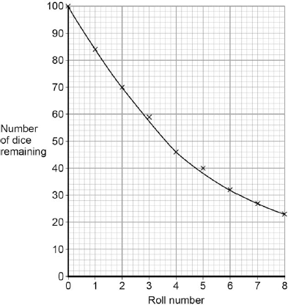
Use Figure 1 to determine the half-life for these dice using this model. Show on Figure 1 how you work out your answer.
Half-life = ________________________ rolls
(2)
(c) A teacher uses a protactinium (Pa) generator to produce a sample of radioactive material that has a half-life of 70 seconds. In the first stage in the protactinium generator, uranium (U) decays into thorium (Th) and alpha (α) radiation is emitted.
The decay can be represented by the equation shown in Figure 2.
Figure 2
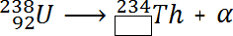
Determine the atomic number of thorium (Th) 234.
Atomic number = ______________________
(1)
(d) When protactinium decays, a new element is formed and radiation is emitted.
The decay can be represented by the equation shown in Figure 3.
Figure 3
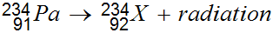
When protactinium decays, a new element, X, is formed.
Use information from Figure 2 and Figure 3 to determine the name of element X.
___________________________________________________________________
(1)
(e) Determine the type of radiation emitted as protactinium decays into a new element.
Give a reason for your answer.
___________________________________________________________________
___________________________________________________________________
___________________________________________________________________
___________________________________________________________________
(2)
(f) The teacher wears polythene gloves as a safety precaution when handling radioactive materials.
The polythene gloves do not stop the teacher’s hands from being irradiated.
Explain why the teacher wears polythene gloves.
___________________________________________________________________
___________________________________________________________________
___________________________________________________________________
___________________________________________________________________
(2)
(Total 10 marks)

Mark schemes
Q1.
(a) to vary the current.
1
(b) the temperature of the filament increases
allow the filament heats up
1
(c) E = 12 × 8.5
1
E = 102 (J)
an answer of 102 (J) scores 2 marks
1
(d) (LED lamp)
longer lifetime (per lamp)
1
wastes less energy
or
lower input energy (for same light energy output)
1
[6]
Q2.
(a) gravitational potential
1
kinetic
1
chemical
1
(b) flying drones may damage aircraft
or
falling drones may injure people
or
damage buildings / vehicles
allow any sensible suggestion of a hazard caused by a flying / falling drone
1
(c) energy transferred = power × time
allow E = Pt
1
(d) t = 25 × 60 = 1500 (s)
1
E = 65 × 1500
1
E = 97 500 (J)
an answer of 97 500 (J) scores 3 marks
allow 2 marks for an answer of 1625 (J)
1
[8]
Q3.
(a) potential
1
(b) (i) 13 200
allow 1 mark for correct substitution, ie 660 × 20 provided no subsequent step shown
2
(ii) 16.5
allow 1 mark for correct
or
correctly calculated
substitution, ie or
provided no subsequent step shown
2
[5]
Q4.
(a) apparatus diagram to show:
• aluminium block (surrounded by insulation)
1
• thermometer and immersion heater inside (or in contact with) aluminium
1
• joulemeter connected to immersion heater
or
ammeter and voltmeter connected correctly around immersion heater
full credit can be given for a correct alternative method
ignore position or absence of stopclock
ignore position or absence of electric balance
1

(b)
Level 3: The design/plan would lead to the production of a valid outcome. All key steps are identified and logically sequenced. | 5-6
Level 2: The design/plan would not necessarily lead to a valid outcome. Most steps are identified, but the plan is not fully logically sequenced. | 3-4
Level 1: The design/plan would not lead to a valid outcome. Some relevant steps are identified, but links are not made clear. | 1-2
No relevant content | 0
Indicative content
measurements:
• energy (transferred) using joulemeter or ammeter, voltmeter and stopclock
• mass using electric balance
• temperature change using thermometer
SHC calculation:
E = mcθ
or
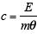
valid results:
• repeat practical and calculate a mean
• plot a graph of temperature against time and use linear section of graph for temperature change
• small (eg 10 °C) temperature change (so cylinder isn’t significantly hotter than surroundings)
safety:
immersion heater gets very hot so avoid touching (heating element) with bare hand
6
(c) immersion heater gets very hot so avoid touching (heating element) with bare hand
allow not all of the energy (as measured by the joulemeter) is transferred to the block
1
(so) temperature increase not as high as it should be for the total energy transferred
allow justification using the equation:
1
[11]
Q5.
(a) Marks awarded for this answer will be determined by the Quality of Written Communication (QWC) as well as the standard of the scientific response. Examiners should also refer to the information in the Marking guidance.
0 marks
No relevant content.
Level 1(1-2 marks)
There is a basic explanation of one feature
or
a simple statement relating reduction in energy transfer to one feature.
Level 2(3-4 marks)
There is a clear explanation of one feature
or
a simple statement relating reduction in energy transfer to two features.
Level 3(5-6 marks)
There is a detailed explanation of at least two features
or
a simple statement relating reduction in energy transfer to all four features.
Examples of the points made in response
extra information
accept throughout:
heat for energy
loss for transfer
plastic cap:
• plastic is a poor conductor
accept insulator for poor conductor
• stops convection currents forming at the top of the flask so stopping energy transfer by convection
• molecules / particles evaporating from the (hot) liquid cannot move into the (surrounding) air so stops energy transfer by evaporation
• plastic cap reduces / stops energy transfer by conduction / convection / evaporation
glass container:
• glass is a poor conductor so reducing energy transfer by conduction
• glass reduces / stops energy transfer by conduction
vacuum:
• both conduction and convection require a medium / particles
• so stops energy transfer between the two walls by conduction and convection
• vacuum stops energy transfer by conduction / convection
silvered surfaces:
• silvered surfaces reflect infrared radiation accept heat for infrared
• silvered surfaces are poor emitters of infrared radiation
• infrared radiation (partly) reflected back (towards hot liquid)
• silvered surfaces reduce / stop energy transfer by radiation
6
(b) (the ears have a) small surface area
ears are small is insufficient
1
so reducing energy radiated / transferred (from the fox)
accept heat lost for energy radiated
do not accept stops heat loss
1
[8]
Q6. (a) (i) 5(.0)
1
(ii) 35 or their (a)(i) × 7 correctly calculated
allow 1 mark for correct substitution, ie 5 or their (a)(i) × 7 provided no subsequent step shown
2
(iii) 525(p)
or
(£) 5.25
or
their (a)(ii) × 15 correctly calculated
if unit p or £ given they must be consistent with the numerical answer
1
(iv) decreases
1
temperature difference (between inside and outside) decreases
accept gradient (of line) decreases
do not accept temperature (inside) decreases
do not accept graph goes down
1
(b) air (bubbles are) trapped (in the foam)
do not accept air traps heat
foam has air pockets is insufficient
1
(and so the) air cannot circulate / move / form convection current
air is a good insulator is insufficient
no convection current is insufficient
answers in terms of warm air from the room being trapped are incorrect and score no marks
1
[8]
Q7. (a) (i) 77
1
(ii) Oil
1
(b) water accept H₂O
1
(c) Carbon dioxide causes global warming
1
[4]
Q8. (a) 78 (°C)
allow 2 marks for correct temperature change ie 22 °C
allow 1 mark for correct substitution
ie 46 200 = 0.5 × 4200 x θ
or
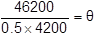
3
(b) 6.4 (W) allow 2 marks for an answer that rounds to 6.4
allow 1 mark for correct substitution
ie 46 200 = P × 7200
an answer of 23 000 or 23 100 or 385 gains 1 mark
2
[5]
Q9. (a) 80 (°C)
1
(b) C
1
temperature after 10 minutes was lowest
or
final temperature was lowest
reason only scores if material C is chosen
allow temperature after 10 minutes was lower
1
(c) lower total temperature rise (for all materials)
allow lower final temperature (for all materials)
1
(because) the rate of temperature increase would be lower
allow lower gradient lines
1
(d) higher resolution
1
reduced risk of misreading instrument
1
(e) polyurethane foam
no marks if polyurethane foam not chosen
1
(because it has the) lowest rate of energy transfer
1
[9]
Q10. (a) advantage
any one from:
• produce no / little greenhouse gases / carbon dioxide
allow produces no / little polluting gases
allow doesn’t contribute to global warming / climate change
allow produce no acid rain / sulphur dioxide
reference to atmospheric pollution is insufficient
produce no harmful gases is insufficient
• high(er) energy density in fuel
accept one nuclear power station produces as much power as several gas power stations
nuclear power stations can supply a lot of or more energy is insufficient
• long(er) operating life
allow saves using reserves of fossil fuels or gas
1
disadvantage
any one from:
• produce (long term) radioactive waste accept waste is toxic
accept nuclear for radioactive
• accidents at nuclear power stations may have far reaching or long term consequences
• high(er) decommissioning costs accept high(er) building costs
• long(er) start up time
1
(b) (i) 12 000 (kWh)
allow 1 mark for correct substitution eg
2000 × 6
or
2 000 000 × 6
or
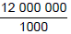

an answer of 12 000 000 scores 1 mark
2
(ii) any idea of unreliability, eg
• wind is unreliable
reference to weather alone is insufficient
• shut down if wind too strong / weak
• wind is variable
1
(c) any one from:
• cannot be seen
• no hazard to (low flying) aircraft / helicopters
• unlikely to be or not damaged / affected by (severe) weather
unlikely to be damaged is insufficient
• (normally) no / reduced shock hazard
safer is insufficient
less maintenance is insufficient
installed in urban areas is insufficient
1
[6]
Q11. (a) (i) water
1
heated
accept boiled or turned to steam
do not accept evaporated
1
generator
1
(ii) geothermal power stations provide a reliable source of electricity
1
(b) falling water
1
[5]
Q12. (a) Marks awarded for this answer will be determined by the Quality of Written Communication (QWC) as well as the standard of the scientific response. Examiners should also apply a ‘best-fit’ approach to the marking.
0 marks
No relevant information
Level 1 (1-2 marks)
There is a relevant statement about an energy saving method
Level 2 (3-4 marks)
There is at least one clear comparison of energy saving methods and their cost effectiveness with an appropriate calculation
Level 3 (5-6 marks)
There is a comparison of energy saving methods and their cost effectiveness with appropriate calculations. Comparison to include further detail.
examples of physics points made in the response
examples of relevant statements
• energy efficient boiler saves the most (energy / money) per year
• loft insulation costs the least to install
• double-glazing costs the most to install
examples of statements that include cost effectiveness
• loft insulation is the most cost effective in the long term
• double-glazing is the least cost effective
• loft insulation has the shortest payback time
• double-glazing has the longest payback time
• payback time calculated for any method
payback times:
energy efficient boiler: 6.25 years
loft insulation: 2 years
double glazing: 100 years
cavity wall insulation: 2.86 years
examples of further detail
• for cost effectiveness install in the following order: loft, cavity wall, boiler, double-glazing
• for reducing energy use install in the following order: boiler, loft, cavity wall, double glazing
• don’t install double-glazing for insulation purposes
• double-glazing won’t pay for itself in your lifetime
• justified choice of best / worst method
6
(b) (i) how effective a material is as an insulator
accept ‘heat’ for energy
accept how effective a material is at keeping energy in
accept the lower the U-value the better the insulator
accept the lower the U-value the lower the rate of energy transfer
1
(ii) (the U-value) decreases
1
[8]
Q13.
(a) any two from:
• nuclear
• oil
• (natural) gas
2
(b) 4 (hours)
1
(c) a system of cables and transformers
1
(d) The power output of wind turbines is unpredictable
1
(e) 1500 / 0.6
1
2500 (wind turbines)
1
allow 2500 with no working shown for 2 marks
(f) Most energy resources have negative environmental effects.
1
[8]
Q14. (a) weight (lifted)
or
height (lifted)
1
(b) any two from:
• calculate a mean
• spot anomalies
• reduce the effect of random errors
2
(c) as speed increases, the efficiency increases
1
(but) graph tends towards a constant value
or
appears to reach a limit accept efficiency cannot be greater than 100%
1
(d) heating the surroundings
1
(e) 0 (%)
1
[7]
Mark schemes
Q1. (a) Level 2 (3–4 marks):
A detailed and coherent explanation is provided. The student makes logical links between clearly identified, relevant points.
Level 1 (1–2 marks):
Simple statements are made, but not precisely. The logic is unclear.
0 marks:
No relevant content
Indicative content
• friction (between cloth and rod) causes
• electrons (to) move
• from the acetate rod or to the cloth
• (net) charge on cloth is now negative
• (net) charge on rod is now positive
4
(b) there is a force of attraction between the acetate rod and the cloth
(reason)
1
unlike charges attract
or
negative charges attract positive charges
1
(c) increase
1
(d) 0.000025 × 60 000
1
1.5 (J)
1
accept 1.5 (J) with no working shown for 2 marks
[9]
Q2. (a) to vary the current.
1
(b) the temperature of the filament increases
allow the filament heats up
1
(c) E = 12 × 8.5
1
E = 102 (J)
an answer of 102 (J) scores 2 marks
1
(d) (LED lamp)
longer lifetime (per lamp)
1
wastes less energy
or
lower input energy (for same light energy output)
1
[6]
Q3. (a) he may receive an electric shock
or
he may be electrocuted
1
if he touches the live wire
1
(b) 10 690 = I × 230
1
I = 10 690 / 230
1
46.478(260) (A)
1
46
1
allow 46 (A) with no working shown for 4 marks
(c) cost is higher
1
more energy is used (per second)
1
[8]
Q4.
(a) 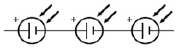
1
(b) 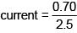
1
current = 0.28 (A)
an answer of 0.28 (A) scores 2 marks
1
(c) 0.60 (V)
1
product of potential difference and current gives highest value
1
(d) 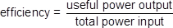
1
(e)
1
useful power output = 0.20 × 2.4
1
useful power output = 0.48 (W)
an answer of 0.48 (W) scores 3 marks
1
[9]
Q5. (a) charge
1
(b) (i) blue
1
(ii) earth wire
1
fuse
1
(c) (i) case is non-metal / non-conducting / plastic / insulator
must refer to case / outside of appliance
do not accept plastic coating / covering
1
(ii) earth (wire)
1
(d) (i) 60 (W)
P = 3 × 20 gains 1 mark
provided no subsequent step shown
2
(ii) 15
300 = 20 × Q
or
20 = 300 / Q gains 1 mark
2
C / coulombs
must clearly be upper case C accept J / V or As
1
[11]
Q6. (a) (i) 150
1
(ii) transferred to the surroundings by heating
reference to sound negates mark
1
(iii) 0.75
450 / 600 gains 1 mark
accept 75% for 2 marks
maximum of 1 mark awarded if a unit is given
2
(iv) 20 (s)
correct answer with or without working gains 2 marks
correct substitution of 600 / 30 gains 1 mark
2
(b) (i) to avoid bias
1
(ii) use less power and last longer
1
1 LED costs £16, 40 filament bulbs cost £80
or
filament costs (5 times) more in energy consumption
1
(iii) any one from:
• availability of bulbs
• colour output
• temperature of bulb surface
1
[10]
Q7. (a) (i) (3-pin) plug
do not accept plug socket
1
(ii) live and neutral
1
(iii) double
1
(b) direct current (d.c.) only
1
(c) (i) live
1
(ii) too great a current flows
accept a surge of current
accept too great a power
accept an electrical fault
do not accept voltage / energy / electricity too high
1
(iii) can be reset
accept does not need replacing
1
(disconnects circuit) faster
cheaper is insufficient
does not melt is insufficient
quicker to fix / replace is insufficient
1
[8]
Q8. (a) current
1
(b) 4.2 = 3.5 × 10^{–3} × R
1
R = 4.2 / 3.5 × 10^{–3}
1
R = 1200 (Ω) an answer of 1200 (Ω) scores 3 marks
an answer of 1.2 scores 2 marks
1
(c) conversion from minutes to seconds (300 s)
1
Q = 0.0035 × (5 × 60)
1
Q = 1.05 C
an answer of 1.05 (C) scores 3 marks
an answer of 17.5 scores 1 mark
an answer of 1050 or 0.0175 scores 2 marks
1
(d) (potential difference) increases
1
(because thermistor) resistance increases
2nd mark dependent on scoring 1st mark
1
(e) 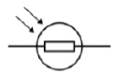
1
[10]
Q9. (a) last box ticked
1
(b) (i) use hotter water (than 60 °C) accept use boiling water
accept use water at any stated temperature above 60 °C
or
add ice cubes
accept add water at any stated temperature below 12 °C
use different temperatures is insufficient
1
(ii) the current increases as the temperature increases
1
(iii) 0.02 (A)
1
(iv) 5 (V)
or
their (b)(iii) × 250 correctly calculated
allow 1 mark for correct substitution ie V = 0.02 × 250
or
V = their (b)(iii) × 250
2
(v) the resistance increases
1
[7]
Q10. (a) 4
1
(b) (i) 2 allow 1 mark for correct substitution ie

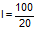
provided no subsequent step
2
(ii) 5 allow 1 mark for correct substitution ie

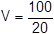
provided no subsequent step
2
[5]
Q11. (a) 20
1
(b) 50
1
(c) (i) 115
1
(ii) 230
1
(iii) if one goes out the other still works
or
brighter
accept power (output) is greater
can be switched on/off independently is insufficient
1
(d) the outside/casing is plastic
there is plastic around the wires is insufficient
it is plastic is insufficient
1
and plastic is an insulator
an answer the light fitting is double insulated gains both marks
1
(e) (residual current) circuit breaker
accept RCCB
accept RCBO
accept RCCD
accept RCB
accept miniature circuit breaker / MCB
trip switch is insufficient
breaker is insufficient
do not accept earth wire
1
[8]
Q12. (a) V = 0.10 × 45
1
4.5 (V)
1
(b) R = 12 / 0.10
1
total resistance = 120 (Ω)
1
R = 120 – 105 = 15 (Ω)
1
(c) (total) resistance decreases
1
(so) current increases
1
[7]
Q13. (a) current at 0.5 V = 0.91 (A)
1
P = 0.91 × 0.5
1
P = 0.455 (W) an answer of 0.455 (W) scores 3 marks
1
(b) straight line with positive gradient
allow for 1 mark a straight line that passes through (0.1, 0)
1
positive y-axis intercept ignore any values on y-axis
1
(c)
1
total P = 3.47 (W)
1
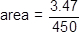
1
area = 7.7 × 10^{–3} (m²)
an answer of 7.7 × 10^{–3} (m²) scores 4 marks
allow use of student’s calculated incorrect total power for last 2 marking points
1
(d) connect the solar cells in parallel
1
(so that) the current has multiple paths it can take
or
the total resistance is less than the resistance of one solar cell
1
[11]
Q14. (a) battery, lamp and ammeter connected in series with variable resistor
1
voltmeter in parallel with (filament) lamp
1
(b) Level 2 (3–4 marks):
A detailed and coherent description of a plan covering all the major steps is provided.
The steps are set out in a logical manner that could be followed by another person to
obtain valid results.
Level 1 (1–2 marks):
Simple statements relating to relevant apparatus or steps are made but they may
not be in a logical order. The plan would not allow another person to obtain valid results.
0 marks:
No relevant content
Indicative content
• ammeter used to measure current
• voltmeter used to measure potential difference
• resistance of variable resistor altered to change current in circuit or change potential difference (across filament lamp)
• resistance (of filament lamp) calculated or R=V / I statement
• resistance calculated for a large enough range of different currents that would allow a valid conclusion about the relationship to be made
4
(c) (as current increases) resistance increases (at an increasing rate)
1
(d) any value between 6.3 and 6.9 (Ω)
1
(e) A: Filament lamp
1
B: Resistor at constant temperature
1
C: Diode
1
[11]
Mark schemes
Q1. Level 3 (5–6 marks):
Clear and coherent description of both methods including equation needed to calculate density. Steps are logically ordered and could be followed by someone else to obtain valid results.
Level 2 (3–4 marks):
Clear description of one method to measure density or partial description of both methods. Steps may not be logically ordered.
Level 1 (1–2 marks):
Basic description of measurements needed with no indication of how to use them.
0 marks:
No relevant content.

Indicative content
For both:
• measure mass using a balance
• calculate density using ρ = m / V
Metal cube:
• measure length of cube’s sides using a ruler
• calculate volume
Small statue:
• immerse in water
• measure volume / mass of water displaced
• volume of water displaced = volume of small statue
[6]
Q2. (a) range of speeds
1
moving in different directions
accept random motion
1
(b) internal energy
1
(c) density = mass / volume
1
(d) 0.00254 / 0.0141
1
0.18
1
accept 0.18 with no working shown for the 2 calculation marks
kg / m³
1
[7]
Q3. (a) (i) random distribution of circles in the box with at least 50 % of circles touching
1
random distribution of circles occupies more than 50 % of the space
judged by eye
1
(ii) (large) gaps between particles
accept particles do not touch
accept particles are spread out
1
(so) easy to push particles closer (together)
or
forces between particles are negligible / none
an answer in terms of number of particles is insufficient
1
(b) (i) (both are) random
accept a correct description of random eg unpredictable or move around freely or in all directions
they take up all the space is insufficient
they are spread out is insufficient
they move in straight lines is insufficient
1
(ii) (speed also) increases
1
[6]
Q4.
(a) (black) is a good absorber of (infrared) radiation
1
(b) (i) amount of energy required to change (the state of a substance) from solid to liquid (with no change in temperature)
melt is insufficient
1
unit mass / 1kg
1
(ii) 5.1 × 10⁶ (J)
accept 5 x 10⁶
allow 1 mark for correct substitution ie E = 15 × 3.4 × 10⁵
2
(c) (i) mass of ice
allow volume / weight / amount / quantity of ice
1
(ii) to distribute the salt throughout the ice
1
to keep all the ice at the same temperature
1
(iii) melting point decreases as the mass of salt is increased
allow concentration for mass
accept negative correlation
do not accept inversely proportional
1
(d) 60 000 (J)
accept 60 KJ
allow 2 marks for correct substitution ie E = 500 × 2.0 × 60
allow 2 marks for an answer of 1000 or 60
allow 1 mark for correct substitution ie
E = 500 × 2.0 or 0.50 × 2.0 × 60
allow 1 mark for an answer of 1
3
(e) Marks awarded for this answer will be determined by the Quality of Communication (QC) as well as the standard of the scientific response. Examiners should also apply a ‘best-fit’ approach to the marking.
0 marks
No relevant content
Level 1 (1–2 marks)
There is an attempt at a description of some advantages or disadvantages.
Level 2 (3–4 marks)
There is a basic description of some advantages and / or disadvantages for some of the methods
Level 3 (5–6 marks)
There is a clear description of the advantages and disadvantages of all the methods.
examples of the points made in the response
extra information
energy storage
advantages:
• no fuel costs
• no environmental effects
disadvantages:
• expensive to set up and maintain
• need to dig deep under road
• dependent on (summer) weather
• digging up earth and disrupting habitats
salt spreading
advantages:
• easily available
• cheap
disadvantages:
• can damage trees / plants / drinking water / cars
• needs to be cleaned away
undersoil heating
advantages:
• not dependent on weather
• can be switched on and off
disadvantages:
• costly
• bad for environment
6
[18]
Q5.
(a) surface area
or
duration of experiment
accept shape of beaker
size of beaker is insufficient
1
(b) any two from:
• takes readings automatically
ignore easier or takes readings for you
• takes readings more frequently
• reduces / no instrument reading error
ignore human error
• higher resolution
allow better resolution
• don't need to remove probe to take reading
• more accurate
2
(c) (i) 0.07 (°C/s)
allow 1 mark for obtaining a temperature drop of 7 (°C)
allow 1 mark for an answer between 0.068 and 0.069 (°C/s)
2
(ii) rate of temperature change is greater at the start
accept rate of evaporation is greater at the start
or
rate of temperature change decreases
allow rate of evaporation decreases
allow temperature decreases faster at the start
1
(iii) A
reason only scores if A is chosen
lower temperature decrease (over 200 seconds)
accept lower gradient
1
(iv) no effect (as rate of evaporation is unchanged)
allow larger temperature change (per second as mass of liquid is lower)
1
(d) particles with more energy
accept particles with higher speeds
1
leave the (surface of the) liquid
1
(which) reduces the average (kinetic) energy (of the remaining particles)
allow reference to the total energy of the liquid reducing
1
[11]
Q6. accept atoms / particles for ions throughout
(a metal has) free electrons
accept mobile for free
1
(kinetic) energy of (free) electrons increases
accept energy of ions increases
accept ions vibrate with a bigger amplitude
accept ions vibrate more
do not accept electrons vibrate more
1
(free) electrons move faster
1
or
electrons move through metal
accept electrons collide with other electrons / ions
(so) electrons transfer energy to other electrons / ions
accept ions transfer energy to neighbouring ions
1
[4]

Q7.
(a) Student A’s measurements had a higher resolution
1
Student B was more likely to misread the temperature
1
(b) a random error
1
(c) 8.4 °C
1
(d) 740 (seconds) allow answers in the range 730 – 780
1
(e) 0.40 × 199 000
1
79 600 (J)
1
accept 79 600 (J) with no working shown for 2 marks
(f) stearic acid has a higher temperature than the surroundings
accept stearic acid is hotter than the surroundings
1
temperature will decrease until stearic acid is the same as the room temperature / surroundings
1
[9]
Q8. (a) (i) radiation
1
(ii) traps (small pockets of) air
do not accept it’s an insulator
do not accept reduces conduction and / or convection
do not allow it doesn’t allow heat to escape
1
(b) (i) bigger temperature difference (between the water and surroundings)
at the start (than at the end)
do not accept water is hotter
1
(ii) starting temperature (of the water)
accept thickness of fleece
do not accept same amount of fleece
do not accept thermometer / can
do not accept time is the same
1
(iii) 18 (°C)
correct answer only
1
(iv) M
1
smallest temperature drop (after 20 mins)
cannot score if M is not chosen
accept it’s the best insulator
accept smallest loss in heat
accept keeps heat / warmth in for longer
1
[7]
Q9.
(a) (i) Z
1
(ii) X
1
(b) (i) moving randomly
1
(ii) stronger than
1
(c) (i) evaporation
1
(ii) any one from:
• becomes windy
• temperature increases
accept (becomes) sunny
“the sun” alone is insufficient
• less humid
1
[6]
Q10.
(a) dependent
1
(b) (probe) C
allow 103.2
1

largest difference between reading and actual temperature
reason only scores if C chosen
accept larger
it is 3.2 greater is insufficient
comparing C with only one other probe is insufficient
1
(c) (i) 12(°C)
accept a value between 12.0 and 12.2 inclusive
1
(ii) 140 (seconds)
accept an answer between 130 and 150 inclusive
1
temperature starts to rise
only scores if time mark awarded
accept the temperature was lowest (at this time)
1
(iii) increase
accept faster (rate)
1
[7]
Q11.
(a) 1 (cm³)
1
(b) pressure is inversely proportional to volume
1
data to prove inversely proportional relationship
eg 8 × 200 = 1600
and 10 × 160 = 1600
if no other marks score allow for 1 mark: as volume decreases pressure increases
2
(c) (as the gas is compressed) the volume of gas decreases
1
(so there are) more frequent collisions of gas particles with container walls
1
(and) each particle collision with the wall causes a force
1
(so there is a) greater force on walls
1
[8]
Q12.
(a) solid
particles vibrate about fixed positions
1
closely packed
accept regular
1
gas
particles move randomly
accept particles move faster
accept freely for randomly
1
far apart
1
(b) amount of energy required to change the state of a substance from liquid to gas (vapour)
1
unit mass / 1 kg
dependent on first marking point
1
(c) 41000 or 4.1 × 10⁴ (J)
accept
41400 or 4.14 × 10⁴
correct substitution of
0.018 × 2.3 × 10⁶ gains 1 mark
2
(d) AB
changing state from solid to liquid / melting
1
at steady temperature
dependent on first AB mark
1
BC
temperature of liquid rises
1
until it reaches boiling point
dependent on first BC mark
1
[12]

Mark schemes
Q1.
(a) cosmic rays
1
radon gas
1
(b) radioactive decay is a random process
1
(c) the lead lining absorbs the emitted radiation
1
(d) subtract the background count from 159
1
(e) beta
1
beta is negatively charged
1
(so is) attracted to positive plate
or
(so is) repelled by negative plate
1
[8]
Q2.
(a) 7
1
(b) 3
1
number of protons
reason only scores if 3 chosen
1
(c) levels
1
(d)
correct order only
1
1
1
(e) shorter half-life (than the other sources)
1
exposure time to radiation is shorter
1
[9]
Q3.
(a) a uranium nucleus
1
absorbs a neutron
1
(uranium-236 nucleus) splits into two smaller nuclei
or
Kr and Ba nuclei
or
krypton and barium nuclei
1
and releases 3 neutrons and energy
1
(b) light nuclei
1
join to form a heavier nucleus
allow hydrogen nuclei for light nuclei
allow helium nucleus for heavier nucleus
1
(some of the) mass of the nuclei is converted to energy
allow particles for nuclei
1
(c) any two from:
• easy to obtain / extract
• available in (very) large amounts
• releases more energy (per kg)
do not accept figures only
naturally occurring is insufficient
seawater is renewable is insufficient
less cost is insufficient
allow produces little / no radioactive waste
2
[9]

Q4. (a) most alpha particles pass straight through the atom
1
which shows that the atom is mostly empty space
1
very few alpha particles are deflected through a large angle
1
which shows the atom contains a nucleus where the mass / charge of the atom is concentrated
1
(b) electron may absorb electromagnetic radiation
full credit may be scored for a description of an electron emitting electromagnetic radiation
1
(and) move further from the nucleus
1
to a higher energy level
1
[7]
Q5. (a) (i) splitting of a(n atomic) nucleus do not accept splitting an atom
1
(ii) Neutron
1
(b) (i) nuclei have the same charge
or
nuclei are positive accept protons have the same charge
1
(ii) (main sequence) star
accept Sun or any correctly named star
accept red (super) giant
1
(c) (i) any two from:
• easy to obtain / extract
• available in (very) large amounts
• releases more energy (per kg)
do not accept figures only
• produces little / no radioactive waste.
naturally occurring is insufficient
seawater is renewable is insufficient
less cost is insufficient
2

(ii) any one from:
• makes another source of energy available
• increases supply of electricity
• able to meet global demand
• less environmental damage
• reduces amount of other fuels used.
accept any sensible suggestion
accept a specific example
accept a specific example
1
(d) 12
allow 1 mark for obtaining 3 half-lives
2
[9]
Q6.
(a) (i) both lose 2 protons and (2) neutrons
accept changes by 2 protons and 2 neutrons
1
(ii) different number of protons (in the nucleus)
accept different atomic number
do not accept different number of protons and neutrons or different mass number
ignore electrons
1
(iii) gamma involves no change in the number of protons (in the nucleus)
or gamma is a wave (not a particle)
do not accept number of neutrons
and / or protons
ignore electrons
1
(b) (i) water because
both material and reason required
for all energy values the thickness
of water needed to absorb (90% of)
the radiation is more than the other materials
accept thickness of water required is always more
than the other materials
1
(ii) 6
allow 1 mark for obtaining both correct values 72
and 12 from graph
allow 1 mark for incorrect values 71 and / or
11 from graph evaluated correctly
2

(c) any three from:
may be scored on annotated diagram provided
not negated elsewhere
• most (alpha) particles passed
undeflected / straight through the gold
• suggesting most of the atom is empty (space)
• a few (alpha) particles scattered / deflected through (very) large angles
accept repelled
do not accept reflected / rebound /
bounce back
• suggesting a concentrated / small nucleus
• nucleus is positive because it repels the positive (alpha) particles
no reference to experiment, maximum 1 mark
3
[9]
Q7.
(a) 78
1
(b) atomic
1
(c) (i) 131
correct order only
1
54
1
(ii) 32 (days)
allow 1 mark for showing 4 half-lives provided no subsequent step
2
(iii) limits amount of iodine-131 / radioactive iodine that can be absorbed
accept increases level of non-radioactive iodine in thyroid
do not accept cancels out iodine-131
1
so reducing risk of cancer (of the thyroid)
accept stops risk of cancer (of the thyroid)
1
[8]

Q8. (a) (average) time taken for the amount / number of nuclei / atoms (of the isotope in a sample) to halve
or
time taken for the count rate (from a sample containing the isotope) to fall to half
accept (radio)activity for count rate
1
(b) 60 ±3 (days)
1
indication on graph how value was obtained
1
(c) (i) cobalt(-60)
1
gamma not deflected by a magnetic field
or
gamma have no charge dependent on first marking point
accept (only) emits gamma
gamma has no mass is insufficient do not accept any reference to half-life
1
(ii) strontium(-90)
1
any two from:
• only has beta
• alpha would be absorbed
• gamma unaffected
• beta penetration / absorption depends on thickness of paper
if thorium(-232) or radium(-226) given, max 2 marks can be awarded
2
(iii) cobalt(-60)
1
shortest half-life accept half-life is 5 years
dependent on first marking point
1
so activity / count rate will decrease quickest
1
(iv) americium(-241) / cobalt(-60) / radium(-226)
1
gamma emitter
1
(only gamma) can penetrate lead (of this box) do not allow lead fully absorbs gamma
1
[14]
Q9.
(a) Nucleus splitting into two fragments and releasing two or three neutrons
1
(at least one) fission neutron shown to be absorbed by additional large nucleus and causing fission
1
two or three additional neutrons released from fission reaction
1
This diagram would gain all 3 marks:
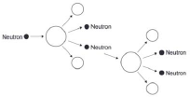
(b) lowering the control rods increases the number of neutrons absorbed
accept converse description
1
(so) energy released decreases
1
allow changing the position of the control rods affects the number of neutrons absorbed for 1 mark
(c) rate of increase between 240 and 276 (MW / min)
2
allow 1 mark for attempt to calculate gradient of line at 10 minutes
[7]
Q10.
(a) inside the Sun
1
(b) fusion
1
(c) energy
1
[3]
Q11. (a) (i) (atoms with the) same number of protons
allow same atomic number
or same proton number
1
(atoms with) different number of neutrons
allow different mass number
1
(ii) 82
1
(iii) 124
1
(b) (i) 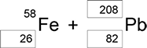

1 mark for each correct box
3
(ii) (a) neutron
1
(iii) 4.0 × 10⁻⁴ (s)
or
0.0004
3.00 × 10⁸ × 0.1 = 12 000 / t
gains 1 mark
2
(iv) particles need to travel a large distance
1
equipment would have to be very long
1
with circular paths long distances can be accommodated in a smaller space
1
(c) (i) the average time for the number of nuclei to halve
1
the time for count rate to halve
1
(ii) 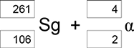
1 mark if top boxes total = 265
and bottom boxes total = 108
1 mark for 4 and 2 for alpha
2

(d) (i) 3 plotted points
± ½ small square
1
best line through points
1
(ii) 190−205 (pm)
or correct from student’s line
1
[20]
Q12.
(a) cannot predict which dice / atom will ‘decay’
accept answers given in terms of ‘roll a 6’
1
cannot predict when a dice / atom will ‘decay’
1
(b) 3.6 to 3.7 (rolls)
allow 1 mark for attempt to read graph when number of dice = 50
2
(c) 90
1
(d) uranium
1
(e) beta
1
proton number has gone up (as neutron decays to proton and e–)
1
(f) prevents contamination
or
prevents transfer of radioactive material to teacher’s hands
1
which would cause damage / irradiation over a longer time period.
1
[10]

