Rail transport
Advantages:
- it is often cheaper to travel by train (for a single person), than it is to travel by car and pay for petrol and car parking,
- train companies normally run group promotions for discounted tickets,
- train companies often run promotions with other major attractions so that more people will travel to those attractions by train, and therefore help the environment,
- Trains can often get you somewhere quicker than driving,
- You can sometimes reserve seats on trains,
- You can get the Eurostar train from St Pancras to France or Belgium,
- You can take your car on the train if you catch it at Folkestone, Kent and then you have your own car to drive in France, Germany etc.
- You can sleep on the tain,
- You can take your own entertainment with you, or do work on the train,
- Discounted fares available,
- Fairly low environmental impact

Disadvantages:
- you can’t just go when you want to. Trains have a timetable that you must stick to. This means you could end up somewhere hours earlier or later you want to.
- It is more expensive for groups of people to buy train tickets, than it would be for them all to fit into one car with one tank of petrol.
- There aren’t always train stations near to your start or end destination, meaning you still need to find transport to or from the train station, which might be very expensive and isn’t good for the environment,
- Trains mostly only go to large towns and cities,
- You mostly only find trams and underground systems in the major towns and cities,
- Sometimes trains take a lot longer than driving e.g. if you get a stopping train,
- If there is a problem on the train line e.g. snow or leaves, the train will be delayed. You have no option but to stay on the train and end up very late,
- You often have to stand on the train,
- You sometimes have to change trains several times,
- Not all train stations are accessible for disabled customers,
- Overcrowded at busy times (like going to and from work)

Air travel
Advantages:
- very fast travel,
- you can get flights and airlines to suit all budgets,
- there are in-flight facilities like toilets, food and entertainment,
- there are airports in all major cities,
- lots of facilities like shops and restaurants at airports,
Disadvantages:
- you can’t go when you want to – you have to fly when the airline wants to fly,
- the prices go up massively at peak times of the year e.g. school holidays,
- very bad for the environment,
- you might have to make transfer flights,
- very expensive and there aren’t often discounts offered

Water transport
Advantages:
- major ferry routes offer transport to France, Ireland and the British Islands,
- some towns use water transport to get around the town e.g. the Isle of Wight Ferry, the Mersey water taxis in Liverpool and boat services on the River Thames in London.
- You can go on canal boat holidays,
- Ferry trips and cruises can be very relaxing and beautiful,
- Sometimes there are promotions being run which means that the ferry trip is very cheap,
- You can take your own car with you on a ferry, so you don’t need to hire one or use public transport when you get there,
- You can take your own car to France, Spain, Germany etc.

Disadvantages:
- it can be really expensive,
- it’s a very slow way of getting somewhere,

Think about the different groups of people and how the different travel options would suit some better than others.

Impact of tourism - Whenever tourists visit a destination they affect it. They affect its environment and they affect the local community who live there. These are tourism’s impacts. There are both positive and negative impacts.

Host community – are the local people at the destination who look after the needs of tourists.

Seasonal tourism – tourism that only happens at certain times of the year e.g. snow resorts only get tourism at the time of the year when there is snow; beach resorts get tourism when it is hottest there, or coldest at the country that people are leaving; school holidays increase tourism etc.

Peak season – is the busiest period of the year for leisure and tourism destinations.

Shoulder season – the tourism flow is at an intermediate level. It is either side of the peak (high) season.

More Economically Developed Countries (MEDCs) – are countries that generally have a higher standard of living e.g. UK, USA, Australia, Canada, Japan etc.

Less Economically Developed Countries (LEDCs) – are countries where the standard of living is very low and they may not have much money e.g. the Gambia, Kenya, (many African countries), many South American countries, many Asian countries.

Tourism impacts can be classified as:

- Social impacts – affect the people e.g. their way of life and what facilities are available for them.

- Economic impacts – affect jobs, businesses and income at the destinations. They are to do with money.

- Environmental impacts – affect not just the nature of the destination, but also the global environment.

 | Positive impact | Negative impact
Social | Leisure facilities that open in destinations for tourists can also be used by the local people. This can improve their health and quality of life.  Tourism brings different people into contact with each other, so they understand each other and their beliefs and cultures better. | Leisure facilities that cater for tourists may be too expensive for many local people to use, and they may sometimes replace cheaper ones that were already there and they could afford to use.  Some local people (especially young people) might start to copy the behaviour of the tourists instead of living their traditional ways of life.  Some traditional jobs and ways of life have been disrupted e.g. local farmers have left farming and now work in the tourism industry. Many of these are young people, which are leaving elderly people working the farms.  Some local religious ceremonies and traditional dances etc. are being performed for the benefit of the tourists. This takes away the true meaning and significance. Trips to local villages are also organised in many places, and this can lead to an increase in begging from locals and a dependence on the tourists to give them hand-outs.
Economic | Tourists spend money. This increases the income of businesses at the destination.  Businesses employ more staff so there are more jobs as waiting staff, hotel staff, bar staff, child-care services, lifeguards, holiday reps, sports instructors, tour guides etc. for them.  The members of the host community that now have jobs, will spend their money in local businesses and they will pay taxes to the government, so the whole area benefits. | Some tourists spend money in businesses that are not local to the destination e.g. McDonalds. This money doesn’t go to the host community. This is called economic leakage.  Tourism is often seasonal which means that there are fewer jobs out of season, and people might lose their jobs (or only be given temporary, seasonal ones to begin with).
Environmental | Air travellers can offset their carbon footprint by paying extra for their tickets to support projects that take carbon out of the atmosphere e.g. by planting trees.  The environment of destinations can be improved to make it attractive to tourists. They can turn it into a green destination which is one that appeals to visitors for its clean, natural environment. This happened in Brighton in 2008.  Tourist can become active in the conservation of the beautiful places they visit e.g. the UK National Trust (not National Parks) conserves landscapes and historic buildings. | Travel to destinations causes pollution through an increase in emissions from aeroplanes and cars in their destination. The amount of carbon emissions a traveller adds by a journey is called their carbon footprint.  Some tourists may:  - use land that might otherwise have been used for farmland,  - use more water in the hotels for drinking, washing, cooking and cleaning,  - use more fuel and power for electricity and heating,  - waste from tourism facilities can pollute rivers, lakes and seas,  - rubbish created by tourists may be dumped on the surface and in landfill sites,  - tourism facilities create noise pollution, as do transport vehicles,  - Tourist developments can ruin the appearance of the destination.

Case study of tourism impacts – Machu Picchu, Cusco, Peru.

See previous notes on Machu Picchu for map, pictures and additional information.

Social impacts:
Advantages:
- Assigned camp sites with proper toilet facilities must be used.
- The indigenous people of Peru are actively involved in working to preserve their spiritual and cultural heritage.
- The contract that the government had awarded to Peru Hotels SA to build a cable car has been blocked, which means that their way of life is not being compromised.
- Porters will not be asked to carry more than 20 kilos, which protects the local people from injury and also means that more people are needed to fill this job position.
- Flights are not allowed over the Inca ruins of Machu Picchu, to protect their way of life.
- Machu Picchu was declared a World Heritage cultural and natural site in 1983 and comprises about 80,000 acres, so their way of life and community is being protected.
- Brings in money to support community facilities and services that otherwise might not be developed.
- Encourages civic involvement and pride.
- Provides cultural exchange between hosts and guests.
- Encourages the preservation and celebration of local festivals and cultural events.
- Facilities and infrastructure supported by tourism (e.g. the Inca railway) can also benefit residents.
- Encourages the learning of new languages and skills.

Negatives:
- May attract visitors whose lifestyles and ideas conflict with the community's.
- May change individual behaviour and family relationships.
- If the rules are ignored, the overloading of porters leads to health problems.
- May lead to the loss of traditional values and culture through copying visitor behaviour
- Crowding and congestion on the roads, footpaths and in the narrow streets.
- Tourists compete with residents for available services and facilities. Backpackers use the local train rather than the much more luxurious and expensive tourist train which would benefit the host community more.
- Can lead to an increase in crime in the area.
- Ignoring the importance of burial sites by the removal and display of human remains from Machu Picchu to bring more tourists in. This has contributed to the destruction of the Indian spiritual heritage.

Economic impacts:
Advantages:
- Only licensed tour operators are permitted to sell Inca Trail packages, which means that all money is kept for local people.
- The town of Aguas Calientes will now receive 10 percent of ticket receipts from Machu Picchu to improve the infrastructure, including sewage and waste treatment.
- Admission to Machu Picchu has increased from $10 to $20.
- Attracts high-spending tourists from higher socio-economic groups.
- Provides governments with extra tax revenues each year through accommodation and restaurant taxes, airport taxes, sales taxes, Inca trail and Machu Picchu entrance fees, employee income tax etc. At $20 an entrance ticket, Machu Picchu generates $6 million a year for Peru, while the Inca trail brings in another $3 million, according to Machu Picchu Management.
- Creates local jobs and business opportunities. These include those jobs directly related to tourism (hotel and tour services) and those that indirectly support tourism (such as food production and housing construction).
- The multiplier effect:
- Brings new money into the economy. Tourist money is returned to the local economy as it is spent over and over again.
- Helps attract additional businesses and services to support the tourist industry.

Disadvantages:
- The trail will be closed one month each year for maintenance (January or February), which means that there will be fewer tourists so less money for the host community.
Inflates property values and prices of goods and services.
- Employment tends to be seasonal. Workers are laid off in the low season.
- Tourist numbers can be adversely affected by events beyond the control of the destination e.g. terrorism, economic recession. This is a problem in Peru for the country is over-dependent upon tourism.
- Economic leakage - the money earned by tourism does not stay in the country but is used to pay for imports required by tourists.
- The jobs provided are usually poorly paid.

Environmental impacts:
Advantages:
- Groups may not stay more than four nights on that portion of the Inca Trail that lies within the Machu Picchu sanctuary, which reduces the opportunity for damage to occur from tourists.
- All rubbish must be carried out of the Trail.
- Flights are not allowed over the Inca ruins of Machu Picchu, to reduce noise pollution and carbon emissions over the ruins.
- There is a limit of 2500 people a day allowed to visit the site ruins at Machu Picchu, to protect it from erosion and damage.
- Conservationists say visitors should wear soft shoes to reduce pressure on the ruins
- Programa Machu Picchu, a conservation program is being established to protect the environment and the development of the town of Aguas Calientes.
- Fosters conservation and preservation of natural, cultural and historical resources.
- The contract that the government had awarded to Peru Hotels SA to build a cable car has been blocked, which means that the area won’t be damaged further by it.

Disadvantages:
- Up to 2,000 people visit the Machu Picchu citadel every day, with visitor numbers growing at 6 percent a year. The site is being slowly eroded by tourists' feet.
- Machu Picchu is located among steep slopes that are constantly being eroded by heavy rains and landslides are common. Although the recovery of the original terraces, many of which are still buried under the vegetation, helps to stabilise the slopes and ensure conservation, it is a costly undertaking.
- Timber has been cut along the Inca trail for fuel for cooking and forest fires in the vicinity have threatened Machu Picchu on several occasions.
- Until now, the influx of visitors has been kept under control to the extent that the only way of reaching the site was by railway. But plans to build a road from Cuzco and if the cable car that they want to build to run from the valley to the top of Machu Picchu is built (it is currently blocked from being built) this could lead to irreparable harm being done.
- The number of people hiking along the Inca Trail rose from 6,000 in 1984 to 82,000 in 2000. The trail is being eroded and tea bags and water bottles litter the route, where campsites are scarce.
- Unorganized growth in local towns in the area is causing human waste to be pumped direct into the Urubamba river. Aguas Calientes has doubled in size as more hotels and restaurants have been built to accommodate the needs of tourists, and the burden is evident in the heaps of rubbish that is piled along the banks of the Urubamba river.
- Helicopters have been allowed to fly in tourists and operate low-flying tours, thereby disturbing not only the peaceful quality of the ruins, but potentially damaging them. Peru's Institute of Natural Resources said those flights led to the disappearance of a rare species of orchid and the Andean Condor from the area.

Sustainability – is meeting the needs of the present tourists and their host communities and environments whilst protecting and improving tourist, community and environmental needs for the future (meeting the needs of today’s customers while not spoiling the future for others).

Sustainable behavior in leisure and tourism could be:
- reducing carbon emissions,
- using renewable energy and conserving energy,
- hotels using locally produced food,
- employing local staff and using local suppliers,
- recycling and reducing waste,
- limiting visitor numbers.

Behaving sustainably minimises the negative impacts of leisure and tourism. It helps to protect the future of the environment and of destinations and their people. This is important for the economic future of destinations as people will not want to visit places that have been spoilt by tourism’s negative impact in the past.

Sustainable development – is about making changes that improve activities and facilities for customers in ways that minimise negative impacts – this means in ways that protect the environment and local people’s way of life for the future. Visitors will still be able to enjoy destinations and local population’s way of life in the future.

UK example of sustainable tourism – Eden Project, Cornwall

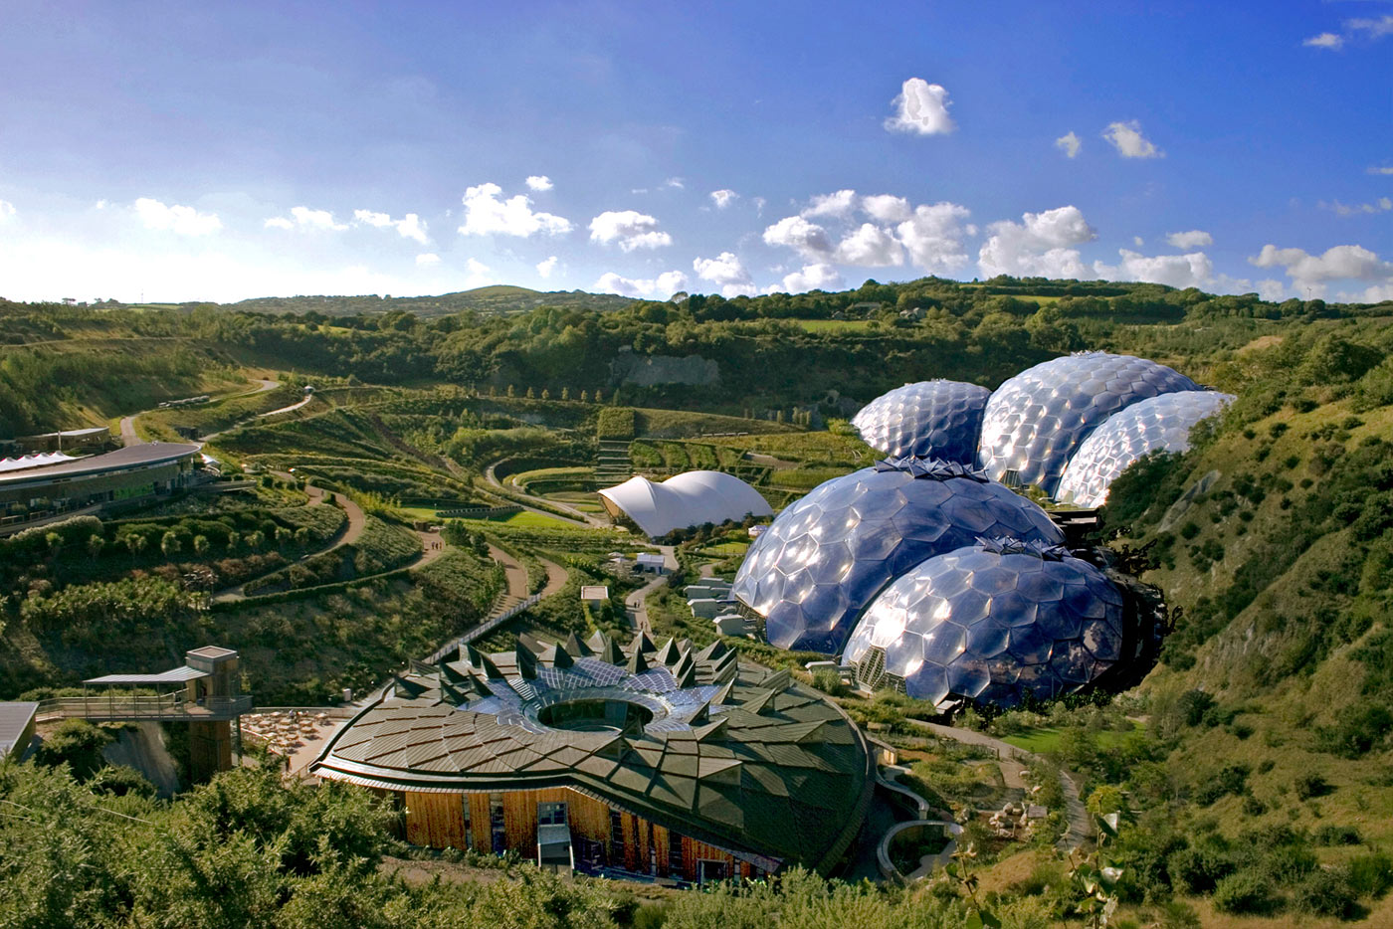

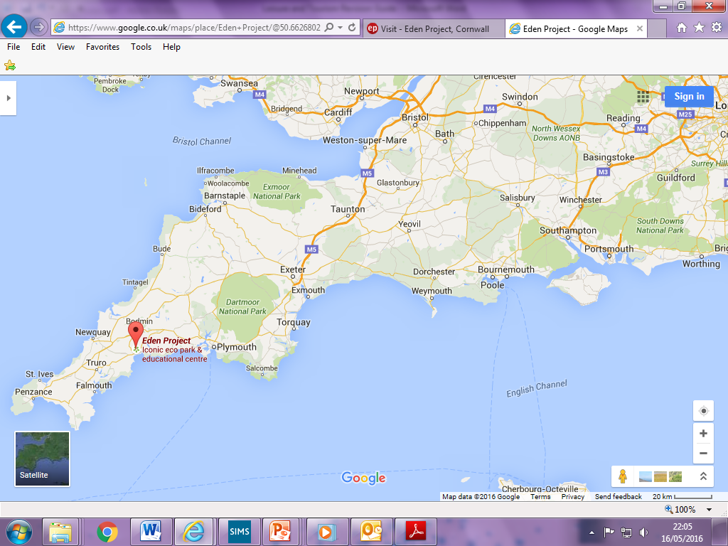
Eden Project, Bodelva, near St Austell, Cornwall.
Farnborough

The Eden Project, near St Austell in Cornwall (south west England) is a large-scale built attraction based on a conservation theme. It is built on the site of a disused china clay pit, and is promoted as a ‘global garden’. It has large dome-shaped conservatories called ‘biomes’, which enclose plants of different environments from around the world – one which simulates the Mediterranean environment by growing citrus and olive plants etc.; one which grows cacti etc to simulate the desert environment; and one which grows tropical rainforest plants to simulate the rainforest ecosystem. Outside the biomes, they grow crops, including tea and hops, bamboo and flowers.

Visitors can explore and learn about the variety of nature around the world. There are children’s play areas, story-telling sessions, cafes, restaurants, a visitor centre, and education centre and a gift shop.

The Eden Project tries to be a sustainable development by:
- Educating visitors through exhibitions, events, workshops and projects working with schools, in how they can help to conserve the environment.
- Promoting public transport and cycling as ways to travel to the attraction,
- Seeking to ensure that the Eden Project benefits the local economy,
- Sourcing food for its cafes and restaurants from local farmers,
- Managing waste disposal carefully.

Overseas example of sustainable tourism – Khao Sok eco-lodges in Khao Sok National Park, Thailand

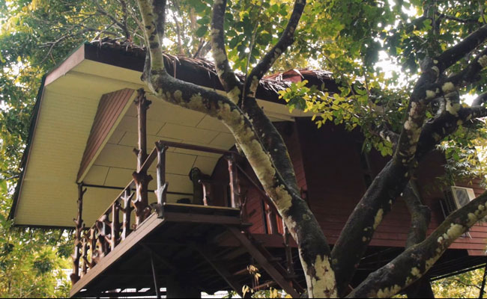

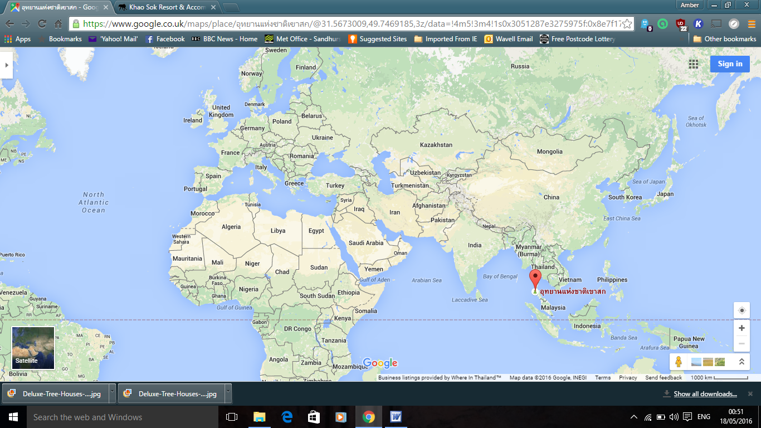
Khao Sok National Park, Thailand
Farnborough

Khao Sok National Park is a natural attraction in rural Thailand. Thailand is an LEDC in south east Asia. The River Sok runs through the National Park, and the Khao Sok eco-lodges are on the river. The National Park is in a mountainous, rainforest environment, and tourists enjoy the beautiful scenery of limestone cliffs, waterfalls and dense jungle. Apart from viewing the scenery and watching the wildlife, visitors can take part in the following activities:
- trekking un the jungle with local guides,
- elephant trekking,
- canoe trips,
- night-time wildlife safaris,
- lake tours.

The owners of the Khao Sok eco-lodge have different eco-tents or lodges to suit different budgets and lifestyles, including deluxe lodges, family lodges and standard lodges. They practice sustainable tourism because:
- they employ local people both in the lodge and as guides,
- buy all their supplies locally, including food,
- pay local taxes on their profits,
- encourage guests to behave as responsible tourists and not feed the animals e.g. lemurs and gibbons etc. This is so that they do not become dependent on human handouts and therefore they remain wild,
- the lodge’s rubbish is recycled, and the owners help local people to do this as well,
- the reduce the spread of plastic drinking water bottles, e.g. they refill local people’s bottles for half the price of a new bottle of water. This makes a positive environmental impact.

We need these forms of sustainable tourism because we need to conserve planet earth from people who are:
- using up the world’s natural resources,
- polluting the land, water and air with their waste and emissions,
- causing the climate to change (global warming and climate change),
- damaging the habitats of other creatures,
- spoiling the appeal of destinations for future visitors.

The government and public now think that:
- leisure and tourism should be developed but should be developed sustainably,
- tourists should behave sensitively in destinations, be aware of their impact and understand that host communities may have different attitudes and cultures from their own.

Greenwashing - ecotourism is seen to be such a good thing that some companies try to promote products and services as being more environmentally friendly than they really are. E.g. hotels claiming to be eco-lodges just because they are set in the countryside; and some safaris being promoted as ecotourism even though they do not help to conserve the environment.

Homestay – is staying with a friend or relative, either for free or as a paying guest. This benefits LEDCs because people learn about the lives of others in other countries at first hand.

Responsible tourism – is visiting destinations in ways that harm the environment and local people as little as possible. Tourism that is responsible is therefore sustainable. Responsible tourists act in destinations in ways that maximise the positive impacts of tourism. E.g. UK visitors to long-haul destinations in LEDCs can act responsibly by buying products and services directly from local people.

Ecotourism – is visiting a leisure and tourism destination because of the appeal of its natural environment, while negatively affecting the environment as little as possible. Ecotourism is normally tourism on a small scale because mass tourism is likely to affect a destination’s natural environment. Ecotourists try to be responsible tourists and to benefit the local communities they visit socially and economically. The aims of ecotourism are to:
- help people to enjoy and learn about the natural environment in leisure and tourism destinations,
- conserve the natural environment of leisure and tourism destinations by minimising the negative environmental impacts of tourism,
- make positive impacts that improve the environment and the lives and well-being of local people.

