Questions
Q1.
Alkanes are now being used as aerosol propellants as an alternative to CFCs.
Although they have no effect on the ozone layer, they have the disadvantage of
A having high reactivity.
B being hard to evaporate.
C being greenhouse gases.
D having an unpleasant smell.

(Total for question = 1 mark)

Q2.
Which type of radiation is absorbed by molecules and results in the greenhouse effect?

A Infrared
B Microwave
C Ultraviolet
D X-ray
(Total for Question = 1 mark)

Q3.
Which of the following is a greenhouse gas?
A Argon
B Nitrogen
C Oxygen
D Water vapour
(Total for question = 1 mark)

Q4.
Which of the following is not a greenhouse gas?

A H₂O
B NO
C CH₄
D O₂
(Total for Question = 1 mark)

Q5.
Consider the infrared spectrum shown below.
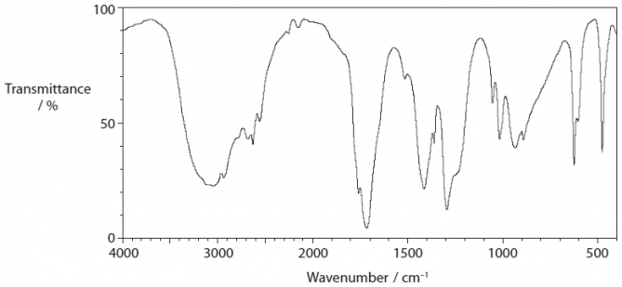
The IR absorption ranges associated with some organic functional groups are given below.
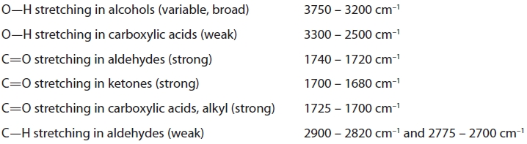
Which of the following could have produced the above spectrum?
A An aldehyde
B An alcohol
C A carboxylic acid
D A ketone

(Total for question = 1 mark)

Q6.
What effect does infrared radiation have on the covalent bonds in water molecules in the atmosphere?
A They are broken to form free radicals.
B They are broken into ions.
C The bonds vibrate more vigorously.
D There is no effect on the bonds.

(Total for question = 1 mark)

Q7.
How many of the following molecules will absorb IR radiation?
A Two
B Three
C Four
D Five
(Total for question = 1 mark)

Q8.
Molecules absorb IR radiation because
A they change their polarity when they vibrate.
B they change their velocity when they vibrate.
C they change their magnetic field when they vibrate.
D they change their direction of rotation when they vibrate.
(Total for question = 1 mark)

Q9.
These questions concern the use of infrared (IR) spectra to identify organic compounds. The IR absorption ranges associated with some organic functional groups are given below.
A O—H stretching in alcohols at 3750 − 3200 cm⁻¹
B CO stretching in aldehydes at 1740 − 1720 cm⁻¹
C CO stretching in ketones at 1700 − 1680 cm⁻¹
D CO stretching in carboxylic acids at 1725 − 1700 cm⁻¹
(a) When propan−2−ol is refluxed with potassium dichromate(VI) and sulfuric acid, the product will show a peak due to
(1)
A
B
C
D
(b) When propan−1−ol is heated with potassium dichromate(VI) and sulfuric acid, the product, that is distilled off as it is formed, will show a peak due to
(1)
A
B
C
D
(Total for question = 2 marks)

Q10.
The infrared spectrum below is most likely to be that of a member of which homologous
series?
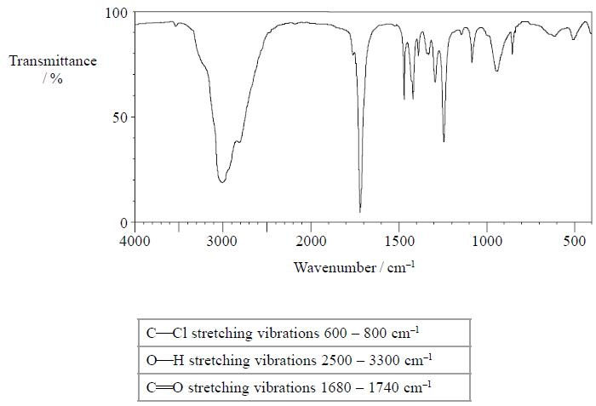
A Alcohol
B Chloroalkane
C Aldehyde
D Carboxylic acid
(Total for question = 1 mark)

Q11.
Infrared (IR) spectra can be used to follow the progress of reactions involving
propan-1-ol and propan-2-ol. Some absorption ranges by chemical bonds in the IR
spectrum are given below.
1 O—H stretching in alcohols at 3750 − 3200 cm⁻¹
2 CO stretching in aldehydes at 1740 − 1720 cm⁻¹
3 CO stretching in ketones at 1700 − 1680 cm⁻¹
4 CO stretching in carboxylic acids at 1725 − 1700 cm⁻¹
(a) To identify the formation of the product when propan-1-ol has been partially
oxidized, you can look for absorptions in the IR spectrum at absorption range
(1)
A 1
B 2
C 3
D 4
(b) To monitor whether all of the sample of propan-2-ol has been oxidized, you can
look for
(1)
A a lack of absorptions in the IR spectrum at 1.
B a lack of absorptions in the IR spectrum at 2.
C absorptions in the IR spectrum at 3.
D absorptions in the IR spectrum at 4.
(Total for question = 2 marks)

Q12.
Which of the following features is shown by the mass spectra of propanone and propanal?
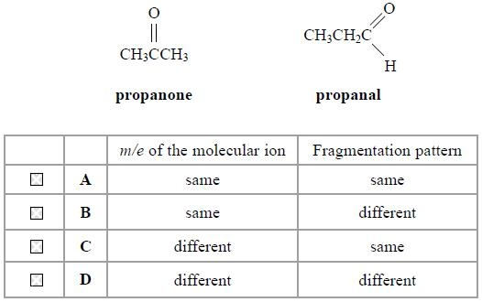
(Total for question = 1 mark)

Q13.
There would be a major peak in the mass spectrum for butan-1-ol, CH₃CH₂CH₂CH₂OH, but not for butan-2-ol, CH₃CH₂CH(OH)CH₃, at m/e value
A 15
B 17
C 29
D 43
(Total for Question = 1 mark)

Q14.
Which of the following values for the mass/charge ratio for singly charged ions would
be present in the mass spectrum of propanal, CH₃CH₂CHO, but not of propanone,
CH₃COCH₃?
A 15
B 29
C 43
D 58
(Total for question = 1 mark)

Q15.
A compound which has major peaks with mass / charge ratio at 29, 57 and 58 in the mass spectrum could be

A propanal, CH₃CH₂CHO.
B propanone, CH₃COCH₃.
C propan-1-ol, CH₃CH₂CH₂OH.
D propan-2-ol, CH₃CH(OH)CH₃.
(Total for Question = 1 mark)

Q16.
The molecular (parent) ion in the mass spectrum of a hydrocarbon containing ¹²C and ¹H only

A is the peak with highest relative abundance.
B is the peak with highest charge.
C is the peak produced by the most stable fragment.
D is the peak with highest mass to charge ratio.
(Total for Question = 1 mark)

Q17.
Methanol dissolves in water mainly due to the formation of new
A hydrogen bonds.
B dipole-dipole forces.
C London forces.
D covalent bonds.
(Total for Question = 1 mark)

Q18.
Consider the following organic liquids:
A ethanal
B ethanol
C tetrachloromethane
D trichloromethane
(a) Each liquid is run from a burette. Which liquid would not be deflected significantly by a charged rod?
(1)
A
B
C
D
(b) Which liquid would react with phosphorus(V) chloride to give a gas which fumes in moist air?
(1)
A
B
C
D
(c) Which liquid would you expect to have the peak at the greatest mass/charge ratio in its mass spectrum?
(1)
A
B
C
D
(d) Which liquid has an infrared spectrum with a broad absorption due to hydrogen bonding?
(1)
A
B
C
D
(Total for question = 4 marks)

Q19.
When propanal, CH₃CH₂CHO, and propanone, CH₃COCH₃, are compared using
physical methods of analysis, which of the following is not correct?
A The carbonyl groups absorb at very similar frequencies of the IR spectrum.
B The compounds will have different patterns in the fingerprint region of the IR spectrum.
C The compounds will form different fragmentation patterns in a mass spectrum.
D The compounds will have molecular ion peaks at different mass to charge ratios in a mass spectrum.
(Total for question = 1 mark)

Q20.
In a mass spectrum of butane, C₄H₁₀, where would a peak be seen for the molecular ion if it had a charge of 2+?
A 29
B 56
C 58
D 60

(Total for question = 1 mark)

Q21.
The enthalpy change of neutralization of an acid by an alkali is measured by adding 10.0 cm³ of hydrochloric acid to 10.0 cm³ of sodium hydroxide. 10.0 cm³ pipettes with an accuracy of ±0.04 cm³ are used to measure out both solutions.
The overall percentage error in measuring the total volume of the reaction mixture is
A ±0.04%
B ±0.08%
C ±0.4%
D ±4.0%
(Total for Question = 1 mark)

Mark Scheme
Q1.

Q2.

Q3.

Q4.

Q5.

Q6.

Q7.

Q8.

Q9.

Q10.

Q11.

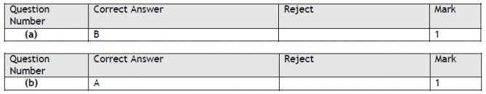

Q12.

Q13.

Q14.

Q15.

Q16.

Q17.

Q18.

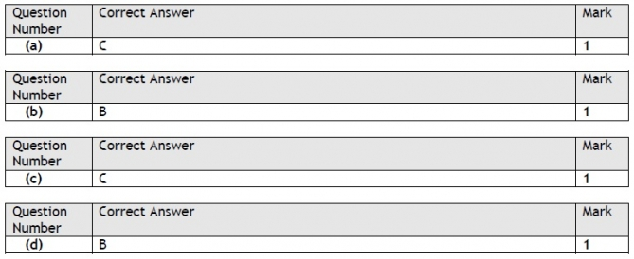

Q19.

Q20.

Q21.

