dQuestions
Q1.
In a molecule of ethene, C₂H₄, how many π (pi) bonds are present?
A One
B Two
C Three
D Four
(Total for question = 1 mark)

Q2.
A hazard that is particularly associated with alkanes is that they are
A corrosive.
B flammable.
C toxic by inhalation.
D toxic by skin absorption.
(Total for question = 1 mark)

Q3.
Scientists are developing sources of energy as alternatives to fuels produced from crude oil. Which of the following reasons for doing this is incorrect?
(1)
A Crude oil is being used up faster than it is being formed.
B Burning hydrocarbons affects global carbon dioxide levels.
C Hydrocarbons from crude oil are a source of essential chemicals other than fuels.
D Carbon dioxide produced by burning hydrocarbons is toxic to plants.

(Total for question = 1 mark)

Q4.
Which of these statements about carbon-carbon double bonds is false?
A The two ends of a molecule cannot rotate relative to each other, about the axis
of the double bond.
B They are twice as strong as a carbon-carbon single bond.
C They have a higher electron density than a single bond.
D They consist of a sigma bond and a pi bond.
(Total for question = 1 mark)

Q5.
Which of the following pairs are cis-trans isomers?
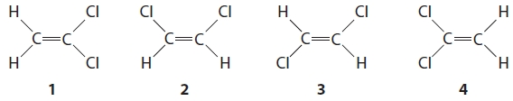
A 1 and 2
B 1 and 4
C 2 and 3
D 3 and 4

(Total for question = 1 mark)

Q6.
Which of the following mixtures could not form when octane, C₈H₁₈, is cracked?
A propane + pentene
B butane + butene
C pentane + propene
D heptane + ethene
(Total for question = 1 mark)

Q7.
How many isomers are there of C₅H₁₂?
A Two
B Three
C Four
D Five
(Total for question = 1 mark)

Q8.
Isomers have different
A empirical formulae.
B molecular formulae.
C skeletal formulae.
D molar masses.
(Total for question = 1 mark)

Q9.
Cracking crude oil

A separates the mixture into pure compounds.
B separates the mixture into a number of fractions.
C separates saturated compounds from unsaturated ones.
D decreases the average number of carbon atoms per molecule.
(Total for Question = 1 mark)

Q10.
Which of the following molecules does not contain a double bond?
A CO₂
B C₂Cl₄
C C₃F₈
D C₂H₂Cl₂

(Total for question = 1 mark)

Q11.
Name the alkene shown below.
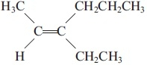
A Z-4-ethylhex-4-ene
B E-3-ethylhex-2-ene
C Z-3-ethylhex-2-ene
D E-3-propylpent-2-ene
(Total for question = 1 mark)

Q12.
This question concerns the following compounds
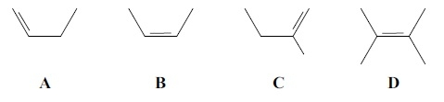
Which of these compounds will show geometric (E–Z or cis/trans) isomerism?
A
B
C
D
(Total for question = 1 mark)

Q13.
Which of the following alkenes exhibits E-Z isomerism?
A H₃CCHC(CH₃)₂
B (CH₃)₂CCH₂
C H₂CCHCH₂CH₃
D H₃CCHCHCH₃
(Total for question = 1 mark)

Q14.
Which of the following is a major effect caused by increased carbon dioxide levels arising from the burning of fossil fuels?

A Melting of polar ice caps.
B Damage to the ozone layer.
C Increased acid rain.
D Increased skin cancer.
(Total for Question = 1 mark)

Q15.
In the reaction between ethene and bromine, the bromine molecule acts as an
electrophile.
Which of the following statements is true?
A Ethene acts as a nucleophile because it is polar.
B Ethene acts as a nucleophile because it can donate a pair of electrons to bromine.
C Ethene is not a nucleophile in this reaction.
D Ethene acts as a nucleophile because it donates a single electron to bromine.
(Total for question = 1 mark)

Q16.
Which of the following statements correctly describes an environmental problem caused
by the burning of hydrocarbon fuels?
A The carbon dioxide is toxic and kills plants.
B The smoke produced reflects sunlight and leads to global warming.
C The water produced results in a damaging increase in rainfall.
D The carbon dioxide produced absorbs heat radiated from the Earth and leads to
global warming.
(Total for question = 1 mark)

Q17.
Which of the following equations shows the first step in the mechanism for the reaction between hydrogen bromide and ethene?
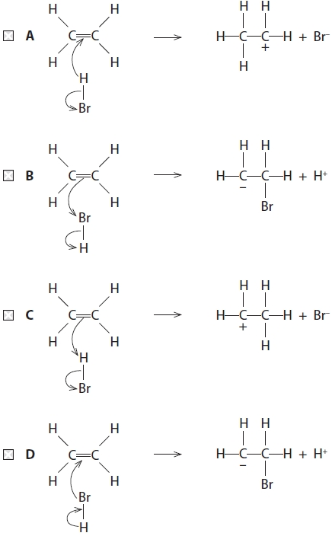

(Total for question = 1 mark)

Q18.
(a) Which of the following represents a step in the mechanism during the reaction between ethene and hydrogen bromide?
(1)
A C₂H₄ + Br⁺ → C₂H₄Br⁺
B C₂H₄ + HBr → C₂H₅⁺ + Br⁻
C C₂H₄ + HBr → C₂H₅• + Br•
D C₂H₄ + HBr → C₂H₄Br⁻ + H⁺
(b) The mechanism of the reaction between ethene and hydrogen bromide is
(1)
A electrophilic addition.
B electrophilic substitution.
C nucleophilic addition.
D nucleophilic substitution.

(Total for question = 2 marks)

Q19.
Which of the following compounds shows geometric (E-Z or cis-trans) isomerism?

A but-1-ene
B 2-methylbut-1-ene
C but-2-ene
D 2-methylbut-2-ene
(Total for Question = 1 mark)

Q20.
An electrophile is defined as a species that

A is an electron pair acceptor.
B is an electron pair donor.
C has a negative charge.
D has a positive charge.
(Total for Question = 1 mark)

Q21.
A compound Z contains, by mass, 26.7% carbon, 2.2% hydrogen, and 71.1% oxygen. The empirical formula of Z is
A CHO₂
B C₂H₂O₄
C CHO
D C₂H₂O₂
(Total for question = 1 mark)

Q22.
Ethane reacts with chlorine when the substances are exposed to UV radiation.
(a) The equation for this reaction is
(1)
A C₂H₆ + Cl₂ → C₂H₅Cl + HCl
B C₂H₆ + Cl₂ → C₂H₄Cl₂ + H₂
C C₂H₆ + Cl₂ → 2CH₃Cl
D C₂H₄ + Cl₂ → C₂H₄Cl₂
(b) The role of the UV radiation in the reaction is to
(1)
A break the Cl—Cl bond forming Cl• free radicals.
B break the Cl—Cl bond forming Cl⁺ and Cl⁻ ions.
C break the C—C bond in ethane forming CH₃• free radicals.
D break a C—H bond in ethane forming C₂H₅• free radicals.
(c) The overall reaction between ethane and chlorine is best described as
(1)
A addition.
B homolytic fission.
C heterolytic fission.
D substitution.
(Total for question = 3 marks)

Q23.
When methane reacts with chlorine, a mixture of products forms. Which product provides the strongest evidence for a free radical mechanism?
A C₂H₆
B CH₃Cl
C HCl
D CHCl₃
(Total for question = 1 mark)

Q24.
This question is about the reaction of methane with bromine in sunlight.
(1)
CH₄ + Br₂ → CH₃Br + HBr
(a) This reaction is best described as

A electrophilic addition.
B electrophilic substitution.
C free radical addition.
D free radical substitution.
(b) One of the steps in the mechanism of this reaction is
(1)
•CH₃ + Br• → CH₃Br
This step is

A initiation.
B propagation.
C termination.
D reduction.
(c) This reaction produces a mixture of products.
Which of the following is most likely to form, as well as bromomethane?
(1)

A ethane
B propane
C butane
D pentane
(d) When human skin is overexposed to sunlight, it is likely to lead to skin cancer.
What is the radiation in sunlight that leads to skin cancer?
(1)

A microwaves
B infrared
C visible light
D ultraviolet
(Total for Question = 4 marks)

Q25.
Which of the following alkenes exhibits E/Z isomerism?

A But-1-ene
B But-2-ene
C 2-Methylpropene
D Propene
(Total for Question = 1 mark)

Q26.
How many compounds have the formula C₅H₁₂?
A 1
B 2
C 3
D 4
(Total for question = 1 mark)

Q27.
The correct name for the compound shown below is
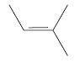
A 2-methylbut-3-ene
B 3-methylbut-2-ene
C 3-methylbut-3-ene
D 2-methylbut-2-ene
(Total for question = 1 mark)

Q28.
The equations below show some of the processes that occur when methane and chlorine
react.
A Cl₂(g) → 2Cl•(g)
B Cl•(g) + CH₄(g) → CH₃•(g) + HCl(g)
C CH₃•(g) + CH₃•(g) → C₂H₆(g)
D Cl₂(g) + CH₄(g) → CH₃Cl(g) + HCl(g)
(a) Which equation shows a propagation step?
(1)
A
B
C
D
(b) Which equation shows an initiation step?
(1)
A
B
C
D
(c) Which equation shows a termination step?
(1)
A
B
C
D
(Total for question = 3 marks)

Q29.
The mechanism of the reaction represented by the equation
is an example of
A Free radical substitution
B Free radical addition
C Electrophilic substitution
D Electrophilic addition
(Total for question = 1 mark)

Q30.
What is the systematic name for the following compound?
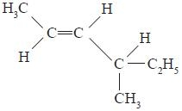
A Z-4-methylhex-2-ene
B E-2-ethylpent-3-ene
C Z-4-ethylpent-2-ene
D E-4-methylhex-2-ene
(Total for question = 1 mark)

Q31.
What is the systematic name for the compound with the following formula?
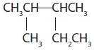

A 2-methyl-3-ethylbutane
B 1,2,3-trimethylbutane
C 2,3-dimethylpropane
D 2,3-dimethylpentane
(Total for Question = 1 mark)

Q32.
The repeat unit of a polymer is shown below.
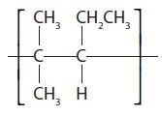
The systematic name of the alkene monomer that forms this polymer is

A 2-methyl-3-ethylpropene
B 2-methylpent-2-ene
C 2-methylpent-3-ene
D 4-methylpent-2-ene
(Total for Question = 1 mark)

Q33.
What is the systematic name for the hydrocarbon shown below?
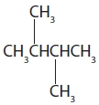
A 1,4-dimethylbutane
B 2,3-dimethylbutane
C 2,3-dimethylhexane
D 1,1,2,2-tetramethylethane

(Total for question = 1 mark)

Q34.
The reaction of bromine with propene is an example of
A electrophilic substitution.
B free radical substitution.
C electrophilic addition.
D free radical addition.
(Total for question = 1 mark)

Q35.
An organic compound reacts with chlorine in the presence of ultraviolet light. The
relative molecular mass of the product has increased by 34.5 compared with the original
compound. What is the reaction mechanism?
A Free radical substitution
B Electrophilic substitution
C Nucleophilic substitution
D Free radical addition
(Total for question = 1 mark)

Q36.
What is the IUPAC name of the compound shown below?
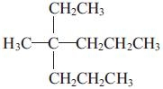
A 2-ethyl-2-propylpentane
B 3-methyl-3-propylhexane
C 4-methyl-4-propylhexane
D 4-ethyl-4-methylheptane
(Total for question = 1 mark)

Q37.
What is the correct name for the compound below?
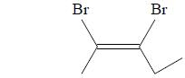
A E-2,3-dibromopent-2-ene
B E-2,3-dibromopent-3-ene
C Z-2,3-dibromopent-3-ene
D Z-2,3-dibromopent-2-ene
(Total for question = 1 mark)

Q38.
How many structural isomers does the alkane C₅H₁₂ have?
A 4
B 3
C 2
D 1
(Total for question = 1 mark)

Q39.
The structural formula of 5-chloro-2,2-dimethylhexane is
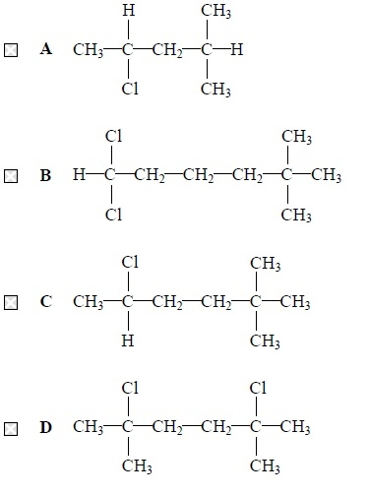
(Total for question = 1 mark)

Q40.
Which of the following substances, obtained from the fractional distillation of crude oil,
has the lowest boiling temperature?
A refinery gas
B kerosene
C diesel oil
D lubricating oil
(Total for question = 1 mark)

Q41.
Which of the following is the correct order for the processes used to obtain petrol from
petroleum (crude oil)?
A Petroleum → fractional distillation → reforming → petrol.
B Petroleum → reforming → fractional distillation → petrol.
C Petroleum → reforming → fractional distillation → petrol.
D Petroleum → fractional distillation → reforming → petrol.
(Total for question = 1 mark)

Q42.
In the following outline of the Periodic Table, the letters A to D are not the symbols of the elements.
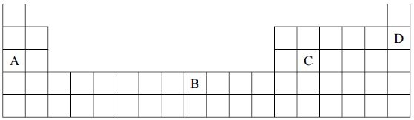
Select from A to D the element which
(a) is a non-metal with a high melting temperature and boiling temperature.
(1)
A
B
C
D
(b) is in the d block of the Periodic Table.
(1)
A
B
C
D
(c) has a very stable electronic structure.
(1)
A
B
C
D
(d) is a metal with a high melting temperature and boiling temperature.
(1)
A
B
C
D
(Total for Question = 4 marks)

Q43.
This question concerns the reaction of hydrogen bromide with propene.
(a) This reaction requires
(1)
A normal laboratory conditions.
B the presence of UV light.
C the presence of a suitable catalyst.
D heating under reflux.
(b) The reaction is best described as
(1)
A nucleophilic substitution.
B electrophilic substitution.
C nucleophilic addition.
D electrophilic addition.
(c) The major product of the reaction will be
(1)
A 1-bromopropane
B 2-bromopropane
C 1,2-dibromopropane
D 2-bromopropene
(Total for Question = 3 marks)

Q44.
If propene, CH₃CH==CH₂, is reacted with aqueous acidified potassium manganate(VII)
the organic product is
A CH₃CH(OH)CH₂OH
B CH₃CH(OH)CH₃
C HOCH₂CH₂CH₂OH
D CH₃CH₂CH₂OH
(Total for question = 1 mark)

Q45.
Propene reacts with hydrogen chloride gas to give mainly
A 1-chloropropane (CH₃CH₂CH₂Cl)
B 2-chloropropane (CH₃CHClCH₃)
C 3-chloroprop-1-ene (CH₂CHCH₂Cl)
D 1,2-dichloropropane (CH₃CHClCH₂Cl)
(Total for question = 1 mark)

Q46.
This question is about the organic compounds shown below.
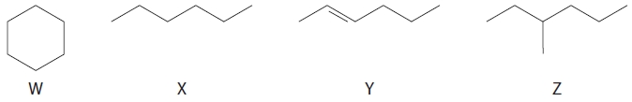
(a) The compounds which are isomers are
(1)
A W and X
B W and Y
C W and Z
D X and Z
(b) Which compound can react with chlorine to form C₆H₁₂C_{l2} as the only product?
(1)
A Compound W
B Compound X
C Compound Y
D Compound Z
(c) Which compound is reformed in the oil industry, producing one mole of a compound with formula C₆H₆ and four moles of hydrogen, H₂, only?
(1)
A Compound W
B Compound X
C Compound Y
D Compound Z

(Total for question = 3 marks)

Q47.
Four of the reactions of propene are shown on the diagram below.
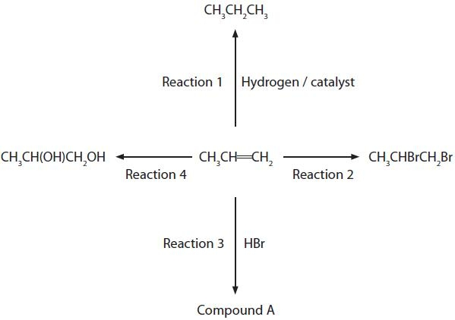
(a) Nickel is often used as the catalyst for Reaction 1. Use your Periodic Table to select which of the following metals can be used instead of nickel to catalyse Reaction 1.
(1)
A Potassium
B Calcium
C Gallium
D Palladium
(b) Nickel is often used as the catalyst for Reaction 1. Use your Periodic Table to select which of the following metals can be used instead of nickel to catalyse Reaction 1.
(1)
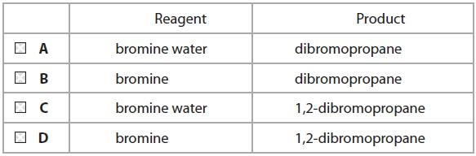
(c) What is formed in Reaction 3?
(1)
A Only 1-bromopropane
B Only 2-bromopropane
C A mixture of bromopropanes containing mainly 2-bromopropane
D A mixture of bromopropanes containing mainly 1-bromopropane
(d) A mixture of dilute sulfuric acid and which of the following reagents is needed for
Reaction 4?
(1)
A KOH
B KMnO₄
C H₂O₂
D O₂
(e) The reaction of propene in Reaction 4 can be classified both as
(1)
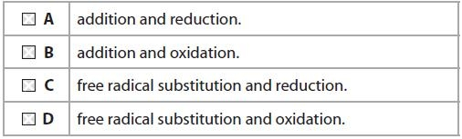
(Total for question = 5 marks)

Q48.
Many organic compounds have toxic vapours. For this reason
A a naked flame should never be used when carrying out experiments with organic compounds.
B gloves should usually be worn when carrying out experiments with organic compounds.
C a fume cupboard should be used wherever possible when carrying out experiments with organic compounds.
D most experiments with organic compounds are banned in schools and colleges.
(Total for Question = 1 mark)

Mark Scheme
Q1.

Q2.

Q3.

Q4.

Q5.

Q6.

Q7.

Q8.

Q9.

Q10.

Q11.

Q12.

Q13.

Q14.

Q15.

Q16.

Q17.

Q18.

Q19.

Q20.

Q21.

Q22.

Q23.

Q24.
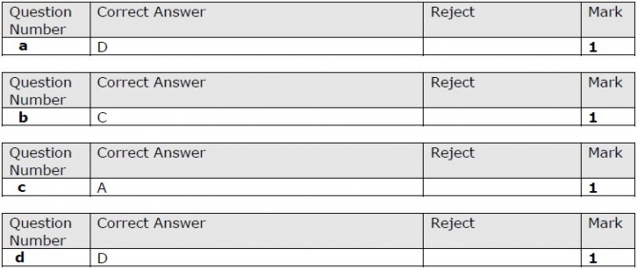

Q25.

Q26.

Q27.

Q28.

Q29.

Q30.

Q31.

Q32.

Q33.

Q34.

Q35.

Q36.

Q37.

Q38.

Q39.

Q40.

Q41.

Q42.
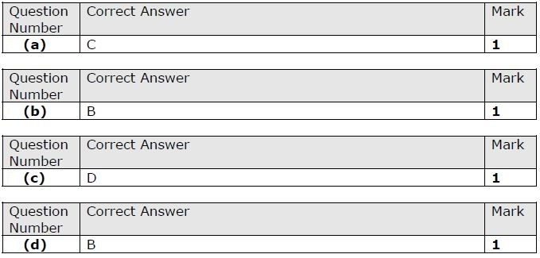

Q43.

Q44.

Q45.

Q46.

Q47.

Q48.

