Questions
Q1.
The reaction between carbon monoxide and hydrogen reaches a dynamic equilibrium.
(a) Which of these statements about a dynamic equilibrium is not true?
(1)
A The forward rate of reaction is equal to the backward rate of reaction.
B The concentrations of the products and reactants do not change.
C The concentrations of the products and reactants are equal.
D The equilibrium can be approached from either direction.
(b) The K_{c} expression for the above reaction is
(1)
A 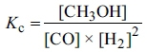
B 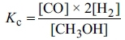
C 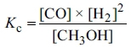
D 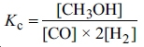
(Total for question = 2 marks)

Q2.
(a) For the equilibrium reaction between hydrogen and iodine
H₂(g) + I₂(g) 2HI(g)
increasing the pressure of the system
(1)

A has no effect on the rate or the position of equilibrium.
B increases the rate but does not affect the position of equilibrium.
C increases the rate and shifts the equilibrium to the right.
D increases the rate and shifts the equilibrium to the left.
(b) The equation for the equilibrium reaction between hydrogen and iodine may also be written as
½H₂(g) + ½I₂(g) HI(g)
This change to the equation, compared to that in part (a),
(1)

A has no effect on the value of the equilibrium constant.
B halves the value of the equilibrium constant.
C doubles the value of the equilibrium constant.
D square roots the value of the equilibrium constant.
(Total for Question = 2 marks)

Q3.
Ammonium chloride decomposes on heating:
NH₄Cl(s) NH₃(g) + HCl(g)
The equilibrium constant, K_{p}, for this reaction equals
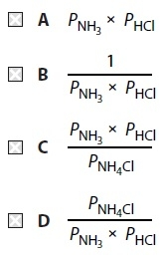
(Total for Question = 1 mark)

Q4.
Methanol is produced in the equilibrium reaction
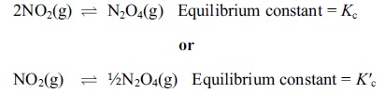
Which expression is correct?
A K_{c} = K'_{c}
B K_{c} = (K'_{c})²
C K_{c} = 2(K'_{c})
D K_{c} = ½K'_{c}
(Total for question = 1 marks)

Q5.
Hydrogen and iodine, both with an initial concentration of 0.010 mol dm⁻³, were allowed to react. At equilibrium, the concentration of hydrogen iodide was 0.0030 mol dm⁻³.
K_{c} is calculated using the values
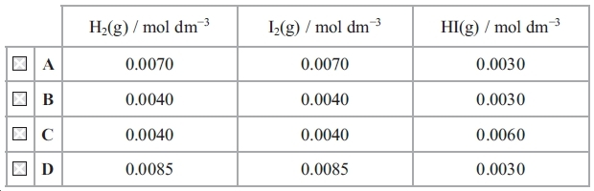
(Total for question = 1 mark)

Q6.
The reaction below reached a dynamic equilibrium from an initial mixture of all four
substances P, Q, R and S in aqueous solution.
The following data were obtained.
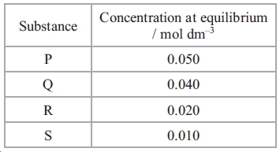
K_{c} for the equilibrium is
A 0.10
B 0.33
C 3.00
D 10.0
(Total for question = 1 mark)

Q7.
Consider the equilibrium below.
CO(g) + Cl₂(g) COCl₂(g)
(a) An increase in pressure by a factor of 2 will
(1)
A quadruple K_{p}.
B double K_{p}.
C have no effect on K_{p}.
D halve K_{p}.
(b) The units of K_{p} are
(1)
A atm⁻²
B atm⁻¹
C atm
D atm²
(Total for question = 2 marks)

Q8.
Iron and steam at high temperature react in a closed vessel to give an equilibrium
mixture
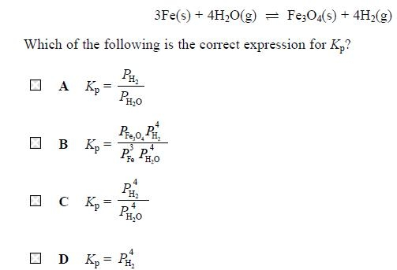
(Total for question = 1 mark)

Q9.
This question is about the equilibrium reaction
Which statement is not correct?
A The units of K_{p} are atm⁻².
B K_{p} increases as temperature is decreased.
C K_{p} increases when the pressure increases.
D K_{p} increases when the total entropy change, ΔS_{total}, increases.
(Total for question = 1 mark)

Q10.
The Haber process is used to make ammonia from nitrogen and hydrogen at 450 °C.
(a) If the partial pressures of these gases were measured in atm, the units of the equilibrium constant K_{p} will be
(1)
A atm
B atm²
C atm⁻²
D atm⁻¹
(b) When the temperature of the system is increased
(1)
A K_{p} decreases.
B K_{p} increases.
C K_{p} stays the same.
D K_{p} first decreases and then increases.
(Total for question = 2 marks)

Q11.
4.0 mol of methanoic acid are reacted with 6.0 mol of ethanol.
The equilibrium mixture contains 3.0 mol of HCOOC₂H₅.
The equilibrium constant, K_{c}, for the reaction is
A 0.33
B 1.0
C 3.0
D 4.0
(Total for question = 1 marks)

Q12.
The equation for the synthesis of methanol is
At equilibrium, when the temperature is 340 K, the total pressure is 20 atm. The moles of each component present at equilibrium are shown in the table below.
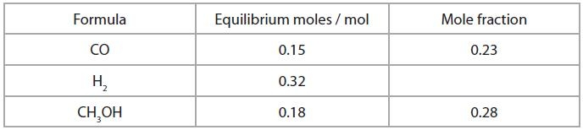
(a) The mole fraction of hydrogen in the equilibrium mixture is
(1)
A 0.23
B 0.46
C 0.49
D 0.92
(b) The numerical value for the equilibrium partial pressure of the carbon monoxide, in atmospheres, is
(1)
A 3.0
B 4.6
C 5.0
D 9.2
(c) Units for the equilibrium constant, K_{p}, for this reaction are
(1)
A no units
B atm
C atm⁻¹
D atm⁻²
(Total for question = 3 marks)

Q13.
What are the units of K_{c} for the following equilibrium?
2SO₂(g) + O2(g) 2SO₃(g)
A atm
B atm ⁻¹
C dm³mol ⁻¹
D mol dm ⁻³
(Total for question = 1 mark)

Mark Scheme
Q1.

Q2.

Q3.

Q4.

Q5.

Q6.

Q7.
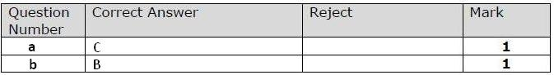

Q8.

Q9.

Q10.

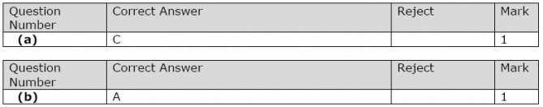

Q11.

Q12.

Q13.

