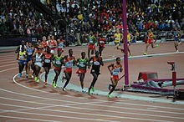
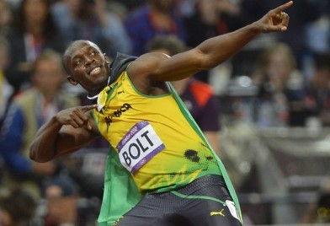
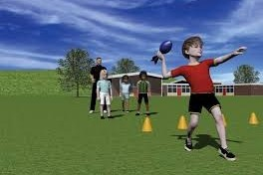
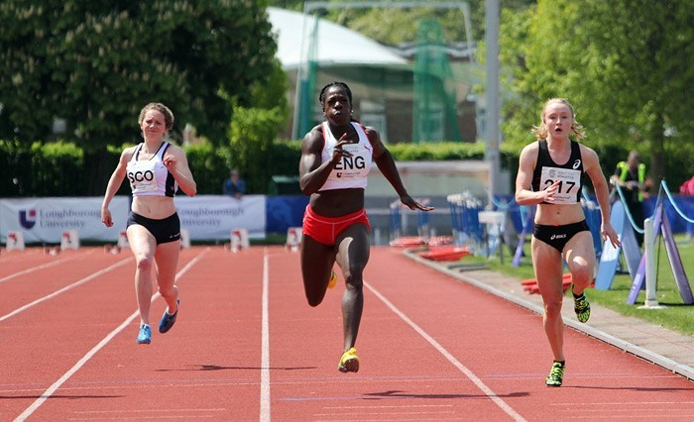
Y3/4 PE Knowledge Organiser— Athletics

Key Knowledge  Learn these key facts—key points in red | Key Vocabulary  Understand these key words |  | Competition Focus
Track: Running Events  50m sprint: Running as fast as you can from the start until the finish  400m: Endurance race meaning you can’t sprint the entire race. You need to pace your race so that you don’t get too tired too quick- ly but have still run as fast as you can.  How quickly can you complete the races?  Running Technique  Having a good technique will help improve  times. When sprinting making sure that you run in a straight line, keep look- ing forward and not at others, run through the line  and dip forward just as your finishing! Maybe you could be the next Usain!  In a longer distance you don’t have to stay in a spe-  cific lane so run on the inside lane as it’s shorter with the turns!  Field: Jumping and Throwing  Howler Throw: Overarm throw trying to launch the howler as far as possible. A straight or bent arm technique can be used  Standing Long Jump: Two foot- ed single jump forward. How far can you jump? | Word | Definition | Elite competitions take place all over the world. The most famous is the  Olympic Games, held every four years.  Events:  100m, 200m, 400m, 800m,  1500m, 5000m, 10000m,  110m hurdles, 400m  hurdles, 4x100m relay, high jump, long jump, triple  jump, javelin, discus, decathlon.  London 2012  Summer 2012 was an  Olympic summer for  England as London hosted the competition. Loads of fun activities took place for all ages around the  country!
 | Speed | To move quickly
 | Acceleration | To go from still to moving at speed as fast as possible
 | Hurdles | An obstacle that a runner may have to jump over during a race
 | Reaction Time | How quickly you react to a stimulus
 | Track | Events that involve running, usually on the running track
 | Field | Events that a based around jumping and throwing
 | Finishing line | The point at which the timer stops—You  DO NOT STOP HERE!
 | Lanes | The running area that you are allowed in
 | Endurance | Being able to repeat a specific movement– running a long distance
 | Power | Force generated by your body to help  move it.
 | Momentum | Creating speed that is used to transfer into power for a jump, throw or to gain top  speed as quickly as possible
 | Relay | Working as a team to complete a race with a baton.

