|  |
| --- |
| PE Knowledge Organiser |

|  |  |  |  |
| --- | --- | --- | --- |
| **Sport focus:** | **Tag Rugby** | **Year 3** | **Autumn 2** |

|  |
| --- |
| **Possible Experiences** |

Keep ball

End ball

Bonus tag

Staggered passing

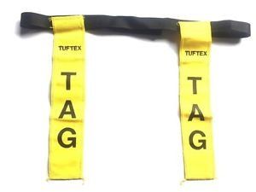

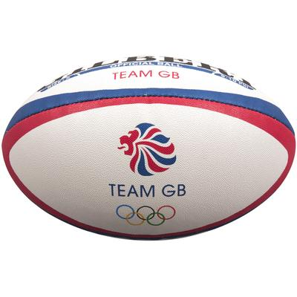

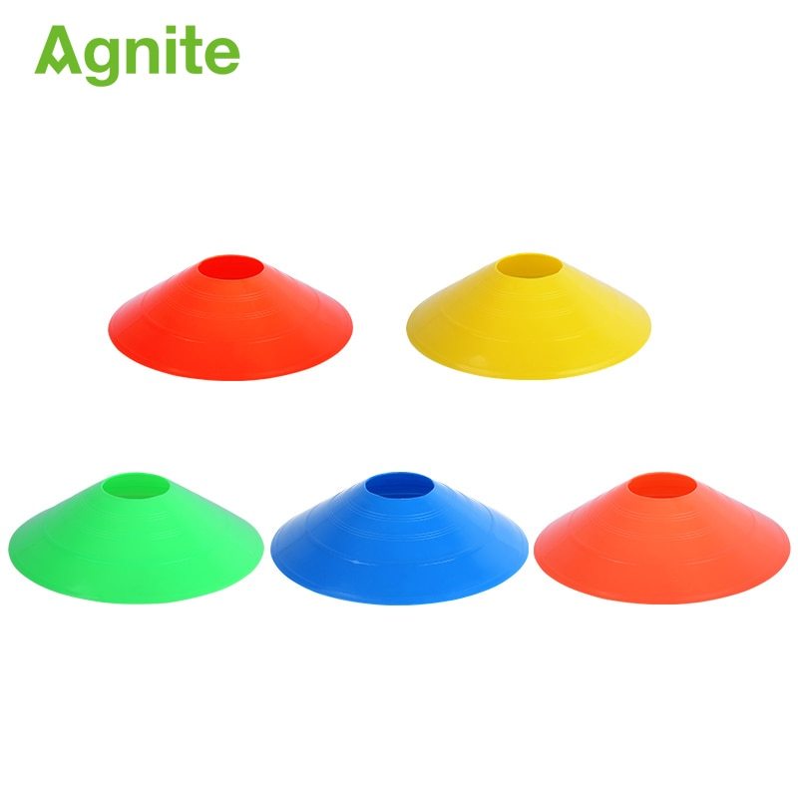

**What? (Key Vocabulary)**

|  |  |
| --- | --- |
| **Spelling** | **Definition/Sentence** |
| **Warm up** | Preparing our bodies for exercise, pumping blood around our bodies faster, to prevent injuries |
| **Cool down** | An easy exercise, done after exercise, to allow the body to transition to a resting |
| **Rugby ball** | An oval shaped ball used in tag rugby |
| **Tagging** | Making contact with the ball carrier or attacking player |
| **Dodging** | Changing direction quickly, avoiding contact with the opposition. |
| **Evasion** | Running into open space. |
| **Invade** | Closing down the space. |
| **Ball carrier** | The player in the game who is carrying the ball. |

|  |
| --- |
| **Diagrams and Symbols** |

**What? (Key Knowledge)**

|  |  |
| --- | --- |
| Teaching Points | |
| Catching a rugby ball with consistently in a line of 4. |  |
| Passing a ball to someone else in the correct direction with correct forward movement. |  |
| How to begin to Influence  opposed conditioned games that involve tagging |  |
| How to evade and invade successfully. |  |
| Talk about reasons for warming up/why exercise is good for health |  |
| Rules | |
| Players can run with the ball until tagged | |
| Players must remain on their feet at all times | |
| The ball must be placed on the floor to score | |
| When tagging, players must shout ‘tag’ and stand still. | |
| Questions | |
| Q. How might you anticipate where the ball is being passed?  A. See where the ball carrier is looking, who is communicating for it, who is in space. | |
| Q. What skills do you need to stop yourself being tagged with the ball?  A. Passing, dummying, dodging and moving into space. | |
| Q. What is more accurate a long or short pass?  A. Short pass, easier to perform and catch. | |
| Q How can you let the player with the ball know you are in space?  A. Communicate specific information e.g. Not yes but left or right, Short or long. | |