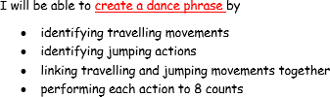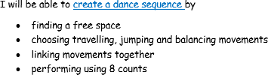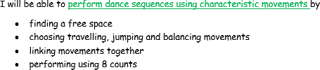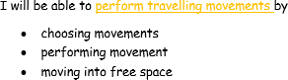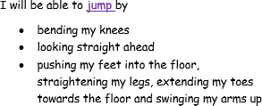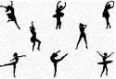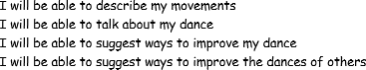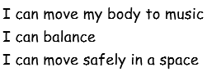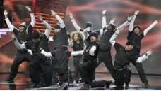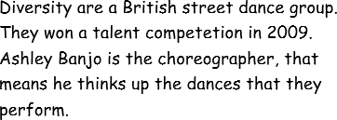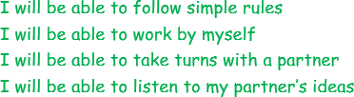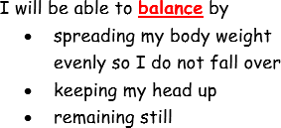

KEY QUESTIONS

How can you improve your sequence?

How do you find a space?

How many beats/counts does each action last for?

Which movements will you choose?

In what order will you perform your sequence?

**KEY VOCABULARY**

**balance –**the ability to distribute the weight evenly when stationary or moving around the room without falling over

**dance phrase –** a sequence of movements or actions

**dance sequence –** a series of movements longer than a phrase

**evaluate –** talk about the things that went well and how to develop and improve

**jump –** leap, spring, bounce, hop, prance, gallop

**link –** join movements together

**travel –** skip, gallop, walk ,tip toe, crawl, jog, waddle, slide, creep, hop