|  |
| --- |
| PE - Knowledge Organiser |

|  |  |  |  |
| --- | --- | --- | --- |
| **Sport focus:** | **Tag Rugby** | **Year 4** | **Autumn 2** |

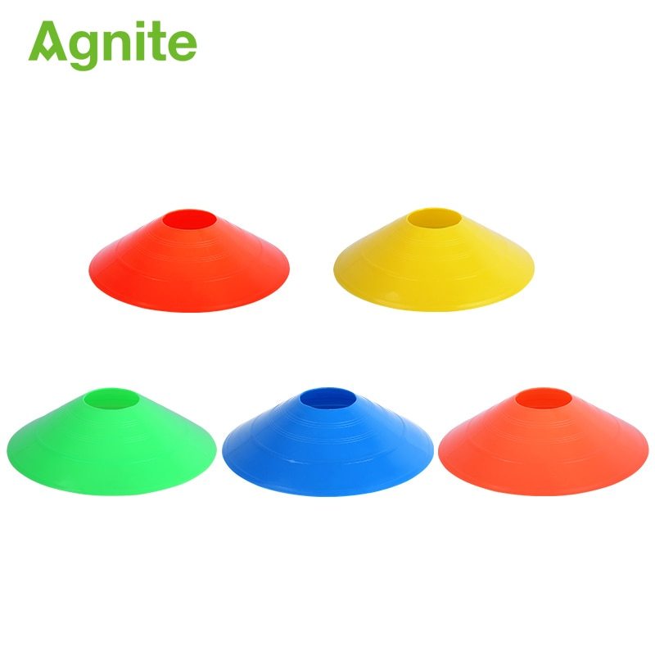

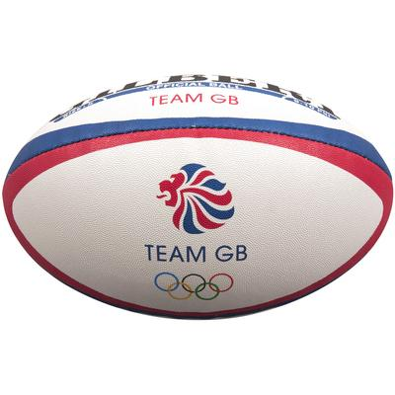

|  |
| --- |
| **Possible Experiences** |

Any directional tag

Number tag

Bonus tag

2v1

**What? (Key Vocabulary)**

|  |  |
| --- | --- |
| **Spelling** | **Definition/Sentence** |
| **Warm up** | Preparing our bodies for exercise, pumping blood around our bodies faster, to prevent injuries |
| **Cool down** | An easy exercise, done after exercise, to allow the body to transition to a resting |
| **Dodging** | Changing direction quickly, avoiding contact with the opposition. |
| **Try** | The grounding of the ball on or over the try line. |
| **Evasion** | Running into open space (Attacking) |
| **Invade** | Closing down the space (Defending) |
| **Closing down** | The skill of a defender get close enough to remove a tag. |
| **Turn over ball** | The possession of the ball being lost |

|  |
| --- |
| **Diagrams and Symbols** |



**What? (Key Knowledge)**

|  |  |
| --- | --- |
| Teaching Points | |
| How to influence opposed conditioned games involving tagging. |  |
| How to control and catch a ball with movement. |  |
| How to accurately pass to someone else in a backwards direction. |  |
| How to move with a ball in opposed situations |  |
| How to evade and invade |  |
| Understanding of tactics and rules of rugby. |  |
| I can talk about reasons for warming up/why exercise in good for health. |  |
| Rules | |
| Players can run with the ball until tagged | |
| Players must remain on their feet at all times | |
| The ball must be placed on the floor to score | |
| When tagging, players must shout ‘tag’ and stand still. | |
| Questions | |
| Q. What is easier to tag – a player running at you or a player running around you?  A. A player running at you, force the tagger to reach for you. | |
| Q Why would you pass before being tagged?  A.Because there is a player in a better position to make ground or to score. | |
| Q. What are you looking for as the ball carrier?  A. Where there is space and where the defender in inactive. | |
| Q. What can the support players do without the ball?  A. Scan and communicate the space options to ball carrier. | |