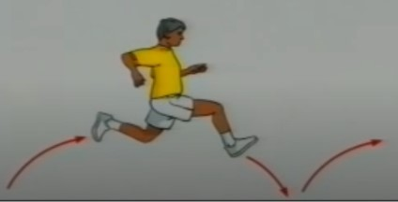
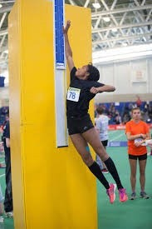
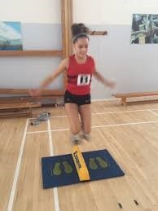
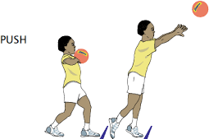
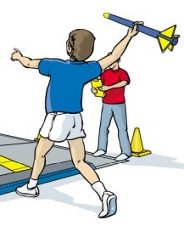
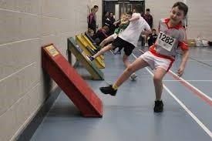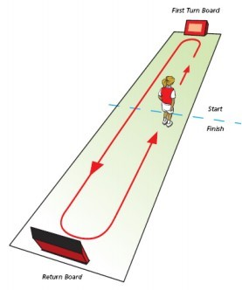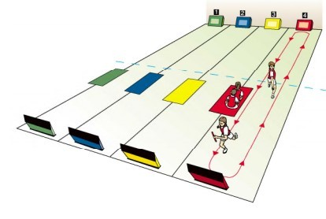
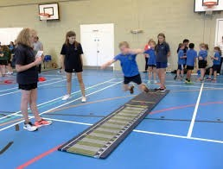
Y3/4 PE Knowledge Organiser— Indoor Athletics

Key Knowledge  Learn these key facts—key points in red |  |  | Key Vocabulary  Understand these key words |  | Competition Focus
Vertical jump— how high can jump? | Jumping  Long jump and 5  strides—how far can you go in  Long jump—1 jump 5 strides—5 steps  Speed Bounce— in 20 seconds  how many 2 footed side to side jumps can you do? |  | Word | Definition | Elite competitions take  place all over the world on indoor tracks which are a 200m oval with a 60m  sprint track in the middle.  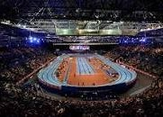  Events:  60m, 60m hurdles, 400m,  800m, 1500m, 3000m. High  jump, long jump, triple jump, pole vault, shot put and Hepthalon (men) / pentathlon (women)  British Indoor  European Indoors World Indoors
 |  |  | Speed | To move quickly
 |  |  | Acceleration | To go from still to moving at speed as fast
 |  |  |  | as possible
 |  |  | Momentum | Creating speed that is used to transfer into
 |  |  |  | power for a jump, throw or to gain top
 |  |  |  | speed as quickly as possible
 |  |  | Turning Board | Designed to help you turn at a wall as
 |  |  | (Return board) | quickly as possible.
 |  |  | Reaction Time | How quickly you react to a stimulus
 |  |  | Agility | The ability to speed up / slow down and
 |  |  |  | change direction.
Running
Running starts in the middle of the hall goes to one end then
the other and back to the
middle (1 lap) -
sometimes obstacles are on the track too. Individual or as a team
Throwing
 |  |  | Finishing line | The point at which the timer stops—You
 |  |  |  | DO NOT STOP HERE!
Chest push—using a
basketball—try to send it as far as pos-
 |  |  | Obstacle | An object such as a hurdle, post, tunnel or speed bounce.
sible. |  |  | Consistency | Being able to perform the same skill
 |  |  |  | accurately repetitively.
Overarm Throw—shuttlecock / |  |  | Accuracy | Using aim to get objects to a target
foam javelin used.
How far can you throw it? |  |  | Power | Force generated by your body to help  move it.
 |  |  | Relay | Working as a team to complete a race with
 |  |  |  | a baton.

