**Year 6 Autumn 2 Term Knowledge Organiser**

**Why is the Torah so important within Judaism?**



**What I will learn in the future…**

|  |  |
| --- | --- |
| Star Vocabulary | |
| **Torah** | The law of God as revealed to Moses and recorded in the first five books of the Hebrew scriptures |
| **Sefer Torah** | A book of Hebrew religious literature. |
| **Mantle** | Cloth covers used to decorate and protect Torah scrolls. |
| **Shabbat** | The Sabbath – a day of religious observance |
| **Synagogue** | The building where a Jewish assembly or congregation meets for religious worship. |
| **Simchat Torah** | A Jewish holiday that celebrates and marks the conclusion of Sukkot. |
| **Talmud** | The Jewish Law |
| **Yad** | a handheld pointer used for reading the Sefer Torah. |

**What I should know already...**

What does it mean to be a member of a Jewish Community?

Why are festivals, celebrations and holy days so important within Judaism?

What sources of authority are there within Judaism?

**Facts**

* **Link to previous RE topic** - Most Jews believe that everything God does is for good.
* **Link to Year 5 learning -**The Torah contains five books revealed to Moses by God on Mount Sinai. A special pointed is used to follow the words when reading it.
* The Torah is taken out during prayer services on Shabbat, Mondays and Thursdays.
* The Torah contains 613 commandments and Jews refer to the 10 best known of these.



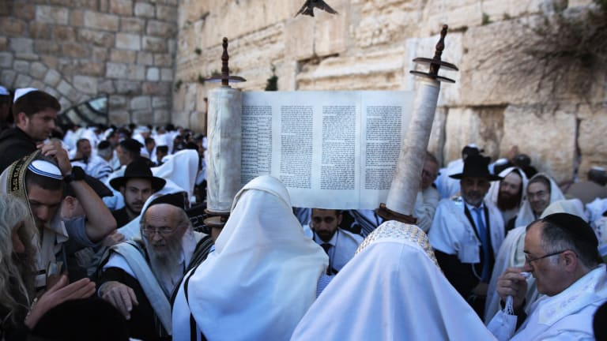

Speak sensitively and in a reasoned way about both the benefits and challenges of belonging to a religious community in contemporary society

**Attainment Skills**

Speak about the variety of religious practices that people of faith follow, explaining how these shape individuals, groups and societies

Discuss the connections between beliefs, teachings and the issues that face human societies in the world today by drawing on the perspectives of different faiths and beliefs

Use appropriate religious vocabulary to explain why different forms of religious and moral expression are important to members of faith and belief communities

Speak about how religions address some of the major questions in human life, identifying how sources of authority underpin these perspectives

Identity some of the most important issues about meaning, purpose and truth and speak about both their own and others’ views on these issues