**What is significant to Christians about Jesus’ life and teachings?**

**Year 5 Autumn 2 Term Knowledge Organiser**



|  |  |
| --- | --- |
| Star Vocabulary | |
| **Jesus** | The Son of God |
| **Messiah** | Messiah is a Hebrew word meaning ‘anointed one’. Christians believe that Jesus is the Messiah because through his crucifixion and resurrection he brought salvation to humankind. |
| **Parable** | A short story that teaches a moral or spiritual lesson. |
| **Church** | The building used for public and Christian worship. |
| **Nativity** | A theme in Christian art depicting the new-born Jesus with the virgin Mary. |
| **Jerusalem** | This is the place where Jesus preached, died and was resurrected. |
| **Bethlehem** | Bethlehem is the cradle of Christianity, the site of the church of the nativity, where Christians believe Mary gave birth to Jesus in a stable. |

**What I should know already...**

**What I will learn in the future…**

In what ways do Christians in different denominations worship?

**Facts**

* Christians believe that Jesus Christ was the Son of God, given as a sacrifice so that humans would have the possibility of eternal life in Heaven.
* Jesus preached, taught in parables, and gathered disciples.
* It is believed that through his crucifixion and subsequent resurrection, God offered humans salvation and eternal life, that Jesus died to atone for sin to make humanity right with God.
* His three basic teachings included the need for justice, morality, and service to others.
* Through his teachings, and by setting an example of selfless love, Christians believe that Jesus guides people to live less sinful lives.

What is the significance of Easter within Christianity?

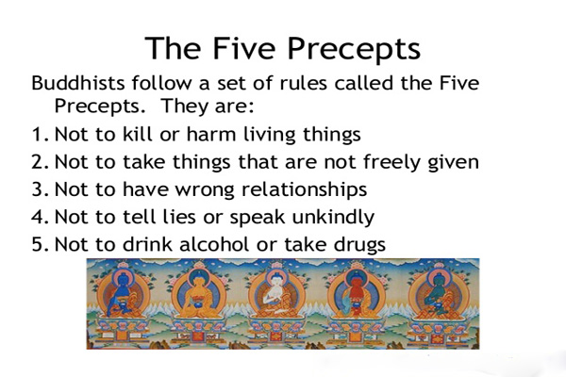

Articulate their own insights and feelings about human identity, belonging and engagement with faith and belief traditions

**Attainment Skills**

Explain the reasons why people belong to religious communities

Ask meaningful questions about important aspects of life, identify and the role of religion in this context

Use a range of religious terms to explain the similarities and differences between diverse forms of religious expression

Ask thoughtful questions about the purpose of life and show an understanding of how religions address these questions

Explain how religious beliefs are derived from sources of authority and help to address big questions