solve one-step problems involving multiplication and division.

solve problems, including missing number problems, involving multiplication and division

Year 2 Multiplication and Division Knowledge Organiser

**Sentence Stems**

**There are ____ equal groups with ____ in each group.**

**There are ____ altogether.**

**Misconceptions: Why?**

Arrays – Children may not make an array accurately and have an uneven number of rows or columns.

**Star Vocabulary**

|  |  |
| --- | --- |
| **Multiplication** | The process or skill of multiplying. |
| **Skip Counting** | The method of counting forward by numbers other than 1. |
| **Equal Groups** | Same number of objects in each group. |
| **Array** | An arrangement of objects, numbers or pictures in rows and columns. |
| **Bar Model** | A pictorial representation of a problem where bars are used to represent known and unknown numbers. |
| **Twice as big** | Two times bigger. |

**Factual & Conceptual Fluency progression**

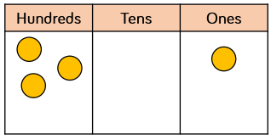

Secure and maintain fluency in all multiplication tables, and corresponding division facts, through continued practice.

Recall the 3, 6 and 9 multiplication tables, and corresponding division facts.

Recall the 11 and 12 multiplication tables, and corresponding division facts.

Recall the 7-multiplication table, and corresponding division facts.

Secure and maintain fluency in addition and subtraction within and across 10, through continued practice.

Recall the 2, 4 and 8 multiplication tables, and corresponding division facts.

Addition and subtraction across 10.

Addition and subtraction within 10.

Recall the 10 and 5 multiplication tables, and corresponding division facts.