Questions
Q1.
If the mean C−−H bond enthalpy is +x, which of the following represents a process with
an enthalpy change of +4x?
A C(g) + 4H(g) → CH₄(g)
B CH₄(g) → C(g) + 4H(g)
C CH₄(g) → C(s, graphite) + 2H₂(g)
D C(s, graphite) + 2H₂(g) → CH₄(g)
(Total for question = 1 mark)

Q2.
Which equation represents the reaction for which the enthalpy change, ΔH, is the mean bond energy of the C-F bond?

A CF₄(g) → C(g) + 4F(g)
B ¼CF₄(g) → ¼C(g) + F(g)
C C(g) + 4F(g) → CF₄(g)
D ¼C(g) + F(g) → ¼CF₄(g)
(Total for Question = 1 mark)

Q3.
The enthalpy change for the reaction
is +1648 kJ mol⁻¹. Hence the mean bond enthalpy for the C–H bond is
A +329.6 kJ mol⁻¹
B +412.0 kJ mol⁻¹
C +1648 kJ mol⁻¹
D +6592 kJ mol⁻¹
(Total for question = 1 mark)

Q4.
For which of the following reactions is the enthalpy change equal to the bond enthalpy of H-I?
A
B
C 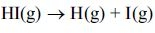
D 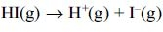
(Total for Question = 1 mark)

Q5.
Some mean bond enthalpy values are given in the table below.
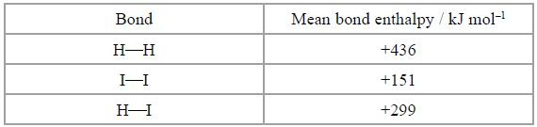
What is the enthalpy change for the reaction shown below in kJ mol⁻¹?
A +436 + 151 − 299 = +288
B −436 − 151 + 299 = −288
C +436 +151 − (2 × 299) = −11
D −436 − 151 + (2 × 299) = +11
(Total for question = 1 mark)

Q6.
Consider the following bond enthalpy values.
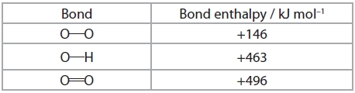
For the reaction
the enthalpy change, in kJ mol⁻¹, is
A −102
B +102
C +350
D +394

(Total for question = 1 mark)

Q7.
1.40 g of an alkene gave 3.77 g of a dichloroalkane on reaction with chlorine.
What is the molecular formula of the alkene?
A C₂H₄
B C₃H₆
C C₄H₈
D C₆H₁₂

(Total for question = 1 mark)

Q8.
Given the following data:
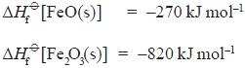
select the expression which gives the enthalpy change, in kJ mol⁻¹, for the reaction:
A (−820 × ½) + 270 = −140
B (+820 × ½) − 270 = +140
C −820 + (270 × 2) = −280
D +820 − (270 × 2) = +280
(Total for question = 1 mark)

Q9.
In an endothermic reaction in aqueous solution, which of the following is correct?
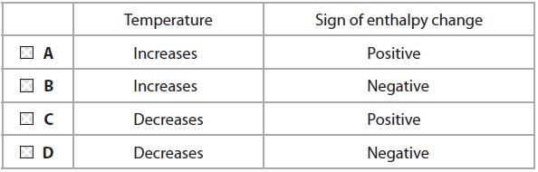
(Total for question = 1 mark)

Q10.
The enthalpy change for the reaction
cannot be measured directly since some carbon dioxide is always formed in the reaction.
It can be calculated using Hess's Law and the enthalpy changes of combustion of
graphite and of carbon monoxide.
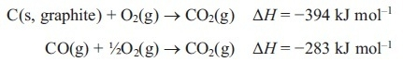
The enthalpy change for the reaction of graphite with oxygen to give carbon monoxide
is
A −677 kJ mol⁻¹
B +111 kJ mol⁻¹
C −111 kJ mol⁻¹
D +677 kJ mol⁻¹
(Total for question = 1 mark)

Q11.

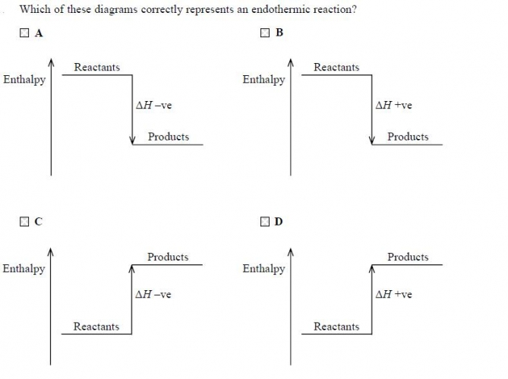
(Total for question = 1 mark)

Q12.
The enthalpy change for the reaction between hydrochloric acid and sodium hydroxide is −56 kJ mol⁻¹. Therefore
A the reaction is exothermic and the temperature rises.
B the reaction is exothermic and the temperature falls.
C the reaction is endothermic and the temperature rises.
D the reaction is endothermic and the temperature falls.
(Total for Question = 1 mark)

Q13.
In an experiment performed to measure the enthalpy change for the reaction
3.0 g of zinc powder (an excess) was added to 30.0 cm³ of copper(II) sulfate solution
of concentration 1.00 mol dm⁻³. The temperature rise of the mixture was 47.6 K.
Assuming that the heat capacity of the solution is 4.2 J K⁻¹ g⁻¹, the enthalpy change for
the reaction is given by
A ΔH = −(30 x 4.2 x 47.6) ÷ 0.03
B ΔH = −(33 x 4.2 x 47.6) ÷ 0.03
C ΔH = −(30 x 4.2 x 47.6) x 0.03
D ΔH = −(33 x 4.2 x 47.6) x 0.03
(Total for question = 1 mark)

Q14.
When 10 cm³ of 2 mol dm⁻³ hydrochloric acid is reacted with 10 cm³ of 2 mol dm⁻³ sodium hydroxide solution, the temperature change is ΔT.
When the reaction is repeated with 50 cm³ of each solution, the temperature change is
A ΔT
B 5 × ΔT
C × ΔT
D 10 × 2 × ΔT
(Total for question = 1 mark)

Q15.
The equation for the complete combustion of butanone, C₂H₅COCH₃, is
C₂H₅COCH₃(l) + 5½O₂(g) → 4CO₂(g) + 4H₂O(l) ΔH = −2440 kJ mol⁻¹
From the above data, the standard enthalpy change of formation of butanone, in kJ mol⁻¹, is

A −280
B +280
C −1760
D +1760
(Total for Question = 1 mark)

Q16.
Consider the following information:
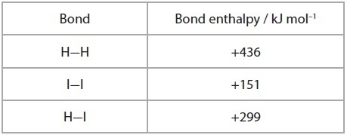
For the reaction
H₂(g) + I₂(g) → 2HI(g)
the enthalpy change, in kJ mol⁻¹, is

A +288
B +144
C −11
D −5.5
(Total for Question = 1 mark)

Q17.
The standard enthalpy changes of formation of carbon dioxide and of methanoic acid are −394 kJ mol⁻¹ and −409 kJ mol⁻¹ respectively. Calculate the enthalpy change for the reaction
H₂(g) + CO₂(g) → HCOOH(l)
A −803 kJ mol⁻¹
B −15 kJ mol⁻¹
C +803 kJ mol⁻¹
D +15 kJ mol⁻¹
(Total for question = 1 mark)

Q18.
In an experiment to determine the enthalpy change of combustion of an alcohol, a spirit burner containing the alcohol was weighed, lit and placed under a copper can containing a known volume of water. The temperature rise of the water was measured and the burner re-weighed. The enthalpy change calculated from the results was much less exothermic than the value reported in the literature.
Which of the following factors is most likely to be the cause of this error?
A Heat loss around the side of the copper can.
B The use of a thermometer with a range of 0 - 110 °C rather than 0 - 50 °C.
C The use of a measuring cylinder for measuring the water rather than a pipette.
D Evaporation of the alcohol during the weighing.
(Total for question = 1 mark)

Q19.
The enthalpy change of atomization of iodine is the value of ΔH for the process
A I₂(s) → I₂(g)
B I₂(s) → 2I(g)
C I₂(g) → 2I(g)
D ½I₂(s) → I(g)
(Total for question = 1 mark)

Q20.
The standard enthalpy changes of formation of some sulfur species are:
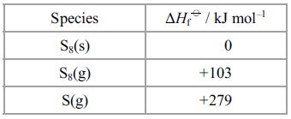
The enthalpy of atomization of sulfur is (in kJ mol⁻¹)
A 103 ÷ 8
B 279 ÷ 8
C 279
D (103 ÷ 8) + 279
(Total for Question = 1 mark)

Q21.
The molar enthalpy change of combustion of some alkanes is given below in kJ mol⁻¹.
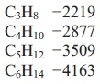
Another alkane was found to have an enthalpy change of combustion of −6125 kJ mol⁻¹
The alkane is
A C₇H₁₆
B C₈H₁₈
C C₉H₂₀
D C₁₀H₂₂
(Total for question = 1 mark)

Q22.
Which equation represents the reaction for which the enthalpy change, ΔH, is the mean
bond enthalpy of the C–H bond?
A ¼CH₄(g) → ¼C(g) + H(g)
B CH₄(g) → C(s) + 2H₂(g)
C CH₄(g) → C(g) + 4H(g)
D CH₄(g) → C(g) + 2H₂(g)
(Total for question = 1 mark)

Q23.
Which equation represents the reaction for which the enthalpy change is the standard
enthalpy change of formation, ΔH_{f}, of sodium nitrate, NaNO₃?
A 2Na(s) + N₂(g) + 3O₂(g) → 2NaNO₃(s)
B Na(s) + ½N₂(g) + 1½O₂(g) → NaNO₃(s)
C Na(s) + N(g) + 3O(g) → NaNO₃(s)
D Na(g) + ½N₂(g) + 1½O₂(g) → NaNO₃(g)
(Total for question = 1 mark)

Q24.
For which of the following changes is the value of ΔH negative?
A K(g) → K⁺(g) + e⁻
B K⁺Cl–(s) → K⁺(g) + Cl⁻(g)
C Cl(g) + e⁻ → Cl⁻(g)
D Cl₂(g) → 2Cl(g)
(Total for question = 1 mark)

Q25.
The enthalpy change for the reaction to form hydrated sodium thiosulfate crystals cannot be measured directly.
The following Hess cycle can be used.
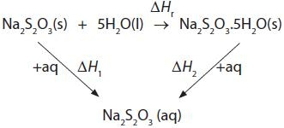
The enthalpy change for the reaction, ΔH_{r}, is equal to
A ΔH₁ + ΔH₂
B ΔH₁ − ΔH₂
C −ΔH₁ − ΔH₂
D −ΔH₁ + ΔH₂
(Total for question = 1 mark)

Q26.
When a solution of barium chloride is added to sulfuric acid, a white precipitate is formed. The ionic equation (including state symbols) for this reaction is
A
B
C
D
(Total for Question = 1 mark)

Q27.
Given the following information
CH₄(g) → C(g) + 4H(g) ΔH = +Q kJ mol⁻¹
the mean bond enthalpy for the C—H bond in methane is

A +Q
B +Q/4
C −Q
D −Q/4
(Total for Question = 1 mark)

Q28.
The concentration of blood glucose is usually given in millimoles per dm³ or
mmol dm⁻³. A reading of 5.0 mmol dm⁻³ is within the normal range. Glucose has a
molar mass of 180 g mol⁻¹. What mass of glucose dissolved in 1 dm³ of blood would
give this normal reading?
A 0.090 g
B 0.18 g
C 0.90 g
D 9.0 g
(Total for question = 1 mark)

Q29.
The standard enthalpy change for the combustion of graphite is −393.5 kJ mol⁻¹ and that of diamond is −395.4 kJ mol⁻¹.
What is the standard enthalpy change for the reaction below, in kJ mol⁻¹?
C(s, graphite) → C(s, diamond)
A −1.9
B +1.9
C −788.9
D +788.9

(Total for question = 1 mark)

Q30.
The standard enthalpy change of neutralization when an acid reacts with an alkali is the number of kilojoules released by the
A formation of one mole of salt.
B formation of one mole of water
C neutralization of one mole of acid.
D neutralization of one mole of alkali.

(Total for question = 1 mark)

Q31.
The standard enthalpy changes of combustion of carbon, hydrogen and methane are
shown in the table below.
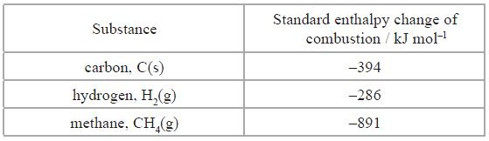
Which one of the following expressions gives the correct value for the standard enthalpy
change of formation of methane in kJ mol⁻¹?
A 394 + (2 × 286) − 891
B −394 − (2 × 286) + 891
C 394 + 286 − 891
D −394 − 286 + 891
(Total for question = 1 mark)

Q32.
In an experiment to measure the enthalpy change of a reaction involving gases, which of the following conditions must always be kept constant?
A Pressure
B Temperature
C Volume
D Temperature and pressure
(Total for question = 1 mark)

Q33.
The reaction for which the enthalpy change is the standard enthalpy change of formation of water, is
A H₂(g) + ½O₂(g) → H₂O(l)
B H₂(g) + ½O₂(g) → H₂O(g)
C 2H₂(g) + O₂(g) → 2H₂O(l)
D 2H₂(g) + O₂(g) → 2H₂O(g)

(Total for question = 1 mark)

Q34.
This question is about some standard enthalpy changes, ΔH
A enthalpy of reaction
B enthalpy of combustion
C mean bond enthalpy
D bond enthalpy
(a) Which enthalpy change is represented by p?
(1)
A
B
C
D
(b) Which enthalpy change is represented by q?
(1)
A
B
C
D
(c) Which enthalpy change is represented by r?
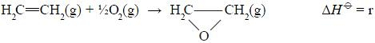
(1)
A
B
C
D
(Total for question = 3 marks)

Mark Scheme
Q1.

Q2.

Q3.

Q4.

Q5.

Q6.

Q7.

Q8.

Q9.

Q10.

Q11.

Q12.

Q13.

Q14.

Q15.

Q16.

Q17.

Q18.

Q19.

Q20.

Q21.

Q22.

Q23.

Q24.

Q25.

Q26.

Q27.

Q28.

Q29.

Q30.

Q31.

Q32.

Q33.

Q34.

