Summer 1:
Week 1: 20.04.20
Spellings

Practise these words.

Read | Trace | Practise | Practise | Practise | Practise
accommodate | accommodate
accompany | accompany
according | according
achieve | achieve
aggressive | aggressive

Now write a sentence for each word. Can you spell it correctly in each sentence without looking at the table?

__________________________________________________________________________________________________________________________________________________________________________________________________________________________________________________________________________________________________________________________________________________________________________________________________________________________________________________________________________________________________________________________________________________________________________________________________________________
__________________________________________________________________
Maths
Complete Week 22, Day 1 Fluent in Five
I have… | ÷ 10 | ÷ 100 | ÷ 1000
6345 | 634.5 | 63.45 | 6.345
5051
7334
843.2
343
I have… | X 10 | X 100 | X 1000
23 | 230 | 2300 | 23000
456
34
2.6
2.76

Remember you can use a place value grid
6345 ÷ 10 =
th | h | t | o | 1/10
6 | 3 | 4 | 5

True or False?
Explain the mistake if there is one!
- 654 ÷ 10 = 6540
- 452 x 100 = 45200
- 463 ÷ 100 = 3.46

English
Describe the picture below using interesting verbs, nouns, adjectives and adverbs
Remember your work needs to be better than mine!
Mrs White’s example: Example: Stalking intimidatingly, the majestic eagle perched awaiting its next prey

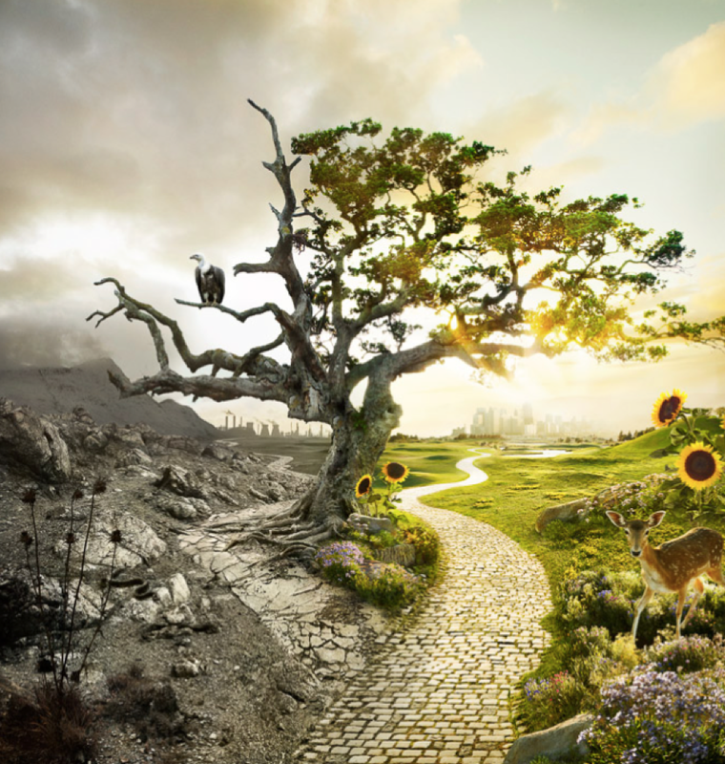

Words you could use:
stalking eagle majestic intimidatingly angrily
wind sunlight shimmer warmth
________________ ________________ ________________ ________________
________________ ________________ ________________ ________________
________________ ________________ ________________ ________________
________________ ________________ ________________ ________________
________________ ________________ ________________ ________________
________________ ________________ ________________ ________________
________________ ________________ ________________ ________________
________________ ________________ ________________ ________________
________________ ________________ ________________ ________________
________________ ________________ ________________ ________________

