ALEC REED ACADEMY
Mastery Booklet(Chemistry)
(Paper 1)
Name : ______________________
Teacher : ____________________
Date Given : __________________
These booklets are a consolidation of your learning. They should be used in the following way – You should attempt the questions WITHOUT looking at the answers. Then mark your questions with Green pen and add any missing marks you missed.
THIS WILL IMPROVE YOUR GRADES…!!

Year 11 GCSE Intervention Support 2019-20
These are your science exam dates for your
Paper 1
Biology 1…. …12th May 2020
Chemistry 1….. 14th May 2020
Physics 1…… 20th May 2020
These are your science exams for your
Paper 2
Biology2 1stJune 2020
Chemistry 2 10th June 2020
Physics 2 12th June 2020

IMPORTANT: This is not instead of revision at home. You should still do your own revision. This is just to help you with the toughest parts.
We know you have a lot to revise for and preparing for your exams can be stressful so here is a tool to help you.

STEP 1: You have finished your (B1, C1, and P1) year 9-11 learning so you can target all the areas you want support with.
HOW TO USE THIS BOOKLET
You know best. What your strengths and target areas are so please can you pick the topics you want most help with.
Tips:

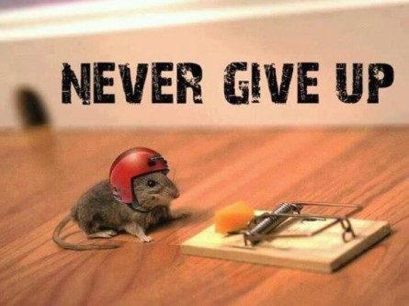
Revision Tips
1. Plan to revise. Don’t sit down without knowing what to do, it feels awful.
Try this…. “Right I am going to do 30 minutes on radioactivity. I will list 10 key facts, one idea I find tough and try 1 past paper question.”
So plan your tasks and topics. It really helps. Ask for help with making a revision plan.
2. Avoid distractions. Revise with a friend so you don’t think about what they are doing. Avoid revising when really tired or hungry.
3. Reward yourself. “If I do an hour or two this morning then I can go out this afternoon”.
4. Make stuff. Put up posters, make flash cards or revision cards. Post-it your room with key ideas. Keep what you’ve made to help you realise you are working well.
5. Practice past paper questions. You have been provided with a free book of these and they are one of the best things you can do. Remember to B.U.G. (Box the keyword, Underline important info, Go through it twice).

Revision tools
1. Use Sam Learning. The centre code is TA6CT1 https://www.samlearning.com/ Use your revision guide to help with the tasks/tests.
2. Don’t just read your revision guide. Make lists of keywords then test yourself to see if you can describe the keywords. Practice drawing key diagrams from memory. Use the question pages in the revision guides.
3. Google “AQA Science A past papers” for year 10 topics. Google “AQA science past papers” for year 11 stuff. Lots to choose from.
4. GCSE Bitesize has recently been given a makeover and now has lots of helpful videos linked to the tests and tasks.
5. Check out www.getrevising.co.uk. Free revision planner tool and many free resources. For a small monthly fee you can download other people’s revision materials for AQA science.
6. Phone apps. App store search cgp revision guides, they are fairly cheap if you want an on the go revision guide.
7. YOUTUBE The “mygcse science” youtube channel has really lovely walkthrough commentaries with pictures for all your B/C/P topics. Have a look.

Q1. There are eight elements in the second row (lithium to neon) of the periodic table.
(a) Figure 1 shows a lithium atom.
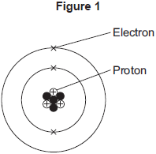
(i) What is the mass number of the lithium atom in Figure 1?

Tick (✔) one box.
3
4
7
(1)
(ii) What is the charge of an electron?

Tick (✔) one box.
–1
0
+1
(1)
(iii) Protons are in the nucleus. Which other sub-atomic particles are in the nucleus?

Tick (✔) one box.
ions
molecules
neutrons
(1)
(b) What is always different for atoms of different elements?

Tick (✔) one box.
number of neutrons
number of protons
number of shells
(1)
(c) Figure 2 shows the electron arrangements of three different atoms, X, Y and Z. These atoms are from elements in the second row (lithium to neon) of the periodic table.
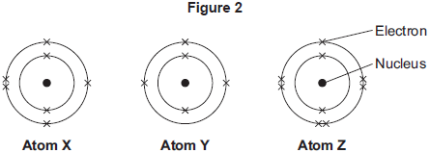
Which atom is from an element in Group 3 of the periodic table?

Tick (✔) one box.
Atom X
Atom Y
Atom Z
(1)
(d) Figure 3 shows the electron arrangement of a different atom from an element in the second row of the periodic table.
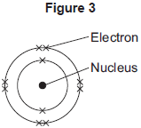
(i) Give the chemical symbol of this element.
_____________________________________________________________
(1)
(ii) Why is this element unreactive?
_____________________________________________________________
_____________________________________________________________
(1)
(Total 7 marks)
Q2. There are eight elements in the second row (lithium to neon) of the periodic table.
(a) Figure 1 shows an atom with two energy levels (shells).
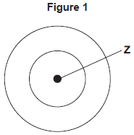
(i) Complete Figure 1 to show the electronic structure of a boron atom.
(1)
(ii) What does the central part labelled Z represent in Figure 1?
____________________________________
(1)
(iii) Name the sub-atomic particles in part Z of a boron atom.
Give the relative charges of these sub-atomic particles.
_____________________________________________________________
_____________________________________________________________
_____________________________________________________________
(3)
(b) The electronic structure of a neon atom shown in Figure 2 is not correct.
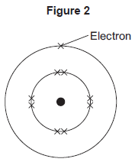
Explain what is wrong with the electronic structure shown in Figure 2.
_________________________________________________________________
_________________________________________________________________
_________________________________________________________________
_________________________________________________________________
_________________________________________________________________
(3)
(Total 8 marks)

Q3.This question is about atoms.
(a) What does the number 19 represent in ?
_________________________________________________________________
(1)
(b) How many atoms are present in one mole of fluorine atoms?
Tick (✔) one box.

2.03 × 10²⁶
2.06 × 10²³
6.02 × 10²³
6.02 × 10²⁶
(1)
(c) The plum pudding model of the atom was replaced by the nuclear model.
The nuclear model was developed after the alpha particle scattering experiment.
Compare the plum pudding model with the nuclear model of the atom.
_________________________________________________________________
_________________________________________________________________
_________________________________________________________________
_________________________________________________________________
_________________________________________________________________
_________________________________________________________________
_________________________________________________________________
(4)
(d) An element has three isotopes.
The table shows the mass numbers and percentage of each isotope.

 | Isotope 1 | Isotope 2 | Isotope 3
Mass number | 24 | 25 | 26
Percentage (%) | 78.6 | 10.1 | 11.3
Calculate the relative atomic mass (A_{r}) of the element.
Give your answer to 3 significant figures.
_________________________________________________________________
_________________________________________________________________
_________________________________________________________________
_________________________________________________________________
Relative atomic mass = ____________________
(2)
(Total 8 marks)
Q4.A student investigated the law of conservation of mass.
The law of conservation of mass states that the mass of the products is equal to the mass of the reactants.
This is the method used.
1. Pour lead nitrate solution into a beaker labelled A.
2. Pour potassium chromate solution into a beaker labelled B.
3. Measure the mass of both beakers and contents.
4. Pour the solution from beaker B into beaker A.
5. Measure the mass of both beakers and contents again.
When lead nitrate solution and potassium chromate solution are mixed, a reaction takes place.
This is the equation for the reaction:
Pb(NO₃)₂(aq) + K₂CrO₄(aq) ⟶ PbCrO₄(s) + 2KNO₃(aq)
(a) What would the student see when the reaction takes place?
_________________________________________________________________
_________________________________________________________________
(1)
(b) The table shows the student’s results.

 | Mass in g
Beaker A and contents before mixing | 128.71
Beaker B and contents before mixing | 128.97
Beaker A and contents after mixing | 154.10
Beaker B after mixing | 103.58
Show that the law of conservation of mass is true.
Use the data from the table above.
_________________________________________________________________
_________________________________________________________________
_________________________________________________________________
(2)
(c) What is the resolution of the balance used to obtain the results in the table?
Tick (✔) one box.

0.01 g |  |  | 0.1 g |  |  | 1 g |  |  | 100 g
(1)
(d) Calculate the relative formula mass (M_{r}) of lead nitrate Pb(NO₃)₂
Relative atomic masses (A_{r}): N = 14 O = 16 Pb = 207
_________________________________________________________________
_________________________________________________________________
_________________________________________________________________
Relative formula mass = ____________________
(2)
(e) The formula of potassium chromate is K₂CrO_{4.} The charge on the potassium ion is +1 .What is the formula of the chromate ion?
Tick (✔) one box.

CrO₄⁺
CrO₄²⁺
CrO₄⁻
CrO₄²⁻
(1)
(f) Another student also tests the law of conservation of mass using the same method.
The student uses a different reaction.This is the equation for the reaction.
Na₂CO₃(aq) + 2HCI(aq) ⟶ 2NaCl(aq) + CO₂(g) + H₂O(I)
Explain why this student’s results would not appear to support the law of conservation of mass.
_________________________________________________________________
_________________________________________________________________
_________________________________________________________________
_________________________________________________________________
_________________________________________________________________
(3)
(Total 10 marks)
Q5.The periodic table on the Data Sheet may help you answer these questions.
(a) Many chemists have contributed to the development of the periodic table.

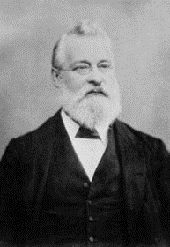
John Newlands was one of the first chemists who attempted to classify elements in a systematic way based on atomic weight. In 1866 he suggested that there was a repeating pattern of elements with similar properties every eighth element.
Part of Newlands’ periodic table is shown below.
H | Li | Be | B | C | N | O
F | Na | Mg | Al | Si | P | S
Cl | K | Ca | Cr | Ti | Mn | Fe
Co, Ni | Cu | Zn | Y | In | As | Se
Br | Rb | Sr | Ce, La | Zr | Di, Mo | Ro, Ru

Many chemists in 1866 did not accept Newland’s; periodic table.
(i) Give one piece of evidence which supports Newlands’ ideas.
_____________________________________________________________
_____________________________________________________________
(1)
(ii) Suggest two reasons why many chemists in 1866 did not accept Newlands’ ideas.
1. ____________________________________________________________
_____________________________________________________________
2. ____________________________________________________________
_____________________________________________________________
(2)
(b) Chlorine, bromine and iodine are Group 7 elements.
A student investigated the reactivity of these elements. The student added:
• aqueous chlorine to potassium bromide and potassium iodide solutions
• aqueous bromine to potassium chloride and potassium iodide solutions
• aqueous iodine to potassium chloride and potassium bromide solutions.
The student’s results are shown below.

Solution | Potassium chloride | Potassium bromide | Potassium iodide
Chlorine |  | Solution turned  orange-brown | Solution turned  brown
Bromine | No reaction |  | Solution turned  brown
Iodine | No reaction | No reaction
(i) Use these results to state and explain the trend in reactivity of these Group 7 elements.
_____________________________________________________________
_____________________________________________________________
_____________________________________________________________
_____________________________________________________________
(2)

(ii) Complete the equation below, which represents the reaction between chlorine and potassium bromide.

Cl₂ | + | 2KBr |  | ____ | + | 2KCl
(1)
(iii) In terms of electronic structure, state why chlorine, bromine and iodine are in Group 7.
_____________________________________________________________
_____________________________________________________________
(1)
(c) Lithium, sodium and potassium are Group 1 elements.
Group 1 elements become more reactive down the group.
Explain why in terms of electronic structure.
_________________________________________________________________
_________________________________________________________________
_________________________________________________________________
_________________________________________________________________
_________________________________________________________________
_________________________________________________________________
(3)
(Total 10 marks)
Q6. In 1866 John Newlands produced an early version of the periodic table.
Part of Newlands’ periodic table is shown below.

Column | 1 | 2 | 3 | 4 | 5 | 6 | 7
 | H | Li | Be | B | C | N | O
 | F | Na | Mg | Al | Si | P | S
 | Cl | K | Ca | Cr | Ti | Mn | Fe
Newlands’ periodic table arranged all the known elements into columns in order of their atomic weight. Newlands was trying to show a pattern by putting the elements into columns.

(a) Iron (Fe) does not fit the pattern in column 7.
Give a reason why.
_________________________________________________________________
_________________________________________________________________
(1)
(b) In 1869 Dmitri Mendeleev produced his version of the periodic table.
Why did Mendeleev leave gaps for undiscovered elements in his periodic table?
_________________________________________________________________
_________________________________________________________________
(1)
(c) Newlands and Mendeleev placed the elements in order of atomic weight.
Complete the sentence.
The modern periodic table places the elements in order of
______________________ .
(1)
(d) Lithium, sodium and potassium are all in Group 1 of the modern periodic table.
Explain why.
_________________________________________________________________
_________________________________________________________________
_________________________________________________________________
(2)
(Total 5 marks)
Q7. This question is about the halogens (Group 7).
(a) How do the boiling points of the halogens change down the group from fluorine to iodine?
_________________________________________________________________
_________________________________________________________________
(1)
(b) Sodium bromide is produced by reacting sodium with bromine. Sodium bromide is an ionic compound.
(i) Write down the symbols of the two ions in sodium bromide.
_____________________________________________________________
(1)
(ii) Chlorine reacts with sodium bromide solution to produce bromine and one other product. Complete the word equation for the reaction.
chlorine + sodium bromide bromine + ______________
(1)
(iii) Why does chlorine displace bromine from sodium bromide?
_____________________________________________________________
_____________________________________________________________
(1)
(iv) Use the Chemistry Data Sheet to help you to answer this question.
Suggest which halogen could react with sodium chloride solution to produce chlorine.
_____________________________________________________________
(1)
(Total 5 marks)
Q8. This question is about atomic structure and elements.
(a) Complete the sentences.
(i) The atomic number of an atom is the number of _______________________
(1)
(ii) The mass number of an atom is the number of ________________________
(1)
(b) Explain why an atom has no overall charge.
Use the relative electrical charges of sub-atomic particles in your explanation.
_________________________________________________________________
_________________________________________________________________
_________________________________________________________________
(2)
(c) Explain why fluorine and chlorine are in the same group of the periodic table.
Give the electronic structures of fluorine and chlorine in your explanation.
_________________________________________________________________
_________________________________________________________________
_________________________________________________________________
(2)
(d) The diagram shows the electronic structure of an atom of a non-metal.
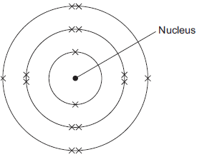
What is the chemical symbol of this non-metal?
Tick () one box.

Ar
O
S
Si
(1)
(e) When elements react, their atoms join with other atoms to form compounds.
Complete the sentences.
(i) Compounds formed when non-metals react with metals consist of
particles called _________________________ .
(1)
(ii) Compounds formed from only non-metals consist of
particles called ____________________ .
(1)
(Total 9 marks)
Q9. Cells contain chemicals which react to produce electricity.
(a) Why can a rechargeable cell be recharged?
_________________________________________________________________
_________________________________________________________________
(1)

(b) Give two factors that affect the voltage produced by a cell.
1. _________________________________________________________________
2. _________________________________________________________________
(2)
(c) Balance the half-equation for the reaction occurring at an electrode in one type of hydrogen fuel cell.
H₂ + OH⁻ ⟶ H₂O + e⁻
(1)
(d) Why is the fuel cell in Question (c) described as an alkaline fuel cell?
_________________________________________________________________
_________________________________________________________________
(1)
(e) Another type of fuel cell uses methanol instead of hydrogen.
The diagram represents the reaction in this fuel cell.
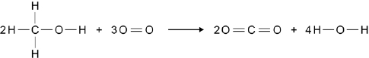
The table shows the bond energies for the reaction.

 | C–H | C–O | O–H | O=O | C=O
Bond energy in kJ / mol | 412 | 360 | 464 | 498 | 805
Calculate the overall energy change for the reaction.
Use the diagram and the table above.
_________________________________________________________________
_________________________________________________________________
_________________________________________________________________
_________________________________________________________________
_________________________________________________________________
_________________________________________________________________
Overall energy change = ____________________ kJ / mol
(3)
(Total 8 marks)
Q10. An atom of aluminium has the symbol
(a) Give the number of protons, neutrons and electrons in this atom of aluminium.
Number of protons _____________________
Number of neutrons _____________________
Number of electrons _____________________
(3)
(b) Why is aluminium positioned in Group 3 of the periodic table?
_________________________________________________________________
_________________________________________________________________
(1)
(c) In the periodic table, the transition elements and Group 1 elements are metals. Some of the properties of two transition elements and two Group 1 elements are shown in the table below.

 | Transition elements |  | Group 1 elements
 | Chromium | Iron | Sodium | Caesium
Melting point  in °C | 1857 | 1535 | 98 | 29
Formula of  oxides | CrO | FeO | Na₂O | Cs₂O
 | Cr₂O₃ | Fe₂O₃
 | CrO₂ | Fe₃O₄
 | CrO₃
Use your own knowledge and the data in the table above to compare the chemical and physical properties of transition elements and Group 1 elements.
_________________________________________________________________
_________________________________________________________________
_________________________________________________________________
_________________________________________________________________
_________________________________________________________________
_________________________________________________________________
_________________________________________________________________
(6)
(Total 10 marks)
Q1.This question is about fluorine.
(a) Figure 1 shows the arrangement of electrons in a fluorine atom.
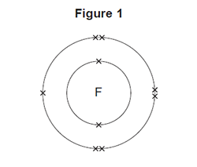
(i) In which group of the periodic table is fluorine?
Group _______________________________
(1)
(ii) Complete the table below to show the particles in an atom and their relative masses.

Name of particle | Relative mass
Proton
Neutron | 1
 | Very small
(2)
(iii) Use the correct answer from the box to complete the sentence.

alkalis | alloys | isotopes
Atoms of fluorine with different numbers of neutrons are
called ________________ .
(1)
(b) Sodium reacts with fluorine to produce sodium fluoride.
(i) Complete the word equation for this reaction.
sodium + ___________________ → ____________________
(1)
(ii) Complete the sentence.
Substances in which atoms of two or more different elements are chemically
combined are called _____________________ .
(1)

(iii) The relative formula mass (M_{r}) of sodium fluoride is 42. Use the correct answer from the box to complete the sentence.

ion | mole | molecule
The relative formula mass (M_{r}), in grams, of sodium fluoride is one
_______________ of the substance.
(1)
(iv) Figure 2 shows what happens to the electrons in the outer shells when a sodium atom reacts with a fluorine atom.
The dots (•) and crosses (×) represent electrons.
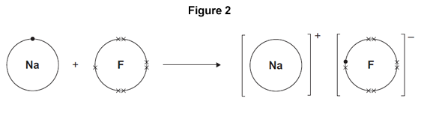
Use Figure 2 to help you answer this question. Describe, as fully as you can, what happens when sodium reacts with fluorine to produce sodium fluoride.
_____________________________________________________________
_____________________________________________________________
_____________________________________________________________
_____________________________________________________________
_____________________________________________________________
_____________________________________________________________
_____________________________________________________________
(4)
(v) Sodium fluoride is an ionic substance. What are two properties of ionic substances?

Tick (✔) two boxes.
Dissolve in water
Gas at room temperature
High melting point
Low boiling point
(2)
(Total 13 marks)
Q2.This question is about magnesium.
(a) (i) The electronic structure of a magnesium atom is shown below.
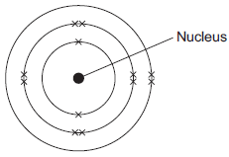
Use the correct answer from the box to complete each sentence.

electrons | neutrons | protons | shells
The nucleus contains protons and ____________________ .
The particles with the smallest relative mass that move around the nucleus are called ____________________ .
Atoms of magnesium are neutral because they contain the same number of
electrons and ____________________ .
(3)
(ii) A magnesium atom reacts to produce a magnesium ion. Which diagram shows a magnesium ion?
Tick () one box.
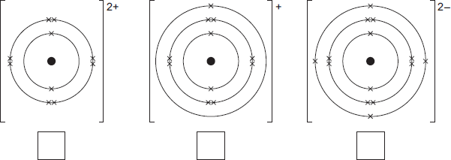
(1)
(b) Magnesium and dilute hydrochloric acid react to produce magnesium chloride solution and hydrogen.
Mg(s) + 2 HCl(aq) MgCl₂(aq) + H₂(g)
(i) State two observations that could be made during the reaction.
1. ____________________________________________________________
2. ____________________________________________________________
(2)
(ii) In this question you will be assessed on using good English, organising information clearly and using specialist terms where appropriate.
Describe a method for making pure crystals of magnesium chloride from magnesium and dilute hydrochloric acid.
In your method you should name the apparatus you will use.
You do not need to mention safety.
_____________________________________________________________
_____________________________________________________________
_____________________________________________________________
_____________________________________________________________
_____________________________________________________________
_____________________________________________________________
_____________________________________________________________
_____________________________________________________________
_____________________________________________________________
_____________________________________________________________
(6)
(Total 12 marks)
Q3. Distress flares are used to attract attention in an emergency.
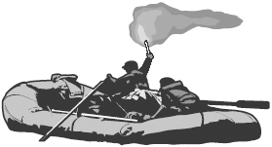
Flares often contain magnesium. Magnesium burns to form magnesium oxide.
(a) The distress flare burns with a bright flame because the reaction is very exothermic.
Complete the following sentence using the correct words from the box.

gives out heat stores heat takes in heat
An exothermic reaction is one which ____________________________________ .
(1)
(b) The diagram shows the electronic structure of a magnesium atom.
The atomic (proton) number of magnesium is 12.
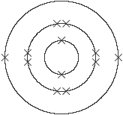
Magnesium atom
The atomic (proton) number of oxygen is 8. Which diagram, A, B, C or D, shows the electronic structure of an oxygen atom?
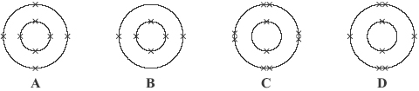
Diagram _______________
(1)
(c) Magnesium ions and oxide ions are formed when magnesium reacts with oxygen. The diagram shows the electronic structure of an oxide ion.
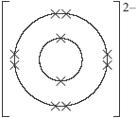
Oxide ion
Which diagram, J, K, L or M, shows the electronic structure of a magnesium ion?
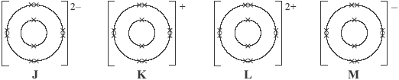
Diagram _______________
(1)
(d) Indigestion tablets can be made from magnesium oxide. The magnesium oxide neutralises some of the hydrochloric acid in the stomach.Draw a ring around the name of the salt formed when magnesium oxide reacts with hydrochloric acid.
magnesium chloride magnesium hydroxide magnesium sulfate
(1)
(Total 4 marks)

Q4. The structures of four substances, A, B, C and D, are represented in Figure 1.
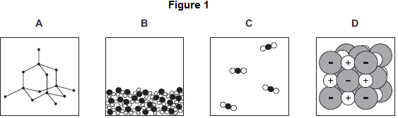
(a) Use the correct letter, A, B, C or D, to answer each question.

(i) | Which substance is a gas?
(1)

(ii) | Which substance is a liquid?
(1)

(iii) | Which substance is an element?
(1)

(iv) | Which substance is made of ions?
(1)
(b) Figure 2 shows the bonding in substance C.
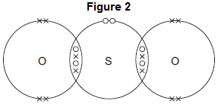
(i) What is the formula of substance C? Draw a ring around the correct answer.

SO₂ | SO² | S₂O
(1)
(ii) Use the correct answer from the box to complete the sentence.

delocalised | shared | transferred
When a sulfur atom and an oxygen atom bond to produce substance C,
electrons are _____________________________________________
(1)
(iii) What is the type of bonding in substance C?
Draw a ring around the correct answer.

covalent | ionic | metallic
(1)
(Total 7 marks)
Q5. The diagram represents a particle of methane.
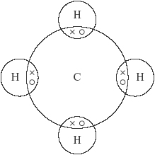
(a) What is the formula of methane? ________________________________________
(1)
(b) Choose a word from the box to answer the question.

atom ion molecule
Which of the words best describes the methane particle shown in the diagram?
_________________________
(1)
(c) Choose a word from the box to answer the question.

covalent ionic metallic
What is the type of bonding shown in the diagram?
_________________________
(1)
(Total 3 marks)

Q6. A drill bit is used to cut holes through materials. The cutting end of this drill bit is covered with very small diamonds.
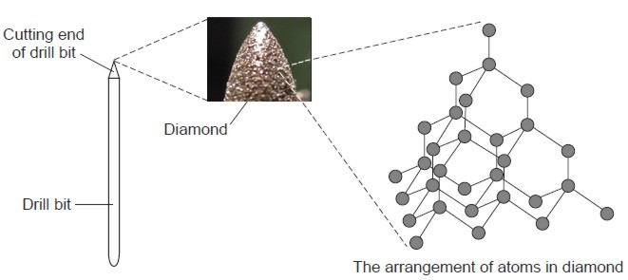
Draw a ring around the correct word in each box.

 |  | carbon
(a) | Diamond is made from | nitrogen | atoms.
 |  | oxygen
(1)
 |  | none
(b) | Diamond has a giant structure in which | some | of the atoms are joined together.
 |  | all
(1)
 |  | covalent
(c) | The atoms in diamond are joined together by | ionic | bonds.
 |  | metallic
(1)
 |  | two
(d) | In diamond each atom is joinedto | three | other atoms.
 |  | four
(1)

 |  | hard.
(e) | Diamond is suitable for the cutting end of a drill bit because itis | shiny.
 |  | soft
(1)
(Total 5 marks)
Q7. This barbecue burns propane gas.
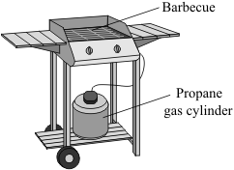
The diagram represents a propane molecule.
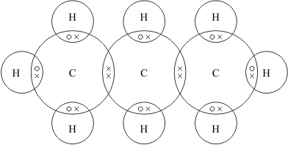
(a) What is the formula of propane?
_________________________________________
(1)
(b) (i) Draw a ring around the name of the particle represented by the symbols ○ and × in the diagram.
electron neutron proton
(1)
(ii) Draw a ring around the type of bonding that holds the atoms together in a propane molecule.
covalent ionic metallic
(1)

(c) Under high pressure in the cylinder propane is a liquid.
Liquid propane evaporates easily to form a gas when the tap on the cylinder is opened.
Draw a ring around the correct answer in each box to explain why propane evaporates easily.

Propane has a | high  low | boiling point because it consists of | large  small | molecules.
(1)
(Total 4 marks)
Triple Q8. Read the article and then answer the questions that follow.

Nanotennis!
Tennis balls contain air under pressure, which gives them their bounce. Normal tennis balls are changed at regular intervals during tennis matches because they slowly lose some of the air. This means that a large number of balls are needed for a tennis tournament, using up a lot of materials.
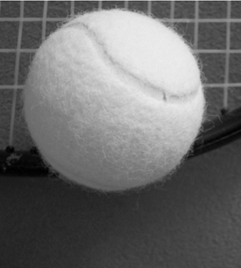
‘Nanocoated’ tennis balls have a ‘nanosize’ layer of butyl rubber. This layer slows down the escape of air so that the ball does not lose its pressure as quickly. The ‘nanocoated’ tennis balls last much longer and do not need to be replaced as often.
(a) How does the ‘nanosize’ layer make the tennis balls last longer?
_________________________________________________________________
_________________________________________________________________
(1)
(b) Put a tick () next to the best description of a ‘nanosize’ layer.

Description | ()
A layer one atom thick.
A layer a few hundred atoms thick.
A layer millions of atoms thick.
(1)
(c) Suggest why using ‘nanocoated’ tennis balls would be good for the environment.
_________________________________________________________________
_________________________________________________________________
_________________________________________________________________
_________________________________________________________________
(2)
(Total 4 marks)
Q9. Glass is made from silicon dioxide.
(a) Silicon dioxide has a very high melting point. Other substances are added to silicon dioxide to make glass. Glass melts at a lower temperature than silicon dioxide. Suggest why.
_________________________________________________________________
_________________________________________________________________
(1)
(b) Sodium oxide is one of the substances added to silicon dioxide to make glass.
(i) Sodium oxide contains Na⁺ ions and O^{2–} ions. Give the formula of sodium oxide.
_____________________________________________________________
(1)
(ii) Sodium oxide is made by heating sodium metal in oxygen gas.
Complete the diagram to show the outer electrons in an oxygen molecule (O₂).
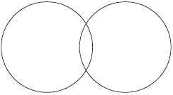
(2)
(c) Glass can be coloured using tiny particles of gold. Gold is a metal. Describe the structure of a metal.
_________________________________________________________________
_________________________________________________________________
_________________________________________________________________
_________________________________________________________________
_________________________________________________________________
_________________________________________________________________
(3)
(Total 7 marks)
Q10. Iron is the main structural metal used in the world.
(a) The diagram represents the particles in iron, Fe.
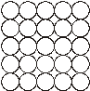
Draw a ring around the correct word in the box to complete the sentence.

Iron is described as an element because all the | atoms  compounds  metals | are the same.
(1)
(b) Stainless steel is mostly iron. The diagram represents the particles in stainless steel.
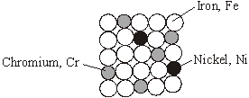
Use the correct words from the box to complete the sentences about alloys.

metal mixture molecule polymer smart structure
Stainless steel is an alloy because it is a __________________________________ of iron, chromium and nickel.
An alloy is made up of more than one type of _____________________________
Stainless steel alloys are harder than iron because the different sized atoms added
change the ________________________________________ .
An alloy that can return to its original shape after being deformed is called a
___________________________________ alloy.
(4)
(c) In the UK, we use about 1.8 billion steel cans every year but only 25% are recycled.
Used steel cans are worth about £100 per tonne. Recycling saves raw materials and reduces waste that would end up in landfill. Producing steel by recycling used cans saves 75% of the energy that would be needed to produce steel from iron ore. This also reduces carbon dioxide emissions.
(i) Give two reasons, from the information above, to explain why recycling used steel cans is a good idea.
1. ____________________________________________________________
_____________________________________________________________
2. ____________________________________________________________
_____________________________________________________________
(2)
(ii) Suggest how the local council could increase the percentage of used steel cans that are recycled.
_____________________________________________________________
_____________________________________________________________
(1)
(Total 8 marks)
Q11. The picture shows a wooden bowl. The pieces of wood used for this bowl were dyed different colours.
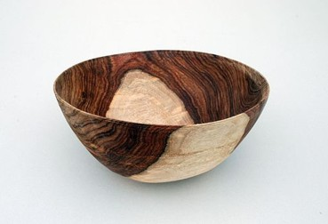
The artist who made the bowl explained why he dissolved the coloured dyes in methanol.

I use different coloured dyes dissolved in methanol
I use methanol because with dyes dissolved in water the wood needs to be soaked for a longer time.
The bowl dries more quickly if I use methanol instead of water.
(a) The artist uses methanol instead of water.Give two reasons why.
1. _________________________________________________________________
_________________________________________________________________
2. _________________________________________________________________
_________________________________________________________________
(2)
(b) The diagram shows how the atoms are bonded in methanol.
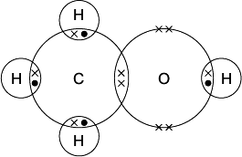
Draw a ring around:
(i) the formula of methanol

CH₄O | CH⁴O | CHO₄
(1)
(ii) the type of bonding in methanol.

covalent | ionic | metallic
(1)
(c) Methanol has a low boiling point.
Tick () the reason why.

Reason why | Tick ()
It has a giant covalent structure.
It is made of small molecules.
It has a giant metallic structure.
(1)
(Total 5 marks)
Q12. Silicon dioxide is used as a lining for furnaces.Furnaces can be used to melt iron for recycling.
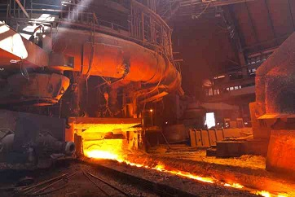
The diagram shows a small part of the structure of silicon dioxide.
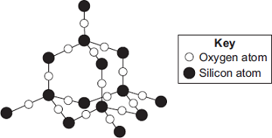
Explain why silicon dioxide is a suitable material for lining furnaces.
_____________________________________________________________________
_____________________________________________________________________
_____________________________________________________________________
_____________________________________________________________________
_____________________________________________________________________
_____________________________________________________________________
_____________________________________________________________________
(Total 4 marks)
Q13. This question is about the properties and uses of materials. Use your knowledge of structure and bonding to answer the questions.
(a) Explain how copper conducts electricity.
_________________________________________________________________
_________________________________________________________________
_________________________________________________________________
_________________________________________________________________
_________________________________________________________________
(2)
(b) Explain why diamond is hard.
_________________________________________________________________
_________________________________________________________________
_________________________________________________________________
_________________________________________________________________
_________________________________________________________________
(2)

(c) Explain why thermosetting polymers are better than thermosoftening polymers for saucepan handles.
_________________________________________________________________
_________________________________________________________________
_________________________________________________________________
_________________________________________________________________
_________________________________________________________________
(2)
(Total 6 marks)
Q14. The article gives some information about graphene.

Nanotunes!
Carbon can be made into nano-thin, strong sheets called graphene.
A graphene sheet is a single layer of graphite.
Graphene conducts electricity and is used in loudspeakers.
The picture shows the structure of graphene.
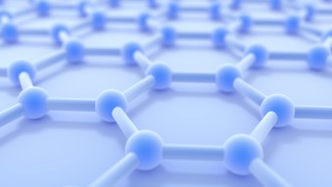

(a) Use the picture and your knowledge of bonding in graphite to:
(i) explain why graphene is strong;
_____________________________________________________________
_____________________________________________________________
_____________________________________________________________
_____________________________________________________________
_____________________________________________________________
(3)
(ii) explain why graphene can conduct electricity.
_____________________________________________________________
_____________________________________________________________
_____________________________________________________________
(2)
(b) Graphite is made up of layers of graphene. Explain why graphite is a lubricant.
_________________________________________________________________
_________________________________________________________________
_________________________________________________________________
(2)
(Total 7 marks)
Q1.This question is about carbon and gases in the air.
(a) Carbon atoms have protons, neutrons and electrons.
Complete the table by writing the relative mass of a neutron and an electron.

Name of particle | Relative mass
proton | 1
neutron
electron
(2)
(b) What is the total number of protons and neutrons in an atom called?

Tick () one box.
The atomic number
The mass number
One mole of the atom
(1)

(c) An atom of carbon has six electrons.
Which structure, A, B or C, represents the electronic structure of the carbon atom?
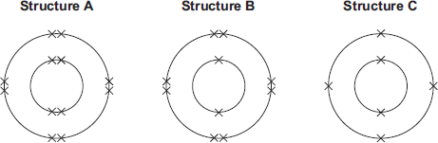

The carbon atom is structure
(1)
(d) Carbon reacts with oxygen to produce carbon dioxide (CO₂).
(i) How many different elements are in one molecule of carbon dioxide?
_____________________________________________________________
(1)
(ii) What is the total number of atoms in one molecule of carbon dioxide?
_____________________________________________________________
(1)
(e) Sometimes carbon reacts with oxygen to produce carbon monoxide (CO).
(i) Calculate the relative formula mass (M_{r}) of carbon monoxide.
Relative atomic masses (A_{r}): C = 12; O = 16
_____________________________________________________________
_____________________________________________________________
M_{r} of carbon monoxide = _______________
(1)
(ii) Calculate the percentage by mass of carbon in carbon monoxide.
_____________________________________________________________
_____________________________________________________________
Percentage by mass of carbon in carbon monoxide = _____%
(1)

(f) Carbon dioxide is one of the gases in the air.
(i) The graph shows the percentage of argon and the percentage of carbon dioxide in the air.
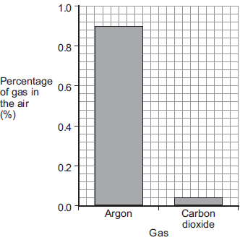
What is the percentage of argon in the air?
Percentage of argon = ____________________ %
(1)
(ii) An instrumental method is used to measure the amount of carbon dioxide in the air. Give one reason for using an instrumental method.
_____________________________________________________________
_____________________________________________________________
(1)
(Total 10 marks)
Q2. Citric acid is a weak acid.
(a) Explain what is meant by a weak acid.
_________________________________________________________________
_________________________________________________________________
_________________________________________________________________
_________________________________________________________________
(2)
A student titrated citric acid with sodium hydroxide solution. This is the method used.
1. Pipette 25.0 cm³ of sodium hydroxide solution into a conical flask.
2. Add a few drops of thymol blue indicator to the sodium hydroxide solution.
Thymol blue is blue in alkali and yellow in acid.
3. Add citric acid solution from a burette until the end-point was reached.
(b) Explain what would happen at the end-point of this titration. Refer to the acid, the alkali and the indicator in your answer.
_________________________________________________________________
_________________________________________________________________
_________________________________________________________________
_________________________________________________________________
_________________________________________________________________
(3)
(c) Explain why a pipette is used to measure the sodium hydroxide solution but a burette is used to measure the citric acid solution
_________________________________________________________________
_________________________________________________________________
_________________________________________________________________
(2)
(d) The table shows the student’s results.

 | Titration 1 | Titration 2 | Titration 3 | Titration 4 | Titration 5
Volume of citric acid solution in cm³ | 13.50 | 12.10 | 11.10 | 12.15 | 12.15
The equation for the reaction is:
C₆H₈O₇ + 3 NaOH ⟶ C₆H₅O₇Na₃ + 3 H₂O
The concentration of the sodium hydroxide was 0.102 mol / dm ³
Concordant results are those within 0.10 cm ³ of each other. Calculate the concentration of the citric acid in mol / dm ³. Use only the concordant results from the table in your calculation.
You must show your working.
_________________________________________________________________
_________________________________________________________________
_________________________________________________________________
_________________________________________________________________
_________________________________________________________________
Concentration = ____________________ mol / dm ³
(5)
(Total 12 marks)
Q3.A student investigated the reactions of copper carbonate and copper oxide with dilute hydrochloric acid.
In both reactions one of the products is copper chloride.
(a) Describe how a sample of copper chloride crystals could be made from copper carbonate and dilute hydrochloric acid.
_________________________________________________________________
_________________________________________________________________
_________________________________________________________________
_________________________________________________________________
_________________________________________________________________
_________________________________________________________________
(4)
(b) A student wanted to make 11.0 g of copper chloride.
The equation for the reaction is:
CuCO₃ + 2HCl → CuCl₂ + H₂O + CO₂
Relative atomic masses, A_{r}: H = 1; C = 12; O = 16; Cl = 35.5; Cu = 63.5
Calculate the mass of copper carbonate the student should react with dilute hydrochloric acid to make 11.0 g of copper chloride.
_________________________________________________________________
_________________________________________________________________
_________________________________________________________________
_________________________________________________________________
Mass of copper carbonate = _________________________ g
(4)
(c) The percentage yield of copper chloride was 79.1 %.
Calculate the mass of copper chloride the student actually produced.
_________________________________________________________________
_________________________________________________________________
Actual mass of copper chloride produced = ____________ g
(2)

(d) Look at the equations for the two reactions:
Reaction 1 CuCO₃(s) + 2HCl(aq) → CuCl₂(aq) + H₂O(l) + CO₂(g)
Reaction 2 CuO(s) + 2HCl(aq) → CuCl₂(aq) + H₂O(l)
Reactive formula masses: CuO = 79.5; HCl = 36.5; CuCl₂ = 134.5; H₂O = 18
The percentage atom economy for a reaction is calculated using:
Calculate the percentage atom economy for Reaction 2.
_________________________________________________________________
_________________________________________________________________
_________________________________________________________________
_________________________________________________________________
Percentage atom economy = ________________________ %
(3)
(e) The atom economy for Reaction 1 is 68.45 %.
Compare the atom economies of the two reactions for making copper chloride. Give a reason for the difference.
_________________________________________________________________
_________________________________________________________________
(1)
(Total 14 marks)
Q4. Cobalt forms coloured compounds.
A pink cobalt compound reacts with hydrochloric acid. The reaction can be represented as:
pink cobalt compound + hydrochloric acid ⇌ blue cobalt compound + water
The forward reaction is endothermic. When both cobalt compounds are present in a solution at equilibrium, the equilibrium mixture is purple.
(a) What is meant by equilibrium?
_________________________________________________________________
_________________________________________________________________
_________________________________________________________________
_________________________________________________________________
(2)
(b) The equilibrium mixture is cooled.
Explain what happens to the concentration of the pink cobalt compound.
_________________________________________________________________
_________________________________________________________________
_________________________________________________________________
_________________________________________________________________
_________________________________________________________________
_________________________________________________________________
(3)
(c) More hydrochloric acid is added.
Explain what happens to the colour of the equilibrium mixture
________________________________________________________________
_________________________________________________________________
_________________________________________________________________
_________________________________________________________________
_________________________________________________________________
(3)
(d) Why does cobalt form different coloured compounds?
_________________________________________________________________
(1)
(e) An oxide of cobalt has the formula Co₂O₃
Which cobalt ion is present in this oxide?
Tick (✔) one box.

Co⁺
Co²⁺
Co³⁺
Co⁴⁺
(1)

(f) Cobalt compounds can act as catalysts.
Which two statements about cobalt compounds are correct?
Tick (✔) two boxes.

They allow reactions to reach equilibrium more quickly.
They are reactants in reactions catalysed by cobalt compounds.
They are used up when acting as catalysts.
They increase the equilibrium yield of reactions.
They provide a different reaction pathway.
(2)
(g) The reaction of hydrogen with carbon monoxide is catalysed by cobalt metal.
Balance the equation for the reaction.
H₂ + CO ⟶ C₆H₁₄ + H₂O
(1)
(h) C₆H₁₄ is an alkane.
What is the formula of an alkane containing 18 hydrogen atoms?
__________________________________
(1)
(i) The graph shows a reaction profile diagram for a reaction without a catalyst.
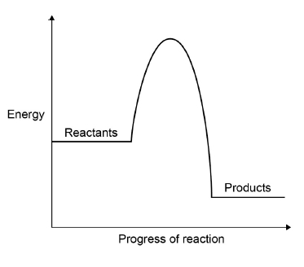
On the graph:
• draw the reaction profile diagram for a catalysed reaction
• draw and label an arrow to show the activation energy for the reaction without a catalyst.
(2)
(Total 16 marks)
Q5. Some students were investigating the rate at which carbon dioxide gas is produced when metal carbonates react with an acid. One student reacted 1.00 g of calcium carbonate with 50 cm³, an excess, of dilute hydrochloric acid.
The apparatus used is shown in Diagram 1.
Diagram 1
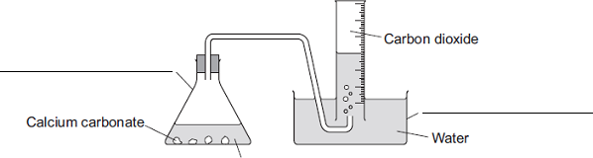
Dilute hydrochloric acid
(a) Complete the two labels for the apparatus on the diagram.
(2)
(b) The student measured the volume of gas collected every 30 seconds.
The table shows the student’s results.

Time in  seconds | Volume of carbon dioxide  collected in cm³
30 | 104
60
90 | 198
120 | 221
150 | 232
180 | 238
210 | 240
240 | 240

(i) Diagram 2 shows what the student saw at 60 seconds.
Diagram 2
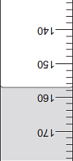
What is the volume of gas collected?
Volume of gas = __________ cm³
(1)
(ii) Why did the volume of gas stop changing after 210 seconds?
_____________________________________________________________
_____________________________________________________________
(1)
(c) Another student placed a conical flask containing 1.00 g of a Group 1 carbonate (M₂CO₃) on a balance. He then added 50 cm³, an excess, of dilute hydrochloric acid to the flask and measured the mass of carbon dioxide given off.The equation for the reaction is:
M₂CO₃ + 2HCl 2MCl + H₂O + CO₂
The final mass of carbon dioxide given off was 0.32 g.
(i) Calculate the amount, in moles, of carbon dioxide in 0.32 g carbon dioxide.
Relative atomic masses (A_{r}): C = 12; O = 16
_____________________________________________________________
_____________________________________________________________
_____________________________________________________________
Moles of carbon dioxide = __________ moles
(2)
(ii) How many moles of the metal carbonate are needed to make this number of moles of carbon dioxide?
_____________________________________________________________
Moles of metal carbonate = __________ moles
(1)
(iii) The mass of metal carbonate used was 1.00 g.
Use this information, and your answer to part (c) (ii), to calculate the relative formula mass (M_{r}) of the metal carbonate.
If you could not answer part (c) (ii), use 0.00943 as the number of moles of metal carbonate. This is not the answer to part (c) (ii).
_____________________________________________________________
_____________________________________________________________
Relative formula mass (M_{r}) of metal carbonate = __________
(1)
(iv) Use your answer to part (c) (iii) to calculate the relative atomic mass (A_{r}) of the metal in the metal carbonate (M₂CO₃) and so identify the Group 1 metal in the metal carbonate.
If you could not answer part (c) (iii), use 230 as the relative formula mass of the metal carbonate. This is not the answer to part (c) (iii).
To gain full marks, you must show your working.
_____________________________________________________________
_____________________________________________________________
_____________________________________________________________
_____________________________________________________________
Relative atomic mass of metal is ____________________________________
Identity of metal _________________________________________________
(3)
(d) Two other students repeated the experiment in part (c).
(i) When the first student did the experiment some acid sprayed out of the flask as the metal carbonate reacted. Explain the effect this mistake would have on the calculated relative atomic mass of the metal.
_____________________________________________________________
_____________________________________________________________
_____________________________________________________________
_____________________________________________________________
_____________________________________________________________
_____________________________________________________________
(3)

(ii) The second student used 100 cm³ of dilute hydrochloric acid instead of 50 cm³.
Explain the effect, if any, this mistake would have on the calculated relative atomic mass of the metal.
_____________________________________________________________
_____________________________________________________________
_____________________________________________________________
_____________________________________________________________
_____________________________________________________________
(3)
(Total 17 marks)
Q6. In this question you will be assessed on using good English, organising information clearly and using specialist terms where appropriate.
A student used the equipment shown to do a titration.
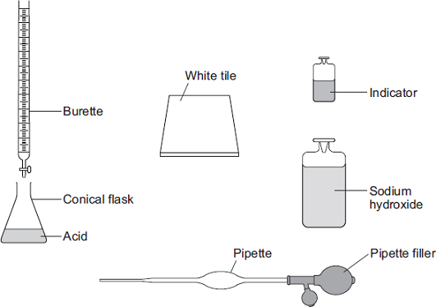
Describe how the student should use this equipment to find the volume of sodium hydroxide solution that reacts with a known volume of acid.
Include any measurements the student should make.
Do not describe how to do any calculations.
_____________________________________________________________________
_____________________________________________________________________
_____________________________________________________________________
_____________________________________________________________________
_____________________________________________________________________
_____________________________________________________________________
_____________________________________________________________________
_____________________________________________________________________
_____________________________________________________________________
_____________________________________________________________________
_____________________________________________________________________
_____________________________________________________________________
_____________________________________________________________________
_____________________________________________________________________
(Total 6 marks)
Q7. Magnesium reacts with steam to produce hydrogen gas and magnesium oxide.
A teacher demonstrated the reaction to a class. The figure below shows the apparatus the teacher used.
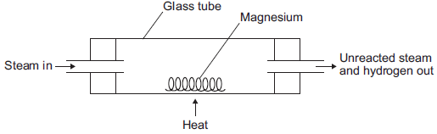
(a) (i) The hydrogen produced was collected. Describe how to test the gas to show that it is hydrogen.
Test __________________________________________________________
_____________________________________________________________
Result ________________________________________________________
_____________________________________________________________
(2)
(ii) Explain why the magnesium has to be heated to start the reaction.
_____________________________________________________________
_____________________________________________________________
_____________________________________________________________
_____________________________________________________________
(2)
(b) The equation for the reaction is:
Mg(s) + H₂O(g) MgO(s) + H₂(g)
(i) The teacher used 1.00 g of magnesium.
Use the equation to calculate the maximum mass of magnesium oxide produced.
Give your answer to three significant figures.
Relative atomic masses (A _{r}): O = 16; Mg = 24
_____________________________________________________________
_____________________________________________________________
_____________________________________________________________
_____________________________________________________________
Maximum mass = ____________________ g
(3)
(ii) The teacher’s demonstration produced 1.50 g of magnesium oxide.
Use your answer from part (b)(i) to calculate the percentage yield.
If you could not answer part (b)(i), use 1.82 g as the maximum mass of magnesium oxide. This is not the answer to part (b)(i).
_____________________________________________________________
Percentage yield = ____________________ %
(2)
(iii) Give one reason why the percentage yield is less than 100%.
_____________________________________________________________
_____________________________________________________________
_____________________________________________________________
(1)
(Total 10 marks)
Q8. The Haber Process is used to produce ammonia from nitrogen and hydrogen. The equation for the reaction is:
N₂ + 3H₂ ⇌ 2NH₃
(a) An ammonia molecule has the formula NH_{3,} How many atoms are there in one molecule of ammonia? Tick (✔) one box.

2 |  |  | 3 |  |  | 4 |  |  | 6
(1)
(b) What does the symbol ⇌ mean?
_________________________________________________________________
(1)
(c) Draw one line from each gas to the source of that gas.
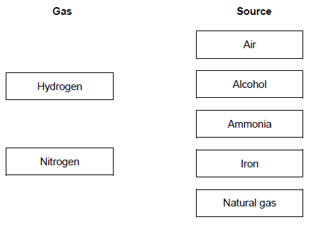
(2)
The diagram shows the Haber process.
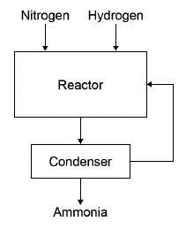

A mixture of ammonia, hydrogen and nitrogen gases leave the reactor.
Table 1 shows the boiling points of the gases.

Table 1
Gas | Boiling point in °C
Ammonia | – 33
Nitrogen | – 196
Hydrogen | – 253
(d) The mixture is cooled to a temperature at which only the ammonia condenses to a liquid.
Which temperature could be used?
Tick (✔) one box.

− 20 °C
− 40 °C
− 200 °C
− 260 °C
(1)

(e) What happens to the unreacted nitrogen?
Tick (✔) one box.

Collected and sold
Recycled to the reactor
Released into the air
Used as a catalyst
(1)
Ammonia from the Haber process can be used to produce fertilisers.
Table 2 gives information about two compounds used in fertilisers.

Table 2
Fertiliser | Compound | Cost in £ / kg
A | Potassium chloride | 0.24
B | Diammonium phosphate | 0.35
(f) What type of bonding is present in potassium chloride? Tick (✔) one box.

Covalent
Ionic
Metallic
(1)
(g) Diammonium phosphate has the chemical formula (NH₄)₂HPO_{4.} Which two elements in (NH₄)₂HPO₄ improve agricultural productivity?
Tick (✔) two boxes.

Chlorine
Hydrogen
Nitrogen
Oxygen
Phosphorus
A farmer uses fertilisers A and B on a field with an area of 0.05 km²
(2)
(h) 50 kg of fertiliser A will cover an area of 0.01 km²
Calculate the cost of fertilising a field with an area of 0.05 km² with fertiliser A.
Use Table 2.
_________________________________________________________________
_________________________________________________________________
Cost = £ ____________________
(2)
(i) Fertiliser B is more expensive than fertiliser A. Suggest why the farmer uses both fertilisers.
_________________________________________________________________
_________________________________________________________________
(1)
(Total 12 marks)
Q9. Sodium hydroxide neutralises sulfuric acid. The equation for the reaction is:
2NaOH + H₂SO₄ → Na₂SO₄ + 2H₂O
(a) Sulfuric acid is a strong acid. What is meant by a strong acid?
_________________________________________________________________
_________________________________________________________________
_________________________________________________________________
(2)
(b) Write the ionic equation for this neutralisation reaction. Include state symbols.
_________________________________________________________________
(2)
(c) A student used a pipette to add 25.0 cm³ of sodium hydroxide of unknown concentration to a conical flask. The student carried out a titration to find out the volume of 0.100 mol / dm³ sulfuric acid needed to neutralise the sodium hydroxide. Describe how the student would complete the titration.
You should name a suitable indicator and give the colour change that would be seen.
_________________________________________________________________
_________________________________________________________________
_________________________________________________________________
_________________________________________________________________
_________________________________________________________________
_________________________________________________________________
_________________________________________________________________
_________________________________________________________________
_________________________________________________________________
(4)

(d) The student carried out five titrations. Her results are shown in the table below.

 | Titration 1 | Titration 2 | Titration 3 | Titration 4 | Titration 5
Volume of 0.100 mol / dm³ sulfuric acid in cm³ | 27.40 | 28.15 | 27.05 | 27.15 | 27.15
Concordant results are within 0.10 cm³ of each other. Use the student’s concordant results to work out the mean volume of 0.100 mol / dm³ sulfuric acid added.
_________________________________________________________________
_________________________________________________________________
_________________________________________________________________
Mean volume = _____________________________ cm³
(2)
(e) The equation for the reaction is:
2NaOH + H₂SO₄ → Na₂SO₄ + 2H₂O
Calculate the concentration of the sodium hydroxide. Give your answer to three significant figures.
_________________________________________________________________
_________________________________________________________________
_________________________________________________________________
_________________________________________________________________
_________________________________________________________________
Concentration = _______________________ mol / dm³
(4)
(f) The student did another experiment using 20 cm³ of sodium hydroxide solution with a concentration of 0.18 mol / dm³.
Relative formula mass (M_{r}) of NaOH = 40
Calculate the mass of sodium hydroxide in 20 cm³ of this solution.
_________________________________________________________________
_________________________________________________________________
_________________________________________________________________
Mass = ________________ g
(2)
(Total 16 marks)
Q10. Nitrogen and hydrogen react to produce ammonia in the Haber process.
Figure 1 shows the Haber process.
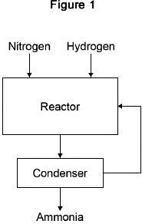
A gaseous mixture of ammonia, hydrogen and nitrogen leaves the reactor. Table 1 shows the boiling points of the gases.

Table 1
Gas | Boiling point in °C
Ammonia | −33
Nitrogen | −196
Hydrogen | −253
(a) Suggest how ammonia is separated from the other gases.
_________________________________________________________________
_________________________________________________________________
_________________________________________________________________
_________________________________________________________________
(2)
(b) What happens to the unreacted hydrogen and nitrogen?
_________________________________________________________________
_________________________________________________________________
(1)
The equation for the reaction is:
N₂(g) + 3H₂(g) ⇌ 2NH₃(g)
The forward reaction is exothermic.
(c) Calculate the volume of ammonia produced from the complete reaction of 825 dm ³ of hydrogen.
_________________________________________________________________
_________________________________________________________________
_________________________________________________________________
Volume of ammonia = ____________________ dm ³
(2)
(d) The Haber process uses a temperature of 450 °C and a pressure of 200 atmospheres. Why are these conditions used? Tick two boxes.

A higher pressure is maintained using less energy
A higher temperature would increase the equilibrium yield
A lower pressure would decrease the equilibrium yield
A lower temperature would make the reaction too slow
There are more product molecules than reactant molecules
(2)
Most of the ammonia produced is used to make fertilisers.
Table 2 shows information about compounds used as fertilisers.

Table 2
Compound | Formula | Cost in £ / tonne
A | NH₄NO₃ | 220
B | (NH₄)₂HPO₄ | 350
C | KCl | 235
(e) Which element in compound A improves agricultural productivity?
_________________________________________________________________
(1)
(f) Which two compounds can be mixed to make a fertiliser containing three elements that improve agricultural productivity? Give a reason why you have chosen these compounds.
Compounds ___________ and ___________
Reason ____________________________________________________________
(2)
(g) Figure 2 shows a flow chart for the production of compounds B and C.
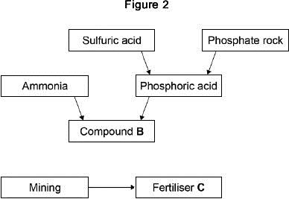
Suggest two possible reasons for the difference in cost between compounds B and C.
1. _________________________________________________________________
_________________________________________________________________
2. _________________________________________________________________
_________________________________________________________________
(2)
(Total 12 marks)
Q1. Lithium carbonate reacts with dilute hydrochloric acid. A group of students investigated the volume of gas produced.This is the method used.
1. Place a known mass of lithium carbonate in a conical flask.
2. Measure 10 cm³ of dilute hydrochloric acid using a measuring cylinder.
3. Pour the acid into the conical flask.
4. Place a bung in the flask and collect the gas as shown in Figure 1.
Figure 1
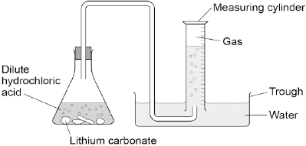
(a) Figure 2 shows the measuring cylinder.
Figure 2
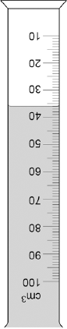
What volume of gas has been collected?
Volume = __________________ cm³
(1)
(b) The table below shows the students’ results.

Mass of lithium carbonate in g | Volume of gas in cm³
0.0 | 0
0.1 | 22
0.2 | 44
0.3 | 50
0.4 | 88
0.5 | 96
0.6 | 96
0.7 | 96
On Figure 3:
• Plot these results on the grid.
• Complete the graph by drawing two straight lines of best fit.

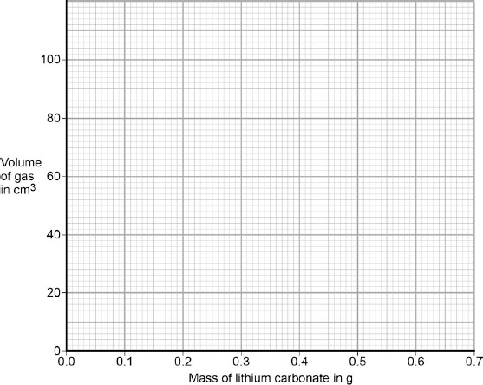
(4)
(c) What are two possible reasons for the anomalous result?

Tick two boxes.
Too much lithium carbonate was added.
The bung was not pushed in firmly enough.
There was too much water in the trough.
The measuring cylinder was not completely over the delivery
The conical flask was too small.
(2)
(d) Describe the pattern the graph shows up to 0.4 g of lithium carbonate added.
_________________________________________________________________
_________________________________________________________________
_________________________________________________________________
_________________________________________________________________
(2)
(e) Lithium carbonate decomposes when heated.
The equation shows the decomposition of lithium carbonate.
Li₂CO₃ (s) → Li₂O (s) + CO₂ (g)
Figure 4 shows the apparatus a student used to decompose lithium carbonate.
Figure 4
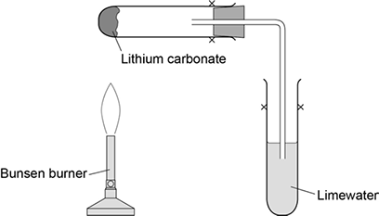
Why does the limewater bubble?
_________________________________________________________________
_________________________________________________________________
(1)
(f) The student repeated the experiment with potassium carbonate.
The limewater did not bubble.
Suggest why there were no bubbles in the limewater.
_________________________________________________________________
_________________________________________________________________
(1)
(Total 11 marks)
Q2. This question is about metal oxides.
When sodium is heated in oxygen, sodium oxide is produced.
(a) Balance the equation for the reaction.
_______ Na + O₂ ⟶ 2 Na₂O
(1)
(b) Why is this an oxidation reaction?
_________________________________________________________________
________________________________________________________________
(1)

(c) Sodium oxide is added to water and shaken. Universal indicator is added.
The pH of the solution is 14. What is the colour of the universal indicator?
Tick (✔) one box.

Green
Purple
Red
Yellow
(1)
(d) Aluminium oxide reacts with hydrochloric acid to produce a salt. What is the name of the salt produced?
Tick (✔) one box.

Aluminium chloride
Aluminium nitrate
Aluminium sulfate
Aluminium sulfide
(1)
A student investigates the solubility of four metal oxides and four non-metal oxides in water. The student tests the pH of the solutions formed. The table shows the student’s results.

Type of oxide | Oxide | Solubility in water | pH of solution
Metal oxides | Sodium oxide | Soluble | 14
 | Calcium oxide | Soluble | 10
 | Magnesium oxide | Slightly soluble | 9
 | Zinc oxide | Insoluble | No solution formed
Non-metal oxides | Carbon dioxide | Soluble | 5
 | Sulfur dioxide | Soluble | 2
 | Phosphorus oxide | Soluble | 1
 | Silicon dioxide | Insoluble | No solution formed
The student makes two conclusions.
Conclusion 1: ‘All metal oxides produce alkaline solutions.’
Conclusion 2: ‘All non-metal oxides produce acidic solutions.’
(e) Explain why the student’s conclusions are only partly correct. Use information from the table above.
_________________________________________________________________
_________________________________________________________________
_________________________________________________________________
_________________________________________________________________
_________________________________________________________________
(4)
(f) Give an improved conclusion for metal oxides. Use the table above.
_________________________________________________________________
_________________________________________________________________
_________________________________________________________________
(2)
(Total 9 marks)
Q3. A scientist produces zinc iodide (ZnI₂). This is the method used.
1. Weigh 0.500 g of iodine.
2. Dissolve the iodine in ethanol.
3. Add an excess of zinc.
4. Stir the mixture until there is no further change.
5. Filter off the excess zinc.
6. Evaporate off the ethanol.
(a) Ethanol is flammable.Suggest how the scientist could carry out Step 6 safely.
_________________________________________________________________
_________________________________________________________________
(1)
(b) Explain why the scientist adds excess zinc rather than excess iodine.
_________________________________________________________________
_________________________________________________________________
_________________________________________________________________
_________________________________________________________________
(3)
(c) Calculate the minimum mass of zinc that needs to be added to 0.500 g of iodine so that the iodine fully reacts. The equation for the reaction is:
Zn + I₂ ⟶ ZnI₂
Relative atomic masses (M_{r}): Zn = 65 I = 127
_________________________________________________________________
_________________________________________________________________
_________________________________________________________________
Minimum mass of zinc = ____________________ g
(3)
A different scientist makes zinc iodide by the same method. The scientist obtains 12.5 g of zinc iodide.The percentage yield in this reaction is 92.0%.
(d) What is the maximum theoretical mass of zinc iodide produced in this reaction?
_________________________________________________________________
_________________________________________________________________
_________________________________________________________________
_________________________________________________________________
Maximum theoretical mass = ____________________ g
(3)
(e) Suggest one reason why the percentage yield in this reaction is not 100%.
_________________________________________________________________
_________________________________________________________________
(1)
(f) The scientist makes a solution of zinc iodide with a concentration of 0.100 mol / dm³
Calculate the mass of zinc iodide (ZnI₂) required to make 250 cm³ of this solution.
Relative atomic masses (A_{r}): Zn = 65 I = 127
_________________________________________________________________
_________________________________________________________________
_________________________________________________________________
_________________________________________________________________
Mass = ____________________ g
(3)
(Total 14 marks)
Q4. This question is about compounds.
(a) The table gives information about the solubility of some compounds.

Soluble compounds
All potassium and sodium salts
All nitrates
Chlorides, bromides and iodides, except those of silver and lead
Use information from the table to answer these questions.
(i) Name a soluble compound that contains silver ions.
_____________________________________________________________
(1)
(ii) Name a soluble compound that contains carbonate ions.
_____________________________________________________________
(1)
(b) Metal oxides react with acids to make salts. What type of compound is a metal oxide?
_________________________________________________________________
(1)
(c) Lead nitrate solution is produced by reacting lead oxide with nitric acid.
(i) State how solid lead nitrate can be obtained from lead nitrate solution.
_____________________________________________________________
_____________________________________________________________
(1)
(ii) Balance the equation for the reaction.
PbO + HNO₃ Pb(NO₃)₂ + H₂O
(1)
(iii) Give the total number of atoms in the formula Pb(NO₃)₂
_____________________________________________________________
(1)
(d) An oxide of lead that does not have the formula PbO contains 6.21 g of lead and 0.72 g of oxygen.
Calculate the empirical formula of this lead oxide.
Relative atomic masses (A_{r}): O = 16; Pb = 207
You must show your working to gain full marks.
_________________________________________________________________
_________________________________________________________________
_________________________________________________________________
_________________________________________________________________
_________________________________________________________________
_________________________________________________________________
Empirical formula = ____________________
(4)
(Total 10 marks)
Q5. This question is about zinc.
Figure 1 shows the electrolysis of molten zinc chloride.
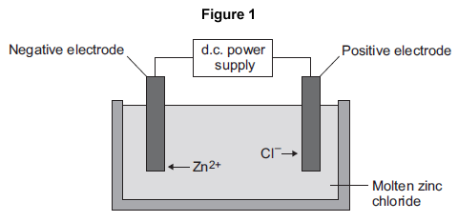
(a) Zinc chloride is an ionic substance. Complete the sentence.
When zinc chloride is molten, it will conduct _________________________ .
(1)
(b) Zinc ions move towards the negative electrode where they gain electrons to produce zinc.
(i) Name the product formed at the positive electrode.
____________________________________
(1)
(ii) Explain why zinc ions move towards the negative electrode.
_____________________________________________________________
_____________________________________________________________
_____________________________________________________________
_____________________________________________________________
(2)
(iii) What type of reaction occurs when the zinc ions gain electrons?

Tick (✔) one box.
Neutralisation
Oxidation
Reduction
(1)
(c) Zinc is mixed with copper to make an alloy.
(i) Figure 2 shows the particles in the alloy and in pure zinc.
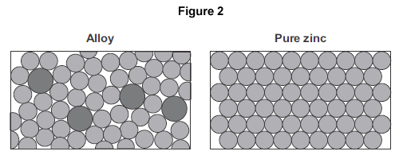
Use Figure 2 to explain why the alloy is harder than pure zinc.
_____________________________________________________________
_____________________________________________________________
_____________________________________________________________
_____________________________________________________________
(2)
(ii) Alloys can be bent. Some alloys return to their original shape when heated.
What name is used for these alloys?
_____________________________________________________________
(1)
(Total 8 marks)
Q6.This question is about iron and aluminium.
(a) Iron is extracted in a blast furnace. Figure 1 is a diagram of a blast furnace.
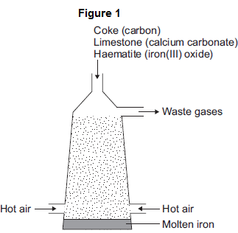
(i) Calcium carbonate decomposes at high temperatures.
Complete the word equation for the decomposition of calcium carbonate.
calcium carbonate _____________________ +
_____________________
(2)
(ii) Carbon burns to produce carbon dioxide. The carbon dioxide produced reacts with more carbon to produce carbon monoxide. Balance the equation.
C(s) + CO₂(g) _____ CO(g)
(1)
(iii) Carbon monoxide reduces iron(III) oxide:
Fe₂O₃(s) + 3 CO(g) 2 Fe(s) + 3 CO₂(g)
Calculate the maximum mass of iron that can be produced from 300 tonnes of iron(III) oxide.
Relative atomic masses (A_{r}): O = 16; Fe = 56
_____________________________________________________________
_____________________________________________________________
_____________________________________________________________
_____________________________________________________________
Maximum mass = _______________ tonnes
(3)
(b) Aluminium is extracted by electrolysis, as shown in Figure 2.
Figure 2
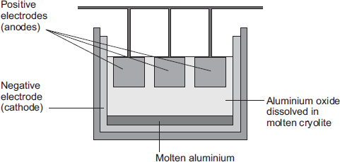
(i) Why can aluminium not be extracted by heating aluminium oxide with carbon?
_____________________________________________________________
(1)
(ii) Explain why aluminium forms at the negative electrode during electrolysis.
_____________________________________________________________
_____________________________________________________________
_____________________________________________________________
_____________________________________________________________
_____________________________________________________________
_____________________________________________________________
(3)
(iii) Explain how carbon dioxide forms at the positive electrodes during electrolysis.
_____________________________________________________________
_____________________________________________________________
_____________________________________________________________
_____________________________________________________________
_____________________________________________________________
(3)
(Total 13 marks)
Q7. Sodium carbonate reacts with dilute hydrochloric acid:
Na₂CO₃ + 2HCl → 2NaCl + H₂O + CO₂
A student investigated the volume of carbon dioxide produced when different masses of sodium carbonate were reacted with dilute hydrochloric acid. This is the method used.
1. Place a known mass of sodium carbonate in a conical flask.
2. Measure 10 cm³ of dilute hydrochloric acid using a measuring cylinder.
3. Pour the acid into the conical flask.
4. Place a bung in the flask and collect the gas until the reaction is complete.
(a) The student set up the apparatus as shown in the figure below.
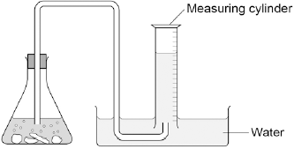
Identify the error in the way the student set up the apparatus.
Describe what would happen if the student used the apparatus shown.
_________________________________________________________________
_________________________________________________________________
_________________________________________________________________
_________________________________________________________________
(2)
(b) The student corrected the error. The student’s results are shown in the table below.

Mass of sodium carbonate  in g | Volume of carbon dioxide gas  in cm³
0.07 | 16.0
0.12 | 27.5
0.23 | 52.0
0.29 | 12.5
0.34 | 77.0
0.54 | 95.0
0.59 | 95.0
0.65 | 95.0
The result for 0.29 g of sodium carbonate is anomalous. Suggest what may have happened to cause this anomalous result.
_________________________________________________________________
_________________________________________________________________
(1)
(c) Why does the volume of carbon dioxide collected stop increasing at 95.0 cm³?
_________________________________________________________________
_________________________________________________________________
(1)
(d) What further work could the student do to be more certain about the minimum mass of sodium carbonate needed to produce 95.0 cm³ of carbon dioxide?
_________________________________________________________________
_________________________________________________________________
(1)
(e) The carbon dioxide was collected at room temperature and pressure.
The volume of one mole of any gas at room temperature and pressure is 24.0 dm³. How many moles of carbon dioxide is 95.0 cm³? Give your answer in three significant figures.
_________________________________________________________________
_________________________________________________________________
_________________________________________________________________
________________________________________ mol
(2)
(f) Suggest one improvement that could be made to the apparatus used that would give more accurate results. Give a reason for your answer.
_________________________________________________________________
_________________________________________________________________
_________________________________________________________________
(2)
(g) One student said that the results of the experiment were wrong because the first few bubbles of gas collected were air.
A second student said this would make no difference to the results.
Explain why the second student was correct.
_________________________________________________________________
_________________________________________________________________
_________________________________________________________________
_________________________________________________________________
(2)
(Total 11 marks)
Q8. This question is about magnesium and magnesium chloride.
(a) Magnesium chloride contains magnesium ions (Mg²⁺) and chloride ions (Cl⁻).
Describe, in terms of electrons, what happens when a magnesium atom reacts with chlorine atoms to produce magnesium chloride.
_________________________________________________________________
_________________________________________________________________
_________________________________________________________________
_________________________________________________________________
_________________________________________________________________
_________________________________________________________________
_________________________________________________________________
(4)
(b) Magnesium chloride can be electrolysed.
The diagram below shows two experiments for electrolysing magnesium chloride.
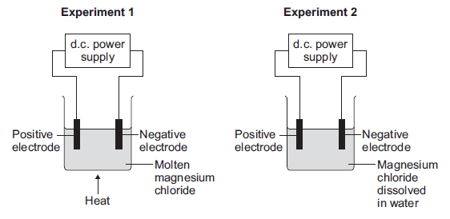
(i) Explain why magnesium chloride must be molten or dissolved in water to be electrolysed.
_____________________________________________________________
_____________________________________________________________
_____________________________________________________________
(2)
(ii) Explain how magnesium is produced at the negative electrode in Experiment 1.
_____________________________________________________________
_____________________________________________________________
_____________________________________________________________
_____________________________________________________________
_____________________________________________________________
(3)
(iii) In Experiment 2 a gas is produced at the negative electrode.
Name the gas produced at the negative electrode.
____________________________________
(1)
(iv) Suggest why magnesium is not produced at the negative electrode in Experiment 2.
_____________________________________________________________
_____________________________________________________________
(1)
(v) Complete and balance the half equation for the reaction at the positive electrode.
_____ Cl⁻ → Cl₂ + _____
(1)
(c) Magnesium is a metal. Explain why metals can be bent and shaped.
_________________________________________________________________
_________________________________________________________________
_________________________________________________________________
_________________________________________________________________
(2)
(Total 14 marks)
Q9.Rock salt is a mixture of sand and salt. Salt dissolves in water. Sand does not dissolve in water.
Some students separated rock salt. This is the method used.
1. Place the rock salt in a beaker.
2. Add 100 cm³ of cold water.
3. Allow the sand to settle to the bottom of the beaker.
4. Carefully pour the salty water into an evaporating dish.
5. Heat the contents of the evaporating dish with a Bunsen burner until salt crystals start to form.
(a) Suggest one improvement to step 2 to make sure all the salt is dissolved in the water.
_________________________________________________________________
_________________________________________________________________
(1)
(b) The salty water in step 4 still contained very small grains of sand.
Suggest one improvement to step 4 to remove all the sand.
_________________________________________________________________
_________________________________________________________________
(1)
(c) Suggest one safety precaution the students should take in step 5.
_________________________________________________________________
_________________________________________________________________
(1)

(d) Another student removed water from salty water using the apparatus in the figure below.
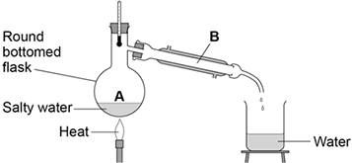
Describe how this technique works by referring to the processes at A and B.
_________________________________________________________________
_________________________________________________________________
_________________________________________________________________
(2)
(e) What is the reading on the thermometer during this process?
__________________ °C
(1)
(Total 6 marks)
Q10. A student investigated the reactivity of different metals.The student used the apparatus shown in the figure below.
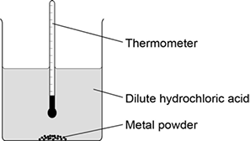
The student used four different metals. The student measured the temperature rise for each metal three times. The student’s results are shown in the table below.

Metal | Temperature rise in °C |  |  | Mean  temperature  rise in °C
 | Test 1 | Test 2 | Test 3
Calcium | 17.8 | 16.9 | 17.5
Iron | 6.2 | 6.0 | 6.1 | 6.1
Magnesium | 12.5 | 4.2 | 12.3 | 12.4
Zinc | 7.8 | 8.0 | 7.6 | 7.8
(a) Give two variables the student should control so that the investigation is a fair test.
1. _________________________________________________________________
_________________________________________________________________
2. _________________________________________________________________
_________________________________________________________________
(2)
(b) One of the results for magnesium is anomalous. Which result is anomalous? Suggest one reason why this anomalous result was obtained.
Result _____________________________________________________________
_________________________________________________________________
Reason ____________________________________________________________
_________________________________________________________________
(2)
(c) Calculate the mean temperature rise for calcium.
_________________________________________________________________
Mean temperature rise = _______________ °C
(1)
(d) The temperature rose when the metals were added to sulfuric acid.
Give one other observation that might be made when the metal was added to sulfuric acid.
How would this observation be different for the different metals?
_________________________________________________________________
_________________________________________________________________
_________________________________________________________________
(2)
(e) Aluminium is more reactive than iron and zinc but less reactive than calcium and magnesium. Predict the temperature rise when aluminium is reacted with dilute hydrochloric acid.
_________________________________________________________________
Temperature rise = _______________ °C
(1)
(Total 8 marks)
Q11.A student makes a hypothesis:
‘When different salt solutions are electrolysed with inert electrodes, the product at the negative electrode is always a metal’.
(a) Describe how you would test this hypothesis in the laboratory. You should:
• draw a labelled diagram of the apparatus
• give the independent variable
• describe what you would see at the negative electrode if the hypothesis is true.
Diagram

Independent variable
_________________________________________________________________
Observation
_________________________________________________________________
(5)
(b) The student’s hypothesis is only partially correct.Explain why the product at the negative electrode is not always a metal.
_________________________________________________________________
_________________________________________________________________
_________________________________________________________________
(2)
(c) Predict the product at the positive electrode in the electrolysis of:
• sodium chloride solution
• copper sulfate solution.
Sodium chloride solution _______________________________________________
Copper sulfate solution ________________________________________________
(2)
(Total 9 marks)
Q12. A student investigated the reactivity of three different metals.
This is the method used.
1. Place 1 g of metal powder in a test tube.
2. Add 10 cm³ of metal sulfate.
3. Wait 1 minute and observe.
4. Repeat using the other metals and metal sulfates.

The student placed a tick in the table below if there was a reaction and a cross if there was no reaction.

 | Zinc | Copper | Magnesium
Copper sulfate
Magnesium sulfate
Zinc sulfate

(a) What is the dependent variable in the investigation?

Tick one box.
Time taken
Type of metal
Volume of metal sulfate
Whether there was a reaction or not
(1)
(b) Give one observation the student could make that shows there is a reaction between zinc and copper sulfate.
_________________________________________________________________
_________________________________________________________________
(1)
(c) The student used measuring instruments to measure some of the variables.
Draw one line from each variable to the measuring instrument used to measure the variable.

Variable |  | Measuring instrument
 |  | Balance
 |  | Measuring cylinder
Mass of metal powder
 |  | Ruler
 |  | Burette
Volume of metal sulfate
 |  | Theromometer
 |  | Test tube
(2)
(d) Use the results shown in table above to place zinc, copper and magnesium in order of reactivity.
Most reactive _____________________
_____________________
Least reactive _____________________
(1)
(e) Suggest one reason why the student should not use sodium in this investigation.
_________________________________________________________________
_________________________________________________________________
(1)
(f) Which metal is found in the Earth as the metal itself?

Tick one box.
Calcium
Gold
Lithium
Potassium
(1)
(g) Iron is found in the Earth as iron oxide (Fe₂O₃).
Iron oxide is reduced to produce iron.
Balance the equation for the reaction.
___Fe₂O₃ + ___C → ___Fe + ___CO₂
(1)
(h) Name the element used to reduce iron oxide.
_________________________________________________________________
(1)
(i) What is meant by reduction?

Tick one box.
Gain of iron
Gain of oxide
Loss of iron
Loss of oxygen
(1)
(Total 10 marks)
Q1. A camping stove uses propane gas.
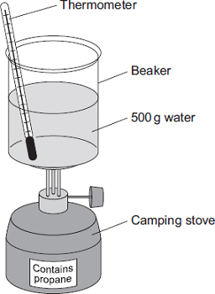
(a) A student did an experiment to find the energy released when propane is burned.
The student:
• put 500 g water into a beaker
• measured the temperature of the water
• heated the water by burning propane for 1 minute
• measured the temperature of the water again.
The student found the temperature change was 20 °C. The student can calculate the energy released, in joules (J), using the equation:
energy released (J) = mass of water (g) × 4.2 × temperature change (°C)
(i) Use the student’s result to calculate the energy released in joules (J).
_____________________________________________________________
_____________________________________________________________
Energy released = _________________________ J
(2)
(ii) State two safety precautions that the student should take during the experiment.
1. ____________________________________________________________
_____________________________________________________________
2. ____________________________________________________________
_____________________________________________________________
(2)
(iii) Tick () two boxes which describe how the student could make his result more accurate.

Tick ()
Stir the water before measuring the temperature.
Heat the water until it boils.
Place a lid on the beaker.
Use a larger beaker for the water.
(2)
(b) The change in energy when propane is burned can be shown in an energy level diagram.
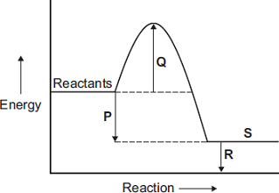
Draw one line from each description to the correct letter.

Description |  | Letter
 |  | P
products
 |  | Q
activation energy
 |  | R
energy released by the reaction
 |  | S
(3)
(c) Propane and hydrogen are both used as fuels. Some information about propane and hydrogen is given in the table.

Fuel | Resource | Products formed when fuel burned
propane | crude oil | carbon dioxide and water
hydrogen | water | water
Use the information in the table to suggest two disadvantages that propane has as a fuel compared to hydrogen.
1. _________________________________________________________________
2. _________________________________________________________________
(2)
(Total 11 marks)
Q2. Instant cold packs are used to treat sports injuries.
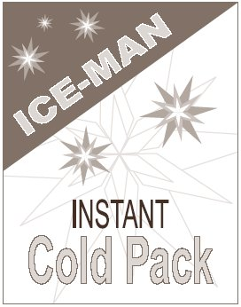
One type of cold pack has a plastic bag containing water.
Inside this bag is a smaller bag containing ammonium nitrate. The outer bag is squeezed so that the inner bag bursts. The pack is shaken and quickly gets very cold as the ammonium nitrate dissolves in the water.
(a) One of the statements in the table is correct.
Put a tick () next to the correct statement.

Statement | ()
The bag gets cold because heat energy is given out to the surroundings.
The bag gets cold because heat energy is taken in from the surroundings.
The bag gets cold because plastic is a good insulator.

(1)
(b) Draw a ring around the word that best describes the change when ammonium nitrate dissolves in water.
electrolysis endothermic exothermic
(1)
(c) Suggest and explain why the pack is shaken after the inner bag has burst.
_________________________________________________________________
_________________________________________________________________
_________________________________________________________________
_________________________________________________________________
(2)
(Total 4 marks)
Q3. A student investigated the energy change occurring in the endothermic reaction between potassium hydrogencarbonate and hydrochloric acid.
Figure 1 shows the apparatus used.
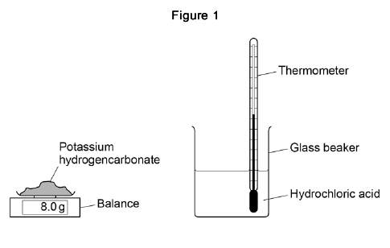
This is the method used.
1. Measure 50 cm³ hydrochloric acid into a glass beaker.
2. Measure 1.0 g of potassium hydrogencarbonate.
3. Add the potassium hydrogencarbonate to the hydrochloric acid.
4. Stir until all the potassium hydrogencarbonate has reacted.
5. Record the lowest temperature reached.
6. Repeat steps 1‒5 two more times.
7. Repeat steps 1‒6 with different masses of potassium hydrogencarbonate.
(a) Which is the most suitable apparatus to use to measure 50 cm³ of hydrochloric acid?
Tick (✔) one box.

Balance
Conical flask
Gas syringe
Measuring cylinder
(1)
(b) The student used a glass beaker for the reaction. Suggest one change to the apparatus that would improve the accuracy of the results. Give a reason for your answer.
_________________________________________________________________
_________________________________________________________________
(2)
(c) Which two variables should the student keep the same to make this a fair test?
Tick two boxes.

Mass of potassium hydrogencarbonate
Same balance
Same thermometer
Starting temperature of hydrochloric acid
Volume of hydrochloric acid
(2)
(d) Figure 2 shows part of the thermometer used to measure the temperature.
What is the temperature reading on the thermometer?
Temperature = ___________ °C
(1)
The table shows a set of results.

 | Test 1 | Test 2 | Test 3
Lowest temperature in °C | 16.1 | 15.8 | 15.9
(e) What is the range of the lowest temperature?
From _________ °C to _________ °C
(1)
(f) Calculate the mean lowest temperature. Use the table above.
_________________________________________________________________
_________________________________________________________________
Mean lowest temperature = ______________________ °C
(2)
(g) How do the results show that the reaction is endothermic?
_________________________________________________________________
_________________________________________________________________
(1)
The graph shows the student’s results.
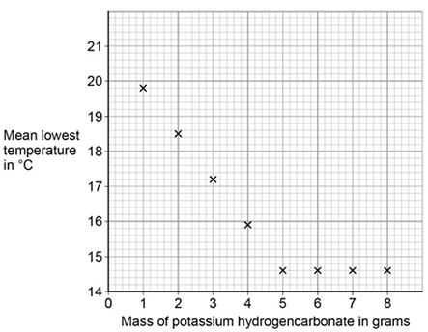
(h) Draw two straight lines of best fit on the graph above.
(2)
(i) Describe how the lowest temperature changes as the mass of potassium hydrogencarbonate added increases.
_________________________________________________________________
_________________________________________________________________
_________________________________________________________________
_________________________________________________________________
_________________________________________________________________
(3)
(Total 15 marks)
Q4. This question is about energy changes in chemical reactions.
(a) Complete the word equation for the combustion of hydrogen.
hydrogen + oxygen → ___________________
(1)
(b) Figure 1 shows a simple energy level diagram.
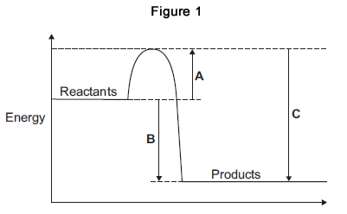
(i) Which arrow, A, B or C, shows the activation energy?

Tick (✔) one box.
A
B
C
(1)
(ii) What type of reaction is shown by the energy level diagram in Figure 1?
Give a reason for your answer.
Type of reaction _________________________________________________
Reason _______________________________________________________
_____________________________________________________________
(2)
(iii) For a reaction, the value of A is 1370 kJ and C is 3230 kJ.
Calculate the value of B.
_____________________________________________________________
_____________________________________________________________
B = _______________________________ kJ
(1)
(c) Alcohols are used as fuels.
A group of students investigated the amount of energy released when different alcohols are burned.
The students used the apparatus shown in Figure 2.
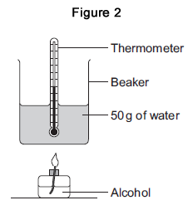
(i) Figure 3 shows the start temperature and the final temperature of the water.
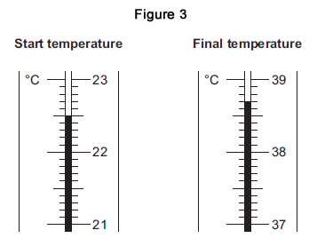
Write the start temperature and the final temperature of the water in Table 1.
Work out the increase in temperature to complete Table 1.

Table 1
Start temperature of the water in °C
Final temperature of the water in °C
Increase in temperature in °C
(3)
(ii) The students worked out the heat energy released by burning 1 g of each alcohol.
The students used the equation:
Heat energy released = m × 4.2 × increase in temperature
Look at Figure 2. What is the value of m?
m = _______________________________ g
(1)
(iii) Table 2 shows the students’ results.

Table 2
Name of alcohol | Number of carbon atoms in one molecule of alcohol | Heat energy released when 1 g of alcohol is burned in kJ
Methanol | 1 | 11.4
Ethanol | 2 | 13.5
Propanol | 3 | 20.1
Butanol | 4 | 16.8
Pentanol | 5 | 17.2
Which value of heat energy released is anomalous?
____________________________________
(1)
(iv) Look at Table 2. What is the relationship between the number of carbon atoms in one molecule of alcohol and the heat energy released when 1 g of the alcohol is burned?
_____________________________________________________________
_____________________________________________________________
(1)
(v) The value in a data book for the amount of heat energy released when 1 g of butanol is burned completely is 36.2 kJ. Suggest two reasons why the students’ result for butanol is lower than the data book value.
1. ____________________________________________________________
_____________________________________________________________
2. ____________________________________________________________
_____________________________________________________________
(2)
(vi) The displayed structure of butanol is:
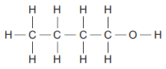
What is the functional group of the alcohol?

Tick (✔) one box.
–– C –– C
–– C –– H
–– O –– H
(1)
(Total 14 marks)
Q5.Cells contain chemicals which react to produce electricity.
(a) Why can a rechargeable cell be recharged?
_________________________________________________________________
_________________________________________________________________
(1)
(b) Give two factors that affect the voltage produced by a cell.
1. _________________________________________________________________
2. _________________________________________________________________
(2)
(c) Balance the half-equation for the reaction occurring at an electrode in one type of hydrogen fuel cell.
H₂ + OH⁻ ⟶ H₂O + e⁻
(1)
(d) Why is the fuel cell in Question (c) described as an alkaline fuel cell?
_________________________________________________________________
_________________________________________________________________
(1)
(e) Another type of fuel cell uses methanol instead of hydrogen. The diagram represents the reaction in this fuel cell.
The table shows the bond energies for the reaction.

 | C–H | C–O | O–H | O=O | C=O
Bond energy in kJ / mol | 412 | 360 | 464 | 498 | 805
Calculate the overall energy change for the reaction. Use the diagram and the table above.
_________________________________________________________________
_________________________________________________________________
_________________________________________________________________
_________________________________________________________________
Overall energy change = ____________________ kJ / mol
(3)
(Total 8 marks)
Q6. Read the information about energy changes and then answer the questions.
A student did an experiment to find the energy change when hydrochloric acid reacts with sodium hydroxide. The equation which represents the reaction is:
HCl + NaOH → NaCl + H₂O
The student used the apparatus shown in the diagram.
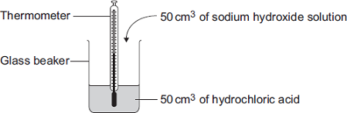
The student placed 50 cm³ of hydrochloric acid in a glass beaker and measured the initial temperature. The student then quickly added 50 cm³ of sodium hydroxide solution and stirred the mixture with the thermometer. The highest temperature was recorded.
The student repeated the experiment, and calculated the temperature change each time.

 | Experiment 1 | Experiment 2 | Experiment 3 | Experiment 4
Initial temperature  in °C | 19.0 | 22.0 | 19.2 | 19.0
Highest temperature in °C | 26.2 | 29.0 | 26.0 | 23.5
Temperature change in °C | 7.2 | 7.0 | 6.8 | 4.5
(a) The biggest error in this experiment is heat loss. Suggest how the apparatus could be modified to reduce heat loss.
_________________________________________________________________
(1)
(b) Suggest why it is important to mix the chemicals thoroughly.
_________________________________________________________________
(1)
(c) Which one of these experiments was probably done on a different day to the others? Give a reason for your answer.
_________________________________________________________________
(1)
(d) Suggest why experiment 4 should not be used to calculate the average temperature change.
_________________________________________________________________
_________________________________________________________________
(1)
(e) Calculate the average temperature change from the first three experiments.
_________________________________________________________________
Answer = _________________________ °C
(1)
(f) Use the following equation to calculate the energy change for this reaction.
Energy change in joules = 100 × 4.2 × average temperature change
_________________________________________________________________
Answer = _________________________ J
(1)
(g) Which one of these energy level diagrams represents the energy change for this reaction? Give a reason for your answer.
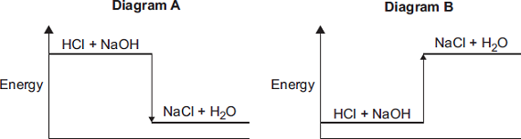
_________________________________________________________________
_________________________________________________________________
(1)
(Total 7 marks)
Q7. Methanol (CH₃OH) can be made by reacting methane (CH₄) and oxygen (O₂).
The reaction is exothermic.
The equation for the reaction is:
(a) The energy level diagram for this reaction is given below.
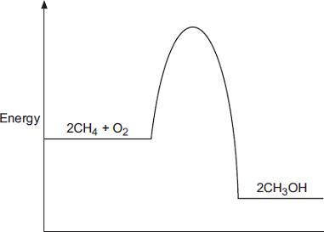
(i) How does the diagram show that this reaction is exothermic?
_____________________________________________________________
_____________________________________________________________
_____________________________________________________________
(1)
(ii) A platinum catalyst can be used to increase the rate of this reaction.
What effect does adding a catalyst have on the energy level diagram?
_____________________________________________________________
_____________________________________________________________
(1)
(b) The equation can also be written showing the structural formulae of the reactants and the product.
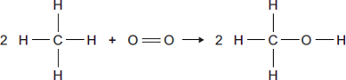
(i) Use the bond energies given in the table to help you to calculate the energy change for this reaction.

Bond | Bond energy in kJ
 | 435
 | 497
 | 336
 | 464
_____________________________________________________________
_____________________________________________________________
_____________________________________________________________
Energy change = ____________________ kJ
(3)
(iii) In terms of the bond energies, why is this an exothermic reaction?
_____________________________________________________________
_____________________________________________________________
(1)
(Total 6 marks)
Q8. Some cars are powered by hydrogen fuel cells.
Figure 1
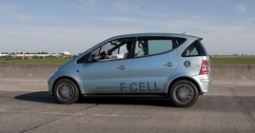
© Robert Couse-Baker (CC BY-SA 2.0) via Flickr
(a) What type of energy is released by hydrogen fuel cells?
_________________________________________________________________
(1)
(b) Owners of cars powered by fuel cells buy hydrogen from hydrogen filling stations.
Figure 2 shows how the number of hydrogen filling stations in the UK is expected to increase up to the year 2030.

Figure 2
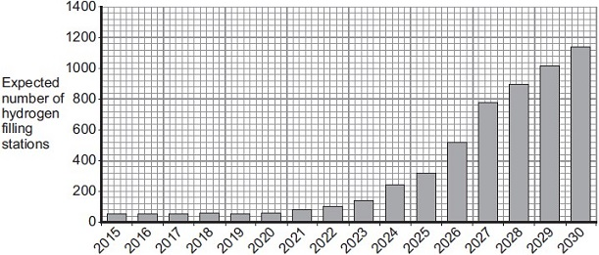
Year
Use the information in Figure 2 and your own knowledge to answer this question.
Suggest two reasons why the UK government might encourage the building of more hydrogen filling stations.
_________________________________________________________________
_________________________________________________________________
_________________________________________________________________
(2)
(c) The equation for the reaction of hydrogen with oxygen is:
2 H₂ + O₂ 2 H₂O
During the reaction, energy is used to break the bonds of the reactants.
Energy is released when new bonds are made to form the product.
Bond energies for the reaction are given in the table below.

Bond | Bond energy in kJ
 | 436
 | 498
 | 464
The structures of the reactants and product are shown in Figure 3.
Figure 3
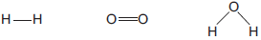

hydrogen | oxygen | water
(i) Calculate the energy change for the reaction:
2 H₂ + O₂ 2 H₂O
_____________________________________________________________
_____________________________________________________________
_____________________________________________________________
_____________________________________________________________
Energy change = _______________ kJ
(3)
(ii) The reaction of hydrogen with oxygen is exothermic. Complete the energy level diagram for this reaction on Figure 4. Clearly label the activation energy.
Figure 4
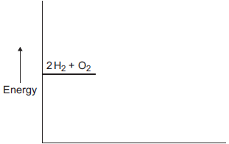
(3)
(Total 9 marks)
Q9.This question is about energy changes in chemical reactions.
(a) Balance the chemical equation for the combustion of methane.
CH₄ + O₂ → CO₂ + H₂O
(1)
(b) Alcohols are used as fuels. A group of students investigated the amount of energy released when an alcohol was burned. The students used the apparatus shown in the diagram below.
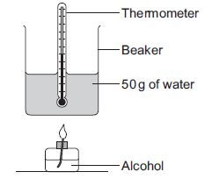
In one experiment the temperature of 50 g of water increased from 22.0 °C to 38.4 °C.The mass of alcohol burned was 0.8 g. Calculate the heat energy (Q) in joules, released by burning 0.8 g of the alcohol.
Use the equation:
Q = m × c × ΔT
Specific heat capacity (c) = 4.2 J / g / °C
_________________________________________________________________
_________________________________________________________________
_________________________________________________________________
Heat energy (Q) = ____________________ J
(3)
(c) The chemical equation for the combustion of ethanol is:
C₂H₅OH + 3O₂ → 2CO₂ + 3H₂O
(i) The equation for the reaction can be shown as:
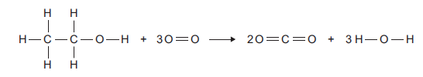

Bond | Bond energy in kJ per mole
C –– H | 413
C –– C | 347
C –– O | 358
C O | 799
O –– H | 467
O O | 495
Use the bond energies to calculate the overall energy change for this reaction.
_____________________________________________________________
_____________________________________________________________
_____________________________________________________________
_____________________________________________________________
Overall energy change = ___________ kJ per mole
(3)
(ii) The reaction is exothermic. Explain why, in terms of bonds broken and bonds formed.
_____________________________________________________________
_____________________________________________________________
_____________________________________________________________
(2)
(iii) Complete the energy level diagram for the combustion of ethanol. On the completed diagram, label:
• activation energy
• overall energy change.
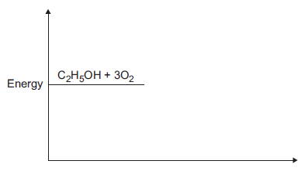
(3)
(Total 12 marks)
Q10. Methane (CH₄) is used as a fuel.
(a) The displayed structure of methane is:
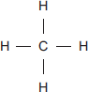
Draw a ring around a part of the displayed structure that represents a covalent bond.
(1)
(b) Why is methane a compound? Tick () one box.

Methane contains atoms of two elements, combined chemically.
Methane is not in the periodic table.
Methane is a mixture of two different elements.
(1)
(c) Methane burns in oxygen.
(i) The diagram below shows the energy level diagram for the complete combustion of methane. Draw and label arrows on the diagram to show:
• the activation energy
• the enthalpy change, ΔH.
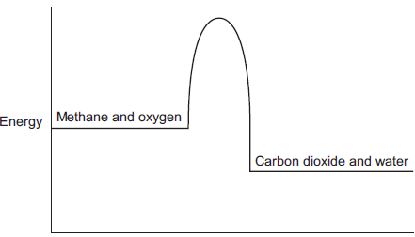
(2)
(ii) Complete and balance the symbol equation for the complete combustion of methane.
CH₄ + _____ CO₂ + _____
(2)
(iii) Explain why the incomplete combustion of methane is dangerous.
_____________________________________________________________
_____________________________________________________________
_____________________________________________________________
_____________________________________________________________
(2)

(iv) Explain why, in terms of the energy involved in bond breaking and bond making, the combustion of methane is exothermic.
_____________________________________________________________
_____________________________________________________________
_____________________________________________________________
_____________________________________________________________
_____________________________________________________________
(3)
(d) Methane reacts with chlorine in the presence of sunlight.
The equation for this reaction is:
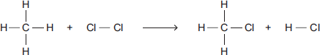
Some bond dissociation energies are given in the table.

Bond | Bond dissociation energy  in kJ per mole
C−H | 413
C−Cl | 327
Cl−Cl | 243
H−Cl | 432
(i) Show that the enthalpy change, ΔH, for this reaction is −103 kJ per mole.
_____________________________________________________________
_____________________________________________________________
_____________________________________________________________
_____________________________________________________________
_____________________________________________________________
(3)
(ii) Methane also reacts with bromine in the presence of sunlight.
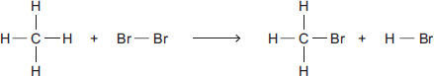
This reaction is less exothermic than the reaction between methane and chlorine.
The enthalpy change, ΔH, is −45 kJ per mole.
What is a possible reason for this?
Tick () one box.

CH₃Br has a lower boiling point than CH₃Cl
The C−Br bond is weaker than the C−Cl bond.
The H−Cl bond is weaker than the H−Br bond.
Chlorine is more reactive than bromine.
(1)
(Total 15 marks)
Q11. The equation for the reaction of ethene and bromine is:
C₂H₄(g) + Br₂(l) C₂H₄Br₂(l)
The reaction is exothermic.
(a) Complete the energy level diagram.
You should label
- the activation energy
- the enthalpy change (∆H).
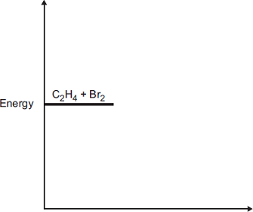
(3)
(b) (i) The equation for the reaction can be represented as:
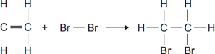

Bond | Bond dissociation energy in kJ per mole
C—H | 413
C ═ C | 614
Br—Br | 193
C—C | 348
C—Br | 276
Use the bond dissociation energies in the table to calculate the enthalpy change (∆H) for this reaction.
_____________________________________________________________
_____________________________________________________________
_____________________________________________________________
_____________________________________________________________
_____________________________________________________________
_____________________________________________________________
Enthalpy change (∆H) = ________ kJ per mole
(3)
(ii) The reaction is exothermic.
Explain why, in terms of bonds broken and bonds formed.
_____________________________________________________________
_____________________________________________________________
_____________________________________________________________
_____________________________________________________________
_____________________________________________________________
(2)
(Total 8 marks)

Mark schemes
Q1.
(a) (i) 7
1
(ii) –1
1
(iii) neutrons
1
(b) number of protons
1
(c) atom Y
1
(d) (i) Ne allow neon
1
(ii) has a full outer shell allow in Group 0 allow a noble gas
or
full outer energy level allow the shells are full
or
has 8 electrons in its outer shell ignore in Group 8
1
[7]
Q2. (a) (i) electronic structure 2,3 drawn
allow any representation of electrons, such as, dots, crosses, or numbers (2,3)
1
(ii) nucleus
1
(iii) protons and neutrons do not allow electrons in nucleus
1
(relative charge of proton) +1 allow positive
1
(relative charge of neutron) 0 allow no charge/neutral
1
ignore number of particles
(b) too many electrons in the first energy level or inner shell
allow inner shell can only have a maximum of 2 electrons
1

too few electrons in the second energy level or outer shell
allow neon has 8 electrons in its outer shell or neon does not have 1 electron in its outer shell / allow neon has a stable arrangement of electrons or a full outer shell
1
neon does not have 9 electrons or neon has 10 electrons
allow one electron missing / allow fluorine has 9 electrons
1
ignore second shell can hold (maximum) 8 electrons or 2,8,8 rule or is a noble gas or in Group 0
max 2 marks if the wrong particle, such as atoms instead of electrons
if no other mark awarded allow 1 mark for the electronic structure of neon is 2,8
[8]
Q3. (a) mass number allow the number of protons + neutrons
1
(b) 6.02 × 10²³
1
(c) Level 2 (3-4 marks):
Scientifically relevant features are identified; the ways in which they are similar / different is made clear.
Level 1 (1-2 marks):
Relevant features are identified and differences noted.
Level 0
No relevant content.
Indicative content
similarities
• both have positive charges
• both have (negative) electrons
• neither has neutrons
differences

plum pudding model | nuclear model
ball of positive charge (spread throughout) | positive charge concentrated at the centre
electrons spread throughout (embedded in the ball of positive charge) | electrons outside the nucleus
no empty space in the atom | most of the atom is empty space
mass spread throughout | mass concentrated at the centre
4
(d) 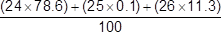
or
(24 × 0.786) + (25 × 0.101) +
(26 × 0.113)
1
= 24.3
1
an answer of 24.3 scores 2 marks
[8]
Q4. (a) precipitate / solid formed
allow colour change
1
(b) total mass before = 257.68 g
total mass after = 257.68 g
1
so the mass of products equals
the mass of the reactants
1
(c) 0.01 g
1
(d) 207 + (2 × 14) + (6 × 16)
or
207 + 2 × [14 + (3 × 16)]
1
= 331
1
an answer of 331 scores 2 marks
(e) CrO₄²⁻
1
(f) carbon dioxide is a gas
allow a gas is produced
1
the gas escapes during the reaction
1
(so) the mass at the end is less than expected
1
[10]

Q5. (a) (i) a correct link between any two named elements eg same group / column
same properties / number of outer electrons
allow some link between any two elements in the same group (in both Newlands and or the modern periodic table)
1
(ii) any two from: ignore statements about lack of evidence / proof
• elements still being discovered
or
no gaps for undiscovered elements
• some boxes have 2 elements in them
• metals and non-metals in same column / mixed up
accept some elements in same column have different properties.
allow any sensible suggestion about misplaced elements eg
copper in group 1 elements
• pattern for first 16 or so elements only
allow did not work for all elements
2
(b) (i) Cl > Br > I
accept reactivity / it decreases down the group
or
I < Br < Cl
1
Cl has 2 reactions, Br has 1 reaction, I doesn’t react
owtte
allow Cl has most / more reactions and I has least / less reactions (must be clear about where Br fits in)
1
(ii) Br₂
allow multiples / fractions if correctly completed and balanced
1
(iii) (they) have 7 outer electrons
allow (they) have 7 electrons in highest occupied (energy) level / shells / rings
1
(c) outer / last / final must be mentioned once in correct context,
otherwise max 2 marks comparative required on all three points
accept converse ie less reactive up group
down group (atom / elements) bigger
or
outer electrons (level / shell /ring) further from nucleus / centre ignore more electrons
or
more shells / level / rings
do not accept more outer shells for this mark
1
force(s) / attraction(s) are weaker
allow electron(s) attracted less easily
allow electron(s) less under influence (of nucleus)
or
more shielding
or
1
attracts less
do not accept magnetic / gravitational / intermolecular forces
electron(s) lost more easily
allow electron(s) more likely to be lost
allow easier to give away
1
[10]
Q6. (a) (iron) is a metal accept transition element
allow (iron) had different properties (to oxygen and sulfur) ignore electrons
1
(b) so that elements with similar properties could be placed together
allow to make the pattern fit
ignore undiscovered elements
1
(c) atomic number(s) allow proton number(s)
1
(d) all have one electron in the outer shell (highest energy level)
allow same number of electrons in the outer shell (highest energy level)
1
(so they) have similar properties
or
react in the same way allow specific reactions e.g. with water
1
[5]
Q7. (a) increase
1
(b) (i) Na⁺ and Br⁻ both required
1
(ii) sodium chloride allow NaCl
do not allow sodium chlorine
1
(iii) chlorine is more reactive than bromine
allow converse argument
allow symbols Cl, Cl₂, Br and Br₂
allow chlorine / it is more reactive
do not allow chloride or bromide
1
(iv) fluorine
allow F / F_{2.} do not allow fluoride.
1
[5]
Q8. (a) (i) protons
allow “protons or electrons”, but do not allow “protons and electrons”
1
(ii) protons plus / and neutrons
1
(b) (because the relative electrical charges are) −(1) for an electron and +(1) for a proton
allow electrons are negative and protons are positive
1
and the number of electrons is equal to the number of protons
if no other mark awarded, allow 1 mark for the charges cancel out
1
(c) (the electronic structure of) fluorine is 2,7 and chlorine is 2,8,7
allow diagrams for the first marking point
1
(so fluorine and chlorine are in the same group) because they have the same number of or 7 electrons in their highest energy level or outer shell
if no other mark awarded, allow 1 mark for have the same / similar properties
1
(d) S
1
(e) (i) ions
1
(ii) molecules
1
[9]
Q9. (a) the chemical reaction is reversible
1
(b) any two from:
• type of electrode
• electrolyte
• concentration of electrolyte
• temperature
2
(c) H₂ + 2OH⁻ → 2H₂O + 2 e⁻ allow multiples
1
(d) contains OH⁻ ions
1
(e) (bonds broken)
((6 × 412) + (2 × 360) + (2 × 464) + (3 × 498)) = 5614
1
(bonds made)
((4 × 805) + (8 × 464)) = 6932
1
(overall energy change)
(6932 − 5614) = −1318 (kJ / mol)
allow ecf from marking point 1 and / or marking point 2
1
an answer of 1318 (kJ / mol) scores 3 marks
[8]
Q10. (a) 13 (protons)
The answers must be in the correct order.
if no other marks awarded, award 1 mark if number of protons and electrons are equal
1
14 (neutrons)
1
13 (electrons)
1
(b) has three electrons in outer energy level / shell
allow electronic structure is 2.8.3
1
(c) Level 3 (5–6 marks):
A detailed and coherent comparison is given, which demonstrates a broad knowledge and understanding of the key scientific ideas. The response makes logical links between the points raised and uses sufficient examples to support these links.
Level 2 (3–4 marks):
A description is given which demonstrates a reasonable knowledge and understanding of the key scientific ideas. Comparisons are made but may not be fully articulated and / or precise.
Level 1 (1–2 marks):
Simple statements are made which demonstrate a basic knowledge of some of the relevant ideas. The response may fail to make comparisons between the points raised.
0 marks:
No relevant content.

Indicative content
Physical
Transition elements
• high melting points
• high densities
• strong
• hard
Group 1
• low melting points
• low densities
• soft
Chemical
Transition elements
• low reactivity / react slowly (with water or oxygen)
• used as catalysts
• ions with different charges
• coloured compounds
Group 1
• very reactive / react (quickly) with water / non-metals
• not used as catalysts
• white / colourless compounds
• only forms a +1 ion
6
[10]

Mark schemes
Q1.
(a) (i) 7 / seven
1
(ii) 1 do not accept –1
1
Electron
1
(iii) isotopes
1
(b) (i) (sodium + ) fluorine → sodium fluoride
1
(ii) compounds
1
(iii) mole
1
(iv) sodium (atom) loses
1
fluorine (atom) gains
1
one electron
1
ions formed
1
allow sodium forms positive (ion) or fluorine forms negative (ion)
allow form ionic bond allow to gain a full outer shell of electrons
allow forms noble gas structure
max 3 if reference to incorrect particle / bonding
(v) Dissolve in water
1
High melting point
1
[13]
Q2. (a) (i) neutrons this order only
1
electrons
1
protons
1
(ii) box on the left ticked
1
(b) (i) effervescence / bubbling / fizzing / bubbles of gas
do not accept just gas alone
1
magnesium gets smaller / disappears
allow magnesium dissolves
allow gets hotter or steam produced
ignore references to magnesium moving and floating / sinking and incorrectly named gases.
1
(ii) Marks awarded for this answer will be determined by the Quality of Communication (QC) as well as the standard of the scientific response. Examiners should also refer to the information in the Marking Guidance and apply a ‘best–fit’ approach to the marking.
0 marks
No relevant content
Level 1 (1−2 marks)
There are simple statements of some of the steps in a procedure for obtaining magnesium chloride.
Level 2 (3−4 marks)
There is a description of a laboratory procedure for obtaining magnesium chloride from dilute hydrochloric acid and magnesium.
The answer must include a way of ensuring the hydrochloric acid is fully reacted or a method of obtaining magnesium chloride crystals.
Level 3 (5−6 marks)
There is a well organised description of a laboratory procedure for obtaining magnesium chloride that can be followed by another person.
The answer must include a way of ensuring the hydrochloric acid is fully reacted and a method of obtaining magnesium chloride crystals.
examples of the points made in the response:
• hydrochloric acid in beaker (or similar)
• add small pieces of magnesium ribbon
• until magnesium is in excess or until no more effervescence occurs *
• filter using filter paper and funnel
• filter excess magnesium
• pour solution into evaporating basin / dish
• heat using Bunsen burner
• leave to crystallise / leave for water to evaporate / boil off water
• decant solution
• pat dry (using filter paper).
*Student may choose to use a named indicator until it turns a neutral colour, record the number of pieces of magnesium added then repeat without the indicator.
6
[12]
Q3. (a) gives out (heat)
1
(b) D
1
(c) L
1
(d) magnesium chloride
1
[4]
Q4.
(a) (i) C
1
(ii) B
1
(iii) A
1
(iv) D
1
(b) (i) SO₂
1
(ii) shared
1
(iii) covalent
1
[7]
Q5. (a) CH₄ 4 should be below halfway up H / tail of 4 below the dotted line
1
(b) molecule
1
(c) covalent
1
[3]
Q6. (a) carbon
1
(b) all
1
(c) covalent
1
(d) four
1
(e) hard
1
[5]
Q7. (a) C₃H₈
capital letters for symbols numbers must be halfway or lower down the element symbol allow H₈C₃ do not allow 3:8 or C₃ and H₈
1
(b) (i) electron
1
(ii) covalent
1
(c) low and small both for 1 mark
1
[4]
Q8 (a) Stops / reduces air from escaping (owtte)
allow keeping shape or keeping it hard
1
(b) a layer a few hundred atoms thick
1
(c) any two from:
• last longer
• use fewer balls
• less materials or save resources
• less manufactured
accept less factories
• less energy
• less fuel
• less pollution / greenhouse effect / global warming
• less waste
ignore references to cost / recycling
any two ideas
2
[4]

Q9. (a) weaker bonds
allow (other substances) react with the silicon dioxide
or
fewer bonds ignore weaker / fewer forces
or
disruption to lattice
do not accept reference to intermolecular forces / bonds
1
(b) (i) Na₂O
do not accept brackets or charges in the formula
1
(ii)
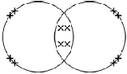
electrons can be shown as dots, crosses, e or any combination
2 bonding pairs
accept 4 electrons within the overlap
1
2 lone pairs on each oxygen
accept 4 non-bonding electrons on each oxygen
1
(c) lattice / regular pattern / layers / giant structure / close-packed arrangement
1
(of) positive ions or (of) atoms
1
(with) delocalised / free electrons
reference to incorrect particles or incorrect bonding or incorrect structure = max 2
1
[7]
Q10. (a) atoms
1
(b) mixture
1
metal
1
structure
1
smart
1
(c) (i) any two from:
• saves raw materials / iron ore
• saves energy / fuels
accept cheaper / saves money
• make new / useful items
• make money / it is economic
• reduces pollution
allow less harmful for the environment
• decreases cost of steel cans
• reduces carbon dioxide emissions
• decreases waste materials / use of landfill
2
(ii) any one from:
• provide information / education of the need to recycle
• legislate against / charge for waste
• reward / pay people to recycle
accept fine people for not recycling
• put labels on the cans
• provide recycling bags / bins / areas
1
[8]
Q11. (a) any two from
assume it = methanol
allow converse for water
• shorter / quicker soaking time
allow it is quicker
• takes less time / quicker to dry
or faster evaporation
• dissolves quicker / better in methanol
2
(b) (i) CH₄O
1
(ii) covalent
1
(c) it is made of small molecules
1
[5]
Q12. high melting point
reference to incorrect bonding or incorrect particles or incorrect structure = max 3
accept will not melt (at high temperatures)
ignore withstand high temperatures
1
because a lot of energy needed to break bonds
1
because it is covalent or has strong bonds
accept bonds are hard to break
1
and because it is a giant structure or a macromolecule or a lattice
ignore many bonds
1
[4]
Q13. (a) has delocalised electrons
accept free (moving) electrons
1
(so electrons) can move through the structure/metal
accept (so electrons) can carry charge through the structure/metal
accept (so electrons) can form a current
1
reference to incorrect particles or incorrect bonding or incorrect structure = max 1
(b) giant structure
accept lattice
accept each atom forms four bonds (with other carbon atoms)
ignore macromolecular
1
strong bonds
accept covalent do not accept ionic
1
reference to intermolecular forces/bonds or incorrect particles = max 1
(c) thermosetting polymers do not melt (when heated)
accept thermosetting polymers do not change shape (when heated)
accept thermosetting polymers have high(er) melting points
ignore thermosetting polymers do not soften (when heated)
1
due to cross-links (between chains)
accept due to bonds between chains
1
reference to smart polymers = max 1
accept converse argument
[6]
Q14. (a) (i) giant lattice
allow each carbon atom is joined to three others
1
atoms in graphene are covalently bonded
max. 2 marks if any reference to wrong type of bonding
1
and covalent bonds are strong or need a lot of energy to be broken
allow difficult to break
1
(ii) because graphene has delocalised electrons
allow each carbon atom has one free electron
1
which can move throughout the structure
do not accept just electrons can move.
1
(b) because there are weak forces between molecules
allow no bonds between the layers
1
so layers / molecules can slip / slide.
1
[7]
Mark schemes
Q1. (a) 1
must be in this order
1
very small
accept negligible, 1 / 2000
allow zero
1
(b) The mass number
1
(c) C
1
(d) (i) 2
1
(ii) 3
1
(e) (i) 28
1
(ii) 42.9 accept ecf from (e)(i) accept 42 - 43
1
(f) (i) 0.9
1
(ii) any one from:
• accurate
• sensitive
• rapid
• small sample.
1
[10]
Q2. (a) produces H⁺ / hydrogen ions in aqueous solution
1
(but is) only partially / slightly ionised
1
(b) indicator changes colour
1
from blue to yellow allow from blue to green
1
(when) the acid and alkali are (exactly) neutralised
or
(when) no excess of either acid or alkali
1
(c) pipette measures one fixed volume (accurately)
1
(but) burette measures variable volumes (accurately)
1
(d) 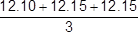
1
(mean titre =) 12.13(3) (cm ³)
1
(moles NaOH = conc × vol) = 0.00255
1
(moles citric acid = moles NaOH) = 0.00085
1
(conc acid = moles / vol) = 0.0701 (mol / dm ³)
allow ecf from steps 1, 2, 3 and / or 4
allow an answer of 0.0701 (mol / dm ³) without working for 1 mark only
1
[12]
Q3. (a) add excess copper carbonate (to dilute hydrochloric acid)
accept alternatives to excess, such as ‘until no more reacts’
1
filter (to remove excess copper carbonate)
reject heat until dry
1
heat filtrate to evaporate some water or heat to point of crystallisation
accept leave to evaporate or leave in evaporating basin
1
leave to cool (so crystals form) until crystals form
1
must be in correct order to gain 4 marks
(b) M_{r} CuCl₂ = 134.5 correct answer scores 4 marks
1
moles copper chloride = (mass / M_{r} = 11 / 134.5) = 0.0817843866
1
M_{r} CuCO₃= 123.5
1
Mass CuCO₃ (=moles × M₂= 0.08178 × 123.5) = 10.1(00)
1
accept 10.1 with no working shown for 4 marks

(c)
or
11.0 × 0.791
1
8.70 (g)
1
accept 8.70(g) with no working shown for 2 marks
(d) Total mass of reactants = 152.5
1
134.5
152.5 allow ecf from step 1
1
88.20 (%)
1
allow 88.20 with no working shown for 3 marks
(e) atom economy using carbonate lower because an additional product is made or carbon dioxide is made as well allow ecf
1
[14]
Q4. (a) in a closed system
1
the rate of the forward and backward reactions are equal
1
(b) concentration increases
1
(because) reaction / equilibrium moves to the left / reactant side
1
(since the) reverse reaction is exothermic
allow (so that) temperature increases
1
(c) becomes blue
1
(because) reaction / equilibrium moves to the right / product side
1
(so) concentration of blue cobalt compound increases
allow (so that) concentration of hydrochloric acid decreases
1

(d) (cobalt has) ions with different charges
allow (cobalt is a) transition metal
1
(e) Co³⁺
1
(f) they allow reactions to reach equilibrium more quickly
1
they provide a different reaction pathway
1
(g) 13H₂ + 6CO → C₆H₁₄ + 6H₂O
allow multiples
1
(h) C₈H₁₈
1
(i) curve below printed curve
do not accept different reactant or product levels
1
vertical arrow from reactant level to peak of printed curve
1
an answer of:
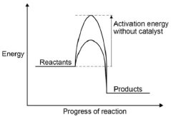
scores 2 marks
[16]
Q5. (a) left hand: (conical) flask
do not accept round bottomed
flask or container which is not a flask
1
right hand: beaker / trough accept plastic box
1
(b) (i) 157
1
(ii) all calcium carbonate used up or reaction stopped
do not accept all acid used up
1
(c) (i) 0.007(272727…)
correct answer with or without working gains 2 marks
if answer incorrect, allow (0.32 / 44) for 1 mark
2
(ii) 0.007(272727…)
allow ecf from (c)(i)
1
(iii) (M_{r} = mass / moles = 1 / 0.00727…) = 137.5 or 138
allow ecf from (c)(ii) if use 0.00943 moles then = 106
if use 0.007 allow 143 (142.857)
1
(iv) (138) – 60 (= 78)
23 / 85
1
(78 / 2) = 39
1
potassium
sodium / rubidium
identity of metal ecf on A_{r}, but must be Group 1
If no working max 1 mark
1
(d) (i) (relative atomic mass) would decrease
1
because the mass lost greater
1
so moles carbon dioxide larger or moles metal carbonate greater
1
(ii) no change
1
because the acid (already) in excess
1
so the amount carbon dioxide lost is the same
1
[17]

Q6. Marks awarded for this answer will be determined by the Quality of Written Communication (QWC) as well as the standard of the scientific response.
0 marks
No relevant content.
Level 1 (1-2 marks)
There is a simple description of using some of the equipment.
Level 2 (3-4 marks)
There is a description of an experimental method involving a measurement, or including addition of alkali to acid (or vice versa).
Level 3 (5-6 marks)
There is a description of a titration that would allow a successful result to be obtained.
Examples of chemistry points made in the response could include:
• acid in (conical) flask
• volume of acid measured using pipette
• indicator in (conical) flask and sodium hydroxide in burette
• white tile under flask
• slow addition
• swirling
• colour change
• volume of sodium hydroxide added
Extra information
• allow acid in the burette to be added to sodium hydroxide in the (conical) flask
• allow any specified indicator colour change need not be specified
[6]
Q7. (a) (i) lit splint or ignite the gas
1
(squeaky) pop / explosion
1
(ii) because it provides energy (for the reaction)
1
to break bonds (in the reactants) or so the particles collide successfully
ignore reference to frequency or rate of collisions
because it provides the activation energy gains 2 marks
1
(b) (i) 1.67(g) allow 1.66-1.68
correct answer (to 3 significant figures) with or without working gains 3 marks
if answer incorrect allow up to 2 marks for the following steps:
24 → 40
1.00 → 40 / 24
or
moles magnesium = 1 / 24 or 0.04(17)
multiply by 40
allow ecf from incorrect ratio or incorrect number of moles
3
(ii) if correct answer from part (b)(i) used
allow ecf from part (b)(i)
89.8 or 90
if 1.82 g used
82.4 or 82
correct answer with or without working gains 2 marks
if answer incorrect, allow the following for 1 mark:
1.50 / 1.67 (or their answer from part (b)(i))
if 1.82 g used: 1.50 / 1.82
2
(iii) any one from:
ignore measurement errors
• not all the magnesium reacted
allow the reaction may be reversible
• some of the magnesium oxide / product may have been left in the tube or may have been lost
ignore magnesium lost
• different / unexpected reaction
• magnesium not pure
1
[10]
Q8. (a) 4
1
(b) reversible (reaction)
1

(c) 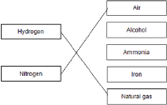
1
1
(d) −40 °C
1
(e) recycled to the reactor
1
(f) ionic
1
(g) nitrogen
1
phosphorus
1
(h) 0.24 × 50 × 5
allow £87.50
1
= £60
1
an answer of £60 scores 2 marks
(i) may need to use nitrogen, phosphorus and potassium
allow neither fertiliser has all the elements / nutrients needed.
[12]
Q9. (a) (sulfuric acid is) completely / fully ionised
1
In aqueous solution or when dissolved in water
1
(b) H⁺(aq) + OH⁻(aq) → H₂O(l)
allow multiples 1 mark for equation 1 mark for state symbols
2
(c) adds indicator, eg phenolpthalein / methyl orange / litmus added to the sodium hydroxide
(in the conical flask)
do not accept universal indicator
1
(adds the acid from a) burette
1
with swirling or dropwise towards the end point or until the indicator just changes colour
1
until the indicator changes from pink to colourless (for phenolphthalein) or yellow to red
(for methyl orange) or blue to red (for litmus)
1
(d) titrations 3, 4 and 5
or
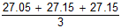
1
27.12 cm³
accept 27.12 with no working shown for 2 marks
1
allow 27.1166 with no working shown for 2 marks
(e) Moles H₂SO₄ = conc × vol = 0.00271 allow ecf from 8.4
1
Ratio H₂SO₄:NaOH is 1:2
or
Moles NaOH = Moles H₂SO₄ × 2 = 0.00542
1
Concentration NaOH = mol / vol = 0.00542 / 0.025 = 0.2168
1
0.217 (mol / dm³)
accept 0.217 with no working for 4 marks
1
accept 0.2168 with no working for 3 marks
(f) × 0.18 = no of moles
or
0.15 × 40 g
1
0.144 (g)
1
accept 0.144g with no working for 2 marks
[16]
Q10. (a) cool
1
to −34 °C allow temperatures below −34 °C but above −196 °C
1
(b) recycled (to the reactor)
1
(c) 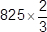
1
= 550 (dm ³)
1
an answer of 550 (dm ³) scores 2 marks
(d) a lower pressure would decrease the equilibrium yield
1
a lower temperature would make the reaction too slow
1
(e) nitrogen / N
1
(f) B and C
1
contain nitrogen, phosphorus and potassium
1
(g) (B)
any two from:
• more stages
• uses more energy
• uses more raw materials
• takes longer allow converse for C
2
[12]
Mark schemes
Q1. (a) 36 cm³
1
(b) all points correct ± ½ small square
2
allow 1 mark if 6 or 7 of the points are correct
2 best fit lines drawn
must not deviate towards anomalous point
2
allow 1 mark if 1 line correct
(c) The bung was not pushed in firmly enough.
1
The measuring cylinder was not completely over the delivery tube.
1
(d) as mass of lithium carbonate increases volume of gas produced increases
1
linear / (directly) proportional
1
(e) A gas / carbon dioxide is produced.
allow because the air in the tube expands
1
(f) any one from:
• Potassium carbonate does not decompose to produce carbon dioxide / a gas.
• Potassium carbonate does not decompose at the temperature of the Bunsen
burner or the Bunsen burner is not hot enough to decompose potassium carbonate.
• When potassium carbonate decomposes a gas is not formed.
1
[11]
Q2. (a) 4 Na + O₂ ⟶ 2Na₂O allow multiples
1
(b) (sodium) gains oxygen
1
(c) purple
1
(d) aluminium chloride
1
(e) Level 2 (3-4 marks):
Relevant reasons are identified, given in detail and logically linked to form a clear account.
Level 1 (1-2 marks):
Points are identified and stated simply, but their relevance is not clear and there is no attempt at logical linking.
Level 0
No relevant content
Indicative content
conclusion 1
• pH values above 7 are alkaline
• sodium oxide, calcium oxide and magnesium oxide do form alkaline solutions (so correct for those)
• not all metal oxides form solutions (so incorrect for zinc oxide)
conclusion 2
• pH values below 7 are acidic
• carbon dioxide, sulfur dioxide and phosphorus oxide do form acidic solutions (so correct for those)
• not all non-metal oxides form solutions (so incorrect for silicon oxide)]
4
(f) metal oxides produce alkaline solutions if they dissolve in water
allow 1 mark for most metal oxides produce alkaline solutions
2
[10]
Q3. (a) heat with a water bath
or
heat with an electric heater
or
allow to evaporate / crystallise at room temperature
1
(b) to make sure that all the iodine reacts
allow so can see the reaction is complete
1
(as) excess iodine would remain in solution
1
(so) iodine could not be filtered off
allow (whereas) excess zinc could be filtered off
or
(so) the zinc iodide would not be pure
allow (so) would have to separate iodine from zinc iodide
1
(c) 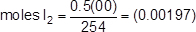
allow moles I₂ = 0.00197
allow 65 g Zn: 254 g I₂
1
mass Zn = 0.00197 × 65 (g)
1
mass = 0.128 (g)
1
allow an expression 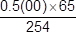 (g) for the first 2 marks
(d) 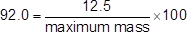
1
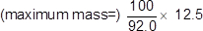
1
= 13.6 (g)
allow 13.5869... (g)
1
(e) some product lost on separation allow incomplete reaction
1
(f) M_{r} ZnI₂ = 319
1
moles needed
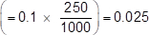
or
mass per dm ³ = 31.9 (g)
1
(mass) = 7.98 (g)
allow 7.975 / 8.0 (g)
1
an answer of 7.975, 7.98 or 8.0 (g) scores 3 marks
[14]
Q4. (a) (i) silver nitrate
allow AgNO₃
1
(ii) potassium carbonate or
allow K₂CO₃
sodium carbonate
allow Na₂CO₃
1
(b) base allow ionic
ignore insoluble or soluble
ignore alkali
1
(c) (i) evaporate
or
crystallise
allow heat or boil or leave (to evaporate) allow cool
ignore filtration unless given as an alternative
do not accept freeze or solidify
1
(ii) 2 (HNO₃)
accept multiples
1
(iii) 9
accept nine
1
(d) 6.21 / 207 0.72 / 16
1 mark for dividing mass by A_{r}
1
= 0.03 = 0.045
1 mark for correct proportions (allow multiples)
1
2 3
1 mark for correct whole number ratio (allow multiples). Can be awarded from formula.
1
Pb₂O₃
allow O₃Pb₂
ecf allowed throughout if sensible attempt at step 1
correct formula with no working gains 1 mark
1
[10]
Q5. (a) electricity
allow an electric current
1
(b) (i) chlorine/Cl₂
do not accept chloride
1
(ii) (zinc ions are) positive
ignore to gain electrons
1
and (opposite charges) attract
1
(iii) reduction
1
(c) (i) in alloy:
accept converse
different sized atoms/particles
or
no layers/rows
accept layers distorted
1
so cannot slide
1
(ii) shape memory (alloys)
accept smart
1
[8]
Q6. (a) (i) calcium oxide
in either order
1
carbon dioxide accept correct formulae
1
(ii) C(s) + CO₂(g) → 2CO(g) allow multiples
1
(iii) 210 (tonnes)
award 3 marks for the correct answer with or without working
allow ecf for arithmetical errors
if answer incorrect allow up to 2 marks for any of the steps below:
160 → 112
300 → 112 / 160 × 300
or
moles Fe₂O₃ = 1.875 (× 10⁶) or 300 / 160
moles of Fe = 3.75 (× 10⁶) or 2 × moles Fe₂O₃
mass Fe = moles Fe × 56
105 (tonnes) scores 2 (missing 1:2 ratio)
420 (tonnes) scores 2 − taken M_{r} of iron as 112
3
(b) (i) aluminium is more reactive than carbon or carbon is less reactive than aluminium
must have a comparison of reactivity of carbon and aluminium
accept comparison of position in reactivity series.
1
(ii) (because) aluminium ions are positive
ignore aluminium is positive
1
and are attracted / move / go to the negative electrode / cathode
1
where they gain electrons / are reduced / Al³⁺ + 3e⁻ → Al
accept equation or statements involving the wrong number of electrons.
1
(iii) (because) the anodes or (positive) electrodes are made of carbon / graphite
1
oxygen is produced (at anode)
1
which reacts with the electrodes / anodes
do not accept any reference to the anodes reacting with oxygen from the air
equation C + O₂ CO₂ gains 1 mark (M3)
1
[13]
Q7. (a) (delivery) tube sticks into the acid
1
the acid would go into the water or the acid would leave the flask or go up the delivery
tube
ignore no gas collected
1
(b) any one from:
• bung not put in firmly / properly
• gas lost before bung put in
• leak from tube
1
(c) all of the acid has reacted
1
(d) take more readings in range 0.34 g to 0.54 g
1
take more readings is insufficient ignore repeat
(e) 95
24000
1
0.00396
or
3.96 × 10⁻³
1
accept 0.00396 or 3.96 × 10⁻³ with no working shown for 2 marks
(f) use a pipette / burette to measure the acid
1
because it is more accurate volume than a measuring cylinder
or
greater precision than a measuring cylinder
or
use a gas syringe to collect the gas
so it will not dissolve in water
or
use a flask with a divider
accept description of tube suspended inside flask
so no gas escapes when bung removed
1
(g) they should be collected because carbon dioxide is left in flask at end
1
and it has the same volume as the air collected / displaced
1
[11]
Q8. (a) magnesium loses two electrons and chlorine gains one electron
accept magnesium loses electrons and chlorine gains electrons for 1 mark
ignore oxidation and reduction
2
one magnesium and two chlorines accept MgCl₂
1
noble gas structure
or
eight electrons in the outer shell
accept full outer shell (of electrons)
or
(electrostatic) attraction between ions
or
forms ionic bonds
do not accept covalent bonds
1
reference to incorrect particles or incorrect bonding or incorrect structure = max 3
(b) (i) because ions can move ignore ions attracted
do not accept molecules / atoms moving
do not accept incorrect reference to electrons moving
1
(and ions move) to the electrodes
or
(and ions) carry charge
1
accept converse for solid
(ii) magnesium (ions) attracted (to the electrode)
1
so magnesium ions gain electrons
accept magnesium ions are reduced
ignore oxidised
1
2 electrons
accept a correct half equation for 2nd and 3rd marking points
1
(iii) hydrogen allow H₂
1
(iv) magnesium is more reactive than hydrogen
accept converse
allow magnesium is high in the reactivity series or magnesium is very/too reactive.
do not accept magnesium ions are more reactive than hydrogen ions
1
(v) 2 Cl⁻ → Cl₂ + 2e⁻ must be completely correct
1
(c) layers (of particles/atoms/ions)
1
(particles/atoms/ions/layers) can slide
1
any mention of intermolecular / weak bonds/forces = max 1
[14]
Q9. (a) any one from:
• heat
• stir
1
(b) filter accept use a centrifuge accept leave longer (to settle)
1
(c) any one from:
• wear safety spectacles
• wear an apron
1
(d) evaporation at A
1
condensation at B
1
(e) 100
1
[6]
Q10. (a) any two from:
• concentration / volume of dilute hydrochloric acid
• mass of metal powder
• surface area of metal powder
• stirring (of any) / rate of stirring
allow reacted for the same length of time
2
(b) 4.2 °C allow Magnesium Test 2
1
and any one from:
• lower mass of magnesium added
• surface area of magnesium too low
• magnesium coated in magnesium oxide (so took a while to start reacting)
• not stirred
• not stirred as quickly as the other metals
• not reacted for as long a time as the other metals
allow reason for break in circuit
1
(c) 17.4(°C)
1
(d) bubbles of gas
1
more (bubbles) seen with calcium than other metals
allow any correct comparison between two metals
1
(e) any value between 7.9 °C and 12.3 °C
1
[8]
Q11. (a) (diagram) complete circuit with power supply
1
test solution in beaker or other appropriate apparatus
1
Electrodes allow carbon, platinum or inert electrodes
1
(independent variable)
salt solutions (with different metal ions)
1
(observation)
solid / metal deposit on the negative electrode
1

(b) (sometimes) hydrogen is produced
1
(because) the metal is more reactive than hydrogen
1
(c) chlorine
1
oxygen
1
[9]
Q12. (a) Whether there was a reaction or not
1
(b) brown / orange / dark deposit on zinc
or
blue solution turns colourless / paler
1
(c) Variable Measuring instrument
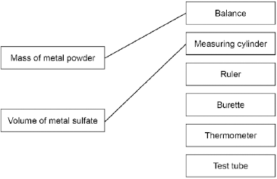
more than one line drawn from a variable negates the mark
2
(d) (Most reactive) Magnesium
Zinc
(Least reactive) Copper
must all be correct
1
(e) would not be safe or
too reactive allow too dangerous
1
(f) Gold
1
(g) 2Fe₂O₃ + 3C → 4Fe + 3CO₂ allow multiples
1

(h) carbon
1
(i) Loss of oxygen
1
[10]

Mark schemes
Q1. (a) (i) 42 000
correct answer gains 2 marks with or without working
allow 42 kJ
if answer incorrect : correct substitution 500 x 4.2 x 20 gains 1 mark
2
(ii) any two from:
• eye protection
• lab coat
• heat-proof mat
• (heat-proof) gloves
• (long) hair tied back
• stand up
• secure the beaker
2
(iii) Stir the water before measuring the temperature.
1
Place a lid on the beaker.
1
(b) the products → S
1
the activation energy → Q
1
the energy released by the reaction → P
1
(c) carbon dioxide produced
it = propane allow converse arguments
allow greenhouse gas / global warming / atmospheric pollution
(crude oil / propane) non-renewable
1
allow crude oil running out
1
[11]
Q2. (a) the bag gets cold because heat energy is taken in from the surroundings
1
(b) endothermic
1
(c) any two from:
• mix / spread (the ammonium nitrate and water)
• dissolve faster(*)
• get cold faster or so the whole bag gets cold(*)
(*)allow increase rate or quicker reaction
• particles collide more or more collisions
2
[4]
Q3. (a) measuring cylinder
1
(b) use a polystyrene cup allow insulate the beaker and / or use a lid
1
better insulator
or
reduces energy transfer from the surroundings
1
(c) starting temperature of hydrochloric acid
1
volume of hydrochloric acid
1
(d) 21.4 (°C)
1
(e) 15.8 (°C) to 16.1 (°C) allow 16.1 (°C) to 15.8 (°C)
1
(f) 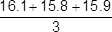
=15.9 (°C) an answer of 15.9(333..) (°C) scores 2 marks
1
allow 15.9(333..) (°C)
1
(g) temperature decreases
1
(h) straight line from (1.0, 19.8) to (5.0, 14.6)
ignore continuation of line in either direction
1
horizontal straight line from (5.0, 14.6 to 8.0, 14.6)
ignore continuation of line in either direction
1
the answer below scores 2 marks
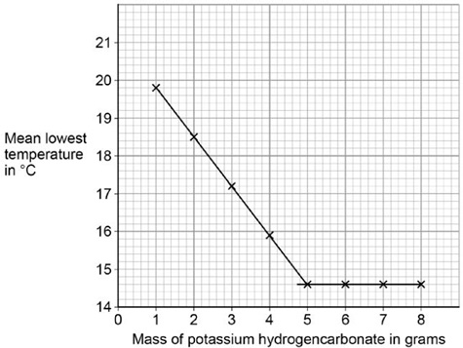
(i) (lowest) temperature decreases
1
to 14.6 °C
or
until 5 g added
1
then no change to temperature (after 5 g solid added)
or
then temperature remains at 14.6 °C (after 5 g solid added)
1
[15]
Q4. (a) water / H₂O allow steam or hydrogen oxide
1
(b) (i) A
1
(ii) exothermic
1
products (energy) lower than reactants (energy)
1
(iii) 1860 (kJ)
1
(c) (i) 22.5
1
38.7
1
16.2
allow ecf for correct subtraction
1
(ii) 50 (g)
1
(iii) 20.1 (kJ) allow propanol ignore 3
1
(iv) as the number of carbon atoms (in one molecule of alcohol) increases the heat energy given out increases (when the alcohol is burned)
1
(v) any two from:
• no lid
• no insulation
• no draught shield
Allow heat / energy loss to surroundings for any one of these marks
• incomplete combustion
• inaccurate measurement
• no repeats (to calculate a mean)
2
(iv) -O-H
1
[14]
Q5. (a) the chemical reaction is reversible
1
(b) any two from:
• type of electrode
• electrolyte
• concentration of electrolyte
• temperature
2
(c) H₂ + 2OH⁻ → 2H₂O + 2 e⁻
allow multiples
1
(d) contains OH⁻ ions
1
(e) (bonds broken)
((6 × 412) + (2 × 360) + (2 × 464) + (3 × 498)) = 5614
1
(bonds made)
((4 × 805) + (8 × 464)) = 6932
1
(overall energy change)
(6932 − 5614) = −1318 (kJ / mol)
allow ecf from marking point 1 and / or marking point 2
1
an answer of 1318 (kJ / mol) scores 3 marks
[8]
Q6. (a) eg plastic (beaker) / insulation / lid / cover or any mention of enclosed
any sensible modification to reduce heat loss
ignore prevent draughts
ignore references to gas loss
ignore bomb calorimeter
1
(b) all the substances react or all (the substances) react fully / completely or heat evolved quickly or distribute heat
‘so they react’ is insufficient for the mark
accept increase chances of (successful) collisions / collision rate increase
do not accept rate of reaction increase / make reaction faster
1
(c) experiment 2 and
different / higher / initial / starting temperature
accept experiment 2 and the room is hotter / at higher temperature
do not accept temperature change / results higher
1
(d) temperature change does not fit pattern
accept anomalous / odd or it is the lowest or it is lower than the others or it is different to the others
‘results are different’ is insufficient
1
(e) 7 / 7.0
1
(f) (100 × 4.2 × 7) = 2940 ecf from (e)
1
(g) diagram A and
reaction exothermic / heat evolved / Δ H is negative / temperature rises
accept energy is lost (to the surroundings)
accept energy of products lower than reactants
allow arrow goes downwards
1
[7]
Q7. (a) (i) energy / heat of products less than energy of reactants
allow converse
allow products are lower than reactants
allow more energy / heat given out than taken in
allow methanol is lower
allow energy / heat is given out / lost
allow ΔH is negative
1
(ii) lowers / less activation energy allow lowers energy needed for reaction
or it lowers the peak/ maximum
do not allow just ‘lowers the energy’
1
(b) (i) (8 × 435) + 497 = 3977
accept: bonds broken: (2 × 435) + 497 = 1367
1
(6 × 435) + (2 × 336) + (2 × 464) = 4210
bonds made: (2 × 336) + (2 × 464) = 1600
1
3977 – 4210 = (–) 233
energy change:
1367 – 1600 = (–) 233
ignore sign
allow ecf
correct answer (233) = 3 marks with or without working
1
(ii) energy released forming (new) bonds is greater than energy needed to break (existing) bonds allow converse
do not accept energy needed to form (new) bonds greater than energy needed to break (existing) bonds
1
[6]
Q8. (a) electrical
1
(b) using hydrogen saves petrol / diesel / crude oil
allow crude oil is non-renewable
ignore hydrogen is renewable
1
using hydrogen (in fuel cells) does not cause pollution
accept no carbon dioxide produced
allow less carbon dioxide produced allow hydrogen produces only water
1
(c) (i) (–)486
correct answer with or without working gains 3 marks
if answer is incorrect:
(2 × 436) + 498 or 1370 gains 1 mark
4 × 464 or 1856 gains 1 mark
correct subtraction of ecf gains 1 mark
3
(ii) products lower than reactants
1
reaction curve correctly drawn
1
activation energy labelled
1
[9]
Q9. (a) CH₄ + 2O₂ → CO₂ + 2H₂O allow multiples
1
(b) 3444 J
if answer incorrect:
one mark for temperature increase = 16.4 °C
one mark for mass of water = 50 g
ecf for one incorrect value gains two marks for correct calculation
no ecf for two incorrect values
3
(c) (i) 1276 (kJ per mole)
ignore + or -
if answer incorrect:
[(5 × 413) + 347 + 358 + 467] + [(3 × 495)] = 4722 (1 mark)
[(4 × 799) + (6 × 467)] = 5998 (1 mark)
correct subtraction of calculated energy values (1 mark)
3
(ii) because energy released when bonds form is greater than energy used when bonds broken
allow converse
if no mark awarded allow one mark for energy is used to break bonds
or
one mark for energy is released when bonds form
2
(iii) products line lower than reactants
1
activation energy labelled
1
overall energy change labelled
1
[12]
Q10. (a) circle round any one (or more) of the covalent bonds
any correct indication of the bond − the line between letters
1
(b) Methane contains atoms of two elements, combined chemically
1
(c) (i) activation energy labelled from level of reagents to highest point of curve
ignore arrowheads
1
enthalpy change labelled from reagents to products
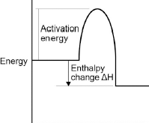
arrowhead must go from reagents to products only
1
(ii) 2 O₂
1
2 H₂O
if not fully correct, award 1 mark for all formulae correct.
ignore state symbols
1
(iii) carbon monoxide is made
1
this combines with the blood / haemoglobin or prevents oxygen being carried in the blood / round body or kills you or is toxic or poisonous
dependent on first marking point
1
(iv) energy is taken in / required to break bonds
accept bond breaking is endothermic
1
energy is given out when bonds are made
accept bond making is exothermic
1
the energy given out is greater than the energy taken in
this mark only awarded if both of previous marks awarded
1
(d) (i) energy to break bonds = 1895
calculation with no explanation max = 2
1
energy from making bonds = 1998
1
1895 − 1998 (= −103)
or
energy to break bonds = 656
energy from making bonds = 759
656 − 759 (= −103)
allow: bonds broken − bonds made =
413 + 243 − 327 − 432 = -103 for 3 marks.
1
(ii) The C — Br bond is weaker than the C — Cl bond
1
[15]
Q11. (a) products are at a lower energy level than reactants
if candidate has drawn a profile for an endothermic reaction penalise first marking point only
1
activation energy correctly drawn and labelled
1
ΔH correctly labelled
1
(b) (i) –93 (kJ per mole)
correct answer with or without working gains 3 marks
allow 2 marks for +93 kJ per mole
if any other answer is seen award up to 2 marks for any two of the steps below:
bonds broken (614 + 193) = 807 (kJ) or (614 + 193 + (4 × 413)) = 2459(kJ)
bonds formed (348 + 276 + 276) = 900(kJ) or 348 + (2 × 276) + (4 × 413) = 2552(kJ)
bonds broken – bonds formed
allow ecf for arithmetical errors
3
(ii) more energy is released when the bonds (in the products) are formed
1
than is needed to break the bonds (in the reactants)
if no other marks gained, allow 1 mark for energy released for bond making and energy used for bond breaking
1
[8]

