Week 2 Day 4
Spellings

Practise these words.

Read | Trace | Practise | Practise | Practise | Practise
forty | forty
frequently | frequently
government | government
guarantee | guarantee
harass | harass

Now write a sentence for each word. Can you spell it correctly in each sentence without looking at the table?

__________________________________________________________________________________________________________________________________________________________________________________________________________________________________________________________________________________________________________________________________________________________________________________________________________________________________________________________________________________________________________________________________________________________________________________________________________________
__________________________________________________________________
Maths
Work out the following number sentences using the column method.
245 X 26 = | 424 X 36 =
817 X 55 = | 753 X 48 =
155 X 24 = | 219 X 72 =
475 X 28 = | 8216 X91 =

English
Write as many adjectives (describing words) as you can around the image.
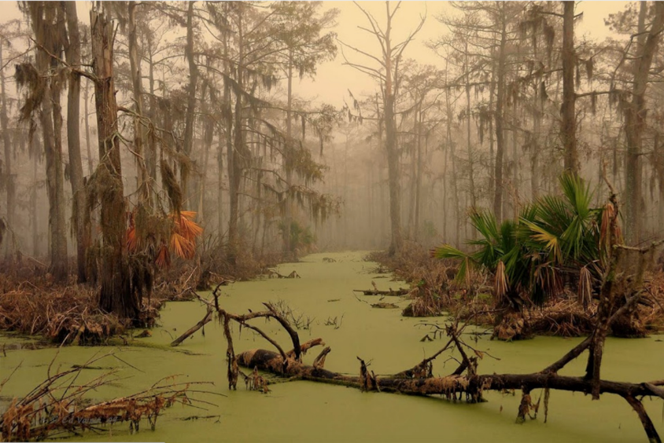
Swamp life
Decrepit

Mysterious

Look at this image from the highway man, use senses to think about what may be around you.
hear | touch | see | taste | smell

