Dear Year 1 students and parents.

This timetable is a guideline for what your child can study daily basis. While there are extended activities for children to complete on the school website, please can you use the Oak National Academy website for daily lessons in English Maths and Foundation subjects. There are 3 hours of daily lesson and this website is updated weekly. The website is accessible from PC, laptops, tablets and mobile phones.

https://www.thenational.academy/online-classroom

Please click on ‘schedule’ - Year group 1 - topic
This will take you to daily lessons for English, Maths and Topic.

https://www.thenational.academy/online-classroom/schedule/#schedule

Subject | Monday | Tuesday | Wednesday | Thursday | Friday
Reading  https://www.alecreedacademy.co.uk/page/?title=Student+Resources&pid=177  Spellings:  Week 1: Spelling Pattern:  ed suffix  Week 2  Spelling Pattern:  er/est suffix  Week 3  Spelling Pattern:  ing suffix | https://my.risingstars-uk.com/Default.aspx?cid=DL28402  Login using your rising stars login details. The centre ID is 28402  There have been lots of books allocated to each child and they also have interactive comprehensions to engage with. | https://my.risingstars-uk.com/Default.aspx?cid=DL28402  Login using your rising stars login details. The centre ID is 28402  There have been lots of books allocated to each child and they also have interactive comprehensions to engage with. | https://my.risingstars-uk.com/Default.aspx?cid=DL28402  Login using your rising stars login details. The centre ID is 28402  There have been lots of books allocated to each child and they also have interactive comprehensions to engage with. | https://my.risingstars-uk.com/Default.aspx?cid=DL28402  Login using your rising stars login details. The centre ID is 28402  There have been lots of books allocated to each child and they also have interactive comprehensions to engage with. | https://my.risingstars-uk.com/Default.aspx?cid=DL28402  Login using your rising stars login details. The centre ID is 28402  There have been lots of books allocated to each child and they also have interactive comprehensions to engage with.
Writing | Daily Lesson https://www.thenational.academy/online-classroom/year-1/#schedule | Daily Lesson https://www.thenational.academy/online-classroom/year-1/#schedule | Daily Lesson https://www.thenational.academy/online-classroom/year-1/#schedule | Daily Lesson https://www.thenational.academy/online-classroom/year-1/#schedule | Daily Lesson https://www.thenational.academy/online-classroom/year-1/#schedule
Maths  https://central.espresso.co.uk/espresso/modules/subject/index.html?subject=862390&grade=ks1&&source=espresso-home-keystage1subjects  login details  student23122 alecreed | Daily maths Lesson:  https://www.thenational.academy/online-classroom/year-1/#schedule | Daily maths Lesson:  https://www.thenational.academy/online-classroom/year-1/#schedule | Daily maths Lesson:  https://www.thenational.academy/online-classroom/year-1/#schedule | Daily maths Lesson:  https://www.thenational.academy/online-classroom/year-1/#schedule | Daily maths Lesson:  https://www.thenational.academy/online-classroom/year-1/#schedule
Creative Time | Banksy style stencil painting  https://www.bbc.co.uk/bitesize/clips/z2nqg82 | Painting a Cityscape  https://www.bbc.co.uk/bitesize/clips/zgsdv4j | Making a Blow painting  https://www.youtube.com/watch?v=zkSW_C2gPj8  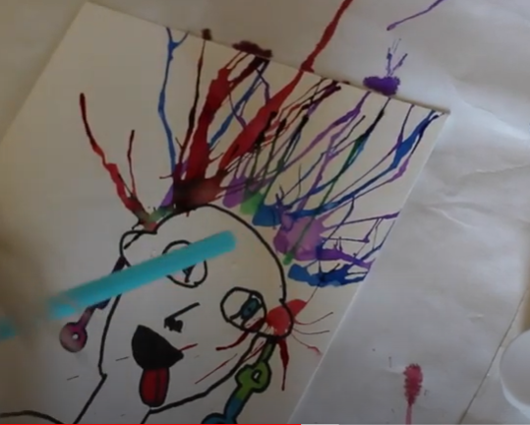 | Picasso Portrait  https://www.youtube.com/watch?v=wrXmE6XYbYw  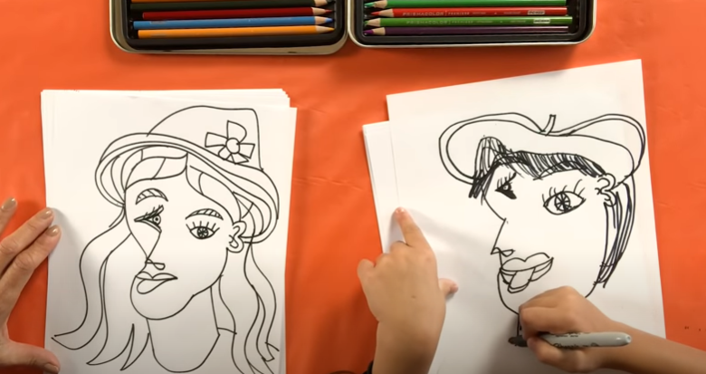 | Painting with a cotton wool bud  https://www.bbc.co.uk/bitesize/clips/zs9yj6f  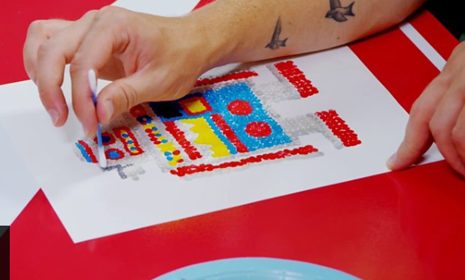

Below are suggested activities that you could be practicing on a regular basis.

Spellings - See the year 1 & 2 spelling list that is attached on the school website.  You could do any of the following activities:  -Write silly sentences with your spellings.  -Rainbow spellings  -Write a story that includes each of your spelling words.  -Hold a quiz with the members of your family. | Times tables - knowing our times tables is extremely important, especially as we move into year 2.  2x https://www.youtube.com/watch?v=3yf3xgE8wMc  5x https://www.youtube.com/watch?v=2KyDZ7f1RfE  10x https://www.youtube.com/watch?v=UfvIlQNlBH4 | Physical Activity - make sure you are trying to be active every day.  - Watch Joe Wicks PE lessons live every day at 9:00am or watch his previous videos at any time of day.  - Create your own circuit and teach it to the members of your family.  - Watch some of the Just Dance videos on YouTube and get dancing for 20 - 30 minutes.

