MONEY and CALCULATION

Can combine amounts and calculate change

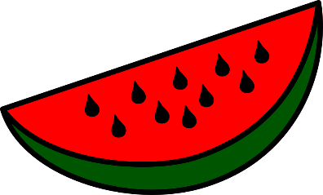
- Mia buys a pineapple and a slice of watermelon.
57p
£1 and 16p
How much change does she get from £2?

- Aya buys a toy, a snack and a drink.
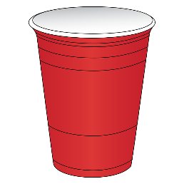
55p
£1 and 5p
25p
How much change does she get from £5?

- Oliver buys two toys for £1 and 15p each and a drink for 20p.

Harriet buys some grapes for 86p and a drink for 52p.

Who gets the most change from £3?
Explain your answer.

