Week 1 Day 2
Spellings

Practise these words.

Read | Trace | Practise | Practise | Practise | Practise
amateur | amateur
ancient | ancient
apparent | apparent
appreciate | appreciate
attached | attached

Now look up the definition, write it. How many of these words can you fit into one sentence?

__________________________________________________________________________________________________________________________________________________________________________________________________________________________________________________________________________________________________________________________________________________________________________________________________________________________________________________________________________________________________________________________________________________________________________________________________________________
__________________________________________________________________
Maths
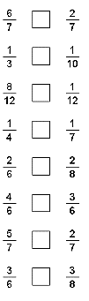
Use the greater than, less than or equals sign to compare the following numbers.
> < =
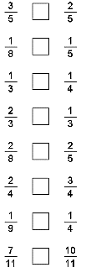

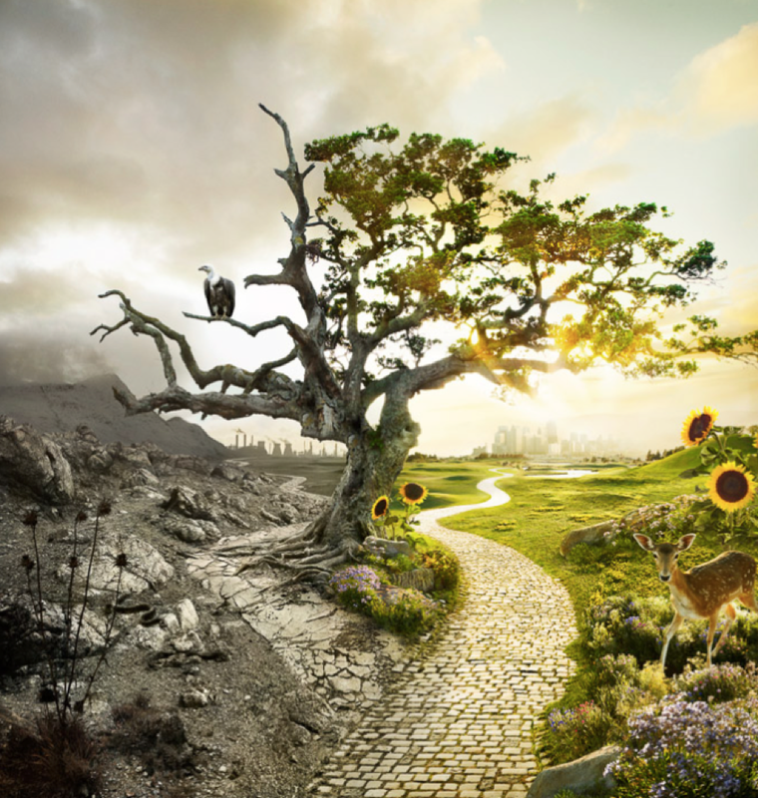
English
Fronted Adverbials
There are three types of fronted adverbial: How something happens, when something happens and where something happens. It describes the verb (action) in the sentence. REMEMBER the , after!
Example: As darkness fell, the branches groaned in agony at the sight of the deadly clouds.
How | When | Where
Like a deadly preditor, | As the thunder grumbled, | Under the broad oak tree,

Write a variety of sentences using the fronted adverbials you have thought of. You could even up-level some that you did yesterday!
Example: As the thunder grumbled, the majestic eagle stalked intimidatingly as it perched awaiting its next prey.
_________________________________________________________________________________________________________________________________________________________________________________________________________________________________________________________________________________________________________________________________________________________________________________________________________________________________________________________________________________________________________________________

