Week 3 Day 4
Spellings

Practise these words.

Read | Trace | Practise | Practise | Practise | Practise
physical | physical
prejudice | prejudice
privilege | privilege
profession | profession
programme | programme

Now write a sentence for each word. Can you spell it correctly in each sentence without looking at the table?

__________________________________________________________________________________________________________________________________________________________________________________________________________________________________________________________________________________________________________________________________________________________________________________________________________________________________________________________________________________________________________________________________________________________________________________________________________________
__________________________________________________________________
Maths
Find the missing lengths of these shapes
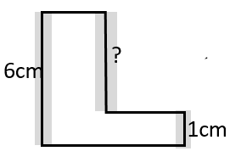  Example: 6 – 1 = 5cm | 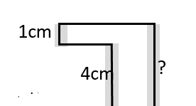 | 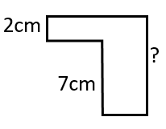

Area – the space inside a shape. Remember to find the area we do width X Length
What is the area of this rectangle?  6cm  8cm | Find the area of this triangle.  (Remember that we find the area of the rectangle then divide this by 2!)  7cm  9cm | What is the total area of these 2 shapes?  14cm  4cm  11cm  5cm
Draw accurately with a ruler, a rectangle with width 9cm, and length of 6cm and calculate its area. |  | What is the area of this compound shape?  8cm  2cm  8cm  2cm

English
Write an acrostic poem about your dreams. What do you dream of doing? What do you want to achieve? We all have a dream, let’s make it an positive one!
