Week 3 Day 5
Spellings

Practise these words.

Read | Trace | Practise | Practise | Practise | Practise
queue | queue
recognise | recognise
recommend | recommend
restaurant | restaurant
rhyme | rhyme

Now write a sentence for each word. Can you spell it correctly in each sentence without looking at the table?

__________________________________________________________________________________________________________________________________________________________________________________________________________________________________________________________________________________________________________________________________________________________________________________________________________________________________________________________________________________________________________________________________________________________________________________________________________________
__________________________________________________________________
Maths
Area – is space inside a shape. You can calculate the area by multiplying the length by the width. Calculate the area for these shapes.
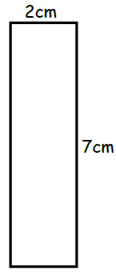  Example:  2 X 7 = 14cm² | 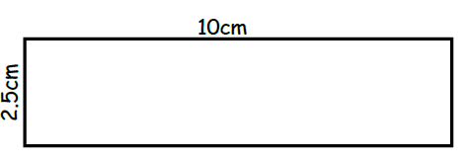
 | 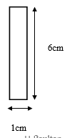

Find the area of these compound shapes. Remember to find the missing lengths first! You need to split these into two shapes and then combine the area.
Example  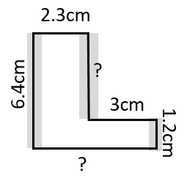  5.3cm  5.2cm  2.3 X 6.4 = 14.72cm²  3 X 1.2 = 3.6cm²  14.72 + 3.6 = 18.32cm² | 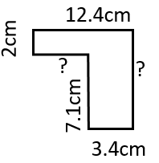 | 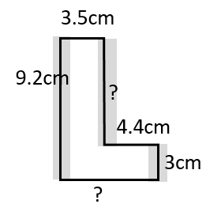

English
You have 60 seconds to read and complete the comprehension. Can you do it? Record your time.
