Events

An event is a single, specially organised occasion that acts as a temporary visitor attraction e.g. going to Glastonbury in Somerset, UK in June for the Glastonbury Festival; going to Rio de Janeiro, Brazil in August 2016 for the Olympics or to the NEC in Birmingham in March 2016 for Crufts.
___________________________________________________________________________

Visitor attractions are leisure facilities. Their customers are mostly tourists and they are likely to have travelled to it from where they live or from where they are staying if they are on holiday. You need UK and overseas case studies for these, and there are five types of visitor attraction:

Natural attractions – are physical (naturally made) features such as waterfalls, mountains and valleys e.g.
- UK case study is The Giant’s Causeway in Bushmills, Northern Ireland.
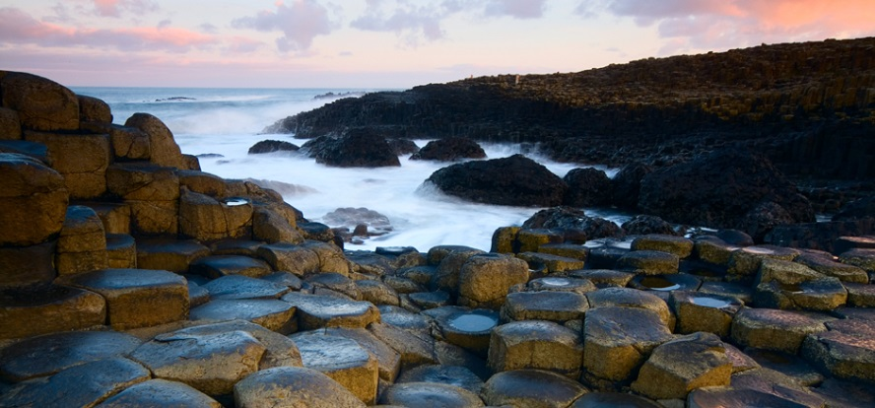

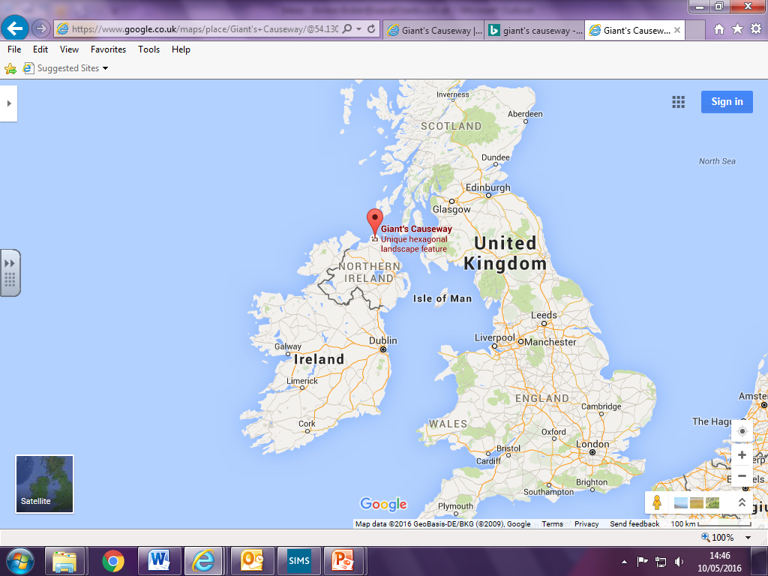
Farnborough
Giant’s Causeway in Bushmills, Northern Ireland.
The Giant’s Causeway is an area of hexagonal stone (Basalt) columns that are the result of an ancient volcanic eruption. It was declared as a UNESCO World Heritage Site in 1986, and is also a nature reserve. The columns form stepping stones that lead from the bottom of the cliff, and disappear into the sea. Legend has it that the stones are the remains of a causeway (a road which goes across a body of water) to Scotland, which was built by a giant so that he could meet a Scottish Giant for a fight.
Leisure activities to do there are:
- Go on a tour of movie locations e.g. ‘Game of Thrones’ is filmed in locations all round that area,
- Go to the Visitors Centre which has received awards for innovation and sustainability,
- Drive along the coastal highway, visiting all the sights along the way.
- See the romantic remains of ‘Dunluce Castle’,
- visit the ruins of the 6th century stone fort ‘Altagore Cashel’,
- walk over the ‘Carrick-a-Rede rope bridge’ which is a swaying little bridge that hovers almost 100 feet over a dramatic chasm with the Atlantic Ocean below you,
- go on a tour of the ‘Old Bushmills Distillery’, Ireland’s oldest working Whiskey distillery,
- visit Rathlin West Lighthouse on Rathlin Island,
- stay in a restored lightkeeper’s house at Blackhead.
It meets the needs of different groups of people by:
- Use the interactive exhibition exploring the Giant's Causeway
- For international tourists, there is an audio guide available, providing information in nine languages.
- There is an audio guide for visually impaired visitors.
- There is a grab-and-go coffee shop
- There are local and unique gifts for sale in shop
- There is a Bureau de Change for international tourists to be able to change currency,
- Parking across three car parks and Park and Ride facility,
- Baby-changing facilities
- Pushchairs and baby back-carriers admitted
- Accessible path for pushchairs
- Mobility parking
- Visitor Centre is accessible
- Accessible toilets and Changing Places facilities (key on request)
- Grounds - partly accessible, grass, uneven, narrow, loose and hard gravel paths, steep slopes, steps, undulating terrain
- Some visitors may require assistance from their companion
- Accessible trail for wheelchair users.

- Overseas case study is The Grand Canyon in Arizona, USA.
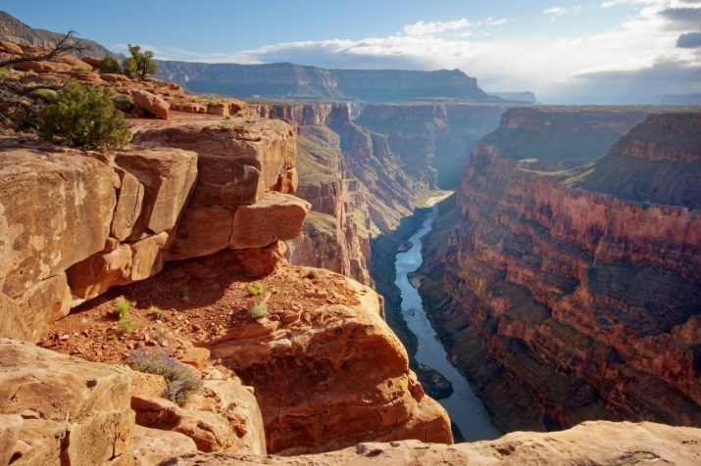

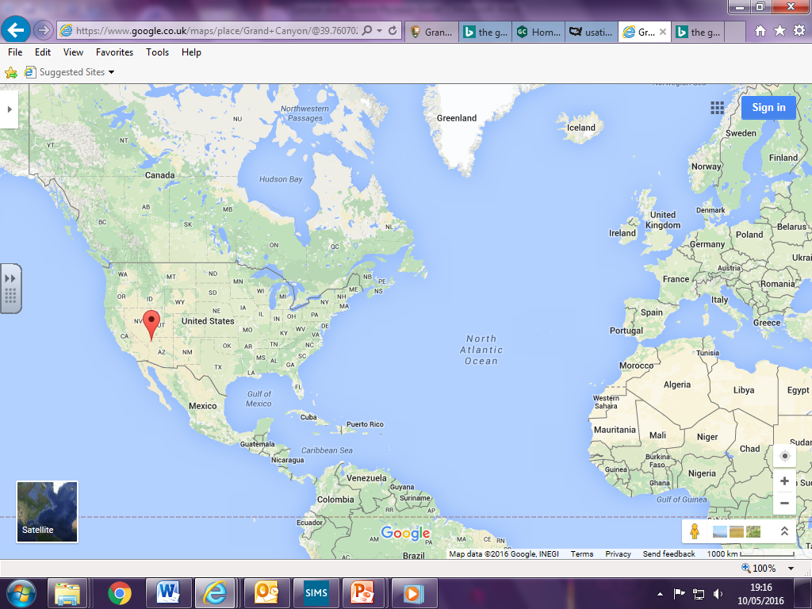
The Grand Canyon, Arizona, USA.
Farnborough
Las Vegas, Nevada, USA.
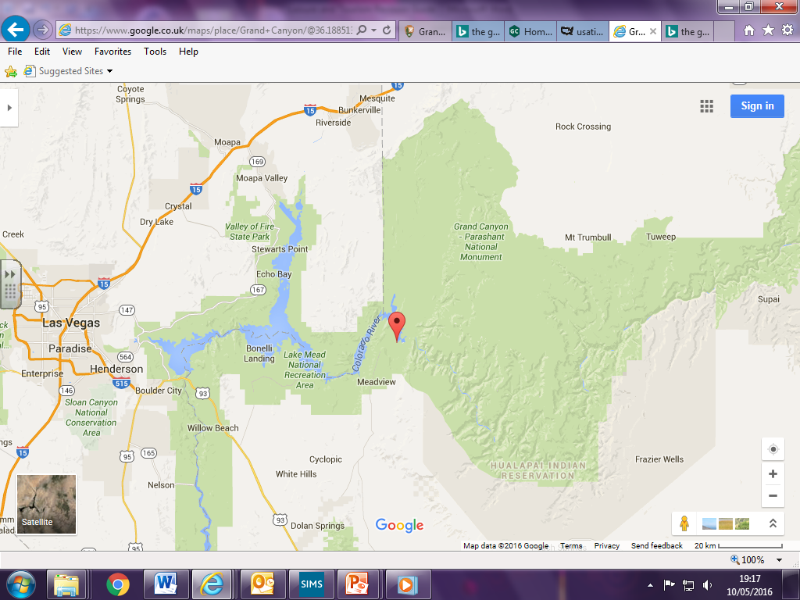
The Grand Canyon, Arizona, USA.

The Grand Canyon is a canyon that is 277 miles long, up to 18 miles wide, and a mile deep. It was formed by the Colorado River eroding the landscape and carving it out. It’s approximately a 5 hour drive to Las Vegas, which is in the next state of Nevada. It is within the Grand Canyon National Park.
Leisure activities to do there are:
- take a helicopter ride over the canyon,
- go hiking/backpacking,
- take a river boat ride or go white-water rafting on the Colorado River,
- retrace the Santa Fe line on the Grand Canyon railway,
- ride a mule,
The Skywalk is a horseshoe shaped bridge with a glass walkway which extends out over the Grand Canyon so you can look directly down. Book a Skywalk experience.
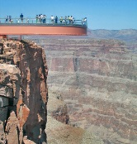
- visit the casinos in Las Vegas,
- go camping,
- there are several visitor centres, cafes, restaurants and shops to suit all budgets and groups of people,
It meets the needs of different groups of people by:
- Many of the facilities at Grand Canyon are historic and built before current accessibility standards were set. The terrain is rugged with narrow, rocky trails and steep cliffs. Visitors using wheelchairs or who have visual impairments may need assistance.
- All park shuttle buses are wheelchair accessible.
- Shuttle buses are equipped with ramps and space to carry passengers in wheelchairs.
- A Scenic Drive Accessibility Permit allows entry for visitors with mobility issues access to some areas closed to public traffic. The permit is available at entrance gates, National Park Service visitor centres, and hotel lobbies.
-The Accessibility Permit also acts as a temporary parking permit for designated parking.

Historic sites – are places such as ancient monuments and old buildings that have become attractions for visitors e.g.

- UK case study is Stonehenge in Amesbury, near Salisbury in Wiltshire.

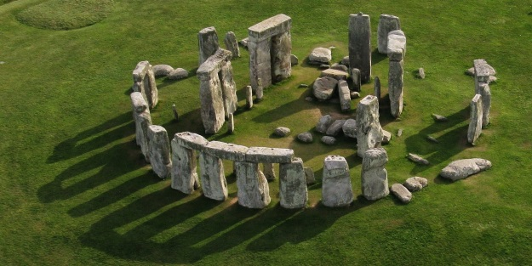
Farnborough
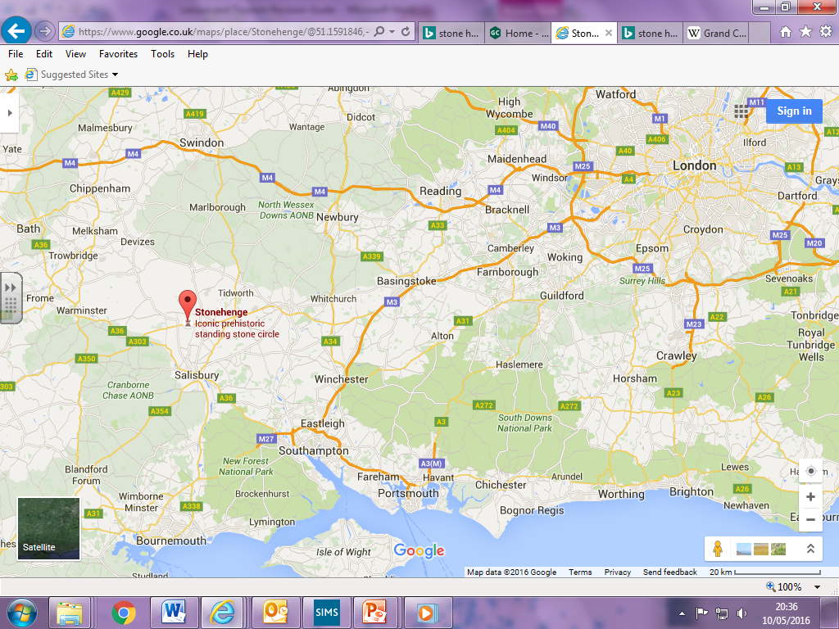
Salisbury, Wiltshire.
Stonehenge in Amesbury, Wiltshire.

Stonehenge was built about 4,500 years ago, but nobody knows why it was built or who built it.
Leisure activities to do there are:
- go to the visitor centre,
- see the Neolithic houses outside the visitor centre,
- visit nearby Salisbury for shopping and night life,
- visit ‘Old Sarum’ town, cathedral and castle which is nearby,
- visit Avebury stone works which is about 25 miles north,
- visit ‘Salisbury Museum’ and ‘Wiltshire Museum’ to see artifacts that were removed from the Stonehenge area,
- visit Woodhenge which is in the nearby village of Durrington,
- go for walks in the Wiltshire countryside,
- visit the Stonehenge café,
- visit the Stonehenge shop,
It meets the needs of different groups of people by:
- audio-visual displays,
- pick up and touch tactile objects and replica artefacts for children to play with.
- buy a Children's Activity Pack (£2.99) from the shop, to use during your visit, or to keep everyone entertained on the journey home.
- ride on the free shuttle bus to the stones to rest tired legs,
- Baby changing and baby feeding facilities are available at the visitor centre.
- the café offers high chairs as well as child-sized portions and a healthy children's lunch box, plus wooden cutlery and bottle/food warming.
- In the summer months families are welcome to picnic near the visitor centre and the Stone Circle (saving money).
- There are no toilet facilities in the wider landscape but there are plenty in the visitor centre.
- The main areas - in and around the car park, visitor centre and the Stone Circle - are accessible by wheelchair via tarmac and grass paths (subject to weather). However, there are no paths in the wider grass landscape.
- The visitor shuttle service is accessible for wheelchairs and access onto the shuttle service is step-free.
- There are accessible toilets at the visitor centre, including an adult changing area, and an accessible emergency-only toilet close to the Stones.
- Audio descriptive tour (subject to availability).
- Large print guides, orientation leaflets and exhibition highlight tours.
- Transcripts of audio tours are available and are compatible with many hearing aids.
- Induction loop available.

- Overseas case study is Machu Picchu in Peru, South America.
Farnborough
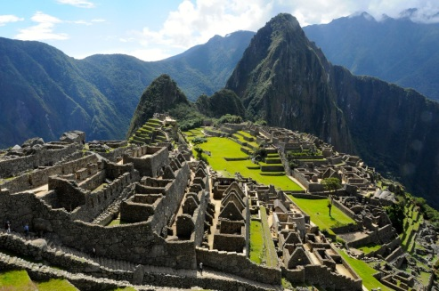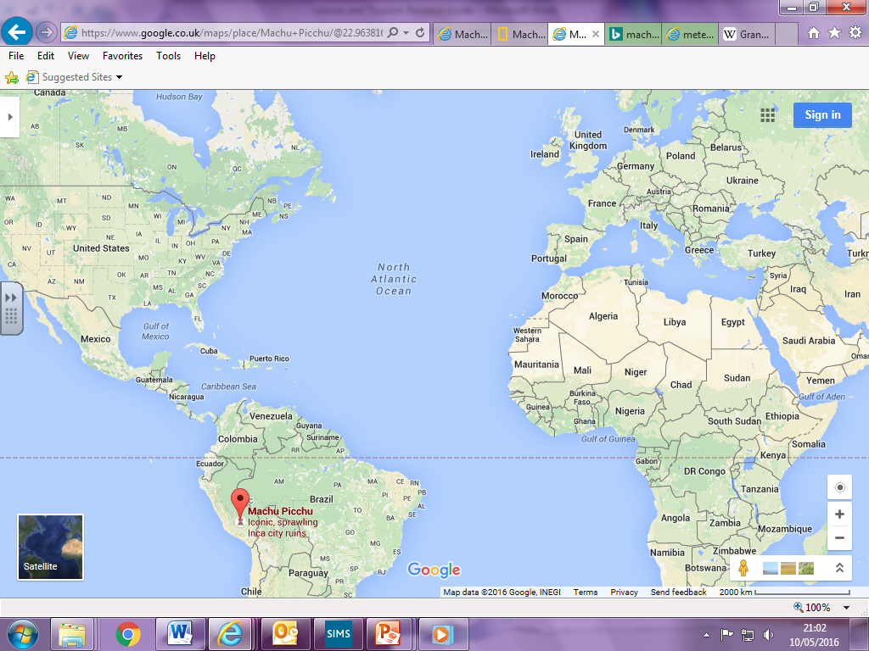
Machu Picchu, Peru.
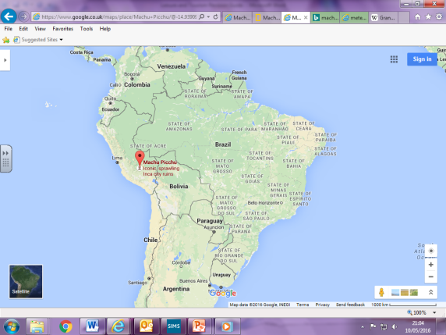
Machu Picchu is approximately 7,000 feet up into the Andes mountain range in Peru, South America. It was built by the Inca in around 1450 and was abandoned in the early 16th century (nobody knows why). It was completely forgotten about until an explorer discovered it in 1911. The nearest city is Cusco, which is a beautiful Incan town with many Spanish buildings, but there is a closer town called Aguas Calientes where there are lots of cafes, restaurants and bars.

Leisure activities to do there are:
- take a 4 day hike along the Inca Trail and up into the Andes to see Machu Picchu,
- take a jungle trek through the Amazon,
- whitewater rafting,
- explore the markets in Cusco,
- learn to weave in the Andean highlands,
- go on a trip to visit Lake Titicaca, which is Peru’s largest lake,
- exlpore the wildlife of Peru,
It meets the needs of different groups of people by:
- ‘Inka Wheelchairs Tours’ provides off-road wheelchairs and a guide to allow wheelchair users to be able to explore some of the attractions of Machu Picchu, which they would otherwise not be able to do.
- visit the cafes, restaurants and bars in Cusco,
- elderly, families with children and disabled people may prefer to take the Inca Train for the first 104 km of the Inca Trail, and then they only have to hike the final 4 – 5 hours (approx. 9 miles uphill). The Inca Trail is very steep and winding in most places.
- The train will also drop you off at the 82 km point if preferred, and you can walk the final 26 miles
- before or after you final trek, visit Aguas Calientes (Machu Picchu Town) for a range of cafes, restaurants and bars to suit all budgets and tastes. These have baby changing facilities etc. e.g. The Tree House Restaurant.

Theme Parks – are large attractions includingf rides that are spread over a large site e.g.

- UK case study is Thorpe Park, Chertsey, Surrey.

Thorpe Park is in Chertsey, Surrey, and is easily reached from the M3. It is owned by The Merlin Entertainments Group.
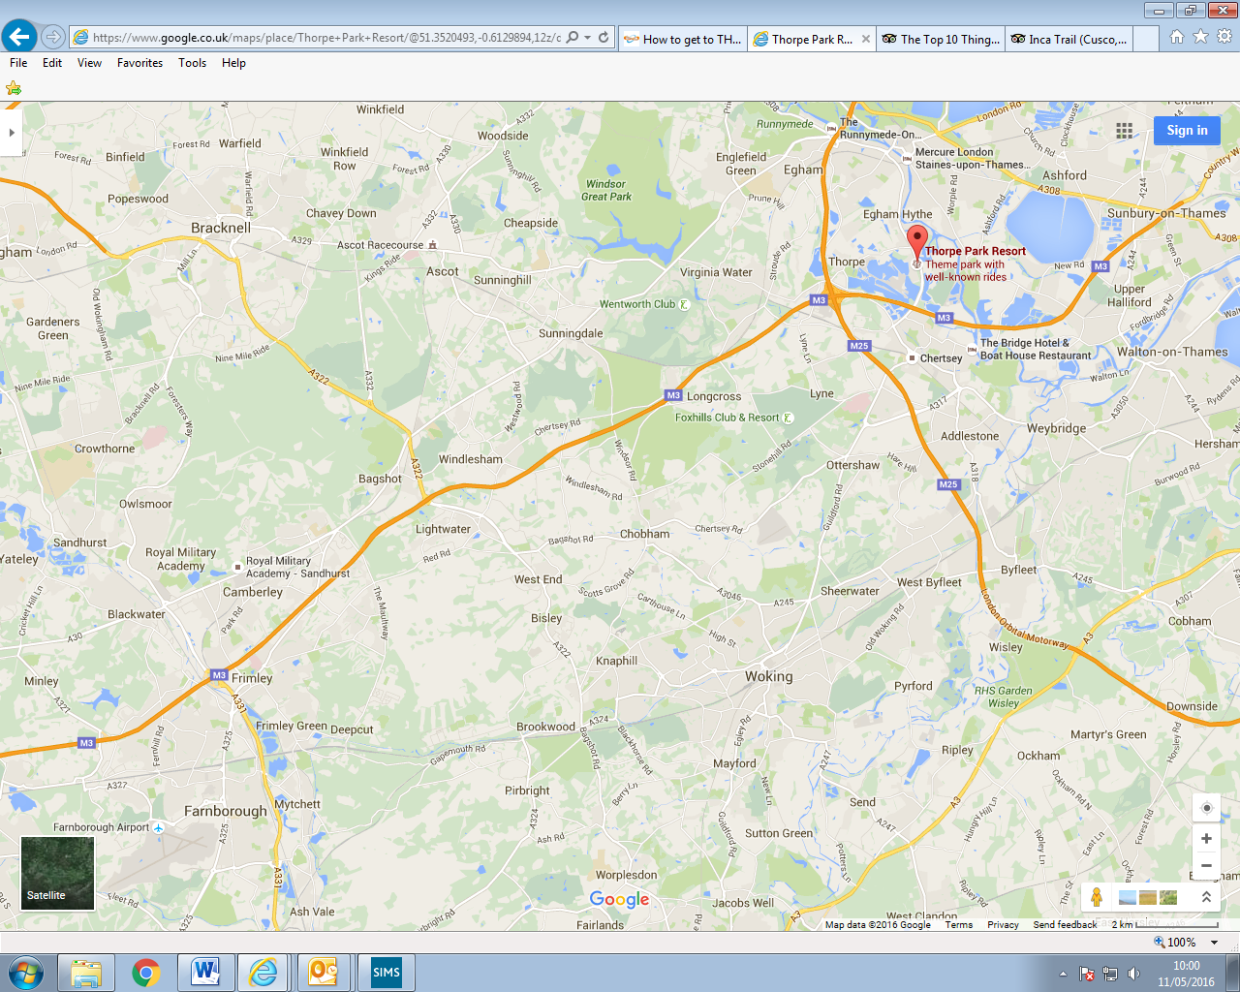
Farnborough
Thorpe Park

Leisure activities to do there are:
- Derren Brown’s Ghost Train experience,
- I’m a celebrity, get me out of here maze,
- Stealth, Saw, Colossus etc. rides,
- Fright Nights,
- visit Windsor Castle which is 8 miles north east of the park.
It meets the needs of different groups of people by:
- Buggies & Baby Change
- Free Resort WiFi
- First Aid Point
- Parking
- Ticket concessions (discounted tickets for children, families, a free ticket for a helper of a disabled person),
- Ride Access Passes (for a disabled guest and up to 3 helpers which means they can go to the front of the queue)
- Guide Dogs
- Toilets (disabled toilets available)
- Wheelchair Hire
- THORPE SHARK Hotel (has disabled accessible rooms as well)

- Overseas case study is Disneyland Resort, Paris, France.

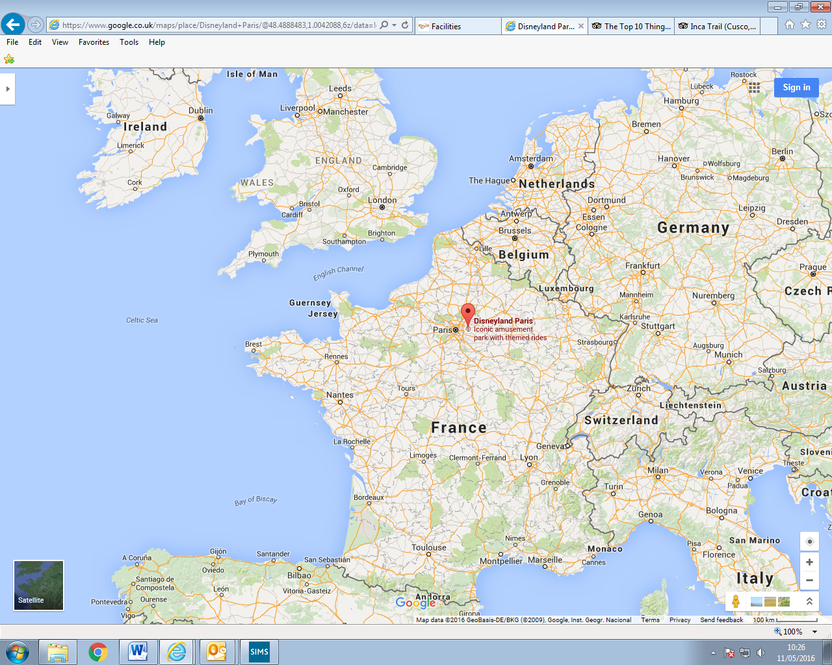
Disneyland, Paris
Farnborough
Leisure activities to do there are:
- Indiana Jones and the Temple of Peril, Pirates of the Caribbean, Sleeping Beauty Castle, Phantom Manor rides.
- go into Paris to go shopping,
- visit the Eiffel Tower in Paris,
- visit Notre Dame Cathedral,
- go for a boat ride on the River Seine in Paris,
- visit the Louvre Museum in Paris.

It meets the needs of different groups of people by:
- Priority cards for disabled people so thay can go to the frint of the queue with up to 4 people.
- Visitors with Hearing Impairment can use the hearing loops
- Visitors with Reduced Mobility – there are ramps and wheelchair access
- Visitors with Visual Impairment have access to braille information
- First Aid
- They provide a service whereby they will store medications for you
- the hotel has disabled accessible rooms and facilities.
- toilet facilities have baby changing facilities,
- food outlets have disabled access and child friendly facilities.

Major sports/entertainment venues – are nationally important sports or entertainment facilities such as stadia (stadium’s), arenas and theatres e.g.

- UK case study is Wembley Stadium, London.
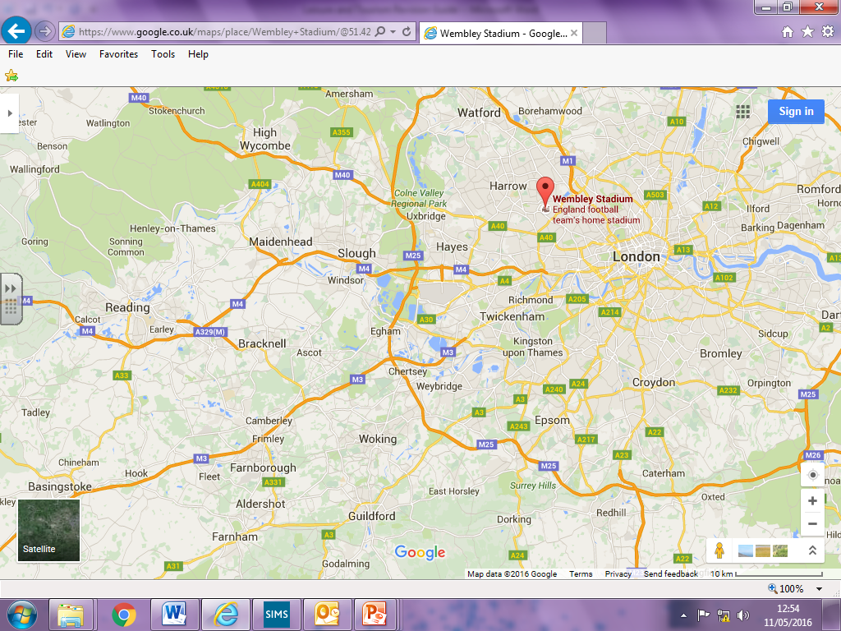
Farnborough
Wembley Stadium, London

You know what facilities they provide and how it meets the needs of different groups of people!

- Overseas case study is Camp Nou, Barcelona, Spain.
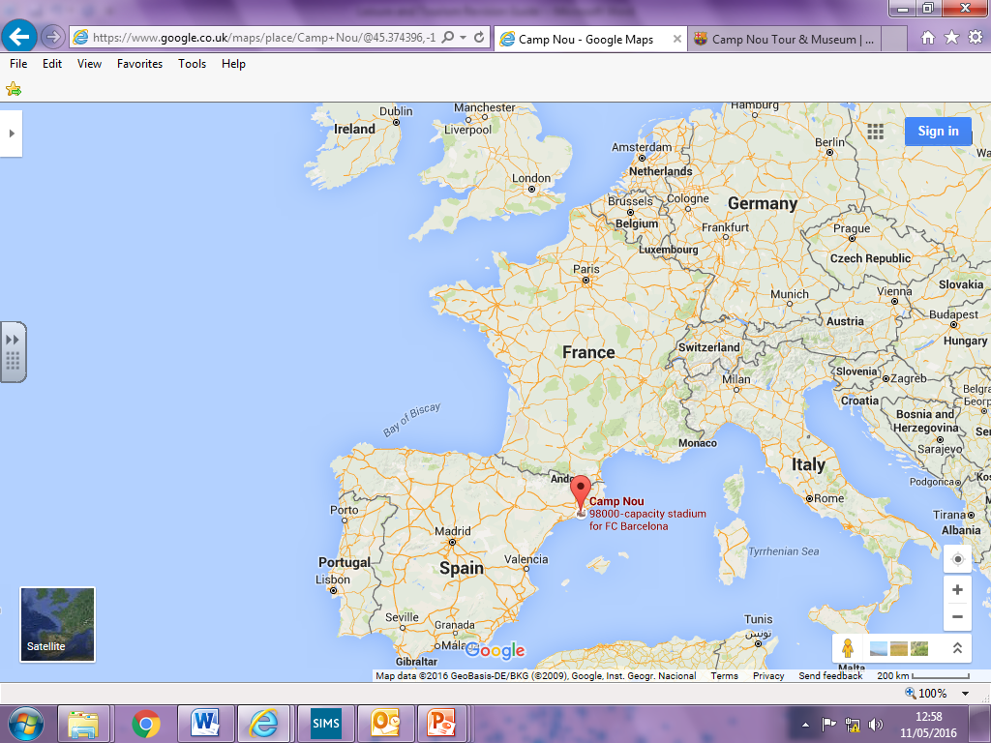
Camp Nou, Barcelona, Spain.
Farnborough

Camp Nou is the football stadium for FC Barcelona. It is the largest stadium in Spain (in terms of how many people it can hold) and the second largest stadium in the World (Wembley is sixth). It is also used for international matches and hosted some of the 1982 World Cup matches.
Leisure activities to do there are:
- go on a tour of Camp Nou called ‘The Camp Nou Experience’,
- go to the Camp Nou Museum,
- download one of the 7 different apps that they have created e.g. ‘FCB Albums’ where you create a printed FC Barcelona photo album from your phone,
- shop in the ‘FCBotiga megastore’,
- get married there,
- hold a meeting there,
- ‘Palau Blaugrana’ is a sports hall at the stadium which is used for basketball, handball, 5-a-side and roller hockey teams,
- go to Barca Ice which is an ice rink at the stadium. There are skate schools for beginners as well,
- eat at ‘Roma 2009’ which is a 5* restaurant at the stadium,
- there are many other fast food kiosks and restaurants.
It meets the needs of different groups of people by:
- accessible seating area for wheelchairs users,
- easy access seating for disabled people who aren’t in wheelchairs,
- the website has sign language on their videos for hearing impaired people,
- they run a project called "T’Acompanyem" with the Red Cross, whereby they offer a home pick-up service for SOME season ticket holders,
- ramps,
- baby changing facilities.

Built attractions – are facilities such as museums and art galleries that have been specifically built to attract visitors e.g.

- UK case study is The London Eye, London.
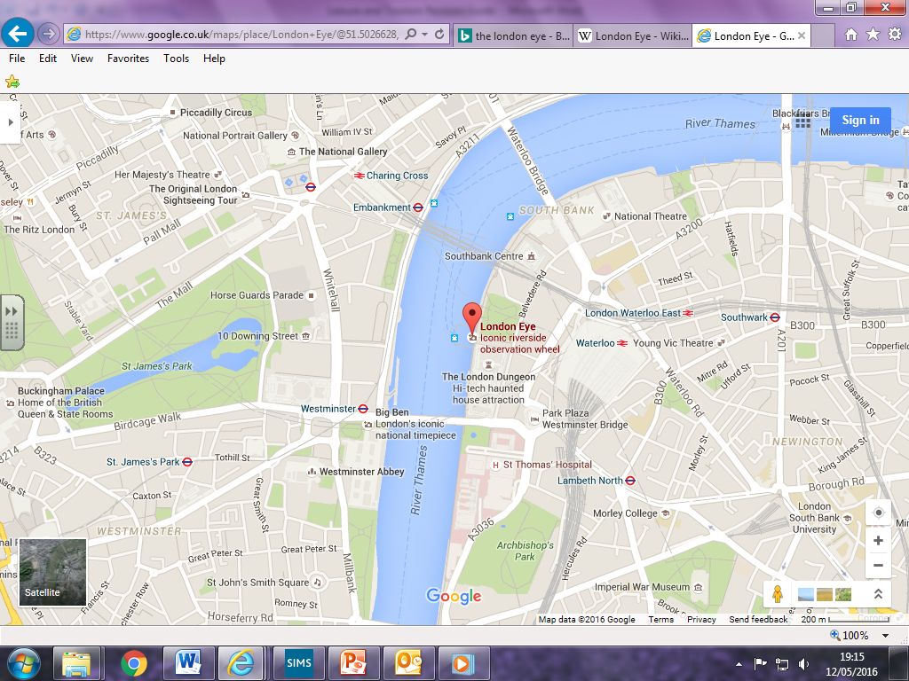
Waterloo train station (if you get the train from Farnborough Main, this is where you will arrive).
The London Eye

The London Eye is a giant Ferris wheel on the South Bank of the River Thames in London. It is 443 feet (135 m) tall and the wheel has a diameter of 394 feet (120 m). When it was built in 1999 it was the world's tallest Ferris wheel, but it isn’t any more.

Leisure activities to do there are:
- one rotation of the eye lasts for approx. 30 mins,
- Visit a nearby attraction such as Shrek's Adventure!, London Dungeon, London SEA LIFE Aquarium and Madame Tussards,
- go on a River Cruise on the River Thames,
- book a private capsule,
- hold a party in a capsule (there must be a minimum of 3 adults in each capsule),
- book a party package whereby they provide you with food, drinks and and cake for an additional price,
- the Pommery Champagne Bar overlooks the River Thames,
- gift shop,
- The London Eye 4D Cinema Experience is the first live action, 4D attraction film ever produced in the UK and contains the first ever 3D aerial photography over London,
- you can buy souvenir photos of your experience,
- Dining at 135 is a truly fabulous dining experience for up to 8 guests in a provate capsule where the London Eye will be exclusively opened for you out of hours,
It meets the needs of different groups of people by:
- there is a bench in the middle of the capsule, but it is first come, first served.
- A pushchair/buggy can go with you onto the Coca-Cola London Eye but it must remain completely closed/folded throughout the experience, and on the entrance and exit ramps, or it can be left at the ticket office,
- free carer ticket for disabled people who MUST have a carer with them at all times,
- they offer a discount to people in the military,
- they offer discounted tickets if bought with a rail pass, which will suit large groups and families,
- fully accessible for disabled people with wheelchair access and disabled toilets,
- there are hearing loop facilities for hearing impaired,
- there are a limitied number of wheelchairs available for loan at the ticket desk,
- assistance dogs are allowed on the Eye,
- baby changing facilities,
- toilets.

- Overseas case study is the Grand Canyon Skywalk, Arizona, USA.

(See overseas natural attraction case study for map and photo).

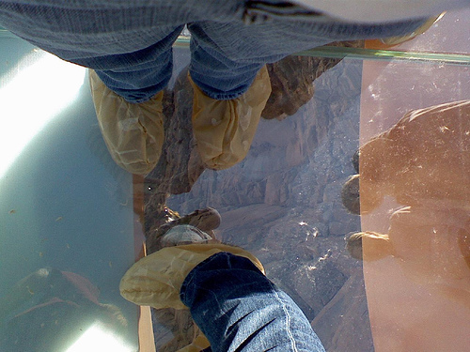
Looking through the glass-bottomed bridge (you need to wear protective covers on your shoes).

The Skywalk is a cantilever bridge platform made of glass which extends out of the Grand Canyon in Arizona, USA. The esge of the Grand Canyon is 70 feet behind you and the other side of it is 3 miles in front of you. If you look down through the glass, there is 4,000 feet of air between you and the bottom of the Grand Canyon. It is on the Hualapai Indian Reservation that is just East of Las Vegas.

Leisure activities to do there are:
- you can buy different priced packages to go on the Skywalk, so that different budgets can afford it. These packages are the ‘Legacy Gold’ package which includes a Skywalk Ticket to walk on the glass bridge; a Meal at viewpoint of choice; Hualapai (the local native American tribe) Visitation Certificate; Photo Opportunities with Hualapai Members; Hop-on Hop-off Shuttle to all view points on the Grand Canyon. The ‘Hualapai VIP’ package include all of the above including a Hualapai Tour Guide; a Native America Gift; and a Tour the viewpoints in a private vehicle (up to 10 people per vehicle) instead of the shuttle.
- whitewater rafting,
- horse riding,
- stay at the Hualapai Ranch hotel
- see the natural attraction case study for more leisure facilities in the area.
It meets the needs of different groups of people by:
- the path up to the Skywalk is unpaved and is difficult for wheelchair users,
- they take very good care of wheelchair users and do everything they can to e enable them to use the Skywalk,
- the Hualapai Ranch is also tricky for wheelchair users, but there are some ramps and they try to help as much as they can,
- some people say that it isn’t suitable for small children as it can be very windy (it is safe though),
- a lot of people think it is too much money – certainly not suitable for those on a budget like students etc.

Think about how each different group of people would be able to use each of the different types of attraction – you might be asked to write about a completely different attraction to your case studies, so use your common sense. How do they attract each of the different types of customers and meet their needs?
- Single people,
- couples,
- families with children,
- groups travelling together,
- different age groups (children, teenagers, young adults, mature adults, retired people),
- different ethnic and cultural groups, and
- people with special needs and disabilities.

People travel to destinations in different ways and each method will appeal to different groups of people due to cost; convenience and comfort; accessibility; environmental impact. They all have advantages and disadvantages.
Mode of transport – are the forms of transport e.g. rail, air, road etc.
Transport providers – are leisure and tourism organisations that operate travel services.
Budget carriers – are transport carriers that carry people at discounted rates e.g. budget airlines like easyjet.

Different modes of transport are:
- Road transport (cars, buses, coaches, taxis and cycles),
- Rail transport (trains, trams and underground systems),
- Water transport (ferries and other ships and boats e.g. hovercraft),
- Air transport (aeroplane and helicopter).
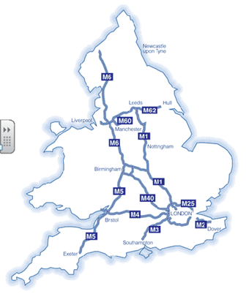
Holyhead Ferry Port
Liverpool Lime Street Liverpool John Lennon Airport Liverpool Ferry Port
Newcastle Ferry Port
Manchester Piccadilly Manchester Airport

Manchester Airport
Hull Ferry Port
Southampton Airport Southampton Ferry Port
Folkestone Ferry Port
Dover Ferry Port
Bristol Temple Meads Bristol International Airport
Glasgow Central Glasgow International Airport
Birmingham New Street Birmingham International
Edinburgh Waverley, Edinburgh, Scotland Edinburgh Airport
Stansted Airport
Luton Airport
Gatwick Airport
City Airport
Heathrow Airport
The major London train stations are:
- Waterloo,
- Paddington,
- Charing Cross,
- Euston,
- King’s Cross,
- Victoria,
- Liverpool Street,
- London Bridge, and
- St Pancras International (where you get the train for the Eurostar train to France and Belgium).

Plymouth Ferry Port
Portsmouth Ferry Port

Advantages and disadvantages of each type of travel

You will need to think about the advantages and disadvantages of each mode of transport for different customers (groups of people) and the different types of journey. Think about the advantages and disadvantages in terms of:
- cost,
- convenience and comfort,
- accessibility, and
- environmental impact.
Use your common sense to work out what each group of people would think about them in terms of the factors above.

Road transport
Advantages:
- you can leave whenever you want to – there is no fixed time,
- If there are lots of you travelling, it is cheaper for you all to fit in one car than many separate rail tickets,
- Buses are easily available in towns and cities, and they are cheaper and more environmental than lots of separate people driving cars,
- Taxis are an easy and comfortable option for people who don’t own their own cars,
- The cost of taxis drops considerably the more people you have in it, therefore they are suitable for large groups of people,
- Cycling creates no emissions,
- Cycling keeps you fit,
- Lots of people travelling on one bus is better for the environment than lots of individual people all driving cars,
- Hiring a car when you arrive at your destination, is often cheaper than using public transport for the whole of your stay away. Europcar is an example of a car hire company,
- Long distance coach travel will often have toilets and entertainment on board, so you don’t need to stop so often,
- You can sleep on coach journeys,
- Privacy as you don’t have to share a space with strangers,
- Very easy to transport luggage and equipment.

Disadvantages:
- the roads are extemely busy at peak times e.g. when people are driving to and from work,
- Bus services are not always available in villages and countryside areas,
- Taxis are a very expensive option,
- Buses are often incredibly slow,
- You have to wait for the buses – you can’t just travel when you want to,
- Petrol can be very expensive,
- Cars create a lot of greenhouse gases – particularly if there are lots of cars being driven with only one person in them,
- Someone needs to stay awake to drive when you’re travelling by car,
- You can’t work en route,
- The journey can be very long and boring,
- Traffic jams, road works and congestion delays.

