Number Problems
test 3

- The number in the box above two other boxes is the sum of the two numbers below it. Work out the missing numbers.
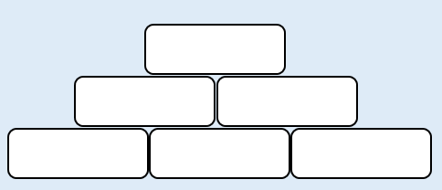
68
19
27
22

- The number in the box above two other boxes is the sum of the two numbers below it. Work out the missing numbers.
39
10
16

3. Write four number sentences using the information in this bar model.

67
89
156

