Questions
Q1.
The compound 1,2-diaminoethane, H₂NCH₂CH₂NH₂, is a bidentate ligand; in formulae, it is usually abbreviated to 'en'.
When 1,2-diaminoethane is added to [Co(NH₃)₆]²⁺ in aqueous solution, [Co(en)₃]²⁺ is formed. What is the best explanation for this?
A There are much stronger bonds between the ligands and the cobalt(II) ion in [Co(en)₃]²⁺ than in [Co(NH₃)₆]²⁺.
B When [Co(en)₃]²⁺ is formed from [Co(NH₃)₆]²⁺ the reaction is exothermic.
C When [Co(en)₃]²⁺ is formed from [Co(NH₃)₆]²⁺ the total entropy change is positive.
D When [Co(en)₃]²⁺ is formed from [Co(NH₃)₆]²⁺ the reaction has a low activation energy.

(Total for question = 1 mark)

Q2.
What type of bonding occurs between the metal ion and ligand in the complex ion
[Cu(H₂O)₆]²⁺?
A Metallic
B Ionic.
C Hydrogen
D Dative covalent
(Total for question = 1 mark)

Q3.
The ligands that form complex ions are either neutral, like NH₃, or negatively charged, like CN⁻. Nickel(II) ions, Ni²⁺, form complexes with both these ligands. The bonding between Ni²⁺ and the ligands in these complexes is

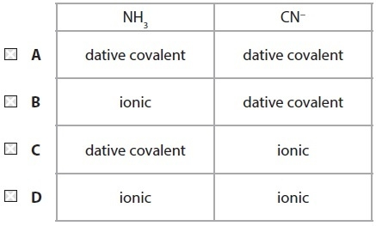
(Total for Question = 1 mark)

Q4.
Which of the following physical methods of chemical analysis is used in modern breathalysers?

A Infrared spectroscopy
B Mass spectrometry
C Nuclear magnetic resonance
D Ultraviolet spectroscopy
(Total for Question = 1 mark)

Q5.
In the first commonly used breathalyser, acidified potassium dichromate(VI) was usedwhich was reduced to chromium(III) by alcohol.
The colour change seen when alcohol was present in a motorist's breath is from
A orange to green.
B orange to yellow.
C yellow to green.
D yellow to orange.
(Total for question = 1 mark)

Q6.
In the manufacture of sulfuric acid, sulfur dioxide is converted to sulfur trioxide using a catalyst of vanadium(V) oxide:
2SO₂(g) + O₂(g) 2SO₃(g)
The electronic configuration of vanadium is [Ar] 3d³ 4s², so the mechanism for this reaction is most likely to involve a sequence in which vanadium(V) is converted to

A vanadium(VI) by oxygen then back to vanadium(V) by sulfur dioxide.
B vanadium(VI) by sulfur dioxide then back to vanadium(V) by oxygen.
C vanadium(IV) by oxygen then back to vanadium(V) by sulfur dioxide.
D vanadium(IV) by sulfur dioxide then back to vanadium(V) by oxygen.
(Total for Question = 1 mark)

Q7.
Although platinum is very unreactive, it is used as a catalyst in catalytic converters in
motor cars. Which of the following is true?
A It converts nitrogen oxides and carbon monoxide to nitrogen and carbon dioxide
by adsorbing the reactants on its surface so weakening their bonds.
B It converts nitrogen oxides and carbon monoxide to nitrogen and carbon dioxide
by being able to change its oxidation state.
C It oxidizes unburnt fuel to carbon monoxide.
D It oxidizes unburnt fuel to carbon dioxide.
(Total for question = 1 mark)

Q8.
Platinum forms a complex with the formula Pt(NH₃)₂Cl₂ and chromium forms a complex ion with the formula CrCl₄⁻.
(a) Considering the shapes of these complexes,
(1)
A both complexes are square planar.
B both complexes are tetrahedral.
C Pt(NH₃)₂Cl₂ is tetrahedral and CrCl₄⁻ is square planar.
D Pt(NH₃)₂Cl₂ is square planar and CrCl₄⁻ is tetrahedral.
(b) Considering the structures of these complexes,
(1)
A both complexes form stereoisomers.
B neither complex forms a stereoisomer.
C Pt(NH₃)₂Cl₂ forms a stereoisomer but CrCl₄⁻ does not.
D CrCl₄⁻ forms a stereoisomer but Pt(NH₃)₂Cl₂ does not.
(c) Considering the bonding between the central atom and the ligands in these complexes
(1)
A the bonding in both complexes is dative covalent.
B the bonding in both complexes is ionic.
C the bonding in Pt(NH₃)₂Cl₂ is dative covalent and in CrCl₄⁻ is ionic.
D the bonding in Pt(NH₃)₂Cl₂ is ionic and in CrCl₄⁻ is dative covalent.
(Total for question = 3 marks)

Q9.
Chromium has the electronic configuration [Ar]3d⁵4s¹. Which of the following compounds is unlikely to exist?
A K₃CrO₄
B CrO₂Cl₂
C KCrO₂Cl
D KCrO₄

(Total for question = 1 mark)

Q10.
All metal hydroxides dissolve in acid. When aqueous solutions of sodium hydroxide and ammonia are added separately to samples of chromium(III) hydroxide, in both cases the solid dissolves to form a green solution. How should these reactions be classified?

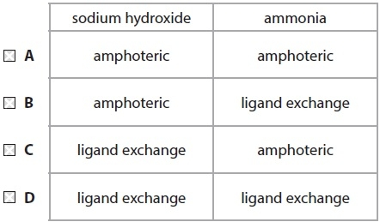
(Total for Question = 1 mark)

Q11.
Which of the following gives the electronic configuration for chromium and for the Cr³⁺ ion?
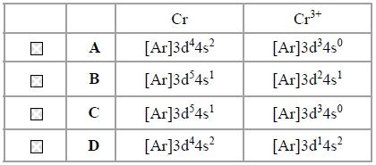.
(Total for question = 1 mark)

Q12.
When concentrated ammonia solution is added to a green solution of chromium(III) sulfate, a green precipitate is formed which slowly dissolves in excess of the concentrated ammonia solution.
The chromium-containing species formed in these reactions are
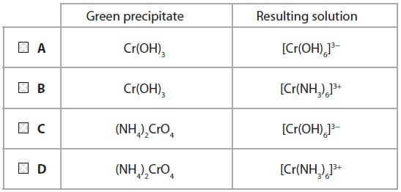
(Total for question = 1 mark)

Q13.
A hydrated transition metal ion is colourless. Which of the following could be the electronic configuration of this ion?
A [Ar] 3d⁵4s²
B [Ar] 3d⁸
C [Ar] 3d¹⁰4s²
D [Ar] 3d¹⁰
(Total for question = 1 mark)

Q14.
When excess aqueous ammonia is added to a solution containing Zn²⁺(aq) ions, a colourless solution is formed. This solution is colourless because

A zinc does not form complex ions.
B the d orbitals of Zn²⁺ in the complex formed are not split into different energy levels.
C the energy difference between the d orbitals of Zn²⁺ in the complex formed does not correspond to the visible region of the spectrum.
D the d orbitals of Zn²⁺ in the complex formed are full.
(Total for Question = 1 mark)

Q15.
Which of the following gives the colours of solutions containing Cr₂O₇²⁻, CrO₄²⁻,
hydrated Cr³⁺ and hydrated Cr²⁺, in this order?
A Yellow, orange, green, blue
B Orange, yellow, green, blue
C Orange, yellow, blue, green
D Orange, green, yellow, blue
(Total for question = 1 mark)

Q16.
When a solution containing 0.10 mol of chromium(III) chloride, CrCl₃.6H₂O, is treated with excess silver nitrate solution, 0.20 mol of silver chloride, AgCl, is immediately
precipitated. The formula of the complex ion in the solution is
A [Cr(OH)₆]^{3–}
B [Cr(H₂O)₆]³⁺
C [CrCl(H₂O)₅]²⁺
D [CrCl₂(H₂O)₄]⁺
(Total for question = 1 mark)

Q17.
Four complex ions have the following formulae:
A Cu(edta)²⁻
B Zn(H₂O)₆²⁺
C Ni(NH₃)₆²⁺
D CrCl₄²⁻
(a) Which complex ion is most likely to be tetrahedral in shape?
(1)
A
B
C
D
(b) Which complex ion is most likely not to be coloured?
(1)
A
B
C
D
(c) Each of these complex ions may be formed by ligand exchange from an aqua
complex. For which complex ion is the entropy change of this reaction most
positive?
(1)
A
B
C
D
(Total for question = 3 marks)

Q18.
Copper(II) sulfate solution is blue. This is because
A excited electrons emit light in the blue region of the spectrum as they drop back to the ground state.
B excited electrons emit light in the red region of the spectrum as they drop back to the ground state.
C electrons absorb light in the red region of the spectrum and the residual frequencies are observed.
D electrons absorb light in the blue region of the spectrum and the residual frequencies are observed.
(Total for question = 1 mark)

Q19.
One method of manufacturing hydrazine (N₂H₄) involves the action of sodium chlorate(I) on excess ammonia at 443 K and 50 atm. The yield is normally around 80% but, if just 1 part per million of copper(II) ions is present, the yield drops to 30%.
The most likely explanation for this is the ability of copper(II) ions to
A form complex ions with ammonia.
B catalyse reactions producing other nitrogen compounds.
C reduce the hydrazine as it is formed.
D reduce the sodium chlorate(I).
(Total for question = 1 mark)

Q20.
When dichromate(VI) ions, Cr₂O₇²⁻, react with iron(II) ions in acidic solution, the
products are chromium(III) ions and iron(III) ions. In what ratio do the dichromate(VI)
ions and the iron(II) ions react?
A 1:6
B 1:5
C 2:5
D 1:3
(Total for question = 1 mark)

Q21.
In aqueous solution, manganate(VI) ions disproportionate into manganate(VII) ions and manganese(IV) oxide when carbon dioxide is bubbled through the solution. The ionic equation for the reaction is
3MnO₄²⁻(aq) + 4H⁺(aq) → 2MnO₄⁻(aq) + MnO₂(s) + 2H₂O(l)
The role of the carbon dioxide is to

A lower the pH of the solution.
B raise the pH of the solution.
C oxidize the manganate(VI) ions.
D reduce the manganate(VI) ions.
(Total for Question = 1 mark)

Q22.
Chlorine is prepared in the laboratory by the reaction of potassium manganate(VII) with concentrated hydrochloric acid. The ionic half-equations and their standard electrode potentials are

½Cl₂(g) + e⁻ Cl⁻(aq) E = +1.36 V
MnO₄⁻(aq) + 8H⁺(aq) + 5e⁻ Mn²⁺(aq) + 4H₂O(l) E = +1.51 V
(a) Concentrated hydrochloric acid is preferred to 1 mol dm⁻³ hydrochloric acid because

A it lowers the activation energy of the reaction.
B the reaction is thermodynamically unfavourable under standard conditions.
C it increases the rate of reaction.
D it increases the equilibrium constant, K_{c}, for the overall reaction.
(b) From the half-equations it may be deduced that

A 1 mol of manganate(VII) ions reacts with 5 mol of chloride ions.
B 5 mol of manganate(VII) ions reacts with 1 mol of chloride ions.
C 1 mol of manganate(VII) ions reacts with 2.5 mol of chlorine.
D 2.5 mol of manganate(VII) ions reacts with 1 mol of chlorine.
(Total for Question = 2 marks)

Q23.
An electrochemical cell consists of a standard hydrogen electrode and a Cu²⁺(aq)|Cu(s) electrode which uses copper(II) sulfate solution. Which one of the following does not affect the e.m.f. of the cell?
A The volume of the copper(II) sulfate solution.
B The temperature.
C The pressure of the hydrogen.
D The concentration of the copper(II) sulfate solution.
(Total for question = 1 mark)

Q24.
The apparatus below can be used to measure the value of for the reaction
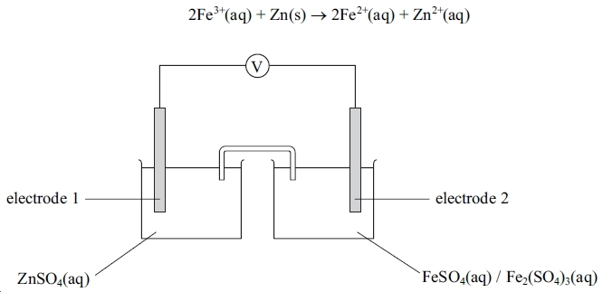
The electrodes are:
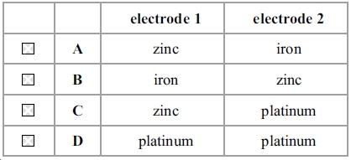
(1)

(Total for question = 1 mark)

Q25.
for four reactions are shown in the table below.
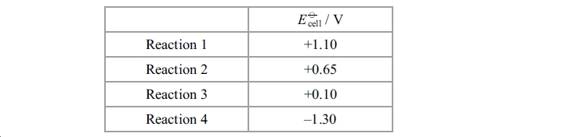
Which reaction
(a) is thermodynamically not feasible?
(1)
A Reaction 1
B Reaction 2
C Reaction 3
D Reaction 4

(b) has the largest value for ln K?
(1)
A Reaction 1
B Reaction 2
C Reaction 3
D Reaction 4
(Total for question = 2 marks)

Q26.
Copper reacts with silver ions according to the reaction below.
for this reaction is
A +0.46 V
B +1.14 V
C +1.26 V
D +1.94 V
(Total for question = 1 mark)

Q27.
The diagram below shows an electrochemical cell.
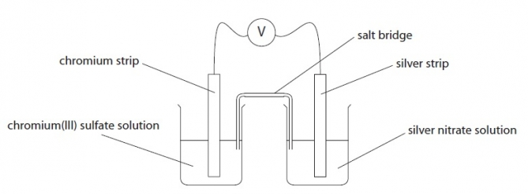
(a) The salt bridge in this cell is best prepared by soaking filter paper in a
A 1 mol dm⁻³ solution of potassium bromide.
B 1 mol dm⁻³ solution of potassium chloride.
C saturated solution of potassium nitrate.
D saturated solution of potassium iodide.
(1)
(b) The relevant standard electrode potentials for this cell are shown below.
Cr³⁺(aq) + 3e⁻ Cr(s) E = −0.74 V
Ag+⁻(aq) + e⁻ Ag(s) E = +0.80 V
(1)
The emf of the cell shown in the diagram is
A +1.54 V
B −1.54 V
C +0.06 V
D −0.06 V
(c) The mass of 1 mol of chromium(III) sulfate (Cr₂(SO₄)₃) is 392 g. Hence, for the cell in the diagram to measure the standard electrode potential, 1 dm³ of the chromium(III) sulfate solution used must contain
(1)
A 104 g of chromium(III) sulfate.
B 196 g of chromium(III) sulfate.
C 392 g of chromium(III) sulfate.
D 784 g of chromium(III) sulfate.
(Total for question = 3 marks)

Q28.
The electrode potential for a cell can be used to calculate the equilibrium constant for
the cell reaction. This is because
A is proportional to lnK.
B is proportional to K.
C ln is proportional to lnK.
D ln is proportional to K.
(Total for question = 1 mark)

Q29.
The diagram below shows a cell set up between a standard copper metal / copper(II) ion electrode and a silver metal / silver(I) ion electrode in which the silver ion concentration is 0.1 mol dm⁻³.
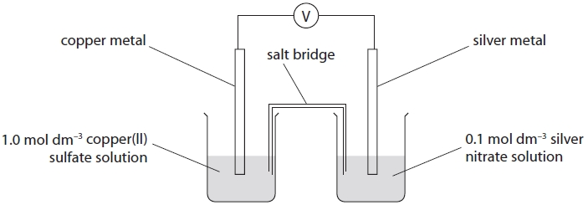
At 298 K, the emf of this cell was +0.40 V. The electrode potential of the copper metal / copper(II) ion electrode is +0.34 V. What is the electrode potential of this silver metal / silver(I) ion electrode?
A −0.74 V
B −0.06 V
C +0.06 V
D +0.74 V

(Total for question = 1 mark)

Q30.
What is the electronic configuration of the stable scandium ion?
A [Ar] 3d⁰ 4s²
B [Ar] 3d¹ 4s¹
C [Ar] 3d⁰ 4s¹
D [Ar] 3d⁰ 4s⁰

(Total for question = 1 mark)

Q31.
The electronic configuration of iron is [Ar]3d⁶4s². What is the electronic configuration of the iron(II) ion, Fe²⁺?
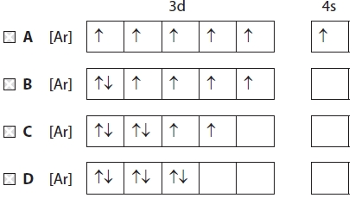

(Total for question = 1 mark)

Q32.
The electronic structure of the chromium(III) ion, Cr³⁺, is

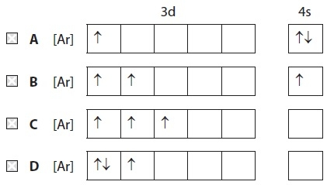
(Total for Question = 1 mark)

Q33.
The equation for the reaction of iron and nickel(II) ions in aqueous solution is
Fe(s) + Ni²⁺(aq) → Fe²⁺(aq) + Ni(s)
Under standard conditions the value of the equilibrium constant, K_{c}, for this reaction is greater than 1. Hence, for this reaction,

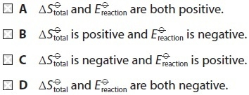
(Total for Question = 1 mark)

Q34.
For the reaction
at 450 K the total entropy change, ΔS_{total}, is negative. Hence the equilibrium constant, K_{p}, for this reaction at 450 K is
A zero.
B positive and greater than 1.
C positive and less than 1.
D negative.

(Total for question = 1 mark)

Q35.
Some fuel cells are used to produce energy from the combination of hydrogen and oxygen. The half-equations for a hydrogen-oxygen fuel cell in alkaline solution are
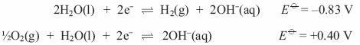
(a) The equation for the cell reaction is
(1)
A 3H₂O(l) + ½O₂(g) → H²(g) + 4OH⁻(aq)
B H₂(g) + 4OH⁻(aq) → 3H₂O(l) + ½O₂(g)
C H₂(g) + ½O₂(g) → H₂O(l)
D H₂O(l) → H₂(g) + ½O₂(g)
(b) From the data above, E_{cell} for the reaction in the hydrogen-oxygen fuel cell is
(1)
A −0.43 V
B +0.43 V
C −1.23 V
D +1.23 V
(c) An advantage of operating a hydrogen fuel cell over a conventional jet engine for powering an aeroplane is
(1)
A it is 100% efficient.
B it does not produce greenhouse gas emissions.
C it does not produce emissions which damage the ozone layer.
D hydrogen is easier to transport.
(Total for question = 3 marks)

Q36.
The transition metal complex Pt(NH₃)₂Cl₂ exists as two geometric isomers. This is because the complex
A is square-planar.
B is tetrahedral.
C contains a double bond.
D is octahedral.
(Total for question = 1 mark)

Q37.
Transition metals are often used as heterogeneous catalysts. Which of the following processes does not occur during such a catalysed reaction?

A Adsorption of reactant molecules on the surface of the metal.
B Bond breaking in the reactant molecules.
C Desorption of product molecules from the surface of the metal.
D An overall change in the oxidation number of the metal.
(Total for Question = 1 mark)

Q38.
When a few drops of aqueous ammonia are added to a solution containing [Cr(H₂O)₆]³⁺
ions the product formed will be
A [Cr(NH₃)₆]³⁺
B Cr(H₂O)₃(OH)₃
C [Cr(NH₃)₄]³⁺
D [Cr(H₂O)₂(OH)₄]⁻
(Total for question = 1 mark)

Q39.
Hydrogen peroxide, H₂O₂, can be analysed by titration. The hydrogen peroxide solution is treated with acidified potassium iodide solution, and the liberated iodine is titrated with a standard solution of sodium thiosulfate, Na₂S₂O₃. The products are iodide ions and tetrathionate ions, S₄O₆²⁻.
Which of the following applies to this reaction?
.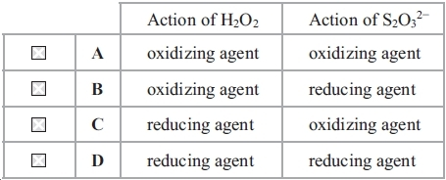
(Total for question = 1 mark)

Q40.
In a hydrogen-oxygen fuel cell, hydrogen is
A oxidized at the anode.
B oxidized at the cathode.
C reduced at the anode.
D reduced at the cathode.

(Total for question = 1 mark)

Q41.
The hydrolysis of a transition metal cation can be represented by the following equation
[M(H₂O)₆]^{n+}(aq) + H₂O(l) [M(H₂O)₅OH]^{(n−1)+}(aq) + H₃O⁺(aq)
In this reaction

A the solvent H₂O is acting as an acid by donating a proton to the metal cation.
B the pH of the solution will be lower if the value of n is 2 instead of 3.
C the equilibrium position lies further to the right if the value of n is 3 instead of 2.
D the oxidation state of the metal in the cation has decreased from n to (n − 1).
(Total for Question = 1 mark)

Q42.
When EDTA is added to [Cu(NH₃)₄]²⁺ in aqueous solution, the copper(II)-EDTA complex, [Cu(EDTA)]²⁻, predominates in the resulting solution.
This is best explained by the fact that when [Cu(EDTA)]²⁻ is formed from [Cu(NH₃)₄]²⁺
A there are much stronger bonds between the ligands and the copper(II) ion.
B the reaction has a low activation energy.
C the reaction is exothermic.
D the total number of particles on the right-hand side of the equation is greater than on the left.

(Total for question = 1 mark)

Q43.
Consider the equation below.
[Cu(H₂O)₆]²⁺(aq) + 4NH₃(aq) [Cu(NH₃)₄]²⁺(aq) + 6H₂O(l)
This reaction is best described as

A acid-base.
B redox.
C addition.
D ligand exchange.
(Total for Question = 1 mark)

Q44.
Which of the following species is not able to act as a ligand in the formation of transition metal complexes?
A C₆H₅NH₂
B NH₃
C NH₂CH₂CH₂CH₂NH₂
D NH₄⁺
(Total for question = 1 mark)

Q45.
In nitric(V) acid, HNO₃, the oxidation number of the nitrogen is +5. This means that the nitrogen in nitric acid

A has five electrons in its outer shell.
B is an ion with a charge of +5.
C would have a charge of +5 if its bonding electrons were transferred completely.
D forms five covalent bonds in total.
(Total for Question = 1 mark)

Q46.
In which of the following ions does the metal have an oxidation number of +2?
A MnO₄²⁻
B VO²⁺
C [Fe(CN)₆]⁴⁻
D [CrCl₂(H₂O)₄]⁺

(Total for question = 1 mark)

Q47.
Which of the following shows the correct oxidation states of chromium in the ions given?
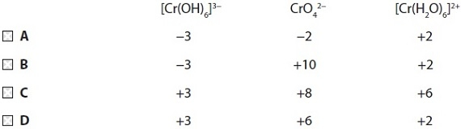
(Total for Question = 1 mark)

Q48.
In which of the following ions does the metal have an oxidation number of +3?
A MnO₄²⁻
B VO²⁺
C [Fe(CN)₆]⁴⁻
D [CrCl₂(H₂O)₄]⁺

(Total for question = 1 mark)

Q49.
Copper metal is oxidized to Cu²⁺ by nitrate(V) ions which are reduced to nitrogen monoxide, NO.
By considering the changes to the oxidation numbers of copper and nitrogen, it can be deduced that in this reaction
A 2 mol of copper reacts with 3 mol of nitrate(V) ions.
B 2 mol of copper reacts with 5 mol of nitrate(V) ions.
C 3 mol of copper reacts with 2 mol of nitrate(V) ions.
D 5 mol of copper reacts with 2 mol of nitrate(V) ions.

(Total for question = 1 mark)

Q50.
A solution of potassium manganate(VII) was used to determine the concentration of iron(II) ions in solution by titration in the presence of excess dilute sulfuric acid.
(a) With the potassium manganate(VII) in the burette, the end-point of the reaction is when the solution in the conical flask turns
(1)
A colourless.
B pink.
C green.
D orange.
(b) If insufficient acid is added, the titre value is
(1)
A low and a brown precipitate forms.
B low and a green precipitate forms.
C high and a brown precipitate forms.
D high and a green precipitate forms.

(Total for question = 2 marks)

Q51.
For any reversible reaction, ln K is proportional to
A both ΔS_{total} and E_{cell}.
B ΔS_{total} but not E_{cell}.
C E_{cell} but not ΔS_{total}.
D neither E_{cell} nor ΔS_{total}.
(Total for question = 1 mark)

Q52.
Four reactions involving the transition elements copper and chromium are given below.
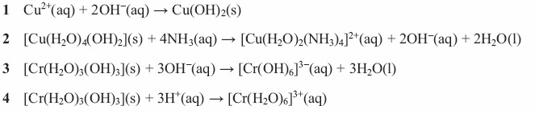
(a) Which reaction produces a dark blue solution?
(1)
A 1
B 2
C 3
D 4
(b) Which two reactions show the amphoteric behaviour of a metal hydroxide?
(1)
A 1 and 2
B 2 and 3
C 2 and 4
D 3 and 4
(c) Predict, without calculation, which reaction has the most negative value for ΔS_{system}.
(1)
A 1
B 2
C 3
D 4
(Total for question = 3 marks)

Q53.
Which of the following reagents would enable you to separate iron(III) hydroxide from a mixture of iron(III) hydroxide and copper(II) hydroxide?
A Dilute hydrochloric acid
B Aqueous ammonia
C Dilute nitric acid
D Sodium hydroxide solution
(Total for question = 1 mark)

Q54.
The hexaaquacopper(II) ion, [Cu(H₂O)₆]²⁺, is blue because the water ligands
A split the p-orbital energies and p-p electron transitions emit blue light.
B split the d-orbital energies and d-d electron transitions absorb all but blue light.
C split the p-orbital energies and p-p electron transitions absorb all but blue light.
D split the d-orbital energies and d-d electron transitions emit blue light.
(Total for question = 1 mark)

Q55.
In the reaction of manganate(VII) ions with reducing agents in strongly acidic solution,
the half-reaction for the reduction is
A MnO₄⁻ + 4H⁺ + 3e⁻ → MnO₂ + 2H₂O
B MnO₄⁻ + 4H⁺ + 5e⁻ → Mn²⁺ + 2H₂O
C MnO₄⁻ + 8H⁺ + 3e⁻ → Mn²⁺ + 4H₂O
D MnO₄⁻ + 8H⁺ + 5e⁻ → Mn²⁺ + 4H₂O
(Total for question = 1 mark)

Q56.
The reaction between iron and nickel(II) sulfate may be represented by the ionic equation
(a) This reaction is classified as a redox reaction because
Ni²⁺(aq) + Fe(s) Ni(s) + Fe²⁺(aq)
(1)
A the nickel(II) ions are oxidized and iron acts as an oxidizing agent.
B the nickel(II) ions are oxidized and iron acts as a reducing agent.
C the nickel(II) ions are reduced and iron acts as a reducing agent.
D the nickel(II) ions are reduced and iron acts as an oxidizing agent.
(b) This reaction proceeds spontaneously, therefore
(1)
A E_{cell} and ΔS_{total} for this reaction must both be positive.
B E_{cell} and ΔS_{total} for this reaction must both be negative.
C E_{cell} for this reaction must both be positive and ΔS_{total} negative.
D E_{cell} for this reaction must both be negative and ΔS_{total} positive.
(Total for question = 2 marks)

Q57.
Which of the following will not reduce an acidified solution of potassium dichromate(VI)?

A (CH₃)₂C(OH)CH₃
B FeSO₄
C CH₃CH₂CH(OH)CH₃
D Zn
(Total for Question = 1 mark)

Q58.
In the titration of iodine with standard sodium thiosulfate solution, starch is often used
as an indicator. The starch should not be added until nearly all the iodine has reacted
because
A it is decomposed by high concentrations of iodine.
B the blue complex formed is bleached by high concentrations of iodine.
C the blue complex formed with high concentrations of iodine is insoluble and
does not re-dissolve as more thiosulfate is added.
D the starch reacts with the thiosulfate ions being added.
(Total for question = 1 mark)

Q59.
To measure the standard electrode potential for the Ag⁺(aq)‌Ag(s) electrode, the mostsuitable chemical for the solution in a salt bridge to connect the two half cells is
A potassium chloride.
B potassium iodide.
C potassium nitrate.
D potassium sulfate.
(Total for question = 1 mark)

Q60.
Which of the following is not planar?

A 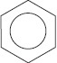
B CCl₄
C BF₃
D [Pt(NH₃)₂Cl₂]
(Total for Question = 1 mark)

Q61.
The shapes of the complexes [CrCl₄]⁻ and [Pt(NH₃)₂Cl₂] are
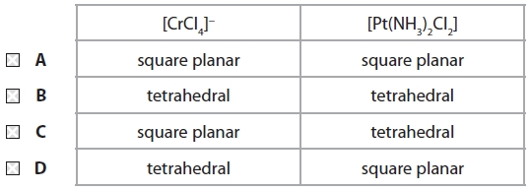

(Total for question = 1 mark)

Q62.
The compound [Pt(NH₃)₂Cl₂] is
A tetrahedral with no isomers.
B square planar with no isomers.
C tetrahedral with two isomers.
D square planar with two isomers.
(Total for question = 1 mark)

Q63.
The shapes of the complexes [CrCl₄]⁻ and [CuCl₂]⁻ are
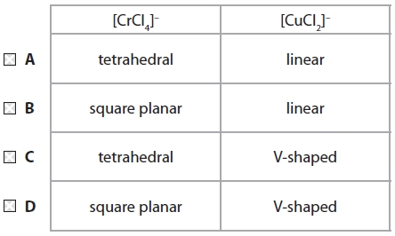

(Total for question = 1 mark)

Q64.
EDTA ions form a complex with aqueous nickel(II) ions as shown by the equation
[Ni(H₂O)₆]²⁺(aq) + (EDTA)⁴⁻(aq) Ni(EDTA)²⁻(aq) + 6H₂O(l)
Aqueous nickel(II) ions also form a complex ion with ammonia as shown by the equation
[Ni(H₂O)₆]²⁺(aq) + 6NH₃(aq) [Ni(NH₃)₆]²⁺(aq) + 6H₂O(l)
Aqueous nickel(II) ions form a more stable complex with EDTA ions than with ammonia because

A six ammonia ligands cause steric hindrance around the central nickel(II) ion.
B EDTA ions carry a negative charge whereas ammonia molecules do not.
C there is a large increase in entropy when aqueous nickel(II) ions react with EDTA ions, but not when aqueous nickel(II) ions react with ammonia.
D ammonia molecules tend to evaporate from the solution of the complex whereas EDTA ions do not.
(Total for Question = 1 mark)

Q65.
The diagram below shows a cell set up between a copper metal / copper(II) ion electrode and a reference electrode, known as a calomel electrode.
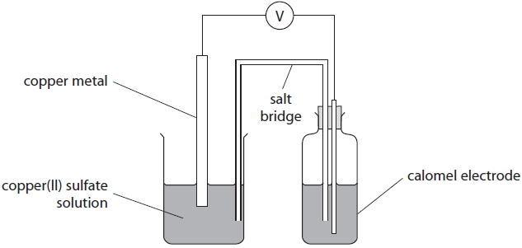
Under standard conditions, the emf of this cell was −0.07 V. The standard electrode potential of the copper metal / copper(II) ion electrode is +0.34 V. Hence the standard electrode potential of the calomel electrode is
A −0.41 V
B −0.27 V
C +0.27 V
D +0.41 V

(Total for question = 1 mark)

Q66.
Which answer corresponds to the correct value of for the oxidation of hydrogen peroxide by manganate(VII) ions? The half-reactions are
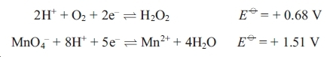
The overall equation is
A = + 2.19 V
B = – 0.83 V
C = – 0.38 V
D = + 0.83 V
(Total for question = 1 mark)

Q67.
The standard electrode potentials of two half reactions are shown below.
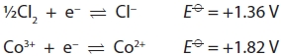
Which of the following processes is thermodynamically favourable? The reaction of
A Co²⁺ with Cl₂ to form Cl⁻
B Co²⁺ with Cl⁻ to form Cl₂
C Co³⁺ with Cl₂ to form Cl⁻
D Co³⁺ with Cl⁻ to form Cl₂

(Total for question = 1 mark)

Q68.
The acid used in a standard hydrogen electrode to provide a 1 mol dm⁻³ solution ofhydrogen ions is
A ethanoic acid.
B phosphoric(V) acid.
C sulfuric acid.
D hydrochloric acid.
(Total for question = 1 mark)

Q69.
Which of these statements about a standard hydrogen electrode, for which E = 0 V, is
not correct?
A The hydrogen gas is at a pressure of 1 atm.
B A solution containing 1 mol dm⁻³ of H⁺(aq) ions is used.
C A platinum electrode is used.
D The temperature is kept at 20 °C.
(Total for question = 1 mark)

Q70.
The conditions needed for the value of the standard hydrogen electrode to be exactly
0 V are
A 1 mol dm⁻3 solution of hydrogen ions, 1 atm pressure of hydrogen, 25°C.
B 1 mol dm⁻³ solution of hydrogen ions, 1 atm pressure of hydrogen, room temperature.
C 1 mol dm⁻³ solution of hydrogen ions, laboratory pressure of hydrogen, 25°C.
D 0.1 mol dm⁻³ solution of hydrogen ions, 1 atm pressure of hydrogen, 25°C.
(Total for question = 1 mark)

Q71.
Which of the following successive ionization energies (values in kJ mol⁻¹) could have
come from a transition element?
A 496 4563 6913 9544 13352 16611 20115 25941
B 590 1145 4912 6474 8144 10496 12320 14207
C 717 1509 3249 4940 6985 9200 11508 18956
D 2081 3952 6122 9370 12177 15239 19999 23069
(Total for question = 1 mark)

Q72.
Titanium has the electronic structure 1s²2s²2p⁶3s²3p⁶3d²4s². Which of the following compounds is unlikely to exist?

A K₃TiF₆
B K₂TiF₆
C K₂Ti₂O₅
D K₂TiO₄
(Total for Question = 1 mark)

Q73.
Sodium thiosulfate was used to determine the concentration of iodine by titration.
(a) The sodium thiosulfate solution was prepared by dissolving 4.5 g of sodium thiosulfate in water and making the solution up to 250 cm³ in a volumetric flask. The volumetric flask is accurate to ± 0.3 cm³ so, to match this accuracy, the mass of the sodium thiosulfate should be accurate to at least
(1)
A ± 0.5 g
B ± 0.05 g
C ± 0.005 g
D ± 0.0005 g
(b) With the sodium thiosulfate in the burette, what is the colour of the solution in the conical flask at the end-point of the reaction?
(1)
A Blue-black
B Colourless
C Red-brown
D Yellow

(Total for question = 2 marks)

Q74.
This question is about a titration to determine the iron content of a tablet. The iron(II)ions in the tablet are oxidized to iron(III) ions by acidified manganate(VII) ions whichare reduced to manganese(II) ions.
(a) The mole ratio of iron(II) to manganate(VII) ions in the reaction is
(1)
 | Fe²⁺ | MnO₄₋
A | 1 | 5
B | 2 | 5
C | 5 | 2
D | 5 | 1
(b) A 0.200 g tablet is dissolved to make exactly 100 cm³ of solution. 10 cm³ of this solution
is found to contain 5.38 × 10⁻⁵ mol of iron(II) ions.
The percentage by mass of iron (Ar = 55.8) in the tablet is
(1)
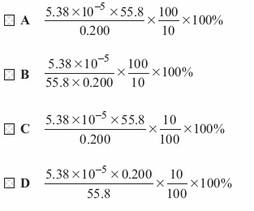
(Total for question = 2 marks)

Q75.
For the reaction
Zn(s) + Cu²⁺(aq) → Cu(s) + Zn²⁺(aq)
is positive. From this it can be deduced that, for this reaction,
A and lnK are positive.
B and lnK are negative.
C is positive and lnK is negative.
D is negative and lnK is positive.

(Total for question = 1 mark)

Q76.
When aqueous sodium hydroxide is added to an aqueous solution of a transition metal compound, a green precipitate is formed which dissolves in excess sodium hydroxide forming a green solution. The transition metal ion present in the original solution is
A Cr³⁺
B Fe³⁺
C Fe²⁺
D Ni²⁺

(Total for question = 1 mark)

Q77.
Consider the following reaction.
S₂O₈²⁻(aq) + 2I⁻(aq) → 2SO₄²⁻(aq) + I₂(aq)
Which of the following ions could catalyse this reaction?

A Zn²⁺
B Al³⁺
C Fe²⁺
D Na⁺
(Total for Question = 1 mark)

Q78.
For which of the following are both tests acceptable evidence for a driver to besuccessfully prosecuted for excess alcohol in the blood in many countries?
A A dichromate(VI) breath analyser and a blood test.
B A dichromate(VI) breath analyser and a fuel cell breath analyser.
C A dichromate(VI) breath analyser and an infrared breath analyser.
D An infrared breath analyser and a blood test.
(Total for question = 1 mark)

Q79.
Which of the following is always proportional to E for a chemical reaction?

A ΔH_{reaction}
B ΔS_{system}
C ΔS_{surroundings}
D ΔS_{total}
(Total for Question = 1 mark)

Q80.
The electrode system based on the half-equation below has the standard electrode potential +1.51 V.
MnO₄⁻(aq) + 8H⁺(aq) + 5e⁻ Mn²⁺(aq) + 4H₂O(l) E = +1.51 V
Which of the following statements about this electrode system is correct?

A Changing the concentration of Mn²⁺(aq) would cause a change in the electrode potential.
B Mn²⁺(aq) is acting as an oxidizing agent.
C The electrode used is made of manganese.
D When connected to a standard hydrogen electrode, the resulting cell voltage would be +0.51 V.
(Total for Question = 1 mark)

Q81.
The graph below shows the variation in the colour intensity of different solutions formed by mixing a 0.05 mol dm⁻³ solution of a metal ion X and a 0.05 mol dm⁻³ solution of a complexing agent Y, in the proportions shown on the graph.
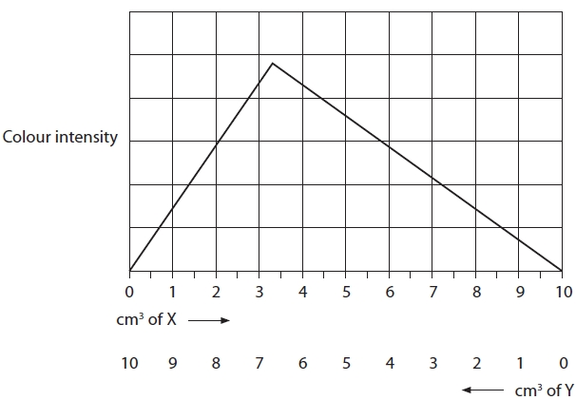
The most likely formula of the complex formed is
A X₂Y
B XY₂
C XY₃
D X₃Y

(Total for question = 1 mark)

Q82.
Sulfur dioxide reacts with hydrogen sulfide to form water and sulfur. By considering the changes in the oxidation numbers of sulfur, it can be deduced that, in this reaction
A 1 mol of sulfur dioxide oxidizes 2 mol of hydrogen sulfide.
B 1 mol of sulfur dioxide reduces 2 mol of hydrogen sulfide.
C 2 mol of sulfur dioxide oxidizes 1 mol of hydrogen sulfide.
D 2 mol of sulfur dioxide reduces 1 mol of hydrogen sulfide.

(Total for question = 1 mark)

Q83.
Vanadium is classified as a transition metal. This is because vanadium
A is a d-block element.
B has incompletely filled d orbitals.
C forms stable ions with incompletely filled d orbitals.
D forms stable ions in which it has different oxidation states.
(Total for question = 1 mark)

Q84.
The element zinc, with electronic configuration 1s²2s²2p⁶3s²3p⁶3d¹⁰4s², is not regarded as a transition element because
A the oxide of zinc is amphoteric.
B none of its ions has an unpaired electron in the d-subshell.
C it does not readily form complex ions.
D it has a boiling temperature low enough for it to be easily distilled.
(Total for question = 1 mark)

Mark Scheme
Q1.

Q2.

Q3.

Q4.

Q5.
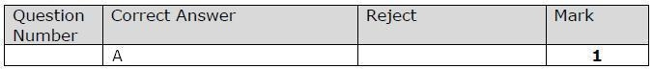

Q6.

Q7.

Q8.

Q9.

Q10.

Q11.

Q12.

Q13.

Q14.

Q15.

Q16.

Q17.

Q18.

Q19.

Q20.

Q21.

Q22.

Q23.

Q24.

Q25.

Q26.

Q27.

Q28.

Q29.

Q30.

Q31.

Q32.

Q33.

Q34.

Q35.
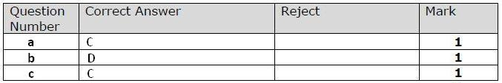

Q36.

Q37.

Q38.

Q39.

Q40.

Q41.

Q42.

Q43.

Q44.

Q45.

Q46.

Q47.

Q48.

Q49.

Q50.

Q51.
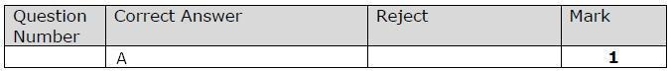

Q52.
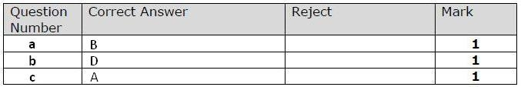

Q53.

Q54.

Q55.

Q56.

Q57.

Q58.

Q59.
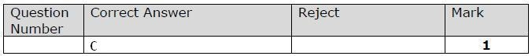

Q60.

Q61.

Q62.

Q63.

Q64.

Q65.

Q66.

Q67.

Q68.
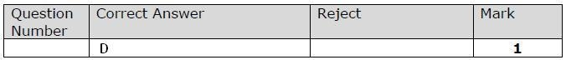

Q69.

Q70.

Q71.

Q72.

Q73.

Q74.
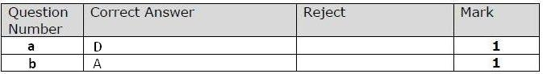

Q75.

Q76.

Q77.

Q78.
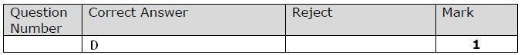

Q79.

Q80.

Q81.

Q82.

Q83.

Q84.

