Reading extract and questions:
Year 4

The Water Cycle

When you hear about the water cycle, do you imagine some kind of bike that travels on water? This would make sense but the water cycle actually describes how water moves throughthe Earth’s surface,atmosphere and below ground.This is a process that continues in an everlasting circle, which is where the word ‘cycle’ comes in. Let’s find out more.

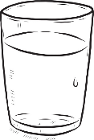
Solid, liquid and gas
You might be used to water being a runny liquid that you use for drinking, washing and playing in but it can also exist as a solid (ice) and a gas (steam or water vapour). The water cycle describes water’s journey from liquid to vapour to liquid again, sometimes becoming a solid in between.

Evaporation
The water cycle is powered by the heat of the sun. It warms up water in places like oceans and lakeswhich makes it turn from a liquid into a gas and rise up into the sky. This process is called evaporation. The water vapour collects in the sky to create clouds.
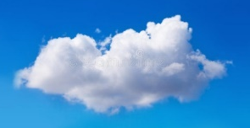
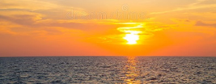

Condensation
In a process named condensation, water vapour in the clouds cools until it becomes water once more.

Precipitation
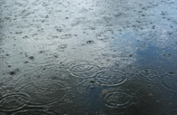
This liquid water then falls from the sky. It could take the form of rain or snow but also as sleet or hail. Sleet is when liquid water freezes before it hits the ground and hail is small lumps of ice and snow that can drop from the clouds during a thunderstorm. This step of the cycle is precipitation.

Collection
The fourth stage of the water cycle is collection. During this process, fallen water collects in oceans and lakes before it evaporates into the sky to continue the cycle.
condensation

evaporation
precipitation

collection

Wonderful water
Water is essential for all life on earth. Because water is recycled and does not leave the earth, it has been around for millions of years, meaning that you might be drinking water that a dinosaur once drank!You may not know that about three quarters of your body is actually made up of water!

Questions for The Water Cycle

Vocabulary
1. Look at the section Evaporation. Find and copy a word that means gathers.

_______________________

2. …through the Earth’s surface. What does the word surface mean?

_____________________________________________________________

3. Water is essential for all life on earth.Which word below means the same as essential?

Tick one
necessary recycled

insignificant collected

Retrieval
4. Where does water collect in the collection stage?

_____________________________________________________________

5. Why might you be ‘drinking water that a dinosaur once drank’?

_______________________________________________________________________________________

6. Complete the missing sections of this diagram.

condensation

collection

Inference
7. ‘… sometimes becoming a solid in between.’

Give two examples from the text of when water is a solid.

1. __________________________

2. __________________________

8. If we can’t see water evaporating from oceans and lakes, how do we know about it?

_______________________________________________________________________________________

9. Look at the statements below. Which is true? Tick one then explain your answer underneath.

Precipitation means when rain falls from the sky. _____

Precipitation means when liquid water falls from the sky. _____

_______________________________________________________________________________________

_______________________________________________________________________________________

Summarise
10. Here are some summaries of different paragraphs in the text. Number them from 1 to 4 to show the order in which they appear in the text.

Water is very important and very old.
Water can take different forms.
How clouds are formed.
Liquid water falls to earth.

Authorial intent
11. Read these passages:
When you hear about the water cycle, do you imagine some kind of bike that travels on water?
Let’s find out more.
You might be used to water being a runny liquid that you use for drinking, washing and playing in…

a. Why does the author write parts of the text in this style?

_______________________________________________________________________________________

_______________________________________________________________________________________

b. Find one other example of the author writing in this style and write it below.

_______________________________________________________________________________________

