Module 4.2.4 – Analytical techniques
- Compound X is an atmospheric pollutant emitted from fuel combustion of petrol and diesel vehicles. Compound X is a potent human carcinogen.
• Analysis of compound X showed the following percentage composition by mass:
C, 88.89%; H, 11.1%.
• Mass spectrometry showed a molecular ion peak at m/z = 54.
• Compound X reacts with H2 in the presence of a nickel catalyst in a 1 : 2 molar ratio.
Analyse and interpret this information to determine a possible structure for compound X. Show all your working. ( 5marks )

- An organic molecule, A, has been found. Scientists are trying to work out what the molecule is. The IR spectrum, mass spectrum and the percentage of each element is given. Deduce the structure of the molecule:
Element | Percentage composition (%)
Carbon | 54.5
Hydrogen | 9.1
Oxygen | 36.4
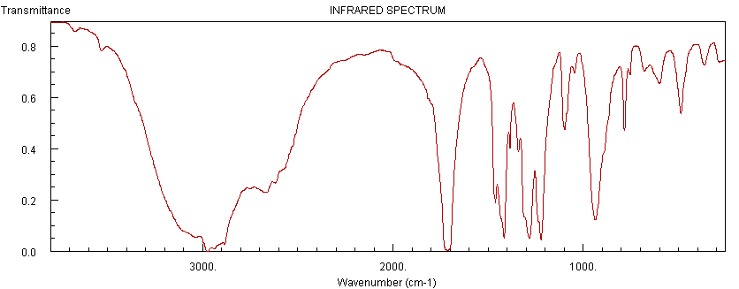
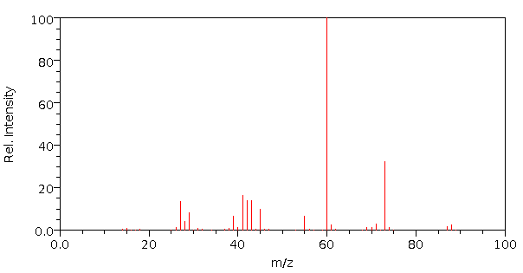
(10 marks)
- Bromobutane, CH3CH2CH2CH2Br, can be reacted with hot aqueous sodium hydroxide to prepare butan-1-ol.
CH3CH2CH2CH2Br + OH– → CH3CH2CH2CH2OH + Br–
The butan-1-ol produced can be analysed by mass spectrometry.
(i)Predict two fragment ions that you would expect to see in the mass spectrum of butan-1-ol and state the m/z value of each ion. [2]
(ii)State a use of mass spectrometry outside of the laboratory. (1]
(iii) Predict the IR peaks you would expect of the product (2)

Total = 20 marks

