Questions
Q1.
The following cycle represents the enthalpy changes w, x, y and z, occurring when an
ionic solute, AX₂(s), dissolves in water.
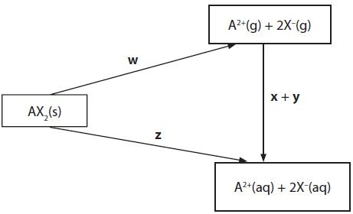
Which of the changes is the lattice energy of AX₂(s)?
A ½ w
B − w
C z
D z − x − y
(Total for question = 1 mark)

Q2.
The equation for the enthalpy of hydration for a magnesium ion is
A Mg²⁺(s) + aq → Mg²⁺(aq)
B Mg²⁺(g) + aq → Mg²⁺(aq)
C Mg²⁺(aq) → Mg²⁺(g) + aq
D Mg²⁺(aq) → Mg²⁺(s) + aq
(Total for question = 1 mark)

Q3.
2-methylpropane has a smaller standard molar entropy at 298 K than butane. The best explanation for this is that 2-methylpropane has

A a lower boiling temperature.
B a higher standard molar enthalpy change of formation.
C fewer ways of distributing energy quanta.
D more ways of distributing energy quanta.
(Total for Question = 1 mark)

Q4.
Which of the following is true for the exothermic reaction shown below?
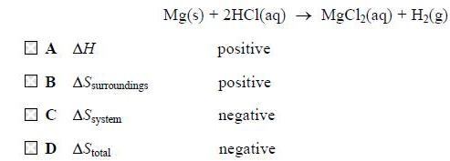
(Total for question = 1 mark)

Q5.
Which of these solid substances is likely to have the greatest standard entropy? Use of
the data booklet is not required.
A SnO
B SnO₂
C SnBr₂
D SnBr₄
(Total for question = 1 mark)

Q6.
This question is about calcium chloride, CaCl₂.
It can be formed by burning calcium in chlorine.
You must include a sign and units in your answers to the calculations in this question.
(a) (i) The standard molar entropy at 298 K for 1 mole of chlorine molecules, Cl₂, is +165 J mol⁻¹ K⁻¹. Use this, and appropriate values from your Data Booklet, to calculate the standard entropy change, , for this reaction.
(2)
*(ii) Explain fully why the sign for the standard entropy change of the system, is as you would expect.
(2)
.............................................................................................................................................
.............................................................................................................................................
.............................................................................................................................................
.............................................................................................................................................
(b) Calculate the total entropy change, , in J mol⁻¹ K⁻¹, for this reaction, giving your answer to three significant figures.
(2)
(c) Use the standard entropy change of the surroundings, , to calculate the standard enthalpy change, , in kJ mol⁻¹, for the reaction at 298 K.
(2)
(d) 0.0500 mol of calcium chloride, prepared by burning calcium in chlorine, is added to 51.8 cm³ of water.
50.0 cm³ of a 1.00 mol dm⁻³ solution is formed, and the temperature rise, ΔT, is 15.0°C.
(i) Calculate the energy transferred, in joules, for this process using:
Energy transferred in joules = volume of solution formed × 4.2 × ΔT
(1)
(ii) Calculate the enthalpy change of solution, , of calcium chloride in kJ mol⁻¹.
(2)
*(iii) The enthalpy change of hydration of Ca²⁺(g) is −1560 kJ mol⁻¹.
Use this, your value from (d)(ii) and the experimental lattice energy from your Data Booklet, to calculate the standard enthalpy change of hydration of Cl⁻(g).
(3)
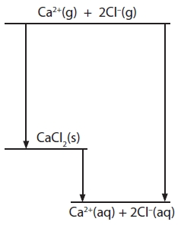
Answer ........................................................... kJ mol⁻¹
(iv) Draw diagrams to represent hydrated calcium ions and hydrated chloride ions.
(2)
(v) Suggest why the addition of anhydrous calcium chloride to water results in an increase in temperature and a decrease in volume.
(2)
Temperature increases
.............................................................................................................................................
.............................................................................................................................................
.............................................................................................................................................
Volume decreases
.............................................................................................................................................
.............................................................................................................................................
.............................................................................................................................................

(Total for question = 18 marks)

Q7.
When ammonium nitrate crystals dissolve in water, the entropy of the system
A remains the same.
B falls, because the hydrated ions are more ordered than the solid.
C rises, because the ions in the crystal become hydrated in the solution.
D rises, because the ions are arranged more randomly in the solution than in the
crystal.
(Total for question = 1 mark)

Q8.
A decrease in the entropy of the system, ΔS_{system}, occurs when
A water freezes.
B water boils.
C water reacts with sodium.
D water reacts with ethanoyl chloride.
(Total for question = 1 marks)

Q9.
The overall equation for a reaction between two chemicals, M and N, is
M + 2N → P + Q
(a) This reaction occurs spontaneously at room temperature. Which of the following must be true?
(1)

A ΔH is positive.
B ΔH is negative.
C ΔS is positive.
D ΔS is negative.
(b) The reaction above occurs in two stages via an intermediate, T.
M + N → T slow
N + T → P + Q fast
From this it can be deduced that the rate equation for the reaction between M and N is
(1)

A rate = k[M][N]
B rate = k[M][N]²
C rate = k[M][T]
D rate = k[N][T]
(Total for Question = 2 marks)

Q10.
Which reaction has an enthalpy change equal to the enthalpy of hydration of the sodium ion?
A Na⁺(g) + excess H₂O(l) → Na⁺(aq)
B Na⁺(g) + 1 mol of H₂O(l) → Na⁺(aq)
C Na⁺(s) + excess H₂O(l) → Na⁺(aq)
D Na⁺(s) + 1 mol of H₂O(l) → Na⁺(aq)
(Total for question = 1 mark)

Q11.
Which reaction has the most positive entropy change for the system, ΔS_{system}?
A NaOH(aq) + HCl(aq) → NaCl(aq) + H₂O(l)
B AgNO₃(aq) + NaCl(aq) → AgCl(s) + NaNO3(aq)
C C₂H₄(g) + HCl(g) → C₂H₅Cl(l)
D C₄H₁₀(g) → C₂H₄(g) + C₂H₆(g)
(Total for question = 1 mark)

Q12.
Barium carbonate decomposes in an endothermic reaction when heated to 1500 K.
BaCO₃(s) → BaO(s) + CO₂(g)
What are the signs of the entropy changes at 1500 K?
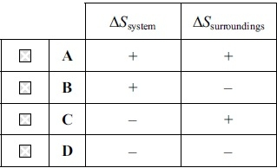
(Total for question = 1 mark)

Q13.
The reaction below is carried out at 25 °C. Use the equation and the data to answer the questions that follow.
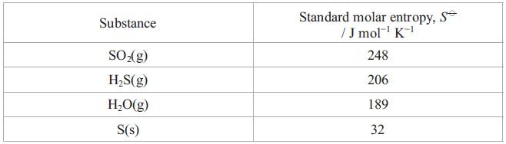
(a) The standard entropy change of the system, in J mol⁻¹ K⁻¹, is
(1)
A −186
B +186
C −233
D +233
(b) The standard entropy change of the surroundings, in J mol⁻¹ K⁻¹, is
(1)
A 107.4 × 1000 / 25
B −107.4 × 1000 / 25
C 107.4 × 1000 / 298
D −107.4 × 1000 / 298
(Total for question = 2 marks)

Q14.
Calcium carbonate decomposes at high temperature to form calcium oxide and carbon dioxide:
CaCO₃(s) → CaO(s) + CO₂(g)
Calcium carbonate is thermodynamically stable at room temperature because for this reaction

A the activation energy is high.
B the enthalpy change, ΔH, is positive.
C entropy change of the system (ΔS_{system}) is positive.
D entropy change of the system (ΔS_{system}) is negative.
(Total for Question = 1 mark)

Q15.
Energy is evolved when one mole of gaseous calcium ions is hydrated.
This reaction is more exothermic than the corresponding value for barium ions, Ba²⁺, because the
A ionization energy of calcium is greater than that of barium.
B lattice energy of calcium oxide is more exothermic than that of barium oxide.
C solubility of calcium hydroxide in water is less than that of barium hydroxide.
D ionic radius of Ca²⁺ is less than that of Ba²⁺.
(Total for question = 1 mark)

Mark Scheme
Q1.

Q2.

Q3.

Q4.

Q5.

Q6.
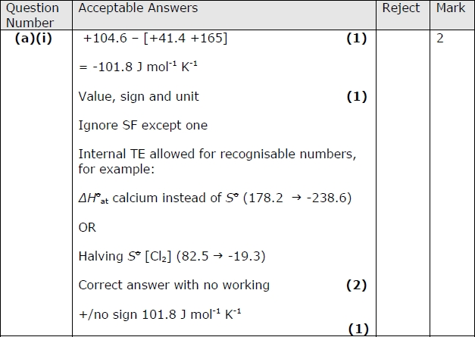
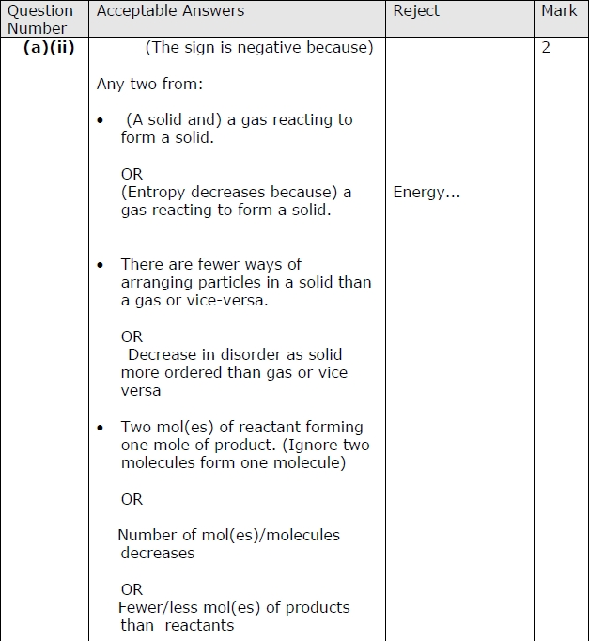
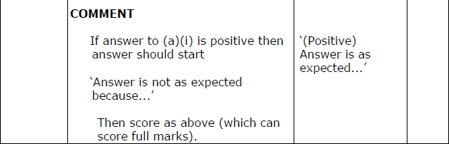
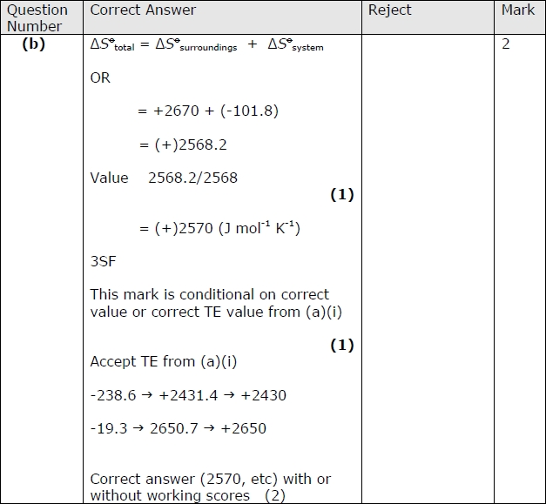
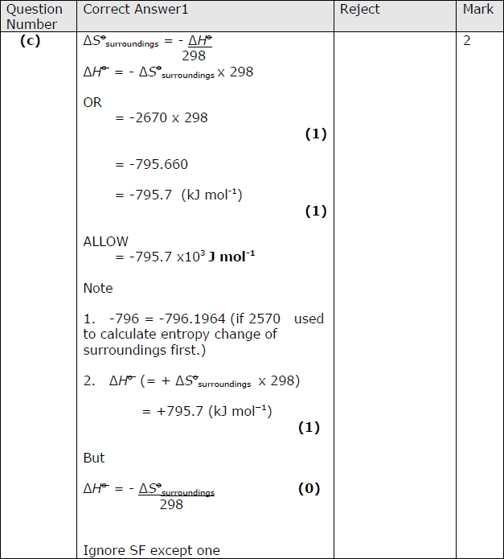
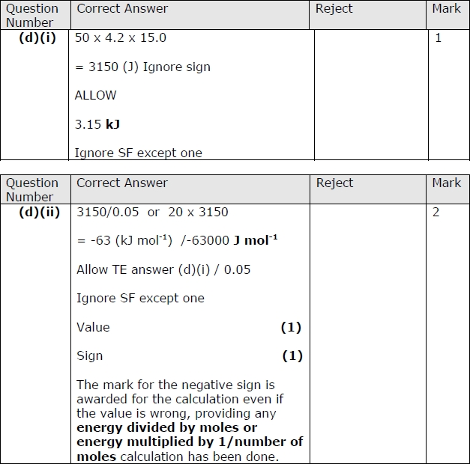
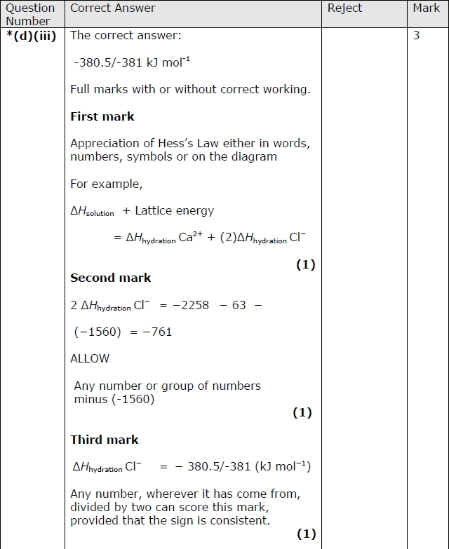
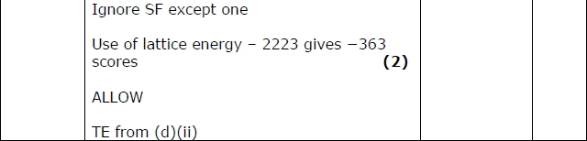
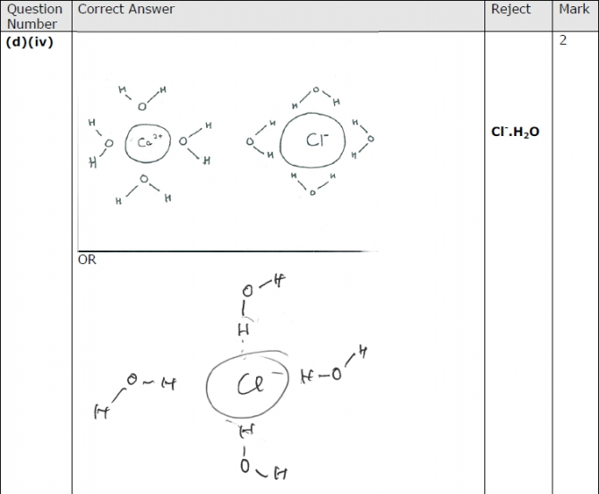
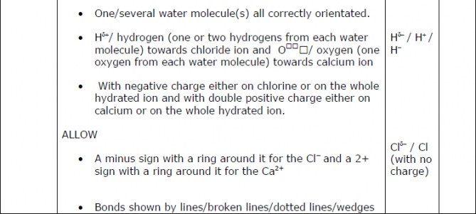
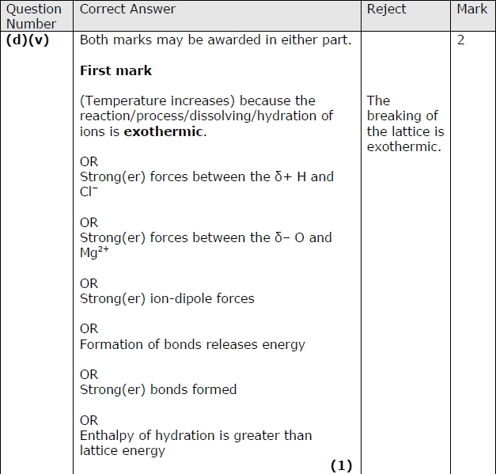
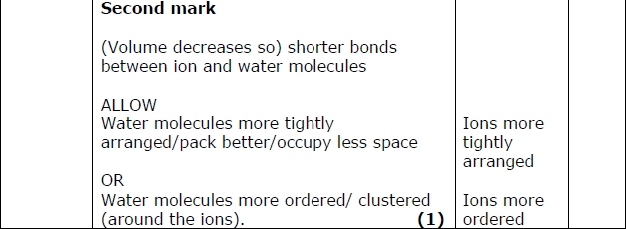

Q7.

Q8.

Q9.

Q10.

Q11.

Q12.

Q13.
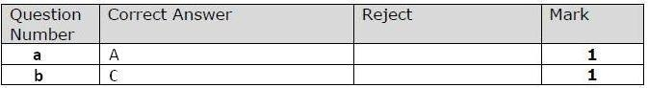

Q14.

Q15.

