Propaganda Posters of World War One
What does Propaganda mean?
- Propaganda is information that is spread for the purpose of promoting a cause or belief.
- During World War One, British propaganda posters were used to:-
- Recruit men to join the army;
- Recruit women to work in the factories and in the Women’s Land Army;
- Encourage people to save food and not to waste it;
- Keep morale high and encourage people to buy government bonds.

Why were propaganda posters needed during World War One?
- When Britain declared war in August 1914 it had only a small professional army, the BEF;
- They desperately needed men to join up and fight;
- Most people did not own radios and TV had not yet been invented;
- The easiest way for the government to communicate with the people was through posters stuck up on walls in all the towns and cities.
Posters became the “weapon on the wall.”

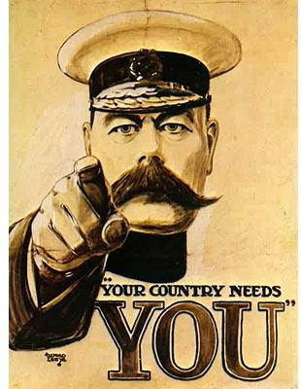
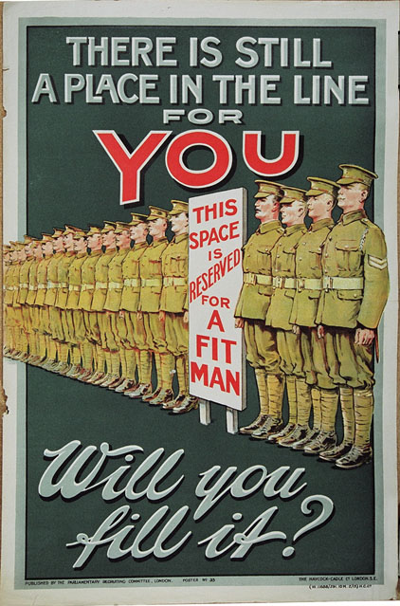
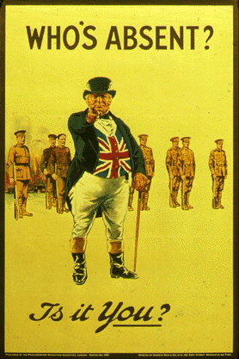
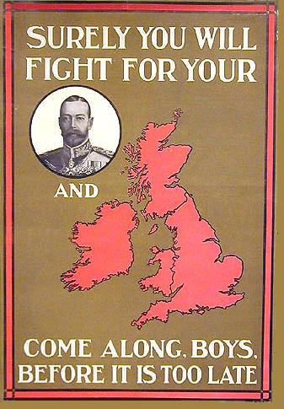
How were men encouraged to join the army?
Men were made to feel unmanly and cowardly for staying at home.

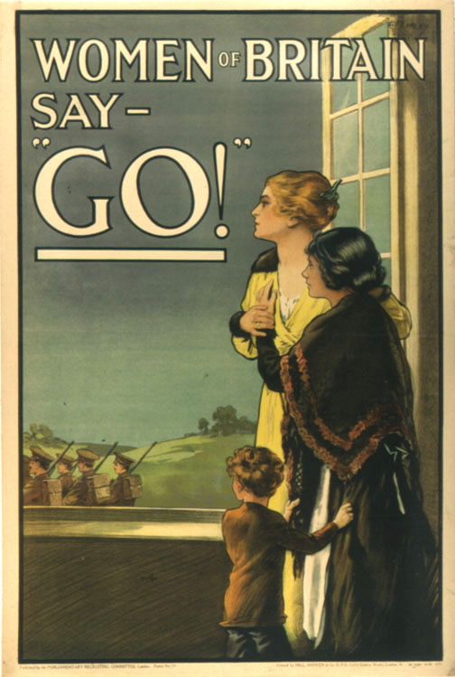
How were women used to encourage men to join the army?
Women were encouraged to pressurise their husbands,
boyfriends, sons and brothers to join up.

How was fear used?
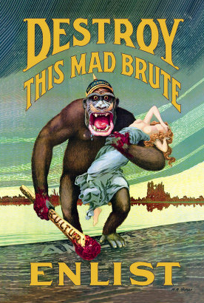
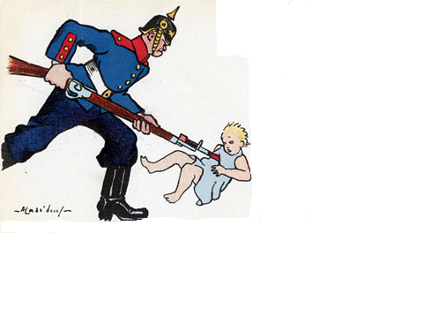
- Some posters tried to motivate men to join up through fear;

- Posters showed the atrocities that the Germans were said to be committing in France and Belgium;

- People were encouraged to fear that unless they were stopped, the Germans would invade Britain and commit atrocities against their families.

How were women encouraged to work in the factories or to join the army or the land girls?
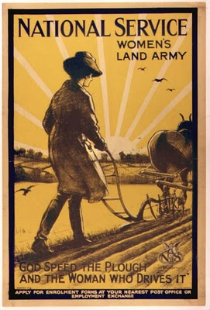
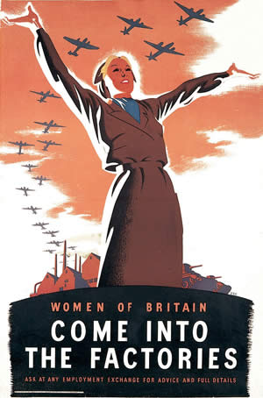
- When the men joined the war, the women were needed to do their jobs;

- There was a massive need for women in the factories, to produce the weapons, ammunition and uniforms needed for the soldiers;

- There was a major food shortage and women were desperately needed to grow food for the people of Britain and the soldiers in France.

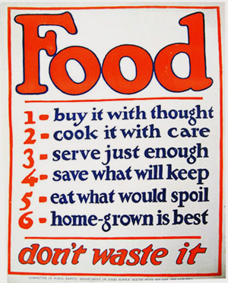
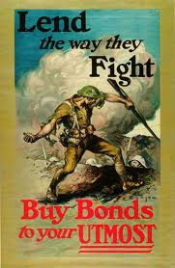
Posters encouraged everyone to do their bit...

- Through joining up;

- Through working for the war effort;

- By not wasting food;

- Through investing in government bonds.

Why are WW1 Propaganda Posters important?

- For historians today, propaganda posters of World War One reveal the values and attitudes of the people at the time;

- They tell us something about the feelings in Britain during World War One.

Task

- Your task is to produce a World War One Propaganda Poster;

- Remember to focus on one of the key reasons for why propaganda posters were produced:-
- To recruit men to join the army;
- To recruit women to work in the factories and in the Women’s Land Army;
- To encourage people to save food and not to waste;
- To keep morale high and encourage people to buy government bonds.

