Q1. (a) State what is meant by the term activation energy of a reaction.
(1)

(b) State in general terms how a catalyst increases the rate of a chemical reaction.
(2)

(c) The curve below shows the Maxwell–Boltzmann distribution of molecular energies, at a constant temperature, in a gas at the start of a reaction. On this diagram the most probable molecular energy at this temperature is indicated by the symbol E_{mp} and the activation energy by the symbol E_{a}.
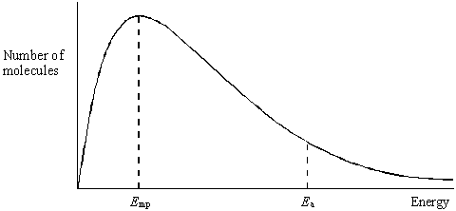
Consider the following changes.
(i) The number of molecules is increased at constant temperature.

(ii) The temperature is decreased without changing the number of molecules.
(iii) A catalyst is introduced without changing the temperature or the number of molecules.
For each of these changes state how, if at all, the following would vary:
• the value of the most probable energy, E_{mp}
• the number of molecules with the most probable energy, E_{mp}
• the area under the molecular energy distribution curve
• the number of molecules with energy greater than the activation energy, E_{a}
(12)
(Total 15 marks)

Q2. (a) Below is a Maxwell–Boltzmann curve showing the distribution of molecular energies for a sample of gas at a temperature T.
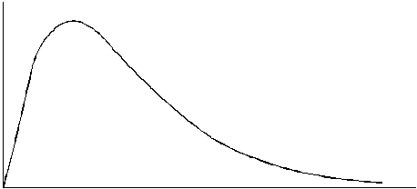
(i) Label the axes on the diagram above.

(ii) What does the area under the curve represent?
.............................................................................................................

(iii) State why this curve starts at the origin.
.............................................................................................................
(4)

(b) (i) State what is meant by the term activation energy.
.............................................................................................................
.............................................................................................................

(ii) The rate of a chemical reaction may be increased by an increase in reactant concentration, by an increase in temperature and by the addition of a catalyst.
State which, if any, of these changes involves a different activation energy. Explain your answer.
Change(s) ...........................................................................................
Explanation .........................................................................................
.............................................................................................................
(5)
(Total 9 marks)

Q3. (a) Define the term activation energy for a reaction.
......................................................................................................................
......................................................................................................................
(2)

(b) Give the meaning of the term catalyst.
......................................................................................................................
......................................................................................................................
(2)

(c) Explain in general terms how a catalyst works.
......................................................................................................................
......................................................................................................................
(2)

(d) In an experiment, two moles of gas W reacted completely with solid Y to form one mole of gas Z as shown in the equation below.
2W(g) + Y(s) → Z(g)
The graph below shows how the concentration of Z varied with time at constant temperature.
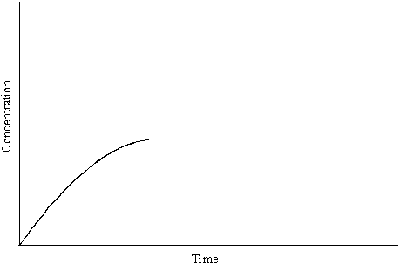
(i) On the axes above, sketch a curve to show how the concentration of W would change with time in the same experiment. Label this curve W.

(ii) On the axes above, sketch a curve to show how the concentration of Z would change with time if the reaction were to be repeated under the same conditions but in the presence of a catalyst. Label this curve Z.

(iii) In terms of the behaviour of particles, explain why the rate of this reaction decreases with time.
.............................................................................................................
.............................................................................................................
(6)
(Total 12 marks)

Q4. The table below contains some standard enthalpy of formation data.

Substance | C(s) | N₂(g) | H₂O(g) | CO₂(g) | NH₄NO₃(s)
ΔH_{f}/ kJ mol^{–1} | 0 | 0 | –242 | –394 | –365

(a) Why are the values of the standard enthalpy of formation for carbon and nitrogen zero?
......................................................................................................................
(1)

(b) State Hess’s Law.
......................................................................................................................
......................................................................................................................
......................................................................................................................
(2)

(c) Use ΔH_{f} data from the table to calculate a value for the enthalpy change for the following reaction.
NH₄NO₃(s) + C(s) → N₂(g) + 2H₂O(g) + CO₂(g)
......................................................................................................................
......................................................................................................................
......................................................................................................................
......................................................................................................................
(3)
(Total 6 marks)

Q5. (a) A sample of a gas was sealed into a flask at temperature T and pressure P. The Maxwell–Boltzmann distribution of energies for the molecules in this sample is shown below.
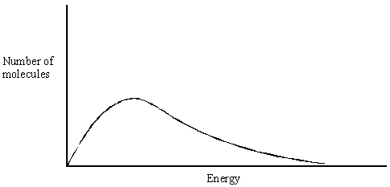
(i) Using the axes above, sketch the curve that you would expect if this sample of gas at pressure P had been cooled. Label this curve X.

(ii) Using the axes above, sketch the curve that you would expect if another sample of the same gas was sealed in the same flask at the original temperature, T, but at a higher pressure. Label this curve Y.
(4)

(b) Gas A decomposes slowly to form gases B and C. An equilibrium is established as shown by the following equation.
A(g) B(g) + C(g) ΔH is positive
(i) In terms of the behaviour of molecules, state what must happen before molecules of A can react to form B and C.
.............................................................................................................
.............................................................................................................

(ii) Explain why the decomposition of A is faster at higher temperatures.
.............................................................................................................
.............................................................................................................
(4)

(c) The graphs below show how, starting from A alone, the concentration of A varies with time at temperatures of 300 K and 320 K for the reversible reaction given in part (b).
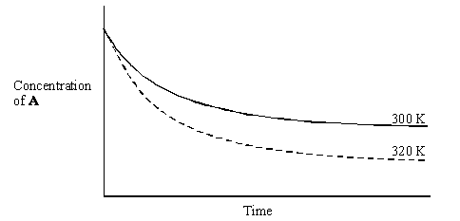
(i) Suggest why, as shown on the graphs, the concentration of A remains constant after a time.
.............................................................................................................

(ii) Explain why, at 320 K, the concentration of A falls to a lower value compared with the reaction at 300 K.
.............................................................................................................
.............................................................................................................
.............................................................................................................
(3)
(Total 11 marks)

Q6. The diagram below represents a Maxwell–Boltzmann distribution curve for the particles in a sample of a gas at a given temperature. The questions below refer to this sample of particles.
(a) Label the axes on the diagram.
(2)

(b) On the diagram draw a curve to show the distribution for this sample at a lower temperature.
(2)

(c) In order for two particles to react they must collide. Explain why most collisions do not result in a reaction.
......................................................................................................................
(1)

(d) State one way in which the collision frequency between particles in a gas can be increased without changing the temperature.
......................................................................................................................
(1)

(e) Suggest why a small increase in temperature can lead to a large increase in the reaction rate between colliding particles.
......................................................................................................................
......................................................................................................................
......................................................................................................................
(2)

(f) Explain in general terms how a catalyst works.
......................................................................................................................
......................................................................................................................
......................................................................................................................
(2)
(Total 10 marks)

Q7. Gas G decomposes as shown in the equation below.
G(g) → X(g) + Y(g)
(a) Draw, on the axes below, a Maxwell–Boltzmann distribution curve for a sample of G in which only a small proportion of molecules has energy greater than the activation energy, E_{a}.
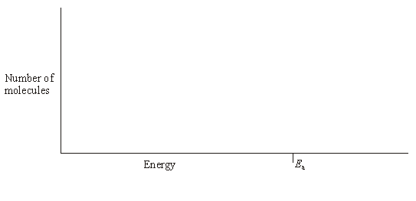
(3)

(b) Define the term activation energy.
......................................................................................................................
......................................................................................................................
(2)

(c) At any time, most of the molecules of G have energy less than the activation energy.
Suggest why, at a constant temperature, most of G eventually decomposes.
......................................................................................................................
......................................................................................................................
(2)

(d) State the effect, if any, of adding a catalyst on the time required for G to decompose, compared with a similar sample without a catalyst. Explain in general terms how the catalyst has this effect.
Time for decomposition ...............................................................................
Explanation ..................................................................................................
......................................................................................................................
(3)
(Total 10 marks)

Q8. The curve below shows how the volume of oxygen evolved varies with time when 50 cm³ of a 2.0 mol dm^{–3} solution of hydrogen peroxide, H₂O₂, decomposes at 298 K.
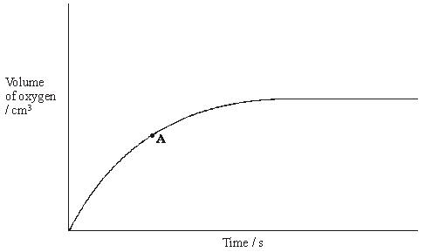
(a) State how you could use the curve to find the rate of reaction at point A.
......................................................................................................................
(1)

(b) Sketch curves, on the above axes, to illustrate how the volume of oxygen evolved would change with time if the experiment was repeated at 298 K using the following.
(i) 100 cm³ of a 1.0 mol dm^{–3} solution of H₂O₂. Label this curve X.
(ii) 25 cm³ of a 2.0 mol dm^{–3} solution of H₂O₂ in the presence of a catalyst.
Label this curve Y.
(4)

(c) Hydrogen peroxide decomposes more rapidly in the presence of aqueous hydrogen bromide. The decomposition proceeds as shown by the following equations.
H₂O₂ + HBr → HBrO + H₂O
HBrO + H₂O₂ → H₂O + O₂ + HBr
(i) Write an equation for the overall reaction.
.............................................................................................................

(ii) Define the term catalyst.
.............................................................................................................
.............................................................................................................

(iii) Give two reasons, other than an increase in the reaction rate, why these equations suggest that hydrogen bromide is behaving as a catalyst.
Reason 1 ............................................................................................
Reason 2 ............................................................................................
(5)
(Total 10 marks)

Q9. (a) Define the term activation energy for a chemical reaction.
(2)
(b) Draw, with labelled axes, a curve to represent the Maxwell–Boltzmann distribution of molecular energies in a gas. Label this curve T₁. On the same axes, draw a second curve to represent the same sample of gas at a lower temperature. Label this curve T₂.
Use these curves to explain why a small decrease in temperature can lead to a large decrease in the rate of a reaction.
(8)

(c) Give one reason why most collisions between gas-phase reactants do not lead to a reaction. State and explain two ways of speeding up a gas-phase reaction other than by changing the temperature.
(5)
(Total 15 marks)

Q10. The gas-phase reaction between hydrogen and chlorine is very slow at room temperature.
H₂(g) + Cl₂(g) → 2HCl(g)
(a) Define the term activation energy.
......................................................................................................................
......................................................................................................................
(2)

(b) Give one reason why the reaction between hydrogen and chlorine is very slow at room temperature.
......................................................................................................................
......................................................................................................................
(1)

(c) Explain why an increase in pressure, at constant temperature, increases the rate of reaction between hydrogen and chlorine.
......................................................................................................................
......................................................................................................................
(2)

(d) Explain why a small increase in temperature can lead to a large increase in the rate of reaction between hydrogen and chlorine.
......................................................................................................................
......................................................................................................................
(2)

(e) Give the meaning of the term catalyst.
......................................................................................................................
......................................................................................................................
(1)

(f) Suggest one reason why a solid catalyst for a gas-phase reaction is often in the form of a powder.
......................................................................................................................
(1)
(Total 9 marks)

Q11. The diagram below shows the Maxwell–Boltzmann distribution of molecular energies in a sample of a gas.
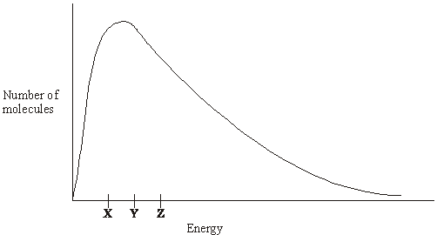
(a) (i) State which one of X, Y or Z best represents the mean energy of the molecules.
.............................................................................................................

(ii) Explain the process that causes some molecules in this sample to have very low energies.
.............................................................................................................
.............................................................................................................
(3)

(b) On the diagram above, sketch a curve to show the distribution of molecular energies in the same sample of gas at a higher temperature.
(2)

(c) (i) Explain why, even in a fast reaction, a very small percentage of collisions leads to a reaction.
.............................................................................................................
.............................................................................................................

(ii) Other than by changing the temperature, state how the proportion of successful collisions between molecules can be increased. Explain why this method causes an increase in the proportion of successful collisions.
Method for increasing the proportion of successful collisions ............
.............................................................................................................
Explanation ….....................................................................................
.............................................................................................................
(4)
(Total 9 marks)

Q12. Kinetic studies enable chemists to suggest mechanisms for reactions.
(a) The following data were obtained in a series of experiments on the rate of the reaction between compounds A and B at a constant temperature.

Experiment | Initial concentration of A/mol dm^{–3} | Initial concentration of B/mol dm^{–3} | Initial rate/  mol dm^{–3} s^{–1}
1 | 0.12 | 0.15 | 0.32 × 10^{–3}
2 | 0.36 | 0.15 | 2.88 × 10^{–3}
3 | 0.72 | 0.30 | 11.52 × 10^{–3}

(i) Deduce the order of reaction with respect to A.
.............................................................................................................
.............................................................................................................

(ii) Deduce the order of reaction with respect to B.
.............................................................................................................
.............................................................................................................
(2)

(b) The following data were obtained in a series of experiments on the rate of the reaction between NO and O₂ at a constant temperature.

Experiment | Initial concentration of NO/mol dm^{–3} | Initial concentration of O₂/mol dm^{–3} | Initial rate/  mol dm^{–3} s^{–1}
4 | 5.0 × 10^{–2} | 2.0 × 10^{–2} | 6.5 × 10^{–4}
5 | 6.5 × 10^{–2} | 3.4 × 10^{–2} | To be calculated

The rate equation for this reaction is
rate = k[NO]²[O₂]
(i) Use the data from Experiment 4 to calculate a value for the rate constant, k, at this temperature, and state its units.
Value of k ............................................................................................
.............................................................................................................
Units of k .............................................................................................
.............................................................................................................

(ii) Calculate a value for the initial rate in Experiment 5.
.............................................................................................................
.............................................................................................................

(iii) Using the rate equation, a scientist suggested a mechanism for the reaction which consisted of the two steps shown below.
Step 1 NO + NO → N₂O₂
Step 2 N₂O₂ + O₂ → 2NO₂
Which did the scientist suggest was the rate–determining step?
.............................................................................................................
(5)
(Total 7 marks)

Q13. The diagram below shows the Maxwell–Boltzmann energy distribution curve for a sample of gas at a fixed temperature. E_{a} is the activation energy for the decomposition of this gas.
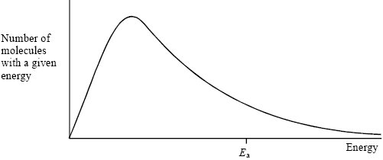
(a) On this diagram sketch the distribution curve for the same sample of gas at a higher temperature.
(3)

(b) (i) What is the effect of an increase in temperature on the rate of a chemical reaction?
Explain your answer with reference to the Maxwell–Boltzmann distribution.
Effect ..................................................................................................
Explanation .........................................................................................
.............................................................................................................
.............................................................................................................

(ii) What is the effect of the addition of a catalyst on the rate of a chemical reaction?
Explain your answer with reference to the Maxwell–Boltzmann distribution.
Effect .................................................................................................
Explanation ........................................................................................
.............................................................................................................
.............................................................................................................
(6)
(Total 9 marks)

Q14. Sodium thiosulfate solution (Na₂S₂O₃) reacts slowly with dilute hydrochloric acid to form a precipitate. The rate of this reaction can be studied by measuring the time (t) that it takes for a small fixed amount of precipitate to form under different conditions. The fixed amount of precipitate is taken as the amount needed to obscure a cross on paper.
The equation for this reaction is shown below.
Na₂S₂O₃ + 2HCl →2NaCl + S + SO₂ + H₂O
(a) Identify the insoluble product of this reaction which forms the precipitate.
......................................................................................................................
(1)

(b) When this reaction takes place, the collision between the reacting particles requires an activation energy. State what is meant by the term activation energy.
......................................................................................................................
......................................................................................................................
(2)

(c) In terms of particles, explain why, at a fixed temperature, you might expect the rate of this reaction to double when the concentration of sodium thiosulfate is doubled and the concentration of hydrochloric acid remains the same.
......................................................................................................................
......................................................................................................................
......................................................................................................................
......................................................................................................................
(2)

(d) (i) State what is meant by the term rate of reaction.
.............................................................................................................
.............................................................................................................
(1)

(ii) Consider the description of the way in which this experiment is carried out.
Use your understanding of the term rate of reaction to explain why it is
possible to use a simplified formula as a measure of the rate of this reaction.
.............................................................................................................
.............................................................................................................
(1)
(Total 7 marks)

Q15. The method of extraction of zinc has changed as different ores containing the element have been discovered and as technology has improved.
Extraction process 1
In the earliest process, calamine (impure zinc carbonate) was heated with charcoal in earthenware pots. This two-stage process gave a low yield of zinc.
ZnCO₃(s) → ZnO(s) + CO₂(g)
ZnO(s) + C(s) → Zn(s) + CO(g)

Extraction process 2
Deposits of calamine were being used up and a new two-stage process was developed using zinc sulfide ores. All of the waste gases from this process were released into the atmosphere.
2ZnS(s) + 3O₂(g) → 2ZnO(s) + 2SO₂(g)
ZnO(s) + C(s) → Zn(s) + CO(g)

Extraction process 3
The modern process uses the electrolysis of aqueous solutions of very pure zinc sulfate. The first step in this process is the same as the first step in Extraction process 2. The second step uses sulfuric acid made from the SO₂ collected in the first step. The third step involves the electrolysis of zinc sulfate solution to form pure zinc.
2ZnS(s) + 3O₂(g) → 2ZnO(s) + 2SO₂(g)
ZnO(s) + H₂SO₄(aq) → ZnSO₄(aq) + H₂O(l)
ZnSO₄(aq) Zn(s)
(a) In the first stage of Extraction process 1 the following equilibrium is established when zinc carbonate is heated in a closed container.
ZnCO₃(s) ZnO(s) + CO₂(g)
Use Le Chatelier’s principle to suggest and explain the effect on the yield of zinc oxide of allowing the carbon dioxide to escape from the container.
......................................................................................................................
......................................................................................................................
......................................................................................................................
......................................................................................................................
......................................................................................................................
......................................................................................................................
(3)

(b) State and explain one environmental reason why Extraction process 3 is an improvement over Extraction process 2.
......................................................................................................................
......................................................................................................................
......................................................................................................................
......................................................................................................................
......................................................................................................................
......................................................................................................................
(3)

(c) Give one reason why Extraction process 3 is an expensive method of making zinc but one which is justified in terms of the product formed.
......................................................................................................................
......................................................................................................................
......................................................................................................................
......................................................................................................................
(2)

(d) Deduce the half-equation for the formation of zinc from zinc ions during the electrolysis of zinc sulfate solution and identify the electrode at which this reaction occurs.
......................................................................................................................
......................................................................................................................
......................................................................................................................
......................................................................................................................
(2)

(e) Identify one reaction from the three extraction processes that is not a redox reaction and state the type of reaction that it is. In terms of redox, state what happens to the carbon in Extraction process 2.
......................................................................................................................
......................................................................................................................
......................................................................................................................
......................................................................................................................
......................................................................................................................
......................................................................................................................
(3)

(f) Zinc and magnesium both react with steam in a similar way. Write an equation for the reaction of zinc with steam and name the products of this reaction.
......................................................................................................................
......................................................................................................................
......................................................................................................................
......................................................................................................................
(2)
(Total 15 marks)

Q16. A scientist used mass spectrometry to analyse a sample of the air near a fertiliser factory. The sample of air included traces of a gas which was shown by its molecular ion to have a precise M_{r} = 44.00105
(a) State the meaning of the term molecular ion.
......................................................................................................................
......................................................................................................................
(1)

(b) (i) Use the following data to show that the trace gas was dinitrogen oxide (N₂O).
Show your working.

Atom | Precise relative atomic mass
¹²C | 12.00000
¹⁴N | 14.00307
¹⁶O | 15.99491

.............................................................................................................
.............................................................................................................
(1)

(ii) Propane is used as a fuel in the fertiliser factory. State why both propane and its combustion product, carbon dioxide, might have been identified as the trace gas if the scientist had used relative molecular masses calculated to one decimal place.
.............................................................................................................
.............................................................................................................
(1)

(iii) State why the precise relative atomic mass for the ¹²C isotope is exactly 12.00000
.............................................................................................................
(1)

(c) Dinitrogen oxide is formed when ammonia is oxidised according to the following equation.
2NH₃(g) + 2O₂(g) → N₂O(g) + 3H₂O(l)
(i) Use the standard enthalpies of formation in the table below to calculate a value for the standard enthalpy change of this reaction.

 | NH₃(g) | O₂(g) | N₂O(g) | H₂O(l)
ΔH_{f}^{ο}/ kJ mol^{–1} | –46 | 0 | +82 | –286
.............................................................................................................
.............................................................................................................
.............................................................................................................
.............................................................................................................
(3)

(ii) State one condition necessary for enthalpies of formation to be quoted as standard values at a specified temperature of 298 K.
.............................................................................................................
(1)
(Total 8 marks)

Q17. An equation for the equilibrium reaction between hydrogen, iodine and hydrogen iodide is shown below.
H₂(g) + I₂(g) 2HI(g)
(a) The curve in the diagram below illustrates the reaction profile for this equilibrium reaction without a catalyst.
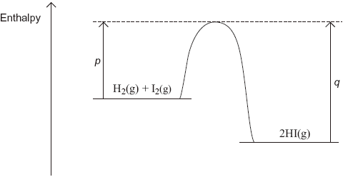
(i) Draw on the diagram a curve to illustrate the reaction profile for this equilibrium reaction with a catalyst.
(2)

(ii) Use the diagram to deduce whether the formation of hydrogen iodide from hydrogen and iodine is exothermic or endothermic.
.............................................................................................................
(1)

(iii) State what the diagram suggests about the sum of the bond enthalpies for the reactant molecules compared with the product molecules.
.............................................................................................................
.............................................................................................................
(1)

(iv) In terms of p and q, identify the following for this equilibrium without a catalyst.
A value for the activation energy for the forward reaction ..................
A value for the overall enthalpy change for the forward reaction
.............................................................................................................
(2)

(b) A mixture of H₂(g) and I₂(g) was allowed to reach equilibrium.
(i) State the effect of a catalyst on the rate of attainment of this equilibrium.
.............................................................................................................
(1)

(ii) State and explain the effect of an increase in total pressure on the rate of attainment of this equilibrium.
Effect of an increase in pressure on rate ..........................................
Explanation ........................................................................................
.............................................................................................................
.............................................................................................................
.............................................................................................................
.............................................................................................................
(3)
(Total 10 marks)

Q18. The diagram below shows a Maxwell–Boltzmann distribution for a sample of gas at a fixed temperature.
E_{a} is the activation energy for the decomposition of this gas.
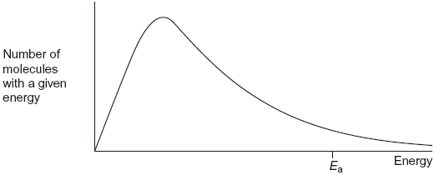
(a) (i) On this diagram, sketch the distribution for the same sample of gas at a higher temperature.
(2)

(ii) With reference to the Maxwell–Boltzmann distribution, explain why an increase in temperature increases the rate of a chemical reaction.
.............................................................................................................
.............................................................................................................
.............................................................................................................
.............................................................................................................
.............................................................................................................
(2)

(b) Dinitrogen oxide (N₂O) is used as a rocket fuel. The data in the table below show how the activation energy for the decomposition of dinitrogen oxide differs with different catalysts.
2N₂O(g) 2N₂(g) + O₂(g)

 | Ea / kJ mol^{–1}
Without a catalyst | 245
With a gold catalyst | 121
With an iron catalyst | 116
With a platinum catalyst | 136

(i) Use the data in the table to deduce which is the most effective catalyst for this decomposition.
.............................................................................................................
(1)

(ii) Explain how a catalyst increases the rate of a reaction.
.............................................................................................................
.............................................................................................................
.............................................................................................................
.............................................................................................................
(2)
(Total 7 marks)

Q19. (a) In the presence of the catalyst rhodium, the reaction between NO and H₂ occurs according to the following equation.
2NO(g) + 2H₂(g) N₂(g) + 2H₂O(g)
The kinetics of the reaction were investigated and the rate equation was found to be
rate = k[NO]²[H₂]
The initial rate of reaction was 6.2 × 10^{–6} mol dm^{–3} s^{–1} when the initial concentration of NO was 2.9 × 10^{–2} mol dm^{–3} and the initial concentration of H₂ was 2.3× 10^{–2} mol dm^{–3}.
(i) Calculate the value of the rate constant under these conditions and give its units.
Calculation ..........................................................................................
.............................................................................................................
.............................................................................................................
.............................................................................................................
Units ....................................................................................................
.............................................................................................................
(3)

(ii) Calculate the initial rate of reaction if the experiment is repeated under the same conditions but with the concentrations of NO and of H₂ both doubled from their original values.
.............................................................................................................
.............................................................................................................
(1)

(b) Using the rate equation and the overall equation, the following three-step mechanism for the reaction was suggested. X and Y are intermediate species.
Step 1 NO + NO X
Step 2 X + H₂ Y
Step 3 Y + H₂ N₂ + 2H₂O
Suggest which one of the three steps is the rate-determining step.
Explain your answer.
Rate-determining step..................................................................................
Explanation ..................................................................................................
......................................................................................................................
......................................................................................................................
(Extra space) ...............................................................................................
......................................................................................................................
(2)
(Total 6 marks)

Q20. This question is about the extraction of titanium from titanium(IV) oxide by a two-stage
process.
The first stage in the process produces titanium(IV) chloride. In the second stage,
titanium(IV) chloride is converted into titanium.
The enthalpy change for the second stage can be determined using Hess’s Law.
(a) Give one reason why titanium is not extracted directly from titanium(IV) oxide using carbon.
.....................................................................................................................
.....................................................................................................................
(1)

(b) Give the meaning of the term enthalpy change.
.....................................................................................................................
.....................................................................................................................
.....................................................................................................................
(1)

(c) State Hess’s Law.
.....................................................................................................................
.....................................................................................................................
.....................................................................................................................
.....................................................................................................................
(1)

(d) Define the term standard enthalpy of formation.
.....................................................................................................................
.....................................................................................................................
.....................................................................................................................
.....................................................................................................................
.....................................................................................................................
.....................................................................................................................
(3)

(e) The following standard enthalpy of formation data refer to the second stage in the extraction of titanium.

 | TiCl₄(g) | Na(I) | NaCl(s) | Ti(s)
ΔH_{f}^{ο}/ kJ mol^{–1} | –720 | +3 | –411 | 0

(i) State why the value for the standard enthalpy of formation of Na(I) is not zero.
.............................................................................................................
.............................................................................................................
(1)

(ii) Use data from the table to calculate a value for the standard enthalpy change of the following reaction.
TiCl₄(g) + 4Na(I) 4NaCl(s) + Ti(s)
.............................................................................................................
.............................................................................................................
.............................................................................................................
.............................................................................................................
.............................................................................................................
.............................................................................................................
.............................................................................................................
(3)

(iii) State the role of sodium in this reaction.
.............................................................................................................
(1)
(Total 11 marks)

Q21. The rate of a chemical reaction is influenced by the size of the activation energy. Catalysts are used to increase the rates of chemical reactions but are not used up in the reactions.
(a) Give the meaning of the term activation energy.
.....................................................................................................................
.....................................................................................................................
.....................................................................................................................
.....................................................................................................................
(2)

(b) Explain how a catalyst increases the rate of a reaction.
.....................................................................................................................
.....................................................................................................................
.....................................................................................................................
.....................................................................................................................
(2)

(c) The diagram below shows the Maxwell–Boltzmann distribution of molecular energies, at a constant temperature, in a gas at the start of a reaction.
On this diagram the most probable molecular energy at this temperature is shown by the symbol E_{mp}
The activation energy is shown by the symbol E_{a}
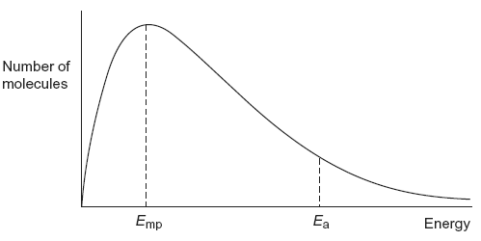
To answer the questions (c)(i) to (c)(iv), you should use the words increases, decreases or stays the same. You may use each of these answers once, more than once or not at all.
(i) State how, if at all, the value of the most probable energy (E_{mp}) changes
as the total number of molecules is increased at constant temperature.
.............................................................................................................
(1)

(ii) State how, if at all, the number of molecules with the most probable energy (E_{mp}) changes as the temperature is decreased without changing the total number of molecules.
.............................................................................................................
(1)

(iii) State how, if at all, the number of molecules with energy greater than the activation energy (E_{a}) changes as the temperature is increased without c hanging the total number of molecules.
.............................................................................................................
(1)

(iv) State how, if at all, the area under the molecular energy distribution curve changes as a catalyst is introduced without changing the temperature or the total number of molecules.
.............................................................................................................
(1)

(d) For each of the following reactions, identify a catalyst and name the organic product of the reaction.
(i) The fermentation of an aqueous solution of glucose.
Catalyst ..............................................................................................
Name of organic product ....................................................................
.............................................................................................................
(2)

(ii) The hydration of but-2-ene.
Catalyst ..............................................................................................
Name of organic product ....................................................................
.............................................................................................................
(2)
(Total 12 marks)

Q22.At high temperatures and in the presence of a catalyst, sulfur trioxide decomposes according to the following equation.
2SO₃(g) |  | 2SO₂(g) | + | O₂(g) | ∆H^{ϴ} = +196 kJ mol^{–1}

(a) In an experiment, 8.0mol of sulfur trioxide were placed in a container of volume 12.0 dm³ and allowed to come to equilibrium.
At temperature T₁ there were 1.4 mol of oxygen in the equilibrium mixture.
(i) Calculate the amount, in moles, of sulfur trioxide and of sulfur dioxide in the equilibrium mixture.
Amount of sulfur trioxide .......................................................................
Amount of sulfur dioxide ........................................................................
(2)

(ii) Write an expression for the equilibrium constant, K_{c}, for this equilibrium.
...............................................................................................................
...............................................................................................................
(1)

(iii) Deduce the units of K_{c} for this equilibrium.
...............................................................................................................
...............................................................................................................
(1)

(iv) Calculate a value of K_{c} for this equilibrium at temperature T₁
(If you were unable to complete the calculations in part (a)(i) you should assume that the amount of sulfur trioxide in the equilibrium mixture was 5.8 mol and the amount of sulfur dioxide was 2.1 mol. These are not the correct values.)
...............................................................................................................
...............................................................................................................
...............................................................................................................
...............................................................................................................
...............................................................................................................
...............................................................................................................
(Extra space) ........................................................................................
...............................................................................................................
(3)

(b) The experiment was repeated at the same temperature using the same amount of sulfur trioxide but in a larger container.
State the effect, if any, of this change on:
(i) the amount, in moles, of oxygen in the new equilibrium mixture
...............................................................................................................
(1)

(ii) the value of K_{c}
...............................................................................................................
(1)

(c) The experiment was repeated in the original container but at temperature T₂
The value of K_{c} was smaller than the value at temperature T₁
State which is the higher temperature, T₁ or T₂
Explain your answer.
Higher temperature ........................................................................................
Explanation ....................................................................................................
........................................................................................................................
........................................................................................................................
........................................................................................................................
........................................................................................................................
(Extra space) .................................................................................................
........................................................................................................................
(3)
(Total 12 marks)

Q23.The initial rate of the reaction between two gases P and Q was measured in a series of experiments at a constant temperature. The following rate equation was determined.
rate = k[P]²[Q]
(a) Complete the table of data below for the reaction between P and Q.

Experiment | Initial [P] /mol dm^{–3} | Initial [Q] /mol dm^{–3} | Initial rate /mol dm^{–3} s^{–1}
1 | 0.20 | 0.30 | 1.8 = 10^{–3}
2 | 0.40 | 0.60
3 | 0.60 |  | 5.4 = 10^{–3}
4 |  | 0.90 | 12.2 = 10^{–3}

(Space for working) .......................................................................................
........................................................................................................................
........................................................................................................................
........................................................................................................................
........................................................................................................................
(3)

(b) Use the data from Experiment 1 to calculate a value for the rate constant k and deduce its units.
Calculation .....................................................................................................
........................................................................................................................
........................................................................................................................
........................................................................................................................
........................................................................................................................
Units ...............................................................................................................
........................................................................................................................
(3)

(c) Consider the graphs E, F, G and H below.
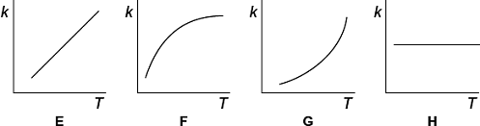
Write in the box below the letter of the graph that shows how the rate constant k varies with temperature.
(1)
(Total 7 marks)

Q24.The diagram shows the Maxwell–Boltzmann distribution of molecular energies in a gas at two different temperatures.
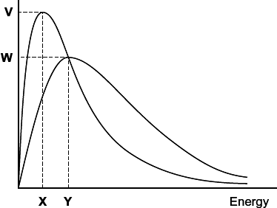
(a) One of the axes is labelled. Complete the diagram by labelling the other axis.
(1)

(b) State the effect, if any, of a solid catalyst on the shape of either of these distributions.
........................................................................................................................
........................................................................................................................
(1)

(c) In the box, write the letter, V, W, X or Y, that represents the most probable energy of the molecules at the lower temperature.
(1)

(d) Explain what must happen for a reaction to occur between molecules of two different gases.
........................................................................................................................
........................................................................................................................
........................................................................................................................
........................................................................................................................
(2)

(e) Explain why a small increase in temperature has a large effect on the initial rate of a reaction.
........................................................................................................................
........................................................................................................................
........................................................................................................................
........................................................................................................................
(1)
(Total 6 marks)

Q25.Gases P and Q react as shown in the following equation.

2P(g) | + | 2Q(g) |  | R(g) | + | S(g)

The initial rate of the reaction was measured in a series of experiments at a constant temperature. The following rate equation was determined.
rate = k[P]²[Q]

(a) Complete the table of data for the reaction between P and Q.

Experiment | Initial [P] / mol dm^{–3} | Initial [Q] / mol dm^{–3} | Initial rate / mol dm^{–3} s^{–1}
1 | 2.5 × 10^{–2} | 1.8 × 10^{–2} | 5.0 × 10^{–5}
2 | 7.5 × 10^{–2} | 1.8 × 10^{–2}
3 | 5.0 × 10^{–2} |  | 5.0 × 10^{–5}
4 |  | 5.4 × 10^{–2} | 4.5 × 10^{–4}

(Space for working) .......................................................................................
........................................................................................................................
........................................................................................................................
........................................................................................................................
(3)

(b) Use the data from Experiment 1 to calculate a value for the rate constant (k) at this temperature. Deduce the units of k.
Calculation .....................................................................................................
........................................................................................................................
........................................................................................................................
........................................................................................................................
Units ...............................................................................................................
........................................................................................................................
(3)
(Total 6 marks)

Q26.The manufacture of food grade phosphoric acid for use in cola drinks begins with the production of pure white phosphorus from the mineral fluoroapatite, Ca₅F(PO₄)₃
(a) Complete the following equation for the manufacture of phosphorus.
....Ca₅F(PO₄)₃ + 9SiO₂ + ....C 9CaSiO₃ + CaF₂ + ....CO + ....P
(1)

(b) As the phosphorus cools, it forms white phosphorus, P₄
Give the oxidation state of phosphorus in each of the following.
P₄ .............................................................
H₃PO₄ ......................................................
(2)

(c) Fertiliser grade phosphoric acid is manufactured from sulfuric acid and calcium phosphate.
Use the following precise relative atomic mass data to show how mass spectrometry can be used to distinguish between pure sulfuric acid (H₂SO₄) and pure phosphoric acid (H₃PO₄) which both have M_{r} = 98 to two significant figures.

Atom | Precise relative atomic mass
¹H | 1.00794
¹⁶O | 15.99491
³¹P | 30.97376
³²S | 32.06550

........................................................................................................................
........................................................................................................................
........................................................................................................................
........................................................................................................................
(1)

(d) Concentrated phosphoric acid is used as a catalyst in the hydration of propene to form the alcohol CH₃CH(OH)CH₃ as the main organic product.
The industrial name for this alcohol is isopropyl alcohol.
(i) State the meaning of the term catalyst.
...............................................................................................................
...............................................................................................................
...............................................................................................................
(Extra space) ........................................................................................
...............................................................................................................
(1)

(ii) State the meaning of the term hydration.
...............................................................................................................
...............................................................................................................
...............................................................................................................
(Extra space) ........................................................................................
...............................................................................................................
(1)

(iii) Write an equation for the hydration of propene to form isopropyl alcohol.
Give the IUPAC name for isopropyl alcohol.

Equation ................................................................................................
IUPAC name ..........................................................................................
(2)
(Total 8 marks)

Q27.A student carried out an experiment to determine the rate of decomposition of hydrogen peroxide into water and oxygen gas.
The student used 100 cm³ of a 1.0 mol dm^{–3} solution of hydrogen peroxide at 298K and measured the volume of oxygen collected.
Curve R, in each of Figures 1, 2 and 3, shows how the total volume of oxygen collected changed with time under these conditions.
(a) Draw a curve on Figure 1 to show how the total volume of oxygen collected will change with time if the experiment is repeated at 298 K using 100 cm³ of a 2.0 mol dm^{–3} solution of hydrogen peroxide.
Figure 1

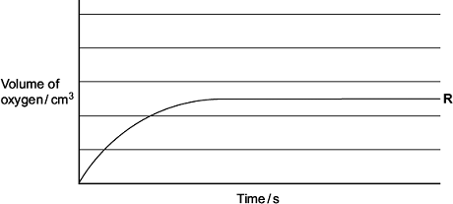
(2)

(b) Draw a curve on Figure 2 to show how the total volume of oxygen collected will change with time if the experiment is repeated at 298 K using 100 cm³ of a 0.4 mol dm^{–3} solution of hydrogen peroxide.
Figure 2

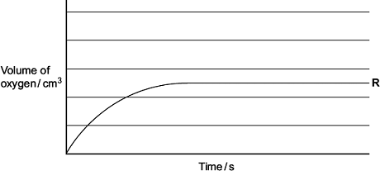
(2)

(c) Draw a curve on Figure 3 to show how the total volume of oxygen collected will change with time if the original experiment is repeated at a temperature higher than 298 K.
You should assume that the gas is collected at a temperature of 298 K.
Figure 3

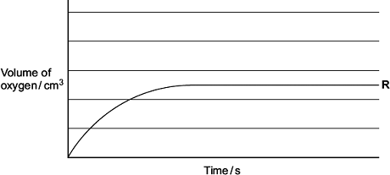
(2)

(d) Explain why the slope (gradient) of curve R decreases as time increases.
........................................................................................................................
........................................................................................................................
........................................................................................................................
........................................................................................................................
(Extra space) .................................................................................................
........................................................................................................................
(2)

(e) The student discovered that hydrogen peroxide decomposes at a faster rate when a few drops of aqueous hydrogen bromide are added to the solution.
The student found on the Internet that this decomposition is thought to proceed in two steps as shown by the following equations.

Step 1 | H₂O₂ | + | HBr |  | HBrO | + | H₂O
Step 2 | HBrO | + | H₂O₂ |  | H₂O | + | O₂ | + | HBr

(i) Write an equation for the overall reaction.

...............................................................................................................
(1)

(ii) Give one reason, other than the increase in rate of reaction, why the student was able to deduce that hydrogen bromide behaves as a catalyst in this two-step reaction.
...............................................................................................................
...............................................................................................................
...............................................................................................................
(1)
(Total 10 marks)

Q28.A study of equilibrium is important for understanding chemical reactions.
(a) State le Chatelier’s principle.
........................................................................................................................
........................................................................................................................
........................................................................................................................
........................................................................................................................
(Extra space) .................................................................................................
........................................................................................................................

(1)
(b) Catalysts play an important role in many reactions.
(i) State the meaning of the term catalyst.
Explain, in general terms, how catalysts work.
Meaning of the term catalyst .................................................................
...............................................................................................................
...............................................................................................................
How catalysts work ..............................................................................
...............................................................................................................
...............................................................................................................
...............................................................................................................
(3)

(Extra space) ........................................................................................
...............................................................................................................
(ii) State the effect, if any, of a catalyst on the time taken to reach equilibrium.
...............................................................................................................
(1)

(iii) State the effect, if any, of a catalyst on the position of an equilibrium.
...............................................................................................................
(1)

(c) Consider the following equilibrium reactions.
ΔH^{ᶿ} / kJ mol⁻¹

P | H₂(g) + l₂(g) |  | 2Hl(g) |  | −10
Q | CO₂(g) + 3H₂(g) |  | CH₃OH(g) + H₂O(g) |  | −49
R | N₂O₄(g) |  | 2NO₂(g) |  | +58
S | N₂(g) + 3H₂(g) |  | 2NH₃(g) |  | −92
T | C₂H₄(g) + H₂O(g) |  | CH₃CH₂OH(g) |  | −42

In each of parts (c)(i) to (c)(v), you should record in the box one of the letters, P, Q, R, S or T, that corresponds to the equilibrium that best fits the information provided.
You may use each letter once, more than once or not at all.
(i) A decrease in temperature at constant pressure shifts the position of this equilibrium from right to left.
(1)

(ii) This equilibrium uses concentrated phosphoric acid as a catalyst in a hydration reaction.
(1)

(iii) A decrease in pressure at constant temperature shifts the position of this equilibrium from left to right.
(1)

(iv) There is no change in the position of this equilibrium when the pressure is increased at constant temperature.
(1)

(v) An increase in the concentration of steam at constant temperature and constant pressure shifts the position of this equilibrium from right to left.
(1)
(Total 11 marks)

Q29.(a) Figure 1 shows the volume of hydrogen gas collected when a sample of magnesium reacted with an excess of dilute hydrochloric acid.
The rate of this reaction can be studied by measuring the time it takes for a given volume of hydrogen to be collected.
Figure 1
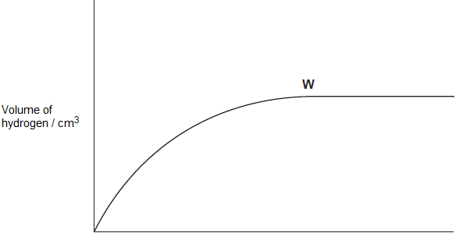
Time / s
(i) State the meaning of the term rate of reaction.
...............................................................................................................
...............................................................................................................
...............................................................................................................
(1)

(ii) State and explain what has happened to the rate of this reaction at point W in Figure 1.
...............................................................................................................
...............................................................................................................
...............................................................................................................
...............................................................................................................
(2)

(iii) In terms of collision theory explain why, at a fixed temperature, the rate of this reaction doubles when the concentration of the hydrochloric acid doubles.
...............................................................................................................
...............................................................................................................
...............................................................................................................
...............................................................................................................
...............................................................................................................
...............................................................................................................
(2)

(b) In a study of the reaction in part (a), a student referred to activation energy.
(i) State the meaning of the term activation energy.
...............................................................................................................
...............................................................................................................
(1)

(ii) Complete Figure 2 by drawing the shape of the reaction profile from reactants to products for an exothermic reaction.
Show the position of the products. Show and label the activation energy.
Figure 2
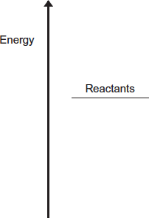
(2)

(c) Barium metal reacts very quickly with dilute hydrochloric acid, but it reacts more slowly with water.
(i) Write an equation for the reaction of barium with water.
...............................................................................................................
(1)

(ii) A solution containing barium ions can be used to show the presence of sulfate ions in an aqueous solution of sodium sulfate.
Write the simplest ionic equation for the reaction that occurs and state what is observed.
Simplest ionic equation
...............................................................................................................
Observation
...............................................................................................................
(2)

(iii) State one use of barium sulfate in medicine.
Explain why this use is possible, given that solutions containing barium ions are poisonous.
Use .......................................................................................................
...............................................................................................................
Explanation ............................................................................................
...............................................................................................................
...............................................................................................................
(2)
(Total 13 marks)

Q30.The diagram shows the Maxwell–Boltzmann distribution for a sample of gas at a fixed temperature.
E_{a} is the activation energy for the decomposition of this gas.
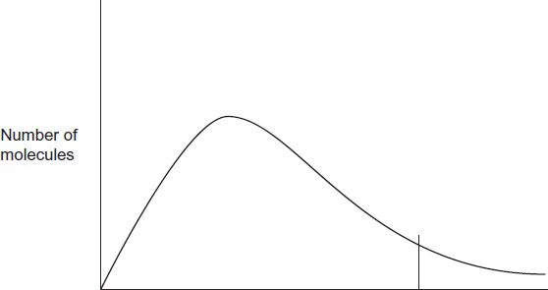
Energy Ea
E_{mp} is the most probable value for the energy of the molecules.
(a) On the appropriate axis of this diagram, mark the value of E_{mp} for this distribution.
On this diagram, sketch a new distribution for the same sample of gas at a lower temperature.
(3)

(b) With reference to the Maxwell–Boltzmann distribution, explain why a decrease in temperature decreases the rate of decomposition of this gas.
........................................................................................................................
........................................................................................................................
........................................................................................................................
........................................................................................................................
........................................................................................................................
........................................................................................................................
........................................................................................................................
........................................................................................................................
(2)
(Total 5 marks)

M1. (a) Activation energy;-
The minimum energy needed for a reaction to occur / start (1)
1

(b) Catalyst effect:-
Alternative route (or more molecules have Ea) (1)
Lower activation energy (1)
2

(c) Increase in moles of gas:-
Position of E_{mp} unchanged (1)
More molecules with E_{mp} (1)
Area under curve increases (1)
Molecules with E E_{a} increased (1)
Temperature decreased:-
Position of E_{mp} moves to the left (1)
More molecules with E_{mp} (1)
Area under curve unchanged (1)
Molecules with E E_{a} decreased (1)
Catalyst introduced:-
Position of E_{mp} unchanged (1)
Molecules with E_{mp} unchanged (1)
Area under curve unchanged (1)
Molecules with E E_{a} increased (1)
12
[15]

M2. (a) (i)
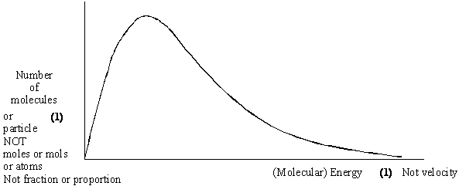

(ii) The total number of particles (or molecules) in the sample
OR the number of molecules present

(iii) No molecules have no energy
OR all molecules have some energy
Do not allow “if there are no molecules there is no energy”
4

(b) (i) The minimum energy required (1)
for a reaction to occur (1)
OR to start reaction or for a successful collision

(ii) Changes: Catalyst (1)
Explanation: Alternative route (1), with a lower activation energy (1)
OR a lower activation energy (1)
so more molecules can react (1)/more molecules have this energy
If change incorrect CE = 0
Allow answers anywhere in b (ii)
5
[9]

M3. (a) minimum energy (1)
required before a reaction can occur or go or start (1)
2

(b) speeds up (changes) reaction rate (1)
without being (chemically) changed (used up) (1)
2

(c) provides alternative reaction route (1)
with a lower activation energy (1)
in (b) and (c) reward 4 marks for 4 points wherever found
2

(d) (i)
(ii)
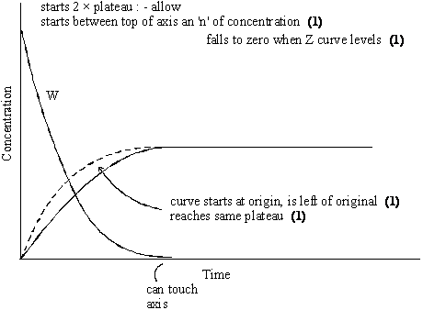

(iii) fewer collisions (1)
W used up (1)
or reactants
or reagents
or fewer particles
6
[12]

M4. (a) They are elements (1)
Ignore irrelevant comments
1

(b) Enthalpy change (1)
or heat energy change or heat change or ΔH or any named enthalpy change C.E. if change not mentioned
Independent of route (1)
OR depends on initial and final states
Only give second mark if first mark awarded except allow if energy used instead of enthalpy
2

(c) ΔH = ΣΔH_{f}(products) ‑ ΣΔH_{f}(reactants) (1) (Or a cycle)
= 2 × –242 + ½ × –394 – (–365) (1) (also implies first mark)
= -316 kJ mol^{–1} (1)
3
Ignore no units penalise wrong units
+316 scores 1/3
[6]

M5. (a) (i) (ii)
4
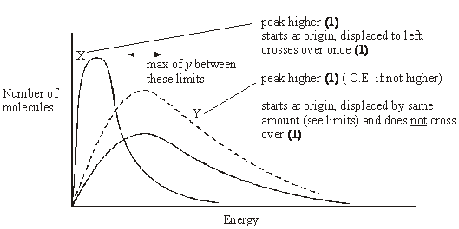

(b) (i) collide (1)
with sufficient energy (or E E_{a}) (1) (or with correct orientation)
(ii) molecules (or particles) have more energy (or move faster) (1)
more molecules (or collisions) have E ≥ E_{a} (or sufficient energy) (1)
4

(c) (i) equilibrium reached (1)
(or rate forward reaction = rate backward)
(ii) Reaction is endothermic (1)
or ΔH +ve
or reverse reaction is exothermic
endothermic reaction favoured (1)
(or reaction shifts to R
or moves forward
or more products formed)
3
[11]

M6. (a)
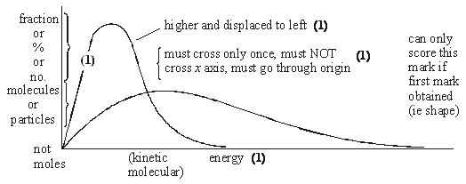
2

(b) See above
2

(c) Energy < E_{a} or must have enough energy (to react) (1)
1

(d) Increase concentration (or pressure) (1)
1

(e) Many (1) more molecules have E > E_{a} / enough energy (1)
NOT KE increases with T
2
(f) Lowers E_{a} (1)
alternative route (1)
2
[10]

M7. (a) Graph starts at origin
1
Graph skewed to left and has decreasing gradient to maximum
1
Graph after maximum decreases in steepness, never
touches x axis, levels out less than 5 mm from x axis.
1

(b) Minimum energy
1
To start a reaction (or for a reaction to occur)
1

(c) Molecules gain energy (or always some molecules have E > E_{a})
1
Due to collisions
1

(d) Decreases
1
E_{a} lowered (1)
By alternative route (1)
So more molecules have energy > E_{a} (1)
max 2
[10]

M8. (a) Gradient (or slope) (or draw a tangent)
1

(b) (i) Curve X is lower and starts at origin
1
And levels out at same volume as original curve
1
(ii) Curve Y is steeper than original and starts at origin
1
Then levels out at half the volume of the original
1

(c) (i) 2H₂O₂ → 2H₂O + O₂
1
(ii) Speeds up (alters the rate of) a chemical reaction
1
Remains unchanged (or not used up)
1
(iii) Remains unchanged (or not used up or not in the
overall reaction equation)
1
Offers alternative reaction route (or acts as an intermediate)
1
[10]

M9. (a) the minimum energy;
1
Energy required for a reaction to occur;
(or to start a reaction or for successful collisions)
1

(b) axes labelled:- y: number (or fraction or %) of molecules (or particles)
x: energy (or KE);
1
curve starts at origin;
1
skewed to right;
1
approaches x axis as an asymptote;
(penalise a curve that levels off > 10% of max peak height or a curve that crosses the energy axis)
1
second curve displaced to the left (and does not cross T₁ curve
for a second time)
1
and peak higher;
1
many fewer molecules;
1
fewer molecules have E > E_{a} ;
(can score this mark from suitably marked curves)
1

(c) molecules (or particles or collisions) do not have enough energy;
(or orientation may be wrong)
1
increase the pressure;
1
(or increase the concentration or reduce the volume)
increases the collision frequency;
(or more collisions)
(do not allow if stated to be due to increase in energy implied by temperature increase)
1
add a catalyst;
1
lowers activation energy (or E_{a}) (Q of L mark);
1
[15]

M10. (a) minimum energy
1
to start a reaction/ for a reaction to occur/ for a successful collision
1
(b) activation energy is high / few molecules/particles have sufficient
energy to react/few molecules/particles have the required
activation energy
(or breaking bonds needs much energy)
1

(c) molecules are closer together/ more particles in a given volume
1
therefore collide more often
1
(d) many
1
more molecules have energy greater than activation energy (QoL)
1

(e) speeds up a reaction but is chemically unchanged at the end
1
(f) increases the surface area
1
[9]

M11. (a) (i) Z (1)
1
(ii) Collisions (1)
Cause some molecules to slow down or lose energy (1)
2
(b) Curve starts at origin and is displaced to the right (1)
Curve lower and does not touch energy axis (1)
2

(c) (i) Only a small percentage/very few collisions have E >E_{a} (1)
1
(ii) Add a catalyst (1)
Lowers E_{a} (1)
More collisions/molecules have energy > E_{a} (1)
3
[9]

M12. (a) (i) 2
1
(ii) 0
1

(b) (i) rate/[NO₂]²[O₂]
1
13
1
mol dm^{–3}
1

(ii) 1.9 × 10^{–3}
1
(iii) Step 2
1
[7]

M13. (a) Peak lower
1
and moved to right
1
start at the origin and curve crosses once only
1

(b) (i) (Rate of reaction) increases
1
(At a higher temperature) more molecules/particles
1
have the minimum energy needed to react/have activation
energy/have successful collisions
Mark CE if incorrect effect given
1

(ii) (Rate of reaction) increases 1
lowers activation energy 1
so that more molecules are able to react 1
Mark CE if incorrect effect given
[9]

M14. (a) Sulfur OR S OR S₈
Sulphur
1

(b) M1 The activation energy is the minimum / least / lowest
Mark these independently
1
M2 Energy for a reaction to occur / to go / to start
OR
Energy for a successful / effective collision
1

(c) Explanation:
M1 Twice as many / double number of particles
M1 NOT molecules
1
M2 More / twice / double (effective) collisions (in a given time)
OR
Double / greater / increased collision frequency
1

(d) (i) (Measured) change in concentration (of a substance) in unit time
/ given time
May be written mathematically
OR the gradient of the concentration (against) time
1

(ii) The measured change / amount (of precipitate) / cloudiness is
fixed or constant or unchanged
1
[7]

M15. (a) M1 The yield of zinc oxide increases/greater
If M1 is given as “decrease” OR “no effect” then CE= 0
M2 Removal of the carbon dioxide results in the equilibrium
Either
Shifting/moving/goes to the right
shifting/moving/goes L to R
favours the forward reaction/towards the products
M3 (By Le Chatelier’s principle) the reaction/equilibrium will
respond so as to replace the CO₂/lost product
OR to make more CO₂
OR to increase concentration of CO₂
For M3, not simply “to oppose the change/to oppose the loss of CO₂/to oppose the removal of carbon dioxide.”
3

(b) M1 Process 2 produces/releases SO₂
OR Process 2 produces/releases CO
M2 It/Process 3 avoids the release of SO₂ OR CO
OR It/Process 3 (captures and) converts SO₂ to H₂SO₄
M3 SO₂ causes acid rain OR is toxic/poisonous
OR CO is toxic/poisonous
3
Ignore “global warming” and “greenhouse gases” and “the ozone layer”
If both CO and SO₂ claimed to form acid rain, treat as contradiction

(c) M1 Process 3 (is expensive because it) uses electrolysis
OR due to high electricity/electrical consumption
M2 this is justified because the product/zinc is pure
Ignore “energy”
Penalise “purer”
2

(d) M1 Zn²⁺ + 2e– Zn
Ignore state symbols
M2 the negative electrode OR the cathode
Ignore absence of negative charge on electron
Accept electrons subtracted from RHS
2

(e) M1 The reaction of ZnO with sulfuric acid
OR the second reaction in Extraction process 3
M2 neutralisation or acid-base
OR alternatively
M1 The reaction of zinc carbonate in Extraction process 1
M1 could be the equation written out in both cases
M2 (thermal) decomposition
M2 depends on correct M1
M3 It/carbon is oxidised/gains oxygen/changes oxidation state/number
from 0 to +2/increase in oxidation state/number in Process 2
Do not forget to award this mark
Ignore reference to electron loss but penalise electron gain
Ignore “carbon is a reducing agent”
3

(f) M1 Zn + H₂O ZnO + H₂
M2 Zinc oxide and hydrogen
OR as an alternative
M1 Zn + 2H₂O Zn(OH)₂ + H₂
M2 Zinc hydroxide and hydrogen
Mark independently
If ZnO₂ is given for zinc oxide in the equation, penalise M1 and mark on
If ZnOH is given for zinc hydroxide in the equation, penalise M1 and mark on
Ignore state symbols
Credit multiples of the equation
If M1 is blank, either of the M2 answers could score
To gain both marks, the names must match the correct equation given.
2
[15]

M16. (a) The molecular ion is
• The molecule with one/an electron knocked off/lost
Ignore the highest or biggest m/z peak
OR
• The molecule with a (single) positive charge
OR
• the ion with/it has the largest/highest/biggest m/z (value/ratio)
Ignore “the peak to the right”
OR
• the ion with/it has an m/z equal to the M_{r}
Ignore “compound”
1

(b) (i) 2(14.00307) + 15.99491 = 44.00105
A sum is needed to show this
1

(ii) Propane/C₃H₈ and carbon dioxide/CO₂ (and N₂O) or
they or both the gases/molecules or all three gases/molecules
have an (imprecise) M_{r} of 44.0 (OR 44)
OR
they have the same M_{r} or molecular mass (to one d.p)
This could be shown in a calculation of relative masses for propane and carbon dioxide
1

(iii) By definition
OR
The standard/reference (value/isotope)
Ignore “element”
Ignore “atom”
1

(c) (i) M1 (could be scored by a correct mathematical expression)
ΔH = ΣΔH_{products} – ΣΔH_{reactants}
OR a correct cycle of balanced equations
M1 and M2 can be scored with correct moles as follows
ΔH + 2(– 46) = +82 + 3(– 286)
ΔH – 92 = – 776
ΔH = 92 – 776 OR 92 + 82 – 858
M3
ΔH = – 684 (kJ mol^{–1}) (This is worth 3 marks)
Award 1 mark ONLY for + 684
Full marks for correct answer.
Ignore units.
Deduct one mark for an arithmetic error.
3

(ii) The value is quoted at a pressure of 100 kPa OR 1 bar or 10⁵ Pa
OR
All reactants and products are in their standard states/their normal
states at 100 kPa or 1 bar
Ignore 1 atmosphere/101 kPa
Ignore “constant pressure”
1
[8]

M17. (a) (i) M1 drawn curve starts at reactants and ends at products
Tapered lines into the original curve gain credit for M1
M2 curve peak is below the one drawn in the question
(and may show one/two humps)
Mark M1 and M2 independently
2

(ii) Exothermic (reaction)
Ignore “ΔH is negative”
1

(iii) Σ bond (enthalpy) reactants < Σ bond (enthalpy) products
The sum for H₂ and I₂/reactants is less than/lower than/smaller than
the sum for 2HI/products
OR
The sum for 2HI/products is more than/larger than/bigger than the
sum for H₂ and I₂/reactants
Accept “It OR the sum will be smaller or less”
1

(iv) M1 p
2
M2 – (q – p)
OR
p – q
OR
– q + p
M2 demands that the sign for an exothermic reaction is part of the outcome mathematically.
Ignore case

(b) (i) Increase/speed up/faster (rate of attainment of equilibrium)
OR
Increase/speed up/faster rate of both forward and reverse reaction
OR
Increase/speed up/faster rate of reaction
Credit “It took less time”
1

(ii) M1 Increase/speed up/faster (rate of attainment of equilibrium)
M2 More particles/molecules in a given volume/space
OR the particles/molecules are closer together
OR an increase in concentration.
M3 More/higher chance of successful/effective/productive
collisions (between particles)
OR more collisions/higher chance of collisions (of particles)
with E>E_{Act}
If M1 is blank, mark on and credit M1 in the text
If M1 is given as “decrease”/“no effect”/”no change” then CE = 0 for clip
In M1, if increase both the forward and reverse reaction, but no mention of rate, penalise M1 but mark on.
In M1, if increase either forward rate or reverse rate only, then penalise M1 but mark on.
Penalise M3 if an increase in the value of E_{Act}/energy of particles is stated.
Max 1 for M2 and M3 if reference to “atoms”
3
[10]

M18. (a) (i) M1 The peak of the new curve is displaced to the right.
M2 All of the following are required
• The new curve starts at the origin
• The peak of the new curve is lower than the original
• and the new curve only crosses the original curve once
• and an attempt has been made to draw the new curve
correctly towards the energy axis but not to touch the
original curve
• the new curve must not start to diverge from the original curve
M1 is low demand
M2 is higher demand.
2

(ii) M1 Increase in the number/proportion of molecules with E ≥ E_{a}
OR more molecules have E ≥ E_{a}
OR more molecules have sufficient energy to react
M2 More effective/productive/successful collisions
Ignore “molecules have more energy”
Ignore “more energetic collisions”
Ignore “molecules gain activation energy”
Ignore “more collisions”
Accept “particles” for “molecules” but NOT “atoms”
Ignore “chance of collision”; this alone does not gain M2
2

(b) (i) Iron OR Fe
1

(ii) M1 Catalysts provide an alternative route/pathway/mechanism
OR
(in this case) surface adsorption/surface reaction occurs.
For M1, not simply “provides a surface” alone
M2 that has a lower activation energy
OR
lowers the activation energy
For M2, the candidate may use a definition of activation energy without referring to the term
2
[7]

M19. (a) (i) 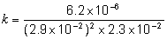
mark is for insertion of numbers into a correctly
rearranged rate equ, k = etc
AE (-1) for copying numbers wrongly or swapping two numbers
1
= 0.32 (min 2sfs)
1
mol^{–2} dm6 s^{–1} Units must be conseq to their k
Any order
If k calculation wrong, allow units conseq to their k
1

(ii) 4.95 × 10^{–5} to 4.97 × 10^{–5} or 5.0 × 10^{–5} (min 2 sfs)
(ignore units)
rate = their k × 1.547 × 10^{–4}
1

(b) Step 2
If wrong no further mark
1
One H₂ (and two NO) (appear in rate equation)
or species (in step 2) in ratio/proportion as in the rate equation
1
[6]

M20. (a) One from
• Ti is not produced
• TiC / carbide is produced OR titanium reacts with carbon
• Product is brittle
• Product is a poor engineering material
Penalise “titanium carbonate”
Ignore “impure titanium”
Credit “titanium is brittle”
1

(b) Heat (energy) change at constant pressure
QoL
1
(c) The enthalpy change in a reaction is independent of
the route taken (and depends only on the initial and final states)
Credit “heat change at constant pressure” as an alternative to “enthalpy change”
1

(d) M1 The enthalpy change / heat change at constant pressure
when 1 mol of a compound / substance / product
For M1, credit correct reference to molecule/s or atom/s
M2 is formed from its (constituent) elements
M3 with all reactants and products / all substances in
standard states
OR all reactants and products / all substances in normal
states under standard conditions / 100 kPa / 1 bar and any
specified T (usually 298 K)
Ignore reference to 1 atmosphere
3

(e) (i) Na / it is not in its standard state / normal state under
standard conditions
OR
Standard state / normal state under standard conditions
for Na is solid / (s)
QoL
Ignore “sodium is a liquid or sodium is not a solid”
1

(ii) M1 ∆H_{r} = ∑∆H_{f} (products) - ∑∆H_{f} (reactants)
M2 ∆H_{r} = 4(−411) − (−720) − 4(+3) = −1644 + 720 − 12 (This also scores M1)
M3 = −936 (kJ mol⁻¹)
Correct answer gains full marks
Credit 1 mark for + 936 (kJ mol⁻¹)
Credit 1 mark for – 924 (kJ mol⁻¹)i.e. assuming value for Na(l) = 0
For other incorrect or incomplete answers, proceed as follows
• check for an arithmetic error (AE), which is either a transposition error or an incorrect multiplication; this would score 2 marks (M1 and M2)
• If no AE, check for a correct method; this requires either a correct cycle with 2Cl₂ and 4Na OR a clear complete statement of M1 which could be in words and scores only M1
3

(iii) Reducing agent
Ignore “reduces titanium”
OR reductant OR reduces TiCl₄
OR electron donor
1
[7]

M21. (a) M1 The activation energy is the minimum / least / lowest energy
Mark independently
Ignore “heat” and ignore “enthalpy”
M2 (energy) for a reaction to occur / to go / to start
OR (energy) for a successful / effective collision
Ignore “breaking the bonds”
2

(b) M1 Catalysts provide an alternative route OR an
alternative mechanism OR alternative / different path(way)
M2 Lowers the activation energy
Mark independently
Ignore reference to “surface”
2

(c) (i) Stay(s) the same
1
(ii) Increases
Credit “increase” or “increased”
1
(iii) Increases
Credit “increase” or “increased”
1
(iv) Stay(s) the same
1

(d) (i) M1 yeast or zymase
M2 ethanol
Ignore “enzyme”
In M2, ignore “alcohol” and ignore any formula
2

(ii) M1 (Concentrated) H₃PO₄ OR (Concentrated) H₂SO₄
M2 butan-2-ol
Credit correct names
Ignore “hydrogenphosphate or hydrogensulfate”
Ignore “dilute” or “aq”
Do not penalise absence of hyphens in name.
In M2, ignore any formula
2
[12]

M22.(a) (i) Mol SO₃ = 5.2
1

Mol SO₂ = 2.8
1

(ii) 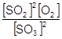
Penalise expression containing numbers or V
Allow ( ) but must have all brackets. If brackets missing but otherwise correct, penalise here but mark on
Ignore subsequent correct working
If Kc wrong (wrong powers or upside down etc) can only score M1 in (a)(iv)
1

(iii) mol dm^{–3}
Allow conseq to their wrong Kc
1

(iv)If Kc wrong in (a)(iv) (wrong powers or upside down etc) can only score M1
Values from (a)(i)
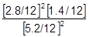 or 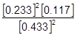
Alternative values
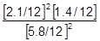
1
M1 For dividing all three by volume – if volume missed or used wrongly, lose M1 & M2 but can score M3 conseq
M2 insertion of values (allow conseq use of their wrong values from (a)(i))
AE (–1) for copying numbers wrongly or swapping two numbers
1

Values from (a)(i)
M3 = 0.0338 or 0.034
(allow 0.03376 to 0.035)
Min 2 sfs
Ignore units in (a)(iv)
If vol missed score only M3
Values from (a)(i)
0.406 - allow values between 0.40 (if correctly rounded) and 0.41
Alternative values
M3 0.0153 or 0.015
(allow 0.015 to 0.017)
Min 2 sfs
Ignore units in (a)(iv)
from alternative values allow 0.18 to 0.184
1

(b) (i) Increase or more moles (of oxygen) or higher
1

(ii) No change or no effect or none or (remains) same
1

(c) M1 T₁
If T₂ CE = 0
1
M2 (At Temp,T2, when Kc is lower) Equm/reaction moves to left or
towards reagent or towards SO₃ OR moles SO₃ increases
1

M3 This reverse reaction is exothermic,
OR
M3 (forward) reaction is endothermic
M2 if Temp is increased Equm/reaction moves to right or towards product
or towards SO₂ OR moles SO₂ increases
OR
M3 (forward) reaction is endothermic
M2 if Temp is decreased Equm/reaction moves to left or towards reagent
or towards SO₃ OR moles SO₃ increases
1
[12]

M23.(a) Exp 2 14.(4) ×10^{–3} OR 1.4(4) ×10^{–2} or 0.014
Allow 2sf
1

Exp 3 0.1(0)
1

Exp 4 0.3(0)
If three wrong answers, check their value of k in 1(b).
They can score all 3 if they have used their (incorrect) value of k. see below.
Exp 2 rate = 0.096 × k
Exp 3 [Q] = 0.015/k
Exp 4 [P] = 0.116/√k
1

(b) 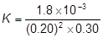
mark is for insertion of numbers into a correctly rearranged rate equ , k = etc
1

= 0.15 (min 2sfs) (allow )
if upside down, score only units mark
AE (–1) for copying numbers wrongly or swapping two numbers
1

mol^{–2} dm⁺⁶ s^{–1}
Any order
If k calculation wrong, allow units conseq to their k
1

(c) G
1
[7]

M24.(a) Number / proportion / percentage / fraction of molecules
Ignore “particles”
1

(b) None OR no effect OR no change
1

(c) X
1

(d) Answers in either order
M1 collision OR collide
Mark independently
M2 collision / molecules / particles
Ignore “correct” amount of energy
with the activation energy
OR with E > E_{act}
OR with sufficient /enough energy
OR with the minimum energy
OR with the correct orientation
2

(e) A small increase in temperature results in many more / much higher proportion of
/ a lot more / significantly more molecules / particles / collisions with E ≥ E_{act} / energy greater than the activation energy / sufficient energy / enough energy / minimum
energy to react
(compared with a small increase in concentration)
Not just “more molecules with E ≥ E_{act}”
The answer must convey that the increase is significant
Accept reference to “atoms”, “molecules”, “particles”
Ignore “species”
1
[6]

M25.(a) Exp 2 4.5 ×10^{–4}
Min 2sf
1

Exp 3 4.5 ×10^{–3}
If three wrong answers, check their value of k in (b).
1

Exp 4 0.043 OR 4.3 ×10^{–2} OR 0.044 OR 4.4 ×10^{–2}
They can score all 3 if they have used their (incorrect) value of k. see below.
Exp 2 rate = k × (1.0125 × 10^{–4})
Exp 3 [Q] = 0.02/k
Exp 4 [P] = 0.0913/√k
1

(b) 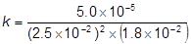
Mark is for insertion of numbers into a correctly rearranged rate equ , k = etc
If upside down, score only units mark from their k
AE (-1) for copying numbers wrongly or swapping two numbers
1

= 4.4(4) (allow 40/9)
1

mol^{–2}dm⁺⁶s^{–1}
Any order
If k calculation wrong, allow units conseq to their k expression
1
[6]

M26. (a) 2Ca₅F(PO₄)₃+ 9SiO₂ +15C9CaSiO₃ + CaF₂ +15CO + 6P
1

(b) M1 (P₄ =) 0
M2 (H₃PO₄ =) (+) 5
Accept Roman numeral V for M2
2

(c) H₂SO₄
Both numbers required
M_{r} = 2(1.00794) + 32.06550 + 4(15.99491)
= 98.06102 or 98.0610 or 98.061 or 98.06 or 98.1
Calculations not required
and
H₃PO₄
M_{r} = 3(1.00794) + 30.97376 + 4(15.99491)
= 97.97722 or 97.9772 or 97.977 or 97.98 or 98.0
1

(d) (i) A substance that speeds up a reaction OR alters / increases the rate of a
reaction AND is chemically unchanged at the end / not used up.
Both ideas needed
Ignore reference to activation energy or alternative route.
1

(ii) The addition of water (QoL ) to a molecule / compound
QoL- for the underlined words
1

(iii) M1 CH₃CH=CH₂ + H₂O CH₃CH(OH)CH₃
(C₃H₆)
For M1 insist on correct structure for the alcohol but credit correct equations using either C₃H₆ or double bond not given.
M2 propan-2-ol
2
[8]

M27. (a) Award in either order for curve
“Steeper” requires line to be on the left of the original line, starting from the origin
M1 curve is steeper than original and starts at the origin
M2 curve levels at the top line on the graph
2

(b) Award in either order for curve
“Shallower” requires line to be on the right of the original line, starting from the origin
M1 curve is shallower than original and starts at the origin
M2 curve levels at the first line on the graph
2

(c) M1 curve would be steeper than original
“Steeper” requires line to be on the left of the original line, starting from the origin
M2 curve levels at the same original volume of O₂
2

(d) M1 The (concentration / amount of) H₂O₂ or reactant falls / decreases / used up
Mark independently
OR
The number of H₂O₂ or reactant molecules/ particles falls / decreases
M2
The rate of reaction / rate of decomposition / rate of formation of oxygen /
frequency of collisions / (effective) collisions in a given time decreases / is
slower
2

(e) (i) 2H₂O₂ → 2H₂O + O₂
Ignore state symbols
Accept only this equation or its multiples
Extra species must be crossed through
1

(ii) hydrogen bromide / it does not appear in the overall equation
OR
hydrogen bromide / it is not used up in the reaction / unchanged at the end of
the reaction
OR
hydrogen bromide / it is regenerated / re-formed (in Step 2)
1
[10]

M28.(a) (If any factor is changed which affects an equilibrium), the (position of) equilibrium will shift / move so as to oppose / counteract the change.
Must refer to equilibrium
Ignore reference to “system” alone
A variety of wording will be seen here and the key part is the last phrase
OR
(When a system / reaction in equilibrium is disturbed), the (position of) equilibrium shifts / moves in a direction which tends to reduce the disturbance
An alternative to shift / move would be the idea of changing / altering the position of equilibrium
1

(b) (i) M1
A substance that speeds up the reaction / alters the rate but is chemically unchanged at the end / not used up
Both ideas needed for M1
Credit can score for M1, M2 and M3 from anywhere within the answer
M2
Catalysts provide an alternative route / alternative pathway / different mechanism
M3
that has a lower activation energy / E_{a}
OR
lowers the activation energy / E_{a}
3

(ii) (Time is) less / shorter / decreases / reduces
Credit “faster”, “speeds up”, “quicker” or words to this effect
1

(iii) None
1

(c) (i) R
1

(ii) T
1

(iii) R
1

(iv) P
1

(v) Q
1
[11]

M29.(a) (i) Change in concentration (of a substance / reactant / product) in unit time / given time / per (specified) unit of time
This may be written mathematically OR may refer to the gradient of a graph of concentration / volume against time
OR
Amount of substance formed / used up in unit time / given time / per (specified) unit of time
Ignore additional information including reference to collisions
1

(ii) At W
M1 (QoL)
The rate / it is zero
M2
The magnesium has all reacted / has been used up
Ignore reference to the acid being used up
OR
No more collisions possible between acid and Mg
OR
Reaction is complete / it has stopped
OR
No more hydrogen / product is produced
2

(iii) M1
Twice / double as many particles / hydrogen ions (in a given volume)
Penalise reference to (hydrochloric acid) molecules in M1
Penalise reference to “HCl particles” in M1
OR
Twice / double as much hydrochloric acid
M2
Twice / double as many effective / successful collisions (in a given time)
OR
Twice / double as many collisions with either sufficient energy to react OR with E ≥ E_{a}
OR
double the successful / effective collision frequency
2

(b) (i) The activation energy is the minimum energy for a reaction to go / start
OR
Minimum energy for a successful/ effective collision
1

(ii) M1 Products lower than reactants on the profile
Mark independently
M2 Activation energy (E_{a}) shown and labelled correctly from reactants to peak of curve
Mark independently
2

(c) (i) Ba + 2H₂O Ba(OH)₂ + H₂
Ba + 2H₂O Ba²⁺ + 2OH⁻ + H₂
Allow multiples
Ignore state symbols
1

(ii) M1 Ba²⁺ + SO₄²⁻ BaSO₄
Ignore state symbols in M1
Not multiples in M1
M2 White precipitate / solid
Extra ions must be cancelled
Penalise contradictory observations in M2
2

(iii) M1 Barium meal / barium swallow / barium enema
Accept a correct reference to M1 written in the explanation in M2, unless contradictory
OR used in X-rays OR to block X-rays OR X-ray contrast medium OR CT scans
M2 BaSO₄ / barium sulfate is insoluble (and therefore not toxic)
For M2 NOT barium ions
NOT barium
NOT barium meal and NOT “It”
Ignore radio-tracing
2
[13]

M30.(a) M1 On the energy axis E_{mp} at the maximum of the original peak
M1 The limits for the horizontal position of E_{mp} are defined as above the word “the” in the sentence below the graph.
M2 The peak of their new curve is displaced to the left and higher than the original.
M3 All of the following are required
• The new curve starts at the origin and should begin to separate from the original almost immediately
• and the new curve crosses the original curve once
• and an attempt has been made to draw the new curve correctly towards the energy axis below the original curve but not to touch the original curve or the axis
3

(b) The rate of reaction decreases as the temperature decreases because
M1 A decrease in the number / proportion of molecules with E ≥ E_{a}
OR fewer molecules have E ≥ E_{a}
OR fewer molecules have sufficient / enough energy to react / decompose
In M1
Ignore “molecules have less energy”.
Ignore “less energetic collisions”.
Ignore “molecules do not gain activation energy”.
Ignore “fewer collisions”.
Credit “particles” for “molecules” but NOT “atoms”.
M2 Fewer effective / productive / successful collisions in a given time / given period
OR fewer frequent effective / productive / successful collisions
OR lower rate of effective / productive / successful collisions
Ignore “chance of collision”; this alone does not gain M2
2
[5]

