ALEC REED ACADEMY
Mastery Booklet (Biology)
(Paper 1)
Name : ______________________
Teacher : ____________________
Date Given : __________________
These booklets are a consolidation of your learning. They should be used in the following way – You should attempt the questions WITHOUT looking at the answers. Then mark your questions with Green pen and add any missing marks you missed.
THIS WILL IMPROVE YOUR GRADES…!!

Year 11 GCSE Intervention Support 2019-20
These are your science exam dates for your
Paper 1
Biology 1…. …12th May 2020
Chemistry 1….. 14th May 2020
Physics 1…… 20th May 2020
These are your science exams for your
Paper 2
Biology2 1stJune 2020
Chemistry 2 10th June 2020
Physics 2 12th June 2020

IMPORTANT: This is not instead of revision at home. You should still do your own revision. This is just to help you with the toughest parts.
We know you have a lot to revise for and preparing for your exams can be stressful so here is a tool to help you.

STEP 1: You have finished your (B1, C1, and P1) year 9-11 learning so you can target all the areas you want support with.
HOW TO USE THIS BOOKLET
You know best. What your strengths and target areas are so please can you pick the topics you want most help with.
Tips:

Revision Tips
1. Plan to revise. Don’t sit down without knowing what to do, it feels awful.
Try this…. “Right I am going to do 30 minutes on radioactivity. I will list 10 key facts, one idea I find tough and try 1 past paper question.”
So plan your tasks and topics. It really helps. Ask for help with making a revision plan.
2. Avoid distractions. Revise with a friend so you don’t think about what they are doing. Avoid revising when really tired or hungry.
3. Reward yourself. “If I do an hour or two this morning then I can go out this afternoon”.
4. Make stuff. Put up posters, make flash cards or revision cards. Post-it your room with key ideas. Keep what you’ve made to help you realise you are working well.
5. Practice past paper questions. You have been provided with a free book of these and they are one of the best things you can do. Remember to B.U.G. (Box the keyword, Underline important info, Go through it twice).

Revision tools
1. Use Sam Learning. The centre code is TA6CT1 https://www.samlearning.com/ Use your revision guide to help with the tasks/tests.
2. Don’t just read your revision guide. Make lists of keywords then test yourself to see if you can describe the keywords. Practice drawing key diagrams from memory. Use the question pages in the revision guides.
3. Google “AQA Science A past papers” for year 10 topics. Google “AQA science past papers” for year 11 stuff. Lots to choose from.
4. GCSE Bitesize has recently been given a makeover and now has lots of helpful videos linked to the tests and tasks.
5. Check out www.getrevising.co.uk. Free revision planner tool and many free resources. For a small monthly fee you can download other people’s revision materials for AQA science.
6. Phone apps. App store search cgp revision guides, they are fairly cheap if you want an on the go revision guide.
7. YOUTUBE The “mygcse science” youtube channel has really lovely walkthrough commentaries with pictures for all your B/C/P topics. Have a look.

Q1. Living organisms are made of cells.
(a) Animal and plant cells have several parts. Each part has a different function.
Draw one line from each cell part to the correct function of that part.
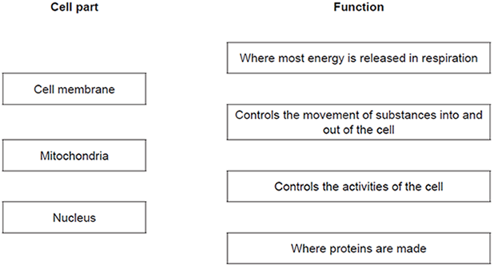
(3)
(b) The diagram below shows a cell from a plant leaf.
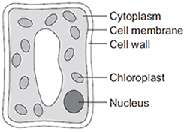
Which two parts in the diagram above are not found in an animal cell?
1. _________________________________________________________________
2. _________________________________________________________________
(2)
(Total 5 marks)

Q2.The diagrams show four types of cell, A, B, C and D.Two of the cells are plant cells and two are animal cells.
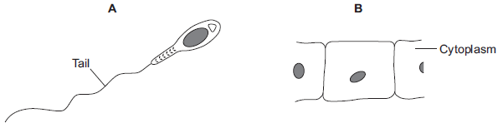
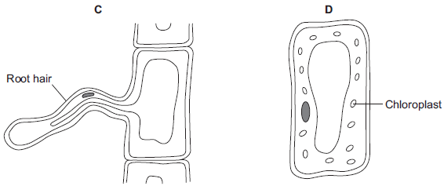
(a) (i) Which two of the cells are plant cells? Tick () one box.

A and B
A and D
C and D
(1)
(ii) Give one reason for your answer.
_____________________________________________________________
_____________________________________________________________
(1)
(b) (i) Which cell, A, B, C or D, is adapted for swimming?
(1)
(ii) Which cell, A, B, C or D, can produce glucose by photosynthesis?
(1)
(c) Cells A, B, C and D all use oxygen. For what process do cells use oxygen?
Draw a ring around one answer.

osmosis | photosynthesis | respiration
(1)
(Total 5 marks)
Q3. The digestive system breaks down food into small molecules. The small molecules can be absorbed into the blood. The diagram below shows the human digestive system.
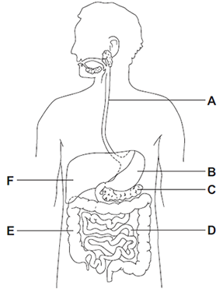
(a) (i) Which letter, A, B, C, D, E or F, shows each of the following organs?

Write one letter in each box.
large intestine
small intestine
stomach
(3)
(ii) Different organs in the digestive system have different functions.
Draw one line from each function to the organ with that function.
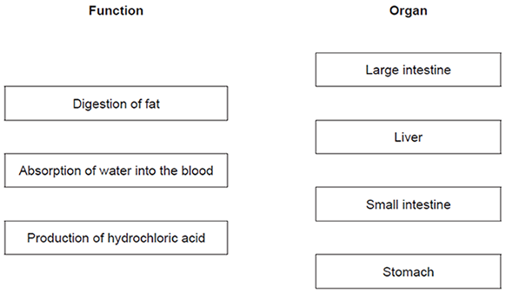
(3)

(b) Glucose is absorbed into the blood in the small intestine. Most of the glucose is absorbed by diffusion. How does the glucose concentration in the blood compare to the glucose concentration in the small intestine?

Tick (✔) one box.
The concentration in the blood is higher.
The concentration in the blood is lower.
The concentration in the blood is the same.
(1)
(Total 7 marks)
Q4. The image below shows some muscle cells from the wall of the stomach, as seen through a light microscope.
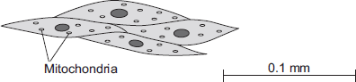
(a) Describe the function of muscle cells in the wall of the stomach.
_________________________________________________________________
_________________________________________________________________
_________________________________________________________________
(2)
(b) Figure above is highly magnified. The scale bar in Figure above represents 0.1 mm.
Use a ruler to measure the length of the scale bar and then calculate the magnification of Figure above.
_________________________________________________________________
_________________________________________________________________
_________________________________________________________________
Magnification = _______________ times
(2)
(c) The muscle cells in Figure above contain many mitochondria. What is the function of mitochondria?
_________________________________________________________________
_________________________________________________________________
_________________________________________________________________
(2)
(d) The ribosomes cannot be seen in Figure above.
(i) What is the function of a ribosome?
_____________________________________________________________
_____________________________________________________________
(1)
(ii) Suggest why the ribosomes cannot be seen through a light microscope.
_____________________________________________________________
_____________________________________________________________
(1)
(Total 8 marks)
Q5. (a) The diagram shows four ways in which molecules may move into and out of a cell. The dots show the concentration of molecules.
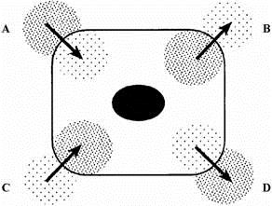
The cell is respiring aerobically.
Which arrow, A, B, C or D, represents:
(i) movement of oxygen molecules; __________
(ii) movement of carbon dioxide molecules? __________
(2)
(b) Name the process by which these gases move into and out of the cell.
_________________________________________________________________
(1)
(c) Which arrow, A, B, C or D, represents the active uptake of sugar molecules by the cell?
_________________________________________________________________
Explain the reason for your answer.
_________________________________________________________________
_________________________________________________________________
_________________________________________________________________
(2)
(Total 5 marks)
Q6. Explain how the human circulatory system is adapted to:
• supply oxygen to the tissues
• remove waste products from tissues.
_____________________________________________________________________
_____________________________________________________________________
_____________________________________________________________________
_____________________________________________________________________
_____________________________________________________________________
_____________________________________________________________________
_____________________________________________________________________
_____________________________________________________________________
_____________________________________________________________________
_____________________________________________________________________
_____________________________________________________________________
_____________________________________________________________________
_____________________________________________________________________
(Total 6 marks)
Q7. A student investigated the effect of different sugar solutions on potato tissue.This is the method used.
1. Add 30 cm³ of 0.8 mol dm⁻³ sugar solution to a boiling tube.
2. Repeat step 1 with equal volumes of 0.6, 0.4 and 0.2 mol dm⁻³ sugar solutions.
3. Use water to give a concentration of 0.0 mol dm⁻³.
4. Cut five cylinders of potato of equal size using a cork borer.
5. Weigh each potato cylinder and place one in each tube.
6. Remove the potato cylinders from the solutions after 24 hours.
7. Dry each potato cylinder with a paper towel.
8. Reweigh the potato cylinders.
The table below shows the results.

Concentration of sugar solution in mol dm⁻³ | Starting  mass in g | Final mass  in g | Change of  mass in g | Percentage  (%) change
0.0 | 1.30 | 1.51 | 0.21 | 16.2
0.2 | 1.35 | 1.50 | 0.15 | X
0.4 | 1.30 | 1.35 | 0.05 | 3.8
0.6 | 1.34 | 1.28 | −0.06 | −4.5
0.8 | 1.22 | 1.11 | −0.11 | −9.0
(a) Calculate the value of X in the table above.
_________________________________________________________________
_________________________________________________________________
Percentage change in mass = _____________________ %
(2)
(b) Why did the student calculate the percentage change in mass as well as the change in grams?
_________________________________________________________________
_________________________________________________________________
(1)
(c) Complete the graph using data from the table above.
• Choose a suitable scale and label for the x-axis.
• Plot the percentage (%) change in mass.
• Draw a line of best fit.
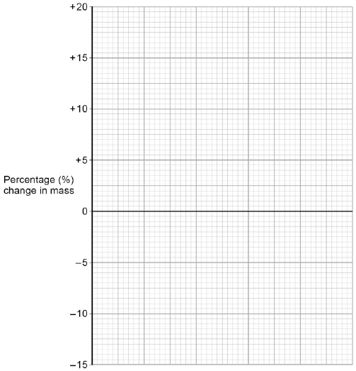
(4)
(d) Use your graph to estimate the concentration of the solution inside the potato cells.
Concentration = ________________________ mol dm⁻³
(1)
(e) The results in the table above show the percentage change in mass of the potato cylinders. Explain why the percentage change results are positive and negative.
_________________________________________________________________
_________________________________________________________________
_________________________________________________________________
_________________________________________________________________
(3)
(f) Suggest two possible sources of error in the method given above.
1. _________________________________________________________________
_________________________________________________________________
2. _________________________________________________________________
_________________________________________________________________
(2)
(Total 13 marks)
Q8. The diagram below shows a cross-section of a plant root. The transport tissues are labelled.
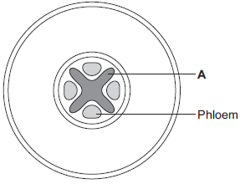
(a) (i) What is tissue A? Draw a ring around the correct answer.
cuticle epidermis xylem
(1)
(ii) Name two substances transported by tissue A.
1. ____________________________________________________________
2. ____________________________________________________________
(2)
(b) Phloem is involved in a process called translocation.
(i) What is translocation?
_____________________________________________________________
_____________________________________________________________
_____________________________________________________________
(1)
(ii) Explain why translocation is important to plants.
_____________________________________________________________
_____________________________________________________________
_____________________________________________________________
_____________________________________________________________
(2)
(c) Plants must use active transport to move some substances from the soil into root hair cells.
(i) Active transport needs energy.
Which part of the cell releases most of this energy?
Tick (✓) one box.

mitochondria
nucleus
ribosome
(1)
(ii) Explain why active transport is necessary in root hair cells.
_____________________________________________________________
_____________________________________________________________
_____________________________________________________________
(2)
(Total 9 marks)
Q9. In this question you will be assessed on using good English, organising information clearly and using specialist terms where appropriate.
Diffusion is an important process in animals and plants. The movement of many substances into and out of cells occurs by diffusion. Describe why diffusion is important to animals and plants. In your answer you should refer to:
• animals
• plants
• examples of the diffusion of named substances.
_____________________________________________________________________
_____________________________________________________________________
_____________________________________________________________________
_____________________________________________________________________
_____________________________________________________________________
_____________________________________________________________________
_____________________________________________________________________
_____________________________________________________________________
_____________________________________________________________________
_____________________________________________________________________
_____________________________________________________________________
(Total 6 marks)
Q1. Figure 1 shows a diagram of the human heart.
Figure 1
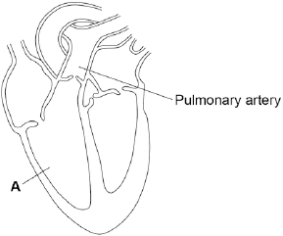
(a) What part of the heart is labelled A?

Tick one box.
Aorta
Atrium
Valve
Ventricle
(1)
(b) Where does the pulmonary artery take blood to?

Tick one box.
Brain
Liver
Lungs
Stomach
(1)
(c) Circle a valve on Figure 1.
(1)
(d) The coronary arteries supply blood to the heart.
Figure 2 shows two coronary arteries.

Figure 2
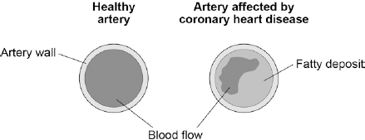
Describe two ways the healthy artery is different from the artery affected by coronary heart disease.
1. _________________________________________________________________
_________________________________________________________________
2. _________________________________________________________________
_________________________________________________________________
(2)
(e) What can be used to treat people with coronary heart disease?

Tick two boxes.
Antibiotics
Hormones
Statins
Stent
Vaccination
(2)
(f) Suggest two risk factors for coronary heart disease.
1. _________________________________________________________________
_________________________________________________________________
2. _________________________________________________________________
_________________________________________________________________
(2)
(g) Figure 3 shows the percentages of adults in the UK who have coronary heart disease.

Figure 3
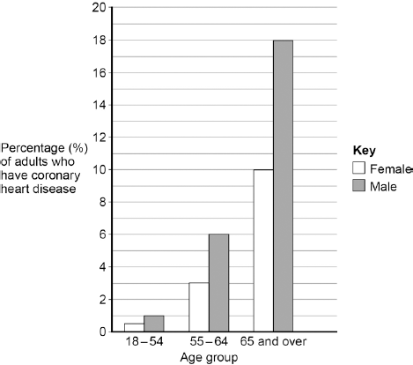
Calculate the difference in the percentage of male and female adults aged 65 and over who have coronary heart disease.
__________________________ %
(1)
(h) Which is the correct conclusion for the data in Figure 3?

Tick one box.
Children do not suffer from coronary heart disease
More males suffer from coronary heart disease than females
More younger people suffer from coronary heart disease than older people
(1)
(Total 11 marks)

Q2. Plants need different substances to survive. Figure 1 shows the roots of a plant.
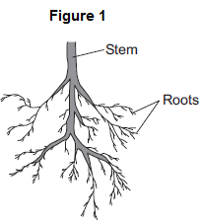

(a) (i) Mineral ions are absorbed through the roots.
Name one other substance absorbed through the roots.
_____________________________________________________________
(1)
(ii) The plant in Figure 1 has a higher concentration of mineral ions in the cells of its roots than the concentration of mineral ions in the soil.
Which two statements correctly describe the absorption of mineral ions into the plant’s roots?
Tick () two boxes.

The mineral ions are absorbed by active transport.
The mineral ions are absorbed by diffusion.
The mineral ions are absorbed down the concentration gradient.
The absorption of mineral ions needs energy.
(2)
(iii) The plant in Figure 1 has roots adapted for absorption.
Figure 2 shows a magnified part of a root from Figure 1.
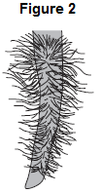
Describe how the root in Figure 2 is adapted for absorption.
_____________________________________________________________
_____________________________________________________________
_____________________________________________________________
_____________________________________________________________
(2)
(b) The leaves of plants have stomata. What is the function of the stomata?
_________________________________________________________________
_________________________________________________________________
(1)
(c) Figure 3 shows the underside of two leaves, A and B, taken from a plant in a man’s house.
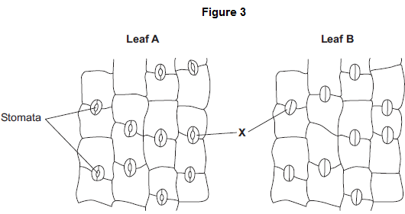
(i) In Figure 3, the cells labelled X control the size of the stomata. What is the name of the cells labelled X? Tick () one box.

Guard cells
Phloem cells
Xylem cells
(1)
(ii) Describe how the appearance of the stomata in leaf B is different from the appearance of the stomata in leaf A.
_____________________________________________________________
_____________________________________________________________
(1)
(iii) The man forgets to water the plant.
What might happen to the plant in the next few days if the stomata stay the same as shown in leaf A in Figure 3?
_____________________________________________________________
_____________________________________________________________
(1)
(Total 9 marks)
Q3. (a) List A gives four structures in the human body. List B gives the functions of some structures in the body. Draw a straight line from each structure in List A to the correct function in List B.
List A – Structure |  | List B – Function
 |  | Surround and protect the lungs
Alveoli
 |  | Filter the blood
Veins
 |  | Carry blood towards the heart
Villi
 |  | Absorb digested food
Ribs
 |  | Allow oxygen to enter the blood
(4)
(b) Draw a ring around the correct answer to complete the sentence.

 | diffusion.
In the lungs, oxygen enters the blood from the air by | filtration.
 | respiration.
(1)
(Total 5 marks)
Q4. An athlete ran as fast as he could until he was exhausted.
(a) Figure 1 shows the concentrations of glucose and of lactic acid in the athlete’s blood at the start and at the end of the run.
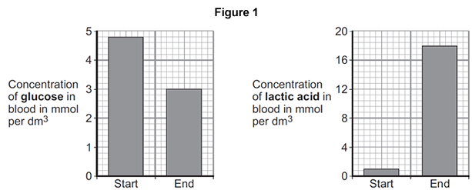
(i) Lactic acid is made during anaerobic respiration. What does anaerobic mean?
_____________________________________________________________
_____________________________________________________________
(1)
(ii) Give evidence from Figure 1 that the athlete respired anaerobically during the run.
_____________________________________________________________
_____________________________________________________________
(1)
(b) Figure 2 shows the effect of running on the rate of blood flow through the athlete’s muscles.

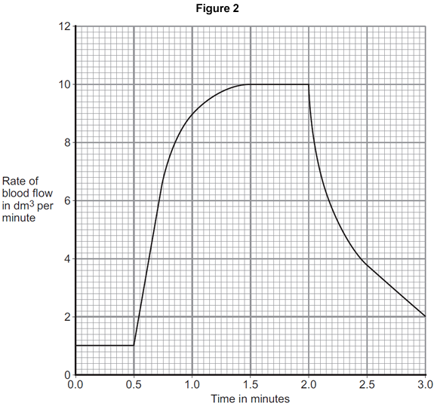
(i) For how many minutes did the athlete run?
Time = ______________________ minutes
(1)
(ii) Describe what happens to the rate of blood flow through the athlete’s muscles during the run. Use data from Figure 2 in your answer.
_____________________________________________________________
_____________________________________________________________
_____________________________________________________________
_____________________________________________________________
(2)
(iii) Explain how the change in blood flow to the athlete’s muscles helps him to run.
_____________________________________________________________
_____________________________________________________________
_____________________________________________________________
_____________________________________________________________
_____________________________________________________________
_____________________________________________________________
_____________________________________________________________
(4)
(Total 9 marks)
Q5. The diagram below shows a cross-section of a plant root. The transport tissues are labelled.
(a) (i) What is tissue A? Draw a ring around the correct answer.
cuticle epidermis xylem
(1)
(ii) Name two substances transported by tissue A.
1. ____________________________________________________________
2. ____________________________________________________________
(2)
(b) Phloem is involved in a process called translocation.
(i) What is translocation?
_____________________________________________________________
_____________________________________________________________
(1)
(ii) Explain why translocation is important to plants.
_____________________________________________________________
_____________________________________________________________
_____________________________________________________________
(2)
(c) Plants must use active transport to move some substances from the soil into root hair cells.
(i) Active transport needs energy. Which part of the cell releases most of this energy? Tick (✓) one box.

mitochondria
nucleus
ribosome
(1)
(ii) Explain why active transport is necessary in root hair cells.
_____________________________________________________________
_____________________________________________________________
_____________________________________________________________
(2)
(Total 9 marks)
Q6. (a) A food contains protein. Describe, in as much detail as you can, what happens to this protein after the food is swallowed.
_________________________________________________________________
_________________________________________________________________
_________________________________________________________________
_________________________________________________________________
_________________________________________________________________
_________________________________________________________________
(4)
(b) The table shows the activity of lipase on fat in three different conditions.

CONDITION | UNITS OF LIPASE ACTIVITY PER MINUTE
Lipase + acid solution | 3.3
Lipase + weak alkaline solution | 15.3
Lipase + bile | 14.5
Explain, as fully as you can, the results shown in the table.
_________________________________________________________________
_________________________________________________________________
_________________________________________________________________
_________________________________________________________________
_________________________________________________________________
(3)
(Total 7 marks)

Q7. The diagram in Figure 1 shows a section through the human heart, seen from the front.
Figure 1
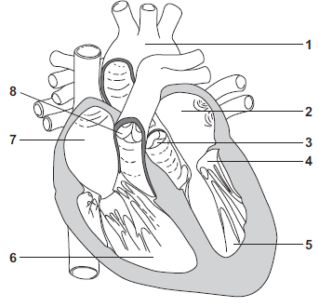
(a) Draw a ring around the correct answer to complete each sentence.

(i) | The wall of the heart is made mostly of | epithelial  glandular  muscular | tissue.
(1)
(ii) The resting heart rate is controlled by the pacemaker.

The pacemaker is located at position | 1.  6.  7.
(1)
(iii) If a person’s heart rate is irregular, the person may be fitted with an artificial pacemaker.

The artificial pacemaker is | an electrical device.  a pump.  a valve.
(1)
(b) (i) Write a number, 2, 5, 6 or 7, in each of the three boxes to answer this question. Which chamber of the heart:
pumps oxygenated blood to the head and body
receives deoxygenated blood from the head and body
receives oxygenated blood from the lungs?
(3)
(ii) Give the number, 3, 4 or 8, of the valve that closes when the blood pressure in the aorta is greater than the blood pressure in the left ventricle.
Write the correct answer in the box.
(1)
(c) The diagram in Figure 2 shows one type of artificial heart valve. The plastic ball is in the closed position.
Figure 2
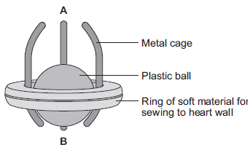
This type of artificial valve could be used to replace a faulty valve in the heart.
(i) What is the function of valves in the heart?
_____________________________________________________________
_____________________________________________________________
(1)
(ii) The artificial valve could be used to replace valve 4 shown in Figure 1.
The artificial valve opens to let blood through when the ball is moved towards A.
Which end of the valve, A or B, should point towards chamber 5?
Explain your answer.
_____________________________________________________________
_____________________________________________________________
_____________________________________________________________
_____________________________________________________________
_____________________________________________________________
(3)

(d) (i) The artificial heart valve may cause blood clots to form on its surface. Describe what happens during blood clotting.
_____________________________________________________________
_____________________________________________________________
_____________________________________________________________
_____________________________________________________________
(2)
(ii) Read the information in the passage.

Replacing a damaged heart valve can dramatically improve the blood circulation and the supply of oxygen to the body’s tissues. The operation to replace a heart valve is a long one during which the patient’s blood goes through a bypass machine.
Sometimes the artificial valve can fail to work. If the surface of the valve becomes rough, small blood clots can form on its surface then break away and be carried around the body by the blood.
Evaluate the advantages and disadvantages of artificial heart valves.
_____________________________________________________________
_____________________________________________________________
_____________________________________________________________
_____________________________________________________________
_____________________________________________________________
_____________________________________________________________
_____________________________________________________________
_____________________________________________________________
_____________________________________________________________
_____________________________________________________________
(4)
(Total 17 marks)
Q8. During exercise, the heart beats faster and with greater force. The ‘heart rate’ is the number of times the heart beats each minute. The volume of blood that travels out of the heart each time the heart beats is called the ‘stroke volume’.
In an investigation, Person 1 and Person 2 ran as fast as they could for 1 minute. Scientists measured the heart rates and stroke volumes of Person 1 and Person 2 at rest, during the exercise and after the exercise. The graph below shows the scientists’ results.
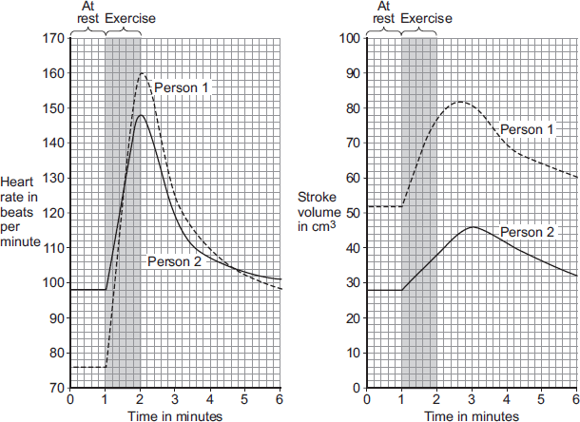
(a) The ‘cardiac output’ is the volume of blood sent from the heart to the muscles each minute.
Cardiac output = Heart rate × Stroke volume
At the end of the exercise, Person 1’s cardiac output = 160 × 77 = 12 320 cm³ per minute.
Use information from Figure above to complete the following calculation of Person 2’s cardiac output at the end of the exercise.
At the end of the exercise:
Person 2’s heart rate = _______________ beats per minute
Person 2’s stroke volume = _______________ cm³
Person 2’s cardiac output = _______________ cm³ per minute
(3)
(b) Person 2 had a much lower cardiac output than Person 1.
(i) Use information from Figure above to suggest the main reason for the lower cardiac output of Person 2.
_____________________________________________________________
_____________________________________________________________
(1)
(ii) Person 1 was able to run much faster than Person 2.
Use information from Figure above and your own knowledge to explain why.
_____________________________________________________________
_____________________________________________________________
_____________________________________________________________
_____________________________________________________________
_____________________________________________________________
_____________________________________________________________
_____________________________________________________________
_____________________________________________________________
_____________________________________________________________
_____________________________________________________________
(5)
(Total 9 marks)
Q9. (a) Complete the table to give one site where digestive substances are made.
Digestive substance | One site of production
bile
amylase
lipase
protease
(4)
(b) Describe two ways that the mouth can break down starchy foods.
_________________________________________________________________
_________________________________________________________________
_________________________________________________________________
(2)
(c) Describe how the liver helps to digest fats.
_________________________________________________________________
_________________________________________________________________
_________________________________________________________________
(2)
(Total 8 marks)
Q10. A group of pupils investigated the digestion of fat by the enzyme lipase.
(a) What two substances are produced when fats are digested?
Tick () two box.

Glucose
Fatty acids
Glycerol
Amino acids
(2)
In the investigation:
• the pupils set up five test tubes
• each tube contained 1 cm³ of fat and 10 cm ³ of lipase solution
• each tube was kept at a different temperature for 24 hours.
(b) (i) Give one control variable in this investigation.
_____________________________________________________________
(1)
(ii) What was the independent variable being investigated?
_____________________________________________________________
(1)
(c) The pH of the solution in each tube was tested at the beginning of the investigation and after 24 hours.
The results of the pupils’ investigation are shown in the table.

Tube | Temperature  in °C | pH at the  beginning | pH after 24  hours
1 | 0 | Neutral | Neutral
2 | 20 | Neutral | ‘Weak’ acid
3 | 40 | Neutral | ‘Strong’ acid
4 | 60 | Neutral | ‘Weak’ acid
5 | 80 | Neutral | Neutral
One pupil said, “We might not have found the best temperature for the lipase to work”.
What more could they do to find the best temperature?
_________________________________________________________________
_________________________________________________________________
_________________________________________________________________
_________________________________________________________________
(2)
(d) The pupils then placed Tube 1 into a water-bath kept at 40 °C.
The tube was left in the water-bath for 24 hours.
(i) What pH would you expect the contents of the tube to be after the extra 24 hours?
Tick () one box.

Neutral
‘Strong’ acid
‘Weak’ acid
(1)
(ii) Give the reason for your answer.
_____________________________________________________________
_____________________________________________________________
(1)
(Total 8 marks)
Q11. After a meal rich in carbohydrates, the concentration of glucose in the small intestine changes.
The table below shows the concentration of glucose at different distances along the small intestine.

Distance along the small intestine in cm | Concentration of glucose in mol dm⁻³
100 | 50
300 | 500
500 | 250
700 | 0
(a) At what distance along the small intestine is the glucose concentration highest?
______________________ cm
(1)
(b) Use the data in the table to plot a bar chart on the graph below.
• Label the y-axis.
• Choose a suitable scale.
(4)
(c) Look at the graph on the previous page.
Describe how the concentration of glucose changes as distance increases along the small intestine.
_________________________________________________________________
_________________________________________________________________
_________________________________________________________________
(2)
(d) Explain why the concentration of glucose in the small intestine changes between 100 cm and 300 cm.
_________________________________________________________________
_________________________________________________________________
_________________________________________________________________
_________________________________________________________________
(2)
(e) Explain why the concentration of glucose in the small intestine changes between 300 cm and 700 cm.
_________________________________________________________________
_________________________________________________________________
_________________________________________________________________
_________________________________________________________________
_________________________________________________________________
_________________________________________________________________
_________________________________________________________________
(3)
(Total 12 marks)
Q12. The villi of the small intestine absorb the products of digestion.
The diagram shows two villi. It also shows parts of some of the surface cells of a villus, as seen with an electron microscope.
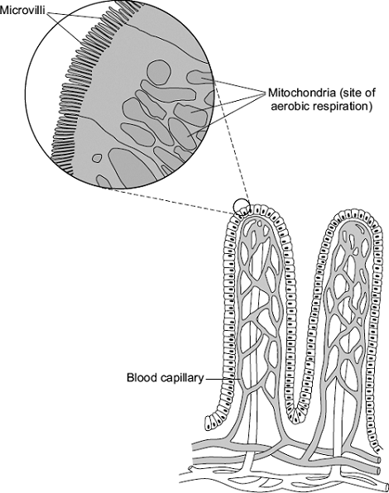

Describe and explain how the villi are adapted to maximise the rate of absorption
of the products of digestion.
_____________________________________________________________________
_____________________________________________________________________
_____________________________________________________________________
_____________________________________________________________________
_____________________________________________________________________
_____________________________________________________________________
_____________________________________________________________________
_____________________________________________________________________
(Total 5 marks)
Q1. Microorganisms cause infections.The human body has many ways of defending itself against microorganisms.
(a) Describe two ways the body prevents the entry of microorganisms.
1. _________________________________________________________________
2. _________________________________________________________________
(2)
(b) In 2014 the Ebola virus killed almost 8000 people in Africa. Drug companies have developed a new drug to treat Ebola.
Explain what testing must be done before this new drug can be used to treat people.
_________________________________________________________________
_________________________________________________________________
_________________________________________________________________
_________________________________________________________________
_________________________________________________________________
_________________________________________________________________
_________________________________________________________________
_________________________________________________________________
_________________________________________________________________
(6)
(Total 8 marks)
Q2. The MMR vaccine is used to protect against measles.
(a) Apart from measles, which two other diseases does the MMR vaccine protect against?
___________________________ and ___________________________
(1)
(b) Read the information.

Measles is a dangerous disease caused by a virus .Normally, MMR vaccinations are given at 1 year old and again at 4 years old. Each vaccination is 90% effective in protecting against the measles virus.
In April 2013, there were 630 cases of measles in children aged 4 and over in a small area of the UK. Of these cases, 504 children had not been vaccinated against MMR at all and only a few had been given a second vaccination.
(i) Calculate the percentage of the children who caught measles in April 2013 who had not been vaccinated against MMR.
_____________________________________________________________
_____________________________________________________________
_____________________________________________________________
Percentage = __________________________________________
(2)
(ii) Suggest one advantage to the population as a whole of children having the second MMR vaccination.
_____________________________________________________________
(1)
(c) (i) What does a vaccine contain?
_____________________________________________________________
_____________________________________________________________
(1)
(ii) Explain how a vaccination prevents infection.
_____________________________________________________________
_____________________________________________________________
_____________________________________________________________
_____________________________________________________________
_____________________________________________________________
(3)

(d) (i) Antibiotics can only be used to treat some infections. Explain why antibiotics cannot be used to treat measles.
_____________________________________________________________
_____________________________________________________________
_____________________________________________________________
(2)
(ii) Why do antibiotics become less useful at treating an infection if the antibiotic is overused?
_____________________________________________________________
_____________________________________________________________
(1)
(Total 11 marks)
Q3. Microorganisms can cause disease.
(a) Draw one line from each disease to the correct description.
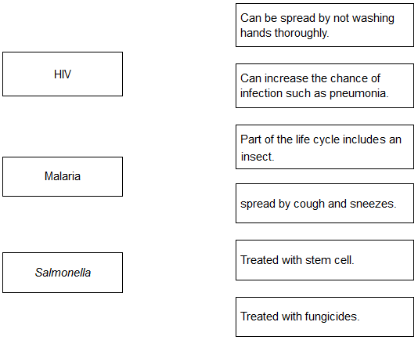
(3)
(b) Gonorrhoea is a sexually transmitted disease. A bacterium causes gonorrhoea. What are the symptoms of gonorrhoea?

Tick two boxes.
Headache
Pain when urinating
Rash
Vomiting
Yellow discharge
(2)
(c) The table below shows the number of people in the UK diagnosed with gonorrhoea in different years.

Number of people diagnosed
with gonorrhoea in thousands
Year | Female | Male
2005 | 5.0 | 12.5
2007 | 5.0 | 12.5
2009 | 5.5 | 12.0
2011 | 6.0 | 14.0
2013 | 7.5 | 22.0
Use the data in the table to complete the graph below.
• The numbers for males have already been plotted.
• Only some of the numbers for females have been plotted.
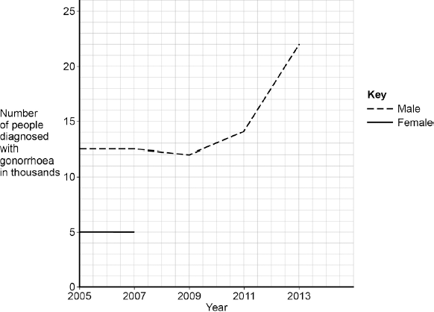
(3)
(d) Describe the patterns in the numbers of males and females with gonorrhoea from 2005 to 2013. Use the data in the graph.
_________________________________________________________________
_________________________________________________________________
_________________________________________________________________
_________________________________________________________________
(3)

(e) Gonorrhoea is treated with an antibiotic. HIV is another sexually transmitted disease.
Explain why prescribing an antibiotic will not cure HIV.
_________________________________________________________________
_________________________________________________________________
_________________________________________________________________
_________________________________________________________________
(2)
(Total 13 marks)
Q4. Hepatitis B is a liver disease caused by a virus. The virus is found in body fluids such as blood, saliva and urine. Diagram 1 shows the structure of the virus in cross section.
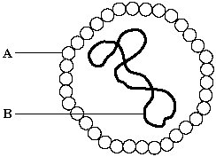
Diagram 1
(a) The human body has several natural defences against viruses. Some of these prevent viruses from entering the body. Others act once the viruses have entered.
(i) Diagram 2 shows a white blood cell attacking a group of viruses.
Complete diagram 2 by drawing the 2nd stage.
1st stage 2nd stage 3rd Stage
Diagram 2
(1)
(ii) What type of chemical is released by some white blood cells to attack viruses?
_____________________________________________________________
(1)
(b) Hepatitis B is more likely to be spread among people who share needles when they inject drugs. Use information given at the beginning of this question to explain why this is so.
_________________________________________________________________
_________________________________________________________________
_________________________________________________________________
(2)
(Total 4 marks)
Q5. Viruses and bacteria cause diseases in humans.
(a) Draw a ring around the correct word to complete the sentence.

 |  | algae.
 | Organisms that cause disease are called | pathogens.
 |  | vaccines.
(1)
(b) In August 2011 the United Nations gave a warning that there was a new strain of the bird flu virus in China. Bird flu may kill humans. The new strain of the bird flu virus could cause a pandemic very quickly.
(i) What is a pandemic?
Tick () one box.

A disease affecting the people all over one country.
A disease affecting hundreds of people
A disease affecting people in many countries.
(1)
(ii) The swine flu virus is carried by pigs. The bird flu virus is likely to spread much more quickly than the swine flu virus. Suggest one reason why.
_____________________________________________________________
_____________________________________________________________
(1)
This notice is from a doctor’s surgery.

Unfortunately,
antibiotics
will NOT get
rid of your flu.
(c) (i) Why will antibiotics not get rid of flu?
_____________________________________________________________
_____________________________________________________________
(1)
(ii) The symptoms of flu include a sore throat and aching muscles.
What would a doctor give to a patient to relieve the symptoms of flu?
_____________________________________________________________
(1)
(iii) It is important that antibiotics are not overused. Explain why. Use words from the box to complete the sentence.

antibody | bacteria | immune | resistant | viruses
Overuse of antibiotics might speed up the development
of __________________________ strains of _________________________
(2)
(Total 7 marks)
Q6. Pathogens are microorganisms that cause infectious diseases.
(a) The graph shows the percentage of children under 5 years old who died from infectious diseases, in the UK, in four different years.
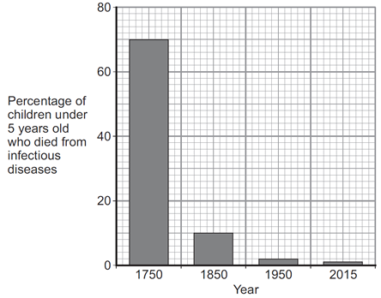
(i) Between 1750 and 1850 vaccinations were also developed.
What is in a vaccine?

Tick (✔) one box.
large amounts of dead pathogens
large amounts of live pathogens
small amounts of dead pathogens
(1)
(ii) The advances in medicine had an effect on death rate. Describe the effect these advances had between 1750 and 1850. To gain full marks you should include data from the graph above.
_____________________________________________________________
_____________________________________________________________
_____________________________________________________________
_____________________________________________________________
(2)
(b) Antibiotics were developed in the 1940s. Antibiotics kill bacteria.
(i) Which one of the following is an antibiotic? Draw a ring around the correct answer.
cholesterol penicillin thalidomide
(1)
(ii) The use of antibiotics has not reduced the death rate due to all diseases to zero. Suggest two reasons why.
1. ____________________________________________________________
_____________________________________________________________
2. ____________________________________________________________
_____________________________________________________________
(2)
(c) In school laboratories, bacteria should be grown at a maximum temperature of 25 °C. Give one reason why companies testing new antibiotics grow bacteria at 37 °C.
_________________________________________________________________
_________________________________________________________________
(1)
(Total 7 marks)
Q7. The influenza virus damages the cells lining the respiratory tract causing sore throats.Coughing and sneezing spread the virus.
(a) Give the correct term for this method of spreading an infection.
_________________________________________________________________
(1)
(b) In an immunisation programme such as that for MMR (Measles, Mumps and Rubella), suggest why it is essential for a large proportion of the child population to be vaccinated in order to protect the few individuals who are unable to be vaccinated.
_________________________________________________________________
_________________________________________________________________
(1)
(c) In some modern influenza vaccines the protein surface sub-units are separated from the virus coat and used for the vaccine. This stimulates an effective immune response in the same way as inactive pathogens.
(i) Explain how this immunity is produced in the body following vaccination, and how further illness from the same virus is prevented.
_____________________________________________________________
_____________________________________________________________
_____________________________________________________________
_____________________________________________________________
_____________________________________________________________
(4)
(ii) This type of immunity resulting from an influenza injection is described
as ________________________ immunity.
(1)
(d) The diagram shows the structure of an influenza virus.
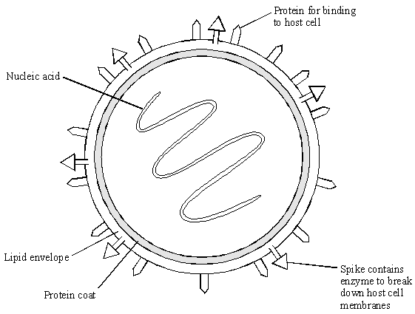
Influenza epidemics can arise because the nucleic acid of the virus frequently changes. This results in changes in the virus structure and so a new strain of the virus is formed. A person who has had influenza or who has been vaccinated may not be immune to the new strain.
Explain why this is so, using the diagram of the influenza virus structure and your knowledge of immunity.
_________________________________________________________________
_________________________________________________________________
_________________________________________________________________
_________________________________________________________________
_________________________________________________________________
(3)
(Total 10 marks)
Q8. Antibiotics can be used to protect our bodies from pathogens.
(a) What is a pathogen?
_________________________________________________________________
_________________________________________________________________
(1)
(b) Bacteria may become resistant to antibiotics.How can doctors reduce the number of bacteria that become resistant to antibiotics?
_________________________________________________________________
_________________________________________________________________
_________________________________________________________________
(2)
(c) Scientists grow microorganisms in industrial conditions at a higher temperature than is used in school laboratories.
(i) Which temperature would be most suitable for growing bacteria in industrial conditions? Draw a ring around the correct answer.

25 °C | 40 °C | 100 °C
(1)
(ii) What is the advantage of using the temperature you gave in part (c)(i)?
_____________________________________________________________
_____________________________________________________________
(1)
(Total 5 marks)
Q9. The diagram shows how an immature egg could be used either to produce cells to treat some human diseases or to produce a baby.
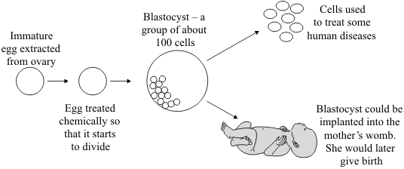
Scientists may be allowed to use this technique to produce cells to treat some human diseases, but not to produce babies. Using information from the diagram, suggest an explanation for this.
_____________________________________________________________________
_____________________________________________________________________
_____________________________________________________________________
_____________________________________________________________________
_____________________________________________________________________
_____________________________________________________________________
_____________________________________________________________________
(Total 4 marks)
Q10. Stem cells can be collected from human embryos and from adult bone marrow.
Stem cells can develop into different types of cell.The table gives information about using these two types of stem cell to treat patients.

Stem cells from human embryos | Stem cells from adult bone marrow
It costs £5000 to collect a few cells. | It costs £1000 to collect many cells.
There are ethical issues in using embryo stem cells. | Adults give permission for their own bone marrow to be collected.
The stem cells can develop into most other types of cell. | The stem cells can develop into only a few types of cell.
Each stem cell divides every 30 minutes. | Each stem cell divides every four hours.
There is a low chance of a patient’s immune system rejecting the cells. | There is a high chance of a patient’s immune system rejecting the cells.
More research is needed into the use of these stem cells. | Use of these stem cells is considered to be a safe procedure.
Scientists are planning a new way of treating a disease, using stem cells. Use only the information above to answer these questions.
(a) Give three advantages of using stem cells from embryos instead of from adult bone marrow.
1. _________________________________________________________________
2. _________________________________________________________________
3. _________________________________________________________________
(3)
(b) Give three advantages of using stem cells from adult bone marrow instead of from embryos.
1. _________________________________________________________________
2. _________________________________________________________________
3. _________________________________________________________________
(3)
(Total 6 marks)
Q11. Read the information about stem cells.

Stem cells are used to treat some human diseases.Stem cells can be collected from early embryos. These stem cells have not begun to differentiate, so they could be used to produce any kind of cell, tissue or organ. The use of embryonic stem cells to treat human diseases is new and, for some diseases, trials on patients are happening now.Stem cells can also be collected from adult bone marrow. The operation is simple but may be painful. Stem cells in bone marrow mainly differentiate to form blood cells. These stem cells have been used successfully for many years to treat some kinds of blood disease. Recently there have been trials of other types of stem cell from bone marrow. These stem cells are used to treat diseases such as heart disease.
Evaluate the use of stem cells from embryos or from adult bone marrow for treating human diseases. You should give a conclusion to your evaluation.
_____________________________________________________________________
_____________________________________________________________________
_____________________________________________________________________
_____________________________________________________________________
_____________________________________________________________________
_____________________________________________________________________
_____________________________________________________________________
_____________________________________________________________________
_____________________________________________________________________
(5)
(Total 5 marks)
Q12. (a) How many pairs of chromosomes are there in a body cell of a human baby?
_________________________________________________________________
(1)
(b) Place the following in order of size, starting with the smallest, by writing
numbers 1 – 4 in the boxes underneath the words.
(1)
(c) For a baby to grow, its cells must develop in a number of ways.
Explain how each of the following is part of the growth process of a baby.
(i) Cell enlargement
_____________________________________________________________
(1)
(ii) The process of cell division by mitosis
_____________________________________________________________
_____________________________________________________________
_____________________________________________________________
_____________________________________________________________
_____________________________________________________________
(3)
(d) Why is cell specialisation (differentiation) important for the development and growth of a healthy baby from a fertilised egg?
_________________________________________________________________
_________________________________________________________________
(2)
(Total 8 marks)
Q13. Diagram 1 shows the nucleus of a body cell as it begins to divide by mitosis.
Diagram 1
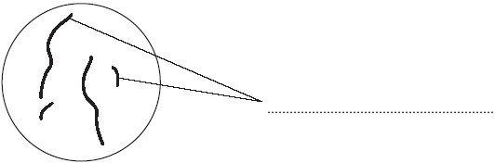
(a) Use a word from the box to label Diagram 1.

alleles chromosomes gametes
(1)
(b) Complete Diagram 2 to show what the nucleus of one of the cells produced by this mitosis would look like.
Diagram 2
(1)
(c) Stem cells from a recently dead embryo can be grown in special solutions.Some facts about stem cells are given below.
• Stem cells from an embryo can grow into any type of tissue.
• Stem cells may grow out of control, to form cancers.
• Large numbers of stem cells can be grown in the laboratory.
• Stem cells may be used in medical research or to treat some human diseases.
• Patients treated with stem cells need to take drugs for the rest of their life to prevent rejection.
• Collecting and growing stem cells is expensive.
Use only the information above to answer these questions.
(i) Give two advantages of using stem cells.
1. ____________________________________________________________
_____________________________________________________________
2. ____________________________________________________________
_____________________________________________________________
(2)
(ii) Give two disadvantages of using stem cells.
1. ____________________________________________________________
_____________________________________________________________
2. ____________________________________________________________
_____________________________________________________________
(2)
(Total 6 marks)
Q14. (a) A healthy diet should be balanced. What is meant by a balanced diet?
_________________________________________________________________
_________________________________________________________________
_________________________________________________________________
_________________________________________________________________
(2)
(b Cholesterol has important functions in the body. Some cholesterol is produced by the liver. Cholesterol is needed in the body to make the hormone oestrogen.
(i) Name the organ in the body which produces oestrogen.
_____________________________________________________________
(1)
(ii) What effect does oestrogen have on the female reproductive cycle?
_____________________________________________________________
_____________________________________________________________
(1)
(iii) Oestrogen is a naturally occurring steroid hormone.
Give one artificial use of a steroid hormone in the body.
_____________________________________________________________
_____________________________________________________________
(1)

(c) The graph below shows the effect of the mass of cholesterol in the diet on:
• the concentration of cholesterol in the blood
• the mass of cholesterol produced by the liver.
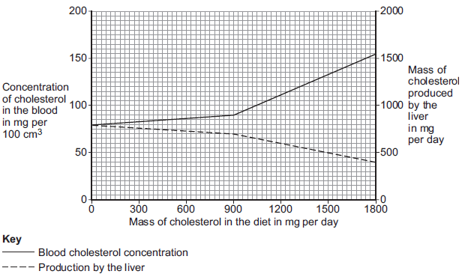
Describe the effect of increasing the mass of cholesterol in the diet on the mass of cholesterol produced by the liver. To gain full marks you should include data from the graph in your answer.
_________________________________________________________________
_________________________________________________________________
_________________________________________________________________
(2)
(d) Large amounts of cholesterol in the diet switch off the production of an enzyme called reductase, in the liver. An increase of the enzyme reductase increases the production of cholesterol by the liver.
(i) Which part of a liver cell is responsible for controlling the production of reductase?
_____________________________________________________________
_____________________________________________________________
(1)
(ii) High blood cholesterol concentrations increase the likelihood of heart and circulatory diseases. Doctors can prescribe statins to control the concentration of cholesterol in the blood. Suggest how statins work.
_____________________________________________________________
_____________________________________________________________
(1)
(Total 9 marks)
Q1. Anaerobic respiration happens in muscle cells and yeast cells. The equation describes anaerobic respiration in muscle cells.
glucose lactic acid
(a) How can you tell from the equation that this process is anaerobic?
_________________________________________________________________
_________________________________________________________________
(1)
(b) Exercise cannot be sustained when anaerobic respiration takes place in muscle cells. Explain why.
_________________________________________________________________
_________________________________________________________________
_________________________________________________________________
_________________________________________________________________
(2)

(c) The diagram below shows an experiment to investigate anaerobic respiration in yeast cells.
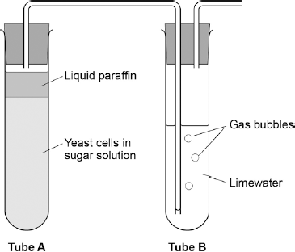
What gas will bubble into Tube B?

Tick one box.
Carbon dioxide
Nitrogen
Oxygen
Water vapour
(1)
(d) Describe how you could use tube B to measure the rate of the reaction in tube A.
_________________________________________________________________
_________________________________________________________________
_________________________________________________________________
(2)
(e) Anaerobic respiration in yeast is also called fermentation.
Fermentation produces ethanol.
Give one use of fermentation in the food industry.
_________________________________________________________________
(1)
(Total 7 marks)
Q2. An athlete ran as fast as he could until he was exhausted.
(a) Figure 1 shows the concentrations of glucose and of lactic acid in the athlete’s blood at the start and at the end of the run.
(i) Lactic acid is made during anaerobic respiration. What does anaerobic mean?
_____________________________________________________________
_____________________________________________________________
(1)
(ii) Give evidence from Figure 1 that the athlete respired anaerobically during the run.
_____________________________________________________________
_____________________________________________________________
(1)
(b) Figure 2 shows the effect of running on the rate of blood flow through the athlete’s muscles.

(i) For how many minutes did the athlete run?
Time = ______________________ minutes
(1)
(ii) Describe what happens to the rate of blood flow through the athlete’s muscles during the run. Use data from Figure 2 in your answer.
_____________________________________________________________
_____________________________________________________________
_____________________________________________________________
_____________________________________________________________
(2)
(iii) Explain how the change in blood flow to the athlete’s muscles helps him to run.
_____________________________________________________________
_____________________________________________________________
_____________________________________________________________
_____________________________________________________________
_____________________________________________________________
_____________________________________________________________
_____________________________________________________________
(4)
(Total 9 marks)
Q3. Some students investigated the effect of light intensity on the rate of photosynthesis.
They used the apparatus shown in Diagram 1.
Diagram 1
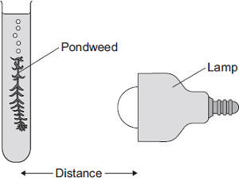
The students:
• placed the lamp 10 cm from the pondweed
• counted the number of bubbles of gas released from the pondweed in 1 minute
• repeated this for different distances between the lamp and the pondweed.
(a) The lamp gives out heat as well as light. What could the students do to make sure that heat from the lamp did not affect the rate of photosynthesis?
_________________________________________________________________
_________________________________________________________________
(1)
(b) The table shows the students’ results.

 | Distance in cm | Number of bubbles  per minute
 | 10 | 84
 | 15 | 84
 | 20 | 76
 | 40 | 52
 | 50 | 26
(i) At distances between 15 cm and 50 cm, light was a limiting factor for photosynthesis. What evidence is there for this in the table?
_____________________________________________________________
_____________________________________________________________
(1)
(ii) Give one factor that could have limited the rate of photosynthesis when the distance was between 10 cm and 15 cm.
_____________________________________________________________
(1)
(c) In this question you will be assessed on using good English, organising information clearly and using specialist terms where appropriate. Diagram 2 shows a section through a plant leaf.
Diagram 2
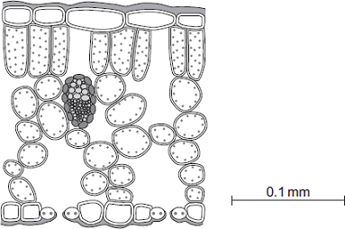
Describe the structure of the leaf and the functions of the tissues in the leaf.
You should use the names of the tissues in your answer.
_________________________________________________________________
_________________________________________________________________
_________________________________________________________________
_________________________________________________________________
_________________________________________________________________
_________________________________________________________________
_________________________________________________________________
_________________________________________________________________
_________________________________________________________________
_________________________________________________________________
_________________________________________________________________
_________________________________________________________________
(6)
(Total 9 marks)
Q4. (a) Complete the equation for photosynthesis. Draw a ring around each correct answer.

 |  | hydrogen |  | alcohol
Carbon dioxide | + | nitrogen | light energy | glucose | + | oxygen
 |  | water |  | methane
(2)
Some students investigated the effect of light intensity on the rate of photosynthesis in pondweed. The diagram shows the apparatus the students used.
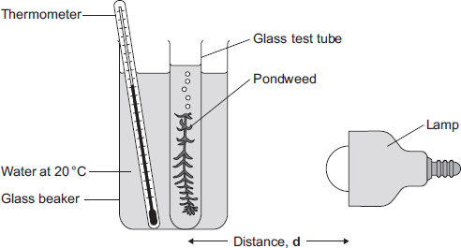
The closer the lamp is to the pondweed, the more light the pondweed receives. The students placed the lamp at different distances, d, from the pondweed. They counted the number of bubbles of gas released from the pondweed in 1 minute for each distance.
(b) A thermometer was placed in the glass beaker. Why was it important to use a thermometer in this investigation?
_________________________________________________________________
_________________________________________________________________
_________________________________________________________________
_________________________________________________________________
(3)
(c) The students counted the bubbles four times at each distance and calculated the correct mean value of their results.The table shows the students’ results.

Distance  d in cm | Number of bubbles per minute
 | 1 | 2 | 3 | 4 | Mean
10 | 52 | 52 | 54 | 54 | 53
20 | 49 | 51 | 48 | 52 | 50
30 | 32 | 30 | 27 | 31 | 30
40 | 30 | 10 | 9 | 11
(i) Calculate the mean number of bubbles released per minute when the lamp was 40 cm from the pondweed.
_____________________________________________________________
_____________________________________________________________
Mean number of bubbles at 40 cm = ______________________
(2)
(ii) On the graph paper below, draw a graph to show the students’ results:
• add a label to the vertical axis
• plot the mean values of the number of bubbles
• draw a line of best fit.
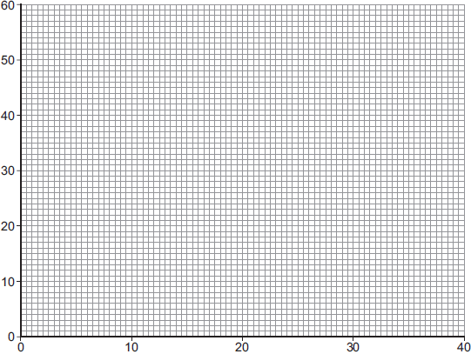
Distance d in cm
(4)
(iii) One student concluded that the rate of photosynthesis was inversely proportional to the distance of the lamp from the plant. Does the data support this conclusion? Explain your answer.
_____________________________________________________________
_____________________________________________________________
_____________________________________________________________
_____________________________________________________________
_____________________________________________________________
(2)
(d) Light intensity, temperature and concentration of carbon dioxide are factors that affect the rate of photosynthesis. Scientists investigated the effects of these three factors on the rate of photosynthesis in tomato plants growing in a greenhouse. The graph below shows the scientists’ results.
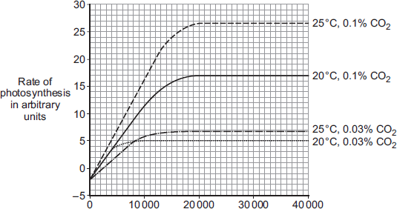
Light intensity in lux
A farmer in the UK wants to grow tomatoes commercially in a greenhouse.
The farmer read about the scientists’ investigation.
During the growing season for tomatoes in the UK, natural daylight has an intensity higher than 30 000 lux.
The farmer therefore decided to use the following conditions in his greenhouse during the day:
• 20°C
• 0.1% CO₂
• no extra lighting.
Suggest why the farmer decided to use these conditions for growing the tomatoes. You should use information from the scientists’ graph in your answer.
_________________________________________________________________
_________________________________________________________________
_________________________________________________________________
_________________________________________________________________
_________________________________________________________________
_________________________________________________________________
(4)
(Total 17 marks)

Q5. The diagram shows a fermenter. This fermenter is used for growing the fungus
Fusarium. Fusarium is used to make mycoprotein.
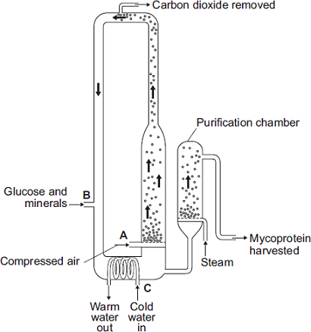
(a) Bubbles of air enter the fermenter at A. Give two functions of the air bubbles.
1. _________________________________________________________________
_________________________________________________________________
2. _________________________________________________________________
_________________________________________________________________
(2)
(b) Why is glucose added to the fermenter?
_________________________________________________________________
_________________________________________________________________
(1)
(c) The fermenter is prevented from overheating by the cold water flowing in through the heat exchanger coils at C. Name the process that causes the fermenter to heat up.
_________________________________________________________________
(1)
(d) It is important to prevent microorganisms other than Fusarium growing in the fermenter.
(i) Why is this important?
_____________________________________________________________
_____________________________________________________________
(1)
(ii) Suggest one way in which contamination of the fermenter by microorganisms could be prevented.
_____________________________________________________________
_____________________________________________________________
(1)
(e) Human cells cannot make some of the amino acids which we need. We must obtain these amino acids from our diet. The table shows the amounts of four of these amino acids present in mycoprotein, in beef and in wheat.

Name of  amino acid | Amount of amino acid per 100 g  in mg |  |  | Daily amount  needed by a  70 kg human  in mg
 | Mycoprotein | Beef | Wheat
Lysine | 910 | 1600 | 300 | 840
Methionine | 230 | 500 | 220 | 910
Phenylalanine | 540 | 760 | 680 | 980
Threonine | 610 | 840 | 370 | 490
A diet book states that mycoprotein is the best source of amino acids for the human diet. Evaluate this statement. Remember to include a conclusion in your evaluation.
_________________________________________________________________
_________________________________________________________________
_________________________________________________________________
_________________________________________________________________
_________________________________________________________________
_________________________________________________________________
(4)
(Total 10 marks)
Q6. One factor that may affect body mass is metabolic rate.
(a) (i) What is meant by metabolic rate ?
_____________________________________________________________
_____________________________________________________________
(1)
(ii) Metabolic rate is affected by the amount of activity a person does. Give two other factors that may affect a person’s metabolic rate.
1. ____________________________________________________________
_____________________________________________________________
2. ____________________________________________________________
_____________________________________________________________
(2)
(b) Predicted early death is the number of years that a person will die before the mean age of death for the whole population.
The predicted early death of a person is affected by their body mass. Scientists have calculated the effect of body mass on predicted early death.
The graph shows the results of the scientists’ calculations.
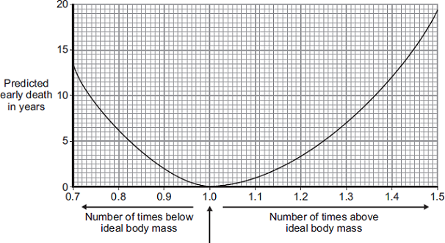
Ideal body mass
The number of times above or below ideal body mass is given by the equation:
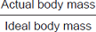
In the UK the mean age of death for women is 82. A woman has a body mass of 70 kg. The woman’s ideal body mass is 56 kg.
(i) Use the information from the graph to predict the age of this woman when she dies.
_____________________________________________________________
_____________________________________________________________
Age at death = ___________ years
(2)

(ii) The woman could live longer by changing her lifestyle. Give two changes she should make.
1. ____________________________________________________________
_____________________________________________________________
2. ____________________________________________________________
_____________________________________________________________
(2)
(Total 7 marks)
Q7. (a) Complete the equation for photosynthesis.
______________ + water 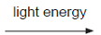 ______________ + ______________
(3)
(b) The rate of photosynthesis in a plant depends on several factors in the environment.
These factors include light intensity and the availability of water.
Describe and explain the effects of two other factors that affect the rate of photosynthesis.
You may include one or more sketch graphs in your answer.
_________________________________________________________________
_________________________________________________________________
_________________________________________________________________
_________________________________________________________________
_________________________________________________________________
_________________________________________________________________
_________________________________________________________________
_________________________________________________________________
_________________________________________________________________
(5)
(Total 8 marks)

Q8. Figure 1 shows an athlete running on a treadmill.
Figure 1
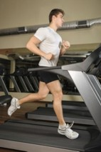
After running for several minutes, the athlete’s leg muscles began to ache.
This ache was caused by a high concentration of lactic acid in the muscles.
(a) The equation shows how lactic acid is made.
glucose lactic acid (+ energy)
Name the process that makes lactic acid in the athlete’s muscles.
_________________________________________________________________
(1)
(b) Scientists investigated the production of lactic acid by an athlete running at different speeds. In the investigation:
• the athlete ran on the treadmill at 4 km per hour
• the scientists measured the concentration of lactic acid in the athlete’s blood after 2 minutes of running.
The investigation was repeated for different running speeds.Figure 2 shows the scientists’ results.
Figure 2
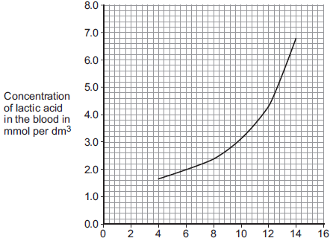
Treadmill speed in km per hour
(i) How much more lactic acid was there in the athlete’s blood when he ran at 14 km per hour than when he ran at 8 km per hour?
____________________________________________________________
_____________________________________________________________
_____________________________________________________________
Answer = _____________ mmol per dm³
(2)
(ii) Why is more lactic acid made in the muscles when running at 14 km per hour than when running at 8 km per hour?
_____________________________________________________________
_____________________________________________________________
_____________________________________________________________
_____________________________________________________________
_____________________________________________________________
(3)
(Total 6 marks)
Q9. A student ran on a treadmill for 5 minutes. The speed of the treadmill was set at 12 km per hour.The graph below shows the effect of the run on the student’s heart rate.
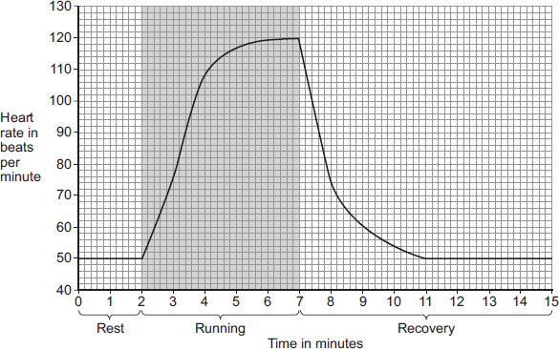
(a) (i) What was the student’s heart rate at rest?
_______________ beats per minute
(1)
(ii) After the end of the run, how long did it take for the student’s heart rate to return to the resting heart rate?
_______________ minutes
(1)

(b) During the run, the student’s muscles needed larger amounts of some substances than they needed at rest.
(i) Which two of the following substances were needed in larger amounts during the run? Tick () two boxes.

carbon dioxide
glucose
lactic acid
oxygen
protein
(2)
(ii) Why are the two substances you chose in part (b)(i) needed in larger amounts during the run? Tick () one box.

To help make more muscle fibres
To release more energy
To help the muscles to cool down
(1)
(c) After exercise, a fit person recovers faster than an unfit person.
Let the student’s heart rate at the end of exercise = a.
Let the student’s heart rate after 2 minutes of recovery = b.
The table below shows how the difference between a and b, (a − b), is related to a person’s level of fitness.

(a − b) | Level of fitness
< 22 | Unfit
22 to 52 | Normal fitness
53 to 58 | Fit
59 to 65 | Very fit
> 65 | Top athlete
What is the student’s level of fitness? Use information from the graph and the table.

a = _______________ beats per minute
b = _______________ beats per minute
(a − b) = _______________ beats per minute
Level of fitness = __________________________________
(3)
(d) The student repeated the run with the treadmill set at 16 km per hour.
The student’s heart rate took 3 minutes longer to return to the normal resting rate than when running at 12 km per hour.
Give reasons why it took longer to recover after running faster.
_________________________________________________________________
_________________________________________________________________
_________________________________________________________________
_________________________________________________________________
_________________________________________________________________
_________________________________________________________________
(4)
(Total 12 marks)
Q10. During exercise, the heart beats faster and with greater force. The ‘heart rate’ is the number of times the heart beats each minute.The volume of blood that travels out of the heart each time the heart beats is called the ‘stroke volume’. In an investigation, Person 1 and Person 2 ran as fast as they could for 1 minute. Scientists measured the heart rates and stroke volumes of Person 1 and Person 2 at rest, during the exercise and after the exercise.The graph below shows the scientists’ results.
(a) The ‘cardiac output’ is the volume of blood sent from the heart to the muscles each minute.
Cardiac output = Heart rate × Stroke volume
At the end of the exercise, Person 1’s cardiac output = 160 × 77 = 12 320 cm³ per minute.
Use information from Figure above to complete the following calculation of Person 2’s cardiac output at the end of the exercise. At the end of the exercise:
Person 2’s heart rate = _______________ beats per minute
Person 2’s stroke volume = _______________ cm³
Person 2’s cardiac output = _______________ cm³ per minute
(3)
(b) Person 2 had a much lower cardiac output than Person 1.
(i) Use information from Figure above to suggest the main reason for the lower cardiac output of Person 2.
_____________________________________________________________
_____________________________________________________________
(1)
(ii) Person 1 was able to run much faster than Person 2.
Use information from Figure above and your own knowledge to explain why.
_____________________________________________________________
_____________________________________________________________
_____________________________________________________________
_____________________________________________________________
_____________________________________________________________
_____________________________________________________________
_____________________________________________________________
(5)
(Total 9 marks)
Q11. Photosynthesis uses carbon dioxide to make glucose.
(a) (i) Complete the equation for photosynthesis.
carbon dioxide + _____________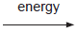 glucose + _____________
(2)
(ii) What type of energy does a plant use in photosynthesis?
_____________________________________________________________
(1)
(iii) Which part of a plant cell absorbs the energy needed for photosynthesis?
_____________________________________________________________
(1)
(b) The graph shows the effect of the concentration of carbon dioxide on the rate of photosynthesis in tomato plants at 20 °C.
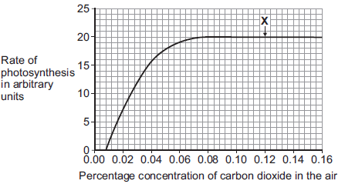
(i) What is the maximum rate of photosynthesis of the tomato plants shown in the graph?
_____________ arbitrary units
(1)
(ii) At point X, carbon dioxide is not a limiting factor of photosynthesis.
Suggest one factor that is limiting the rate of photosynthesis at point X.
_____________________________________________________________
(1)
(c) A farmer plans to grow tomatoes in a large greenhouse.
The concentration of carbon dioxide in the atmosphere is 0.04%.
The farmer adds carbon dioxide to the greenhouse so that its concentration is 0.08%.
(i) Why does the farmer use 0.08% carbon dioxide? Tick () one box.

To increase the rate of growth of the tomato plants
To increase the rate of respiration of the tomato plants
To increase water uptake by the tomato plants
(1)
(ii) Why does the farmer not use a concentration of carbon dioxide higher than 0.08%? Tick () two boxes.

Because it would cost more money than using 0.08%
Because it would decrease the temperature of the greenhouse
Because it would not increase the rate of photosynthesis of the
tomato plants any further
Because it would increase water loss from the tomato plants
(2)
(Total 9 marks)

Mark schemes
Q1.

(a) 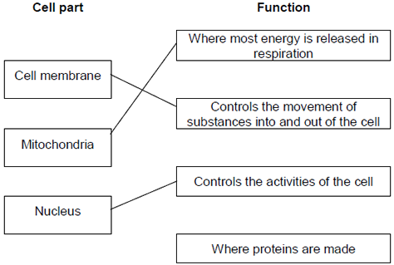
extra lines cancel
3
(b) Cell wall in either order
1
Chloroplast allow (permanent) vacuole
1
[5]
Q2. (a) (i) C and D no mark if more than one box is ticked
1
(ii) any one from: do not allow if other cell parts are given in a list
• (have) cell wall(s)
• (have) vacuole(s)
1
(b) (i) A
apply list principle
1
(ii) D
apply list principle
1
(c) respiration
apply list principle
1
[5]
Q3. (a) (i) large intestine = E
1
small intestine = D
1
stomach = B
1
(ii) 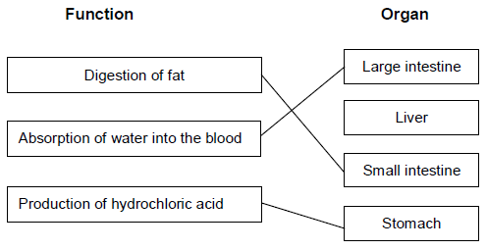
extra lines cancel
3
(b) The concentration in the blood is lower.
1
[7]
Q4. (a) contract / shorten
ignore relax
do not allow expand
1
to churn / move / mix food
accept peristalsis / mechanical digestion
ignore movement unqualified
1
(b) 400
acceptable range 390-410
allow 1 mark for answer in range of 39 to 41
allow 1 mark for answer in range of 3900 to 4100
2
(c) to transfer energy for use
allow to release / give / supply / provide energy
do not allow to ‘make’ / ߢproduce’ / ‘create’ energy
allow to make ATP
ignore to store energy
1

by (aerobic) respiration or from glucose
do not allow anaerobic energy released for respiration = max 1 mark
1
(d) (i) to make protein / enzyme
ignore ‘antibody’ or other named protein
1
(ii) too small / very small
allow light microscope does not have sufficient magnification / resolution
allow ribosomes are smaller than mitochondria
ignore not sensitive enough
ignore ribosomes are transparent
1
[8]
Q5. (a) (i) A
(ii) B
for 1 mark each
2
(b) diffusion (reject osmosis)
for one mark
1
(c) C
because uptake against a concentration / diffusion gradient
(reject osmosis)
(if C not given, then idea of movement essential)
for 1 mark each
2
[5]
Q6.Level 3 (5–6 marks):
A detailed and coherent explanation is provided with most of the relevant content, which demonstrates a comprehensive understanding of the human circulatory system . The response makes logical links between content points.
Level 2 (3–4 marks):
The response is mostly relevant and with some logical explanation. Gives a broad understanding of the human circulatory system. The response makes some logical links between the content points.
Level 1 (1–2 marks):
Simple descriptions are made of the roles of some of the following: heart function, gas exchange, named blood vessels, named blood cells. The response demonstrates limited logical linking of points.
0 marks:
No relevant content.
Indicative content
• dual / double circulatory system which means that it has higher blood pressure and a greater flow of blood to the tissues
• heart made of specialised (cardiac) muscle cells which have long protein filaments that can slide past each other to shorten the cell to bring about contraction for pumping blood
• heart pumps blood to lungs in pulmonary artery so that oxygen can diffuse into blood from air in alveoli
• blood returns to heart via pulmonary vein where muscles pump blood to the body via aorta
• oxygen carried by specialised cells / RBCs which contain haemoglobin to bind oxygen and have no nucleus so there is more space available to carry oxygen
• arteries carry oxygenated blood to tissues where capillaries deliver oxygen to cells for respiration and energy release
• thin walls allow for easy diffusion to cells
• large surface area of capillaries to maximise exchange
• waste products removed eg CO₂ diffuse from cells into the blood plasma
• blood goes back to the heart in veins which have valves to prevent backflow
• cardiac output can vary according to demand / is affected by adrenaline

accept annotated diagrams
[6]
Q7. (a) (0.15 / 1.35) × 100
1
11.1 (%) allow 11.1 (%) with no working shown for 2 marks
1
(b) to allow results to be compared
or
they had different masses at the start
1
(c) axis correct scale and labelled
1

5 points correctly plotted allow ecf from 05.1
allow 1 mark for 4 points correctly plotted
2
line of best fit
1
(d) 0.5 allow 0.45–0.55
1
(e) (0.0 to 0.4) water moves into cells
1
(0.6 to 0.8) water leaves cells
1
by osmosis
1
(f) any two from:
• concentration of solutions
• drying of chips
• accuracy of balance
• evaporation from tubes
2
[13]
Q8. (a) (i) xylem
1
(ii) water
1
minerals / ions / named example(s) ignore nutrients
1
(b) (i) movement of (dissolved) sugar
allow additional substances, eg amino acids / correct named sugar (allow sucrose / glucose)
allow nutrients / substances / food molecules if sufficiently qualified
ignore food alone
1
(ii) sugars are made in the leaves
1
so they need to be moved to other parts of the plant for respiration / growth / storage
1
(c) (i) mitochondria
1
(ii) for movement of minerals / ions Do not accept ‘water’
1
against their concentration gradient
1
[9]
Q9. Marks awarded for this answer will be determined by the Quality of Written Communication (QWC) as well as the standard of the scientific response. Examiners should also apply a ‘best-fit’ approach to the marking.
0 marks
No relevant content.
Level 1 (1 – 2 marks)

An example is given of a named substance or
a process
or
there is an idea of why diffusion is important eg definition.
Level 2 (3 – 4 marks)
At least one example of a substance is given
and
correctly linked to a process in either animals or plants.
Level 3 (5 – 6 marks)
There is a description of a process occurring in either animals or plants that is correctly linked to a substance
and
a process occurring in the other type of organism that is correctly linked to a substance.

examples of points made in the response
Importance of diffusion:
• to take in substances for use in cell processes
• products from cell processes removed
Examples of processes and substances:
• for gas exchange / respiration: O₂ in / CO₂ out
• for gas exchange / photosynthesis: CO₂ in / O₂ out
• food molecules absorbed: glucose, amino acids, etc
• water absorption in the large intestine
• water lost from leaves / transpiration
• water absorption by roots
• mineral ions absorbed by roots
extra information
Description of processes might include:
• movement of particles / molecules / ions
• through a partially permeable membrane
• (movement of substance) down a concentration gradient
• osmosis: turgor / support / stomatal movements
[6]

Mark schemes
Q1.
(a) ventricle
1
(b) lungs
1
(c) valve circled on heart
1
(d) no fatty deposit
1
healthy artery is wider / bigger hole / has more blood flow
1
(e) statins
1
stent
1
(f) any two from:
• smoking
• high-fat diet
• lack of exercise allow:
• overweight / obese
• having high blood pressure
• having high cholesterol
2
(g) 8 (%)
1
(h) more males have coronary heart disease than females
1
[11]
Q2.
(a) (i) water / H₂O
accept oxygen
allow H₂O
do not allow H²O or H2O
1
(ii) the mineral ions are absorbed by active transport
1
the absorption of mineral ions needs energy
1
(iii) have (many root) hairs
1
(which) give a large surface area (for absorption)
1
(b) carbon dioxide in
or
oxygen out
or
control water loss
accept gas exchange
ignore gases in and out
ignore gain / lose water
1
(c) (i) guard cells
1
(ii) (stomata are) closed
allow there is no gap / space
1
(iii) plant will wilt / droop
ignore die
1
[9]
Q3.
(a)
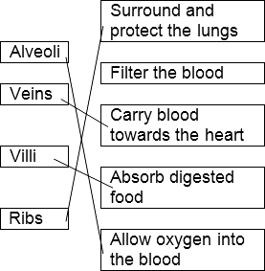

4 correct = 4 marks
3 correct = 3 marks
2 correct = 2 marks
1 correct = 1 mark
extra line from a structure cancels the mark
4
(b) diffusion
1
[5]
Q4.
(a) (i) without oxygen
allow not enough oxygen
ignore air
ignore production of CO₂
ignore energy
1
(ii) more / high / increased lactic acid (at end)
allow approximate figures (to show increase)
ignore reference to glucose
1
(b) (i) 1.5
allow only 1.5 / 1½ / one and a half
1
(ii) increases at first and levels off
ignore subsequent decrease
1
suitable use of numbers eg
rises to 10 / by 9 (dm³ per min)
or
increases up to 1.5 (min) / levels off after 1.5 (min) (of x axis timescale)
allow answer in range 1.4 to 1.5
or
after the first minute (of the run)
1
(iii) supplies (more) oxygen
1
supplies (more) glucose
1
need ‘more/faster’ once only for full marks
allow removes (more) CO₂ / lactic acid / heat as an alternative for either marking point one or two, once only
for (more) respiration
1
releases (more) energy (for muscle contraction)
do not allow energy production or for respiration
1
[9]

Q5.
(a) (i) xylem
1
(ii) water
1
minerals / ions / named example(s) ignore nutrients
1
(b) (i) movement of (dissolved) sugar
allow additional substances, eg amino acids / correct named sugar (allow sucrose / glucose)
allow nutrients / substances / food molecules if sufficiently qualified
ignore food alone
1
(ii) sugars are made in the leaves
1
so they need to be moved to other parts of the plant for respiration / growth / storage
1
(c) (i) mitochondria
1
(ii) for movement of minerals / ions Do not accept ‘water’
1
against their concentration gradient
1
[9]
Q6.
(a) digested / broken down / made soluble by protease enzyme
in stomach
in small intestine / from stomach / from pancreas
into amino acids
amino acids / small molecules absorbed into blood
any four for 1 mark each
4
(b) ideas that
lipase / enzyme works best in alkaline / neutral conditions
acid denatures or inactivates enzyme / inhibits enzyme activity
bile emulsifies fat / bile produces larger surface area of fats / bile alkaline
for enzyme to work on / which increase activity of enzymes
any three for 1 mark each
3
[7]
Q7. (a) (i) muscular
1
(ii) 7
1
(iii) an electrical device
1
(b) (i) in sequence:
5
1
7
1
2
1
(ii) 3
1
(c) (i) prevent backflow (of blood) / allow flow in only one direction / in the correct direction
1
(ii) A
no mark, but max 2 marks if incorrect
2 / atrium contracts / pressure in 2 increases
1
blood pushes ball (down / towards ventricle / towards 5 )
allow this point even if valve in wrong part of heart
1
(opens valve which) allows blood into 5 / ventricle
or converse points re closing the valve
1
(d) (i) involvement of platelets / eg platelets ‘trigger’ clotting process / release enzyme(s) / release ‘clotting factors’
1
fibrinogen to fibrin
or
meshwork formed (which traps blood cells)
1
(ii) any four from:
to gain 4 marks candidates should include at least:
one advantage and one disadvantage

Advantages
(improved circulation / O₂ supply) provides:
• more cell respiration
• more energy released
• (more) active life / not so tired / more physical activity
Disadvantages
• danger of surgery / operation
• infection from surgery / operation
• valve may need replacing
• clots may form and block blood vessels
may need to take anti-coagulants – eg warfarin
• clots may cause heart attacks / strokes
4
[17]
Q8. (a) 5624
allow 2 marks for:
• correct HR = 148 and correct SV = 38 plus wrong answer / no answer
or
• only one value correct and ecf for answer allow 1 mark for:
• incorrect values and ecf for answer
or
• only one value correct
3
(b) (i) Person 2 has low(er) stroke volume / SV / described
eg Person 2 pumps out smaller volume each beat
do not allow Person 2 has lower heart rate
1
(ii) Person 1 sends more blood (to muscles / body / lungs)
1
(which) supplies (more) oxygen
1
(and) supplies (more) glucose
1
(faster rate of) respiration or transfers (more) energy for use
ignore aerobic / anaerobic
allow (more) energy release
allow aerobic respiration transfers / releases more energy (than anaerobic)
do not allow makes (more) energy
1
removes (more) CO2 / lactic acid / heat allow less oxygen debt
or less lactic acid made
or (more) muscle contraction / less muscle fatigue
if no other mark awarded,
allow person 1 is fitter (than person 2) for max 1 mark
1
[9]
Q9. (a) liver
1
mouth or salivary glands or
duodenum or small intestine or
pancreas
1
Pancreas accept duodenum or ileum or
small intestine do not accept stomach
1
stomach or duodenum or ileum or
small intestine or pancreas
1
(b) teeth breakdown food accept chewing
1
amylase or saliva (breaks down starch)
1
(c) produces bile (salts)
1
emulsifies (fat) or produces droplets or disperses fat)
1
[8]
Q10. (a) fatty acids
1
glycerol
1
(b) (i) any one from:
• (same) amount / 1cm^{3 fat}
• (same) amount / 10cm^{3 lipase / enzyme}
• (kept for) 24 hours or (same length of) time
1
(ii) temperature allow heat / warmth
1
(c) (carry out experiments) using more temperatures / smaller intervals
ignore repeat unqualified do not accept longer time
1
between 20 and 60 °C / around 40 °C
accept extra single temperature in range 20 °C – 60 °C but cannot be 20 °C, 40 °C or 60 °C
1
(d) (i) ‘strong’ acid
1
(ii) enzyme works / not destroyed / not denatured / not damaged
do not accept enzyme not killed
accept any indication that the fat is digested
accept same as tube 3 / tube at 40 °C
accept optimum temperature / at or near body temperature
1
[8]
Q11. (a) 300
1
(b) suitable scale on y-axis
1
label y-axis
1
4 bars drawn correctly allow 1 mark for 3 correct bars
2
(c) increases from 50 to 500
1
then decreases from 500 to 0
1
(d) carbohydrates broken down / digested into sugars
1
broken down by carbohydrase or amylase
1
(e) absorption of glucose
1
into blood
1
by active transport
allow diffusion
1
[12]
Q12.
D – many microvilli (1)
Ex – provide large surface area (1)
five points made
max 3 descriptions
max 3 explanations
D – many capillaries / good blood supply (1)
Ex – maintain concentration / diffusion gradient or quickly removes food (1)
D – thin wall / one cell thick surface / capillaries near surface (1)
allow villi are thin
ignore villi are one cell thick
Ex – short distance for food to travel (1)
D – many mitochondria (1)
Ex – provide energy / ATP for active uptake / transport (1)
[5]

Mark schemes
Q1. (a) any two from:
• acid in the stomach kills pathogens in food
• skin forms a barrier / produces antimicrobial secretions
• hairs in the nose trap (particles which may contain) pathogens
• trachea / bronchi has mucus which traps pathogens
or
bronchi have cilia which waft mucus to throat to be swallowed
2
(b) Level 3 (5–6 marks):
A clear, logical and coherent answer, with no significant redundancy. The student understands the process and links this to reasons for clinical trials.

Level 2 (3–4 marks):
A partial answer with errors and ineffective reasoning or linkage.
Level 1 (1–2 marks):
One or two relevant points but little linkage of points or logical reasoning.

0 marks:
No relevant content.
Indicative content
• pre-clinical trials of the new drug on cells / tissues / live animals
• to test toxicity, dosage and efficacy
• clinical trials / test on healthy volunteers and Ebola patients at very low doses
• so that you can monitor for safety / side effects
• and only then do trials to find the optimum dosage and test for efficacy
• double blind trial / use of placebo
• which does not contain the new drug
• random allocation of Ebola patients to groups
• so no one knows who has placebo / the new drug
• peer review of data
• to help prevent false claims
6
[8]
Q2. (a) mumps
in either order rubella / German measles
both needed for the mark
ignore measles unqualified
1
(b) (i) 80(.0)
allow 1 mark for or 0.8
2
(ii) less chance of epidemic / pandemic
or
less chance of spread of disease / measles / mumps / rubella
allow idea of herd immunity (increased protection for those who are not vaccinated)
ignore less chance of getting the disease or to eradicate the disease
1
(c) (i) dead / inactive pathogens / viruses / bacteria
allow antigens / proteins from pathogens / viruses / bacteria
ignore microorganisms
1
(ii) white blood cells produce antibodies
1
antibodies produced rapidly (on re-infection) or response rapid (on re-infection)
allow ecf if antibodies incorrectly identified in first marking point
1
these antibodies kill pathogens / viruses / bacteria
do not accept idea that original antibodies remain in blood and kill pathogens
1
(d) (i) antibiotics don’t kill viruses allow antibiotics only kill bacteria
1
(because measles) virus / pathogen lives inside cells
allow antibiotics do not work inside cells or killing virus / pathogen would kill / damage cell
1
(ii) (bacteria / pathogens) develop resistance (to antibiotic)
ignore reference to immunity
ignore viruses develop resistance
1
[11]
Q3. (a)
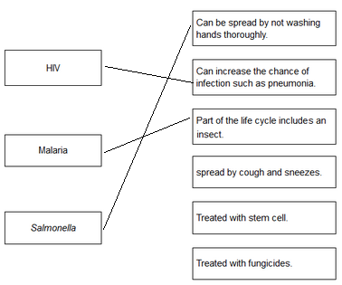
each extra line negates a mark
4
(b) pain when urinating
1
yellow discharge
1
(c) three correct plots allow 1 mark for two correct plots
2
correctly drawn line
1
(d) any three from:
• (fairly) level / steady up to 2009
allow numbers of males fall (slightly) and females rise (slightly) up to 2009
• (there is a) rise after 2009
• males are (always) higher than females
• males rising faster than females
allow overall increase (from 2005 to 2013)
3
(e) HIV is a virus
1
(and) antibiotics are only effective against bacteria
or
antibiotics do not kill viruses
allow viruses live inside cells
1
[13]
Q4. (a) (i) diagram shows extensions of intact cell membrane around viruses
1
(ii) antibodies
allow enzymes re (ii)
allow interferon
ignore antitoxins / proteins
1
(b) virus is transferred
1
(virus in) blood / body fluids – transfer (via needles)
1
[4]
Q5. (a) pathogens
1
(b) (i) A disease affecting people in many countries
1
(ii) birds fly / migrate accept converse
OR
human contact with birds more likely
birds not contained / difficult to control movement
OR
there are more birds (than pigs)
1

(c) (i) antibiotics (only) kill bacteria ignore flu is caused by a virus unqualified
OR
antibiotics don’t kill viruses ignore virus resistant / immune
1
(ii) painkillers
accept any correct named painkiller, eg aspirin or paracetamol
allow antivirals / Tamiflu
ignore medicine / tablets
1
(iii) resistant
1
bacteria
1
in this order
[7]
Q6. (a) (i) small amounts of dead pathogens
1
(ii) decrease
1
by 60 (%)
allow from 70(%) to 10(%) allow other correct data treatment
1
(b) (i) penicillin
1
(ii) any two from:
• antibiotics only kill bacteria
allow antibiotics do not kill viruses
• some bacteria are resistant (to antibiotics)
allow MRSA not killed by antibiotics
• (correct) antibiotics not always used
allow course not completed
• deficiency disease(s) not caused by bacteria or cannot be treated by antibiotics
• inherited disease(s) not caused by bacteria or cannot be treated by antibiotics
• ‘lifestyle’ diseases not caused by bacteria or cannot be treated by antibiotics
eg heart disease / cancer
if no other mark given allow 1 mark for not all diseases are caused by bacteria or some diseases are caused by viruses
2
(c) bacteria grow faster
allow this is body temp (at which pathogens grow)
1
[7]
Q7. (a) droplet infection or aerosol infection
do not accept airborne accept airborne droplets
1
(b) so there is no large group which could catch the infection/pass on the infection
converse – if large numbers can’t pass it on the virus is less likely to reach those few who are susceptible
1
(c) (i) any four of the following points:-
example of a 3 mark answer: Lymphocytes produce specific antibodies…...
comment on specificity applied to antibodies or lymphocytes
(recognition by) lymphocytes;
(white cells) make antibodies;
antibodies destroy/neutralise the virus/antigen/protein subunit;
do not accept antibodies KILL viruses
accept white blood cells replicate
accept some white cells form memory cells/live a long time;
accept subsequent infection results in very rapid antibody production;
max 4
(ii) active;
1
(d) any three of the following points
Structure change in:
protein for binding to host cell;
accept changes in surface proteins (of protein coat)
spike containing enzyme;
changes in antigen
Fit: existing/circulating/old antibodies don’t match new virus strain shape/new antigen/new binding protein;
Wrong antibodies: injection does not stimulate antibodies against all strains/different antigens; accept wrong antibodies for 1 mark
max 3
[10]

Q8. (a) microorganism / bacteria / virus / fungus that causes (infectious) disease
1
(b) reduce / stop use of (current) antibiotics
1
(reduce / stop use) for non-serious / mild / viral infections
allow ensure course is completed allow use of variety of antibiotics
1
(c) (i) 40 °C
1
(ii) any one from:
• microorganisms grow / reproduce / work / act faster
• results / product acquired sooner
1
[5]
Q9. any four from:
• cells used to treat diseases do not go on to produce a baby
• produces identical cells for research
• cells would not be rejected allow cells can form different types of cells
• (immature) egg contains only genetic information / DNA /
genes / chromosomes from mother or there is only one parent
• asexual / no mixing of genetic material / no sperm involved /
no fertilisation or chemical causes development
• baby is a clone
• reference to ethical / moral / religious issues
allow ethically wrong
NB cloning is illegal gains 2 marks ignore unnatural
• risk of damage to the baby in correct context
[4]
Q10.
(a) comparisons are not required but should be credited
accept a clear indication of the statement even if incomplete
can develop into most other types of cell
1
each cell divides every 30 minutes
1
low chance of rejection by the patient’s immune system
1
(b) any three from:
• cheaper / only costs £1000 this must be comparative ignore costs £1000
• can collect many (stem) cells
• adults give permission for their own bone marrow to be collected
comparisons are not required but should be credited
• safe
3
[6]
Q11. Marks should not be awarded for simply copying the information provided
A mark may be awarded for a comparison between treatments if the answer only involves copied information
any four from:
For all 4 marks to be awarded, there must be at least 1 pro and 1 con
embryo stem cells – examples of
pros
• can treat a wide variety / lots of diseases / problems
• many available / plentiful
• using them better than wasting them
• painless
cons
• (possible) harm / death to embryo
• (relatively) untested / unreliable / may not work
allow long term effects not known
or may be more risky
• embryo can’t be ‘asked’ / ‘embryo rights’ idea
adult bone marrow stem cells – examples of
pros
• no ethical issues (in collection) or permission given
• quick recovery
• (relatively) safe
allow does not kill (donor) / low risk
• well tried / tested / know they work
cons
• operation hazards eg infection
• few types of cell / tissue produced or few diseases / problems treated
• painful so may deter donors
4
Conclusion to evaluation: A reasoned conclusion from the evidence
1
[5]
Q12.
(a) 23
1
(b) chromosome nucleus gene cell
2 3 1 4
1
(c) (i) any one from
(cells which are bigger) take up more space
(cells) have to get bigger or mature to divide
1
(ii) chromosomes duplicate or
make exact copies of self accept forms pairs of chromatids
1
nuclei divide accept chromatids or chromosomes separate
1
identical (daughter) cells formed
accept for example, skin cells make more skin cells or cells are clones
1
(d) any two from
Differentiation mark
babies need or are made of different types of cells or cells that have
different functions
accept different cells are needed for different organs
Division or specialisation mark
as fertilised egg starts to divide each cell specialises to form a part of the body
accept specialised cells make different parts of the body
Growth mark
specialised cells undergo mitosis to grow further cells
accept cells divide or reproduce to form identical cells
2
[8]
Q13. (a) chromosomes
1
(b) diagram showing four separate chromosomes two long and two short
(as in diagram 1)
allow each chromosome shown as two joined chromatids
do not allow if chromosomes touching each other
1
(c) (i) any two from:
• can grow into any type of tissue / named tissue
• used in medical research
• used to treat human diseases
• large numbers can be grown
2
(ii) any two from:
• expensive
• grow out of control / ref cancers
• may be rejected
• need for drugs (for rest of life)
2
[6]
Q14. (a) any two from:
• right amount of nutrients or different / all foods
• right amount of energy
• for (individual) needs
‘right amount’ only needed once for both marks to be awarded
2
(b) (i) ovaries / ovary
allow placenta
1
(ii) any one from:
• inhibits follicle stimulating hormone / FSH production
• inhibits maturation of eggs
ignore ref to site of production of FSH
allow stimulates LH production or stimulates preparation of womb lining
1

(iii) any one from:
• stimulate muscle growth
• used in (oral) contraceptives
1
(c) small (rate of) decrease then bigger (rate of) decrease
1
idea that change of rate (of decrease) at 900 (mg per day)
If no other mark awarded allow 1 mark for decrease
1

(d) (i) gene(s) / nucleus / chromosome(s) / DNA
allow ribosome
1
(ii) reduces production of cholesterol (by liver)
allow idea of switching off gene for reductase (production)
allow switch off / reduce / inhibit reductase (production)
allow reduces absorption of cholesterol (by intestine)
allow statins (might) breakdown / destroy cholesterol
1
[9]
Mark schemes
Q1.
(a) no oxygen (is used)
1
(b) muscles become fatigued / stop contracting
1
because not enough energy is transferred
1
(c) carbon dioxide
1
(d) count the bubbles
or
measure volume of gas
1
in a given time
1
(e) brewing / bread making
allow other suitable use of fermentation in food industry
1
[7]
Q2.
(a) (i) without oxygen allow not enough oxygen
ignore air
ignore production of CO₂
ignore energy
1
(ii) more / high / increased lactic acid (at end)
allow approximate figures (to show increase)
ignore reference to glucose
1
(b) (i) 1.5 allow only 1.5 / 1½ / one and a half
1
(ii) increases at first and levels off ignore subsequent decrease
1
suitable use of numbers eg
rises to 10 / by 9 (dm³ per min)
or
increases up to 1.5 (min) / levels off after 1.5 (min) (of x axis timescale)
allow answer in range 1.4 to 1.5
or
after the first minute (of the run)
1
(iii) supplies (more) oxygen
1
supplies (more) glucose
1
need ‘more/faster’ once only for full marks
allow removes (more) CO₂ / lactic acid / heat as an alternative for either marking point one or two, once only
for (more) respiration
1
releases (more) energy (for muscle contraction)
do not allow energy production or for respiration
1
[9]
Q3. (a) any one from: ignore ‘check temperature’
• add a water bath
• heat screen
• use LED
• low energy bulb / described
1
(b) (i) rate / number of bubbles decreases
accept converse with reference to increasing light or shorter distance
or
less oxygen / gas released
ignore reference to rate of photosynthesis
1
(ii) temperature / CO₂ (concentration)
accept ‘it was too cool’ or not enough CO₂
accept number of chloroplasts / amount of chlorophyll
allow heat
allow CO2
do not allow CO²
1
(c) Marks awarded for this answer will be determined by the Quality of Written Communication (QWC) as well as the standard of the scientific response. Examiners should also refer to the information in the Marking guidance, and apply a ‘best-fit’ approach to the marking.
0 marks
No relevant content.
Level 1 (1-2 marks)
There is a brief description of at least 1 tissue or at least 1 function of an indicated part of the leaf.
The account lacks clarity or detail.
Level 2 (3-4 marks)
There is a clear description which includes at least 1 named tissue and at least 1 correct function described for an indicated part of the leaf.
Level 3 (5-6 marks)
There is a detailed description of most of the structures and their functions.
Examples of responses:
• epidermis
• cover the plant
• mesophyll / palisade
• photosynthesises
• phloem
• xylem
• transport.

The following points are all acceptable but beyond the scope of the specification:
• (waxy) cuticle – reduce water loss
• epidermis – no chloroplasts so allows light to penetrate
• stomata / guard cells – allow CO₂ in (and O₂ out) or controls water loss
• palisade (mesophyll) – many chloroplasts to trap light
– near top of leaf for receiving more light
• spongy (mesophyll) – air spaces for rapid movement of gases
6
[9]
Q4.(a) LHS = water
1
RHS = glucose
1
(b) any three from:
• (measure) temperature
ignore reference to fair test
• to check that the temperature isn’t changing
• rate of reaction changes with temperature
• temperature is a variable that needs to be controlled
allow lamp gives out heat
3
(c) (i) 10
correct answer = 2 marks
allow 1 mark for:

allow 1 mark for correct calculation without removal of anomalous result ie 15
2
(ii) graph:
allow ecf from (c)(i)
label on y-axis as ‘number of bubbles per minute’
1
three points correct = 1 mark
allow ± 1 mm
four points correct = 2 marks
2
line of best fit = smooth curve
1
(iii) as distance increases, rate decreases – pro
allow yes between 20 – 40
1
but should be a straight line / but line curves – con / not quite pro
allow not between 10 – 20
if line of best fit is straight line, allow idea of poor fit
1
(d) any four from:
• make more profit / cost effective
• raising temp. to 25 °C makes very little difference at 0.03% CO₂
• (at 20 °C) with CO₂ at 0.1%, raises rate
• (at 20 °C with CO₂ at 0.1%) → >3x rate / rises from 5 to 17
• although 25 °C → higher rate, cost of heating not economical
• extra light does not increase rate / already max. rate with daylight
accept ref to profits c.f. costs must be favourable
4
[17]
Q5. (a) circulating / mixing / described or temperature maintenance
1
supply oxygen
or for aerobic conditions
or for faster respiration
do not allow oxygen for anaerobic respiration
1
(b) energy supply / fuel / use in respiration
do not allow just food / growth
ignore reference to aerobic / anaerobic
or material for growth / to make mycoprotein
1
(c) respiration
allow exothermic reaction allow catabolism
ignore metabolism ignore aerobic / anaerobic
1
(d) (i) any one from:
• compete (with Fusarium) for food / oxygen or reduce yield of Fusarium
• make toxic waste products or they might cause disease / pathogenic or harmful to people / to Fusarium
do not allow harmful unqualified
1
(ii) steam / heat treat / sterilise fermenter (before use)
not just clean
or
steam / heat treat / sterilise
glucose / minerals / nutrients / water (before use)
or
filter / sterilise air intake
or
check there are no leaks
allow sterilisation unqualified not just use pure glucose
1
(e) any three from:
• beef is best or beef is better than mycoprotein
• mycoprotein mainly better than wheat
• more phenylalanine in wheat than in mycoprotein
allow equivalent numerical statements
• but no information given on other amino acids / costs / foods
3
overall conclusion:
statement is incorrect because
either
it would be the best source for vegetarians
or
for given amino acids, beef is the best source
or
three foods provide insufficient data to draw a valid conclusion
1
[10]
Q6.
(a) (i) rate of chemical reactions (in the body)
1
(ii) any two from:
• heredity / inheritance / genetics
• proportion of muscle to fat or (body) mass
allow (body) weight / BMI
• age / growth rate
• gender
accept hormone balance or environmental temperature
ignore exercise / activity
2
(b) (i) 77
correct answer with or without working gains 2 marks
allow 1 mark for 70 / 56 or 1.25 or 5
2
(ii) increase exercise accept a way of increasing exercise
1
reduce food intake accept examples such as eat less fat / sugar
allow go on a diet or take in fewer calories
ignore lose weight
ignore medical treatments such as gastric band / liposuction
1
[7]
Q7. (a) LHS – carbon dioxide / CO₂
allow CO2 ignore CO²
1
RHS in either order
glucose / carbohydrate / sugar allow starch allow C₆H₁₂O₆ / C6H12O6 ignore C⁶H¹²O⁶
1
Oxygen allow O₂ / O2 ignore O² / O
1
(b) any five from:
• factor 1: CO² (concentration)
• effect - as CO₂ increases so does rate and then it levels off or shown in a graph
• explanation:
(graph increases) because CO₂ is the raw material or used in photosynthesis / converted to organic substance / named eg
or
(graph levels off) when another factor limits the rate.
accept points made via an annotated / labelled graph
• factor 2: temperature
allow warmth / heat
• effect – as temperature increases, so does the rate and then it decreases or shown in a graph
allow ‘it peaks’ for description of both phases
• explanation:
(rise in temp) increases rate of chemical reactions / more kinetic energy
allow molecules move faster / more collisions
or
(decreases) because the enzyme is denatured.
context must be clear = high temperature
allow other factor plus effect plus explanation:
eg light wavelength / colour / pigments / chlorophyll / pH / minerals / ions / nutrients / size of leaves
2nd or 3rd mark can be gained from correct description and explanation
5
[8]
Q8. (a) anaerobic respiration allow phonetic spelling
1
(b) (i) 4.4
4.2, 4.3, 4.5 or 4.6 with figures in tolerance (6.7 to 6.9 and 2.3 to 2.5) and correct working gains 2 marks
4.2, 4.3, 4.5 or 4.6 with no working shown or correct working with one reading out of tolerance gains 1 mark
correct readings from graph in the ranges of 6.7 to 6.9 and 2.3 to 2.5 but no answer / wrong answer gains 1 mark
2
(ii) more energy is needed / used / released
do not allow energy production
(at 14 km per hour) ignore work
1
not enough oxygen (can be taken in / can be supplied to muscles)
allow reference to oxygen debt
do not allow less / no oxygen
1
so more anaerobic respiration (to supply the extra energy) or more glucose changed to lactic acid allow not enough aerobic respiration
1
[6]
Q9. (a) (i) 50
1
(ii) 4 accept 3.9 − 4.0
1
(b) (i) glucose
1
oxygen
1
(ii) to release more energy
1
(c) correct readings from graph:
a = 120
b = 60 allow 60 - 61
1
calculation correct for candidate’s figures: e.g. a − b = 60
1
level of fitness correct for candidate’s figures: e.g. very fit
1
(d) any four from:
• higher heart rate (at 16 km / h) (so takes longer to slow to normal)
• more energy needed
• not enough O₂ supplied / more O₂ needed / reference to O₂-debt
• (more) anaerobic respiration
• (more) lactic acid made / to be broken down / to remove / to oxidise
• higher blood flow needed to deliver (the required amount of) oxygen.
‘more’ must be given at least once for full marks do not allow more energy produced
allow higher blood flow to remove lactic acid / remove (additional) CO₂
4
[12]
Q10. (a) 5624 allow 2 marks for:
correct HR = 148 and correct SV = 38 plus wrong answer / no answer
or
only one value correct and ecf for answer
allow 1 mark for:
incorrect values and ecf for answer only one value correct
3
(b) (i) Person 2 has low(er) stroke volume / SV / described
eg Person 2 pumps out smaller volume each beat do not allow Person 2 has lower heart rate
1
(ii) Person 1 sends more blood (to muscles / body / lungs)
1
(which) supplies (more) oxygen
1
(and) supplies (more) glucose
1
(faster rate of) respiration or transfers (more) energy for use
ignore aerobic / anaerobic allow (more) energy release
allow aerobic respiration transfers / releases more energy (than anaerobic)
do not allow makes (more) energy
1
removes (more) CO2 / lactic acid / heat allow less oxygen debt
or less lactic acid made
or (more) muscle contraction / less muscle fatigue
if no other mark awarded, allow person 1 is fitter (than person 2) for max 1 mark
1
[9]
Q11. (a) (i) LHS = water accept H₂O do not accept H²O / H2O
1
RHS = oxygen accept O₂ do not accept O / O² / O2
1
(ii) light / sunlight ignore solar / sun / sunshine
do not allow thermal / heat
1
(iii) chloroplasts allow chlorophyll
1
(b) (i) 20
1
(ii) any one from:
• light (intensity)
• temperature.
1
(c) (i) To increase the rate of growth of the tomato plants
1
(ii) Because it would cost more money than using 0.08%
1
Because it would not increase the rate of photosynthesis of the tomato plants any further
1
[9]

