Questions
Q1.
A solid is soluble in water and produces steamy acidic fumes with concentrated sulfuric acid. The solid could be

A potassium carbonate.
B magnesium sulfate.
C silver chloride.
D sodium chloride.
(Total for Question = 1 mark)

Q2.
Which of the following equations represents the change when concentrated sulfuric acid is added to solid potassium chloride at room temperature?
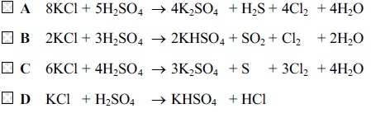
(Total for question = 1 mark)

Q3.
Which of these statements about fluorine is not correct?
A It is a gaseous element at room temperature and pressure.
B It can react with chloride ions to form chlorine.
C It forms salts with Group 1 metals.
D It is less electronegative than chlorine.
(Total for question = 1 mark)

Q4.
Which of the following statements is true?
A Calcium hydroxide is more soluble in water than magnesium hydroxide.
B Chlorine is more electronegative than fluorine.
C Iodine is a stronger oxidizing agent than bromine.
D The first ionization energy of barium is greater than that of strontium.
(Total for question = 1 mark)

Q5.
Which of the following is not a true statement about hydrogen iodide?
A It forms steamy fumes in moist air.
B It dissolves in water to form an acidic solution.
C It forms a cream precipitate with silver nitrate solution.
D It forms dense white smoke with ammonia.
(Total for question = 1 mark)

Q6.
What are the products, other than water, when chlorine is passed through cold, dilute aqueous sodium hydroxide solution?
A NaCl and NaClO
B NaClO and NaClO₃
C NaCl and NaClO₃
D NaClO and NaClO₄
(Total for question = 1 mark)

Q7.
Which of the following is the correct equation for the decomposition of the corresponding nitrate?
A 4LiNO₃ → 2Li₂O + 4NO₂ + O₂
B 4NaNO₃ → 2Na₂O + 4NO₂ + O₂
C Mg(NO₃)₂ → Mg(NO₂)₂ + O₂
D Ba(NO₃)₂ → Ba(NO₂)₂ + O₂

(Total for question = 1 mark)

Q8.
The equation for the reaction between limewater and hydrochloric acid, including state
symbols, is
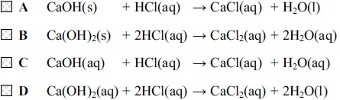
(Total for question = 1 mark)

Q9.
The correct balanced equation for the reaction between heated magnesium and steam, including state symbols, is
A
B
C
D
(Total for Question = 1 mark)

Q10.
When a flame test is carried out on calcium iodide, the colour of the flame is
A yellow-red.
B pale green.
C purple.
D crimson.

(Total for question = 1 mark)

Q11.
The colour observed in a flame test is due to
A electrons jumping to a higher energy level, absorbing energy.
B electrons jumping to a higher energy level, emitting energy.
C electrons dropping from a higher energy level, absorbing energy.
D electrons dropping from a higher energy level, emitting energy.
(Total for question = 1 mark)

Q12.
Which of these metals will give a lilac flame colour?
A Sodium
B Calcium
C Potassium
D Magnesium
(Total for question = 1 mark)

Q13.
The flame produced by a compound containing barium in a flame test is
A colourless.
B green.
C red.
D yellow.
(Total for question = 1 mark)

Q14.
Which concentrated acid would be best for mixing with a salt to carry out a flame test?
A Hydrochloric acid
B Nitric acid
C Phosphoric(V) acid
D Sulfuric acid
(Total for question = 1 mark)

Q15.
Chlorides of Group 1 elements produce coloured flames when
A electrons become excited to a higher energy level.
B excited electrons move from a higher to a lower energy level.
C an outer electron leaves the atom.
D electrons move between the negative and positive ions.
(Total for question = 1 mark)

Q16.
This question is about the following compounds.
A Barium carbonate
B Lithium nitrate
C Potassium bromide
D Potassium nitrate
(a) Which compound gives a green colour in a flame test?
(1)
A
B
C
D
(b) Which compound gives a lilac colour in a flame test and does not decompose on heating?
(1)
A
B
C
D
(Total for question = 2 marks)

Q17.
Which of the following could not be an element in Group 2?
A An element with an oxide which forms a solution of pH 10.
B An element with an insoluble sulfate.
C An element with a chloride which is liquid at room temperature.
D An element with a carbonate which decomposes on heating.
(Total for question = 1 mark)

Q18.
Which of the following does not apply to the elements Mg, Ca, Sr and Ba in Group 2 of the Periodic Table?
A Their oxides, MO, are all basic.
B Their metal hydroxides, M(OH)₂, become more soluble down the group.
C Their oxides, MO, react with water to form the metal hydroxide, M(OH)₂.
D Their carbonates, MCO₃, all decompose on gentle heating.
(Total for question = 1 mark)

Q19.
As Group 2 is descended
A the solubility of hydroxides and of sulfates increases.
B the solubility of hydroxides increases and of sulfates decreases.
C the solubility of hydroxides decreases and of sulfates increases.
D the solubility of hydroxides and of sulfates decreases.
(Total for question = 1 mark)

Q20.
Compound X is a white solid. On heating this compound, a colourless, acidic gas is the only gaseous product. A flame test is carried out on the solid residue and a reddish flame is observed.
Compound X is
A calcium nitrate.
B calcium carbonate.
C magnesium carbonate.
D strontium nitrate.
(Total for question = 1 mark)

Q21.
This question concerns the trends in properties on descending Group 2 of the Periodic Table.
(a) What are the trends in solubility of sulfates and hydroxides down Group 2?
(1)
A Sulfates increase, hydroxides decrease.
B Sulfates decrease, hydroxides increase.
C Sulfates increase, hydroxides increase.
D Sulfates decrease, hydroxides decrease.
(b) What are the trends in thermal stability of carbonates and nitrates down Group 2?
(1)
A Carbonates increase, nitrates decrease.
B Carbonates decrease, nitrates increase.
C Carbonates increase, nitrates increase.
D Carbonates decrease, nitrates decrease.
(c) What are the trends in first ionization energy and electronegativity of the elements
down Group 2?
(1)
A Ionization energy increases, electronegativity decreases.
B Ionization energy decreases, electronegativity increases.
C Ionization energy increases, electronegativity increases.
D Ionization energy decreases, electronegativity decreases.
(Total for Question = 3 marks)

Q22.
As you go down Group 2 of the Periodic Table, which of the following decreases?
A The reactivity of the elements.
B The solubility of the hydroxides of the elements.
C The solubility of the sulfates of the elements.
D The thermal stability of the carbonates of the elements.
(Total for question = 1 mark)

Q23.
Which of the following statements about the elements in Group 7 is incorrect?
A They all show variable oxidation states in their compounds.
B They all form acidic hydrides.
C Electronegativity decreases as the group is descended.
D They all exist as diatomic molecules.
(Total for question = 1 mark)

Q24.
When concentrated sulfuric acid is added to solid sodium bromide, bromine is produced.
When concentrated sulfuric acid is added to solid sodium chloride, no chlorine is produced.
The reason for this difference is
A sulfuric acid is a strong acid.
B hydrogen chloride is a weak acid.
C the chloride ion is a weaker reducing agent than the bromide ion.
D bromine is less volatile than chlorine.
(Total for question = 1 mark)

Q25.
What would be the experimental observations if chlorine gas was bubbled through potassium iodide solution, followed by the addition of cyclohexane?

A The solution turns brown, then two layers are produced and the top layer is purple.
B A white precipitate is formed, which then dissolves to leave a colourless solution.
C Bubbles of gas are seen and then a brown precipitate is formed.
D The solution remains colourless, and then two layers are seen with the bottom layer being brown.
(Total for Question = 1 mark)

Q26.
Which of the following properties of the elements chlorine, bromine and iodine increases with increasing atomic number?
A Boiling temperature
B Bond enthalpy
C Electronegativity
D First ionization energy
(Total for question = 1 mark)

Q27.
When solid samples of sodium carbonate and magnesium carbonate are strongly heated
A both compounds decompose.
B sodium carbonate decomposes but magnesium carbonate does not.
C magnesium carbonate decomposes but sodium carbonate does not.
D neither compound decomposes.
(Total for question = 1 mark)

Q28.
When samples of magnesium nitrate, Mg(NO₃)₂, and calcium nitrate, Ca(NO₃)₂, are heated
A both compounds decompose to form the corresponding nitrite and oxygen.
B both compounds decompose to form the corresponding oxide, nitrogen dioxide and oxygen.
C magnesium nitrate decomposes to form magnesium nitrite and oxygen whereas calcium nitrate decomposes to form calcium oxide, nitrogen dioxide and oxygen.
D magnesium nitrate decomposes to form magnesium oxide, nitrogen dioxide and oxygen whereas calcium nitrate decomposes to form calcium nitrite and oxygen.
(Total for question = 1 mark)

Q29.
What colour precipitate would you expect to see if 1-bromopropane was heated with a
solution of silver nitrate?
A Orange
B White
C Yellow
D Cream
(Total for question = 1 mark)

Q30.
What would be the colour of the solution when iodine is dissolved in a hydrocarbon
solvent?
A Grey
B Brown
C Yellow
D Purple
(Total for question = 1 mark)

Q31.
When solutions of iodine are titrated with aqueous sodium thiosulfate solution, Na₂S₂O₃(aq), the thiosulfate ions are oxidized to
A S₂O₄²⁻
B S₂O₆²⁻
C S₂O₈²⁻
D S₄O₆²⁻
(Total for question = 1 mark)

Q32.
For barium, the third ionization energy is higher than the second ionization energy because
A there is an increase in the number of protons.
B there is an increase in the shielding.
C the ionic radius is greater.
D the electron being removed is closer to the nucleus.

(Total for question = 1 mark)

Q33.
Hydrochloric acid and sodium carbonate solution react as shown below.
2HCl(aq) + Na₂CO₃(aq) → 2NaCl(aq) + CO₂(g) + H₂O(l)
Which sample of sodium carbonate solution will be neutralized by 20 cm³ of 0.05 mol dm⁻³ hydrochloric acid?
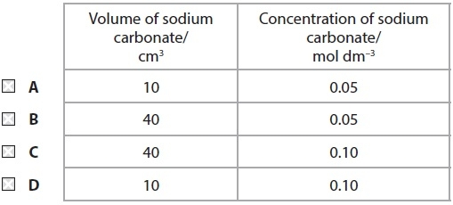
(Total for Question = 1 mark)

Q34.
Going down Group 2 from calcium to barium

A the first ionization energy of the element increases.
B the strength of the metallic bonding increases.
C the polarizing power of the 2+ ion decreases.
D the stability of the nitrate to heat decreases.
(Total for Question = 1 mark)

Q35.
Iodine can react with sodium hydroxide solution to form NaIO₃(aq), according to the
equation below.
Which of the statements about the reaction is false?
A The oxidation number of some iodine atoms goes up.
B At high temperatures NaIO(aq) also forms.
C Sodium ions are spectator ions.
D The oxidation number of some iodine atoms goes down.
(Total for question = 1 mark)

Q36.
When excess calcium is added to water, effervescence occurs and
A a clear colourless solution is formed.
B a cloudy suspension is formed.
C an orange-red flame is seen.
D a yellow flame is seen.
(Total for question = 1 mark)

Q37.
Which of the following reactions is the most likely to occur with chlorine in hot, concentrated sodium hydroxide solution?
A Cl₂ + 2NaOH → NaCl + NaClO + H₂O
B 2Cl₂ + 4NaOH → 3NaCl + NaClO₂ + 2H₂O
C 3Cl₂ + 6NaOH → 5NaCl + NaClO₃ + 3H₂O
D 4Cl₂ + 8NaOH → 7NaCl + NaClO₄ + 4H₂O

(Total for question = 1 mark)

Q38.
Which silver halide is a cream coloured solid which darkens in sunlight and dissolves in concentrated ammonia solution?
A AgF
B AgCl
C AgBr
D AgI
(Total for Question = 1 mark)

Q39.
Consider the following Group 2 compounds.
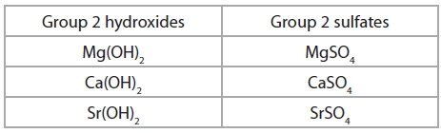
The solubility
A increases down the group for both hydroxides and sulfates.
B increases down the group for hydroxides but increases up the group for sulfates.
C increases up the group for hydroxides but increases down the group for sulfates.
D increases up the group for both hydroxides and sulfates.

(Total for question = 1 mark)

Q40.
Which of these metal hydroxides is the most soluble in water?
A Barium hydroxide
B Calcium hydroxide
C Magnesium hydroxide
D Strontium hydroxide
(Total for question = 1 mark)

Q41.
The best way to confirm the presence of iodine in an aqueous solution is
A adding hexane to form a purple layer.
B adding hexane to form an orange layer.
C adding acidified silver nitrate solution to form a yellow precipitate which is soluble in concentrated ammonia.
D adding acidified silver nitrate solution to form a yellow precipitate which is insoluble in concentrated ammonia.
(Total for question = 1 mark)

Q42.
Starch is often used as an indicator in titrations between sodium thiosulfate and iodine
solutions. What colour change would you see at the end-point as sodium thiosulfate is
added to iodine solution in the presence of starch?
A Yellow to colourless
B Colourless to yellow
C Blue-black to colourless
D Colourless to blue-black
(Total for question = 1 mark)

Q43.
A white solid produces oxygen when it is heated, but no other gases. The solid could be

A lithium nitrate.
B potassium nitrate.
C strontium nitrate.
D calcium oxide.
(Total for Question = 1 mark)

Q44.
The concentration of a solution of potassium iodate(V) can be determined by the liberation of iodine, followed by titration with sodium thiosulfate.
A suitable indicator is

A methyl orange.
B phenolphthalein.
C starch.
D universal indicator.
(Total for Question = 1 mark)

Q45.
10.0 cm³ of 0.250 mol dm⁻³ potassium hydroxide solution was placed in a conical flask
and titrated with 0.200 mol dm⁻³ hydrochloric acid solution, using phenolphthalein as an
indicator.
(a) What colour would phenolphthalein turn at the end-point in this titration?
(1)
A Colourless
B Pink
C Yellow
D Orange
(b) The best piece of apparatus to accurately measure out 10.0 cm³ is a
(1)
A pipette
B burette.
C syringe.
D measuring cylinder.
(c) What volume of 0.200 mol dm⁻³ hydrochloric acid solution was added by the
end-point?
(1)
A 8.00 cm³
B 10.00 cm³
C 12.50 cm³
D 25.00 cm³
(Total for question = 3 marks)

Q46.
During a titration, when the solution in a pipette is transferred to a conical flask, a small amount of liquid remains in the tip of the pipette. This situation should be dealt with by
A leaving the liquid in the pipette which is calibrated to allow for it.
B slightly over-filling the pipette to compensate for the additional volume.
C carefully blowing the liquid out of the pipette to ensure that it is empty.
D repeating the titration.
(Total for question = 1 mark)

Q47.
A series of titrations is carried out using the same conical flask. Before carrying out each titration, the conical flask must be
A rinsed with ethanol.
B rinsed with distilled or deionised water.
C rinsed with the solution that it will contain.
D dried to remove all traces of liquid.
(Total for question = 1 mark)

Q48.
The tolerance of a 25 cm³ pipette is ±0.06 cm³. The percentage error in the measurement of 25 cm³ using this pipette is
A ±0.06%
B ±0.12%
C ±0.24%
D ±0.48%
(Total for question = 1 mark)

Q49.
Which of the following trends occurs going down the elements in Group 2?
A The solubility of the hydroxides increases.
B The first ionization energy increases.
C The solubility of the sulfates increases.
D The stability of the carbonates to heat decreases.
(Total for question = 1 mark)

Q50.
20 cm³ of sulfuric acid, concentration 0.25 mol dm⁻³, was neutralized in a titration with barium hydroxide, concentration 0.50 mol dm⁻³. The equation for the reaction is
(a) The volume of barium hydroxide required was
(1)
A 10 cm³
B 20 cm³
C 25 cm³
D 40 cm³
(b) During the titration, the barium hydroxide was added until it was present in excess.
The electrical conductivity of the titration mixture
(1)
A increased steadily.
B decreased steadily.
C increased and then decreased.
D decreased and then increased.
(Total for question = 2 marks)

Q51.
Calculate the volume of dilute sulfuric acid, concentration 0.500 mol dm⁻³, required to neutralize 20.0 cm³ aqueous sodium hydroxide, concentration 0.100 mol dm⁻³.
A 2.0 cm³
B 4.0 cm³
C 8.0 cm³
D 20.0 cm³
(Total for question = 1 mark)

Mark Scheme
Q1.

Q2.

Q3.

Q4.

Q5.

Q6.

Q7.

Q8.

Q9.

Q10.

Q11.

Q12.

Q13.

Q14.

Q15.

Q16.

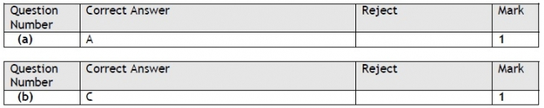

Q17.

Q18.

Q19.

Q20.

Q21.
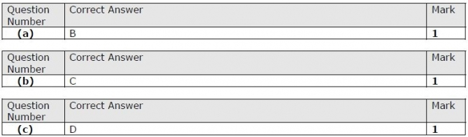

Q22.

Q23.

Q24.

Q25.

Q26.

Q27.

Q28.

Q29.

Q30.

Q31.

Q32.

Q33.

Q34.

Q35.

Q36.

Q37.

Q38.

Q39.

Q40.

Q41.

Q42.

Q43.

Q44.

Q45.

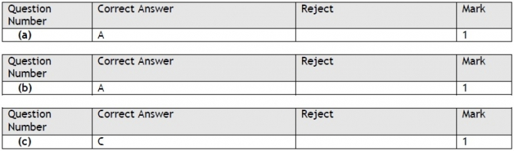

Q46.

Q47.

Q48.

Q49.

Q50.

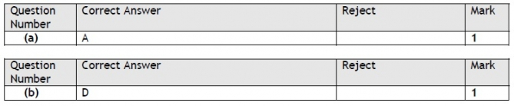

Q51.

