Year

Homophones 1

Commissioned by The PiXL Club Ltd.
August 2019
This resource is strictly for the use of member schools for as long as they remain members of The PiXL Club. It may not be copied, sold nor transferred to a third party or used by the school after membership ceases. Until such time it may be freely used within the member school. All opinions and contributions are those of the authors. The contents of this resource are not connected with nor endorsed by any other company, organisation or institution.PiXL Club Ltd endeavour to trace and contact copyright owners. If there are any inadvertent omissions or errors in the acknowledgements or usage, this is unintended and PiXL will remedy these on written notification.

© Copyright ThePiXL Club Limited, 2019

Homophones 1
Choose the correct homophone to complete each of the sentences below and write it on the line.

The teacher could not ___________ what the boy was saying because the children were making too much noise. | here hear
I wasn’t sure whether the answer to the calculation was ________ or five. | two too to
All the children were ___________ in the DT lesson because they were concentrating on their designs. | quiet quite
As he walked along the shore, he stared out at the ___________ and wondered what creatures lurked in its depths. | see sea
All the countries on the map are labelled with ___________ national flag beside them. | their they’re there
The storm hammered wildly at the door and the wind howled as it ___________ dust down the chimney and into the fireplace. | blew blue

Insert the correct homophone into each of the sentences below. Use the picture as a clue.

Through the towering trees, the __________________  rode swiftly on his horse towards the distant castle. | 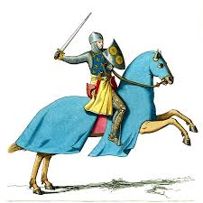
The American black __________________ is an omnivore  which eats plants and berries but also fish. | 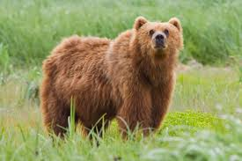

Answers: Homophones 1
Included in each answer is a possible strategy that teachers could use to support pupils in remembering each homophone.

1. hear: you hear with your ear
2. two: link to twice and twins where you can hear the ‘w’
3. quiet: ends with a ‘t’ like silent
4. sea: you see with two eyes
5. their: ther not the e
6. blew: the wind blew

1. knight: a knight protects the king; pronounce the word k-night
2. bear: bears have ears

