On July 28th 1914 began the outbreak of the First World War, aka World War 1 or The Great War for Civilisation. Join us as we learn everything there is to know in our World War 1 facts…
World War 1 facts: Why did it start?
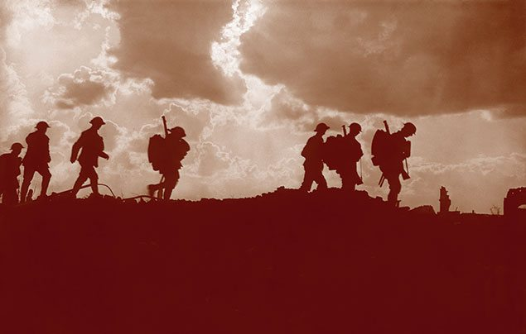
A hundred years might seem like a very long time ago, but it isn’t really. Your great-great grandparents were around then, and they would have lived through, and maybe even taken part in, this terrible conflict.
Lots of history books have been written on World War 1 facts and why it started. But it all boils down to the fact that Europe had split into two large families of countries. The Allies — the British Empire, France, Belgium, Russia and later, the USA — were in one family. And the Central Powers of Germany, Austria, Hungary, Bulgaria and Turkey were in the other. On 4 August 1914, Germany invaded Belgium, and so, standing by its promise to stick up for Belgium, Britain declared war on Germany. The world was at war…

How long did World War 1 last?
When the First World War began that summer, most people thought it would be over by Christmas. Many believed that Britain was so powerful it could win very quickly. In fact, the First World War lasted four terrible years, not four months.
Life in the trenches in World War 1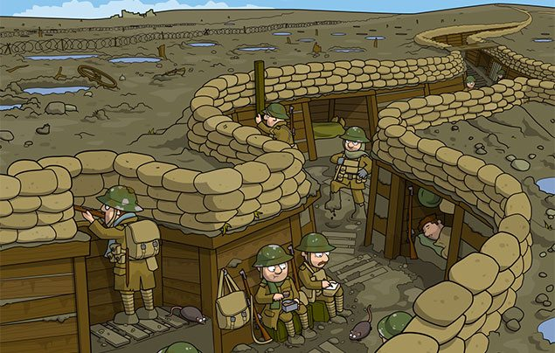Soldiers in the trenches would spend their days doing chores, firing at the enemy, playing cards and writing letters home. Incredibly, nine out of ten men survived!
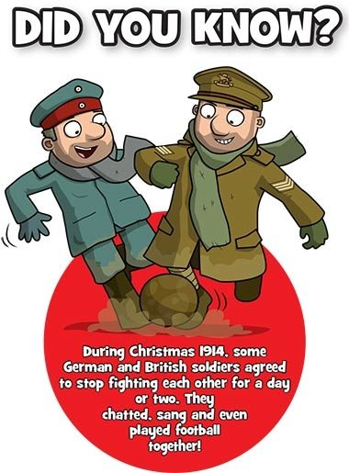
By the winter of 1915, the opposing sides had both dug long ditches called trenches which faced each other, in some places just 30m apart! These lines of narrow trenches stretched from the Belgian coast to Switzerland, and were known as the Western Front. Over five million British soldiers spent time living in these muddy, miserable ditches, taking it in turns to be on the Front Line — the trench closest to the enemy.
Day-to-day life there was smelly and grim. There were millions of giant rats, overflowing latrines (loos) and terrible lice infestations. Not to mention the dead bodies. Every so often, soldiers on the Front Line would be instructed to leave their trench and venture into dangerous No Man’s Land (the area between the sides) to try to push back the enemy.

A new type of war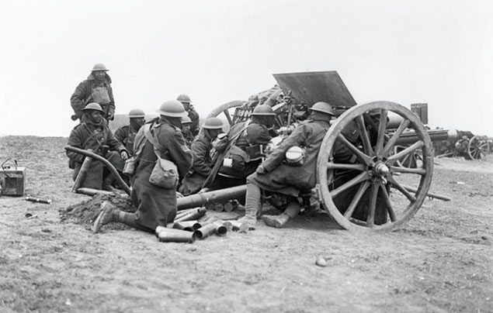These big guns were new to warfare.
This war was very different from conflicts of the past. For the first time, powerful new weapons and vehicles were used – at sea, on land and in the air – resulting in many people being killed or wounded. In Britain, you could sometimes hear what sounded like thunder coming across the English Channel from Europe. In fact, it was the huge boom of big guns, called artillery, being fired on the Western Front. 75% of all men who died in World War 1 were killed by artillery.
The largest battle of the World War 1 – the Battle of the Somme – is known as one of the bloodiest battles in history. It was fought by the French and British against the Germans on both sides of the River Somme in France, and lasted for more than five months. Over a million men were killed or wounded, and it was the first time that a tank was used in combat.

Animals during World War 1
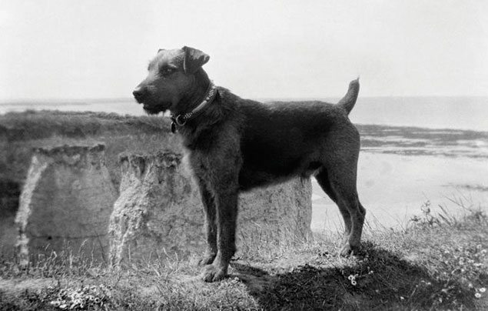This brave Airedale terrier, called Jim, was trained to spot Zeppelins approaching the Kent coast.
Both on the battlefield and back at home, some incredible creatures helped to transport soldiers and goods – and save lives.
Almost a million horses were involved in the war. Soldiers on horseback were known as the Cavalry and horses also pulled some of the gigantic guns, ambulances and supply wagons. Gas from horse droppings could even be used to power lamps!
British families gave their pet dogs to the army so they could carry messages in special tubes on their collars (see above). Dogs were fast, difficult to shoot at, and they also caught rats! Pet pigeons were drafted in to carry messages over long distances, often carrying news from the Front Line back to Britain — Germans trained hawks to kill any carrier pigeons they saw. Goldfish did their bit too — after gas attacks, the gas masks were washed and rinsed. And if the rinsing water killed a goldfish that was placed in it, that meant the masks still had poison on them!

What was life like in Britain during World War 1?
Just because you weren’t in the battle fields didn’t mean you weren’t in the danger zone. Back on the Home Front, Britain was under attack from all sides.
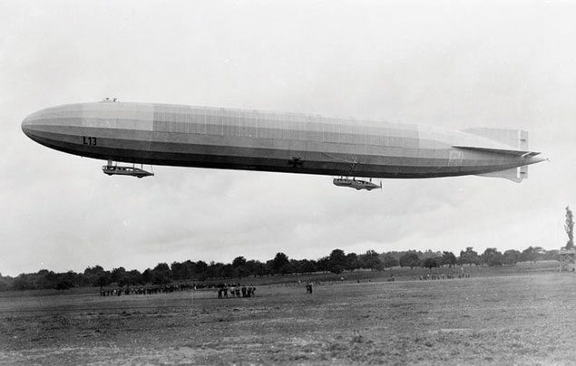These enormous Zeppelin airships dropped bombs on ordinary people’s homes.
It was the first time in history that Britain had come under threat from the sky. Gigantic German airships, known as Zeppelins (below), carried out 52 bombing raids on Britain during the war – killing more than 500. People were terrified of them! To avoid Zeppelin attacks, no lights could be used after sunset and loud noises were banned, too. Large scale bombing raids on British cities were carried out during the day by German biplanes called Gothas.
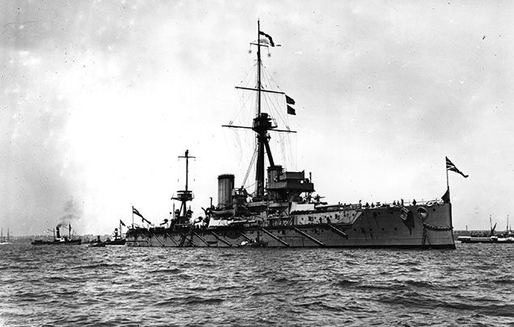
There were threats from the sea, too. Scarborough, Hartlepool and Whitby were the first seaside towns to be shelled by the German navy. Battlecruisers, ships with huge guns, launched a surprise attack on 16 December 1914 – 137 people were killed and 592 injured that night alone.
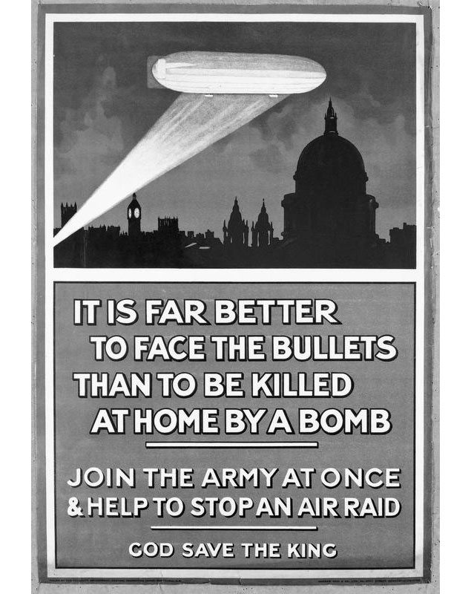People from across the Britain were urged to fight.
But all these attacks on ordinary people only stirred up hatred against the enemy, encouraging more British men to volunteer and fight for their country against “The Beast”. At the start of the war there were just 350,000 men in the British army. But by 1917, there were 3.5 million! Mind you, in 1916, conscription came in – a rule that said ALL healthy men aged 18 – 41 had to fight.

Women during World War 1
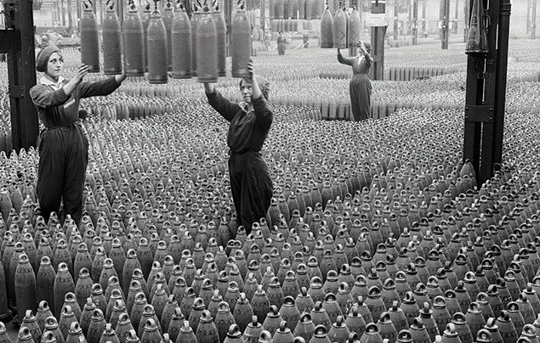Many women worked around the clock in dangerous weapons factories.
Women weren’t allowed to join the army, but the war still completely changed their lives – in some ways, for the better!
Before the war, a woman’s role was in the home. But with the men away at war, help was needed in the workplace – and so millions of women went to work in offices, factories, shops, transport and on farms. Many men were horrified by the idea of females working and, even worse, wearing trousers! But the women proved that they could do the work of men, and do it just as well. Without the women of Britain growing food and making weapons, the war could not have been won.
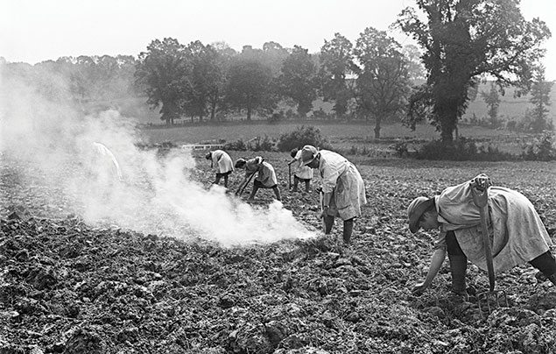The Women’s Land Army was made up of 40,000 women. They grew the food that kept people alive!
When the war was over and the soldiers came home, women were made to leave their new jobs and go back into the home. But not all of them wanted to do that anymore! Their experiences during the war eventually led to women getting more freedoms and rights – including the right to vote!

Children during World War 1
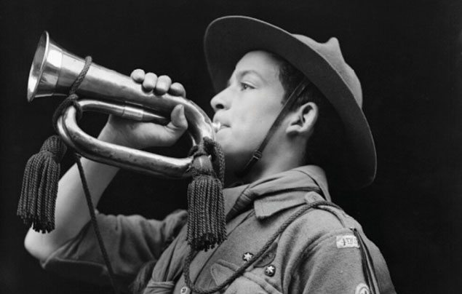Boy scouts played ‘All-Clear’ signals on bugles following air raids.
Did you know that Boy Scouts and Girl Guides had a vital role on the Home Front? Girl Guides would make basic medical equipment for wounded soldiers, like bandages, swabs and slings. They also worked growing vegetables and delivering milk. Boy Scouts collected eggs for injured troops, protected roads and railway lines, and delivered messages.
Children were even paid to collect conkers which could be turned into explosives! They also wrote letters to soldiers and helped to knit socks and scarves for the troops in the winter months. Some boys lied about their age and went off to fight. The youngest of these, Sidney Lewis, was just 12 years old when he joined the army. He was sent home at the age of 13 after fighting in the Battle of the Somme, one of the war’s bloodiest battles.
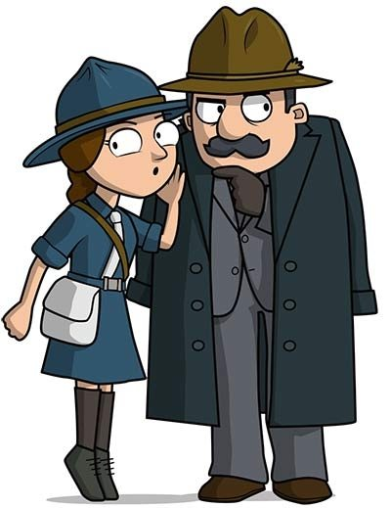
Children were also used to carry messages for MI5, the British Secret Service. The Boy Scouts, who were MI5’s first choice for this work, apparently found it hard to keep sensitive secrets, so Britain’s agents turned to the Girl Guides, instead!

Believe it or not, Winnie The Pooh has his roots in World War 1 Britain. At the time, a young bear cub called Winnie was one of the most popular attractions at London Zoo. He was a mascot belonging to the Canadian Army, who had been left there for safekeeping. The bear was seen by author A. A. Milne‘s son Christopher Robin, who renamed his own toy bear Winnie – and it became the inspiration for his dad’s book, Winnie The Pooh!
Armistice Day
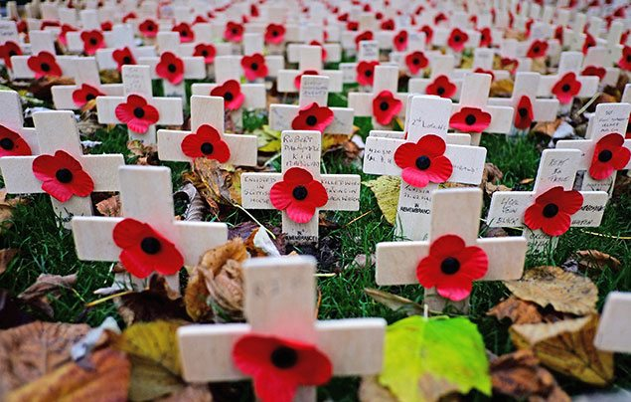
On the 11th hour of the 11th day of the 11th month in 1918, World War 1 officially ended when an agreement (known as an armistice) was signed by Germany and the Allies. This date is known as Armistice Day, and is still commemorated each year when people wear paper poppies to remember those who fought and died in conflicts around the world – the pretty red flowers were the only things that grew on the bloody battlefields of Western Europe.
Sadly, by the time World War 1 was over, more than 18 million people had been killed worldwide. It was hoped it would be the war to end all wars. But this wasn’t to be the case. Just 21 years later, World War 2 broke out.

Your connections to World War 1
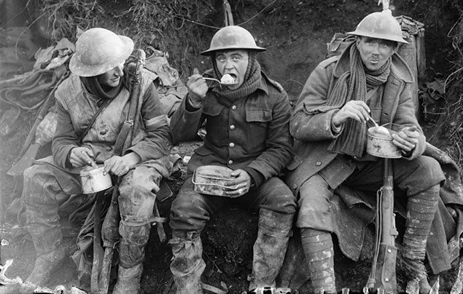
What can you find out about your family’s involvement in World War 1? Ask your grandparents whether their parents, aunties or uncles ever talked about life during this time. Do you have any postcards or photographs from the war? Perhaps there are campaign medals belonging to a relative at home? Write in and tell us about it, we’d love to hear your family stories!

