Week 2 Day 5
Spellings

Practise these words.

Read | Trace | Practise | Practise | Practise | Practise
hindrance | hindrance
identity | identity
immediately | immediately
interfere | interfere
interrupt | interrupt

Now write a sentence for each word. Can you spell it correctly in each sentence without looking at the table?

__________________________________________________________________________________________________________________________________________________________________________________________________________________________________________________________________________________________________________________________________________________________________________________________________________________________________________________________________________________________________________________________________________________________________________________________________________________
__________________________________________________________________

Maths
Use the compact method for multiplication to solve the problems.
Example:  Beyonce went on a shopping spree in London, and bought 24 pairs of shoes. Each pair cost £196.  How much did she spend in total?  Beyonce spent £4704 | A bag holds 90 cherries. Gemma has 25 bags of cherries. How many does she have?
A group of 24 children go on a school trip. The trip costs £124 each. How much will it cost for the entire group? | A school has run out of whiteboard pens! Miss  Evans orders 18 boxes, and each box contains 248 pens.  How many pens will she have?
There are 72 stickers on a sheet. A teacher buys 240 sheets of stickers. How many stickers will there be? | Amy sells 345 footballs per day. How many footballs will she sell in 26 weeks?

English
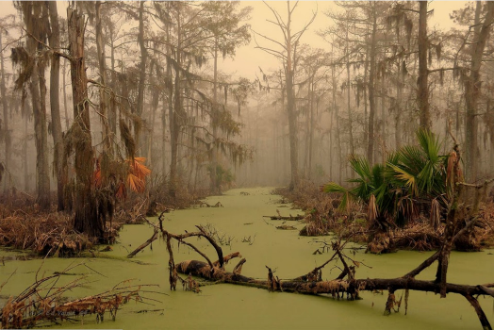
Can you describe what it would be like to walk through a swamp?
Think about using the adjectives, senses you did yesterday and how you might feel about being there.
Try and use some of the conjunctions from previous lessons!
Model- you can either use this to help of carry it on. This does not have to be linked the highway man. Use your imagination! Maybe you could find something inside of there.
As the heat enveloped me, the decrepit trees fell so I hastily glanced around for an escape. Since there were no footprints, I gathered that the swamp had be abandoned for some time. Retched smells filled the humid air and a wave of sickness came over me.
________________________________________________________________________________________________________________________________________________________________________________________________________________________________________________________________________________________________________________________________________________________________________________________________________________________________________________________________________________________________________________________________________________________________________________________________________________________________________________________________________________________________________________________________________________________________________________________________________________________________________________________________________________________________________________________________________________________________________________________________________________________________________________________________________________________________________________________________________________________________________________________________________________________________________________________________________________________________________________________________________________________________________________________________________________________________________________________________________________________________________________________________________________________________________________________________________________________________________________________________________________________________________________________________________________________________________________________________________________________________________________________________________________________________________________________________________________________________________________________________________________________________________________________________________________________________

