Reading extract and questions:
Year 4

The Water Cycle

When you hear about the water cycle, do you imagine some kind of bike that travels on water? This would make sense but the water cycle actually describes how water moves throughthe Earth’s surface,atmosphere and below ground.This is a process that continues in an everlasting circle, which is where the word ‘cycle’ comes in. Let’s find out more.

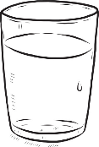
Solid, liquid and gas
You might be used to water being a runny liquid that you use for drinking, washing and playing in but it can also exist as a solid (ice) and a gas (steam or water vapour). The water cycle describes water’s journey from liquid to vapour to liquid again, sometimes becoming a solid in between.

Evaporation
The water cycle is powered by the heat of the sun. It warms up water in places like oceans and lakeswhich makes it turn from a liquid into a gas and rise up into the sky. This process is called evaporation. The water vapour collects in the sky to create clouds.
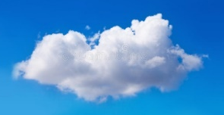
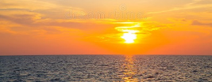

Condensation
In a process named condensation, water vapour in the clouds cools until it becomes water once more.

Precipitation
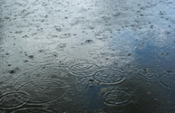
This liquid water then falls from the sky. It could take the form of rain or snow but also as sleet or hail. Sleet is when liquid water freezes before it hits the ground and hail is small lumps of ice and snow that can drop from the clouds during a thunderstorm. This step of the cycle is precipitation.

Collection
The fourth stage of the water cycle is collection. During this process, fallen water collects in oceans and lakes before it evaporates into the sky to continue the cycle.
condensation

evaporation
precipitation

collection

Wonderful water
Water is essential for all life on earth. Because water is recycled and does not leave the earth, it has been around for millions of years, meaning that you might be drinking water that a dinosaur once drank!You may not know that about three quarters of your body is actually made up of water!
Questions for The Water Cycle

Vocabulary
1. This is a process that continues in an everlasting circle. Which word below means the same as everlasting?
Tick one
yearly never-ending

temporary sometimes

2. Look at the section titled Evaporation. Find and copy a word that means the same as make.

____________________

3. Look at the fifth paragraph.

What does the word precipitation mean?

_________________________________________________________________________

Retrieval
4. Look at the second paragraph: ‘Solid, liquid and gas’

Write two things the text says you might use water for.

____________________ and ____________________

5. What powers the water cycle?

____________________

6. Which process follows precipitation in the water cycle?

____________________

Inference
7. In the first paragraph, what tells you that the Earth has underground rivers and lakes?

_______________________________________________________________________________________

8. Look at the statements below. Which is true? Tick one then explain your answer underneath.

Only water that has fallen into oceans or lakes as rain evaporates. _____
Water that has fallen anywhere as rain but ends up in oceans or lakes evaporates. _____

_______________________________________________________________________________________

_______________________________________________________________________________________

9. Look at the section Condensation. Which answer describes how long water remains in clouds before precipitation?
Tick one
It falls to earth straight away.

It always stays in clouds for years.

Water rains down when it heats up.

When it has cooled enough, it falls as rain.

Summarise
10.Using the whole text, tick one box in each row to show whether each statement is true or false.

 | True | False
Water evaporates from clouds to create rain.
Sleet first falls as liquid water then freezes before it hits the ground.
About one quarter of the human body is made of water.

Predict
11. What would happen to life on Earth if there was no water on Earth?

_______________________________________________________________________________________

_______________________________________________________________________________________

