Year 4

Research & Art Work

Week beginning May 18th

Choose an Artist to study. Find out some information about him or her and then produce your own Art work!

Artist study

Choose one of the famous artists below to research.
Challenge yourself to complete the following:

Task 1 Find out Key facts about the artist e.g. place and date of birth, style, famous works, inspiration.

Task 2 Replicate a piece of their work in part or in full. (Replicate means to copy)
How closely did yours match it? How was it different? Write a few sentences to explain your answer.

Task 3 Create an original work in the style of the artist.

Task 4 Reproduce a piece of their work in black and white.

Possible artists to research: Monet, Kandinsky, David Hockney, Andy
Warhol, Picasso, John Constable, Georgia O’Keefe, Emil Nolde.

Keep your work safe to bring into school when you next come in!

Some examples for you to think about:
Picasso

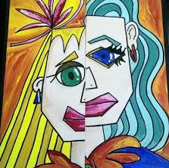

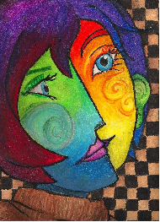

Monet
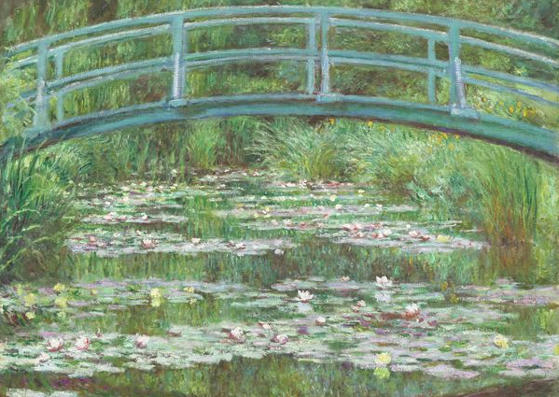

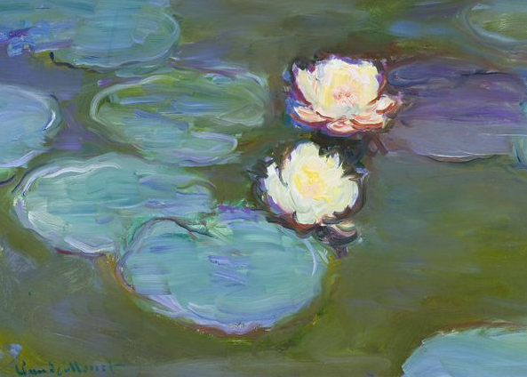

Kandinsky

