Week 2 Day 3
Spellings

Practise these words.

Read | Trace | Practise | Practise | Practise | Practise
exaggerate | exaggerate
excellent | excellent
explanation | explanation
familiar | familiar
foreign | foreign

Now write a sentence for each word. Can you spell it correctly in each sentence without looking at the table?

__________________________________________________________________________________________________________________________________________________________________________________________________________________________________________________________________________________________________________________________________________________________________________________________________________________________________________________________________________________________________________________________________________________________________________________________________________________
__________________________________________________________________
Maths
Use column method for subtraction to solve the problems.

Example:  Bill had saved up £7.93 and then spent £4.86 on a new outfit, how much do Bill have left?  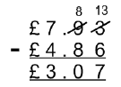  Bill now has £3.07 left. | A holiday costs £179.95. Andy has a total budget of £250 for the holiday and his spending money. How much money will he left to spend on the holiday?
There are 2615 pages in my book. It is the seventh book in a series. I have read 1293. How many more pages do I need to read before I can move onto the eighth book? | Harry had £2257 in his bank account. He had been saving it for 14 years using his birthday money. His mum let him spend £1329 on a special mountain bike. How much was left in his account?
There were 1165 cups delivered to a shop. Half of them were pink. The other half were blue. 237 were broken when they arrived. How many cups were unbroken? | A digital camera cost £261.89 before Christmas. It is reduced by £52.45 in the New Year’s sale. What is the new price?

English
Complete these sentences using conjunctions to join two sentences.
Use these conjunctions to help. Remember FANBOYS and ISAWAWABUB!
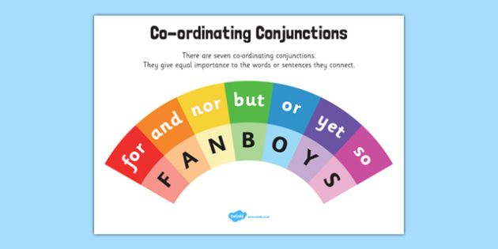
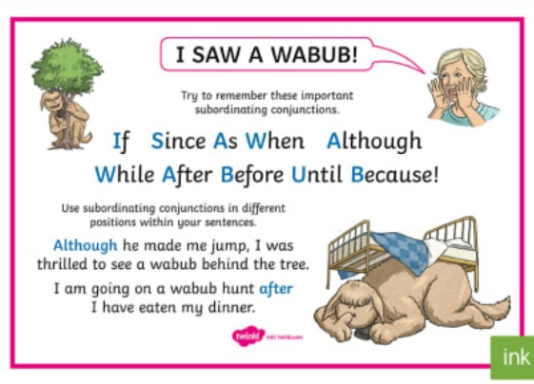
The moors appeared purple _________ the moon was shining over it.
The highwayman rode along the road _________ he reached an old inn.
__________ it was night, the highwayman went to steal from travellers.
Tim adored Bess ________ she seemed fond of the highwayman.
_________ the highwayman confessed his love for Bess, Tim listened silently.
Can you think of any of your own sentences? ____________________________________________________________________________________________________________________________________
__________________________________________________________________
__________________________________________________________________

