Q1. (a) (i) Write an equation for the reduction of pentan-2-one by aqueous NaBH₄ to form pentan-2-ol.
Use [H] to represent the reductant.
.............................................................................................................

(ii) Name and outline a mechanism for this reduction.
Name of mechanism ...........................................................................
Mechanism

(iii) State why the pentan-2-ol produced in this reaction is not optically active.
.............................................................................................................
(7)

(b) Predict the m/z values of the two most abundant fragments in the mass spectrum of pentan-2-one.
Fragment 1 ..................................................................................................
Fragment 2 ..................................................................................................
(2)
(Total 9 marks)

Q2. (a) Draw the structure of ethyl propanoate.

(1)

(b) Name and outline a mechanism for the formation of ethyl propanoate from propanoyl chloride and ethanol.
Name of mechanism ....................................................................................
Mechanism

(5)

(c) The mass spectrum of ethyl propanoate contains a major peak at m/z = 57. Write an equation showing the fragmentation of the molecular ion to form the species responsible for the peak at m/z = 57. Show the structure of this species in your answer.
......................................................................................................................
(2)

(d) Draw the structure of another ester which is an isomer of ethyl propanoate and which gives a major peak at m/z = 71 in its mass spectrum.

(1)
(Total 9 marks)

Q3. The proton n.m.r. spectrum of compound X is shown below.

Compound X, C₇H₁₂O₃, contains both a ketone and an ester functional group. The measured integration trace for the peaks in the n.m.r. spectrum of X gives the ratio shown in the table below.

Chemical shift, δ/ppm | 4.13 | 2.76 | 2.57 | 2.20 | 1.26
Integration ratio | 0.8 | 0.8 | 0.8 | 1.2 | 1.2

Refer to the spectrum, the information given above and the data below the Periodic Table provided to answer the following questions.
(a) How many different types of proton are present in compound X?
......................................................................................................................
(1)

(b) What is the whole-number ratio of each type of proton in compound X?
......................................................................................................................
(1)

(c) Draw the part of the structure of X which can be deduced from the presence of the peak at δ2.20.
......................................................................................................................
(1)

(d) The peaks at δ4.13 and δ1.26 arise from the presence of an alkyl group. Identify the group and explain the splitting pattern.
Alkyl group ....................................................................................................
Explanation ...................................................................................................
......................................................................................................................
......................................................................................................................
(3)

(e) Draw the part of the structure of X which can be deduced from the splitting of the peaks at δ2.76 and δ2.57.
......................................................................................................................
(1)

(f) Deduce the structure of compound X.
......................................................................................................................
(2)
(Total 9 marks)

Q4. (a) A flask containing a mixture of 0.200 mol of ethanoic acid and 0.110 mol of ethanol was maintained at 25 °C until the following equilibrium had been established.
CH₃COOH(l) + C₂H₅OH(l) CH₃COOC₂H₅(l) + H₂O(l)
The ethanoic acid present at equilibrium required 72.5 cm³ of a 1.50 mol dm^{–3} solution of sodium hydroxide for complete reaction.
(i) Calculate the value of the equilibrium constant, K_{c}, for this reaction at 25 °C.
(ii) The enthalpy change for this reaction is quite small. By reference to the number and type of bonds broken and made, explain how this might have been predicted.
(9)

(b) Aspirin can be prepared by acylation using either ethanoyl chloride or ethanoic anhydride, as represented by the equations shown below.
CH₃COCl + HOC₆H₄COOH → CH₃COOC₆H₄COOH + HCl
(CH₃CO)₂O + HOC₆H₄COOH → CH₃COOC₆H₄COOH + CH₃COOH

(i) By a consideration of the intermolecular forces involved, explain why the product HCl is a gas but the product CH₃COOH is a liquid at room temperature.

(ii) Give two industrial advantages of using ethanoic anhydride rather than ethanoyl chloride in the manufacture of aspirin.
(4)
(Total 13 marks)

Q5.(a) Outline a mechanism for the reaction of CH₃CH₂CH₂CHO with HCN and name the product.
Mechanism

Name of product ..........................................................................................
(5)

(b) Outline a mechanism for the reaction of CH₃OH with CH₃CH₂COCl and name the organic product.
Mechanism

Name of organic product ..............................................................................
(5)

(c) An equation for the formation of phenylethanone is shown below. In this reaction a reactive intermediate is formed from ethanoyl chloride. This intermediate then reacts with benzene.
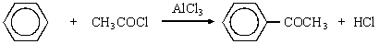
(i) Give the formula of the reactive intermediate.
.............................................................................................................

(ii) Outline a mechanism for the reaction of this intermediate with benzene to form phenylethanone.

(4)
(Total 14 marks)

Q6. The three compounds CH₃CH₂CH₂CH₂OH, (CH₃)₃COH and CH₃CH₂CH₂CHO can be distinguished by use of the following three reagents
1. potassium dichromate(VI) acidified with dilute sulphuric acid
2. Tollens’ reagent
3. ethanoic acid, together with a small amount of concentrated sulphuric acid.
(a) Identify which of these three organic compounds would reduce acidified potassium dichromate(VI). Give the structures of the organic products formed. Write a half-equation for the reduction of dichromate(VI) ions in acidic solution.
(6)

(b) Identify which one of these three organic compounds would reduce Tollens’ reagent. Give the structure of the organic product formed. Write a half-equation for the reduction of Tollens’ reagent.
(3)

(c) Identify which of these three organic compounds would react with ethanoic acid in the presence of concentrated sulphuric acid. In each case, give the structure of the organic product formed.
(4)

(d) State the number of peaks in the proton n.m.r. spectra of CH₃CH₂CH₂CH₂OH and of (CH₃)₃COH. (Analysis of peak splitting is not required.)
(2)
(Total 15 marks)

Q7. (a) Consider the following pair of isomers.
(i) Name compound C.
.............................................................................................................

(ii) Identify a reagent which could be used in a test-tube reaction to distinguish between C and D. In each case, state what you would observe.
Reagent ..............................................................................................
Observation with C ..............................................................................
Observation with D...............................................................................
(4)

(b) Consider the following pair of isomers.
(i) Name compound E.
.............................................................................................................

(ii) Identify a reagent which could be used in a test-tube reaction to distinguish between E and F. In each case, state what you would observe.
Reagent .............................................................................................
Observation with E .............................................................................
Observation with F..............................................................................
(4)

(c) Draw the structure of the chain isomer of F which shows optical isomerism.

(1)
(Total 9 marks)

Q8. (a) The pH of a 0.120 mol dm^{–3} solution of the weak monoprotic acid, HX, is 2.56 at 298 K.
(i) Write an expression for the term pH.
.............................................................................................................

(ii) Write an expression for the dissociation constant, K_{a}, for the weak acid HX and calculate its value at 298 K.
Expression for K_{a} .................................................................................
.............................................................................................................
Calculation ..........................................................................................
.............................................................................................................
.............................................................................................................
.............................................................................................................
(5)

(b) (i) Write an expression for the ionic product of water, K_{w}, and give its value at 298 K.
Expression for K_{w} ................................................................................
Value of K_{w} ..........................................................................................
.............................................................................................................

(ii) Hence, calculate the pH of a 0.0450 mol dm^{–3} solution of sodium hydroxide at 298 K.
.............................................................................................................
.............................................................................................................
.............................................................................................................
(4)

(c) A titration curve is plotted showing the change in pH as a 0.0450 mol dm^{–3} solution of sodium hydroxide is added to 25.0 cm³ of a solution of ethanedioic acid, H₂C₂O₄
The titration curve obtained has two equivalence points (end points).
(i) Write an equation for the reaction which is completed at the first equivalence point.
.............................................................................................................

(ii) When the second equivalence point is reached, a total of 41.6 cm³ of 0.0450 mol dm^{–3} sodium hydroxide has been added.
Calculate the concentration of the ethanedioic acid solution.
.............................................................................................................
.............................................................................................................
.............................................................................................................
.............................................................................................................
.............................................................................................................
(4)

(d) Draw the structure of the organic product formed in each case when, in the presence of a small amount of concentrated sulphuric acid, ethanedioic acid reacts with
(i) an excess of methanol,

.............................................................................................................

(ii) an equimolar amount of ethane-1,2-diol.

.............................................................................................................
(2)
(Total 15 marks)

Q9. Butenedioic acid, HOOCCH=CHCOOH, occurs as two stereoisomers. One of the isomers readily forms the acid anhydride C₄H₂O₃ when warmed.
(a) Draw the structures of the two isomers of butenedioic acid and name the type of isomerism shown.
Use the structures of the two isomeric acids to suggest why only one of them readily forms an acid anhydride when warmed. Draw the structure of the acid anhydride formed.
(6)

(b) Identify one electrophile which will react with butenedioic acid and outline a mechanism for this reaction.
(4)

(c) Write an equation for a reaction which occurs when butenedioic acid is treated with an excess of aqueous sodium hydroxide.
(2)

(d) Describe and explain the appearance of the proton n.m.r. spectrum of butenedioic acid.
(3)
(Total 15 marks)

Q10. (a) Ester X, CH₃CH₂COOCH₃, can be produced by the reaction between propanoyl chloride and methanol. Name X and outline a mechanism for this reaction. Name the mechanism involved.
(6)

(b) The proton n.m.r. spectrum of X is shown below together with that of an isomeric ester, Y. Deduce which of Spectrum 1 and Spectrum 2 is that obtained from X. Use Table 1 on the Data Sheet and the integration data on the spectra to help you to explain your deduction. Suggest a structure for Y.
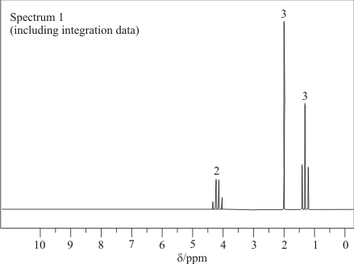
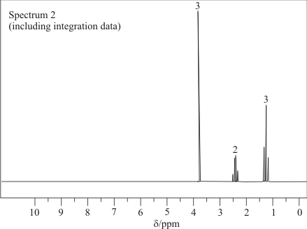
(4)
(Total 10 marks)

Q11. Compounds C and D, shown below, are isomers of C₅H₁₀O
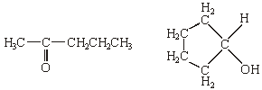
C D
(a) Name compound C.
......................................................................................................................
(1)

(b) Use Table 2 on the Data Sheet to help you to answer this question.
(i) Suggest the wavenumber of an absorption which is present in the infra-red spectrum of C but not in that of D.
.............................................................................................................

(ii) Suggest the wavenumber of an absorption which is present in the infra-red spectrum of D but not in that of C.
.............................................................................................................
(2)

(c) Deduce the number of peaks in the proton n.m.r. spectrum of C.
......................................................................................................................
(1)

(d) Identify a reagent that you could use to distinguish between C and D. For each of C and D, state what you would observe when the compound is treated with this reagent.
Reagent .......................................................................................................
Observation with C .......................................................................................
Observation with D .......................................................................................
(3)

(e) Compound E, CH₃CH₂CH₂CH₂CHO, is also an isomer of C₅H₁₀O
Identify a reagent which will react with E but not with C or D. State what you would observe when E is treated with this reagent.
Reagent .......................................................................................................
Observation with E .......................................................................................
(2)
(Total 9 marks)

Q12. (a) Addition reactions to both alkenes and carbonyl compounds can result in the formation of isomeric compounds.
(i) Choose an alkene with molecular formula C₄H₈ which reacts with HBr to form two structural isomers. Give the structures of these two isomers and name the type of structural isomerism shown.
Outline a mechanism for the formation of the major product.

(ii) Using HCN and a suitable carbonyl compound with molecular formula C₃H₆O, outline a mechanism for an addition reaction in which two isomers are produced.
Give the structures of the two isomers formed and state the type of isomerism shown.
(14)

(b) Explain why ethanoyl chloride reacts readily with nucleophiles.
Write an equation for one nucleophilic addition–elimination reaction of ethanoyl chloride.
(A mechanism is not required.)
(4)
(Total 18 marks)

Q13. (a) Describe how propanal, CH₃CH₂CHO, and propanone, CH₃COCH₃, can be distinguished using
(i) a chemical test and
(ii) the number of peaks in their proton n.m.r. spectra.
(5)

(b) Compound Z can be produced by the reaction of compound X with compound Y as shown in the synthesis outlined below.
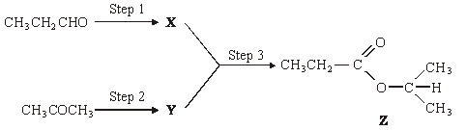
Identify compounds X and Y.
For each of the three steps in the synthesis, name the type of reaction involved and give reagents and conditions. Equations are not required.

(10)
(Total 15 marks)

Q14. Compound U is shown below.
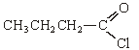
(a) Name compound U.
......................................................................................................................
(1)

(b) (i) State why the mass spectrum of U contains two molecular ion peaks.
.............................................................................................................
(ii) Give the m/z values of these two peaks.
.............................................................................................................
.............................................................................................................
(2)

(c) Name and outline a mechanism for the reaction of U with CH₃OH
Name of mechanism ....................................................................................
Mechanism

(5)
(Total 8 marks)

Q15. (a) (i) The addition of aqueous silver nitrate, followed by concentrated aqueous ammonia, can be used to distinguish between separate aqueous solutions of sodium bromide and sodium iodide.
Record what is observed in the table below.

 | The addition of AgNO₃(aq) | followed by |  | the addition of  concentrated NH₃(aq)
Observation with
NaBr(aq)
Observation with
NaI(aq)

(ii) Explain why it is not possible to distinguish between separate solutions of sodium nitrate and sodium fluoride by the addition of silver nitrate solution.
.............................................................................................................
(5)

(b) When aqueous sodium thiosulphate is added to solid silver bromide a reaction occurs and a colourless solution is formed.
(i) Identify the silver-containing species present in the colourless solution.
.............................................................................................................

(ii) Write an equation for this reaction.
.............................................................................................................

(iii) Give one use of this reaction.
.............................................................................................................
(3)

(c) Aqueous silver nitrate can be used to distinguish between chloroethanoic acid and ethanoyl chloride.
(i) Draw the structure of ethanoyl chloride. Predict what, if anything, you would observe when ethanoyl chloride is added to aqueous silver nitrate.
Structure of ethanoyl chloride

Observation ........................................................................................
.............................................................................................................

(ii) Draw the structure of chloroethanoic acid. Predict what, if anything, you would observe when chloroethanoic acid is added to aqueous silver nitrate.
Structure of chloroethanoic acid

Observation ........................................................................................
.............................................................................................................
(4)

(d) (i) Tollens’ reagent is formed by the addition of aqueous ammonia to aqueous silver nitrate. Identify the silver-containing complex present in Tollens’ reagent and state its shape.
Silver-containing complex ...................................................................
Shape…...............................................................................................
.............................................................................................................

(ii) Draw the structure of methanoic acid. By reference to this structure, suggest why a silver mirror is formed when this acid reacts with Tollens’ reagent.
Structure .............................................................................................
Explanation….......................................................................................
.............................................................................................................

(iii) Deduce the identity of a carbon-containing species formed when methanoic acid reacts with Tollens’ reagent.
.............................................................................................................
(5)
(Total 17 marks)

Q16. (a) Name and outline a mechanism for the reaction between propanoyl chloride,
CH₃CH₂COCl, and methylamine, CH₃NH₂
Draw the structure of the organic product.
(6)

(b) Benzene reacts with propanoyl chloride in the presence of aluminium chloride. Write equations to show the role of aluminium chloride as a catalyst in this reaction. Outline a mechanism for this reaction of benzene.
(5)

(c) Write an equation for the reaction of propanoyl chloride with water. An excess of water is added to 1.48 g of propanoyl chloride. Aqueous sodium hydroxide is then added from a burette to the resulting solution.
Calculate the volume of 0.42 mol dm^{–3} aqueous sodium hydroxide needed to react exactly with the mixture formed.
(5)
(Total 16 marks)

Q17. Consider the reaction sequence shown below.
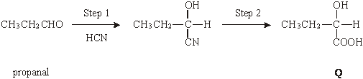
(a) Name and outline a mechanism for the reaction in Step 1.
Name of mechanism ....................................................................................
Mechanism

(5)

(b) (i) Name compound Q formed in Step 2.
.............................................................................................................
(ii) Two stereoisomers are formed by the dehydration of Q. Give the structures of these two isomers and name the type of stereoisomerism shown.
Structures of isomers

Type of stereoisomerism ..............................................................................
(4)

(c) An isomer of Q which has the structure shown below is polymerised to form the biodegradeable polymer known as PHB.
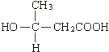
(i) Draw the repeating unit of the polymer PHB.

(ii) Suggest a reason why the polymer is biodegradeable.
.............................................................................................................
.............................................................................................................
(2)

(d) The amino acid R is shown below.
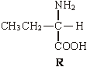
(i) Draw the structure of the zwitterion formed by R.

(ii) Draw the structure of the major organic product formed when an excess of R is reacted with bromomethane.

(iii) Name the mechanism of the reaction which results in the formation of the product given in part (ii).
.............................................................................................................
(3)
(Total 14 marks)

Q18. (a) Compound A, HCOOCH₂CH₂CH₃, is an ester. Name this ester and write an equation for its reaction with aqueous sodium hydroxide.
Name ……….................................................................................................
Equation .......................................................................................................
(2)

(b) The initial rate of reaction between ester A and aqueous sodium hydroxide was measured in a series of experiments at a constant temperature. The data obtained are shown below.

Experiment | Initial concentration of NaOH / mol dm^{–3} | Initial concentration of A / mol dm^{–3} | Initial rate  / mol dm^{–3} s^{–1}
1 | 0.040 | 0.030 | 4.0 × 10^{–4}
2 | 0.040 | 0.045 | 6.0 × 10^{–4}
3 | 0.060 | 0.045 | 9.0 × 10^{–4}
4 | 0.120 | 0.060 | to be calculated

Use the data in the table to deduce the order of reaction with respect to A and the order of reaction with respect to NaOH. Hence calculate the initial rate of reaction in Experiment 4.
Order with respect to A ................................................................................
Order with respect to NaOH .........................................................................
Initial rate in Experiment 4 ............................................................................
......................................................................................................................
(3)

(c) In a further experiment at a different temperature, the initial rate of reaction was found to be 9.0 × 10^{–3} mol dm^{–3} s^{–1} when the initial concentration of A was 0.020 mol dm^{–3} and the initial concentration of NaOH was 2.00 mol dm^{–3}.
Under these new conditions with the much higher concentration of sodium hydroxide, the reaction is first order with respect to A and appears to be zero order with respect to sodium hydroxide.
(i) Write a rate equation for the reaction under these new conditions.
.............................................................................................................

(ii) Calculate a value for the rate constant under these new conditions and state its units.
Calculation ..........................................................................................
.............................................................................................................
.............................................................................................................
Units ....................................................................................................

(iii) Suggest why the order of reaction with respect to sodium hydroxide appears to be zero under these new conditions.
.............................................................................................................
.............................................................................................................
.............................................................................................................
(6)

(d) A naturally-occurring triester, shown below, was heated under reflux with an excess of aqueous sodium hydroxide and the mixture produced was then distilled. One of the products distilled off and the other was left in the distillation flask.
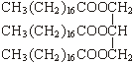
(i) Draw the structure of the product distilled off and give its name.
Structure

Name ..................................................................................................

(ii) Give the formula of the product left in the distillation flask and give a use for it.
Formula ...............................................................................................
Use ......................................................................................................
(4)
(Total 15 marks)

Q19. (a) Name the compound (CH₃)₂NH
......................................................................................................................
(1)

(b) (CH₃)₂NH can be formed by the reaction of an excess of CH₃NH₂ with CH₃Br. Name and outline a mechanism for this reaction.
Name of mechanism ....................................................................................
Mechanism

(5)

(c) Name the type of compound produced when a large excess of CH₃Br reacts with CH₃NH₂ Give a use for this type of compound.
Type of compound ......................................................................................
Use ..............................................................................................................
(2)

(d) Draw the structures of the two compounds formed in the reaction of CH₃NH₂ with ethanoic anhydride.

(2)
(Total 10 marks)

Q20. Consider the sequence of reactions below.
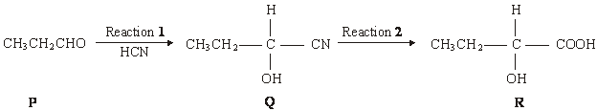
(a) Name and outline a mechanism for Reaction 1.
Name of mechanism ....................................................................................................
Mechanism

(5)

(b) (i) Name compound Q
.............................................................................................................

(ii) The molecular formula of Q is C₄H₇NO. Draw the structure of the isomer of Q which shows geometrical isomerism and is formed by the reaction of ammonia with an acyl chloride.

(3)

(c) Draw the structure of the main organic product formed in each case when R reacts separately with the following substances:
(i) methanol in the presence of a few drops of concentrated sulphuric acid;

(ii) acidified potassium dichromate(VI);

(iii) concentrated sulphuric acid in an elimination reaction.

(3)
(Total 11 marks)

Q21. A possible synthesis of phenylethene (styrene) is outlined below.
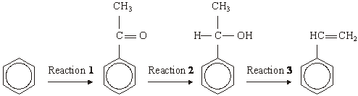
(a) In Reaction 1, ethanoyl chloride and aluminium chloride are used to form a reactive species which then reacts with benzene.
Write an equation to show the formation of the reactive species.
Name and outline the mechanism by which this reactive species reacts with benzene.
(6)

(b) NaBH₄ is a possible reagent for Reaction 2.
Name and outline the mechanism for the reaction with NaBH₄ in Reaction 2.
Name the product of Reaction 2.
(6)
(c) Name the type of reaction involved in Reaction 3 and give a reagent for the reaction.
(2)
(Total 14 marks)

Q22. (a) Write an equation for the formation of methyl propanoate, CH₃CH₂COOCH₃, from methanol and propanoic acid.
......................................................................................................................
(1)

(b) Name and outline a mechanism for the reaction between methanol and propanoyl chloride to form methyl propanoate.
Name of mechanism ....................................................................................
Mechanism

(5)

(c) Propanoic anhydride could be used instead of propanoyl chloride in the preparation of methyl propanoate from methanol. Draw the structure of propanoic anhydride.

(1)
(d) (i) Give one advantage of the use of propanoyl chloride instead of propanoic acid in the laboratory preparation of methyl propanoate from methanol.
.............................................................................................................
.............................................................................................................

(ii) Give one advantage of the use of propanoic anhydride instead of propanoyl chloride in the industrial manufacture of methyl propanoate from methanol.
.............................................................................................................
.............................................................................................................
(2)

(e) An ester contains a benzene ring. The mass spectrum of this ester shows a molecular ion peak at m/z = 136.
(i) Deduce the molecular formula of this ester.
.............................................................................................................
.............................................................................................................
.............................................................................................................

(ii) Draw two possible structures for this ester.

(3)
(Total 12 marks)

Q23. The triester, T, shown below is found in palm oil. When T is heated with an excess of sodium hydroxide solution, the alcohol glycerol is formed together with a mixture of three other products as shown in the following equation.
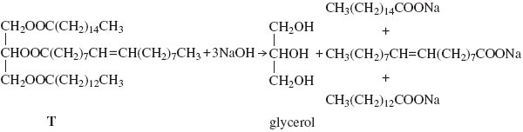
(a) (i) Give the IUPAC name for glycerol.
.............................................................................................................
(1)

(ii) Give a use for the mixture of sodium salts formed in this reaction.
.............................................................................................................
(1)

(b) When T is heated with an excess of methanol, glycerol is formed together with a mixture of methyl esters.
(i) Give a use for this mixture of methyl esters.
.............................................................................................................
(1)

(ii) One of the methyl esters in the mixture has the IUPAC name
methyl (Z)-octadec-9-enoate. Draw two hydrogen atoms on the diagram below to illustrate the meaning of the letter Z in the name of this ester.
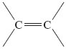
(1)

(iii) One of the other methyl esters in the mixture has the formula CH₃(CH₂)₁₂COOCH₃
Write an equation for the complete combustion of one molecule of this ester.

.............................................................................................................
(1)
(Total 5 marks)

Q24. Two isomeric ketones are shown below.
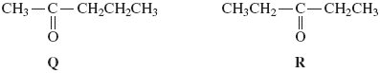
(a) Name and outline a mechanism for the reaction of compound Q with HCN and name the product formed.
Name of mechanism ……............................................................................
Mechanism

Name of product ..........................................................................................
(6)

(b) Some students were asked to suggest methods to distinguish between isomers Q and R.
One student suggested testing the optical activity of the products formed when Q and R were reacted separately with HCN.
By considering the optical activity of these products formed from Q and R, explain why this method would not distinguish between Q and R.
......................................................................................................................
......................................................................................................................
......................................................................................................................
......................................................................................................................
......................................................................................................................
(3)

(c) Other students suggested using mass spectrometry and the fragmentation patterns of the molecular ions of the two isomers to distinguish between them.
They predicted that only one of the isomers would have a major peak at m/z = 57 in its mass spectrum so that this method would distinguish between Q and R.
(i) Identify the isomer that has a major peak at m/z = 57 in its mass spectrum.

.............................................................................................................
(1)

(ii) Write an equation for the fragmentation of the molecular ion of this isomer to form the species that produces the peak at m/z = 57.
.............................................................................................................
(2)

(iii) Predict the m/z value of a major peak in the mass spectrum of the other isomer.
.............................................................................................................
(1)
(Total 13 marks)

Q25. Esters have many important commercial uses such as solvents and artificial flavourings in foods.
Esters can be prepared in several ways including the reactions of alcohols with carboxylic acids, acid anhydrides, acyl chlorides and other esters.
(a) Ethyl butanoate is used as a pineapple flavouring in sweets and cakes.
Write an equation for the preparation of ethyl butanoate from an acid and an alcohol.
Give a catalyst used for the reaction.
......................................................................................................................
......................................................................................................................
......................................................................................................................
......................................................................................................................
......................................................................................................................
......................................................................................................................
......................................................................................................................
......................................................................................................................
(4)

(b) Butyl ethanoate is used as a solvent in the pharmaceutical industry.
Write an equation for the preparation of butyl ethanoate from an acid anhydride and an alcohol.
......................................................................................................................
......................................................................................................................
......................................................................................................................
......................................................................................................................
(3)

(c) Name and outline a mechanism for the reaction of CH₃COCl with CH₃OH to form an ester.

(5)

(d) The ester shown below occurs in vegetable oils. Write an equation to show the formation of biodiesel from this ester.
CH₂OOCC₁₇H₃₁
│
CHOOCC₁₇H₃₃
│
CH₂₃OOCC₁₇H₂₉
......................................................................................................................
......................................................................................................................
......................................................................................................................
......................................................................................................................
......................................................................................................................
......................................................................................................................
......................................................................................................................
......................................................................................................................
(3)

(e) Draw the repeating unit of the polyester Terylene that is made from benzene-1,4-dicarboxylic acid and ethane-1,2-diol.
Although Terylene is biodegradeable, it is preferable to recycle objects made from Terylene.
Give one advantage and one disadvantage of recycling objects made from Terylene.
......................................................................................................................
......................................................................................................................
......................................................................................................................
......................................................................................................................
......................................................................................................................
......................................................................................................................
......................................................................................................................
......................................................................................................................
(4)
(Total 19 marks)

Q26. Many synthetic routes need chemists to increase the number of carbon atoms in a molecule by forming new carbon–carbon bonds. This can be achieved in several ways including
• reaction of an aromatic compound with an acyl chloride
• reaction of an aldehyde with hydrogen cyanide.
(a) Consider the reaction of benzene with CH₃CH₂COCl
(i) Write an equation for this reaction and name the organic product.
Identify the catalyst required in this reaction.
Write equations to show how the catalyst is used to form a reactive intermediate and how the catalyst is reformed at the end of the reaction.
.............................................................................................................
.............................................................................................................
.............................................................................................................
.............................................................................................................
.............................................................................................................
.............................................................................................................
.............................................................................................................
.............................................................................................................
(5)

(ii) Name and outline a mechanism for the reaction of benzene with this reactive intermediate.
.............................................................................................................
.............................................................................................................
.............................................................................................................
.............................................................................................................
.............................................................................................................
.............................................................................................................
.............................................................................................................
.............................................................................................................
(4)

(b) Consider the reaction of propanal with HCN
(i) Write an equation for the reaction of propanal with HCN and name the product.
.............................................................................................................
.............................................................................................................
.............................................................................................................
(2)

(ii) Name and outline a mechanism for the reaction of propanal with HCN
.............................................................................................................
.............................................................................................................
.............................................................................................................
.............................................................................................................
.............................................................................................................
.............................................................................................................
.............................................................................................................
.............................................................................................................
(5)

(iii) The rate-determining step in the mechanism in part (b) (ii) involves attack by the nucleophile.
Suggest how the rate of reaction of propanone with HCN would compare with the rate of reaction of propanal with HCN
Explain your answer.
.............................................................................................................
.............................................................................................................
.............................................................................................................
.............................................................................................................
.............................................................................................................
.............................................................................................................
.............................................................................................................
.............................................................................................................
(2)
(Total 18 marks)

Q27.The reactions of molecules containing the chlorine atom are often affected by other functional groups in the molecule.
Consider the reaction of CH₃CH₂COCl and of CH₃CH₂CH₂Cl with ammonia.
(a) For the reaction of CH₃CH₂COCl with ammonia, name and outline the mechanism and name the organic product.
........................................................................................................................
........................................................................................................................
........................................................................................................................
........................................................................................................................
........................................................................................................................
........................................................................................................................
........................................................................................................................
........................................................................................................................
........................................................................................................................
........................................................................................................................
........................................................................................................................
........................................................................................................................
........................................................................................................................

(Extra space) .................................................................................................
........................................................................................................................
........................................................................................................................
........................................................................................................................
........................................................................................................................
........................................................................................................................
(6)

(b) For the reaction of CH₃CH₂CH₂Cl with an excess of ammonia, name and outline the mechanism and name the organic product.
........................................................................................................................
........................................................................................................................
........................................................................................................................
........................................................................................................................
........................................................................................................................
........................................................................................................................
........................................................................................................................
........................................................................................................................
........................................................................................................................
........................................................................................................................
........................................................................................................................
........................................................................................................................
........................................................................................................................
........................................................................................................................
........................................................................................................................

(Extra space) .................................................................................................
........................................................................................................................
........................................................................................................................
........................................................................................................................
........................................................................................................................
........................................................................................................................
........................................................................................................................
........................................................................................................................
........................................................................................................................
(6)

(c) Suggest one reason why chlorobenzene (C₆H₅Cl) does not react with ammonia under normal conditions.
........................................................................................................................
........................................................................................................................
........................................................................................................................
........................................................................................................................
(Extra space) .................................................................................................
........................................................................................................................
(1)
(Total 13 marks)

Q28.Acyl chlorides such as CH₃COCl are useful compounds in synthesis.
(a) The acyl chloride CH₃COCl reacts with benzene.
(i) Write an equation for this reaction and name the organic product.
Identify a catalyst for the reaction.
Write an equation to show how this catalyst reacts with CH₃COCl to produce a reactive intermediate.
...............................................................................................................
...............................................................................................................
...............................................................................................................
...............................................................................................................
...............................................................................................................
...............................................................................................................
...............................................................................................................
...............................................................................................................
(4)

(ii) Name and outline a mechanism for the reaction of benzene with the reactive intermediate in part (a)(i).
Name of mechanism .........................................................................................................
Mechanism

(4)

(b) Nucleophiles such as alcohols can react with CH₃COCl
The ion CH₃COO⁻ can act as a nucleophile in a similar way.
State the meaning of the term nucleophile.
Draw the structure of the organic product formed by the reaction of CH₃COO⁻ with CH₃COCl
Name the functional group produced in this reaction.
........................................................................................................................
........................................................................................................................
........................................................................................................................
........................................................................................................................
........................................................................................................................
........................................................................................................................
........................................................................................................................
........................................................................................................................
........................................................................................................................
(3)
(Total 11 marks)

Q29.Each of the following conversions involves reduction of the starting material.
(a) Consider the following conversion.
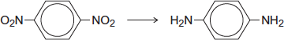
Identify a reducing agent for this conversion.
Write a balanced equation for the reaction using molecular formulae for the nitrogen-containing compounds and [H] for the reducing agent.
Draw the repeating unit of the polymer formed by the product of this reaction with benzene-1,4-dicarboxylic acid.
........................................................................................................................
........................................................................................................................
........................................................................................................................
........................................................................................................................
........................................................................................................................
........................................................................................................................
........................................................................................................................
(Extra space) .................................................................................................
........................................................................................................................
........................................................................................................................
........................................................................................................................
........................................................................................................................
........................................................................................................................
(5)

(b) Consider the following conversion.
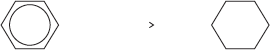
Identify a reducing agent for this conversion.
State the empirical formula of the product.
State the bond angle between the carbon atoms in the starting material and the bond angle between the carbon atoms in the product.
........................................................................................................................
........................................................................................................................
........................................................................................................................
........................................................................................................................
........................................................................................................................
........................................................................................................................
(4)

(c) The reducing agent in the following conversion is NaBH₄
(i) Name and outline a mechanism for the reaction.
Name of mechanism ............................................................................
Mechanism

(5)

(ii) By considering the mechanism of this reaction, explain why the product formed is optically inactive.
...............................................................................................................
...............................................................................................................
...............................................................................................................
...............................................................................................................
...............................................................................................................
...............................................................................................................
...............................................................................................................
...............................................................................................................
(3)
(Total 17 marks)

Q30.Esters are produced by the reaction of alcohols with other esters and by the reaction of alcohols with carboxylic acids.
(a) The esters which make up biodiesel are produced industrially from the esters in vegetable oils.
(i) Complete the equation for this formation of biodiesel.
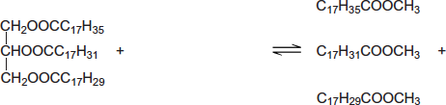
............................................................................
(2)

(ii) Write an equation for the complete combustion of C₁₇H₃₅COOCH₃.
...............................................................................................................
(2)

(b) The ester commonly known as diethyl malonate (DEM) occurs in strawberries and grapes. It can be prepared from acid A according to the following equilibrium.
(i) A mixture of 2.50 mol of A and 10.0 mol of ethanol was left to reach equilibrium in an inert solvent in the presence of a small amount of concentrated sulfuric acid.
The equilibrium mixture formed contained 1.80 mol of DEM in a total volume, V dm³, of solution.
Calculate the amount (in moles) of A, of ethanol and of water in this equilibrium mixture.
Moles of A .............................................................................................
Moles of ethanol ....................................................................................
Moles of water........................................................................................
(3)

(ii) The total volume of the mixture in part (b)(i) was doubled by the addition of more of the inert solvent.
State and explain the effect of this addition on the equilibrium yield of DEM.
Effect ....................................................................................................
Explanation ...........................................................................................
...............................................................................................................
(2)

(iii) Using A to represent the acid and DEM to represent the ester, write an expression for the equilibrium constant K_{c} for the reaction.
...............................................................................................................
...............................................................................................................
(1)

(iv) In a second experiment, the equilibrium mixture was found to contain 0.85 mol of A, 7.2 mol of ethanol, 2.1 mol of DEM and 3.4 mol of water.
Calculate a value of K_{c} for the reaction and deduce its units.
Calculation.............................................................................................
...............................................................................................................
...............................................................................................................
...............................................................................................................
...............................................................................................................
...............................................................................................................
...............................................................................................................
...............................................................................................................
Units.......................................................................................................
...............................................................................................................
(3)
(Total 13 marks)

Q31.Lactic acid, CH₃CH(OH)COOH, is formed in the human body during metabolism and exercise. This acid is also formed by the fermentation of carbohydrates such as sucrose, C₁₂H₂₂O₁₁.
(a) (i) Give the IUPAC name for lactic acid.
...............................................................................................................
(1)

(ii) Write an equation for the formation of lactic acid from sucrose and water.
...............................................................................................................
(1)

(b) A molecule of lactic acid contains an asymmetric carbon atom.
The lactic acid in the body occurs as a single enantiomer.
A racemic mixture (racemate) of lactic acid can be formed in the following two-stage synthesis.
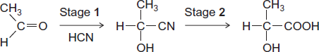
(i) Name and outline a mechanism for Stage 1.
Name of mechanism ............................................................................
Mechanism

(5)

(ii) Give the meaning of the term racemic mixture (racemate).
...............................................................................................................
...............................................................................................................
...............................................................................................................
(1)

(iii) Explain how you could distinguish between a racemic mixture (racemate) of lactic acid and one of the enantiomers of lactic acid.
...............................................................................................................
...............................................................................................................
...............................................................................................................
...............................................................................................................
(2)

(c) A mixture of lactic acid and its salt sodium lactate is used as an acidity regulator in some foods. An acidity regulator makes sure that there is little variation in the pH of food.
(i) Write an equation for the reaction of lactic acid with sodium hydroxide.
...............................................................................................................
(1)

(ii) The acid dissociation constant K_{a} for lactic acid has the value 1.38 × 10⁻⁴ mol dm⁻³ at 298 K.
Calculate the pH of an equimolar solution of lactic acid and sodium lactate.
...............................................................................................................
...............................................................................................................
...............................................................................................................
...............................................................................................................
(2)

(iii) Suggest an alternative name for the term acidity regulator.
Explain how a mixture of lactic acid and sodium lactate can act as a regulator when natural processes increase the acidity in some foods.
Name ...................................................................................................
Explanation ...........................................................................................
...............................................................................................................
...............................................................................................................
...............................................................................................................
(Extra space) ........................................................................................
...............................................................................................................
(3)

(d)

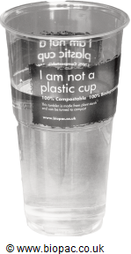The cup shown is made from PLA, poly(lactic acid).
PLA is the condensation polymer formed from lactic acid.
The polymer is described as 100% biodegradable and 100% compostable.
Compostable material breaks down slowly in contact with the moist air in a garden bin. This produces compost that can be used to improve soil.
The manufacturers stress that PLA cups differ from traditional plastic cups that are neither biodegradable nor compostable.

(i) Draw a section of PLA that shows two repeating units.

(2)

(ii) Name the type of condensation polymer in PLA.
...............................................................................................................
(1)

(iii) An intermediate in the production of PLA is a cyclic compound (C₆H₈O₄) that is formed from two PLA molecules.
Draw the structure of this cyclic compound.

(1)

(iv) Traditional non-biodegradable plastic cups can be made from poly(phenylethene), commonly known as polystyrene.
Draw the repeating unit of poly(phenylethene).

(1)

(v) The manufacturers of PLA claim that the material will break down to compost in just 12 weeks.
Suggest one reason why PLA in landfill may take longer than 12 weeks to break down.
...............................................................................................................
...............................................................................................................
(1)
(Total 22 marks)

Q32.This question is about acylium ions, [RCO] ⁺
(a) The acylium ion is formed in a mass spectrometer by fragmentation of the molecular ion of methyl ethanoate.
Write an equation for this fragmentation.
Include in your answer a displayed formula for the radical formed.
........................................................................................................................
(2)

(b) The acylium ion can also be formed from ethanoyl chloride. The ion reacts with benzene to form C₆H₅COCH₃
(i) Write an equation to show the formation of this acylium ion by the reaction of ethanoyl chloride with one other substance.
...............................................................................................................
(2)

(ii) Name and outline a mechanism for the reaction of benzene with this acylium ion.
Name of mechanism ...............................................................................
Mechanism

(4)

(iii) Ethanoic anhydride also reacts with benzene to form C₆H₅COCH₃
Write an equation for this reaction.

........................................................................................................................
(1)
(Total 9 marks)

M1. (a) (i) 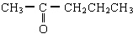 + 2 [H] → CH₃CH(OH)CH₂CH₂CH₃ (1)
or C₅H₁₀O or C₅H₁₁OH

(ii) Name of mechanism: nucleophilic addition (1)
QoL
Mechanism:
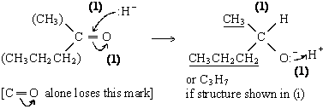

(iii) racemic (racemate) mixture formed (1)
OR explained e.g. 2 enantiomers in equal amounts
7

(b) Fragment 1: 43 ; 43
Fragment 2: 71 ; 15
Any two × (1)
2
[9]

M2. (a) 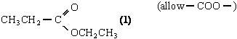 (1)
1

(b) Name of mechanism: (nucleophilic) addition- elimination (1)
Mechanism:
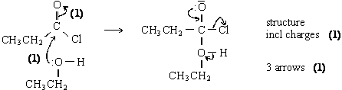
5

(c) CH₃CH₂COOCH₂CH₃⁺• → CH₃CH₂C⁺=O (1) + CH₃CH₂O•
equation (1)
2

(d) CH₃CH₂CH₂COOCH₃ or (CH₃)₂CHCOOCH₃ (1)
Allow C₃H₇COOCH₃
1
[9]

M3. (a) 5 (1)
1
(b) 2:2:2:3:3 (1)
any order but not multiples
1

(c) 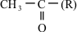 (1)
1

(d) CH₃CH₂ or C₂H₅ or ethyl (1)
δ4.13 (quartet) : CH₂ peak split by CH₃ / next to CH₃ (1)
δ1.26 (triplet) : CH₃ peak split by CH₂ / next to CH₂ (1)
3

(e) CH₂CH₂ (1)
1

(f) 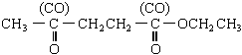(2)
allow (1) for CH₃COCH₂CH₂OCOCH₂CH₃
or CH₃COOCH₂CH₂COCH₂CH₃
Must be C₇H₁₂O₃
2
[9]

M4. (a) (i) Moles NaOH = mv/1000 = 1.50 × 72.5/1000 = 0.108 to 0.11 (1)
Moles of ethanoic acid at equilibrium = moles sodium hydroxide (1)
Moles ester = moles water (=moles acid reacted) (1)
= 0.200 – 0.108 = 0.090 to 0.092 (1)
Moles ethanol = 0.110 – 0.091 = 0.018 to 0.020 (1)
K_{C} = [Ester] [Water]/[Acid] [Alcohol] (1)
Allow if used correctly
= (0.091)²/0.109 × 0.019 = 3.7 to 4.9 (1)
Ignore units
NB Allow the answer 4 one mark as correct knowledge
7

(ii) Similar (types) of bond broken and made (1)
Same number of the bonds broken and made (1)
any number if equal
NB If a list given then the total number of each type of bond broken and made must be the same
2

(b) (i) (Weak) dipole-dipole attraction between HCl molecules (1)
(Strong) hydrogen bonds between CH₃COOH molecules (1)
NB Ignore van der Waals forces
2
(ii) Ethanoic anhydride is
cheap compared to ethanoyl chloride (1)
less corrosive than ethanoyl chloride or HCl evolved (1)
reaction less violent or vigorous or exothermic or dangerous
or safer to use (1)
less vulnerable to hydrolysis (1)
reaction more easily controlled (1)
Max 2
[13]

M5.(a) Mechanism
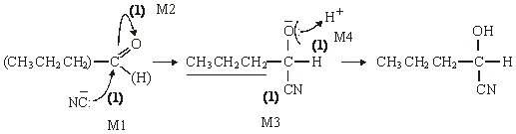

Allow C₃H₇ if structure shown elsewhere
penalise HCN splitting if wrong
Name of product: 2-hydroxypenta(neo)nitrile (1)
or 1-cyanobutan-1-ol
5

(b) Mechanism
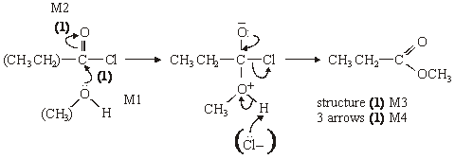
Name of organic product: methylpropanoate (1)
5

(c) (i) ([) CH₃CO (])⁺ (1)
(ii)
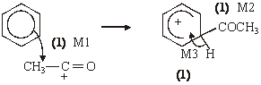
4

Notes
(abc) extra curly arrows are penalised
(a) be lenient on position of negative sign on : CN– but arrow must come from lp
(a)/(b) alone loses M2 but can score M1 for attack on C+, similarly
(a) allow 2-hydroxypentanonitrile or 2-hydroxypenta(ne)nitrile ... pentylnitrile
(b) in M4, allow extra: Cl– attack on H, showing loss of H⁺
(c) (i) allow formula in an “equation”(balanced or not)
be lenient on the position of the + on the formula
(ii) for M1 the arrow must go to the C or the + on the C
don’t be too harsh about the horseshoe, but + must not be close to the saturated C
M3 must be final step not earlier; allow M3 even if structure (M2) is wrong
[14]

Organic points
(1) Curly arrows: must show movement of a pair of electrons,
i.e. from bond to atom or from lp to atom / space
e.g.

(2) Structures
penalise sticks (i.e. 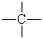) once per paper
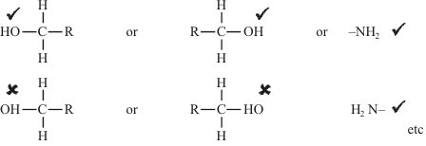
Penalise once per paper
allow CH₃– or –CH₃ or or CH₃
or H₃C–

M6. (a) K₂Cr₂O₇/H₂SO₄ reuced by
CH₃CH₂CH₂CH₂OH (1)
oxidised to CH₃(CH₂)₂CHO (1)
and CH₃(CH₂)₂COOH (1)
CH₃CH₂CH₂CHO (1)
oxidised to CH₃(CH₂)₂COOH (1)
Equation: Cr₂O₇^{2–} + 14H⁺ + 6e– → 2Cr³⁺ + 7H₂O (1)
Note: Deduct one if all three compounds given as reducing agents.
6

(b) Tollens’ reduced by
CH₃CH₂CH₂CHO (1)
oxidised to CH₃(CH₂)₂COOH (1)
Equation [Ag(NH₃)₂]⁺ + e– → Ag + 2NH₃ (1)
3

(c) CH₃CH₂CH₂CH₂OH (1)
Product CH₃CH₂CH₂CH₂OOCCH₃ (1)
(CH₃)₃COH
Product (CH₃)₃COOCCH₃ (1)
4

(d) CH₃CH₂CH₂OH has five peaks (1)
(CH₃)₃COH has two peaks (1)
2
[15]

M7. (a) (i) propyl methanoate (1)
not propanyl
• A wrong reagent or no reagent scores zero
• An incomplete reagent such as silver nitrate for Tollens, or potassium dichromate loses the reagent mark, but can get both observation marks
• penalise observations which just say colour change occurs or only state starting colour

(ii) Reagent: NaHCO₃ (1)
Observation with C: no reaction (1)
Observation with D: effervescence (1)
for C and D NOT Tollens

Test | an identified (hydrogen) carbonate | acidified K₂Cr₂O₇ | acidified KMnO₄ | correct metal | UI or stated indicator | PCl₅
Observation with C | no reaction | goes green | goes colourless | no reaction | no change | no reaction
observation with D | bubbles or CO₂ | no change | no change | bubbles or H₂ | red or correct colour  pH 3 – 6.9 | (misty) fumes

4

(b) (i) Reagent: pentan-2-one (1)
or 2-pentanone
but not pent-2-one or pentyl
(ii) Reagent: Tollen’s or Fehling’s (1)
Observation with E: no reaction (1)
Observation with F: silver mirror or red ppt (1)
for E and F

Test | Tollens | Fehlings or Benedicts | iodoform or I₂/NaOH | acidified K₂Cr₂O₇ | Schiff’s
observation with E | no reaction | no reaction | yellow (ppt) | no change | no reaction
observation with F | silver or mirror or grey or ppt | red or ppt  not red solution | no reaction | goes green | goes pink

4

(c) 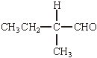 (1)
must be aldehyde. Allow C₂H₅ for CH₃CH₂ otherwise this is the only answer
1
[9]

M8. (a) (i) pH = –log [H⁺] (1)
(ii) Expression for K_{a}: K_{a} = 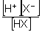 (1)
Calculation: pH = 2.56 ∴ [H⁺] = 2.75 × 10^{–3} (1)
K_{a} = 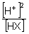 = 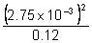 = 6.32 × 10^{–5} (1) (mol dm^{–3})
or [H⁺] = [X–] (1)
depending on approximate made, values of K_{a} = 10^{–5} ×
using [HX] = 0.12 6.30 – 6.32
using [HX] = 0.12 – 2.75... 6.45 – 6.47
using 2.8 and [HX] = 0.12 6.53
using 2.8 and [HX] = 0.12 – 2.8 6.69
upside down K_{a}
5

(b) (i) Expression for K_{w}: K_{w} = [H⁺] [OH–] (1)
Value of K_{w}: (1.0 ×)10^{–14} (mol² dm^{–6}) (1)
ignore units
(ii) [H⁺] = 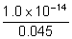 = 2.22 × 10^{–13}
or pOH = 1.35 (1)
pH = 12.65 (1)
must be 2dp in final answer
4

(c) (i) H₂C₂O₄ + OH– → HC₂O₄– + H₂O (1)
(ii) mol OH– = (41.6 × 10^{–3}) × 0.0450 (1) = 1.87 × 10^{–3}
mol H₂C₂O₄ = 9.36 × 10^{–4} (1)
[H₂C₂O₄] = 9.36 × 10^{–4} × 10³/25
= 0.0374 (1)
if moles of H₂C₂O₄ not equal to half moles of OH–, no further marks gained
if mol OH– = 1.9 × 10^{–3}; hence mol H₂C₂O₄ = 9.5 × 10^{–4};
[H₂C₂O₄] = 0.038
4

(d) (i) 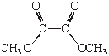 (1)
must be diester allow CH₃OOCCOOCH₃ or CH₃O₂CCO₂CH₃ and similarly in (ii)

(ii)
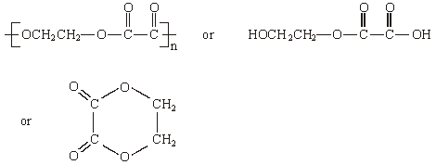
(1)
must be 1:1 proportion allow repeating until alone
(i.e. n not essential)
2
[15]

M9. (a)
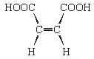
1
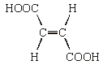
1
NB The bonds shown in the structure must be correct
Isomerism: Geometric or cis-trans
If written answer is correct, ignore incorrect labelling of structures.
If no written answer, allow correctly labelled structures.
1
Both COOH groups must be on the same side/ close together/ cis
1
No rotation about C=C axis
1
Structure
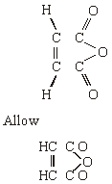
1

(b) Br₂ / HBr / H₂SO₄ / H⁺ / Br⁺ / NO₂⁺ (Mark M1)
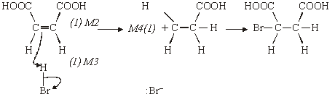

NB If electrophile H⁺ / Br⁺ / NO₂⁺ allow M1, M2 and M4
If the acid is incorrect, M2 and M3 can still be scored
Allow M4 consequentially if repeat error from part (a)
4

(c) e.g. 2NaOH + HO₂CCHCHCO₂H → NaO₂CCHCHCO₂Na + 2H₂O
Both H replaced
1
Balanced for atoms and charges
1
NB Allow ionic equations and 2NaOH + C₄H₄O₄ → C₄H₂O₄Na₂+ 2H₂O
Allow one if structure incorrect but molecular formula
correct
Allow one for a correct equation showing one H replaced

(d) M1 Two peaks
1
M2 No splitting or singlets
1
M3 (Two) non-equivalent protons or two proton environments
1
M4 No adjacent protons
1
M5 Same area under the two peaks or same relative intensity
1
NB Doublet could score M1 and M3 or M5 (Max 2)
More than two peaks CE = 0
Apply the “list principle” to incorrect answers if more
than 3 given
Max 3
[15]

M10. X is methyl propanoate
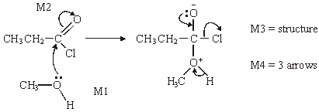
1
M1 for arrow and lone pair,
4
M2 for arrow
addition-elimination
1

Spectrum 2
if thinks Spectrum 1 = X can only score for structure of Y
1
Y is CH₃COOCH₂CH₃
1
The two marks for explanation are awarded for discussing one or more of the
four peaks (not those for the CH₃ of the ethyl groups)
for stated δ values the integration or the splitting should be related to the
structure: e.g. structure of X shows that
at δ 3.7 – 4.1 (1) spectrum of X should have integration 3 / singlet (1)
or
at δ 2.1 – 2.6 (1) spectrum of X should have integration 2 / quartet (1)
Spectrum 2 has these
[OR Spectrum 1 has
at 3.7 – 4.1 (1) quartet / integration 2 (1) so not X
at 2.1 – 2.6 (1) singlet / integration 3 (1) so not X]
2
[10]

M11. (a) Pentan-2-one
1
(b) (i) 1680 – 1750 (cm^{–1})
1
(ii) 3230 – 3550 or 1000 – 1300 (cm^{–1})
1
(iii) 4
1

(c)

Reagent | K₂Cr₂O₇/H⁺ | KMnO₄ /H⁺ | Na | CH₃COOH/  H₂SO₄ | 1
with C | no reaction | no reaction | no reaction | no reaction | 1
with D | goes green | goes colourless | effervescence | smell | 1

(penalise incomplete reagent e.g. K₂Cr₂O₇ or Cr₂O₇ ^{2–}/H⁺ then mark on)

(d)
Reagent | Tollens | Fehlings or Benedicts | 1
with E | silver  (mirror) | red ppt or goes red  (not red solution) | 1

[9]

M12. (a) (i) An appropriate alkene; CH₃CH₂CHCH₂ or (CH₃)₂CCH₂
1
Isomer 1
1
Isomer 2
1
Position isomerism
1
Mechanism
electrophilic attack and electron shift to Br (Unless H⁺ used)
1
carbocation
1
reaction with carbocation
[Allow mechanism marks for the alkene CH₃CHCHCH₃]
[Allow one mark if mechanism for minor product given]
1

(ii) An appropriate carbonyl; CH₃CH₂CHO
1
Mechanism nucleophilic attack and electron shift to O
1
anion intermediate
1
reaction with anion
[Allow mechanism marks for the carbonyl (CH₃)₂CO]
1
Isomer 1
1
Isomer 2
1
Optical isomerism
NB Isomer structures must be tetrahedral
NB Penalise “stick” structures once in part (a)
1

(b) QoL
Large charge on carbonyl carbon atom due to bonding
to O and Cl
1
Nucleophiles have electron pairs which can be donated
1
Equation Species
1
Balanced
1
[18]

M13. (a) (i)

Reagent | Tollens | Fehlings or Benedicts | K₂Cr₂O₇/H⁺  or acidified | KMnO₄/H⁺ | I₂/NaOH
Propanal | silver (mirror) | red ppt or goes red  (not red solution) | goes green | goes colourless | No  reaction
Propanone | no reaction | no reaction | no reaction | no reaction | Yellow  (ppt)

(penalise incomplete reagent e.g. K₂Cr₂O₇ or Cr₂O₇^{2–}/H⁺ then mark on)
3
(ii) propanal 3 peaks
ignore splitting even if wrong
1
propanone 1 peak
1

(b) X is CH₃CH₂COOH or propanoic acid if both name and formula given,
both must be correct, but
1
Y is CH₃CH(OH)CH₃ or propan-2-ol allow propanol with correct formula
1
Mark the type of reaction and reagent/condition independently.
The reagent must be correct or close to score condition
Step 1 Oxidation
K₂Cr₂O₇/H⁺ or other oxidation methods as above
allow Cr₂O₇^{2–}H⁺ if penalised above (ecf)
reflux (not Tollens/Fehlings) or heat or warm
1

Step 2 | reduction or nucleophilic  addition | reduction or  nucleophilic addition | reduction or hydrogenation | 1
 | NaBH₄ | LiAlH₄ | H₂ | 1
 | in (m)ethanol or water or ether  or dry | ether or dry | Ni / Pt etc | 1

Step 3 esterification or (nucleophilic) addition-elimination or condensation
1
(conc) H₂SO₄ or HCl
1
warm (allow without acid reagent if X and Y given as reagents)
1
or reflux or heat
1
[15]

M14. (a) butanoyl chloride
1

(b) (i) Cl has (two) isotopes or ³⁵Cl and ³⁷C1
1
(ii) 106 and 108
1

(c) (nucleophilic) addition-elimination, penalise electrophilic
not esterification
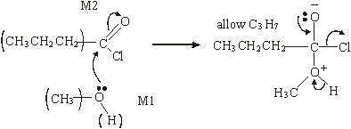
1

M3 for structure
M4 for 3 arrows and lone pair
(only allow for correct M3 or close)
M2 not allowed independent of M1,
but allow M1 for correct attack on C+ if M2 shown as independent first.
4
[8]

M15. (a) (i)

The addition followed by the addition of
of AgNO₃ concentrated NH₃(aq)
Observation with NaBr(aq) | Cream or off white  precipitate or solid (1) | Precipitate  dissolves (1)
Observation with NaI(aq) | Yellow precipitate  or solid (1) | Precipitate insoluble  or no change (1)

(ii) Ag F is soluble;
5
(b) (i) identity: [Ag(S₂O₃)₂]^{3–};
1
(ii) equation: AgI + 2S₂O₃^{2–} → [Ag(S₂O₃)₂]^{3–} + I–
1
(iii) use: in photography or as a fixer;
1

(c) (i) Structure
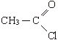
1
Observation: Vigorous or violent or exothermic reaction
or fumes or white precipitate formed immediately
1
(ii) Structure:
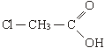
1
Observation: No immediate precipiate or reaction
OR
white precipitate formed very slowly;
1

(d) (i) Silver-containing complex: [Ag(NH₃)₂]⁺;
1
Shape: Linear;
1

(ii) Structure
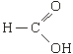
1
Explanation: Methanoic acid contains an aldehyde group;
1

(iii) H₂CO₃ or CO₂ or OC(OH)NH₂ or (NH₂)₂ CO or (NH₄)₂ CO₃
OR
HCOONH₄ ;
1
[17]

M16. (a) (nucleophilic) addition-elimination;
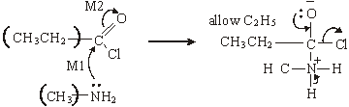

(M3 for structure)
(M4 for 3 arrows and lone pair)
(M2 not allowed independent of M1, but allow M1 for correct attack
on C+ if M2 show as independent first.)
(+on C of C=O loses M2 but ignore δ+ if correct)
(Cl– removing Ft loses M4)
1

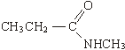
(If MS lost above for wrong C chain, do not penalise same error again here)
5

(b) CH₃CH₂COCl + AlCl₃ → [CH₃CH₂CO]⁺ + AlCl₄–;
(penalise wrong alkyl group once at first error)
(position of + on electrophile can be on O or C or outside [ ]) (penalise wrong curly arrow in the equation or lone pair on AlCl₃)
1

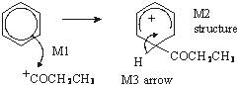  (M1 arrow from within hexagon to C or to + on C)  (don’t penalise position of + on C of RCO+) | (horseshoe must not extend beyond C2 to C6 but can be smaller)  (+ not too close to C1)  (penalise M2 if CH₃ chain wrong again but allow M1 and M3)  (M3 arrow into hexagon unless Kekule)  (allow M3 arrow independent of M2 structure)

3
(or can be gained in mechanism);
1

(c) M1 CH₃CH₂COCl + H₂O → CH₃CH₂COOH + HCl 1
(penalise wrong alkyl group once at first error)
1
M2 M_{r} of CH₃CH₂COCl = 92.5 1
(if Mr wrong, penalise M2 only)
1
M3 moles of CH₃CH₂COCl = 1.48/92.5 = 0.016 1
1
M4 moles NaOH = 2 × 0.016 = 0.032 1
(allow for × 2 conseq to wrong no of moles)
1
M5 volume of NaOH = 0.032/0.42 = 0.0762 dm³ or 76.2 cm³ 1
(with correct units)
(if ×2 missed in M4 lose M5 also)
1
[16]

M17. (a) necleophilic addition;
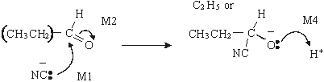
1
M3 structure;
(be lenient on position of charge on CN– )
(M2 not allowed independent of M1,
but allow M1 for correct attack on C+
if M2 show as independent first.)
(+on C of C=O loses M2 but ignore δ+ if correct)
(M4 for arrow and lone pair (only allow for correct M3 or close))
4

(b) (i) 2-hydroxybutanoic acid
1
(ii)
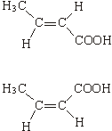

1
geometric(al) or cis-trans
1

(c) (i)
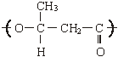
(one unit only) (ignore brackets or n) (trailing bonds are needed)
1

(ii) can be hydrolysed
OR
can be reacted with/attacked by acid/base/nucleophiles/H₂O/OH–;
1

(d) (i)
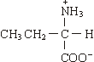
(allow –NH₃⁺)
1

(ii)
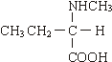
(or zwitterions product)
1

(iii) nucleophilic substitution;
1
[14]

M18. (a) propyl methanoate;
HCOOC₃H₇ + OH– → HCOO– + C₃H₇OH
1
OR
HCOOC₃H₇ + NaOH → HCOONa + C₃H₇OH;
1

(b) order wrt A = 1;
1
order wrt NaOH = 1;
1
Initial rate in Exp 4 = 2.4 × 10^{–3};
1

(c) (i) r(ate) = k[A]
OR
r(ate) = k[A][NaOH]⁰;
(penalise missing [ ] but mark on)
(penalise missing [ ] once per paper)
(if wrong order, allow only units mark conseq on their rate eqs)
(penalise k_{a} or k_{w} etc)
1

(ii) 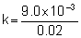;
1
= 0.45;
1
s^{–1};
l

(iii) (large) excess of OH– or [OH–] is large/high;
1
[OH–] is (effectively) constant
OR
[A] is the limiting factor (Q of L mark)
1

(d) (i)
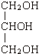
1
propan(e)-1,2,3-triol
OR
1,2,3-propan(e)triol
OR
Glycerol;
1

(ii) CH₃(CH₂)₁₆COONa or C₁₇H₃₅COONa or C₁₈H₃₅O₂Na;
(ignore 3 in front of formula but not if indicating trimer)
1
(not just anion and penalise Na shown as covalently bonded) soap -
allow with detergent but not detergent alone;
1
[15]

M19. (a) dimethylamine
1

(b) nucleophilic substitution
1
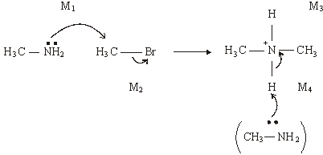
4

(c) quaternary ammonium salt
1
(cationic) surfactant / bactericide / detergent / fabric softener or
conditioner/hair conditioner
1

(d)
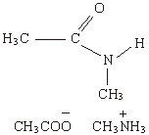

(allow CH₃COOH or CH₃COO– NH₄⁺)
2
[10]

M20. (a) nucleophilic addition
1
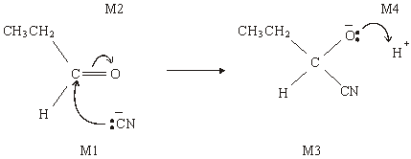
4

(b) (i) 2-hydroxybutanenitrile
1
(ii)
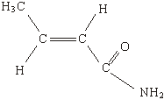
(allow 1 for amide even if not C₄H₇NO, i.e. RCONH₂)
(if not amide, allow one for any isomer of C₄H₇NO which shows
geometric isomerism)
2

(c) (i)
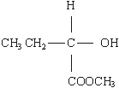
1

(ii)
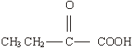
1
(iii) CH₃CH=CHCOOH
1
[11]

M21. (a) CH₃COCl + AlCl₃ → CH₃O + AlCl
(1) equation (1)
2
penalise wrong alkyl group once at first error
position of + on electrophile can be on O or C or outside [ ]
penalise wrong curly arrow in the equation or lone pair on AlCl₃ else ignore

Electrophilic substitution
NOT F/C acylation
1
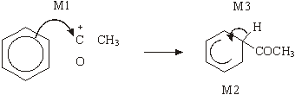
horseshoe must not extend beyond C2 to C6 but can be smaller
+ not too close to C1
M3 arrow into hexagon unless Kekule
allow M3 arrow independent of M2 structure
M1 arrow from within hexagon to C or to + on C
+ must be on C of 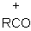
3

(b) Nucleophilic addition
NOT reduction
1
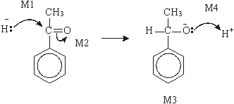

M2 not allowed independent, but can allow M1 for attack of H– on C+ formed
4
1–phenylethan(–1–)ol or (1–hydroxyethyl)benzene
l

(c) dehydration or elimination
1
(conc) H₂SO₄ or (conc) H₃PO₄
allow dilute and Al₂O₃
Do not allow iron oxides
1
[14]

M22. (a) CH₃OH + CH₃CH₂COOH → CH₃CH₂COOCH₃ + H₂O
1
(b) (nucleophilic) addition–elimination NOT acylation
1
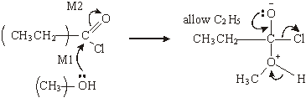
ignore use of Cl– to remove H⁺
M3 for structure
M4 for 3 arrows and lone pair
4

(c)
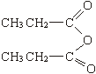
allow C₂H₅ and –CO₂–
allow CH₃CH₂COOCOCH₂CH₃
or (CH₃CH₂CO)₂O
1

(d) (i) faster/not reversible/bigger yield/purer product/no(acid) (catalyst)
required
1
(ii) anhydride less easily hydrolysed or reaction less violent/exothermic
no (corrosive) (HCl) fumes formed or safer or less toxic/dangerous
expense of acid chloride or anhydride cheaper
any one
1

(e) (i) C₈H₈O₂
1
(ii) any two from
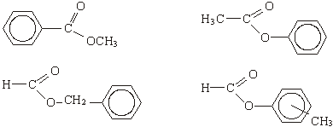
Allow –CO₂– allow C₆H₅
2
[12]

M23. (a) (i) propan(e)-1,2,3-triol or 1,2,3- propan(e)triol
not propyl
ignore hyphen, commas
1

(ii) soaps
allow anionic surfactant
not cationic surfactant
not detergents, not shampoos
1

(b) (i) (bio)diesel
Allow fuel for diesel engines
not biofuel, not oils
1

(ii)
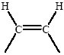
ignore anything else attached except any more H atoms.
1

(iii) CH₃(CH₂)₁₂COOCH₃ + 21½O₂ → 15CO₂ + 15 H₂O
OR
C₁₅H₃₀O₂ or 43/2
not allow equation doubled
1
[5]

M24. (a) nucleophilic addition
1
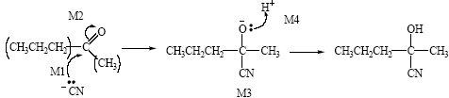
Attack by HCN loses M1 and M2
M2 not allowed independent of M1, but
allow M1 for correct attack on C+
+C=O loses M2
M2 only allowed if correct carbon attacked
allow minus charge on N i.e. :CN–
4
M3 for completely correct structure not including lp
allow C₃H₇ in M3
M4 for lp and arrow
allow without –
1
2-hydroxy-2-methylpentan(e)nitrile
allow 2-hydroxy-2-methylpentanonitrile

(b) Product from Q is a racemic mixture/equal amounts of enantiomers
if no reference to products then no marks;
1
racemic mixture is inactive or inactive explained
not Q is optically active or has a chiral centre etc
1
Product from R is inactive (molecule) or has no chiral centre
1

(c) (i) mark the three sections of (c) separately
1
R or CH₃CH₂COCH₂CH₃

(ii) [CH₃CH₂COCH₂CH₃]^{+.} OR [C₅H₁₀O]^{+.}
1
→ [CH₃CH₂CO]⁺ + .CH₂CH₃
OR → [C₃H₅O]⁺ + .C₂H₅
1
allow molecular formulae
allow without brackets
if brackets not shown, allow dot anywhere on radical or + anywhere on ion

(iii) m/z = 43 or 71
1
[13]

M25. (a) M1 CH₃CH₂CH₂COOH
not C₃H₇COOH
1
M2 CH₃CH₂OH or C₂H₅OH
1
M3 CH₃CH₂CH₂COOCH₂CH₃ + H₂O
allow C₃H₇COOC₂H₅
penalise M3 for wrong products and unbalanced equation
1
M4 H₂SO₄ or HCl or H₃PO₄ conc or dil or neither
not HNO₃
1

(b) M1 CH₃CH₂CH₂CH₂OH
1
not C₄H₉OH
M2 (CH₃CO) ₂O
1
M3 → CH₃COOCH₂CH₂CH₂CH₃ + CH₃COOH
allow CH₃COOC₄H₉
penalise M3 for wrong products and unbalanced equation
1

(c) (nucleophilic) addition-elimination
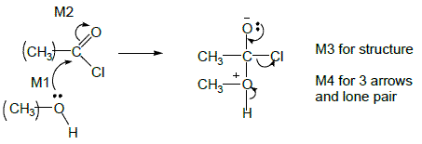
not acylation alone
M2 not allowed indep of M1 but allow M1 for correct attack on C+
+C=O loses M2
only allow M4 after correct or v close M3
ignore Cl– removing H⁺
5

(d)
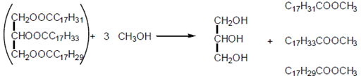
(1) (1) (1)
ignore errors in initial triester
First mark for 3CH₃OH
Third mark for all three esters
3

(e)
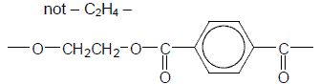
First mark for correct ester link second mark for the rest including trailing bonds
If ester link wrong, lose second mark also
2
Adv reduces landfill
saves raw materials
lower cost for recycling than making from scratch
reduces CO₂ emissions by not being incinerated
not allow cost without qualification
ignore energy uses
1
Disad difficulty/cost of collecting/sorting/processing
product not suitable for original purpose, easily contaminated
not allow cost without qualification
ignore energy uses
1
[19]

M26. (a) (i) C₆H₆ + CH₃CH₂COCl → C₆H₅COCH₂CH₃ + HCl
OR
C₆H₆ + CH₃CH₂CO⁺ → C₆H₅COCH₂CH₃ + H⁺
allow C₂H₅
penalise C₆H₅–CH₃CH₂CO
allow + on C or O in equation
1
Phenylpropanone
OR ethylphenylketone OR phenylethylketone
Ignore 1 in formula, but penalise other numbers
1

AlCl₃
can score in equation
1
CH₃CH₂COCl + AlCl₃ → CH₃CH₂CO⁺ + AlCl₄–
allow C₂H₅
allow + on C or O in equation
1
AlCl₄– + H⁺ → AlCl₃ + HCl
1

(ii) electrophilic substitution
can allow in (a)(i) if no contradiction
1
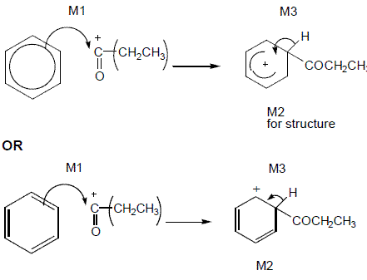
M1 arrow from circle or within it to C or to + on C
horseshoe must not extend beyond C2 to C6 but can be smaller
+ not too close to C1
M2 penalise C₆H₅–CH₃CH₂CO (even if already penalized in (a)(i))
M3 arrow into hexagon unless Kekule
allow M3 arrow independent of M2 structure
ignore base removing H in M3
3

(b) (i) CH₃CH₂CHO + HCN → CH₃CH₂CH(OH)CN OR
C₂H₅CH(OH)CN
aldehyde must be –CHO brackets optional
1
2-hydroxybutanenitrile OR 2-hydroxybutanonitrile
no others
1

(ii) nucleophilic addition
1
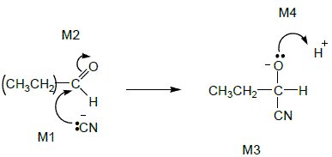
M1 includes lp and arrow to Carbonyl C and minus charge (on either C or N)
Not allow M2 before M1, but allow M1 to C⁺ after non-scoring carbonyl arrow
Ignore δ+, δ– on carbonyl group, but if wrong way round or full + charge on C lose M2
M3 for correct structure including minus sign. Allow C₂H₅
M4 for lp and curly arrow to H⁺
4

(iii) (propanone) slower OR propanal faster
1
inductive effects of alkyl groups
OR
C of C=O less δ+ in propanone
OR
alkyl groups in ketone hinder attack
OR
easier to attack at end of chain
if wrong, no further marks
1
[18]

M27.(a) (Nucleophilic) addition-elimination
• Minus sign on NH₃ loses M1(but not M4 also)
• M2 not allowed independent of M1, but
1

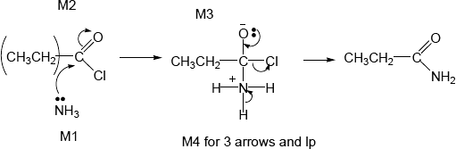

• allow M1 for correct attack on C+
• + rather than δ+ on C=O loses M2
• If Cl lost with C=O breaking, max1 for M1
• M3 for correct structure with charges but lp on O is part of M4
• only allow M4 after correct/very close M3
• For M4, ignore NH₃ removing H⁺ but lose M4 for Cl– removing H⁺ in mechanism,
• but ignore HCl shown as a product
4

propanamide (Ignore -1- )
penalise other numbers
penalise propaneamide and N-propanamide
1

(b) Nucleophilic substitution
• Minus sign on NH₃ loses M1 (not M4 also)
• + rather than δ+ on C=O loses M2
1

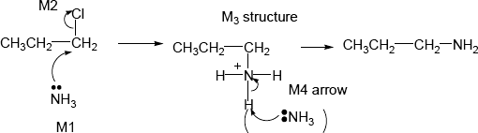
• ALLOW SN1 so allow M2 for loss of Cl– before attack of NH₃ on C+ for M1
• only allow M4 after correct/very close M3
• For M4, ignore NH₃ removing H⁺ but lose M4 for Cl– removing H⁺ in mechanism,
Propylamine (ignore number 1)
• but ignore HCl shown as a product
4

or propan-1-amine or 1-aminopropane (number 1 needed)
penalise other numbers
allow 1-propanamine
1

(c) electron rich ring or benzene or pi cloud repels nucleophile/ammonia
Allow
• C–Cl bond is short/stronger than in haloalkane
• C–Cl is less polar than in haloalkane
• resonance stabilisation between ring and Cl
1
[13]

M28.(a) (i) CH₃COCl + C₆H₆ → C₆H₅COCH₃ + HCl
Not molecular formulae Not allow C₆H₅CH₃CO
1

OR
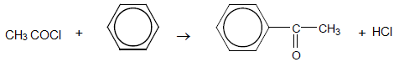
phenylethanone
Ignore number 1 in name but penalise other numbers
1

AlCl₃ can be scored in equation
1

Allow RHS as 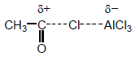

Allow + on C or O in equation but + must be on C in mechanism below
Ignore curly arrows in balanced equation even if wrong
1

(ii) Electrophilic substitution
1

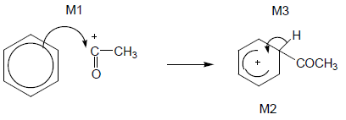
OR
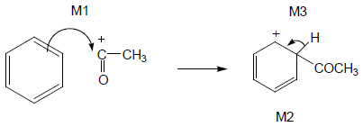
• M1 arrow from within hexagon
to C or to + on C
• + must be on C of CH₃CO in mechanism
• + in intermediate not too close to C1
• Gap in horseshoe must be centred approximately around C1
• M3 arrow into hexagon unless Kekulé
• Allow M3 arrow independent of M2 structure,
• ie + on H in intermediate loses M2 not M3
• Ignore base removing H for M3
3

(b) Electron pair donor or lone pair donor
Allow donator
Allow lone pair used in description of (dative) bond formation
1

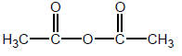
Allow (CH₃CO)₂O
1

(acid) anhydride
Allow ethanoic anhydride but not any other anhydride
1
[11]

M29.(a) Sn / HCl OR Fe / HCl not conc H₂SO₄ nor any HNO₃
Ignore subsequent use of NaOH
Ignore reference to Sn as a catalyst with the acid
Allow H₂ (Ni / Pt) but penalise wrong metal
But NOT NaBH₄ LiAlH₄ Na / C₂H₅OH
1

Equation must use molecular formulae
C₆H₄N₂O₄ + 12 [H]
12[H] and 4H₂O without correct molecular formula scores 1 out of 2
1

→C₆H₈N₂ + 4H₂O
Allow .... + 6H₂ if H₂ / Ni used
Allow −CONH− or −COHN− or −C₆H₄−
1

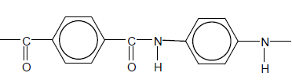
Mark two halves separately: lose 1 each for
• error in diamine part
• error in diacid part
• error in peptide link
• missing trailing bonds at one or both ends
• either or both of H or OH on ends
Ignore n
2

(b) H₂ (Ni / Pt) but penalise wrong metal
NOT Sn / HCl, NaBH₄ etc.
1

CH₂
1

In benzene 120°
1

In cyclohexane 109° 28’ or 109½°
Allow 108° - 110°
If only one angle stated without correct qualification, no mark awarded
1

(c) (i) Nucleophilic addition
1

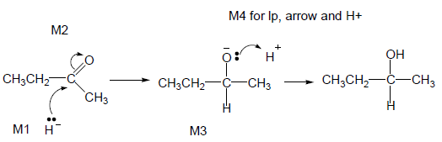
• M2 not allowed independent of M1, but allow M1 for correct attack on C+
• + rather than δ+ on C=O loses M2
• M3 is for correct structure including minus sign but lone pair is part of M4
• Allow C₂H₅
• M1 and M4 include lp and curly arrow
• Allow M4 arrow to H in H₂O (ignore further arrows)
4

(ii) M1 Planar C=O (bond / group)
Not just planar molecule
1

M2 Attack (equally likely) from either side
Not just planar bond without reference to carbonyl
1

M3 (about product): Racemic mixture formed OR 50:50 mixture or
each enantiomer equally likely
1
[17]

M30.(a) (i) 3CH₃OH
Not molecular formula
1

HOCH₂CH(OH)CH₂OH
1

(ii) → 19CO₂ + 19H₂O
Or doubled
1

C₁₇H₃₅COOCH₃ + 27½ or 55/2 O₂
Consequential on correct right-hand side
1

(b) (i) A0.7
1

Ethanol6.4
1

Water3.6
1

(ii) No effect
If wrong, CE= 0
1

Equal moles on each side of equation OR V cancels
Ignore moles of gas
1

(iii) M1 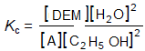

Must have all brackets but allow ( )
1

(iv) M2 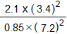

If K_{c} wrong can only score M4 for units consequential to their K_{c} working in (b)(iv)
1

M3 0.55 (min 2dp)
1

M4 No units
1
[13]

M31.(a) (i) 2-hydroxypropanoic acid
OR
2-hydroxypropan(-1-)oic acid
Do not penalise different or missing punctuation or extra spaces.
Spelling must be exact and order of letters and numbers as here.
Can ignore −1− before –oic, but penalise any other numbers here.
1

(ii) C₁₂H₂₂O ₁₁ + H₂O 4CH₃CH(OH)COOH
Allow 4C₃H₆O₃
OR
C₁₂H₂₂O₁₁ + H ₂O 2CH₃CH(OH)COOH + C₆H₁₂O₆
Allow 2C₃H₆O₃
1

(b) (i) Nucleophilic addition
M4 for lp, arrow and H+
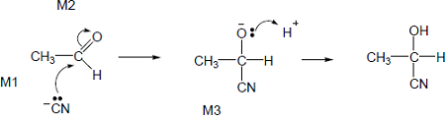
• M1 lp and minus must be on C
• M1 and M4 include lone pair and curly arrow.
• M2 not allowed independent of M1, but allow following some attempt at attack on carbonyl C
• allow M1 for correct attack on C+
• + rather than δ+ on C=O loses M2
• M3 is for correct structure including minus sign but lone pair is part of M4
• Allow arrow in M4 to H of H-CN with arrow forming cyanide ion.
5

(ii) Equal mixture of enantiomers / (optical) isomers
1

(iii) (Plane) polarized light
If missing no further mark.
1

(Polarised light) rotated by single enantiomer but unaffected by racemate
Both needed; not allow bend, twist etc.
1

(c) (i) CH₃CH(OH)COOH + NaOH → CH₃CH(OH)COONa + H₂O
OR CH₃CH(OH)COOH + OH⁻ → CH₃CH(OH)COO⁻ + H₂O
Not ambiguous mol formulae for product - must show COONa or CO₂Na or COO⁻ or CO₂⁻
1

(ii) [H⁺] = K_{a} OR pH = pK_{a}
1

pH = 3.86
Allow more than 2 decimal places but not fewer.
1

(iii) M1 buffer
Ignore acidic but penalise alkaline or basic.
1

Any two out of the three marks M2 , M3 & M4
M2 Large lactate concentration in buffer
OR sodium lactate completely ionised
M3 added acid reacts with / is removed by lactate ion or A⁻ or sodium
lactate or salt
OR equation H⁺ + A⁻ → HA
Ignore reaction of H⁺ with OH⁻
Ignore reference to equilibrium unless it is shown.
M4 ratio [HA] / [A⁻] stays almost constant
Ignore H⁺ or pH remains constant.
Max 2

(d) (i) 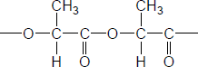
No marks if ester link missing
Correct ester link
allow –COO–
NB Correct answer scores 2
Ignore n here (compare with (d)(iv).
Ignore brackets
1

OR
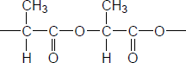
All rest correct with trailing bonds
If OH or COOH on either or both ends, lose one, ie dimer scores 1
If more than two repeating units, lose 1
1

(ii) (Poly)ester ie allow ester
Not terylene.
Ignore spaces and brackets in answer.
1

(iii)
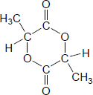
Allow any cyclic C₆H₈O₄
1

(iv)
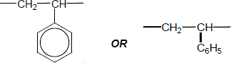
Penalise n here (compare with (d)(i)
Ignore brackets.
Not allow Ph for phenyl.
1

(v) In landfill, no air or UV, to assist decay
OR not enough water or moisture (to hydrolyse polyester)
Allow landfill has / contains:
no or few bacteria / micro-organisms / enzymes compared with compost heap
OR less oxygen
OR lower temperature.
1
[22]

M32.(a) 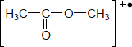
OR 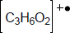
NOT penalise missing brackets.
If wrong ester, no further mark.
1

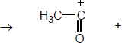
Must be displayed formula
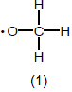
Radical dot must be on O
Ignore lone pair(s) on O in addition to single electron
Allow radical with brackets as
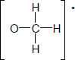
Ignore errors in acylium ion.
1

(b) (i) AlCl₃ or FeCl₃
If wrong no further marks.
1

Correct equation scores 2 - contrast with (b)(iii)
Allow + on C or O in equation.
1

(ii) Electrophilic substitution
Ignore Friedel crafts.
1

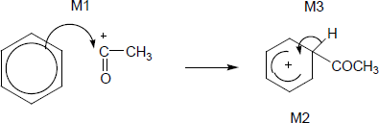
OR
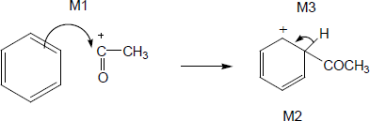
• + must be on C of RCO here
• M1 arrow from within hexagon to C or to + on C
• Gap in horseshoe must approximately be centred around
C1 and not extend towards C1 beyond C2 and C6
• + not too close to C1
• M3 arrow into hexagon unless Kekule
• allow M3 arrow independent of M2 structure, i.e. + on H in
intermediate loses M2 not M3
• ignore base removing H for M3
3

(iii) (CH₃CO)₂O + C₆H₆ C₆H₅COCH₃ + CH₃COOH
OR
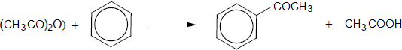
Correct equation scores 1 – contrast with (b)(i)
Not allow molecular formula for ethanoic anhydride or ethanoic acid.
1
[9]

