Questions
Q1.
The first stage in the manufacture of nitric acid is the oxidation of ammonia:
4NH₃(g) + 5O₂(g) 4NO(g) + 6H₂O(g) ΔH = −906 kJ mol⁻¹
(a) In modern industrial plants this reaction is carried out at a pressure of around 3 atm. Which of the following statements is incorrect? The raised pressure
(1)

A helps push the reactants through the reactor.
B shifts the position of equilibrium to the right.
C increases the cost of the reactor.
D increases the energy cost of this part of the process.
(b) A platinum-rhodium alloy catalyst is used in this reaction. Which of the following statements is incorrect? The catalyst
(1)

A lowers the activation energy of the reaction.
B has no effect on the equilibrium constant for the reaction.
C alters the enthalpy change of the reaction.
D reduces the energy cost of this part of the process.
(c) The operating temperature of this reaction is about 900°C. The use of a high temperature
(1)

A increases the rate of the reaction and the equilibrium yield.
B increases the rate of the reaction and decreases the equilibrium yield.
C decreases the rate of the reaction and the equilibrium yield.
D decreases the rate of the reaction and increases the equilibrium yield.
(Total for Question = 3 marks)

Q2.
Consider the equilibrium
Which of the following is true when the total pressure of the system is increased at
constant temperature?
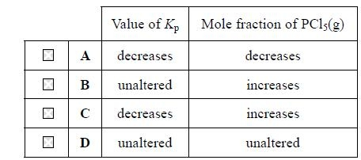
(Total for question = 1 mark)

Q3.
At 100 °C, pure water has a pH of 6, whereas at 25 °C it has a pH of 7. This is because
A the dissociation of water is endothermic, so the concentration of hydrogen
ions is lower at 100 °C than it is at 25 °C.
B the dissociation of water is exothermic, so the concentration of hydrogen ions
is lower at 100 °C than it is at 25 °C.
C the dissociation of water is endothermic, so the concentration of hydrogen
ions is higher at 100 °C than it is at 25 °C.
D at 100 °C, water has a higher concentration of hydrogen ions than of
hydroxide ions.
(Total for question = 1 mark)

Q4.
An important step in the production of sulfuric acid is the oxidation of sulfur dioxide.
2SO₂(g) + O₂(g) 2SO₃(g) ΔH = −196 kJ mol⁻¹
Which of the conditions below is best suited to produce a high yield of sulfur trioxide, SO₃?

A 1 atm pressure and 800 °C.
B 2 atm pressure and 800 °C.
C 1 atm pressure and 400 °C.
D 2 atm pressure and 400 °C.
(Total for Question = 1 mark)

Q5.
(a) For the equilibrium reaction between hydrogen and iodine
H₂(g) + I₂(g) 2HI(g)
increasing the pressure of the system
(1)

A has no effect on the rate or the position of equilibrium.
B increases the rate but does not affect the position of equilibrium.
C increases the rate and shifts the equilibrium to the right.
D increases the rate and shifts the equilibrium to the left.
(b) The equation for the equilibrium reaction between hydrogen and iodine may also be written as
½H₂(g) + ½I₂(g) HI(g)
This change to the equation, compared to that in part (a),
(1)

A has no effect on the value of the equilibrium constant.
B halves the value of the equilibrium constant.
C doubles the value of the equilibrium constant.
D square roots the value of the equilibrium constant.
(Total for Question = 2 marks)

Q6.
1,2-dichloroethane decomposes in the presence of a catalyst.
Which of the following would result in an increase in the equilibrium yield of chloroethene?
A Increasing the temperature.
B Increasing the pressure.
C Increasing the surface area of the catalyst.
D Changing the catalyst to a more efficient one.
(Total for question = 1 mark)

Q7.
Consider the equilibrium below.
CO(g) + Cl₂(g) COCl₂(g)
(a) An increase in pressure by a factor of 2 will
(1)
A quadruple K_{p}.
B double K_{p}.
C have no effect on K_{p}.
D halve K_{p}.
(b) The units of K_{p} are
(1)
A atm⁻²
B atm⁻¹
C atm
D atm²
(Total for question = 2 marks)

Q8.
The Haber process is used to make ammonia from nitrogen and hydrogen at 450 °C.
(a) If the partial pressures of these gases were measured in atm, the units of the equilibrium constant K_{p} will be
(1)
A atm
B atm²
C atm⁻²
D atm⁻¹
(b) When the temperature of the system is increased
(1)
A K_{p} decreases.
B K_{p} increases.
C K_{p} stays the same.
D K_{p} first decreases and then increases.
(Total for question = 2 marks)

Q9.
Methane hydrate is found on continental shelves deep in oceans. It forms methane in an endothermic equilibrium reaction, which may be represented as
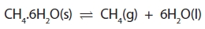
(a) Which of the following changes would decrease the equilibrium yield of methane?
(1)
A Decreasing the temperature and decreasing the pressure.
B Increasing the temperature and decreasing the pressure.
C Decreasing the temperature and increasing the pressure.
D Increasing the temperature and increasing the pressure.
(b) Which of the following would increase the value of the equilibrium constant, K_{p}, for the above equilibrium?
(1)
A Decreasing the pressure
B Increasing the pressure
C Decreasing the temperature
D Increasing the temperature

(Total for question = 2 marks)

Q10.
Methane hydrate is found on continental shelves deep in oceans. It forms methane in an endothermic equilibrium reaction, which may be represented as
(a) Which of the following changes would increase the equilibrium yield of methane?
(1)
A Increasing the temperature and decreasing the pressure.
B Decreasing both the temperature and the pressure.
C Increasing both the temperature and the pressure.
D Decreasing the temperature and increasing the pressure.
(b) Which of the following would decrease the value of the equilibrium constant, K_{p}, for the above equilibrium?
(1)
A Decreasing the pressure
B Increasing the pressure
C Decreasing the temperature
D Increasing the temperature

(Total for question = 2 marks)

Q11.
Methanol is produced in the equilibrium reaction
Addition of more hydrogen to the equilibrium mixture at constant temperature
A increases the equilibrium yield of methanol.
B decreases the equilibrium yield of methanol.
C increases the value of K_{p}.
D decreases the value of K_{p}.
(Total for question = 1 marks)

Q12.
The graph below shows the yield of product in a gaseous equilibrium at different
temperatures and pressures.
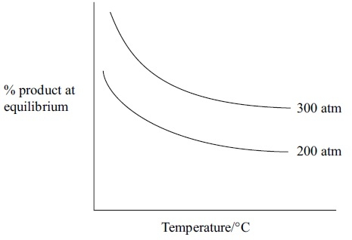
The forward reaction in the equilibrium is
A exothermic, and the number of moles of gas is increasing.
B endothermic, and the number of moles of gas is increasing.
C exothermic, and the number of moles of gas is decreasing.
D endothermic, and the number of moles of gas is decreasing.
(Total for question = 1 mark)

Q13.
Which of these will not improve the overall yield of the Haber process?
N₂(g) + 3H₂(g) 2NH₃(g) ΔH = −92kJ mol⁻¹
A Increasing the pressure.
B Liquefying then removing the ammonia from the reaction.
C Increasing the temperature.
D Recycling unreacted nitrogen and hydrogen.
(Total for question = 1 mark)

Mark Scheme
Q1.
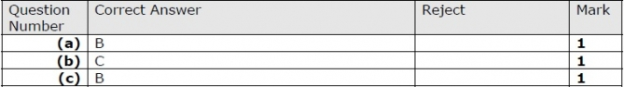

Q2.

Q3.

Q4.

Q5.

Q6.

Q7.
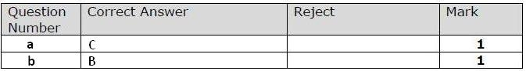

Q8.

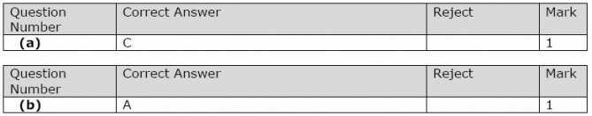

Q9.

Q10.

Q11.

Q12.

Q13.
