Q1. (a) The equation below shows the reaction of 2-bromopropane with an excess of ammonia.
CH₃CHBrCH₃ + 2NH₃ → CH₃CH(NH₂)CH₃ + NH₄Br
Name and outline the mechanism involved.
Name of mechanism ….................................................................................
Mechanism

(5)

(b) When 2-bromopropane is heated with ethanolic potassium hydroxide, an elimination reaction occurs. State the role of potassium hydroxide and outline a mechanism for this reaction.
Role of potassium hydroxide ........................................................................
Mechanism

(5)
(Total 10 marks)

Q2. Reaction of 2-bromobutane with potassium hydroxide can produce two types of product depending on the solvent used. In aqueous solution, the formation of an alcohol, E, is more likely but in ethanolic solution the formation of alkenes is more likely.
(a) For each type of product, name the type of reaction occurring and state the role of the potassium hydroxide.
(4)

(b) Name alcohol E and draw its structural formula. By reference to the structure of the halogenoalkane, explain why the initial step in the mechanism of the reaction producing the alcohol occurs.
(5)

(c) When 2-bromobutane reacts with ethanolic potassium hydroxide, two structurally isomeric alkenes are produced, one of which shows stereoisomerism.
Outline the mechanism for the formation of one of the structurally isomeric alkenes.
Explain why two structurally isomeric alkenes are formed and draw the structure of the second structural isomer. Draw the structural formulae of the two stereoisomers.
(8)
(Total 17 marks)

Q3. (a) Propene reacts with hydrogen bromide by an electrophilic addition mechanism forming 2-bromopropane as the major product.
The equation for this reaction is shown below.
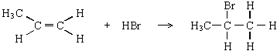
(i) Outline the mechanism for this reaction, showing the structure of the intermediate carbocation formed.

(ii) Give the structure of the alternative carbocation which could be formed in the reaction between propene and hydrogen bromide.

(5)

(b) A substitution reaction occurs when 2-bromopropane reacts with aqueous sodium hydroxide.
(i) Draw the structure of the organic product of this reaction and give its name.
Structure

Name ..................................................................................................

(ii) Name and outline the mechanism for this reaction.
Name of mechanism ...........................................................................
Mechanism

(5)

(c) Under different conditions, 2-bromopropane reacts with sodium hydroxide to produce propene.
(i) Name the mechanism for this reaction.
.............................................................................................................

(ii) State the role of sodium hydroxide in this reaction.
.............................................................................................................
(2)
(Total 12 marks)

Q4. (a) Compounds with double bonds between carbon atoms can exhibit geometrical isomerism.
(i) Draw structures for the two geometrical isomers of 1,2-dichloroethene.
Isomer 1 Isomer 2

(ii) What feature of the double bond prevents isomer 1 from changing into isomer 2?
.............................................................................................................
(3)

(b) When 2-chloropropane reacts with sodium hydroxide, two different reactions occur.
Each reaction produces a different organic product.
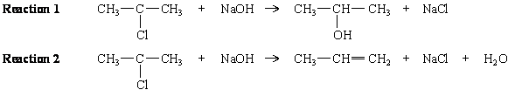
(i) Outline a mechanism for Reaction 1 and state the role of the hydroxide ion in this reaction.
Mechanism

Role of the hydroxide ion ....................................................................

(ii) Outline a mechanism for Reaction 2 and state the role of the hydroxide ion in this reaction.
Mechanism

Role of the hydroxide ion ....................................................................
(7)
(Total 10 marks)

Q5. Ethene is an important starting point for the manufacture of plastics and pharmaceutical chemicals. Most of the ethene used by industry is produced by the thermal cracking of ethane obtained from North Sea gas (Reaction 1). It is also possible to make ethene either from chloroethane (Reaction 2) or from ethanol (Reaction 3).
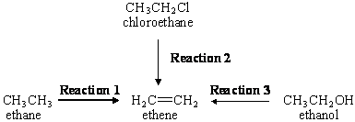
(a) Give essential conditions and reagents for each of Reactions 2 and 3.
(4)

(b) Name and outline a mechanism for Reaction 2. Suggest a reason why chloroethane is not chosen by industry as a starting material to make ethene commercially.
(5)

(c) Name and outline a mechanism for Reaction 3. Suggest why this route to ethene may become used more commonly in the future as supplies of North Sea gas begin to run out.
(6)
(Total 15 marks)

Q6. (a) Chloromethane can be made by the reaction of chlorine with methane.
(i) Give one essential condition for this reaction.
.............................................................................................................

(ii) Name the mechanism for this reaction.
.............................................................................................................

(iii) Further substitution can occur during this reaction. Identify the main organic product when a large excess of chlorine is used in this reaction.
.............................................................................................................
(3)

(b) Ethanenitrile can be made by reacting chloromethane with potassium cyanide.
(i) Write an equation for this reaction.
.............................................................................................................

(ii) Name the mechanism for this reaction.
.............................................................................................................

(iii) Explain, in terms of bond enthalpies, why bromomethane reacts faster than chloromethane with potassium cyanide.
.............................................................................................................
.............................................................................................................
.............................................................................................................
(3)

(c) Ethanenitrile can be hydrolysed to a carboxylic acid by heating it under reflux with a dilute acid. Identify the carboxylic acid formed in this reaction.
......................................................................................................................
(1)

(d) Chloromethane can react with ammonia to produce a primary amine.
(i) What feature of the chloromethane molecule makes it susceptible to attack by an ammonia molecule?
.............................................................................................................

(ii) Name the amine produced in this reaction.
.............................................................................................................

(iii) Outline a mechanism for this reaction.

(6)
(Total 13 marks)

Q7. (a) Bromomethane, CH₃Br, can be formed by a reaction between bromine and methane.
The mechanism for this reaction is similar to the mechanism for the chlorination
of methane.
(i) Name the mechanism for this reaction.
.............................................................................................................

(ii) Give the name of, and state an essential condition for, the first step in the mechanism for this reaction.
Name ..................................................................................................
Essential condition ..............................................................................

(iii) Write an equation for a termination step in the mechanism for this reaction which gives ethane as a product.

.............................................................................................................

(iv) Bromomethane can undergo further substitution. Write an overall equation for the reaction between bromomethane and bromine in which dibromomethane is formed.

.............................................................................................................
(5)

(b) Bromomethane reacts with the nucleophile ammonia according to the following equation.
CH₃Br + 2NH₃ → CH₃NH₂ + NH₄Br
(i) Explain what is meant by the term nucleophile.
.............................................................................................................
.............................................................................................................

(ii) Name the organic product of this reaction.
.............................................................................................................

(iii) Outline a mechanism for this reaction.

(6)
(Total 11 marks)

Q8. Consider the following reaction scheme.
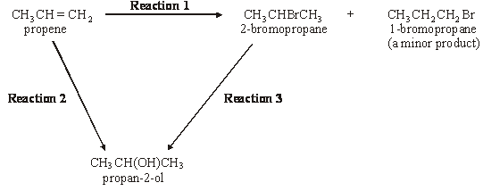
(a) (i) Name the mechanism for Reaction 1.
.............................................................................................................

(ii) Explain why 1-bromopropane is only a minor product in Reaction 1.
.............................................................................................................
.............................................................................................................
.............................................................................................................
(3)

(b) Give a suitable reagent and state the essential conditions required for Reaction 3.
Reagent ........................................................................................................
Conditions .....................................................................................................
(2)

(c) The reagent used for Reaction 3 can also be used to convert 2-bromopropane into propene. State the different conditions needed for this reaction.
......................................................................................................................
(1)

(d) Reaction 2 proceeds in two stages.
Stage 1 CH₃CH=CH₂ + H₂SO₄ → CH₃CH(OSO₂OH)CH₃
Stage 2 CH₃CH(OSO₂OH)CH₃ + H₂O → CH₃CH(OH)CH₃ + H₂SO₄
(i) Name the class of alcohols to which propan-2-ol belongs.
.............................................................................................................

(ii) Outline a mechanism for Stage 1 of Reaction 2, using concentrated sulphuric acid.

(iii) State the overall role of the sulphuric acid in Reaction 2.
.............................................................................................................
(6)
(Total 12 marks)

Q9. Consider the following scheme of reactions for making ethane-1,2-diol from ethene by two different routes.
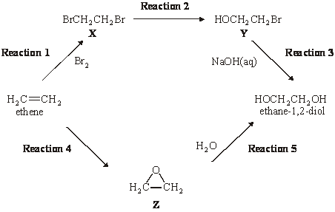
(a) Name compound X and name a mechanism for Reaction 1. Explain why ethene is able to react with bromine in this reaction, given that bromine molecules are non-polar.
(4)

(b) Name and outline a mechanism for Reaction 3. Explain why compound Y is susceptible to attack by hydroxide ions.
(4)
(c) Identify a reagent and a suitable catalyst for Reaction 4. Name compound Z and explain why compound Z reacts readily with water in Reaction 5.
(4)

(d) Give a use for ethane-1,2-diol. For each route from ethene to ethane-1,2-diol, identify one hazard.
(3)
......................................................................................................................
......................................................................................................................
......................................................................................................................
......................................................................................................................
......................................................................................................................
......................................................................................................................
......................................................................................................................
......................................................................................................................
......................................................................................................................
......................................................................................................................
......................................................................................................................
......................................................................................................................
......................................................................................................................
......................................................................................................................
......................................................................................................................
......................................................................................................................
......................................................................................................................
......................................................................................................................
......................................................................................................................
......................................................................................................................
......................................................................................................................
......................................................................................................................
(Total 15 marks)

Q10. (a) Complete the mechanism below by drawing appropriate curly arrows.
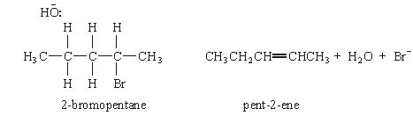
(3)

(b) Draw and name the geometrical isomers of pent-2-ene.
Isomer 1 Isomer 2

Name ............................….................... Name .............…...........................
(2)

(c) Pent-1-ene reacts with hydrogen bromide to produce 2-bromopentane as the major product.
(i) Outline the mechanism for this reaction.

(ii) Identify the minor product formed in this reaction.
.............................................................................................................

(iii) Explain why 2-bromopentane is the major product of this reaction.
.............................................................................................................
.............................................................................................................
.............................................................................................................
(7)
(Total 12 marks)

Q11.Consider the following reaction in which an alkene is formed from a haloalkane.
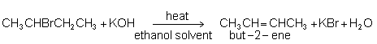
(a) Name the haloalkane used in this reaction.
......................................................................................................................
(1)

(b) Name and outline a mechanism for this reaction.
Name of mechanism ....................................................................................
Mechanism

(4)

(c) Another alkene, which is a structural isomer of but-2-ene, is also formed during this reaction.
(i) State what is meant by the term structural isomers.
.............................................................................................................
.............................................................................................................

(ii) Draw the structure of this other alkene.

(2)
(Total 7 marks)

Q12. Consider the following scheme of reactions.
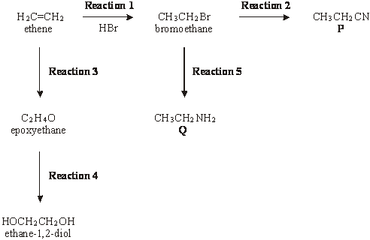
(a) In Reaction 1, ethene undergoes electrophilic addition with hydrogen bromide.
(i) State what is meant by the term electrophile.
.............................................................................................................
.............................................................................................................

(ii) Outline a mechanism for this reaction.

(5)

(b) Epoxyethane is formed from ethene in Reaction 3.
(i) Identify a reagent and a catalyst for this reaction.
Reagent ..............................................................................................
Catalyst ...............................................................................................

(ii) Draw the structure of epoxyethane.

(iii) Identify a reagent which will react with epoxyethane to form ethane-1,2-diol in Reaction 4.
.............................................................................................................
(4)

(c) In Reactions 2 and 5, bromoethane undergoes nucleophilic substitution.
(i) Identify a reagent for Reaction 2. Name the organic product, P.
Reagent for Reaction 2 ......................................................................
Name of product P ..............................................................................

(ii) Identify a reagent for Reaction 5. Name the organic product, Q.
Reagent for Reaction 5 ......................................................................
Name of product Q ..............................................................................

(iii) Outline a mechanism for Reaction 5.

(8)
(Total 17 marks)

Q13. (a) Name and outline a mechanism for the reaction of 2-bromo-2-methylpropane with ethanolic potassium hydroxide to form the alkene 2-methylpropene, (CH₃)₂C=CH₂
Name of mechanism ....................................................................................
Mechanism

(4)

(b) Two stereoisomers of but-2-ene are formed when 2-bromobutane reacts with ethanolic potassium hydroxide.
(i) Explain what is meant by the term stereoisomers.
.............................................................................................................
.............................................................................................................

(ii) Draw the structures and give the names of the two stereoisomers of
but-2-ene.
Stereoisomer 1 Stereoisomer 2

Name ................................................. Name ................................................

(iii) Name this type of stereoisomerism.
.............................................................................................................
(5)

(c) When 2-bromo-2-methylpropane reacts with aqueous potassium hydroxide,
2-methylpropan-2-ol is formed as shown by the following equation.
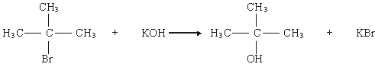
State the role of the hydroxide ions in this reaction.
......................................................................................................................
(1)

(d) Write an equation for the reaction that occurs when CH₃CH₂CH₂CH₂Br reacts with an excess of ammonia. Name the organic product of this reaction.
Equation ......................................................................................................
Name of product ..........................................................................................
(3)
(Total 13 marks)

Q14. (a) Dichloromethane, CH₂Cl₂, is one of the products formed when chloromethane, CH₃Cl, reacts with chlorine.
(i) Name the type of mechanism involved in this reaction and write an equation for each of the steps named below.
Name of type of mechanism ..............................................................
Initiation step
.............................................................................................................
First propagation step
.............................................................................................................
Second propagation step
.............................................................................................................

(ii) Write an overall equation for the formation of dichloromethane from chloromethane.
.............................................................................................................
(5)

(b) A compound contains 10.1% carbon and 89.9% chlorine by mass. Calculate the molecular formula of this compound, given that its relative molecular mass (M_{r}) is 237.0
......................................................................................................................
......................................................................................................................
......................................................................................................................
......................................................................................................................
......................................................................................................................
(3)

(c) Suggest the formulae of two bromine-containing organic compounds formed when dibromomethane, CH₂Br₂, reacts with bromine.
Compound 1 ................................................................................................
Compound 2 ................................................................................................
(2)
(Total 10 marks)

Q15. The reaction of bromine with ethane is similar to that of chlorine with ethane. Three steps in the bromination of ethane are shown below.
Step 1 Br₂ 2Br•
Step 2 Br• + CH₃CH₃ CH₃CH₂• + HBr
Step 3 CH₃CH₂• + Br₂CH₃CH₂Br + Br•

(a) (i) Name this type of mechanism.
.............................................................................................................
(ii) Suggest an essential condition for this reaction.
.............................................................................................................
(iii) Steps 2 and 3 are of the same type. Name this type of step.
.............................................................................................................

(iv) In this mechanism, another type of step occurs in which free-radicals combine. Name this type of step. Write an equation to illustrate this step.
Type of step .......................................................................................
Equation..............................................................................................
(5)

(b) Further substitution in the reaction of bromine with ethane produces a mixture of liquid organic compounds.
(i) Name a technique which could be used to separate the different compounds in this mixture.
.............................................................................................................

(ii) Write an equation for the reaction between bromine and ethane which produces hexabromoethane, C₂Br₆, by this substitution reaction.
.............................................................................................................
(2)

(c) The compound 1,2-dibromo-1,1,2,2-tetrafluoroethane is used in some fire extinguishers. Draw the structure of this compound.

(1)

(d) Halothane is used as an anaesthetic and has the following structure.
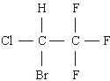
(i) Give the systematic name of halothane.
.............................................................................................................

(ii) Calculate the M_{r} of halothane.
.............................................................................................................
(iii) Calculate the percentage by mass of fluorine in halothane.
.............................................................................................................
(3)
(Total 11 marks)

Q16. (a) Bromoethane, CH₃CH₂Br, reacts with sodium hydroxide in an elimination reaction to form ethene.
(i) Outline a mechanism for this elimination reaction.

(ii) Suggest one reason why this method for making ethene is not used in industry.
.............................................................................................................
.............................................................................................................
(4)

(b) Ethene is used to make epoxyethane.
(i) State why epoxyethane is very reactive.
.............................................................................................................
.............................................................................................................

(ii) Identify the product formed when one molecule of epoxyethane reacts with one molecule of water. Give a use for this product.
Product...............................................................................................
Use .....................................................................................................
(3)
(Total 7 marks)

Q17.Organic reaction mechanisms help to develop an understanding of how and why reactions occur.
(a) Propene reacts with hydrogen bromide by an electrophilic addition mechanism forming 2-bromopropane as the major product.
The equation for this reaction is shown below.
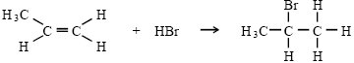
(i) Outline the mechanism for this reaction, showing the structure of the intermediate carbocation formed.

(ii) Give the structure of the alternative carbocation which could be formed in the reaction between propene and hydrogen bromide.

(5)

(b) A substitution reaction occurs when 2-bromopropane reacts with aqueous sodium hydroxide.
(i) Draw the structure of the organic product of this reaction and give its name.
Structure

Name ..................................................................................................

(ii) Name and outline the mechanism for this reaction.
Name of mechanism ...........................................................................
Mechanism

(5)

(c) Under different conditions, 2-bromopropane reacts with sodium hydroxide to produce propene.
(i) Name the mechanism for this reaction
.............................................................................................................
(ii) State the role of sodium hydroxide in this reaction
.............................................................................................................
(2)
(Total 12 marks)

Q18. One of the first substances used as an anaesthetic in medicine was chloroform (trichloromethane, CHCl₃). By 1950, halothane was in common use but by 1990 this had been replaced by more acceptable anaesthetics such as desflurane.
CF₃CHBrCl CF₃CHFOCHF₂
halothane desflurane
One reason for replacing halothane was that it is an organic compound that contains chlorine. Chlorine-containing organic compounds are thought to cause damage to the ozone layer in the upper atmosphere.
(a) Name and outline a mechanism for the reaction of chlorine with methane to form chloromethane (CH₃Cl).
Write an overall equation for the reaction of chlorine with methane to form trichloromethane (CHCl₃).
......................................................................................................................
......................................................................................................................
......................................................................................................................
......................................................................................................................
......................................................................................................................
......................................................................................................................
......................................................................................................................
......................................................................................................................
......................................................................................................................
(5)

(b) Explain how chlorine atoms are formed from chlorine-containing organic compounds in the upper atmosphere.
Explain, with the aid of equations, how chlorine atoms act as a catalyst in the decomposition of ozone into oxygen.
......................................................................................................................
......................................................................................................................
......................................................................................................................
......................................................................................................................
......................................................................................................................
......................................................................................................................
......................................................................................................................
......................................................................................................................
......................................................................................................................
......................................................................................................................
......................................................................................................................
......................................................................................................................
(6)

(c) Use the formulae of the two anaesthetics, halothane and desflurane, to help to explain why desflurane is considered to be a more environmentally acceptable anaesthetic than halothane.
......................................................................................................................
......................................................................................................................
......................................................................................................................
......................................................................................................................
(2)
(Total 13 marks)

Q19. Nucleophiles react with bromoethane in substitution reactions. This type of reaction is illustrated in the following scheme.
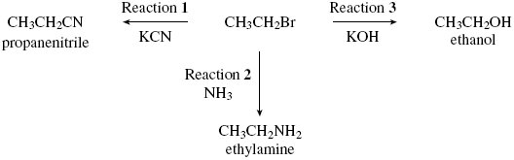
(a) State what is meant by the term nucleophile.
......................................................................................................................
(1)

(b) Outline a mechanism for the reaction of potassium cyanide with bromoethane
(Reaction 1).

(2)

(c) Explain why an excess of ammonia is needed in Reaction 2 to produce a high yield of ethylamine.
......................................................................................................................
......................................................................................................................
(1)

(d) When potassium hydroxide reacts with bromoethane, ethene can also be formed.
Name and outline a mechanism for this reaction.
Name of mechanism ....................................................................................
Mechanism

(4)
(Total 8 marks)

Q20. (a) Consider the following reaction.
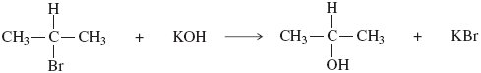
(i) Name and outline a mechanism for this reaction.
Name of mechanism ..........................................................................
Mechanism

(3)

(ii) Name the haloalkane in this reaction.
.............................................................................................................
(1)

(iii) Identify the characteristic of the haloalkane molecule that enables it to undergo this type of reaction.
.............................................................................................................
(1)

(b) An alternative reaction can occur between this haloalkane and potassium hydroxide as shown by the following equation.
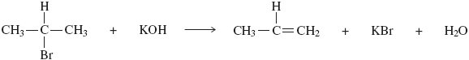
Name and outline a mechanism for this reaction.
Name of mechanism ....................................................................................
Mechanism

(4)

(c) Give one condition needed to favour the reaction shown in part (b) rather than that shown in part (a).
......................................................................................................................
(1)

(d) Alkenes can be polymerised to produce poly(alkenes).
(i) State the type of polymerisation that alkenes undergo.
.............................................................................................................
(1)

(ii) Name the alkene that gives a polymer with the repeating unit shown below.
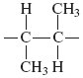
Name of alkene ...................................................................................
(1)
(Total 12 marks)

Q21. Consider the following scheme of reactions.
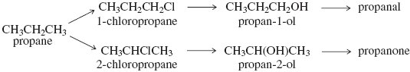
(a) State the type of structural isomerism shown by propanal and propanone.
......................................................................................................................
(1)

(b) A chemical test can be used to distinguish between separate samples of propanal and propanone.
Identify a suitable reagent for the test.
State what you would observe with propanal and with propanone.
Test reagent ................................................................................................
Observation with propanal ...........................................................................
Observation with propanone ........................................................................
(3)

(c) State the structural feature of propanal and propanone which can be identified from their infrared spectra by absorptions at approximately 1720 cm^{–1}.
You may find it helpful to refer to Table 1 on the Data Sheet.
......................................................................................................................
(1)

(d) The reaction of chlorine with propane is similar to the reaction of chlorine with methane.
(i) Name the type of mechanism in the reaction of chlorine with methane.
.............................................................................................................
(1)

(ii) Write an equation for each of the following steps in the mechanism for the reaction of chlorine with propane to form l-chloropropane (CH₃CH₂CH₂Cl).
Initiation step

.............................................................................................................
First propagation step

.............................................................................................................
Second propagation step

.............................................................................................................
A termination step to form a molecule with the empirical formula C₃H₇

.............................................................................................................
(4)

(e) High resolution mass spectrometry of a sample of propane indicated that it was contaminated with traces of carbon dioxide.
Use the data in the table to show how precise M_{r} values can be used to prove that the sample contains both of these gases.

Atom | Precise relative atomic mass
¹²C | 12.00000
¹H | 1.00794
¹⁶O | 15.99491

......................................................................................................................
......................................................................................................................
......................................................................................................................
(2)
(Total 12 marks)

Q22. Chlorine is a useful industrial chemical.
(a) Chlorine gas is used in the manufacture of chlorine-containing organic compounds.
(i) Write equations for the following steps in the mechanism for the reaction of chlorine with ethane to form chloroethane (CH₃CH₂Cl).
Initiation step
.............................................................................................................
First propagation step
.............................................................................................................
Second propagation step
.............................................................................................................
A termination step producing butane.
.............................................................................................................
(4)

(ii) Give one essential condition and name the type of mechanism in this reaction of chlorine with ethane.
Essential condition .............................................................................
Type of mechanism ............................................................................
(2)

(b) Chlorine reacts with cold water.
(i) Write an equation for this reaction.
.............................................................................................................
(1)

(ii) Give one large-scale application of the use of chlorine in water. Explain why it is used in this application even though chlorine is very toxic. Do not include cost.
Example of application….....................................................................
Explanation of use ..............................................................................
(2)

(iii) Two different chlorine-containing compounds are formed when chlorine reacts with cold, dilute sodium hydroxide solution. One of these compounds is sodium chloride.
Name the other chlorine-containing compound formed.
.............................................................................................................
(1)

(c) Chlorine is used in the extraction of bromine from seawater.
(i) Write the simplest ionic equation for the reaction of chlorine with bromide ions.
.............................................................................................................
(1)

(ii) Explain why bromine has a higher boiling point than chlorine.
.............................................................................................................
.............................................................................................................
.............................................................................................................
(2)
(Total 13 marks)

Q23. A student carried out an experiment to study the rates of hydrolysis of some haloalkanes.
(a) In the experiment, two different haloalkanes were placed in separate test tubes containing silver nitrate solution. The haloalkanes reacted with the water in the silver nitrate solution. The student timed how long it took for the first appearance of the silver halide precipitate in each tube at a constant temperature. This time was used to provide a measure of the initial rate of reaction.
The student obtained the following results.

 | 1-bromobutane | 1-iodobutane
Time to form a precipitate / s | 480 | 15
(i) State the meaning of the term hydrolysis.
.............................................................................................................
.............................................................................................................
(1)

(ii) State the colour of the precipitate formed when iodide ions react with silver nitrate and write the simplest ionic equation for this reaction.
Colour of precipitate ...........................................................................
Simplest ionic equation
.............................................................................................................
(2)

(iii) Use your knowledge of the reactions of halide ions with silver nitrate to suggest why the student did not include 1-fluorobutane in this experiment.
.............................................................................................................
.............................................................................................................
(2)

(b) The student used the following enthalpy data to try to account for the different initial rates of hydrolysis of the haloalkanes used in part (a). The student deduced that the rate of hydrolysis of a haloalkane is influenced by the strength of the carbon–halogen bond in the haloalkane.

 | C–Br | C–I
Bond enthalpy / kJ mol^{–1} | 276 | 238
State how the experimental evidence enabled the student to make this deduction.
......................................................................................................................
......................................................................................................................
(1)

(c) The student had read that the reaction of water with haloalkanes was similar to the reaction of aqueous sodium hydroxide with haloalkanes and was an example of a nucleophilic substitution reaction.
(i) State the meaning of the term nucleophile.
.............................................................................................................
(1)

(ii) When a hydroxide ion collides with a molecule of 1-bromobutane, the following reaction occurs.
CH₃CH₂CH₂CH₂Br + OH– → CH₃CH₂CH₂CH₂OH + Br–
Outline the nucleophilic substitution mechanism for this reaction.

(2)

(d) The reaction of hydroxide ions with 2-bromo-2-methylpropane may occur by a different mechanism from the one in part (c). This different mechanism involves the formation of a carbocation.
(i) Complete the following equation by drawing the structure of the carbocation formed when the C–Br bond in 2-bromo-2-methylpropane is broken.
(1)

(ii) Suggest one reason why this reaction occurs by a mechanism involving a carbocation, but the reaction in part (c) (ii) does not.
.............................................................................................................
.............................................................................................................
(1)
(Total 11 marks)

Q24. A student read the following passage on the Internet.

Haloalkanes contain a polar covalent bond. The carbon atom of the polar covalent bond can be attacked by nucleophiles. Nucleophilic attack enables haloalkanes to undergo substitution reactions.
A nucleophilic substitution reaction occurs when a haloalkane undergoes hydrolysis; the rate of hydrolysis of the haloalkane is influenced by the
carbon–halogen bond enthalpy.

(a) Explain the meaning of each of the following terms in the information given above.
(i) nucleophile
.............................................................................................................
.............................................................................................................
.............................................................................................................
(1)

(ii) substitution, as applied to nucleophilic substitution in a haloalkane
.............................................................................................................
.............................................................................................................
.............................................................................................................
(1)

(iii) hydrolysis
.............................................................................................................
.............................................................................................................
.............................................................................................................
(1)

(iv) bond enthalpy, as applied to a carbon–halogen bond.
.............................................................................................................
.............................................................................................................
.............................................................................................................
(1)

(b) Outline a mechanism for the nucleophilic substitution reaction in which
2-bromopropane (CH₃CHBrCH₃) reacts with potassium hydroxide to form
propan-2-ol.

(2)

(c) Haloalkanes also undergo elimination reactions to produce alkenes.
(i) Outline a mechanism for the elimination reaction in which 2-bromopropane reacts with potassium hydroxide to form propene.

(3)

(ii) A student obtained the following infrared spectrum for the product from this elimination reaction.
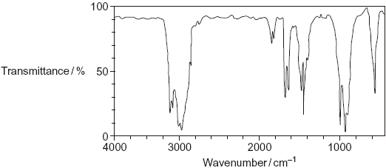
Use information from the infrared spectrum to state and explain how the student deduced that the product was an alkene.
You may find it helpful to refer to Table 1 on the Data Sheet.
.............................................................................................................
.............................................................................................................
.............................................................................................................
.............................................................................................................
.............................................................................................................
(2)
(Total 11 marks)

Q25. (a) The reaction of bromine with propane is similar to that of chlorine with methane.
Three steps in the mechanism for the bromination of propane to form 1-bromopropane are shown below.

Step 1 Br₂ 2Br•
Step 2 Br• + CH₃CH₂CH₃ CH₃CH₂CH₂• + HBr
Step 3 CH₃CH₂CH₂• + Br₂ CH₃CH₂CH₂Br + Br•

(i) Name the type of mechanism in this reaction.
.............................................................................................................
(1)

(ii) Give an essential condition for Step 1 to occur.
.............................................................................................................
(1)

(iii) Name the type of step illustrated by Steps 2 and 3.
.............................................................................................................
(1)

(iv) In this mechanism, a different type of step occurs in which free radicals combine. Name this type of step.
Write an equation to show how hexane could be formed from two free radicals in the mechanism of this reaction.
Type of step .......................................................................................
Equation .............................................................................................
(2)

(v) Write an overall equation for the reaction between bromine and propane by the same mechanism to produce octabromopropane (C₃Br₈).
.............................................................................................................
(1)

(b) Bromine reacts with alkenes, even though bromine is a non-polar molecule.
(i) Explain why bromine molecules react with the double bonds in alkenes.
.............................................................................................................
.............................................................................................................
.............................................................................................................
.............................................................................................................
.............................................................................................................
.............................................................................................................
(2)

(ii) Name the type of mechanism involved in this reaction.
.............................................................................................................
(1)

(iii) Draw the structure of the compound with M_{r} = 387.6 formed when penta-1,4-diene (H₂CCHCH₂CHCH₂) reacts with an excess of bromine.

(1)

(c) Two products are formed when propene reacts with hydrogen bromide.
Draw the structure of the intermediate that leads to the formation of the major product in the reaction of propene with hydrogen bromide.
Give the name of this type of intermediate.
Structure of intermediate

Type of intermediate ....................................................................................
(2)
(Total 12 marks)

Q26. Organic reaction mechanisms help chemists to understand how the reactions of organic compounds occur.
The following conversions illustrate a number of different types of reaction mechanism.
(a) When 2-bromopentane reacts with ethanolic KOH, two structurally isomeric alkenes are formed.
(i) Name and outline a mechanism for the conversion of 2-bromopentane into
pent-2-ene as shown below.
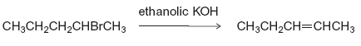

(4)

(ii) Draw the structure of the other structurally isomeric alkene produced when 2-bromopentane reacts with ethanolic KOH.

(1)

(b) Name and outline a mechanism for the following conversion.
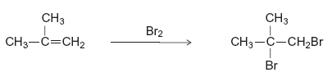

(5)

(c) Name and outline a mechanism for the following conversion.
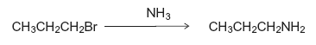

(5)
(Total 15 marks)

Q27. Halogens are used to make halogenated organic compounds.
(a) The refrigerant used in air conditioners is a mixture of fluorinated alkanes. These compounds are made by fluorination reactions.
The mechanism for the reaction of fluorine with an alkane or with a fluoroalkane is a free-radical substitution similar to the reaction of chlorine with methane.
(i) Write the overall equation for the reaction of fluorine with methane to form trifluoromethane (CHF₃).
.............................................................................................................
(1)

(ii) Write equations for the following steps in the mechanism for the reaction of fluorine with trifluoromethane (CHF₃) to form tetrafluoromethane (CF₄).
Initiation step
.............................................................................................................
First propagation step
.............................................................................................................
Second propagation step
.............................................................................................................
A termination step leading to the formation of hexafluoroethane.
.............................................................................................................
(4)

(b) Chlorofluorocarbons (CFCs) were used as refrigerants.
In the upper atmosphere, ultra-violet radiation breaks bonds in the CFCs to produce a reactive intermediate that catalyses the decomposition of ozone.
(i) An example of a CFC is 1,1,1-trichloro-2,2-difluoroethane.
Draw the displayed formula of this CFC.

(1)

(ii) Identify a bond in a CFC that is broken by ultra-violet radiation to produce a reactive intermediate.
Give the name of this reactive intermediate that catalyses the decomposition of ozone.
Write an overall equation for this decomposition of ozone.
Bond broken ......................................................................................
Name of the reactive intermediate .....................................................
Overall equation
.............................................................................................................
(3)
(Total 9 marks)

Q28.Chloromethanes, such as dichloromethane and trichloromethane, are produced in industry as they have many uses.
Trichloromethane has been used in the manufacture of the refrigerant chlorodifluoromethane.
(a) Chlorine can react with dichloromethane (CH₂Cl₂) to form trichloromethane (CHCl₃).
(i) Write an equation for each of the following steps in the mechanism for this reaction.
Initiation step

...............................................................................................................
First propagation step

...............................................................................................................
Second propagation step

...............................................................................................................
(3)

(ii) Give one essential condition for this reaction and name the type of mechanism.
Essential condition ...............................................................................
Type of mechanism ..............................................................................
(2)

(b) An organic product, X, with M_{r} = 154.0 is obtained when chlorine reacts with trichloromethane.
(i) Write an equation for the overall reaction of chlorine with trichloromethane to form X, by the same mechanism as that outlined in part (a)(i).

...............................................................................................................
(1)

(ii) The following infrared spectrum was obtained for a sample of X produced in this reaction.
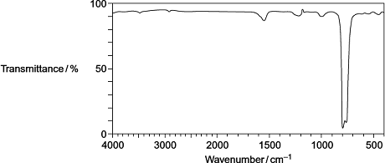

Use this infrared spectrum to explain why it is possible to deduce that this sample of X contains no trichloromethane.
You may find it helpful to refer to Table 1 on the Data Sheet.
...............................................................................................................
...............................................................................................................
...............................................................................................................
...............................................................................................................
...............................................................................................................
(Extra space) ........................................................................................
...............................................................................................................
(2)

(c) Explain, with the aid of equations and the intermediates that form in the ozone layer, why the European Union has banned the use of chlorodifluoromethane (CHClF₂) as a refrigerant.
........................................................................................................................
........................................................................................................................
........................................................................................................................
........................................................................................................................
........................................................................................................................
........................................................................................................................
........................................................................................................................
........................................................................................................................
........................................................................................................................
(Extra space) .................................................................................................
........................................................................................................................
........................................................................................................................
(4)

(d) The compound 2,3,3,3-tetrafluoropropene is the refrigerant used in all new car air conditioners.
(i) Draw the displayed formula for 2,3,3,3-tetrafluoropropene.

(1)

(ii) Give one reason why 2,3,3,3-tetrafluoropropene is a more environmentally acceptable refrigerant than chlorodifluoromethane.
...............................................................................................................
...............................................................................................................
...............................................................................................................
(1)
(Total 14 marks)

Q29.Consider the following reactions.
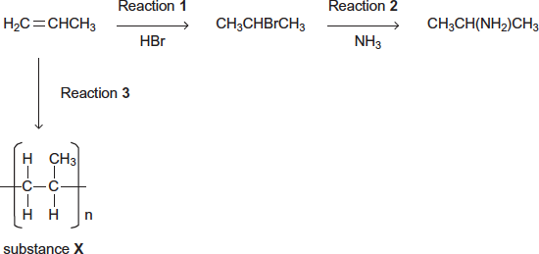
(a) Name and outline a mechanism for Reaction 1.
Name of mechanism .........................................................................................................
Mechanism

(5)

(b) Name and outline a mechanism for Reaction 2.
Name of mechanism .........................................................................................................
Mechanism

(5)

(c) State the type of reaction in Reaction 3.
Give the name of substance X.
........................................................................................................................
........................................................................................................................
........................................................................................................................
(2)

(d) The haloalkane produced in Reaction 1 can be converted back into propene in an elimination reaction using ethanolic potassium hydroxide.
CH₃CHBrCH₃ 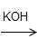 H₂C=CHCH₃
Outline a mechanism for this conversion.

(3)
(Total 15 marks)

Q30.The refrigerant R410A, used in air conditioners, is a mixture of two fluoroalkanes, pentafluoroethane and difluoromethane.
(a) (i) The mechanism for the reaction of fluorine with either an alkane or a fluoroalkane is similar to that for the reaction of chlorine with methane.
Name the type of mechanism for the reaction of chlorine with methane.
...............................................................................................................
(1)

(ii) Write equations for the following steps in the mechanism for the reaction of fluorine with fluoromethane (CH₃F) to form difluoromethane (CH₂F₂).
Initiation step

...............................................................................................................
First propagation step

...............................................................................................................
Second propagation step

...............................................................................................................
A termination step leading to the formation of 1,2-difluoroethane.

...............................................................................................................
(4)

(iii) Write an overall equation for the reaction of fluorine with ethane to form pentafluoroethane (CF₃CHF₂) by this mechanism.
...............................................................................................................
(1)

(b) The refrigerant R112A (CCl₃CF₂Cl) has been banned because of concerns about ozone depletion.
Give the IUPAC name for CCl₃CF₂Cl
........................................................................................................................
(1)

(c) Nitrogen monoxide (NO) catalyses the decomposition of ozone into oxygen.
(i) Write the overall equation for this decomposition.
...............................................................................................................
(1)

(ii) Use the overall equation to deduce Step 3 in the following mechanism that shows how nitrogen monoxide catalyses this decomposition.
Step 1 O₃ O + O₂
Step 2 NO + O₃ NO₂ + O₂
Step 3 ...................................................................................................
(1)
(Total 9 marks)

Q31.In each of the following questions, you should draw the structure of the compound in the space provided.
(a) Draw the structure of the alkene that would form 1,2-dibromo-3-methylbutane when reacted with bromine.

(1)

(b) Draw the structure of the alcohol with molecular formula C₄H₁₀O that is resistant to oxidation by acidified potassium dichromate(VI).

(1)

(c) Draw the structure of the alkene that has a peak, due to its molecular ion, at m/z = 42 in its mass spectrum.

(1)

(d) Draw the structure of the organic product with M_{r} = 73, made from the reaction between 2-bromobutane and ammonia.

(1)
(Total 4 marks)

Q32.Chlorine can be used to make chlorinated alkanes such as dichloromethane.
(a) Write an equation for each of the following steps in the mechanism for the reaction of chloromethane (CH₃Cl) with chlorine to form dichloromethane (CH₂Cl₂).
Initiation step

........................................................................................................................
First propagation step

........................................................................................................................
Second propagation step

........................................................................................................................
The termination step that forms a compound with empirical formula CH₂Cl.
........................................................................................................................
(4)

(b) When chlorinated alkanes enter the upper atmosphere, carbon-chlorine bonds are broken. This process produces a reactive intermediate that catalyses the decomposition of ozone. The overall equation for this decomposition is
2O₃ 3O₂
(i) Name the type of reactive intermediate that acts as a catalyst in this reaction.
...............................................................................................................
(1)

(ii) Write two equations to show how this intermediate is involved as a catalyst in them decomposition of ozone.
Equation 1................................................................................................
Equation 2................................................................................................
(2)
(Total 7 marks)

Q33.Haloalkanes are used in the synthesis of other organic compounds.
(a) Hot concentrated ethanolic potassium hydroxide reacts with 2-bromo-3-methylbutane to form two alkenes that are structural isomers of each other. The major product is 2-methylbut-2-ene.
(i) Name and outline a mechanism for the conversion of 2-bromo-3-methylbutane into 2-methylbut-2-ene according to the equation.
(CH₃)₂CHCHBrCH₃ + KOH (CH₃)₂C=CHCH₃ + KBr + H₂O
Name of mechanism ...........................................................................
Mechanism

(4)

(ii) Draw the displayed formula for the other isomer that is formed.

(1)

(iii) State the type of structural isomerism shown by these two alkenes.

...............................................................................................................
(1)

(b) A small amount of another organic compound, X, can be detected in the reaction mixture formed when hot concentrated ethanolic potassium hydroxide reacts with 2-bromo-3-methylbutane.
Compound X has the molecular formula C₅H₁₂O and is a secondary alcohol.
(i) Draw the displayed formula for X.
(1)

(ii) Suggest one change to the reaction conditions that would increase the yield of X.
...............................................................................................................
...............................................................................................................
(1)

(iii) State the type of mechanism for the conversion of 2-bromo-3-methylbutane into X.
...............................................................................................................
(1)

(iv) Identify one feature of this infrared spectrum of a pure sample of X that may be used to confirm that X is an alcohol.
You may find it helpful to refer to Table 1 on the Data Sheet.
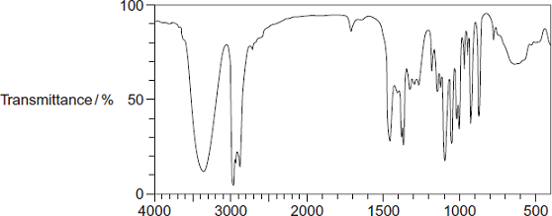
Wavenumber / cm⁻¹
Feature .................................................................................................
...............................................................................................................
(1)
(Total 10 marks)

Q34.(a) The structure of the bromoalkane Z is
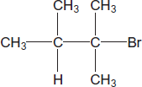
Give the IUPAC name for Z.
Give the general formula of the homologous series of straight-chain bromoalkanes that contains one bromine atom per molecule.
Suggest one reason why 1-bromohexane has a higher boiling point than Z.
........................................................................................................................
........................................................................................................................
........................................................................................................................
........................................................................................................................
........................................................................................................................
........................................................................................................................
........................................................................................................................
(Extra space) ................................................................................................
........................................................................................................................
........................................................................................................................
(3)

(b) Draw the displayed formula of 1,2-dichloro-2-methylpropane.
State its empirical formula.

........................................................................................................................
........................................................................................................................
(2)
(Total 5 marks)

M1. (a) Name of mechanism: nucleophilic substitution (1)
Mechanism:
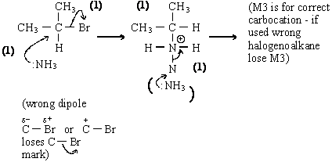
Marks S_{N}1 using same points
M2 requires
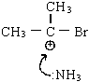
5

(b) Role of potassium hydroxide: Base (1)
Mechanism:
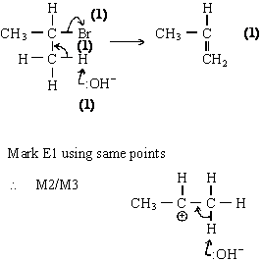
5
[10]

M2. (a) Alcohol: Reaction = Substitution (/ hydrolysis) (1)
Ignore reference to nucleophilic, but electrophilic give zero
Alcohol: Role = nucleophile (/ lone pair donor) (1)
Alkene: reaction = elimination (1)
Ignore ref to nucleophilic or electrophilic
Alkene: base (/ proton acceptor) (1)
If no indication of order in (a) assume as in question.
If order is wrong can still score 'role' mark.
4

(b) Alcohol: Role = butan-2-ol (1)
Not 2-hydroxybutane or but-2-ol
Appropriate structure for CH₃CH(OH) CH₂CH₃ (1)
Brackets not essential

S_{N}2 version | S_{N}1 version
– bond is polar | C–Br bond is polar (1)
Lone pair of OH– | C–Br bond breaks (1)
Attacks the C^{δ+} | forming carbocation / carbonium ion (1)

M1 can be scored from a diagram, M2 and M3 from written explanation only
5

(c)
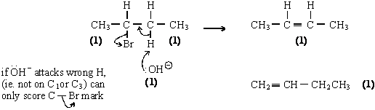
If but-2-ene not given here it may be obtained from cis / trans isomer
H lost from different carbon atoms (1)
H removes from C¹ and C³ to give two isomers (1)
Draws clear Cis and trans isomers for but-2-ene
Can score these marks from a diagram
8
[17]

M3. (a) (i)
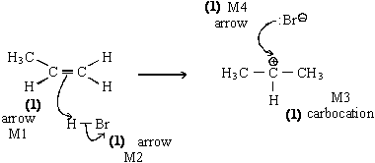

If wrong carbocation, lose structure mark
If wrong alkene, lose structure mark
Can still score ¾ i.e. penalise M3
Penalise M2 if polarity included incorrectly
no bond between H and Br
bond is shown as or

(ii)
credit secondary carbocation here if primary carbocation has been used in (i)
Ignore attack on this carbocation by
5

(b) (i) Structure:
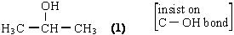

No credit for propan-1-ol even when named correctly
Credit propane-2-ol
Name: propan-2-ol (1)
Not 2-hydroxypropane

(ii) Name of mechanism: nucleophilic substitution (1) (both words)
(NOT S_{N}1 orS_{N}2)
Mechanism:
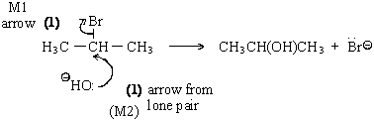

penalise incorrect polarity on C‑Br (M1)
Credit the arrows even if incorrect haloalkane
If S_{N}1, both marks possible
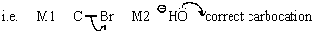
5

(c) (i) elimination (1)
Ignore nucleophylic elimination
Penalise electrophilic elimination
(ii) base (1)
OR proton acceptor
NOT nucleophile (base)
2
[12]

M4. (a) (i)
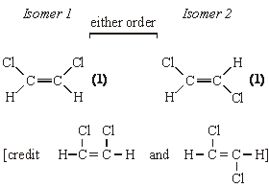

(ii) restricted rotation OR no rotation OR cannot rotate (1)
3

(b) (i) Mechanism:
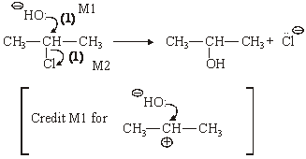
M1 and M2 independent
Curly arrows must be from a bond or a lone pair
Do not penalise sticks
Penalise M1 if precedes (penalise this once)
Penalise incorrect δ+ δ– for M2
Penalise + on C atom for M2
Only allow M1 for incorrect haloalkane
Role of the hydroxide ion: nucleophile (1)
electron pair donor
lone pair donor
NOT nucleophilic substitution

(ii) Mechanism:
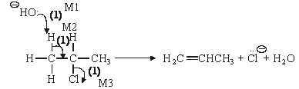
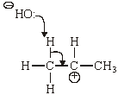
Only allow M1 and M2 for incorrect haloalkane unless RE on (i)
+ charge on H on molecule, penalise M1
M3 independent
M2 must be to correct C–C
M1 must be correct H atom
Credit M1 and M2 via carbocation mechanism
No marks after any attack of C by OH–
Role of the hydroxide ion: base (1)
proton acceptor
accepts H⁺
7
[10]

M5. (a) Reaction 2: NaOH OR KOH (1) M1 alcohol (ic) OR ethanol (ic)(1) M2
ignore heat
Condition mark linked to correct reagent but award M2 if OH– or base or alkali mentioned
Reaction 3: concentrated H₂SO₄ OR H₃PO₄ M1 (1) heat (1) M2
OR 150°C - 200°C
Condition mark linked to correct reagent but award M2 if H₂SO₄ or H₃PO₄, but not concentrated
Penalise reagent and condition if dilute H₂SO₄ / H₃PO₄
4

(b) Mechanism:
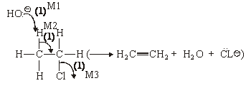
Award M3 independently
M1 and M2 must be to / from correct places
E1 mechanism possible in which M2 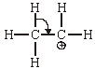
Name: of mechanism = elimination (1)
NOT dehydrohalogenation
Ignore “base” OR “nucleophilic” before elimination
Reason: Reaction 2 has (very) low yield (1)
5
QoL OR chloroethane has to be made (from ethane)
OR chloroethane is expensive
OR chloroethane is not redily available

(c) Mechanism:
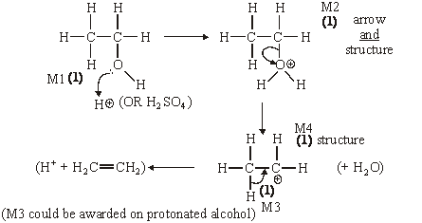
Name of mechanism = elimination (1)
NOT dehydration alone
Reason: Ethanol could come from (fermentation of) renewable
QoL sugars / glucose / carbohydrates / sources (1)
6
[15]

M6. (a) (i) UV light OR sunlight OR T 450°C (1)
NOT high T
(ii) (free) radical substitution (1)
(iii) CCl₄ (1) OR named
3

(b) (i) CH₃Cl + KCN → CH₃CN + KCl (1)
CN– Cl–
(ii) nucleophilic substitution (1)
(iii) C–Br bond is weaker (than C–Cl bond)
OR C–Br bond enthalpy is less than C–Cl (1)
Ignore electronegativity
3

(c) CH₃COOH OR ethanoic acid (1)
1

(d) (i) OR C–Cl is polar (1) OR C atom is electron deficient / δ+
(ii) methylamine (1) only
(iii) S_{N}1 scores full marks
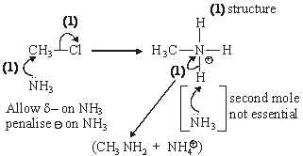
6
[13]

M7. (a) (i) (Free) radical substitution
(Both words needed)
1
(ii) M1 initiation ONLY
1
M2 ultra-violet light OR sunlight OR 1000°C T 450 °C
(Ignore reference to temperature if included with uv light)
(Penalise “high temperature” for M2)
1
(iii) → C₂H₆
(OR CH₃CH₃ as alternative to C₂H₆)
1
(iv) CH₃Br + Br₂ → CH₂Br₂ + HBr
1

(b) (i) Electron pair donor
OR species with an electron pair able to form a covalent bond.
1
(ii) Methylamine
(Credit “aminomethane”)
1

(iii)
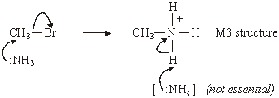
1
M1 arrow to show breakage of C – Br bond
1
M2 arrow from lone pair on N of NH₃ to form bond with C
1
M4 arrow from bond of N – H to N atom of CH₃₃
(Ignore partial charges on haloalkane but penalise if incorrect)
(Accept for M3)
(Full credit for carbocation mechanism; M1 for C – Br bond breakage and M2 for lone pair attack on carbocation)
(Second mole of ammonia not essential to mechanism for full credit)
1
[11]

M8. (a) (i) Electrophilic addition
(Both words required)
1

(ii) M1 the reaction to form 1-bromopropane goes via the primary
carbocation OR 1º carbocation
OR via
M2 primary carbocations are less stable than secondary carbocations
(Credit converse arguments for M1 and M2 i.e. the reaction to form 2-bromopropane goes via the secondary carbocation , M1, and secondary carbocations are more stable than primary carbocations, M2)
(Accept the use of “carbonium ions” as an alternative to carbocation)
1

(b) M1 NaOH OR KOH OR correct name
1
M2 aqueous or solution in water (ignore heat, reflux etc.)
(Penalise M1 for hydroxide ion alone, but mark on and credit M2)
(Credit M2 ONLY for H₂O as reagent and heat / warm / T=50 to 100ºC)
(NaOH(aq) scores M1 and M2 provided it is not contradicted)
(Penalise M2 if NaOH(aq) followed by concentrated or ethanol)
(Penalise M1 and M2 if followed by acid)
1

(c) Ethanolic OR alcoholic OR CH₃CH₂OH / CH₃OH solvent OR
aqueous ethanol/alcohol
OR higher temperature (must be comparative)
(Ignore heat or heat under reflux)
(Credit part (c) independently from part (b))
(Penalise “ethanoic”)
1

(d) (i) Secondary OR 2º
1
(ii) 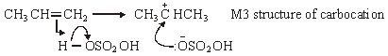
M1 arrow from double bond to H of H – O bond
M2 arrow from bond to oxygen atom to show H – O bond breakage
M4 arrow from lone pair of electrons to carbon atom of carbocation
(Penalise M1 if arrow goes to H₂SO₄ or to formal positive charge on H, but ignore partial charges on sulphuric acid unless wrong)
(Credit M2 for H⁺ ion)
(For M4, accept negative charge anywhere on the ion)
4
(iii) Catalyst ONLY
(Ignore homogeneous, heterogeneous)
1
[12]

M9. (a) M1 X is 1,2-dibromoethane only
1
M2 electrophilic addition
(both words needed)
1
M3 the double bond is a centre of electron density
OR electron-rich
OR nucleophilic
OR a source of an electron pair
OR a pi cloud/bond of electrons
1
M4 a dipole or polarity is induced/created/formed in the
Br-Br bond/molecule -
award this mark only if the quality of language justifies the award.
1

(b) nucleophilic substitution
(both words needed)
1
Mechanism M1 curly arrow from lone pair on oxygen of hydroxide
ion to C atom of C-Br
1
Mechanism M2 curly arrow from C-Br bond to side of Br atom
(a possible repeat error here from Question 4a)
(award a maximum of one mark for the wrong haloalkane)
(credit an SNl mechanism in which Ml will be a curly arrow from the lone pair on oxygen of the hydroxide ion to the correct positive carbon atom)
1
Y is susceptible to attack by hydroxide ions for one of the following
reasons
o the C-Br bond is polar
o the carbon atom is partially positive (or shown as such)
o the carbon atom is electron deficient
1

(c) M1 oxygen
(ignore “air”)
1
M2 silver or silver-based
(penalise silver nitrate)
1
M3 Z is epoxyethane
1
M4 epoxyethane
o has a strained ring structure
o has a bond angle of 60°
o has a bond angle significantly less than tetrahedral
(ignore “unstable”, “has strained bonds”, “is stressed”)
1

(d) Ethane-1,2-diol is used in antifreeze
OR in the manufacture of PET/Terylene/polyester
(penalise “solvent” or “plasticiser”)
1
Hazard in Route via X/Y
o bromine is toxic or corrosive
o sodium hydroxide is corrosive or caustic
1
Hazard in Route via epoxyethane
o risk of explosion in reaction 4
o epoxyethane is toxic
o epoxyethane is a respiratory irritant
o epoxyethane causes neurological damage
1
[15]

M10. (a) M1 curly arrow from lone pair on oxygen of hydroxide ion to
H atom on C-H adjacent to C-Br
1
M2 curly arrow from single bond of adjacent C-H
to adjacent single bond C-C
(only credit M2 if M1 is being attempted to correct H atom)
1
M3 curly arrow from C-Br bond to side of Br atom
(credit M3 independently)
1

(b) Ml credit a correct structure for either geometrical isomer and its
designation as either cis or trans.
OR credit two correct geometrical isomer structures
(ignore the names)
OR credit two correct names for cis pent-2-ene and trans
pent-2-ene (ignore the structures)
1
M2 credit a second mark if all four parts of the required structures and
names are correct.
(credit “linear” structures)
(insist on the alkyl groups being attached clearly by C-C bonds)
1

(c) (i) Ml curly arrow from middle of C = C bond to H atom on H-Br
(penalise M1 if partial negative charge or formal positive
charge on H)
(penalise Ml if pent-2-ene is used)
1
M2 curly arrow from H-Br bond to side of Br atom
1
M3 correct structure for correct secondary carbocation
1
M4 curly arrow from lone pair on bromide ion to the positive
carbon of carbocation, ensuring that bromide ion has a
negative charge.
(with the exception of pent-2-ene, if the wrong alkene is used, only penalise the structure M3)
(penalise the use of two dots in addition to a covalent bond, once only)
1

(ii) 1-bromopentane
1

(iii) Ml 2-bromopentane is formed via the secondary (or 2°)
carbocation
1
OR 1-bromopentane is formed via the primary (or 1°)
carbocation
M2 a secondary carbocation is more stable than a primary
carbocation -
award this mark only if the quality of language justifies
the award.
(the argument must involve clear statements about carbocations)
1
[12]

M11.(a) 2-bromobutane;
1

(b) Elimination;
(penalise “nucleophilic” OR “electrophilic” before the word “elimination”)
1
M1: curly arrow from lone pair on oxygen of hydroxide ion to H atom
on correct C-H adjacent to C-Br;
(penalise M1 if KOH shown as covalent with an arrow breaking the bond)
1
M2: curly arrow from single bond of adjacent C-H to adjacent
single bond C-C;
(only credit M2 if M1 is being attempted to correct H atom)
1
M3: curly arrow from C-Br bond to side of Br atom;
(credit M3 independently unless arrows contradict)
(Credit possible repeat error from 2(c)(iii) for M3)
(If the wrong haloalkane is used OR but-1-ene is produced, award MAX. 2 marks for the mechanism)
(If E1 mechanism is used, give full credit in which M1 and M2 are for correct curly arrows on the correct carbocation)

(c) (i) (structural) isomers/hydrocarbons/compounds/they have the same
molecular formula, but different structural formulas/different structures; 1
(penalise statements which are not expressed in good English and which do not refer clearly to structural isomers i.e. plural)
(penalise statements which refer to “different (spatial) arrangements”)
(credit” different displayed formulas”)
(Q of L mark)
(ii) Correct structure for but-1-ene;
1
[7]

M12. (a) (i) Electron pair/ lone pair acceptor OR seeking/bonds
with an electron pair
(insist on reference to a pair of electrons)
1

(ii) M1 curly arrow from middle of C=C bond of the alkene towards/
alongside the H atom of the H-Br;
(penalise arrows which go towards one of the carbon atoms) (ignore a partial negative charge on the C=C)
1
M2 curly arrow from H-Br bond to side of Br atom;
(penalise M2 if there are formal charges on HBr or if there are partial charges which are the wrong)
(penalise M2 if the single bond has two dots in addition to the line)
1
M3 correct structure for carbocation;
(penalise M3 if the positive charge is placed on the end of a bond) (penalise M3 if any alkene other than ethene is used - all other marks can score)
1
M4 curly arrow from lone pair on bromide ion to the positive carbon
of carbocation, ensuring that bromide ion has a negative charge;

(b) (i) M1 Oxygen OR O₂;
(do not credit “air” alone, but otherwise ignore)
M2 silver OR Ag OR silver-based
(penalise silver nitrate)
1

(ii) correct structure for epoxyethane;
(penalise poorly presented C-O bonds)
1

(iii) water
OR
H₂O;
(credit steam OR H₂SO₄ (aqueous OR dilute) OR NaOH(aq) OR HCl(aq),
OR H₃PO₄(aq), but insist that (aq) is included)
(do not credit HCl or H₂SO₄ (concentrated or without water present))
1

(c) (i) M1: potassium cyanide OR KCN OR sodium Cyanide OR NaCN;
(ignore conditions - dissolved in (aq) or (alc) or KOH(aq) all work) (penalise HCN)
1
M2: propanenitrile;
(credit propan-1-nitrile OR propan nitrile, but not propanitrile)
1

(ii) M1: ammonia OR NH₃;
(If formula is written, insist that it is correct)
(ignore conditions, but penalise acidic)
1
M2: ethylamine;
(credit aminoethane)
1

(iii) M1: curly arrow from lone pair on nitrogen of (correct formula for)
ammonia towards/alongside C atom of C-Br;
(penalise M1 if formula of ammonia is wrong or has a negative charge or has no lone pair or arrow is from negative charge)
1
M2: curly arrow from C-Br bond towards/alongside side Br atom;
(credit M2 independently)
(penalise M2 if formal positive charge on C atom of C-Br)
1

M3: correct structure of the ethylammonium ion;
(credit the structure drawn out with all four bonds around the nitrogen atom OR written as C₂H₅NH₃⁺ OR CH₃CH₂NH₃⁺)
1

M4: curly arrow from the middle of one of the H-N bonds towards the
positive N atom;
(possible to credit M4 on an incorrect ethylammonium ion with no positive charge)
(ignore use of ammonia or bromide ion etc. to remove proton from ethylammonium ion)
(If the wrong haloalkane is used, award MAX. 3 marks for the mechanism) (If S_{N}1 mechanism is used, give full credit in which M1 is for a curly arrow from the lone pair of the N atom of (correct formula for) ammonia towards/alongside the positive carbon atom of CH₃CH₂⁺)
[17]

M13. (a) (base) elimination
(penalise other words before ‘elimination’ e.g. nucleophilic)
1
M1: curly arrow from lone pair of electrons on oxygen of hydroxide ion
(insist on a lone pair of electrons on the oxygen atom and a negative charge, but only credit this mark if the attack is to a correct H atom)
1
M2: curly arrow from the middle of the C-H bond to the middle
of the C–C bond
1
(only credit this mark if the arrow originates from the correct C–H bond and if an attempt has been made at M1)
M3: curly arrow from the middle of the C–Br bond towards/alongside
the Br atom
(credit M3 independently unless the bond breaking is contradicted by an additional arrow)
(penalise curly arrow if the C–Br has a formal positive charge)
(credit full marks for an E1 mechanism, with M2 awarded for a correct curly arrow on the correct carbocation)
(award a maximum of two marks for either an incorrect haloalkane or an incorrect organic product)
(maximum 2 marks for use of 'sticks' for the haloalkane, unless RE from 2(b), when credit can be given)

(b) (i) M1: compounds with the same structural formula
1
M2: but the bonds/groups/atoms have different spatial
arrangements or orientation or configuration/are arranged
differently in space/3D
(ignore reference to the same molecular formula for M1)
1

(ii) M1: correct structural representation for cis-but-2-ene and
its name or its identification as the cis isomer
1
M2: correct structural representation for trans-but-2-ene
and its name or its identification as the trans isomer
(accept representations which are 90° to linear)
(award one mark for two correct structures but either wrong/no names)
(maximum 1 mark for an incorrect alkene)
1
(iii) geometric(al) or cis-trans
1

(c) nucleophile or electron pair donor
(penalise ‘base’)
1

(d) CH₃CH₂CH₂CH₂Br + 2NH₃ → CH₃CH₂CH₂CH₂NH₂ + NH₄Br
(M1 correct product)
(M2 balanced equation using 2NH₃ and leading to NH₄Br)
(penalise M1 for use of C₄H₉NH₂ or for incorrect haloalkane, but allow consequent correct balancing of equation with 2 moles of ammonia)
2
(1–)butylamine
(credit 1–aminobutane and butyl–1–amine)
(award QoL mark for correct spelling)
1
[13]

M14. (a) (i) (free–) radical substitution
(both words required for the mark)
1
initiation Cl₂ → 2Cl·
(credit correct half arrows, but penalise double headed arrows)
1
first propagation CH₃Cl + Cl· → ·CH₂Cl + HCl
1
second propagation ·CH₂Cl + Cl₂ → CH₂Cl₂ + Cl
(penalise the absence of dots on radicals once only)
(penalise radical dot on Cl of CH₂Cl once only)
1

(ii) CH₃Cl + Cl₂ → CH₂Cl₂ + HCl
(penalise if any radicals appear in this equation)
1

(b) M1: mol C = 10.1/12.0 and mol Cl = 89.9/35.5
1
M2: Ratio 0.842 : 2.53 OR 1: 3 OR CCl3
1
M3: 237.0/Mr of CCl₃ = 237.0/118.5 = 2 Therefore C₂Cl₆
(correct answer gains full credit)
1
OR
M1: 237.0 × 10.1/100 and 237 × 89.9/100
1
M2: Ratio 23.9/12.0 : 213/35.5 OR 2 : 6
1
M3: C₂Cl₆
(correct answer gains full credit)
1

(c) any two from CHBr₃ or CBr₄ or C₂H₂Br₄ (or CHBr₂CHBr₂) or
C₂Br₆ (or CBr₃CBr₃)
(ignore HBr or H₂)
(ignore equations and ignore names when given in addition to formulae)
(penalise names alone)
2
[10]

M15. (a) (i) (free–)radical substitution
(both words required for the mark)
1
(ii) uv light OR sunlight OR high temperature OR 150 °C to 500 °C
1
(iii) Propagation
(ignore “chain”, “first”, “second” in front of the word propagation)
1

(iv) Termination
1
•CH₂CH₃ + Br• CH₃CH₂Br
OR 2•CH₂CH₃ C₄H₁₀
(penalise if radical dot is obviously on CH₃, but not otherwise)
(penalise C₂H₅•)
(credit 2Br• Br₂)
(ignore “chain” in front of the word termination)
1

(b) (i) Fractional distillation OR fractionation
(credit gas–liquid chromatography, GLC)
1
(ii) CH₃CH₃ + 6Br₂ C₂Br₆ + 6HBr
(credit C₂H₆ for ethane)
1
(c) Correct structure for CF₂BrCF₂Br drawn out
(penalise “Fl” for fluorine)
1

(d) (i) 2–bromo–2–chloro–1,1,1–trifluoroethane
OR 1–bromo–1–chloro–2,2,2–trifluoroethane
(insist on all numbers, but do not penalise failure to use alphabet)
(accept “flourine” and “cloro” in this instance)
1
(ii) 197.4 only
(ignore units)
1

(iii) (57/197.4 × 100) = 28.9% OR 28.88%
(credit the correct answer independently in part (d)(iii), even if (d)(ii) is blank or incorrectly calculated, but mark consequential on part (d)(ii), if part (d)(ii) is incorrectly calculated, accepting answers to 3sf or 4sf only)
(penalise 29% if it appears alone, but not if it follows a correct answer)
(do not insist on the % sign being given)
(the percentage sign is not essential here, but penalise the use of units e.g. grams)
1
[11]

M16. (a) (i) M1 curly arrow from lone pair of electrons on oxygen of hydroxide ion
(insist on a lone pair of electrons on the oxygen atom and a negative charge, but only credit this mark if the attack is to a correct H atom)
1
M2 curly arrow from the middle of the C–H bond to the middle of
the C–C bond.
(only credit this mark if the arrow originates from the correct
C–H bond and if an attempt has been made at M1)
1

M3 curly arrow from the middle of the C–Br bond towards/alongside
the Br atom.
(credit M3 independently unless the bond breaking is
contradicted by an additional arrow)
(penalise M3 curly arrow if the C–Br has a formal positive charge)
(ignore partial charges on the C–Br bond, but penalise if incorrect)

(credit full marks for an E1 mechanism, with M2 awarded for a correct curly arrow on the correct carbocation)
(award a maximum of two marks for an incorrect haloalkane)
(ignore products)
1

(ii) Haloalkane/C₂H₅Br is made from ethane
OR haloalkane is not (readily) available
OR haloalkane is expensive
OR it is (too) expensive/costly
OR (reaction) yield is too low/poor
OR it is too slow
OR a valid reference to nucleophilic substitution/alcohol formation
occurring as an alternative reaction.
(ignore references to temperature or to energy consumption)
(do not credit statements which refer to the idea that this route
is not chosen, because industry chooses another route e.g. cracking)
1

(b) (i) Strained ring/ bonds/ structure/molecule
OR three–membered ring
OR 60º bond angle
OR bond angle much less than tetrahedral
(penalise “stressed ring”)
(ignore “weak bonds”, ignore “unstable”)
1

(ii) ethane–1,2–diol OR correct structure
(penalise ethylene glycol OR 1,2–dihydroxyethane if these appear alone)
(credit ethan–1,2–diol)
(If both a structure and a formula are given, credit either correct one of these provided the other is a good, if imperfect, attempt)
1

(used in) antifreeze
OR
for OR in the manufacture/making/formation of terylene, polyester,
PET only
(ignore reference to terylene etc. if they accompany “antifreeze”
(penalise “de–icer”, “solvent”, “surfactant”, “plasticizer”)
(If the candidate indicates that the product is antifreeze ,then this can gain credit, but not if contradicted in its use e.g. as de–icer)
1
[7]

M17.(a) (i)
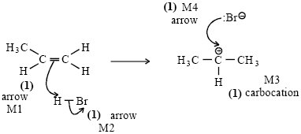
If wrong carbocation, lose structure mark
If wrong alkene, lose structure mark
Can still score ¾ i.e. penalise M3
Penalise M2 if polarity included incorrectly
no bond between H and Br
bond is shown as or
4

(ii)
CH₃CH₂CH₂
credit secondary carbocation here if primary carbocation has
been used in (i)
Ignore attack on this carbocation by o
1

(b) (i) Structure: 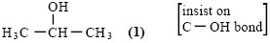
1
Name: propan-2-ol
Not 2-hydroxypropane
1

(ii) Name of mechanism: nucleophilic substitution (both words)
(NOT S_{N}1 or S_{N}2)
1
Mechanism:
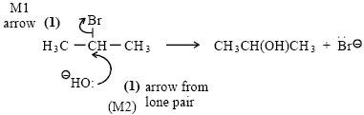
penalise incorrect polarity on C-Br (M1)
Credit the arrows even if incorrect haloalkane
If S_{N}1, both marks possible
2

(c) (i) elimination
1
(ii) base
OR proton acceptor
NOT nucleophile
1
[12]

M18. (a) M1 (Free-) radical substitution
Both words needed
1
M2 Cl₂ → 2Cl•
1
M3 Cl• + CH₄ → •CH₃ + HCl
1
M4 Cl₂ + •CH³ → CH₃Cl + Cl•
1
M5 CH₄ + 3Cl₂ → CHCl₃ + 3HCl
Penalise the absence of a radical dot once only
Ignore termination steps except, if and only if both M3 and M4 do not score, then accept for one mark
Cl• + •CH₃ → CH₃Cl
1

(b) M1 UV (light)/ sunlight / light / UV radiation
M2 C–Cl or carbon-chlorine bond breakage
OR
homolysis of C–Cl
OR
equation to show a chlorine-containing organic
compound forming two radicals
For M1 and M2, ignore use of Cl₂, but credit UV and C–Cl bond breakage if seen
1
M3 Cl• + O₃ → ClO• + O₂
1
M4 ClO• + O₃ → Cl• + 2O₂
Ignore other equations
Penalise the absence of a radical dot once only
Accept radical dot anywhere on either radical.
1
M5 Any one from
• Combination 2O₃ → 3O₂
• Stated that Cl• / chlorine atom is regenerated / not used up
• Stated that the Cl• / chlorine atom is unaffected
by the process.
1
For M5 accept Cl• on both sides of the equation
M6 Stated that the role of the Cl• / chlorine atom is to find an
alternative route OR lower E_{a} / activation energy
1

(c) M1 Halothane contains C–Cl / Cl
OR
Desflurane does not contain C–Cl bonds / Cl
OR
Desflurane contains C–F / F as the only halogen
Mark independently.
For M1, credit the idea that desflurane contains C–F bonds that are difficult to break OR that halothane contains C–Cl bonds which are easy to break.
1
M2 Desflurane / molecules that have fluorine as the only
halogen, cause no damage / do not deplete / do not react
with the ozone (layer)
OR
Halothane / chlorine-containing molecules, damage /
deplete / react with the ozone (layer)
1
[13]

M19. (a) Electron pair donor
OR
Species which uses a pair of electrons
to form a co-ordinate / covalent bond.
QoL
Credit “lone pair” as alternative wording
1

(b)
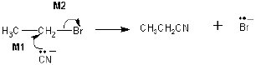
M1 Must show an arrow from the lone pair of electrons
on the carbon atom of the negatively charged
cyanide ion to the central C atom.
M2 Must show the movement of a pair of electrons from
the C-Br bond to the Br atom. Mark M2 independently.
Award full marks for an S_{N}1 mechanism in which M1 is the
attack of the cyanide ion on the intermediate carbocation.
Penalise M1 if covalent KCN is used
Penalise M2 for formal charge on C or incorrect partial charges
Penalise once only for a line and two dots to show a bond.
Max 1 mark for the wrong reactant or “sticks”
2

(c) Ethylamine / CH₃CH₂NH₂ is a nucleophile
OR
Ethylamine could react further
OR
Ethylamine could make secondary / tertiary amines
OR
To make reaction with ammonia more likely
OR
To minimise further substitution
OR
The idea of releasing free amine from the salt
OR
The idea of removing a proton from the intermediate
alkylammonium ion
OR
The idea that ammonia acts both initially as a nucleophile and
then as a base
Do not credit a simple reference to the equation or the mechanism requiring two moles of ammonia.
1

(d) Elimination
Credit “base elimination” but NOT “nucleophilic elimination”
No other prefix.
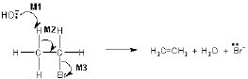
1
M1 Must show an arrow from the lone pair on oxygen of a
negatively charged hydroxide ion to the correct H atom
M2 Must show an arrow from the correct C-H bond to the
C-C bond and should only be awarded if an attempt has
been made at M1
M3 Is independent.
Award full marks for an E1 mechanism in which M2 is on the
correct carbocation.
Mechanism
Penalise M1 if covalent KOH
Penalise M3 for formal charge on C or incorrect partial charges
Penalise once only for a line and two dots to show a bond.
Max 2 marks for the mechanism for wrong reactant or “sticks”
3
[8]

M20. (a) (i) Nucleophilic substitution
1
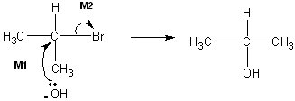
2
M1 must show an arrow from the lone pair of electrons on the
oxygen atom of the negatively charged hydroxide ion to the
central C atom.
M2 must show the movement of a pair of electrons from the
C-Br bond to the Br atom. Mark M2 independently.
Penalise M1 if covalent KOH is used
Penalise M2 for formal charge on C or incorrect partial charges
Penalise once only for a line and two dots to show a bond.
Max 1 mark for the mechanism for the wrong reactant and/or “sticks”
Ignore product
Award full marks for an S_{N}1 mechanism in which M1 is the
attack of the hydroxide ion on the intermediate carbocation.

(ii) 2-bromopropane ONLY
1
(iii) Polar C–Br OR polar carbon–bromine bond OR dipole on C–Br
OR δ+ (δ–)
C atom of carbon–bromine bond is δ+/electron deficient OR C―Br
(Credit carbon–halogen bond as an alternative to
carbon–bromine bond)
It must be clear that the discussion is about the carbon atom of the C–Br bond. NOT just reference to a polar molecule.
Ignore X for halogen
1

(b) Elimination
Credit “base elimination” but NOT “nucleophilic elimination”
No other prefix.
1
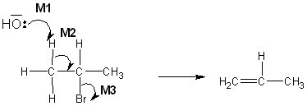
3
M1 must show an arrow from the lone pair on oxygen of a negatively
charged hydroxide ion to the correct H atom
M2 must show an arrow from the correct C-H bond to the C-C bond
and should only be awarded if an attempt has been made at M1
M3 is independent.
Mechanism
Penalise M1 if covalent KOH
Penalise M3 for formal charge on C or incorrect partial charges
Penalise once only for a line and two dots to show a bond.
Max 2 marks for the mechanism for wrong reactant and/or “sticks”
Ignore product
Award full marks for an E1 mechanism in which M2 is on the
correct carbocation.

(c) Any one condition from this list to favour elimination;
Apply the list principle
• alcohol(ic)/ethanol(ic) (solvent)
• high concentration of KOH/alkali/hydroxide OR concentrated
KOH/hydroxide
Ignore “aqueous”
• high temperature or hot or heat under reflux or T = 78 to 100°C
Ignore “excess”
1

(d) (i) Addition (polymerisation) ONLY
Penalise “additional”
1

(ii) But-2-ene ONLY (hyphens not essential)
Ignore references to cis and trans or
E/Z
Ignore butane
1
[12]

M21. (a) Functional group (isomerism)
1
(b)
M1 Tollens’ (reagent)  (Credit ammoniacal silver nitrate OR a description of making Tollens’)  (Ignore either AgNO₃ or [Ag(NH₃)₂⁺]  or “the silver mirror test” on their  own, but mark M2 and M3)  M2 silver mirror  OR  black solid/precipitate  (NOT silver precipitate)  M3 (stays) colourless  or no change or no reaction | M1 Fehling’s (solution) or  Benedict’s solution  (Ignore Cu²⁺(aq) or  CuSO₄ on their own, but mark on to M2 and M3)  M2 Red solid/precipitate  (Credit orange or brown solid)  M3 (stays) blue  or no change or no reaction

Mark on from an incomplete/incorrect attempt at the correct
reagent, penalising M1
No reagent, CE=0
Allow the following alternatives
M1 (acidified) potassium dichromate(VI) (solution)
M2 (turns) green
M3 (stays) orange/no change
OR
M1 (acidified) potassium manganate(VII) (solution)
M2 (turns) colourless
M3 (stays) purple/no change
For M3
Ignore “nothing (happens)”
Ignore “no observation”
3

(c) (Both have) C=O OR a carbonyl (group)
1
(d) (i) (Free-) radical substitution ONLY
Penalise “(free) radical mechanism”
1

(ii) Initiation
Cl₂ → 2Cl•
Penalise absence of dot once only.
First propagation
Cl• + CH₃CH₂CH₃ → •CH₂CH₂CH₃ + HCl
OR C₃H₈
Penalise incorrect position of dot on propyl radical once only.
Penalise C₃H₇• once only
Second propagation
Cl₂ + •CH₂CH₂CH₃ → CH₃CH₂CH₂Cl + Cl•
OR
C₃H₇Cl
Accept CH₃CH₂CH₂• with the radical dot above/below/to the side of the last carbon.
Termination (must make C₆H₁₄)
2 •CH₂CH₂CH₃ → C₆H₁₄ or CH₃CH₂CH₂CH₂CH₂CH₃
Use of the secondary free radical might gain 3 of the four marks
4

(e) M_{r} = 44.06352 (for propane)
M_{r} = 43.98982 (for carbon dioxide)
Mark independently
M1 a correct value for both of these M_{r} values.
M2 a statement or idea that two peaks appear (in the mass spectrum)
OR
two molecular ions are seen (in the mass spectrum).
2
[12]

M22. (a) (i) M1 Initiation
Cl₂ 2Cl•
M2 First propagation
Cl• + CH₃CH₃ •CH₂CH₃ + HCl
C₂H₆
M3 Second propagation
Cl₂ + •CH₂CH₃ CH₃CH₂Cl + Cl•
C₂H₅Cl
M4 Termination (must make C₄H₁₀)
2 •CH₂CH₃ C₄H₁₀ or CH₃CH₂CH₂CH₃
Penalise absence of dot once only.
Penalise + or – charges every time
Penalise incorrect position of dot on ethyl radical once only.
Penalise C₂H₅• once only
Accept CH₃CH₂ • with the radical dot above/below/to the side of the CH₂
Mark independently
4

(ii) M1 ultra-violet/uv/sun light
OR (very) high temperature OR 500 °C ≥ T ≤1000 °C
M2 (free-)radical substitution
Ignore “heat” for M1
Both words needed for M2
For M2, ignore the word “mechanism”
2

(b) (i) Cl₂ + H₂O HClO + HCl
OR
Cl₂ + H₂O 2H⁺ + ClO– + Cl–
Accept HOCl or ClOH
Accept other ionic or mixed representations
Ignore state symbols
1

(ii) M1 Any one from
• in swimming pools
• in drinking water
• to sterilise/disinfect/sanitise water
• in water treatment
Ignore the manufacture of bleach
Ignore “to clean water”
Ignore “water purification”
M2 The (health) benefit outweighs the risk or wtte
OR a clear statement that once it has done its job,
little of it remains OR used in (very) dilute concentrations/
small amounts/low doses
Mark independently but M1 can score from (M2) explanation
2

(iii) Sodium chlorate(I) or sodium hypochlorite
Must be named
Ignore (in)correct formulae
Insist on the (I) in the name
1

(c) (i) Cl₂ + 2Br– Br₂ + 2Cl–
Or half this equation
Ignore state symbols
1

(ii) M1 The relative size (of the molecules/atoms)
Bromine is larger than chlorine OR has more
electrons/electron shells
OR It is larger/It has a larger atomic radius/it is a
larger molecule/atom
M2 How size of the intermolecular force affects
energy needed
The forces between bromine/Br₂ molecules are
stronger (than the forces between chlorine/Cl₂
molecules leading to more energy needed to
separate the molecules) (or converse)
OR bromine/Br₂ has stronger/more (VdW) intermolecular
forces.
(or converse)
For M1 ignore whether it refers to molecules or atoms.
CE = 0 for reference to (halide) ions
Ignore molecular mass
QoL for clear reference to the difference in size of the force between molecules
Penalise M2 if covalent bonds are broken
2
[13]

M23. (a) (i) Splitting/breaking C─ X/bond(s) using/by (adding)/with water
OR
Splitting/breaking the molecule/substance/compound
using/by (adding)/with water
NOT simply the reaction of/with water
NOT simply the addition or adding of water.
NOT the “splitting of water”
Accept any halogen bond, but penalise other specified bonds
1

(ii) M1 yellow ONLY
M2 Ag⁺ + I– → AgI (Ag⁺ I–)
For M1, penalise cream(y) OR white
Ignore pale or light or dark (yellow)
For M2, ignore state symbols
2

(iii) M1 AgF OR silver fluoride is soluble/dissolves (in water)
M2 No result
OR no precipitate
OR no (visible) change would occur
OR colourless solution
Accept “silver flouride”
Mark independently
Ignore reference to C – F bond breakage in M1
Ignore “no reaction” and “nothing”
2

(b) The bond that takes less energy to break/the lower bond enthalpy
(energy)/weaker bond means the precipitate/reaction/hydrolysis
occurs faster/quicker/takes less time
OR
The bond that takes more energy/the higher bond enthalpy
(energy)/stronger bond means the precipitate/reaction/hydrolysis
occurs slower/takes longer/takes more time
Insist on comparative on both bond strength and rate of reaction
1

(c) (i) An electron pair donor
OR
Forms a covalent or co-ordinate or dative bond by donating
a pair of electrons
1
Answer must refer to an electron pair.
Credit “lone pair”
“Attracted” does not equal “donated”

(ii)
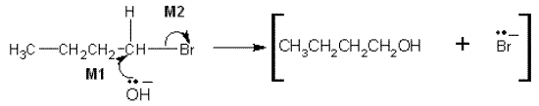
M1 must show an arrow from the lone pair of electrons on the
oxygen atom of the negatively charged hydroxide ion to the
central C atom.
M2 must show the movement of a pair of electrons from the
C─Br bond to the Br atom. Mark M2 independently.
NB The arrows here are double-headed
Penalise M1 if covalent NaOH is used
Penalise M2 for formal charge on C or incorrect partial charges
Penalise once only for a line and two dots to show a bond.
Max 1 mark for the wrong reactant
Award 1 mark only for C-Br bond breakage if an S_{N}1 mechanism is used.
Do not penalise the use of “sticks”
2

(d) (i) Structure of tertiary carbocation (CH₃)₃C+ or drawn out
Insist on a full positive charge on the central C atom.
Penalise a bond to the positive charge.
Be lenient on vertical C-C bonds
1

(ii) Tertiary carbocation/carbonium ion (from 2-bromo-2-methylpropane)
is more stable (than the primary carbocation/carbonium ion)
OR
Primary carbocation/carbonium ion (from 2-bromo-2-methylpropane)
is less stable (than the tertiary carbocation/carbonium ion)
QoL
Ignore reference to the alleged relative stability of haloalkanes
1
[11]

M24. (a) (i) Electron pair donor
OR
Species which uses a pair of electrons to form a
co-ordinate/covalent bond.
Credit “lone pair” as alternative wording
Credit “electron pair donator”
1

(ii) Replacement of the halogen (atom) (by the nucleophile)
OR
The carbon-halogen bond/C-X breaks and a bond forms
with the nucleophile or between the carbon and the nucleophile
They must describe the idea of substitution in a haloalkane.
Accept the idea that a nucleophile replaces the halogen which becomes a halide ion
Penalise reference to “halogen molecule” and penalise the idea that the haloalkane contains a halide
1

(iii) Splitting molecules using/by water
OR
breaking/splitting/dissociating (C¡VX) bond(s)/using/by water
NOT simply the reaction with water or simply the addition of water.
Ignore “compound”
1

(iv) (Heat) energy/enthalpy required/needed/absorbed (at constant
pressure) to break/split it/the (carbon-halogen) bond
OR
(Heat) energy/enthalpy required/needed/absorbed (at constant
pressure) for homolysis of the (C–X/the carbon-halogen) bond
Ignore bond formation
Ignore “average”
1

(b)
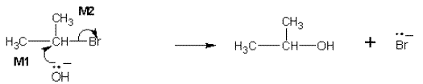
M1 must show an arrow from the lone pair of electrons on the
oxygen atom of the negatively charged hydroxide ion to the
central C atom.
M2 must show the movement of a pair of electrons from the
C-Br bond to the Br atom. Mark M2 independently.
Award full marks for an S_{N}1 mechanism in which M1 is the attack of the
hydroxide ion on the intermediate carbocation.
Penalise M1 if covalent KOH is used
Penalise M2 for formal charge on C or incorrect partial charges
Penalise once only for a line and two dots to show a bond.
Max 1 mark for the wrong reactant
Accept the correct use of “sticks”
2

(c) (i)
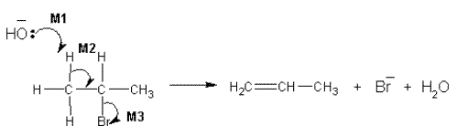
M1 must show an arrow from the lone pair on oxygen of a
negatively charged hydroxide ion to the correct H atom
M2 must show an arrow from the correct C-H bond to the C-C
bond and should only be awarded if an attempt has been
made at M1

M3 is independent provided it is from the original molecule
Award full marks for an E1 mechanism in which M2 is on the
correct carbocation.
Penalise M1 if covalent KOH
Penalise M3 for formal charge on C or incorrect partial charges
Penalise once only for a line and two dots to show a bond.
Max 2 marks for wrong reactant
Accept the correct use of “sticks” for the molecule except for the C-H being attacked
3

(ii) M1 Stated that the spectrum has an absorption/absorbance/
peak in the range 1620 cm^{–1} to 1680 (cm^{–1}) or specified
correctly in this range from the spectrum
M2 depends on correct range or wavenumber being specified
M2 (Infrared absorption) due to C=C OR carbon-carbon double bond
QoL for correct M1 statement which includes both the word absorption (or alternative) and the correct range or wavenumber
Allow “peak” OR “dip” OR “spike” OR “trough”
OR “low transmittance” as alternatives for absorption.
For M2 it is not sufficient simply to state that an alkene has C=C
M2 could be on the spectrum
Ignore reference to other absorptions
2
[11]

M25. (a) (i) (Free-) radical substitution
Both words needed
1

(ii) UV light/Ultra-violet light/sunlight
OR high temperature/150 °C ≤ T ≤ 500 °C
1

(iii) Propagation (Step)
Ignore “first” or “second”
Accept phonetic spelling
1

(iv) M1 Termination (Step)
M2 2CH₃CH₂CH₂• C₆H₁₄
In M2
C₆H₁₄ may be drawn out as CH₃CH₂CH₂CH₂CH₂CH₃
The dot may be anywhere around the terminal CH₂ on the radical
Accept C₃H₇• with dot anywhere
Penalise the absence of any radical dot
2

(v) C₃H₈ + 8Br₂ C₃Br₈ + 8HBr
Or multiples
1

(b) (i) M1 Double bonds are
electron-rich
OR electron pair donors
OR centres of electron density.
M2 Bromine becomes polarised/becomes polar
OR forms an induced dipole
OR becomes δ+/δ–
M1 QoL – require one of these terms
Ignore “(very) negative” and “nucleophile” as applied to the double bond.
Penalise M2 for ion formation from bromine
For M2, do not credit dipole formation solely as a consequence of electronegativity
2

(ii) Electrophilic addition
Both words needed
Accept phonetic spelling
1

(iii) Structure for 1,2,4,5-tetrabromopentane, for example
BrCH₂CHBrCH₂CHBrCH₂Br
OR
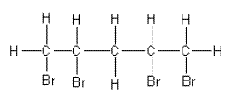
Must be clear that they have drawn 1,2,4,5-tetrabromopentane and does NOT need to be displayed
Credit use of “sticks” for each C-H bond
1

(c) +
M1 Structure of CH₃CHCH₃
M2 (Secondary) Carbocation OR (secondary) carbonium ions
Mark independently
For M1 the positive charge must be on the central carbon atom
Penalise bond to positive charge
Penalise answers which show more than the correct carbocation e.g. the mechanism, unless the intermediate is clearly identified
Credit use of “sticks” for each C-H bond
For M2, penalise “primary” or “tertiary”
2
[12]

M26. (a) (i) M1 Elimination
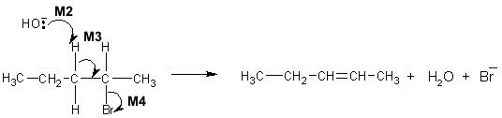

M2 must show an arrow from the lone pair on the oxygen
of a negatively charged hydroxide ion to a correct H atom
M3 must show an arrow from a C-H bond adjacent to
the C-Br bond towards the appropriate C-C bond.
Only award if a reasonable attempt has been made
at the attack on the H atom of the appropriate adjacent C-H
M4 is independent provided it is from their original molecule

Award full marks for an E1 mechanism in which M3 is on the correct carbocation.
N.B. These are double-headed arrows
For M1, accept “Base elimination” but no other prefix.
Penalise M2 if covalent KOH
Penalise M4 for formal charge on C of C-Br or incorrect partial charges on C-Br
Ignore other partial charges
Penalise once only in any part of the mechanism for a line and two dots to show a bond.
Max any 2 of 3 marks for the mechanism for wrong reactant (or wrong product if shown).
Accept the correct use of “sticks” for the molecule except for the C-H being attacked
4

(ii) Structure for pent-1-ene
CH₃CH₂CH₂CH=CH₂
Penalise C₃H₇
Accept correct “sticks”
1

(b) M1 Electrophilic addition
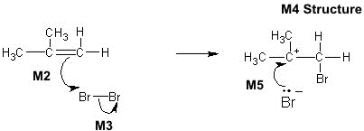

M2 must show an arrow from the double bond towards the Br atom of the Br-Br molecule
M3 must show the breaking of the Br-Br bond.
M4 is for the structure of the tertiary carbocation with Br on the correct carbon atom.

M5 must show an arrow from the lone pair of electrons on the negatively charged bromide ion towards the positively charged carbon atom.
N.B. These are double-headed arrows
For M1, both words required.
For the mechanism
M2 Ignore partial negative charge on the double bond.
M3 Penalise partial charges on Br-Br bond if wrong way and penalise formal charges
Penalise once only in any part of the mechanism for a line and two dots to show a bond
Max any 3 of 4 marks for the mechanism for
wrong organic reactant or wrong organic product (if shown) or primary carbocation.
If HBr is used, max 2 marks for their mechanism
Accept the correct use of “sticks”
5

(c) M1 Nucleophilic substitution
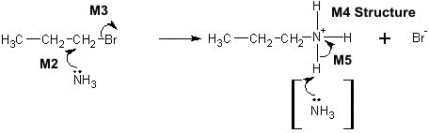

M2 must show an arrow from the lone pair of electrons on the nitrogen
atom of an ammonia molecule to the C atom.
M3 must show the movement of a pair of electrons from the C-Br bond
to the Br atom. M3 is independent provided it is from their original molecule
M4 is for the structure of the alkylammonium ion, which could be a
condensed formula. A positive charge must be shown on/or close to,
the N atom.
M5 is for an arrow from the N-H bond to the N atom.

Award full marks for an S_{N}1 mechanism in which M2 is the attack
of the ammonia on the intermediate carbocation.
N.B. These are double-headed arrows
For M1, both words required.
Penalise M2 if NH₃ is negatively charged.
Penalise M3 for formal charge on C or incorrect partial charges
The second mole of ammonia is not essential for M5; therefore ignore any species here.
Penalise once only for a line and two dots to show a bond.
Max any 3 of 4 marks for the mechanism for wrong organic reactant (or wrong organic product if shown)
Accept the correct use of “sticks”
5
[15]

M27. (a) (i) CH₄ + 3F₂ → CHF₃ + 3HF
1
(ii) M1 Initiation
F₂ → 2F•
M2 First propagation
F• + CHF₃ → •CF₃ + HF
M3 Second propagation
F₂ + •CF₃ → CF₄ + F•
M4 Termination (must make C₂F₆)
2•CF₃ → C₂F₆ or CF₃CF₃
Penalise absence of dot once only.
Radical dot on •CF₃ can be anywhere but if the structure is drawn out, the dot must be on the carbon atom. Penalise this error once only.
Penalise once only for a line and two dots to show a bond.
Penalise each of “Fl” and lower case F, once only in this clip
4

(b) (i) Displayed formula
e.g.
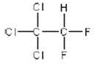
All bonds must be drawn out.
Ignore bond angles. Penalise “sticks”
1

(ii) M1 C–Cl bond OR carbon-chlorine bond
M2 chlorine atom OR chlorine (free) radical
M3 2O₃ → 3O₂
M1 NOT carbon-halogen
Penalise incorrect spelling of chlorine once only in this clip
M2 ignore formulae
Ignore Cl₂ or Cl• or ClO• balanced on both sides of the equation
Ignore other equations leading to the overall equation
3
[9]

M28. (a) (i) M1 Initiation
Cl₂ 2Cl•
Penalise absence of dot once only.
Penalise + or – charges every time
M2 First propagation
Cl• + CH₂Cl₂ •CHCl₂ + HCl
Accept dot anywhere on CHCl₂ radical but if the structure is drawn out, the dot must be on the carbon atom. Penalise this error once only
Penalise once only for a line and two dots to show a bond.
M3 Second propagation
Cl₂ + •CHCl₂ CHCl₃ + Cl•
Penalise once only for double headed curly arrows
Mark independently
3

(ii) M1 Condition
ultra-violet / uv / sun light
OR high temperature
OR 400°C ≤ T ≤ 900°C
M2 Type of mechanism
(free-) radical substitution (mechanism)
2

(b) (i) CHCl₃ + Cl₂ CCl₄ + HCl
Allow X as alternative to CCl₄ only if X is clearly identified as CCl₄
1

(ii) M1 Trichloromethane / CHCl₃ has a C–H bond
OR
X / CCl₄ / it has no C–H bond
M1 must refer to presence or absence of the C–H bond in a compound
M2 The infrared spectrum shows
(absorption / peak for C–H in range) 2850 to 3300 ( cm^{–1}) is missing
M2 answer must refer to / imply the spectrum
Allow the words “dip” OR “spike” OR “low transmittance” as alternatives for absorption.
Ignore references to other absorptions.
2

(c) M1 a statement about bond breakage / formation of Cl•
C–Cl / carbon-chlorine bond breakage occurs
OR Cl• / chlorine (free) radical forms
OR correct equation CHClF₂ Cl• + •CHF₂
Penalise M1, if Cl• is formed from Cl₂ as the only reaction or an additional reaction
Do not penalise an incorrect equation using CHClF₂ if correct reference is made to Cl• formation or C–Cl / carbon-chlorine bond breakage
M2 Cl• + O₃ ClO• + O₂
M3 ClO• + O₃ Cl• + 2O₂
_{M2 and M3 either order}
Penalise absence of dot once only.
Accept dot anywhere on ClO radical
M4 CHClF2 / chlorine-containing compounds/ CFCs damage / react with / decrease the ozone layer
ORthis overall decomposition occurs; 2O3 3O2ORwithout an ozone layer or with a decreased ozone layer, uv radiation is not being “filtered” / prevented from passing through the atmosphere or there is a concern about an increase in skin cancer etc.ORCl• catalyses the decomposition of ozone / a single Cl• causes (chain) reaction / decomposition of many ozone molecules / ozone layer
Award M4 for the general idea behind the EU justification for banning the use of CFCs as refrigerants
Penalise M4 if overall ozone decomposition equation is incorrect
Ignore “greenhouse effect”, “global warming” etc.
₄

_{(d) (i)}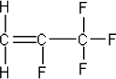
_{All bonds must be drawn out}
₁

(ii) 2,3,3,3-tetrafluoropropene / it does not contain chlorine (atoms) / C–Cl (bonds)
_{Ignore “chlorine molecules”}
ORIt does not produce Cl• / does not produce chlorine (free) radical(s)ORchlorodifluoromethane does contain chlorine / does
produce Cl• / does produce chlorine (free) radical(s)ORC–F is too strong and does not break / create radicalsORC–F is stronger than C–Cl
₁
_{[14]}

M29.(a) M1 electrophilic addition
_{For M1, both words required}
_{Accept phonetic spelling}
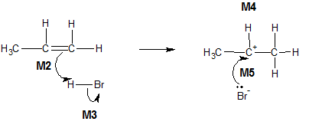
_{For the mechanism}
M2 Ignore partial negative charge on the double bond
M2 must show an arrow from the double bond towards the H atom of the H–Br molecule
M3 Penalise partial charges on H–Br bond if wrong way and penalise formal charges
M3 must show the breaking of the H–Br bond
Penalise once only in any part of the mechanism for a line and two dots to show a bond
M5 must show an arrow from the lone pair of electrons on the negatively charged bromide ion towards the correct (positively charged) carbon atom
Maximum any 3 of 4 marks for the mechanism for wrong (organic) reactant OR wrong organic product (if shown) OR primary carbocation
Accept the correct use of sticks
NB These are double-headed arrows
₅

(b) M1 Nucleophilic substitution
_{For M1, both words required}
_{Accept phonetic spelling}
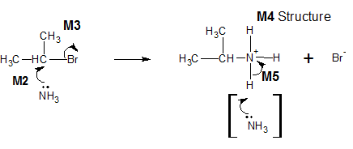
_{For the mechanism}
Penalise M2 if NH3 is negatively charged
M2 must show an arrow from the lone pair of electrons on the nitrogen atom of an ammonia molecule to the correct C atom
Penalise M3 for formal charge on C of the C−Br or incorrect partial charges on C−Br
Penalise M3 for an additional arrow from the Br to something else
M3 must show the movement of a pair of electrons from the C–Br bond to the Br atom. Mark M3 independently provided it is from their original molecule
The second mole of ammonia is not essential for M5; therefore ignore any species here
M4 is for the structure of the alkylammonium ion, which could be a condensed formula. A positive charge must be shown on / or close to, the N atom
Penalise once only for a line and two dots to show a bond
M5 is for an arrow from the N–H bond to the N atom
Maximum any 3 of 4 marks for the mechanism for
wrong organic reactant OR wrong organic product if shown
Award full marks for an SN1 mechanism in which M2 is the attack of the ammonia on the intermediate carbocation
Accept the correct use of “sticks”
NB These are double-headed arrows
₅

(c) M1 (addition) polymerisation OR poly-addition
_{Ignore “additional”}
Credit polyprop-1-ene and polypropylene
_{M2 poly(propene) / polypropene}
Penalise “condensation polymerisation”
₂

_{(d)}
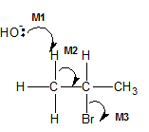
_{Penalise M1 if covalent KOH}
M1 must show an arrow from the lone pair on the oxygen of a negatively charged hydroxide ion to a correct H atom
Penalise M3 for formal charge on C of C–Br or incorrect partial charges on C−Br.
M2 must show an arrow from a correct C–H bond adjacent to the C–Br bond to the appropriate C–C bond. Only award if an arrow is shown attacking the H atom of a correct C−H bond in M1
_{Ignore other partial charges}
Penalise once only in any part of the mechanism for a line and two dots to show a bond
M3 is independent provided it is from their original molecule, but CE=0 if nucleophilic substitution
Maximum any 2 of 3 marks for wrong organic reactant
Award full marks for an E1 mechanism in which M3 is on the correct carbocation.
Accept the correct use of “sticks” for the molecule except for the C–H being attacked
NB These are double-headed arrows
₃
_{[15]}

M30.(a) (i) (Free-) radical substitution
Both underlined words are required
Penalise a correct answer if contradicted by an additional answer
₁

_{(ii) Initiation}
_{F2 2F•}
Penalise absence of dot once only
_{First propagation}
_{F• + CH3F •CH2F + HF}
Penalise + or − charges every time
_{Second propagation}
_{F2 + •CH2F CH2F2 + F•}
Accept dot anywhere on CH2F radical
_{Mark independently}
Termination (must make 1,2-difluoroethane)2 •CH2F CH2FCH2F
Use of half-headed arrows must be correct to score, but if not correct then penalise once only in this clip
₄

(iii) CH3 CH3 + 5F2 CF3CHF2 + 5HF
_{(C2H6)(C2HF5)}
₁

(b) 1,1,1,2-tetrachloro-2,2-difluoroethane
Accept phonetic spelling eg “fluro, cloro”
Penalise “flouro” and “floro”, since QoL
_{OR}
1,2,2,2-tetrachloro-1,1-difluoroethane
_{Ignore commas and hyphens}
₁

_{(c) (i) 2O3 3O2}
ONLY this equation or a multiple
_{Ignore NO over the arrow}
Other species must be cancelled
₁

_{(ii) O + NO2 NO + O2}
ONLY this answer and NOT multiples
Ignore any radical dot on the O atom
₁
_{[9]}

M31.(a) Structure for 3-methylbut-1-ene
_{H2C=CHCH(CH3)2}
Any correct structural representation.
Credit “sticks” and require the double bond.
₁

(b) Structure for 2-methylpropan-2-ol
_{(CH3)3COH}
Any correct structural representation.
_{Credit “sticks”.}
₁

_{(c) Structure for propene}
_{H2C=CHCH3}
Any correct structural representation.
Credit “sticks” and require the double bond.
₁

(d) Structure for 2-aminobutane
_{CH3CH2CH(NH2)CH 3}
Any correct structural representation.
_{Credit “sticks”.}
₁
_{[4]}

_{M32.(a) Initiation}
_{Cl2 2Cl•}
Penalise absence of dot once only.
_{First propagation}
_{Cl• + CH3Cl •CH2Cl + HCl}
Credit the dot anywhere on the radical.
_{Second propagation}
_{Cl2 + •CH2Cl CH2Cl2 + Cl•}
Termination (must make 1,2-dichloroethane)
_{2 •CH2Cl CH2ClCH2Cl}
_{Penalise C2H4Cl2}
₄

(b) (i) (chlorine free) radical
_{Ignore formula.}
₁

(ii) M1 Cl• + O3 ClO• + O2
_{M2 ClO• + O3 Cl• + 2O2}
M1 and M2 could be in either order.
Credit the dot anywhere on the radical.
Penalise absence of dot once only.
Individual multiples acceptable but both need to be doubled if two marks are to be awarded.
₂
_{[7]}

M33.(a) (i) M1 Elimination
M1 Credit “base elimination” but no other prefix.
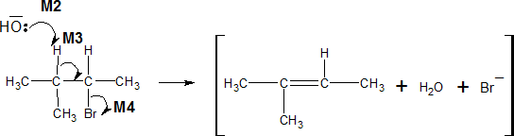
_{Penalise M2 if covalent KOH}
Penalise M4 for formal charge on C or Br of C−Br or incorrect partial charges on C−Br
M2 must show an arrow from the lone pair on the oxygen of a negatively charged hydroxide ion to a correct H atom
_{Ignore other partial charges}
M3 must show an arrow from a correct C−H bond adjacent to the C−Br bond to a correct C-C bond. Only award if an arrow is shown attacking the H atom of a correct adjacent C−H bond in M2
Penalise once only in any part of the mechanism for a line and two dots to show a bond
M4 is independent provided it is from their original molecule, BUT CE=0 for the mechanism (penalise M2, M3 and M4 only) if nucleophilic substitution mechanism is shown
Maximum any 2 of 3 marks for the mechanism for wrong organic reactant or wrong organic product (if shown).
Credit the correct use of “sticks” for the molecule except for the C−H being attacked
Award full marks for an E1 mechanism in which M4 is on the correct carbocation
Penalise M4, if an additional arrow is drawn from Br eg to K⁺
NB These are double-headed arrows
4

(ii) Displayed formula for 3-methylbut-1-ene
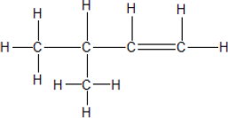
All bonds and atoms must be drawn out, but ignore bond angles
1

(iii) Position(al) (isomerism or isomer)
Penalise any other words that are written in addition to these.
1

(b) (i) Displayed formula for 3-methylbutan-2-ol
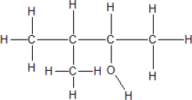
All bonds and atoms must be drawn out, but ignore bond angles.
1

(ii) Any one from
• Lower / decreased temperature OR cold
• Less concentrated (comparative) OR dilute KOH
• Water (as a solvent) / (aqueous conditions)
Ignore “pressure”.
1

(iii) Nucleophilic substitution
Both words needed - credit phonetic spelling.
1

(iv) (Strong / broad) absorption / peak in the range 3230 to 3550 cm⁻¹ or specified value in this range or marked correctly on spectrum
Allow the words “dip” OR “spike” OR “trough” OR “low transmittance” as alternatives for absorption.
1
[10]

M34.(a) 2-bromo-2,3-dimethylbutane
Ignore punctuation.
1

CnH2n+1Br or CnH 2n+1X or CxH2x+1Br
Any order.
1

Stronger / more vdw (forces) between molecules (of 1-bromohexane)
QoL
Allow converse arguments for Z
Not just more IMF.
Ignore size of molecule.
1

(b)
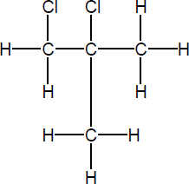
1

C2H4Cl
Any order
1
[5]

