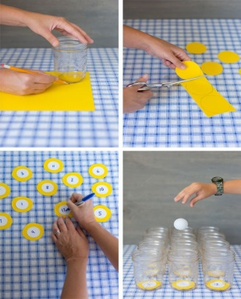
Wednesday Maths:

Create your own Ping Pong maths game!

Have a competition with your family.
Who can get the highest score?
What’s the best technique to shoot the ping pong in the cups?

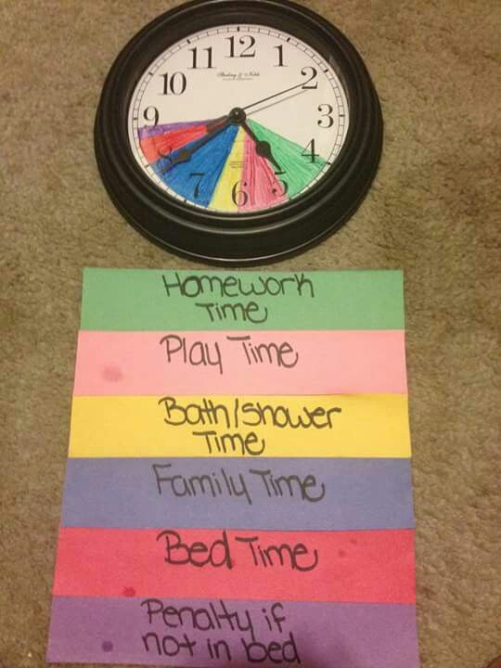

Thursday maths:
Can you create your own clock to show us your daily routine.

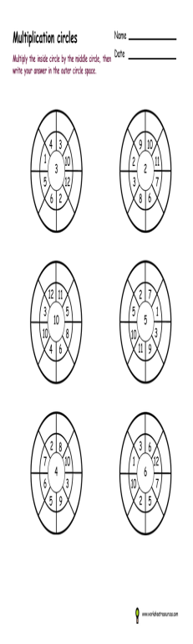

Friday Maths:
Complete this timetable wheel.

Challenge: Can you create your own wheel?

