Hello year 2!
Below are activities that you could complete over the course of a week. Please keep in mind that the tasks below are only suggestions - you can complete as many as you would like at any time. Please connect to ClassDojo where you can stay in touch with your class teacher and also refer to the activities your teacher has posted for you.

Subject | Monday | Tuesday | Wednesday | Thursday | Friday
Reading & Writing  Adventure Story | Watch the film “Up!” if you are able to.  Before watching  What do you think will happen? How did you make this prediction?  While Watching:  Where do you think they will go with the balloons?  Why do you think Carl has chosen balloons?  Use the sentence stem: “I think…because…”  After watching:  Can you summarise the plot?  After watching this film, what is an adventure story?  What would happen if there was a sequel made? | Think about the film “Up!”  Why did Carl decide to build a floating house?  Write what you think it would be like to take off in a floating house.  What would happen if you attached a large amount of balloons to your own house? Where would you go?  Using your senses, sight, touch, smell, taste and hearing describe your adventure. | Begin to plan your own adventure story!  Remember our story mountain. A story must have a beginning, middle and end.  Begin by thinking about the beginning of your story, where are you? Describe your floating home. How did you get there? What can you see?  Build up – Does someone knock at your door? Who is there? | Continue planning and writing your story. Think about the peak of your story mountain, what is the problem or dilemma you face?  Dilemma/Problem – Are there birds sitting on your balloons popping them? Is there a storm?  Resolution – How do you solve this problem?  Conclusion – What happens at the end?  How do you get home?  Did you get home? Maybe you have ended up in another country. Create suspense! | Finish off your story, check for the following:  Have you included:  Adjectives to describe your characters and settings?  Verbs  Proper grammar, including capital letters, full stops and finger spaces?  Expanded noun phrases  Do you have a clear beginning, middle and end?  Have you used conjunctions?  Speech marks when a character is talking?  Share your story on Dojo!
Topic-History, Geography, Science & RE  If you are looking for additional writing activities that link to topic lessons, Jane Considine from the Training Space (On YouTube) holds daily writing lessons that you can watch live or on catch up on their YouTube channel. | Science  Last week you looked at the parts of a plant.  This week have a look at the attached activity about how plants reproduce and grow in nature.  Complete the activity and feedback to your teacher on Dojo. | History  Last week you looked at a video about life in the trenches.  Watch the clip below describing life at home in Britain during the war.  https://www.bbc.co.uk/teach/class-clips-video/home-front/z7stscw  What would you have done during these times? Think about how women and children supported. Make a list of all the ways these groups supported during the war. | Geography  In the summer term we are to be learning about Settlements.  Watch the video below about different settlements  https://www.bbc.co.uk/bitesize/topics/zx72pv4/articles/zrbvjhv  Write what it means and how we classify the following settlements (what do they need to have to be labeled)  - A Hamlet  - A Village  - A Town  - A City  Which do we live in? | RE  Caring for our word.  What does it mean to care for our world?  Think about the communities that you belong in. Home, School, Religious, Northolt, UK etc.  How do you connect within your many communities? How do you take care of our changing world?  Thinking about these points. Brainstorm some ideas about how you can care for our local community. Can you help a neighbour who might be self isolating? How about your parents? How can you care for them while you are at home and not at school?  Share your ideas on Dojo. | News  Watch Espresso News Bites.  What has happened this week?  Write a short paragraph about how this weeks news had made you feel.
Maths  The white rose maths hub has plenty of resources that you can access at home for free.  You can access their problem on the day using the link below.  https://whiterosemaths.com/resources/classroom-resources/problems/ | Last week we looked at patterns in shapes.  Have a look at the quilt patterns and create your own simple or complex patterns. | Complete the attached activity about describing turns.  Can you make your own set of instructions to describe turns of objects using the following language:  - Clockwise  - Anticlockwise  - Full turn  - Quarter turn  - Half turn  - Three quarters turn | Complete the attached worksheet – Turning Turtles.  Read the turn instructions and either cut and stick the turtles in the correct place or draw them. | Look at the Turning My House Around document.  Can you complete what it is asking you to do? Think about what you have been doing throughout this week. How do you describe turns? | Using the language you have learned this week, write a set of instructions to move around your house. Describe each move and turn.  Can your Mum/Dad or sibling follow these instructions?  Ensure you are specific in your steps!
Creative Time | 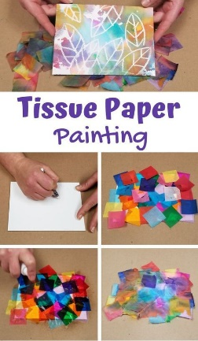  Use a white crayon, or better yet, a wax candle to draw your picture.  Cover your paper in a single layer of tissue paper and wet with a spray bottle or dampened paper towel.  Ensure you have covered your workspace as the colour will bleed through and stain.  Let dry overnight and remove tissue paper to see your artwork! | 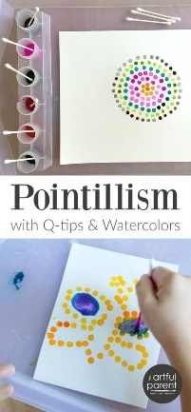  Using a cotton bud, make patterns using paint and single dots.  What can you paint?  If you do not have paints at home, dots of felt tip markers will work as well | 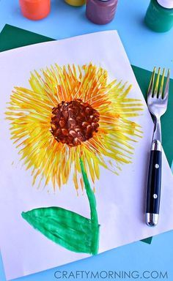  Painting with household objects.  Using a fork, create a beautiful sunflower painting. | 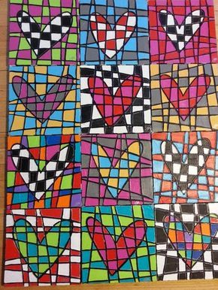  On a piece of blank paper, draw 12 hearts (or another shape of your choice) evenly spaced.  Using a black felt tip, draw lines going across and up/down over your hearts.  Colour each box of your hearts a contrasting colour, and then colour the boxes around two different colours.  Be sure to share your art on Dojo. | Watch the story “The Dot” on Youtube  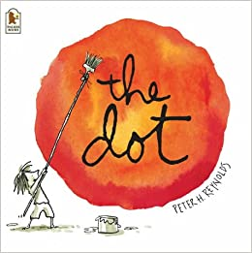  https://www.youtube.com/watch?v=t5mGeR4AQdM  What can you make from a single dot?  Remember, you can never be wrong in art! It’s your creation, you are the artist!

Below are suggested activities that you could be practicing on a regular basis.

Spellings – Keep referring to the year 2 common exception words that you must know how to read and write in year 2.  Keep an eye out for weekly spelling patterns on class dojo. Make sure you have signed up via the email link your teacher has sent you.  You could do any of the following activities:  -Create a word search with your spellings.  -Write silly sentences with your spellings.  -Rainbow spellings  -Write a story that includes each of your spelling words.  -Hold a quiz with the members of your family. | Timestables - knowing our timestables is extremely important, especially your x2, x3, x5, x10’s.  Don’t forget that we also need to know the inverse. E.g. 12 divided by 2 is 6.  Reading- Read a book, magazine, article, leaflet, poster, newspapers. See if you can share what you’ve read with someone else in your family.  Phonics- play on phonics play as it’s a great way to practice your alien words and real words. | Physical Activity - make sure you are trying to be active every day.  - Watch Joe Wicks PE lessons live every day at 9:00am or watch his previous videos at any time of day.  - Create your own circuit and teach it to the members of your family.  - Watch some of the Just Dance videos on YouTube and get dancing for 20 - 30 minutes.  - Have a go at doing some Cosmic Yoga on YouTube

