Hello year 2!
Below are activities that you could complete over the course of a week. Please keep in mind that the tasks below are only suggestions - you can complete as many as you would like at any time. Please connect to ClassDojo where you can stay in touch with your class teacher and also refer to the activities your teacher has posted for you.

Subject | Monday | Tuesday | Wednesday | Thursday | Friday
Reading & Writing  Explanation Texts | Holiday News  Think about what you did during the half term. The weather was lovely and hot and hopefully some of you managed to get out a little bit to enjoy it.  What did you do?  Did you go to the park?  Did you try making something new?  Task: Write a letter to your teacher to tell them all about your holiday news. You can draw pictures to go with this. | Explanation Texts  Have a look at the powerpoint which explains what explanation texts are.  Look at the main features:  Title – explains what the text is for  Opening Statement – about the subject  Clear, simple points about why or how something occurs  Technical words – where appropriate  Conjunctions – e.g. because, resulting in  Present tense  Summary Paragraph  Task: Find your own explanation texts. | Highlighting features  Read the explanation text- How does a Chicken Hatch?  Highlight the features in different colours.  Can you find....  Title  Opening statement  Paragraphs  Technical words  Conjunctions  Time Adverbs  Present Tense words  Task: Highlight features | Writing an Explanation text  Watch a video about the life cycle of a Monarch butterfly.  https://www.youtube.com/watch?v=7AUeM8MbaIk  Can you tell someone all about the stages of the life cycle?  Can you make a list of any technical words you’ve learnt?  Can you draw the life cycle?  Task: Write an explanation text about the life cycle of a butterfly. Write about each stage. | Sharing your text  Can you share your explanation text with someone at home.  Give them some questions to answer about the information you’ve shared.  What is the first stage?  How long does the caterpillar stay in the chrysalis?  Why do butterflies have colourful wings?  Are the patterns the same?  Task: Share your work and questions.
Topic-History, Geography, Science & RE  If you are looking for additional writing activities that link to topic lessons, Jane Considine from the Training Space (On YouTube) holds daily writing lessons that you can watch live or on catch up on their YouTube channel. | Science  Did you know you can experiment re growing your vegetables at home?  Take a look at this website and have a go at trying to regrow a vegetable of your choice.  https://www.ruralsprout.com/regrow-vegetables/  Task: Regrow a vegetable you have at home. | History  We have been learning about WW1 and what life was like.  Watch the video to find out what toys children played with during this time.  https://www.bbc.co.uk/bitesize/clips/zw76pv4  Task: Divide your page into Then and Now. Draw images/write about what toys you play with and what toys were played with during the war. | Geography  Can you make your house/town/village/city or a famous landmark using materials around your home?  You can build it with lego, use empty cardboard boxes and bottles, paper mache.  Task: Make a 3D model of where you live. | Cooking  Change for life have put up lots of fun recipes for you to try cooking at home.  Have a look at the link below and pick your favourite. Give it a go.  https://www.nhs.uk/change4life/recipes  Task: Cook a recipe of your choice (share pictures with your teacher on Class Dojo) | PE  https://www.nhs.uk/10-minute-shake-up/shake-ups  Check out the link and have a go at Disney’s 10 minute shake up’s.  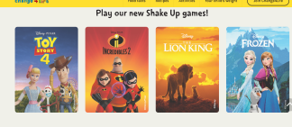  Task: Pick a 10 minute Disney Shake up
Maths  The white rose maths hub has plenty of resources that you can access at home for free.  You can access their problem on the day using the link below.  https://whiterosemaths.com/resources/classroom-resources/problems/ | Summer maths booklet  Complete a few pages of your summer booklet each day. | Summer maths booklet  Complete a few pages of your summer booklet each day. | Summer maths booklet  Complete a few pages of your summer booklet each day. | Summer maths booklet  Complete a few pages of your summer booklet each day. | Play what’s the time Mr Wolf.  https://www.kidspot.com.au/things-to-do/activity-articles/whats-the-time-mr-wolf/news-story/da4c14189849d42a50600e7fae3493f8  Challenge: You may even want to make your own paper clock and show the time instead of shouting it out.
Creative Time | Pointillism  Have a go at creating a picture using lots of tiny dots. You can use a cotton bud and paint or anything you have to hand.  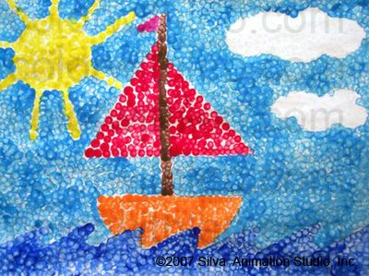 | Mask Making  Why not draw out and create your own masks. Use these masks to act out a story. You may want to act out a scene from your favourite film. Have fun!  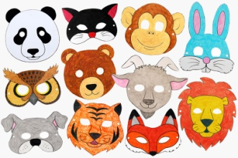 | Lava Lamp  Watch this video and create your own lava lamp.  https://www.youtube.com/watch?v=8OjPXS2OKP8  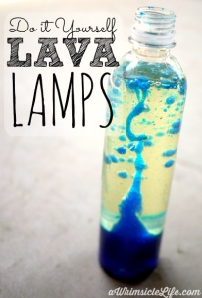 | Salt Dough Craft  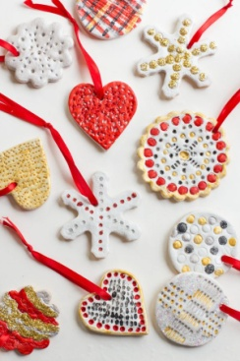  I love this activity as it’s so cool to be able to make your own decorations.  Follow this super simple recipe  https://www.tipsfromatypicalmomblog.com/2017/10/57-fun-things-to-make-with-salt-dough-for-kids.html | Basket making  All you need is rope, card and a hole puncher.  Happy Friday!

Below are suggested activities that you could be practicing on a regular basis.

Spellings – Keep referring to the year 2 common exception words that you must know how to read and write in year 2.  Keep an eye out for weekly spelling patterns on class dojo. Make sure you have signed up via the email link your teacher has sent you.  You could do any of the following activities:  -Create a word search with your spellings.  -Write silly sentences with your spellings.  -Rainbow spellings  -Write a story that includes each of your spelling words.  -Hold a quiz with the members of your family. | Timestables - knowing our timestables is extremely important, especially your x2, x3, x5, x10’s.  Don’t forget that we also need to know the inverse. E.g. 12 divided by 2 is 6.  Reading- Read a book, magazine, article, leaflet, poster, newspapers. See if you can share what you’ve read with someone else in your family.  Phonics- play on phonics play as it’s a great way to practice your alien words and real words. | Physical Activity - make sure you are trying to be active every day.  - Watch Joe Wicks PE lessons live every day at 9:00am or watch his previous videos at any time of day.  - Create your own circuit and teach it to the members of your family.  - Watch some of the Just Dance videos on YouTube and get dancing for 20 - 30 minutes.  - Have a go at doing some Cosmic Yoga on YouTube

