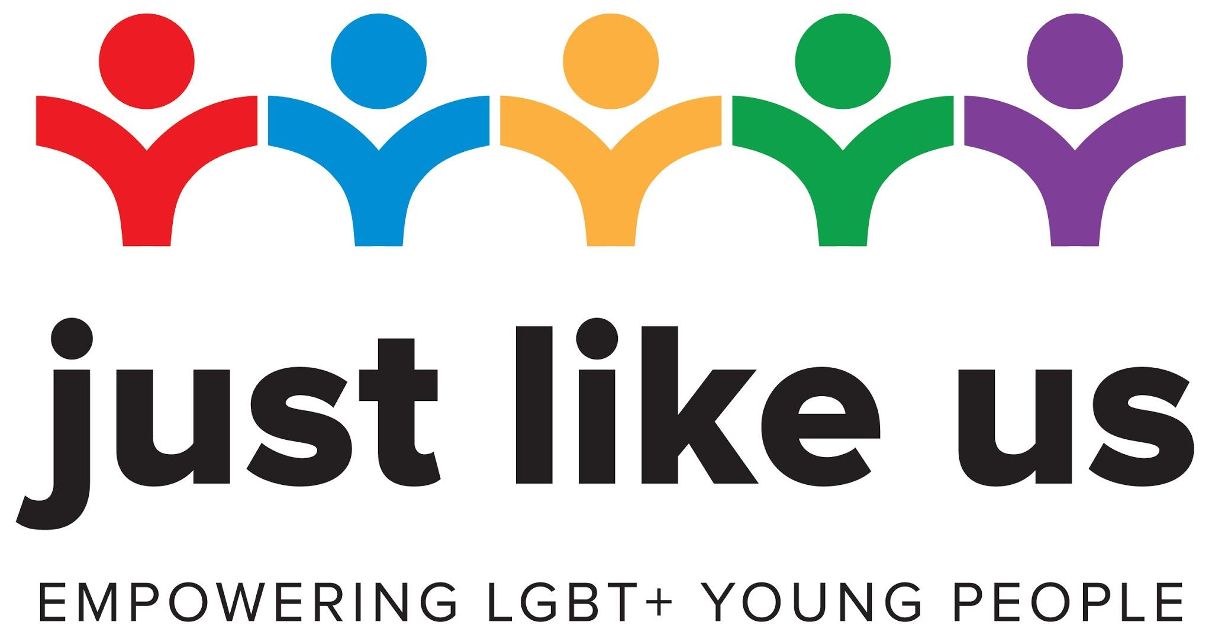

As-and-when activities: primary

Alongside our lesson and activity plans we’ve come up with fun things you can do from home to celebrate School Diversity Week.

Identity Flag 1
Bake Off 2
Message of Support 2
Run a Quiz 2
Write a Story 3

Identity Flag
The rainbow flag has been a symbol for LGBT+ people for almost 50 years. LGBT+ people use the flag at Pride parades to proudly show their identity.

What is identity?

Your identity is made up of all the things that make you who you are, and make you unique! It might include where you’re from, the school you go to, your religion, the things you like doing, as well as many other things.

Create your own identity flag

What would a flag that shows your identity look like? Try creating one yourself on a sheet of A4 paper. Make sure it’s bright and colourful.

Some things you might want to include:
- Pictures of activities you enjoy.
- Something to do with where you’re from (this could be where your family is from, where you were born or where you live now).
- Your favourite colours or foods.
- Things, people or animals that are important to you.

Display your flag wherever you want to show you are proud of your identity. You could put it on your bedroom door. Maybe you could take a picture, send it to relatives that don’t live with you and encourage them to make one too.

Bake Off
What better way to celebrate School Diversity Week than with tasty treats?

We recommend making rainbow cupcakes. They are really easy and a lot of fun!

Have a look at this recipe by Tesco.

Be sure to share pictures of your colourful masterpieces.

As an extra step you could make mini flags using paper, sticky tape and cocktail sticks. Write messages of support for the LGBT+ community on each one.

Message of Support
During lockdown, young people all across the country have been putting messages of support in their windows to make others feel positive.

Create a message to stick in your window. It could encourage people to be kind. It could be a message to cheer people up if they’re feeling low. Perhaps you could mention how it’s important we all work together and support each other despite our differences.

Be sure to write #SDW20 on it and send your messages to Just Like Us too.

Run a Quiz
Create a quiz for your family themed around diversity.

You can use everything you’ve learnt from the School Diversity Week activities to come up with questions.

See if you can video call with relatives that don’t live with you and get them involved too - the more the merrier.

Write a Story
Why not try your hand at writing a story? This could be in the form of a picture book or a comic strip.

The theme of your story should be ‘celebrating difference’.

Make sure it has a beginning, a middle and a (happy) ending. Try and use some of the new words you’ve learned this week.

Again, be sure to share your creations with Just Like Us.

