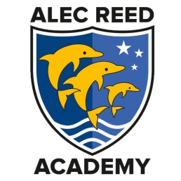

How to order student uniform using Click and Collect

The Academy is operating social distancing to reduce the risk of spreading the Covid virus. As our uniform shop is quite small, we have closed it temporarily and will be selling uniform online only. All orders need to be placed using the online shop and collected from the Academy as follows:
Pick and click
- Visit the uniform shop on the ARA website: https://www.alecreedacademy.co.uk/uniform-shop
- Place your order using the sizing guide.

Collect
- Collect your uniform from the Main Reception in the High School. You will be notified by email when your order is ready for collection.

Returns
- Returns should be made within 30 days of purchase. A full refund will be made, or item exchanged, if the uniform is in the same condition with labels attached. Please keep your email receipt as proof of purchase. Due to Covid, returns will be processed after 3 days.

Opening of the online shop over the summer holiday

- We will be operating a service over the summer break from 20th July to 26th August. Items ordered by Tuesday evening each week will be available for collection on Wednesday each week between 11AM to 1PM. Our daily service for the online shop will resume on 27th August.

Contact

- If you have any queries, please check the Frequently Asked Questions below and if this doesn’t answer your query, please email the uniform shop: Uniformshop@alecreedacademy.co.uk

- For technical queries please contact Finance@alecreedacademy.co.uk

Frequently Asked Questions (FAQ):

How do I get the right size of uniform? A full sizing guide is on the website, please use this. We have also found that when buying High School uniform, parents should check the size of blazer needed using the sizing guide and then buy a one size bigger for the jumper. So, if the blazer needed is 35 inches, the jumper should be 36 inches.

Can I return/exchange my uniform if it does fit? Yes, returns will be accepted
Do I need a ParentPay account? Not to purchase uniform, you will be directed to our online shop. You will still need to create a ParentPay account as we are a cashless academy. New starters will be given ParentPay details in September 20.

Can I pay by cash? No, to minimise the spread of the virus, we will not be accepting any cash.

What uniform do I need to buy? The full list of required uniform can be found on the website: https://www.alecreedacademy.co.uk/uniform-shop

